Name: Katy Douglas

Identifier: F7159709

Module: TT284

Assignment: EMA Part 2

**OU Walking Club Admin Web Application**

**Introduction**

This report evaluates the requirements for the OU Walking Club admin application using initial wireframes followed by a discussion on responsive web design and recommendations on the availability for both the members website and admin application.

The report discusses the differences and importance of authentication and authorisation and recommends ways in which these could be used effectively.

Finally, the report contains acceptance tests for the admin application and discusses the importance of version control through web development.

1a. **Filename:** zy900006_Q1.zip

1b.

**Wireframes**

A wireframe is a blueprint of a website’s design and functionality created using either pen and paper, dedicated software, or both. Using black and white basic shapes and Latin text, a wireframe “take[s] away the concerns about colours, fonts, and imagery, and help[s] focus attention on what’s really important” (The Segue Creative Team, 2013). As wireframes are basic in design and functionality, modifications requested by clients are completed quickly and cost effectively.

For the OU Walking Club website, the header and footer are identical on each page. The navigation bar, footer and logo are placed in positions consistent with the majority of currently active websites. Forms on the website have submit buttons at the bottom similar to forms on other websites. This consistency assists users in learning the website quickly and increases the websites overall usability. The user’s username is located at the top of the page.

Homepage is the main admin hub containing upcoming events, current news items, upcoming and newly submitted walk events and new member requests. All sections are clickable links, helping users navigate quickly and easily. The homepage also includes a login section for admin users to access and change information in the website.

Walk events contains tables of submitted walk events. Items on this page are placed in order of use. The most used options are at the top i.e. new walk button and proposed walks. Active walk entries contain edit buttons allowing any amendments. The layout increases the pages usability and assists staff members to locate information quickly and easily.

New Walk Submission Form contains the requested fields of Walk Name, Date of Walk, Start Time, Meeting Point, Distance of walk in miles, and an area for notes on the walk. There is a drop-down menu to select or change the status of the walk and a submit button at the bottom.

News and Other Events has new entry forms at the top consisting of the requirements for new entries. On submission, news items add the user’s username to the post. The list of created news items is underneath the entry form. The other events section contains two tables under the entry form, current events in the first table and past events in the second.

Members page contains two tables. First is the new member requests table containing requests for membership with accept and reject buttons. Below is a table of members currently registered and shows the members last login date to keep track of member activity. The ability to change membership status and an edit button to update member details are included and consistent with the client’s requirements.

Announcements contains the new announcement form and a table of recent announcements. The form has a text entry box and an attachment option, a table of the members who consented to receive emails, a send date field, quick action today and tomorrow buttons and a submit button. Recent announcement section contains the announcement status and text along with send date and an edit button.

**\*500 Words\***

2a.

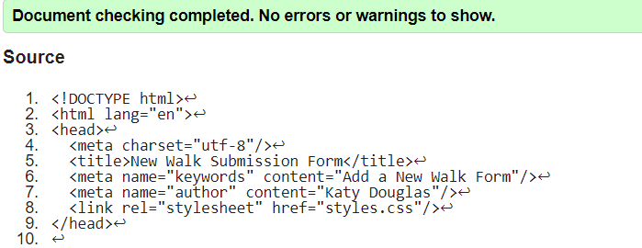

*Figure 1: Screenshot of HTML validation for non-responsive add walk page*

2b.

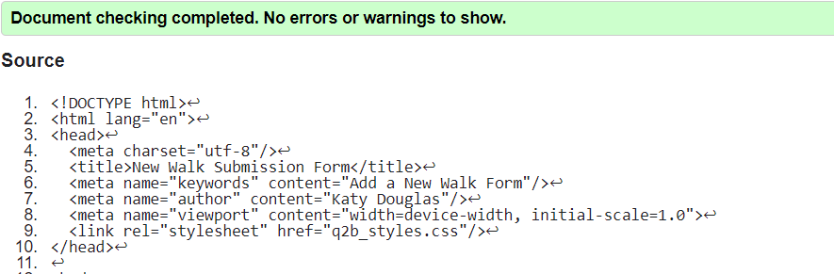

*Figure 2: Screenshot of HTML validation for responsive add walk page*

**Filename**: zy900006_Q2.zip

2c.

**Responsive Design**

The New Walk Submission Form contains elements of code which allow the page to be responsive to screen size, whether this is a laptop or a mobile device.

In the HTML code, a meta-tag was added called viewport. This meta-tag allows the webpage to scale the content to the screen size. Without this meta-tag, a webpage would shrink the whole page onto the small screen making it completely unusable.

Within the CSS style sheet, a media query has been added set to a maximum screen size of 375px allowing for a mobile device. This media query contains several amendments to the original code arranging the existing content to a clearer and usable on a smaller screen. The code is only accessed by the webpage when the screen size is 375px or below.

The measurements for the body margins have been reduced to fit the page width onto a smaller screen. The page is simple and uncluttered increasing the usability for all devices. The user’s login details have moved between the logo and the navigation bar increasing its visibility on a smaller screen. The navigation bar has moved below the logo and login details and is now centred in the page width for clearer viewing and selection. The page footer has been moved up to reduce the length of the page and the amount of whitespace.

The form has been adjusted in several ways allowing for usability and accessibility on laptops and mobile devices. The labels have moved above their corresponding form fields which allows the users to see the complete form on their screen. This removes any requirement for the user to scroll across the page. The complete form also has a tab index order for users to tab through the form increasing the forms accessibility. The Date of Walk and Start Time fields have been coded using their HTML5 tags. These responsive tags allow only relevant and valid data to be entered into the field and instantly inform the user of any invalid data entered. The date field also includes a calendar to manually select a date using a mouse instead of a keyboard.

Both the admin application and the club members website should be responsive to all mobile devices. With the increase in the abilities of mobile technology, “Smartphones have pulled away from laptops to become the most important device used to access the internet” (O’Dea, 2019).

The focus of this should initially be on the club members website as club members are more likely to access the website from a mobile device requiring it to be completely usable and functional on any device.

The admin application need not be completely accessible on mobile devices and could potentially only allow administrators access to a limited selection of functions from the website. These could be basic every day requirements for example the accepting of new members, creating of new walks or creating new announcements. The remaining functions can then be completed on the main website from a laptop.

**\*500 words\***

3.

**Authorisation and Authentication**

According to Gebel (2018), “Authentication is the practice of validating the identity of a registered user attempting to gain access to an application, API, microservices or any other data resource.” Information provided by a user is checked and verified against information stored on the server. If this is a match then access is granted.

The club website and admin application require authorisation processes to gain access. The most common form of authorisation is logging in using a username and password. The username and password are compared to information stored on the server. If the details match, the user is granted access but if it does not match, the user is denied entry.

Another option is to use information already provided by members. When prompted for an email address, the address is checked alongside information on the server, if there is a match a randomly generated one-time use passcode is emailed to the email account. Once the passcode is entered into the website, access is granted.

The most appropriate option for the members site and admin application is to provide both options in a two-step verification process. In doing so, the web application remains secure. The user is asked to log in using their username and password, if this is a match, a one-time passcode is sent to either the users’ email address or mobile phone. Once the correct passcode is entered, the user gains access to the system.

Two-stop verification makes it difficult for someone to try and impersonate a user. They would require a correct username and password along with access to that users email address or mobile phone in order to gain access.

Storing member and staff data on a server contains many security risks which need addressing to ensure data protection.

A brute-force attack occurs when an attacker sets a computer a task of trying combinations of usernames and passwords until they achieve access to website. The two-step verification process ensures that a brute-force attack is a difficult and almost impossible task to perform.

Another way of protecting user data is to ensure all passwords entered are ‘salted’ by adding a random word to the password before being ‘hashed’ or encrypted and stored on the system. To make sure that this is secure, the random word used to salt the password needs to be stored separately to the password.

Once a user has gained access to the system, the server checks the authorisation level of the user to be able to provide correct levels of access to the appropriate sections of the site.

Club members could have several layers of authorisation depending on the length of active membership within the club. New members could only able to view events to attend, middle level members are provided with the extra option of requesting a new walk and the top-level members are provided with the extra options of creating other events.

Providing new members with the highest level of access straight away could potentially open the website up to bullying and negativity attacks on other members or even attempted injected SQL attacks which would cause problems with the website and allow attackers to gain information on other club members and staff.

The admin application requires two levels of access. One for administrators to be able to manage members content and the other for managers containing the admin access along with the ability to add, amend and remove admin accounts and access. Providing an administrator with this type of access could risk errors on the administrators access and a data protection breach of other staff members details.

**\*600 words\***

4.

**Acceptance Tests**

|  |  |
| --- | --- |
| **Test ID: #10001** | |
| Description | Adding a new Walk onto the system with appropriate and correct form entry |
| Set-up | Open up the New Walk Submission Form. |
| Instructions | Create a walk with the following data:  Name of Walk: Teatime walk  Date of Walk: 15/06/2020  Start Time: 18:00  Meeting Point: Outside Wetherspoons  Distance of Walk: 4  Notes: Slight incline through park  Status: Approved  Submit |
| Expected Results | Form submits the above information and adds the walk to the Upcoming walk list |

|  |  |
| --- | --- |
| **Test ID: #10002** | |
| Description | Adding a new Walk onto the system with incorrect form entry |
| Set-up | Open up the New Walk Submission Form. |
| Instructions | Create a walk with the following data:  Name of Walk:  Date of Walk: 31/06/2020  Start Time: 81:00  Meeting Point:  Distance of Walk: Four  Notes: Slight incline through park  Status: Proposed  Submit |
| Expected Results | Form will not submit  **Expected Errors:**  Name of Walk flags error that data is required  Date field flags error that date is invalid  Start time should flag error that time is invalid  Meeting point flags error that data is required  Distance of walk field flags error as invalid entry, numbers only |

|  |  |
| --- | --- |
| **Test ID: #10003** | |
| Description | Editing an existing Walk on the system with appropriate and correct form entry |
| Set-up | Create a walk with the following data:  Name of Walk: Lunchtime stroll  Date of Walk: 01/02/2020  Start Time: 12:00  Meeting Point: Park entrance  Distance of Walk: 5  Notes: Slight incline through park  Status: Proposed.  Submit |
| Instructions | Change the following fields to the following data:  Name of walk: Stroll  Date of walk: 20/06/2020  Start time: 13:00  Distance of Walk: 3  Notes:  Status: Accepted  Submit |
| Expected Results | Form submits the above information, changing the entry on the walk calendar and moves the walk to the Upcoming walk list |

|  |  |
| --- | --- |
| **Test ID: #10004** | |
| Description | Editing an existing Walk on the system with incorrect form entry |
| Set-up | Create a walk with the following data:  Name of Walk: Lunchtime stroll  Date of Walk: 01/02/2020  Start Time: 12:00  Meeting Point: Park entrance  Distance of Walk: 5  Notes: Slight incline through park  Status: Proposed  Submit |
| Instructions | Change the following fields to the below data:  Name of walk: Lunchtime Hike  Change Date Field: 31/06/2020  Change Time field: 27:52  Meeting Point:  Distance of Walk: 10 miles  Submit |
| Expected Results | Form will not submit  **Expected Errors:**  Date field flags error that date is an invalid input  Start time should flag error that time is an invalid input  Meeting point flags error that data is required  Distance of walk field flags error as invalid entry, numbers only |

5a.

**Version Control**

Version control “is an invaluable tool with many benefits to a collaborative software team workflow” (Atlassian, 2019) allowing team members to work on the project simultaneously and commit changes made to the main part, or trunk, of the project.

The repository keeps order to the storage of the project with clearly defined folders and documents. Changes committed by team members are recorded as versions of the project with written notes on the changes. This allows projects to roll back to previous versions if errors occur during development.

Version control contains the ability to create new lines of development called branches. Branches are separate versions of the project which allow edits and amendments to be committed without adding to the project. This allows creating and testing new functions, or fixing bugs, on the project without altering the main version. Once a branch is ready, it is merged into the main project.

Version control is ideally used from the beginning of a project, tracking changes from the start. Each member of the development team requires access to the project’s repository and a section of the project to work on. Any changes that overlap during the merging process are flagged by the version control system for the user to choose which to one to use.

Each change, or related changes, to a working copy need to be committed to the repository together with clear and concise notes on the changes. Commitments need to be made often so each version contains small changes allowing the location of errors and any rollbacks to be completed quickly and easily.

Branches should be used wherever possible for new areas of development, feature changes, or bug fixes to ensure they are correct, working and error free before being merged into the main trunk of the project.

**\*300 words\***

5b.

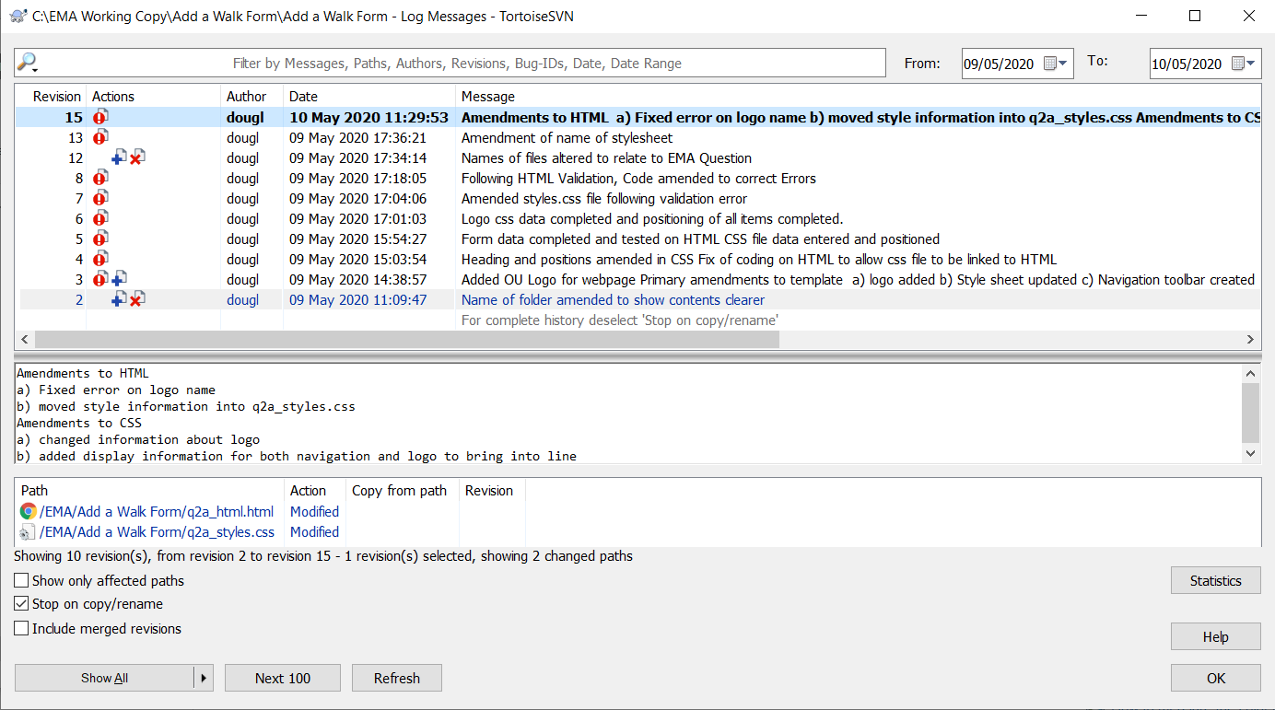

*Figure 3: Screenshot showing log messages following the completion of question 2a*

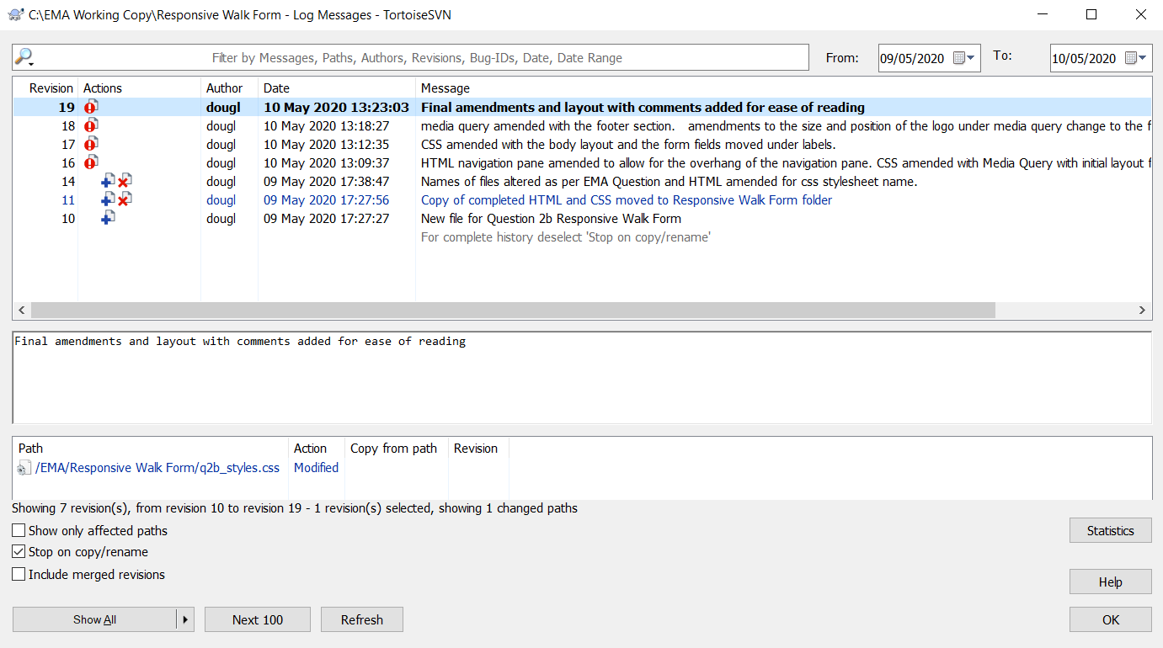

*Figure 4: Screenshot showing log messages following the complete of question 2b.*

**Conclusion**

This report discussed the proposed wireframes for the admin application and responsive web design of the new walk submission form. Access to the club members website through mobile devices was recommended along with a version of the admin application providing limited functions for mobile device access.

The report discussed the importance of authentication and authorisation and recommended a two-step verification for club member and admin application access to reduce the risk of brute-force attack. A way to store the passwords of users by salting and hashing to increase security was also recommended.

The repot explained the importance of version control during web development and provided information and advice on how to effectively use version control throughout the development of the admin application.

6.

**Project Reflection**

During the project, the most useful aspects of my planning was the way I had laid out the project plan so I was able to see each task. The least useful was the way I created the project plan, by listing the question headers and a brief summary of what was required. This could have been more detailed.

On the plan, I listed each task and split each one into sub-tasks to complete and assigned each one an amount of time in hours as an estimate. I found that the amount of time I provided myself for each task was too large and could have been estimated in some sections an hour less and in others significantly more. I did not find the risk assessment useful, however if I was working in a team environment, the risk assessment would have helped to provide contingency plans.

While working through the EMA, I updated the project plan with the duration each section took to complete. I also kept a log of each section using a notebook documenting any problems that occurred during the assignment.

The planning helped with the EMA as I was able to plan each study session with a number of tasks to do, knowing that I had assigned plenty of study time to be able to do it. The breakdown of the tasks helped to minimise what was initially a large assignment and reduce any worry about not finishing the assignment on time.

I did however, miss out a couple of key points on the project plan which were the separate wireframe for the add walk form and the setup of the SVN Repository. This was due to not reading the assignment thoroughly and instead listing the titles of the assignment questions then thinking about what would be needed as tasks in that question.

Due to the missing wireframe, I had to return to the wireframes and re-create the walk page and add a new page called New Walk Submission Form. This then allowed me to proceed more confidently with Question 2 of the assignment. Luckily, I had attended the tutorials surrounding the EMA and therefore was already aware the SVN Repository was required. I pencilled this into my project plan before I created the repository.

In the future I will definitely use a project plan for any EMA’s or large pieces of work to help manage my time and reduce any worry or concerns regarding the size of the assignment and the time allowed for it.

The main lesson I learnt was how to effectively project plan an assignment. Although I overexaggerated the time each task would take, it felt good knowing that the task hadn’t taken as long as I originally assumed.

I also learnt that to be able to provide a more comprehensive project plan, I need to read the assignments thoroughly and make bullet pointed notes for each section as to what is required so I can follow the plan step by step.

**\*500 words\***

**References:**

Atlassian (2019) *Version Control Software: An Overview | Bitbucket* [Online]. Available at https://bitbucket.org/product/version-control-software (Accessed 24 May 2020).

Gebel, G. (2018) *Why you need both authorization and authentication | CSO Online* [Online]. Available at https://www.csoonline.com/article/3269302/why-you-need-both-authorization-and-authentication.html (Accessed 17 May 2020).

O’Dea, S. (2019) *• Devices used to access the internet UK 2019 | Statista* [Online]. Available at https://www.statista.com/statistics/387447/consumer-electronic-devices-by-internet-access-in-the-uk/ (Accessed 17 May 2020).

The Segue Creative Team (2013) *What Are Website Wireframes And Why Do You Need Them?* [Online]. Available at: https://www.seguetech.com/website-wireframes/ (Accessed: 1 May 2020).