SPENDWISE

PROJECT TITILE:
SpendWise – A Simple Backend Learning Project using Node.js, Express, MongoDB, and JWT
Team ID:
SWTID-2026-6032
Team Leader: GANGA K Email id:202400667@sigc.edu
Team Members:
1.Name: DHARANI M Email id:202400571@sigc.edu
2.Name: GOBIKA M Email id:202400404@sigc.edu
3.Name: JANANI P Email id:202400194@sigc.edu

Project Overview
SpendWise is a backend application designed to help beginner developers learn how to build secure REST APIs using Node.js, Express, MongoDB, and JWT authentication. The project focuses on implementing user authentication and basic CRUD operations in a clean and simple way so students can understand how backend systems work in real-world scenarios.
Key Objectives:
- Provide secure user authentication using JWT
- Enable basic CRUD operations on user data (transactions/records)
- Demonstrate MongoDB integration using Mongoose
- Show how protected routes work using middleware
- Maintain a simple and beginner-friendly backend architecture

Target Users:
- Beginner backend developers
- Students learning Node.js and Express
- Freshers preparing for technical interviews
- Anyone who wants a simple project to understand JWT and MongoDB
- Learners who want hands-on practice with REST APIs

Project Instruction
SpendWise is a backend-only project built using Node.js and Express.
Quick Start:
npm init
npm install
npm run dev

steps to create the projects:
- Create the Project Folder
Create a new folder for your backend project or choose an existing directory where you want the project to be stored.
- Open the Folder in Terminal
Open the terminal (or command prompt) and navigate to the project directory using cd.
- Initialize the Node.js Project
Run the following command to create a package.json file:
npm init -y
- Install Required Dependencies
Install the necessary packages for the backend:
npm install express mongoose jsonwebtoken bcrypt cors dotenv
- Create the Project Structure
Inside the project folder, create the following directories:
  - models
  - routes
  - controllers
  - middleware
  - config
- Set Up the Server File
Create a main server file such as server.js or app.js and configure Express and other middleware.
- Add a Development Script
In package.json, add a script to run the server in development mode:
"scripts": {
"dev": "nodemon server.js"
}
- Start the Server
Run the following command to start the backend server:
npm run dev
- Test the API Endpoints
Use tools like Postman or Thunder Client to test your APIs at:
http://localhost:5000

Create Project Folder Structure
Create these folders:
backend-project
│
├── config
├── controllers
├── middleware
├── models
├── routes
│
├── server.js
├── .env
└── package.json

Pre-requisites:
Software Requirements

Software |  | Purpose
Node.js |  | JavaScript runtime for backend
MongoDB |  | NoSQL database for data storage
Npm |  | Package manager
Git |  | Version control system
Code Editor |  | VS Code or similar
Knowledge Requirements
- JavaScript ES6+
- Node.js and Express.js
- MongoDB and Mongoose
- JWT authentication
- Basic REST API concepts
- Git basics

Thumbnail for Project
Thumbnail for Project
- A simple backend project thumbnail representing:
Node.js + Express + MongoDB + JWT + CRUD APIs

Project Architecture Image
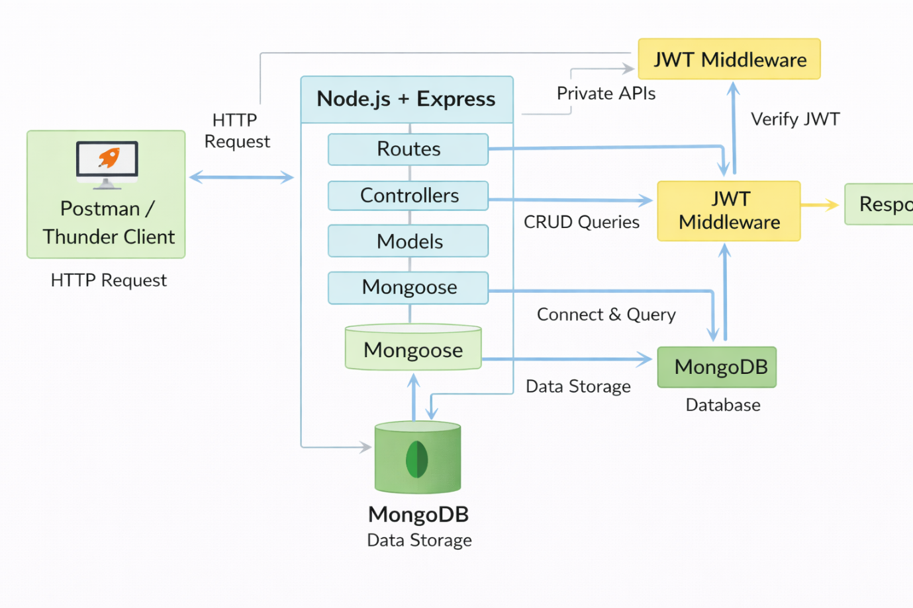

Technical Architecture
Backend Architecture (Node.js + Express)
- Controllers: Handle business logic for authentication and CRUD
- Models: Mongoose schemas for User and Transaction
- Routes: API endpoints for auth and CRUD operations
- Middleware: JWT verification and request protection
- Configuration: Database connection and environment variables

Database Architecture (MongoDB)
- Users Collection:
_id, name, email, password (hashed), createdAt
- Transactions Collection:
_id, userId (FK), title/description, amount/value, createdAt
- Relationship:
Many Transactions belong to One User

ER Diagram:
USER
-----
UserID (PK)
Name
Email
Password
Phone

1
USER -----------< EXPENSE >----------- CATEGORY
| | |
| | |
| v |
| CategoryID (FK) |
| |
v 1
BUDGET -----------------------------------
|
v
CATEGORY

INCOME
------
IncomeID (PK)
Amount
Date
Source
UserID (FK)

Features

# | Feature | Description
1 | User Authentication | JWT-based registration and login
2 | CRUD Operations | Create, Read, Update, Delete transactions
3 | Protected Routes | Secure APIs using JWT middleware
4 | MongoDB Integration | Store and fetch data using Mongoose

Roles and Responsibilities
Student / Developer:
- Write backend code
- Create APIs
- Test APIs using Postman/Thunder Client
- Push code to GitHub
System (Backend):
- Authenticate users using JWT
- Handle CRUD operations
- Store and fetch data from MongoDB
- Protect private routes

User Flow:
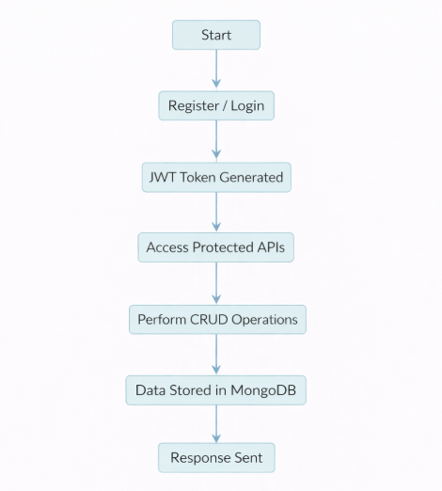

PROJECT SETUP AND CONFIGURATION
Folder Structure

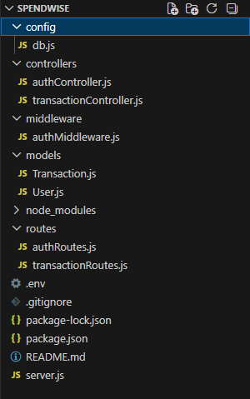

Project Setup
1. Install required tools:
- Node.js
- MongoDB
2. Create project folders:
- server folders (models, routes, controllers, middleware, config)

3. Install Backend Packages:
- Express
- Mongoose
- Cors
- Jsonwebtoken

- Bcrypt
- Dotenv

BACKEND DEVELOPMENT
- Setup Express server
- Create server.js file
- Create .env file and define PORT and DB URL
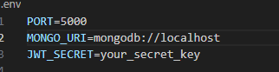
- Configure middleware (cors, express.json)
- User Authentication:
  - Create Register and Login routes
  - Generate JWT token
  - Protect routes using middleware

- Define API Routes:
  - Auth routes
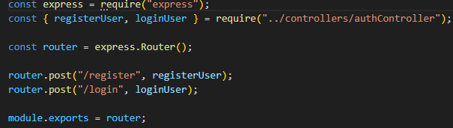
- Implement Data Models:
  - User schema

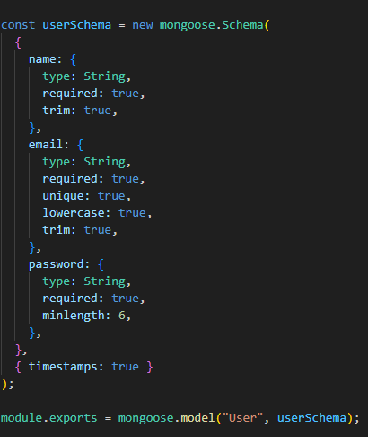

Transaction schema
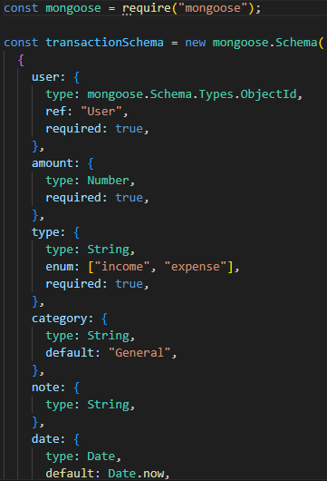

DATABASE DEVELOPMENT
Configure MongoDB
- Use MongoDB Atlas or local MongoDB
- Store connection URL in .env file
- Connect using Mongoose
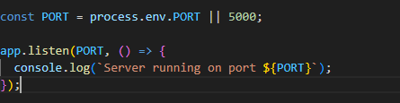
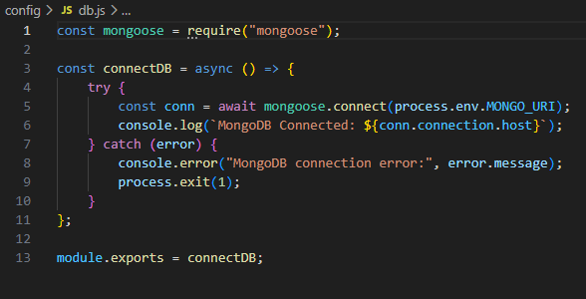
- Use mongoose.connect()
- Handle success and error cases
Create Schema and Models
User Model:
- Name
- email
- password

Data / Transaction Model:
- userId
- title / description
- amount / value
- timestamps
PROJECT EXECUTION
Project Execution Steps:
- Start MongoDB
- Run backend server
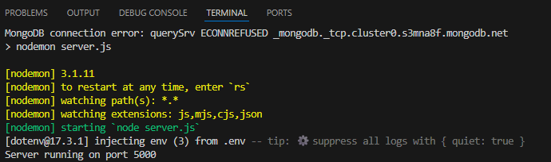

- Test Register API
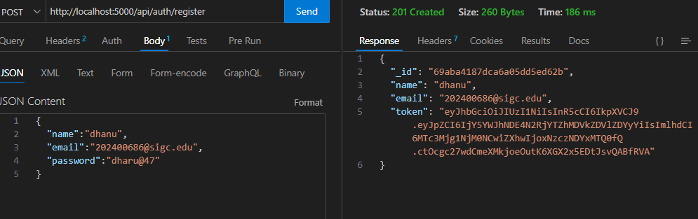
- Test Login API

- Copy JWT token
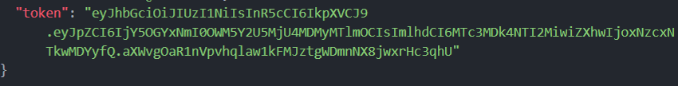
- Use token to access protected CRUD APIs
- Perform Create, Read, Update, Delete operations

OUTPUT SCREENSHOT

- Register API

- Login API
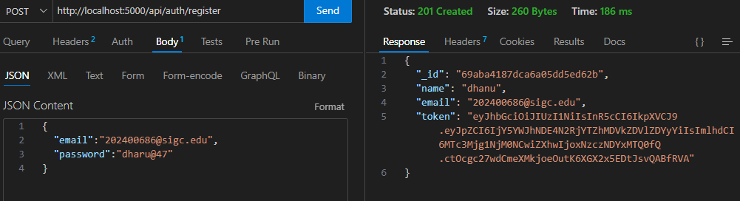
- Create Transaction
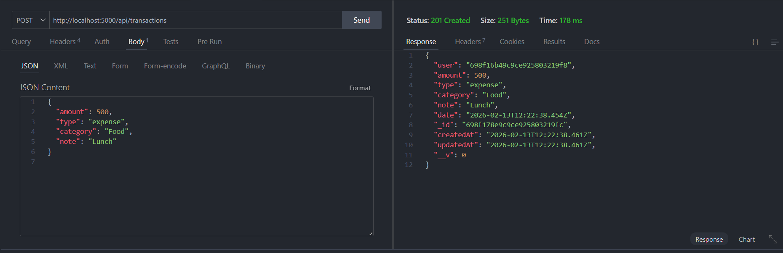

GitHub Link : https://github.com/K-ganga13/SPENDWISE.git

DEMO VIDEO LINK : https://drive.google.com/file/d/1EyPFVVH1678G5ievf4GXHnnGjsaNHX-v/view?usp=sharing

