**IFT3335 TP2 Report**

**1. Experimental design**

To deal with the word meaning disambiguation problem, we aim to classify a word used in a context into the appropriate meaning class. The implementation process mainly includes data preprocessing, analysis of multiple classification algorithms, parameter sensitivity analysis, and draws some experimental conclusions and prospects for future optimization directions.

**2. Data preprocessing**

Data preprocessing mainly includes four parts: data denoising, feature extraction, feature selection and data set division.

**2.2 Feature Extraction**

Feature extraction includes these ways: feature extraction using grammatical part-of-speech granularity (gc) and feature extraction using word granularity (nw). The part-of-speech extraction method is to obtain the part-of-speech of each n adjacent words before and after the predicted word, such as VB VBG NNS IN, and the stem extraction method is to obtain the stems of each n adjacent words before and after the predicted word. Perform stem restoration, such as working->work.

**2.3 Feature Selection**

Since a word can appear several times in the text, and its importance may vary according to its frequency of occurrence. Therefore, consider extracting features from part-of-speech or stemming words by using CountVectorizer and TfidfVectorizer for feature selection, and using "frequency" to measure the importance of a word in the text. Among them, CountVectorizer uses the frequency of each word or part of speech in the entire training corpus as a feature, and TfidfVectorizer uses the word frequency-inverse text frequency of each word or part of speech in the entire corpus as its feature.

**2.4 Dataset division**

This dataset includes 2369 sentences, 6 semantics about "interest" or "interests". Detailed data can be found at: <http://www.d.umn.edu/~tpederse/data.html>, using the training set to train the model.

**3. Performance Analysis and Comparison of Classification Algorithms**

This section first makes a horizontal comparison of the performance of different classifiers under the same feature conditions, and then compares and analyzes different features and parameter settings.

Conclusion: The prediction accuracy of the mlp model is significantly better than other classification models, and the model works best when using n-words features. Therefore, in order to analyze the impact of model parameters on the effect more deeply, the following paragraphs will conduct parameter analysis based on the mlp model.

The mlp model has stronger scalability (the number of neural network layers, the number of hidden layer nodes, optimization methods, etc.), and stronger fitting capabilities, so its performance is also better.

Here are the images for comparison:

**4. Parameter sensitivity analysis**

**4.1 Analysis of removing stop words**

Removing stop words includes removing punctuation marks (such as "/", ":", "\n", etc.), parts of speech ('/IN', '/DT', '/CC') and meaningless vocabulary (tool word list(stoplist).txt) has three parts, no stop words are removed, only punctuation marks and parts of speech are removed. Through experiments, if the words contained in stoplist.txt are removed, the effect of all classifiers will be reduced. We think it is because tool word list(stoplist).txt contains a lot of words and names, Words related to the user's emotional color, whether to delete stop words depends largely on the tasks we are performing and the goals we want to achieve, and we are training a model that can recognize the meaning of "interest", and keep stop words make the classification effect better.

The detailed experimental training parameters and the effects of various classifiers are as follows:

**(1) Remove stop words:**

**(2) Do not remove stop words:**

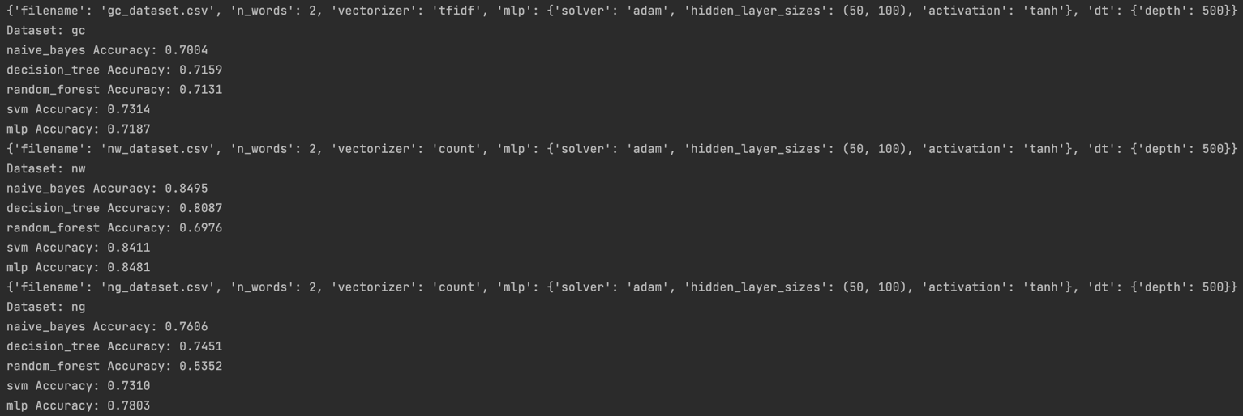

**4.2 Analysis of feature extraction method**

We analyze the three models one by one, let them train five algorithms respectively, and we can get conclusions through comparison.

Conclusion: The model trained using stemmed word features (nw) outperforms the other two methods.

Stemming is to extract the stem or root form of a word, which can reduce the noise interference caused by tense, singular and plural, deformation, etc., and can obtain more useful information in sentences than other methods. For the effect of using only nw as a feature for model training.

**4.2.1 gc_dataset:**

gc_dataset.csv_DecisionTreeClassifier: gc_dataset.csv_MLPClassifier

gc_dataset.csv_MultinomialNB gc_dataset.csv_RandomForestClassifier

gc_dataset.csv_SVC

**4.2.2 ng_dataset:**

ng_dataset.csv_DecisionTreeClassifier. ng_dataset.csv_MLPClassifier

ng_dataset.csv_MultinomialNB

ng_dataset.csv_RandomForestClassifier ng_dataset.csv_SVC

**

**4.2.3 nw_dataset:**

nw_dataset.csv_DecisionTreeClassifier nw_dataset.csv_MLPClassifier

**

nw_dataset.csv_MultinomialNB nw_dataset.csv_RandomForestClassifier

**

nw_dataset.csv_SVC

**4.3 Window size**

Conclusion: Among decision_tree, random_forest, svm, and mlp, we choose the mlp method that has been determined and has the best rendering effect to calculate the performance. We get the best results when the window is 4

At the same time, we consult Levy & Goldberg's paper "Dependency-based word embeddings" to understand the qualitative impact of window size (<https://levyomer.files.wordpress.com/2014/04/dependency-based-word-embeddings-acl-2014.pdf>), they found that larger windows tend to capture more information about topics and domains, and smaller windows tend to capture more information about the word itself, which further demonstrates that we want to train a machine that can recognize "interest "The goal of meaning models is better suited for smaller windows. The detailed experimental results are as follows:

{'filename': 'nw_dataset.csv', 'n_words': 1, 'vectorizer': 'count', 'mlp': {'solver': 'adam', 'hidden_layer_sizes': (50, 100),'activation': 'tanh'}, 'dt': {'depth': 500}} Dataset: nw

mlp Accuracy: 0.8242

{'filename': 'nw_dataset.csv', 'n_words': 2, 'vectorizer': 'count', 'mlp': {'solver': 'adam', 'hidden_layer_sizes': (50, 100), 'activation': 'tanh'}, 'dt': {'depth': 500}} Dataset: nw

mlp Accuracy: 0.8467

{'filename': 'nw_dataset.csv', 'n_words': 3, 'vectorizer': 'count', 'mlp': {'solver': 'adam', 'hidden_layer_sizes': (50, 100), 'activation': 'tanh'}, 'dt': {'depth': 500}} Dataset: nw

mlp Accuracy: 0.8425

{'filename': 'nw_dataset.csv', 'n_words': 4, 'vectorizer': 'count', 'mlp': {'solver': 'adam', 'hidden_layer_sizes': (50, 100), 'activation': 'tanh'}, 'dt': {'depth': 500}} Dataset: nw

mlp Accuracy: 0.8397

{'filename': 'nw_dataset.csv', 'n_words': 5, 'vectorizer': 'count', 'mlp': {'solver': 'adam', 'hidden_layer_sizes': (50, 100), 'activation': 'tanh'}, 'dt': {'depth': 500}} Dataset: nw

mlp Accuracy: 0.8326

**4.4 Analysis of Feature Selection Method**

**TfidfVectorizer and CountVectorizer.**

Conclusion: TfidfVectorizer works better than CountVectorizer on most classifiers.

CountVectorizer only considers the frequency of vocabulary in the text, which belongs to the bag of words model feature, while TfidfVectorizer not only considers the frequency of a certain vocabulary in the text, but also pays attention to the number of all texts containing this vocabulary. It can reduce the impact of high-frequency meaningless words and get more meaningful features.

The experimental training parameters and the effects of various classifiers are as follows:

**(1) tf-idf**

{'filename': 'nw_dataset.csv', 'n_words': 2, 'vectorizer': 'tfidf', 'mlp': {'solver': 'adam', 'hidden_layer_sizes': (50, 100), 'activation': 'tanh'}, 'dt': {'depth': 500}} Dataset: nw

naive_bayes Accuracy: 0.7004

decision_tree Accuracy: 0.7173

random_forest Accuracy: 0.7750

svm Accuracy: 0.9156

mlp Accuracy: 0.9353

**(2) count**

{'filename': 'nw_dataset.csv', 'n_words': 2, 'vectorizer': 'count', 'mlp': {'solver': 'adam', 'hidden_layer_sizes': (50, 100), 'activation': 'tanh'}, 'dt': {'depth': 500}} Dataset: nw

naive_bayes Accuracy: 0.6793

decision_tree Accuracy: 0.7117

random_forest Accuracy: 0.7961

svm Accuracy: 0.9044

mlp Accuracy: 0.9255

**4.5 Classifier parameters**

Perform parameter sensitivity analysis on the best mlp model, including three parts: network layer number, optimizer and activation function.

Although the following parameters do not make much difference to the results of the test methods, there are only some minor differences. But some conclusions can also be drawn:

**4.5.1 Number of Network Layers**

Conclusion: The more hidden nodes in the network to a certain extent, the more layers, the better the fitting effect of the model.

**4.5.2 Optimizer**

Conclusion: adam is slightly better than sgd and lbfgs, and adam is better than sgd in terms of calculation speed.

**4.5.3 Activation function**

Conclusion: tanh is better than relu and logistic

**5. Conclusions and expectations**

Combining the above, it can be concluded that through the preprocessing of the data set, the analysis of various classification algorithms, and the sensitivity analysis of parameters, we found that the mlp model has the best and stable effect, and also found that data processing has a greater impact on the subsequent model results. In the future, we will try more novel data processing, feature processing, and model experiments to discover more meaningful things.