Create the following table structure in SNOWFLAKE by creating your own warehouse. Insert some 10 rows using INSERT command (check task 3 and same way insert for all task tables) in the table by trying different values for all the columns and then check using SELECT *

Once data is loaded, performed the below task

**Task 1:**

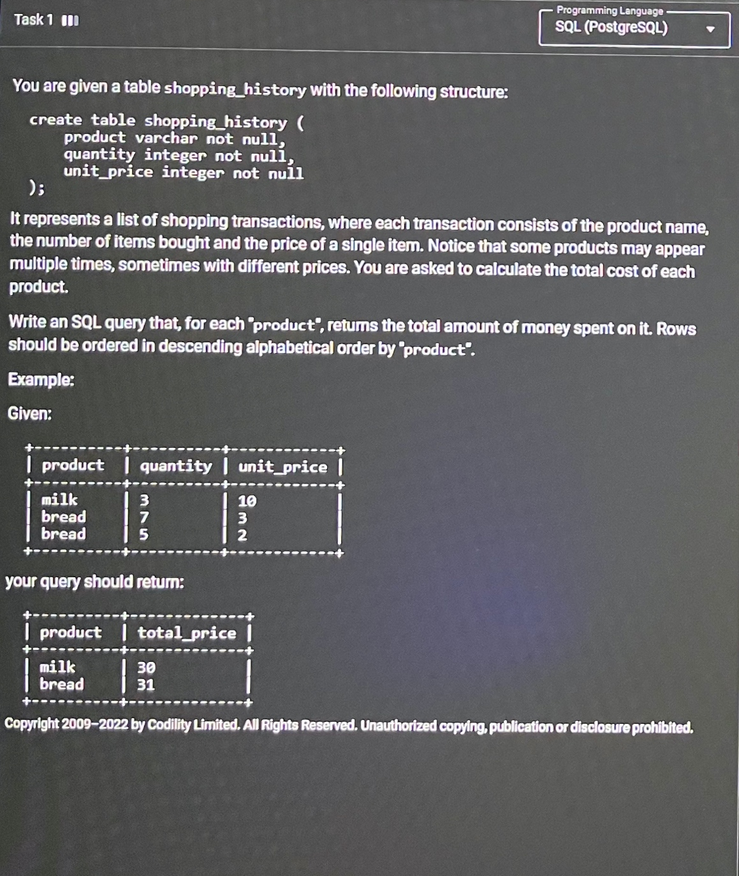

**Task 2:**

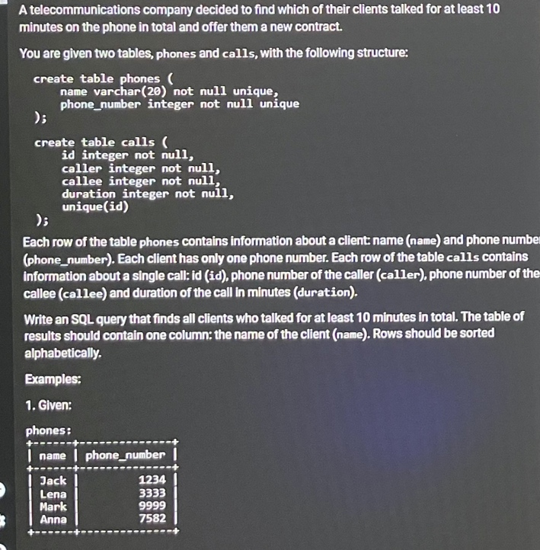 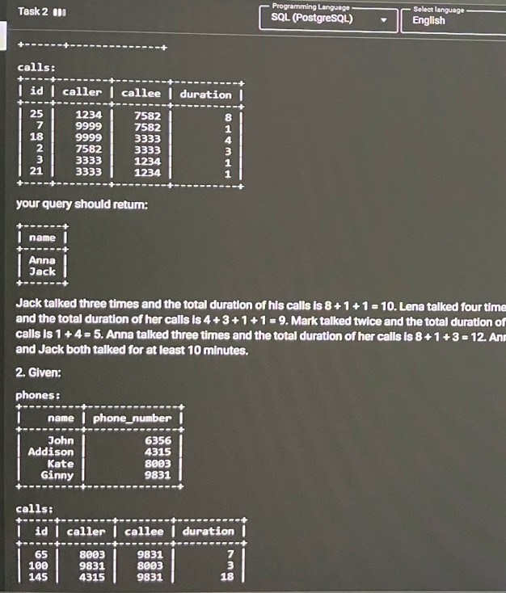

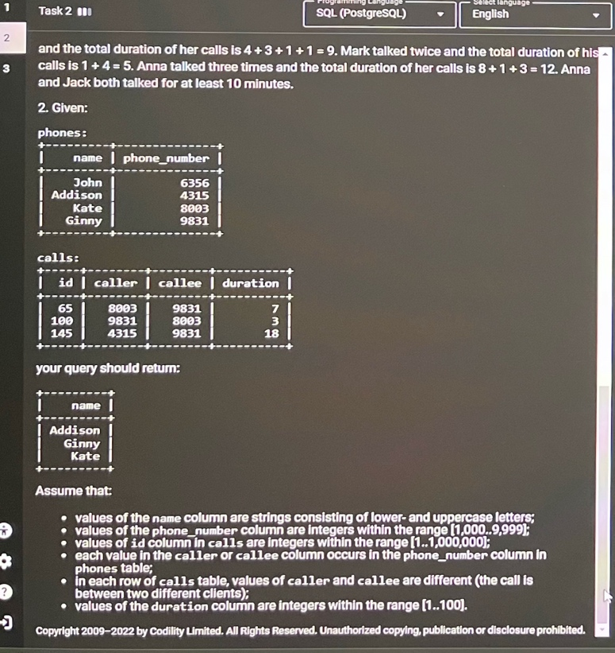

**Task 3:** **Output display is just one column balance**

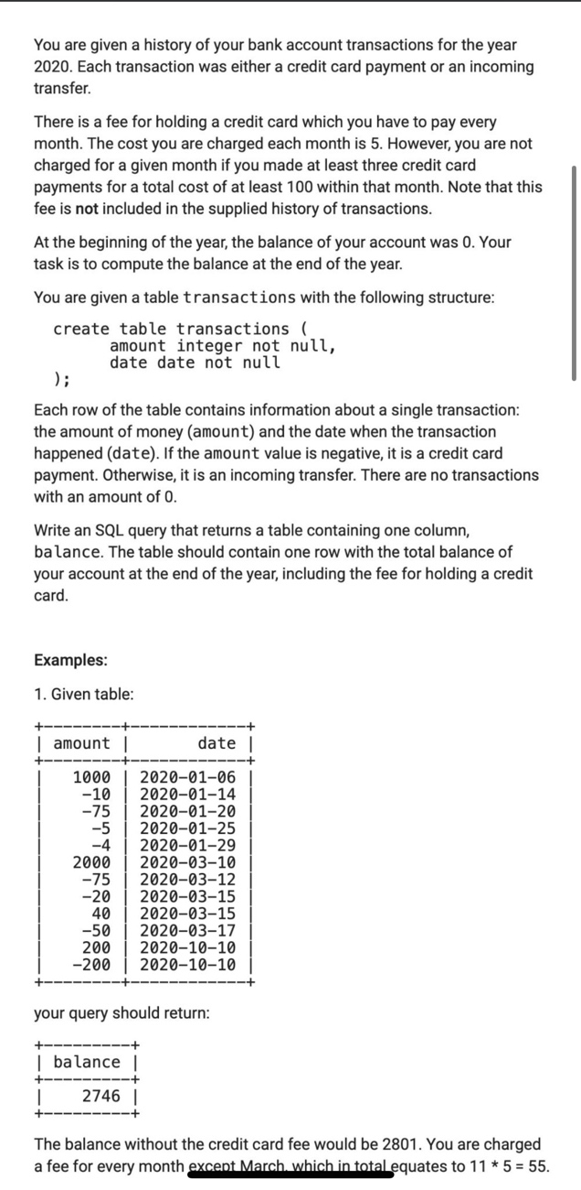 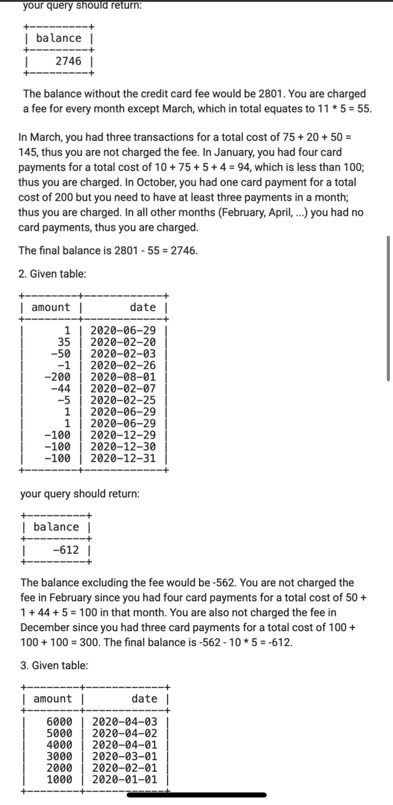

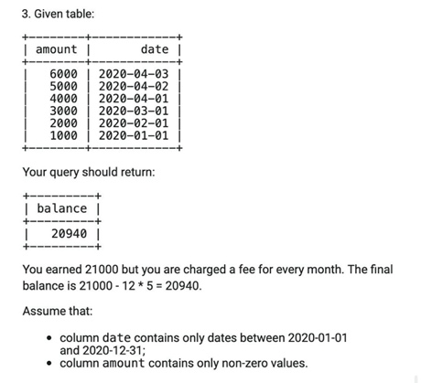

You can add the following data in the table

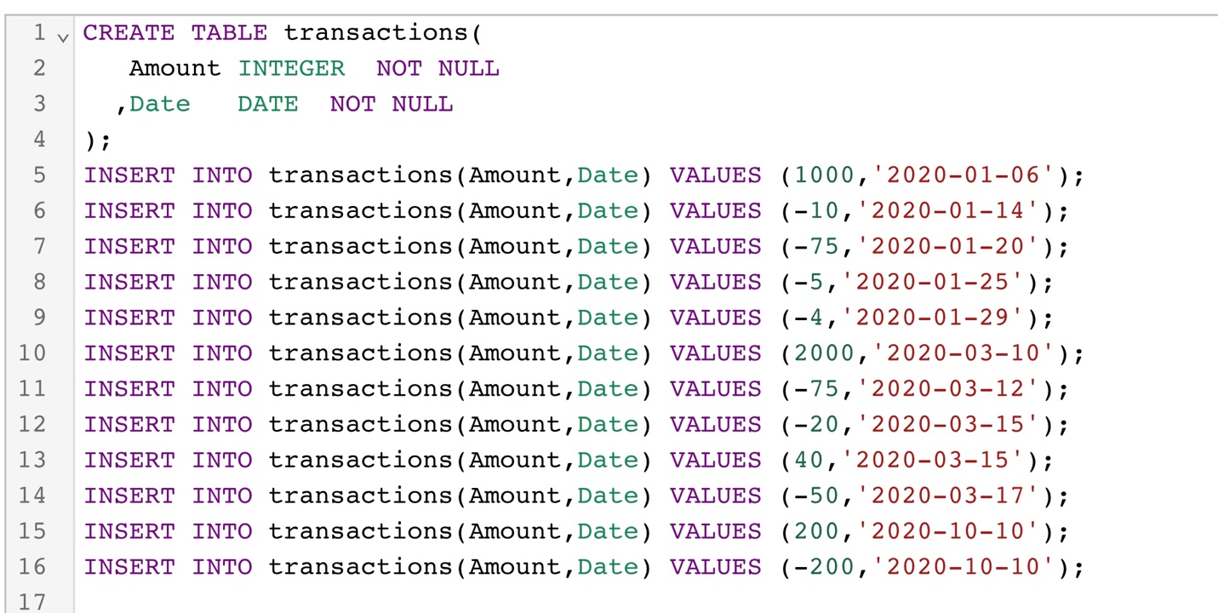

Solution:

create database Assignment1

Use database Assignment1

Drop table SHTSK1

///Task 1 Shopping_history)

create table SHTSK_1

(

"Product" varchar Not null,

"Quantity" integer,

"Unit_price" integer);

Select * from SHTSK_1;

select Product, (Quantity * Unit_Price) as Total_price

from SHTSK_1

//Task2 Telecommunicatio ///

Drop table Phones

create table Phones_1

(

name varchar(20)not null Unique,

phone_number integer not null Unique

);

select * from phones_1;

drop table calls

create table calls_1

(id integer not null,

caller integer not null,

callee integer not null,

duration integer not null,

unique(id)

);

select * from calls_1;

//Task 2 Sql query///

Select A.name

from(

select p.name, c.caller,c.callee,sum(duration) as total_duration

from phones_1 p inner join calls_1 c on (p.phone_number = c.caller and p.Phone_number = c.callee)

Group by p.name,c.caller, c.callee

having total_duration >=10)A

order by 1

//Table for task3//

create table A_transaction

(

amount integer not null,

date date not null

);

select * from A_transaction

//Task 3//

select sum(tranasactions)over(partition by date order by date) as total_balance

from A_r