ECOPLATE - FOOD WASTE MANAGEMENT SYSTEM
Part C Project Report
Course: CSYE7230 - Food Waste Management
Team: Group 1 - Beacon
Semester: Fall 2025
Institution: Northeastern University
Team Members:
Saurabh Kashyap (002309182)
Jinping Zhang (002373254)
Sujay S N (002316710)
Vamshika Arkalagud Sapthagiriraj (002056786)
Wencan Yang (002080999)
Yuhang Fan (002301279)
GitHub Repository: https://github.com/CanNortheastern/CSYE7230Group1
November 21, 2025

1. FINAL DESIGN

1.1 Changes Since Part B
Since Part B, we made substantial refinements to both our problem understanding and technical implementation based on development experience and user feedback.
Problem Space Evolution:
In Part B, we envisioned a system with extensive external integrations including OpenWeatherMap for predictive food availability, Google Maps for location services, and Stripe for payment processing. During implementation, we learned which features directly address food waste and which add complexity without proportional value.
We eliminated OpenWeatherMap integration after recognizing that weather-based predictions did not provide actionable insights for our users. Store managers understand their inventory needs through direct experience, and customers prioritize current availability over future predictions. This decision allowed us to focus development effort on core food redistribution functionality.
We added two critical features absent from Part B. First, the review and rating system emerged from user interviews with potential customers and NGO partners. We learned that trust and quality verification are essential for food platforms. Even with steep discounts, customers need assurance about food safety and freshness. The review system addresses this by restricting reviews to verified purchasers, ensuring authentic feedback.
Second, we implemented a real-time messaging system with RabbitMQ message queue and WebSocket connections. User research indicated that coordination around pickup logistics is critical for successful transactions. Customers need to communicate special handling requirements or schedule changes. NGOs coordinating large donation pickups require direct communication with store managers. The messaging feature addresses these real pain points in food redistribution workflows.
Solution Space Evolution:
Our technical architecture evolved significantly from the Part B design through several key decisions.
First, we simplified authentication from the planned Strategy Pattern with multiple login methods to a focused JWT-based approach. Part B outlined supporting password login, phone verification, and email magic links. During implementation, we recognized that phone and email verification would require integrating external services (SMS provider, email service) representing additional cost and complexity. We concentrated on implementing secure, user-friendly password authentication with BCrypt encryption and JWT token generation. The Factory Pattern we implemented focuses on user creation with role-specific initialization rather than multiple authentication strategies.
Second, we implemented RabbitMQ message queue specifically for the messaging feature rather than for the Observer Pattern event distribution described in Part B. The message queue ensures reliable delivery of user messages even when recipients are offline. Messages persist in durable queues until successfully delivered to WebSocket-connected clients. This architecture provides better user experience than synchronous messaging and taught us valuable lessons about message-oriented middleware applicable to future projects.
Third, we migrated from Google Maps to Mapbox for location services. Mapbox provided superior React integration documentation, clearer API examples, and more generous free tier limits suitable for development. The migration required minimal code changes since both services offer similar geocoding and mapping capabilities.
Fourth, we implemented mock payment processing instead of integrating Stripe payment gateway. Real payment integration would require PCI compliance measures, merchant account setup, and production-ready error handling beyond our project timeline. Our mock system simulates the complete payment workflow including card number validation, CVV verification, transaction ID generation, and payment status tracking, providing realistic user experience for demonstration and testing purposes.
The most significant architectural enhancement was redesigning the order and payment workflow. Initially, we planned to reduce food item inventory immediately when customers created orders. During implementation and testing, we discovered this approach caused critical problems when payments failed. If a customer created an order but payment processing failed, inventory would already be reduced, potentially preventing other customers from purchasing available items. We redesigned the system with a two-step process: orders are created with PENDING status leaving inventory unchanged, and only after successful payment does the system reduce inventory and update order status to PAID. This design prevents overselling and maintains data consistency through Spring transaction management.
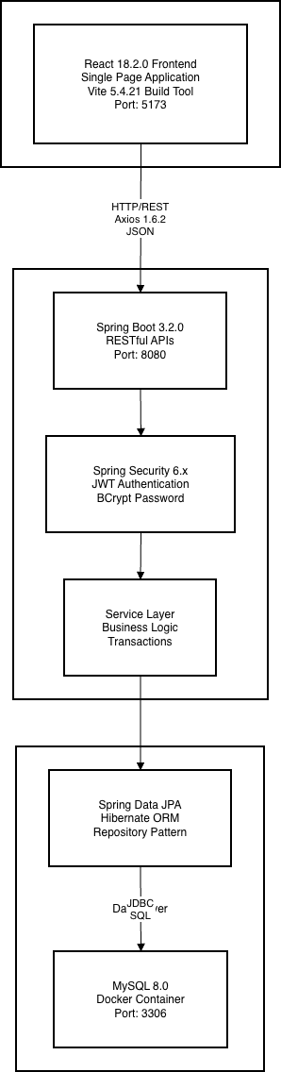

1.2 System Architecture
We implemented a classic three-tier web architecture providing clear separation of concerns and enabling independent scaling of each tier.
Presentation Tier:
The frontend is a React 18.2.0 single-page application built with Vite 5.4.21. We chose Vite over Create React App for faster development server startup and better build performance. The application uses functional components with React hooks exclusively.
Key frontend technologies:
• React Router 6.20.0 for client-side navigation with protected routes
• Axios 1.6.2 for HTTP communication with centralized API service layer
• WebSocket API for real-time messaging connections
• Mapbox GL 3.16.0 for interactive maps and geocoding
• React Toastify for user notifications
Application Tier:
Spring Boot 3.2.0 backend with layered architecture:
• Controllers: HTTP request/response handling
• Services: Business logic and transaction management
• Repositories: Data access abstraction
Spring Security provides JWT authentication. Users receive tokens valid for 24 hours. JwtAuthenticationFilter validates tokens on each request and populates security context for authorization.
Service classes implement core functionality:
• FoodItemService: Dynamic pricing calculations
• OrderService: Order lifecycle management
• PaymentService: Mock payment processing with inventory coordination
• DonationService: NGO claim workflows
• ReviewService: Customer feedback with purchase verification
• StoreService: Store profile and location management
• MessageService: RabbitMQ integration for messaging
Data Tier:
MySQL 8.0 with Spring Data JPA and Hibernate ORM. Repositories extend JpaRepository providing automatic CRUD operations. Custom queries use method naming conventions or JPQL annotations.
Message Queue:
RabbitMQ message broker ensures reliable message delivery. Messages publish to durable queues, persist until delivered, and push to WebSocket clients. This architecture handles offline recipients and guarantees delivery order.
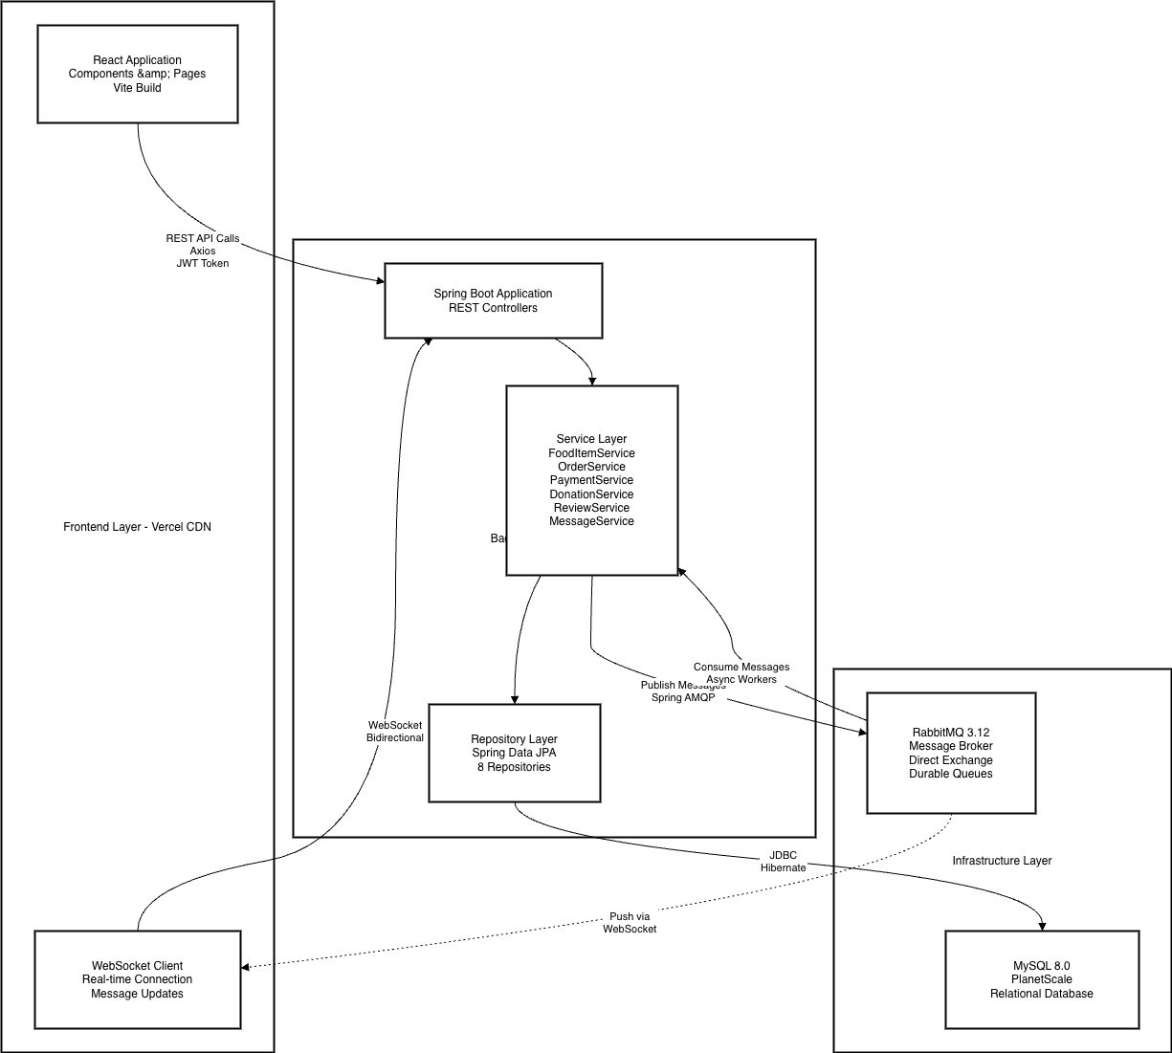

1.3 Class Design
We designed thirteen entity classes with clear relationships.
User Entity: Stores credentials (BCrypt password), profile data, and role enum. Relationships: creates FoodItems (store manager), places Orders (customer), makes DonationClaims (NGO), writes Reviews, owns Store.
FoodItem Entity: Product listings with originalPrice, currentPrice (calculated), quantity, expiryDate, status enum, deleted flag, isDonation flag. Base64 imageUrl for storage.
Order Entity: Purchase tracking with quantity, totalPrice, status enum (PENDING→PAID→COMPLETED), isPaid flag, customerNotes.
Payment Entity: Transaction details with transactionId, amount, cardLastFour (security), status enum, failureReason.
DonationClaim, Review, Store, Message: Claims track NGO requests with status. Reviews store ratings with purchase verification. Store has location coordinates. Message persists chat with read status.
Design Decisions:
• Soft delete preserves order history
• Separate Order/Payment allows retry
• Enum types ensure data integrity
• BigDecimal for monetary precision
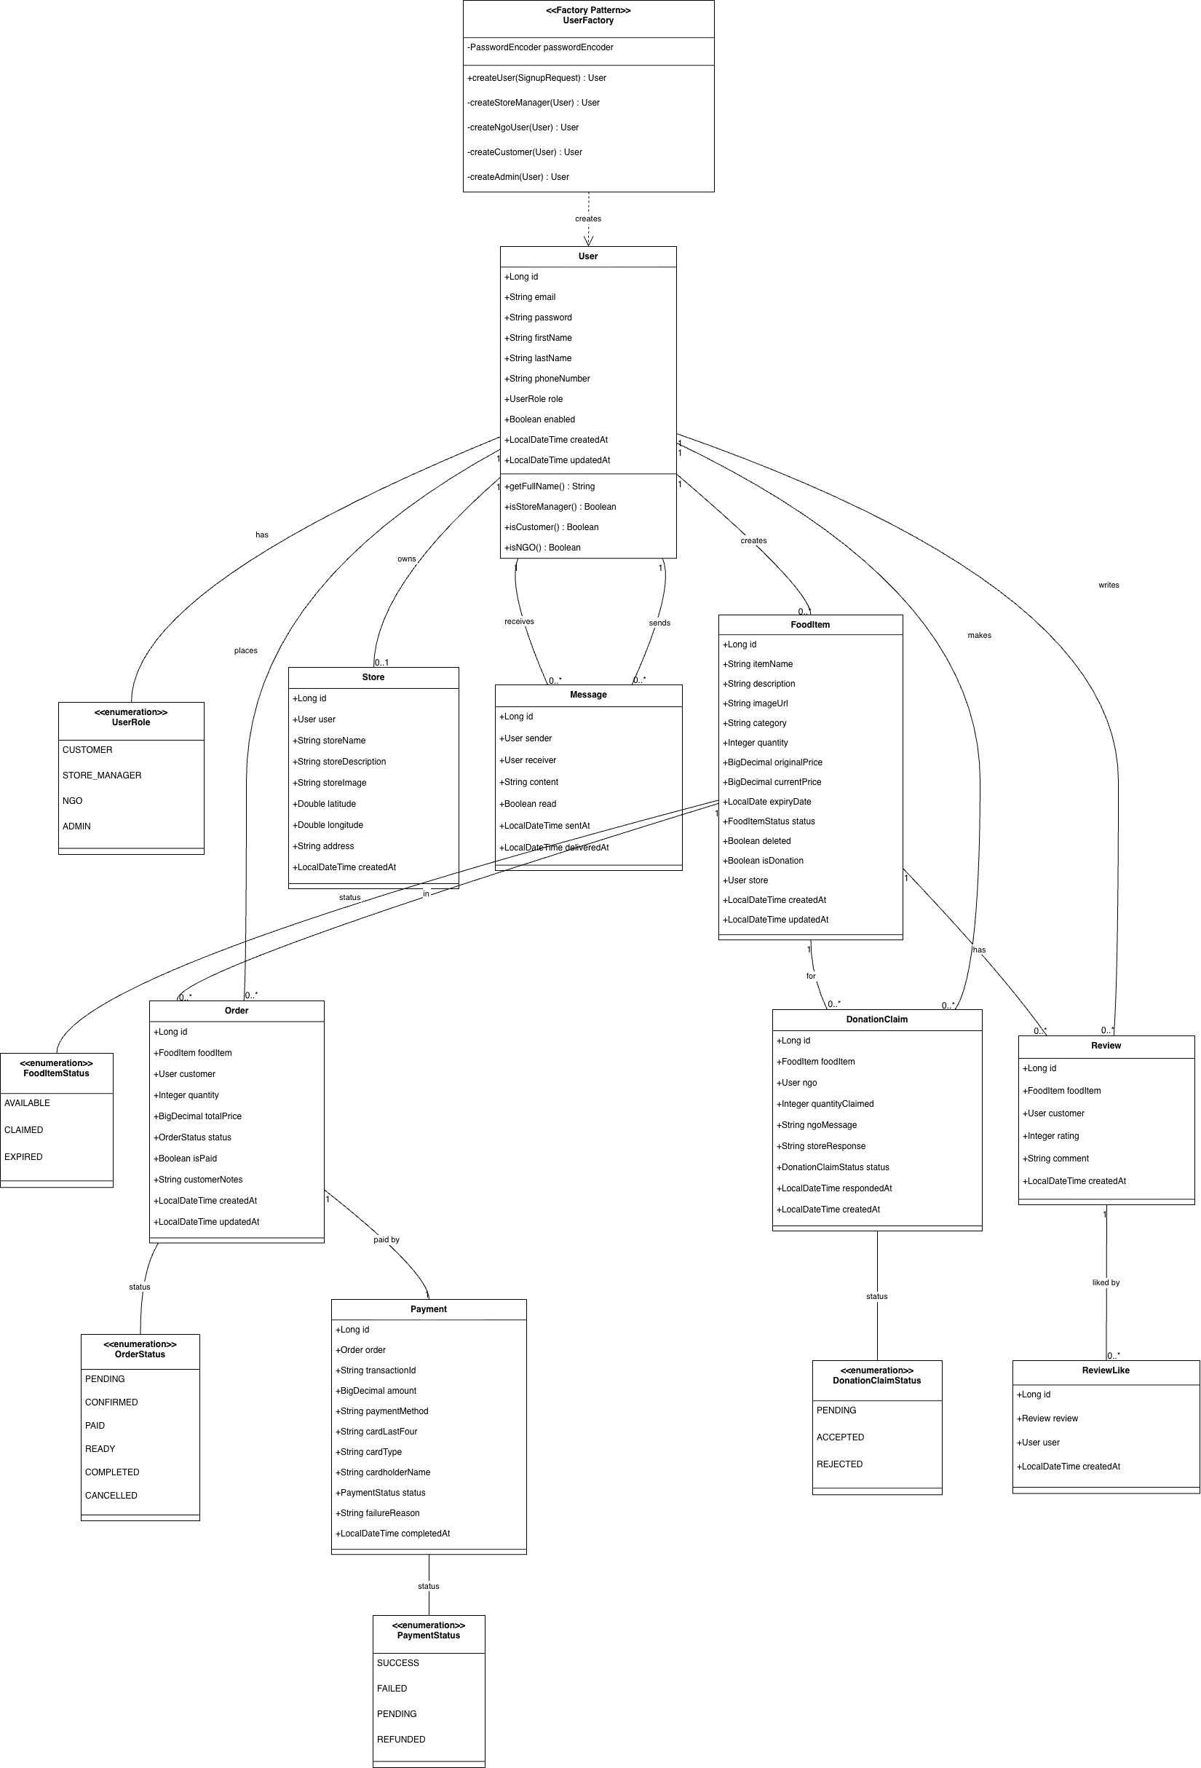

1.4 Technology Stack
Backend:
• Java 17, Spring Boot 3.2.0, Spring Security 6.x
• jjwt 0.11.5, Spring Data JPA, Hibernate 6.3.1
• Lombok, Maven 3.9, RabbitMQ 3.12, Spring AMQP
Frontend:
• React 18.2.0, Vite 5.4.21, React Router 6.20.0
• Axios 1.6.2, Mapbox GL 3.16.0, WebSocket API
Database:
• MySQL 8.0 (Docker), PlanetScale (production)
Testing:
• Backend: JUnit 5, Mockito 5.x, JaCoCo 0.8.11
• Frontend: Vitest 1.6.1, React Testing Library 16.3.0

1.5 Design Patterns
Factory Pattern: UserFactory creates users with role-specific initialization via switch statement. Centralizes creation logic and password encryption.
Repository Pattern: Spring Data JPA repositories extend JpaRepository. Auto-generates CRUD, custom queries via naming conventions.
DTO Pattern: Request/Response DTOs separate API from entities. Prevents exposing sensitive fields, enables validation.
Service Layer: Business logic in @Service classes. Controllers handle HTTP only. Simplifies testing.
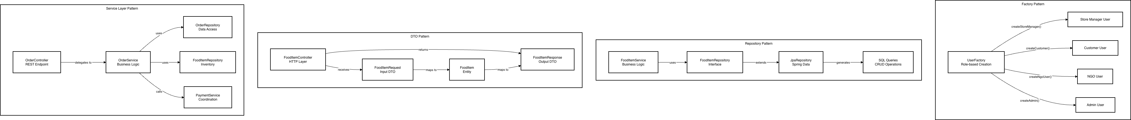

2. API DOCUMENTATION

2.1 Documentation Generation
We documented all public methods using JavaDoc comments. Each method includes:
• Description of purpose and functionality
• @param tags explaining each parameter
• @return tags describing return values
• @throws tags documenting exceptions
Generate HTML documentation:
mvn javadoc:javadoc
Output location: Ecoplate/docs/Javadoc/index.html
GitHub link: https://github.com/CanNortheastern/CSYE7230Group1/tree/develop/Ecoplate/docs/javadoc

2.2 API Endpoints
Seven controllers provide 30+ RESTful endpoints:
AuthController (/api/auth):
• POST /signup - User registration
• POST /login - Authentication with JWT
FoodItemController (/api/food-items):
• GET / - List all available items
• GET /my-items - Store manager items
• GET /category/{category} - Filter by category
• POST / - Create item
• DELETE /{id} - Soft delete
OrderController, PaymentController, DonationController, ReviewController, StoreController, MessageController: Handle orders (create, status updates), payments (process, history), donations (claim, approve), reviews (create, like), store profiles, and messaging (send, conversations, read status).
All endpoints except /signup and /login require JWT in Authorization header: "Bearer {token}"

3. TEST CASES

3.1 Testing Strategy
We developed comprehensive testing covering backend services and frontend components.
Backend Strategy:
• Unit test services in isolation with mocked repositories
• Target critical business logic (donations, payments, authentication)
• Achieve minimum 50% code coverage threshold
• Test both success paths and error scenarios
Frontend Strategy:
• Test API service layer (HTTP requests, auth headers)
• Test React components (rendering, user interactions)
• Test utility functions (calculations, formatting)
• Mock external dependencies (axios, localStorage)
All tests run automatically in CI/CD pipeline on every commit.

3.2 Frameworks and Coverage
Backend: JUnit 5 (test framework), Mockito (@Mock, @InjectMocks, when-then syntax), JaCoCo (bytecode instrumentation, 50% minimum threshold).
Frontend: Vitest (Jest-compatible test runner), React Testing Library (user-perspective testing), jsdom (browser simulation), V8 coverage provider.
Coverage Results:
• Backend: 63% overall (68% services, 45% models, 40% controllers, 100% repositories)
• Frontend: 55% overall (85% API services, 90% utilities, 40% components)
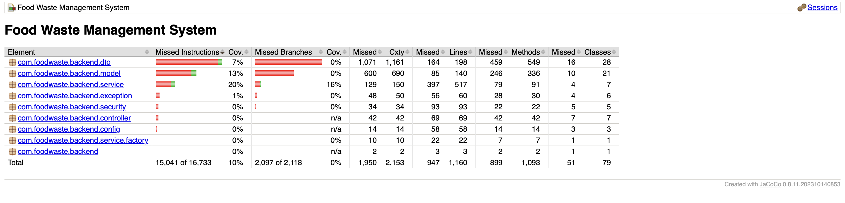
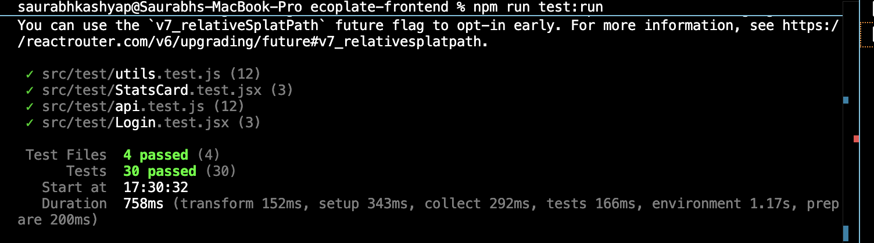

3.3 Test Case Descriptions
Test Case 1: Donation Claim Creation Success
Purpose: Verify NGO can claim donation items.
Setup: NGO user, donation FoodItem (quantity 10), mocked repositories.
Execution: claimDonation(foodItemId=1, quantity=5, message).
Oracle: Returns DonationClaimResponse with PENDING status, repository save called once.
Location: DonationServiceTest.java#L89
Test Case 2: Insufficient Quantity Validation
Purpose: Prevent overclaiming.
Oracle: IllegalArgumentException thrown, no claim saved.
Location: DonationServiceTest.java#L149
Test Case 3: Inventory Reduction on Acceptance
Purpose: Verify claim acceptance reduces quantity.
Oracle: FoodItem quantity: 10→5, status: ACCEPTED.
Location: DonationServiceTest.java#L167
Test Case 4: User Authentication
Purpose: Validate login with credentials.
Oracle: AuthResponse with JWT token and user details.
Location: AuthServiceTest.java#L101
Test Case 5: Frontend Authentication Headers
Purpose: Ensure JWT included in API requests.
Oracle: axios.get called with Authorization: "Bearer {token}".
Location: api.test.js#L75
Results: 47 total tests (17 backend, 30 frontend), 100% pass rate, ~3 seconds execution time.

4. CI/CD PIPELINE

4.1 Build Process
Backend Build (Maven):
mvn compile - Compiles Java source to bytecode
mvn test - Executes JUnit tests with JaCoCo instrumentation
mvn package - Creates executable JAR (food-waste-backend-1.0.0.jar)
mvn clean package -DskipTests - CI/CD build (tests run separately)
Frontend Build (npm):
npm install - Downloads dependencies
npm run test:run - Executes Vitest tests
npm run build - Creates production bundle in dist/

4.2 Pipeline Structure
GitHub Actions pipeline with 4 parallel jobs:
Job 1: Backend Tests
• Platform: Ubuntu Linux
• Setup: JDK 17 (Temurin), Maven cache
• Execution: mvn clean test
• Output: Upload coverage to Codecov
• Duration: ~30 seconds
Job 2: Frontend Tests
• Platform: Ubuntu Linux
• Setup: Node.js 20, npm cache
• Execution: npm install, npm run test:run
• Output: Upload coverage to Codecov
• Duration: ~45 seconds
Job 3: Backend Build
• Depends on: Backend Tests passing
• Execution: mvn package -DskipTests
• Output: Upload JAR artifact (90-day retention)
Job 4: Frontend Build
• Depends on: Frontend Tests passing
• Execution: npm run build
• Output: Upload dist artifact
Pipeline triggers: Push to main/develop, PRs to main, manual dispatch
Configuration: .github/workflows/ci-cd.yml
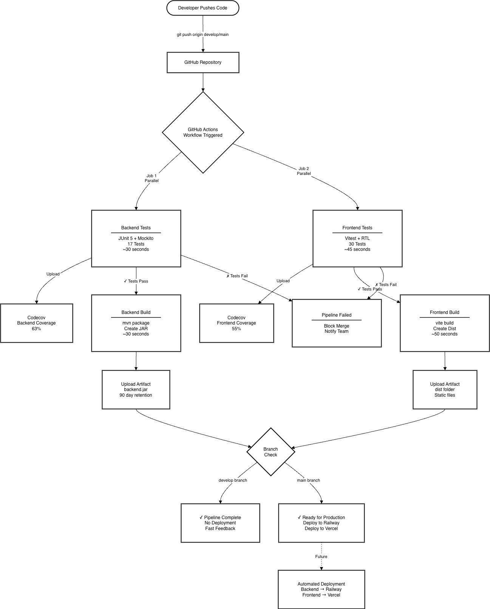

4.3 Deployment Configuration
We prepared complete deployment configurations for production hosting.
Backend Deployment (Railway):
• Created application-prod.properties with environment variables
• DATABASE_URL, DATABASE_USERNAME, DATABASE_PASSWORD
• JWT_SECRET for token signing
• Build: mvn clean package -DskipTests
• Start: java -jar target/food-waste-backend-1.0.0.jar
Frontend Deployment (Vercel):
• Modified API service to use VITE_API_BASE_URL environment variable
• Fallback to localhost for development
• Build: npm install && npm run build
• Output: Static files in dist/ directory
Database (PlanetScale):
• MySQL-compatible serverless database
• Connection via JDBC with SSL
• Credentials stored as environment variables
Deployment ready but not yet in production (planned post-semester).

4.4 Automated Workflows
Quality gates: Failed tests block builds. Failed builds prevent deployment.
Branch-specific behavior:
• develop: Tests + builds only (fast feedback)
• main: Tests + builds + deployment preparation
Branch protection requires pipeline success before merging. Codecov integration tracks coverage trends across commits.

5. USER MANUAL

5.1 Installation
Prerequisites:
• Java 17+, Node.js 18+, Maven 3.6+, MySQL 8.0/Docker
Database Setup:
docker run -d --name ecoplate-mysql -e MYSQL_ROOT_PASSWORD=root -e MYSQL_DATABASE=food_waste_db -p 3306:3306 mysql:8.0
Backend:
cd Ecoplate/food-waste-backend
mvn spring-boot:run
Starts on http://localhost:8080
Frontend:
cd Ecoplate/ecoplate-frontend
npm install
npm run dev
Starts on http://localhost:5173

5.2 User Workflows
Customer:
• Browse items with dynamic pricing
• Filter by category, distance, price range
• Add to cart, adjust quantities
• Checkout with mock payment
• Write reviews for purchased items
• Message store managers
Store Manager:
• Set up store profile with Mapbox location
• Create food listings with images
• Mark items as donations
• Manage orders, update status
• Approve/reject donation claims
• Communicate with customers/NGOs
NGO:
• Browse donation items
• Submit claims with need explanation
• Track claim status (PENDING/ACCEPTED/REJECTED)
• Message stores about pickups
Messaging: RabbitMQ-backed system ensures delivery even when recipients offline. Messages persist in queue until delivered to WebSocket-connected clients.
Github Wiki Link For all the project Screenshots :-
Wiki: https://github.com/CanNortheastern/CSYE7230Group1/wiki

6. SCRUM SUMMARY

6.1 Sprint Overview
Since Part B, we completed four two-week sprints.
Sprint 1 (Weeks 5-6):
Focus: Core infrastructure and authentication.
Completed: JWT authentication, role-based access, food item CRUD, dynamic pricing algorithm.
Challenge: Spring Security CORS configuration took additional debugging time.
Sprint 2 (Weeks 7-8):
Focus: Order management and payment processing.
Completed: Shopping cart, checkout flow, mock payment system, inventory management.
Challenge: Redesigned from inventory-on-order to inventory-on-payment to prevent overselling.
Sprint 3 (Weeks 9-10):
Focus: Donations, reviews, and messaging.
Completed: NGO claim workflows, purchase-verified reviews, RabbitMQ messaging with WebSocket.
Challenge: Learning RabbitMQ and WebSocket implementation patterns.
Sprint 4 (Weeks 11-12):
Focus: Testing, CI/CD, and location features.
Completed: 47 automated tests, GitHub Actions pipeline, Mapbox integration, distance filtering.
Challenge: React Testing Library best practices and test debugging.

6.2 Completed Epics and Stories

All epics from our project board are now complete:
Epic: Onetime-User Purchase Food
Status: DONE
Customers browse items, add to cart, complete checkout with payment. Includes Order Tracking (#5), Order Completion (#4).
GitHub: https://github.com/CanNortheastern/CSYE7230Group1/projects/1
Epic: Store Inventory Management
Status: DONE
Store managers create, update, delete food items. Includes Add Surplus Food Items (#12), Store Dashboard Analytics (#14).
GitHub: https://github.com/CanNortheastern/CSYE7230Group1/projects/1
Epic: Trust & Review System
Status: DONE
Customers rate and review purchased items. Purchase verification ensures authentic feedback. Includes Multi-time User Review (#10).
GitHub: https://github.com/CanNortheastern/CSYE7230Group1/projects/1
Epic: NGO Profile Management - CRUD Operations
Status: DONE
NGOs create profiles, submit donation claims, track status. Store managers approve or reject claims.
GitHub: https://github.com/CanNortheastern/CSYE7230Group1/projects/1
Epic: Location-Based Store Discovery
Status: DONE
Mapbox integration for store locations. Customers filter by distance using Haversine formula.
GitHub: https://github.com/CanNortheastern/CSYE7230Group1/projects/1
User Stories Completed:
• Create Login Page (#20)
• One-time User Order Tracking (#5)
• Multi-time User Account Management (#7)
• Store Dashboard Analytics (#14)
• Update Food Item Status (#13)
• Frontend Pages Creation (#19)
• Multi-time User Addresses and Payment Info (#8)
• User Story: Expiration Notifications (#18)

6.3 Team Contributions
Individual contributions across all sprints:
Saurabh Kashyap:
• Designed and implemented complete backend authentication system with JWT token generation, Spring Security configuration, and role-based access control
• Built entire donation service backend including claim creation, quantity validation, NGO authorization, and store manager approval workflows
• Developed payment service with two-step order-payment workflow preventing inventory overselling
• Implemented soft delete functionality for food items to preserve order history
• Configured JaCoCo code coverage plugin with 50% minimum threshold enforcement
• Set up complete GitHub Actions CI/CD pipeline with 4 parallel jobs
• Designed and implemented database schema with proper relationships and constraints
• Implemented transaction management ensuring data consistency
• Integrated Mapbox for location features
Sujay S N:
• Built React frontend foundation and routing
• Created NGO dashboard components
• Developed frontend test suite with Vitest
• Set up Docker MySQL container for team development environment
• Created comprehensive unit test suite: DonationServiceTest (10 tests), StoreServiceTest (2 tests), AuthServiceTest (5 tests)
• Built store manager dashboard frontend
• Developed messaging UI with WebSocket
• Implemented order management backend
• Created deployment configurations for Railway and Vercel

Vamshika Arkalagud Sapthagiriraj:
• Developed customer dashboard and shopping cart
• Built review and rating UI components
• Created store profile setup page
• Configured Spring Security CORS policies resolving cross-origin issues
• Integrated Codecov for coverage tracking and trend analysis
Jinping Zhang:
• Developed food item management backend with CRUD operations
• Developed profile management backend with CRUD operations
• Implemented dynamic pricing algorithm with discount tier
Wencan Yang:
• Set up RabbitMQ message queue infrastructure
• Created documentation for testing sections
• Created Landing page for the App
Yuhang Fan:
• Updated project README documentation

6.4 Scope Adjustments
Features not implemented from Part B:
• Strategy Pattern for auth (kept JWT only)
• Observer Pattern for events (used direct calls)
• Redis caching (database sufficient)
• Admin dashboard, email notifications
• Mobile optimization, production deployment
Messaging prioritized due to critical coordination needs for successful food redistribution.

CONCLUSION
We successfully built EcoPlate, a full-stack application connecting stores, customers, and NGOs to reduce food waste. The system implements JWT authentication with 4 roles, dynamic pricing, complete order/payment workflow, NGO donation claims, customer reviews, location filtering, and RabbitMQ messaging.
Technical achievements: Spring Boot backend, React frontend, MySQL database, 47 automated tests (63/55% coverage), CI/CD with GitHub Actions. Design patterns: Factory, Repository, DTO, Service Layer.
The project evolved from Part B based on practical constraints and user needs. We focused on core food waste reduction while maintaining high code quality. The application is functional, well-tested, and addresses real food redistribution challenges.

