The University of Newcastle
School of Computer and Information Sciences
COMP3851A - Computing and Information Sciences WIL
Low-Fidelity Wireframes
Newcastle Smart Peer Companion: AI-Assisted Peer Collaboration Platform

Prepared by:
Name | Student ID
Krish Longwani | C3549511
Alas Elizabeth Louise Flores | C3546059
Kaung Sett Paing Tun | C3546060
Berezovik Daniil | C3543315
Hein Myat Thu | C3552370

Project Guidance and Sponsors:
Category | Name
Guidance Advisor | Dr Bobby Chung
Project Sponsor | Dr V Sithira Vadivel
Project Sponsor | Jade Ong

Date: 4 June 2026

Table of Contents
1. Purpose 3
2. Wireframe Overview 3
3. Low-Fidelity Wireframes 4
3.1 Dashboard 4
3.2 Notes 5
3.3 AI Companion 6
3.4 Study Groups 7
3.5 AI Peer Matching 8
3.6 Collaboration Rooms 9
3.7 Knowledge Graph 10
3.8 Analytics 11
4. Summary 12

1. Purpose
This document presents the low-fidelity wireframes for the Newcastle Smart Peer Companion platform. The wireframes show early layout and user interface ideas for the main screens of the system. They are used to visualise how students may navigate the platform, access study groups, upload notes, use AI support, join collaboration rooms, and view learning progress.

2. Wireframe Overview
The low-fidelity wireframes focus on the main platform areas planned for the project. These screens support early validation and discussion before the team progresses into higher-fidelity design or implementation.
Wireframe Screen | Purpose
Dashboard | Main landing page showing study progress, recommendations, active rooms, and learning activity.
Notes | Area for uploading, searching, filtering, and viewing study materials with AI summaries.
AI Companion | AI study assistant screen where students can ask questions, use suggested prompts, and receive support while being reminded to verify information.
Study Groups | Peer discussion area with channels, members, and chat functions.
AI Peer Matching | AI-supported matching page to connect students with similar study topics and learning goals.
Collaboration Rooms | Study session area where students can create or join AI-facilitated collaboration rooms.
Knowledge Graph | Visual map showing connected learning topics, notes, and students.
Analytics | Progress page showing collaboration participation, study activity, and topic mastery.
Table 1: Low-Fidelity Wireframe Overview

3. Low-Fidelity Wireframes

3.1 Dashboard
As shown in Figure 1, this screen supports the dashboard function of the platform.
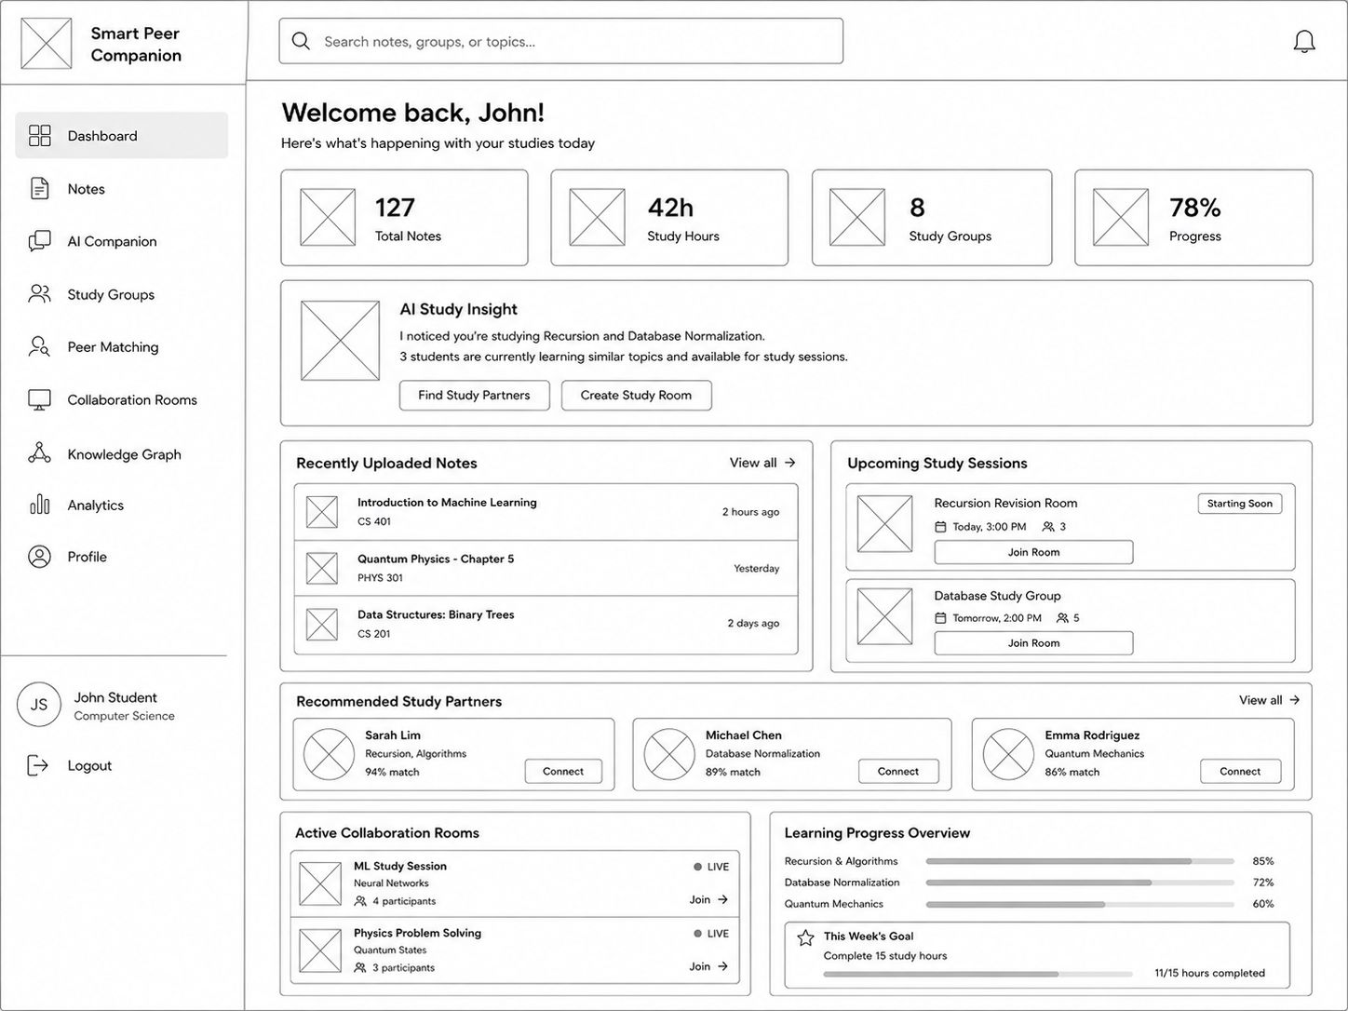
Figure 1: Dashboard Wireframe
The dashboard provides an overview of the student’s study progress, recently uploaded notes, recommended study partners, active collaboration rooms, and learning progress. It acts as the main landing page after login.

3.2 Notes
As shown in Figure 2, this screen supports the notes function of the platform.
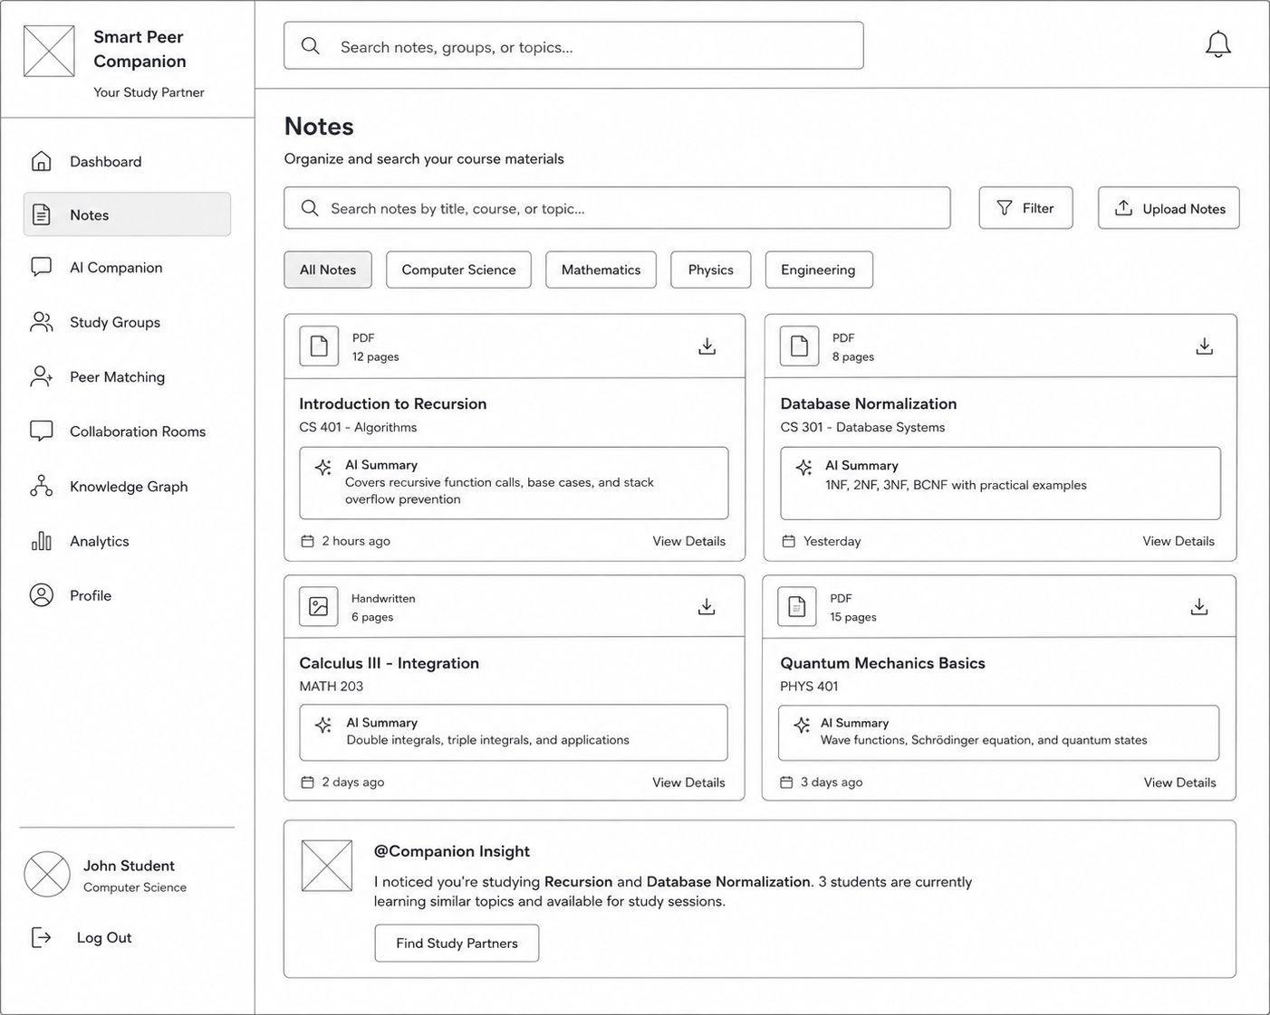
Figure 2: Notes Wireframe
The notes page allows students to organise, search, filter, upload, and access course materials. It also shows AI-generated summaries to help students quickly understand uploaded learning resources.

3.3 AI Companion
As shown in Figure 3, this screen supports the AI companion function of the platform.
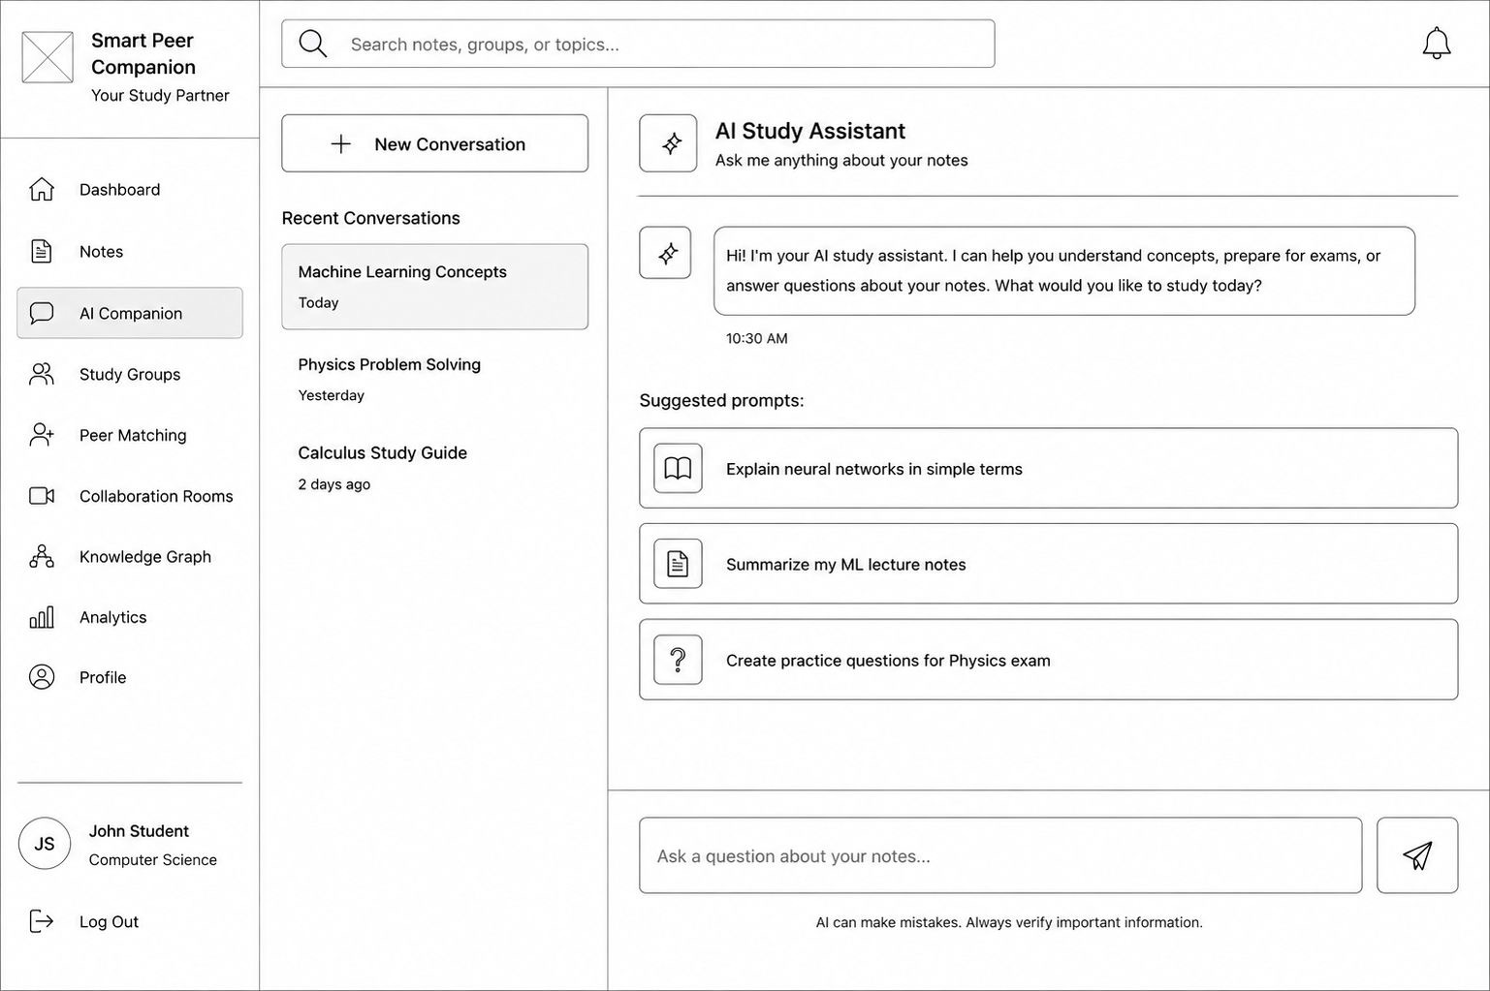
Figure 3: AI Companion Wireframe
The AI Companion page allows students to ask study-related questions, view recent conversations, and use suggested prompts. The reminder at the bottom reinforces that AI can make mistakes and that students should verify important information.

3.4 Study Groups
As shown in Figure 4, this screen supports the study groups function of the platform.
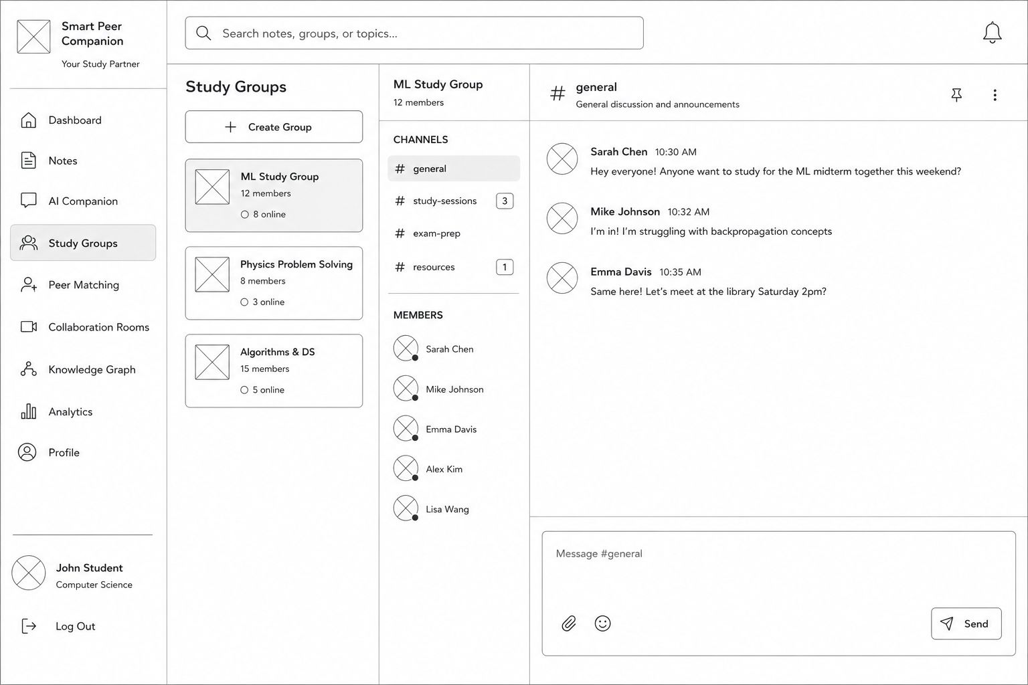
Figure 4: Study Groups Wireframe
The study groups page allows students to join subject-based group discussions. It includes group lists, channels, member information, messages, and a chat box for peer collaboration.

3.5 AI Peer Matching
As shown in Figure 5, this screen supports the AI peer matching function of the platform.
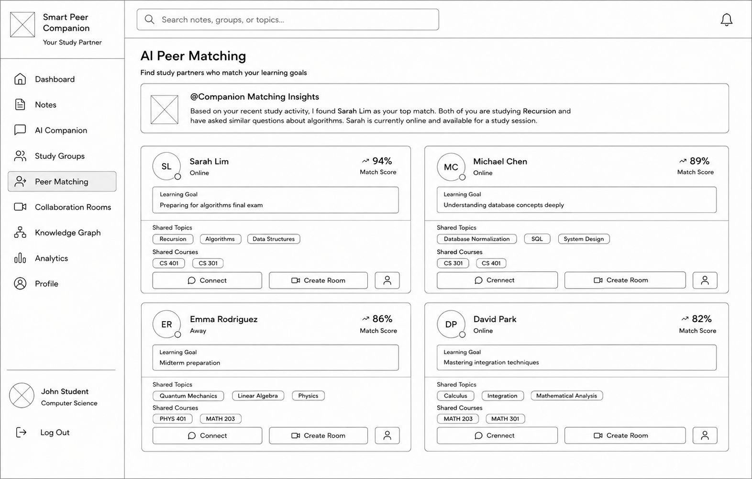
Figure 5: AI Peer Matching Wireframe
The AI peer matching page suggests study partners based on shared topics, learning goals, availability, and recent study activity. This supports the project goal of encouraging peer collaboration rather than isolated AI use.

3.6 Collaboration Rooms
As shown in Figure 6, this screen supports the collaboration rooms function of the platform.
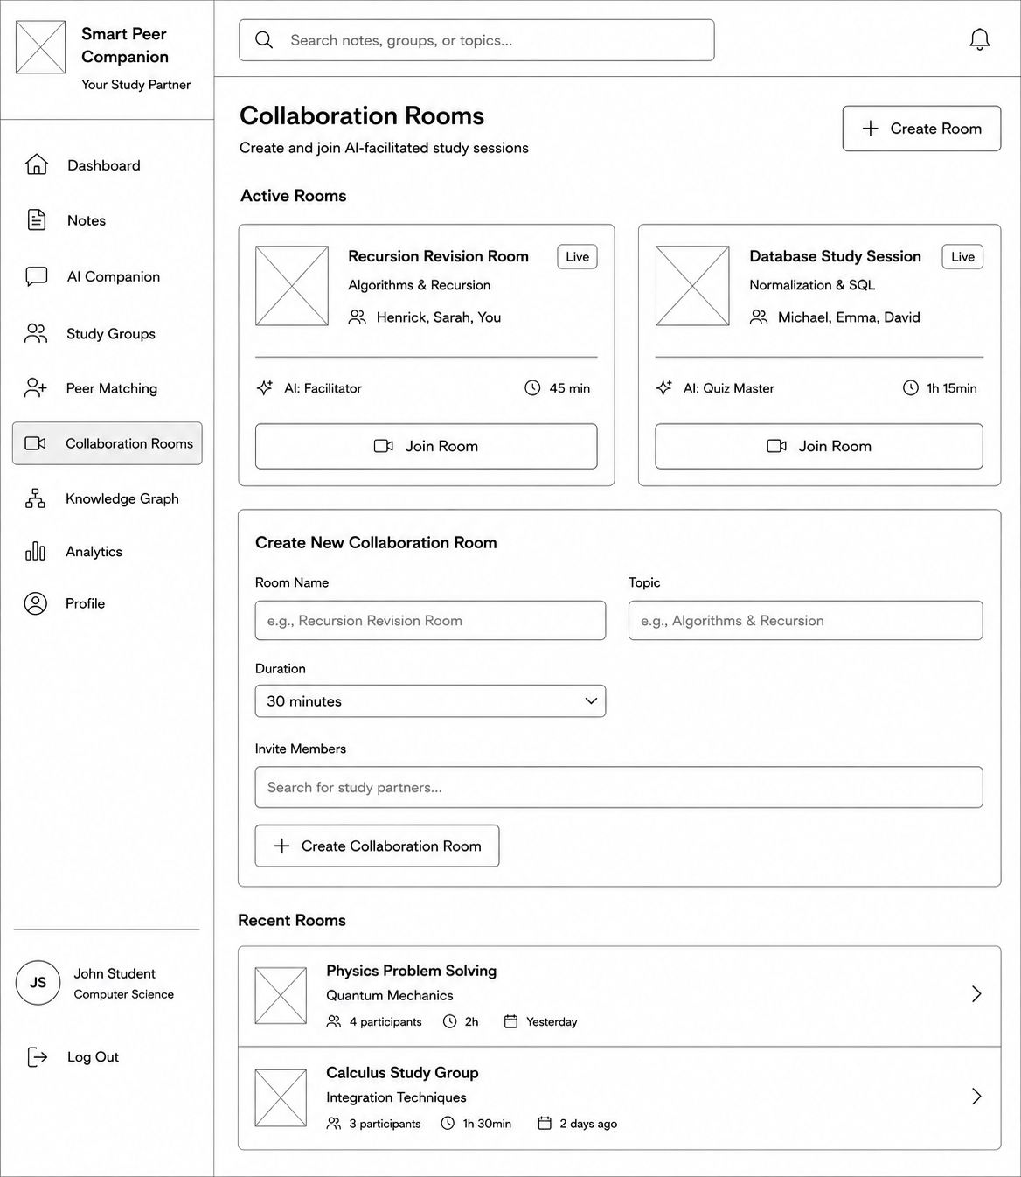
Figure 6: Collaboration Rooms Wireframe
The collaboration rooms page allows students to create or join AI-facilitated study sessions. Students can set a room name, topic, duration, and invite members to collaborate on specific learning problems.

3.7 Knowledge Graph
As shown in Figure 7, this screen supports the knowledge graph function of the platform.
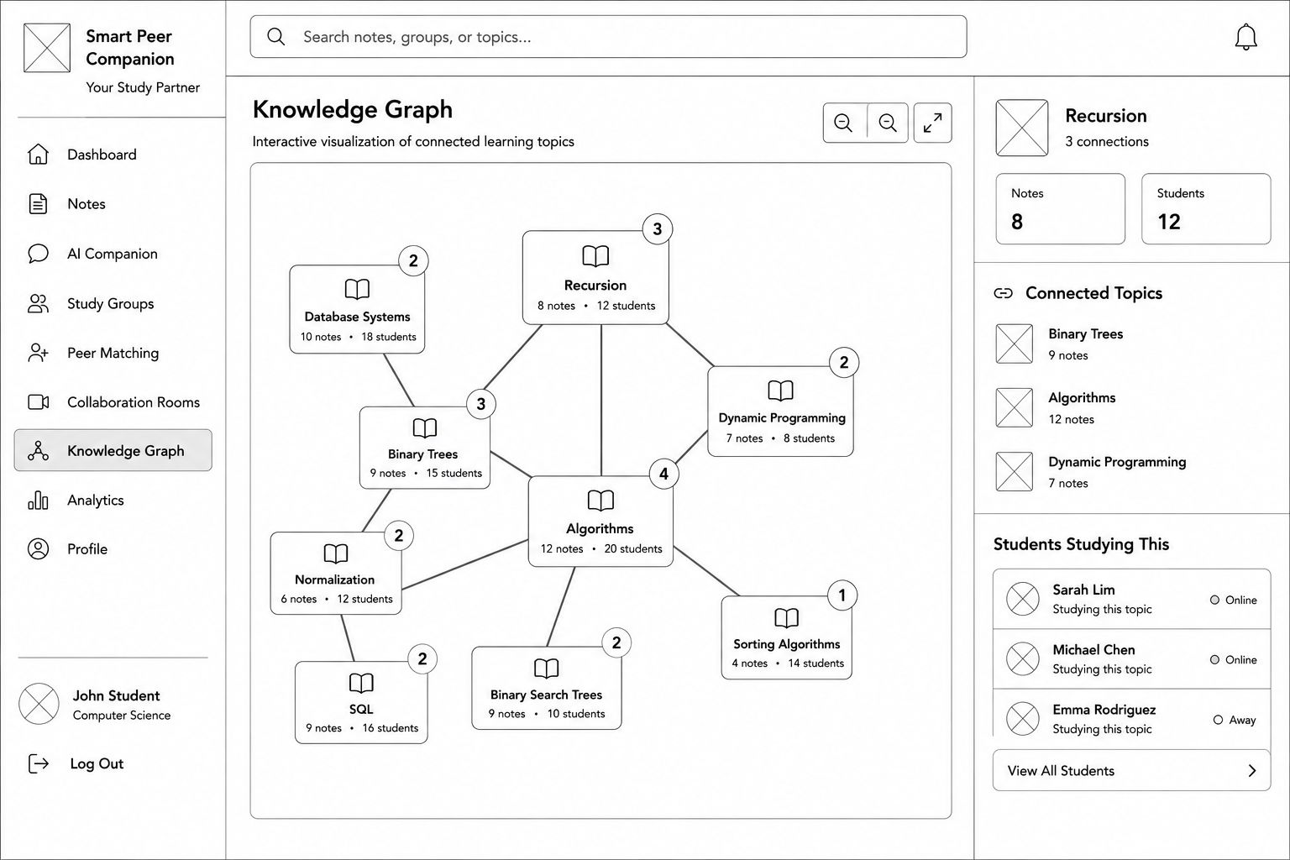
Figure 7: Knowledge Graph Wireframe
The knowledge graph visualises connected learning topics and shows how students, notes, and subjects are linked. This helps students identify related concepts and discover peers studying similar topics.

3.8 Analytics
As shown in Figure 8, this screen supports the analytics function of the platform.
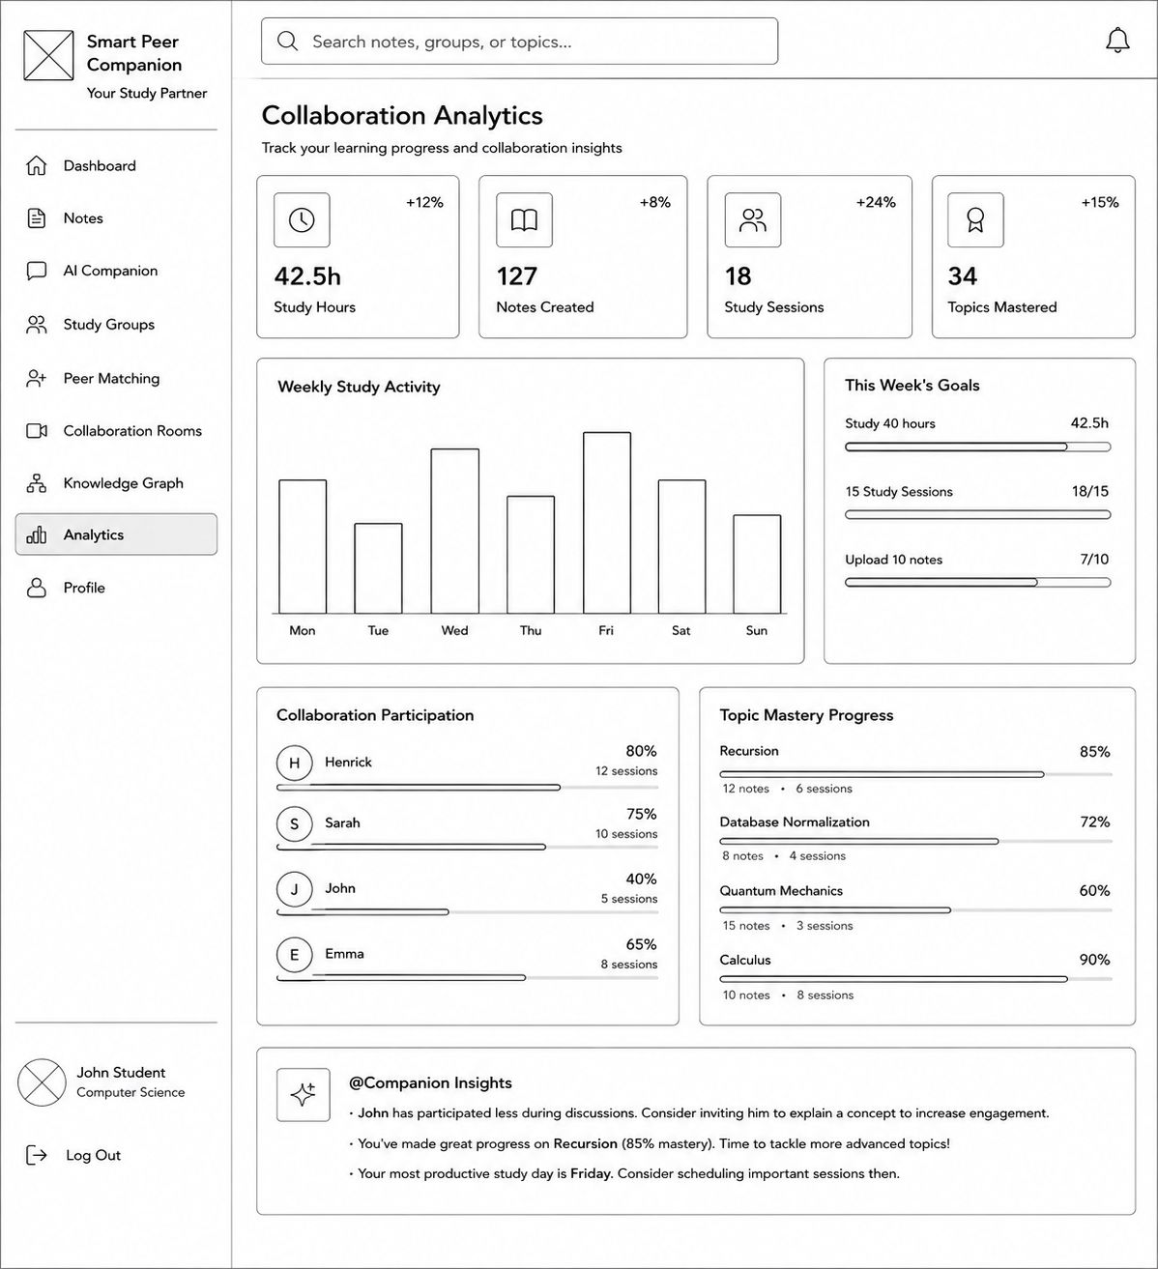
Figure 8: Analytics Wireframe
The analytics page shows study hours, notes created, study sessions, topics mastered, collaboration participation, and topic mastery progress. It helps students track learning and collaboration activity.

4. Summary
The low-fidelity wireframes provide an early visual direction for the Newcastle Smart Peer Companion platform. The designs show how the system can support peer collaboration, AI-assisted learning, study group discussion, note sharing, peer matching, collaboration rooms, knowledge visualisation, and learning progress tracking. The added AI Companion screen further shows how students can directly interact with the AI assistant while being reminded to verify generated responses. These wireframes will be reviewed and refined based on team discussion, sponsor feedback, and future project requirements.

