Smart Peer Companion (SPC)
UML and System Design Diagrams
COMP3851A – Computing and Information Sciences Work Integrated Learning
Team 1
Formatted diagram pack organised under frontend, backend/API, database/storage, AI/RAG, cybersecurity/deployment, and full-stack architecture subheadings.

1. Document Purpose
This document organises the Smart Peer Companion design diagrams by system responsibility rather than only by UML diagram type. Each diagram is placed under the most relevant frontend, backend/API, database/storage, AI/RAG, cybersecurity/deployment, or full-stack architecture section.
The existing images are retained and resized for consistency. Some diagrams are slightly blurry in the original screenshots, but they remain visible and have not been removed.

2. Diagram Organisation by System Area
System Area | Included diagram focus | Suggested responsibility
Frontend and User Experience | Login/register flow, dashboard states, note browsing, uploads, study group channels, personal AI chat. | Daniil / Elizabeth support
Backend and API Layer | Authentication service, channel service, note service, AI request handling, API routing and server-side process logic. | Hein / team support
Database and Storage | PostgreSQL, pgvector embeddings, object storage, learning materials, channel membership, user/session data. | Paing / team support
AI, RAG and Knowledge Graph | Local Llama 3.1, prompt builder, embedding service, RAG pipeline, AI modes, knowledge graph generation. | Krish / team support
Cybersecurity and Deployment | Authentication checks, authorisation, file validation, NudeNet safety check, logging, cloud/development deployment. | Elizabeth / Daniil support

3. Short Use Case Descriptions
Use Case | Short Description
Register Account | Student creates a new SPC account and completes email verification.
Log In | Student enters valid credentials and accesses the dashboard.
Manage Profile | Student views and updates personal profile details.
Invoke @Companion in Public Channel | Student summons the AI companion inside a public channel.
Invoke @Companion in Private Channel | Student summons the AI companion inside a private channel.
Invoke @Companion in Personal Channel | Student asks the AI companion a question in a personal chat.
Choose AI Mode | Student selects Quiz Master, Facilitator, or Summariser mode.
Upload Learning Materials | Student uploads an approved PDF or image for study use.
View Knowledge Graph | Student views concepts and relationships generated from learning materials.
Create Channel | Student creates a public or private study channel.
Join Channel | Student joins an available public channel or an approved private channel.
Send Text Message | Student sends a text message within a channel.

4. Frontend and User Experience
This section groups diagrams that describe the student-facing interface, account access, channels, notes, personal AI chat, and frontend user-session states.

Figure 1. Use Case Diagram Overview
System area: Frontend / System overview | Suggested support: Team
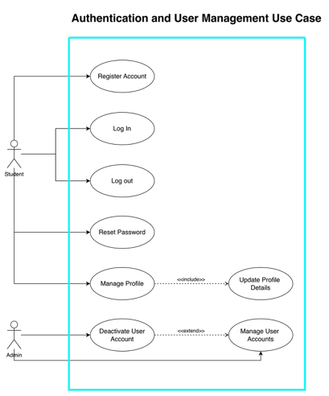
Figure 1: Use Case Diagram Overview
Use case / purpose: Shows the main use case groups across authentication, AI companion, notes, administration, and collaboration.
Formal use case descriptions below correspond directly to the use cases shown in this diagram.

Use Case Description – Register Account
Use case name: | Register Account
Scenario: | A new student creates an SPC account and verifies the registered email address.
Triggering event: | The student selects Register Account.
Brief description: | Creates a pending account, validates unique email details, hashes the password, and sends an email-verification link.
Actors: | Student; Email Service
Related use case: | Log In; Manage Profile
Stakeholders: | Student; System administrator; University/project owner
Preconditions: | Student is not logged in and the email is not already registered.
Postconditions: | A verified active account is available for login.
Flow of activities: | Actor | System
Exception conditions: | 1. Select Register Account.  2. Enter name, email, and password.  3. Submit registration details.  4. Open the verification email and select the link.  Exceptions: Duplicate email, invalid details, expired token, or email delivery failure. | 1. Display the registration form.  2. Validate required fields and email uniqueness.  3. Hash the password and create a pending account.  4. Send a verification link.  5. Validate the token and activate the account.
Table 1: Use Case Description – Register Account

Use Case Description – Log In
Use case name: | Log In
Scenario: | A registered student securely signs in to SPC.
Triggering event: | The student selects Log In and submits credentials.
Brief description: | Validates the account and password, creates a session token, and redirects the student to the dashboard.
Actors: | Student
Related use case: | Register Account; Reset Password; Log Out
Stakeholders: | Student; System administrator
Preconditions: | The account exists, is verified, and is not deactivated.
Postconditions: | An authenticated session is created and the dashboard is displayed.
Flow of activities: | Actor | System
Exception conditions: | 1. Open the login page.  2. Enter email and password.  3. Submit credentials.  Exceptions: Invalid password, unknown email, unverified account, locked/deactivated account, or service failure. | 1. Retrieve the user record.  2. Verify the password hash and account status.  3. Create a session/JWT token.  4. Redirect to the dashboard.
Table 2: Use Case Description – Log In

Use Case Description – Log Out
Use case name: | Log Out
Scenario: | A logged-in student ends the current SPC session.
Triggering event: | The student selects Log Out.
Brief description: | Terminates the active session and returns the interface to the logged-out state.
Actors: | Student
Related use case: | Log In
Stakeholders: | Student; System administrator
Preconditions: | The student has an active authenticated session.
Postconditions: | The session token is revoked or removed and protected pages are no longer accessible.
Flow of activities: | Actor | System
Exception conditions: | 1. Select Log Out.  Exceptions: If the server is unavailable, the client still clears local session data. | 1. Invalidate the current session/token.  2. Clear local authentication data.  3. Return the student to the landing or login page.
Table 3: Use Case Description – Log Out

Use Case Description – Reset Password
Use case name: | Reset Password
Scenario: | A student requests a new password after forgetting the existing password.
Triggering event: | The student selects Reset Password.
Brief description: | Sends a time-limited reset link and updates the stored password hash after validation.
Actors: | Student; Email Service
Related use case: | Log In
Stakeholders: | Student; System administrator
Preconditions: | A registered email address exists.
Postconditions: | A new password hash is stored and previous reset tokens are invalidated.
Flow of activities: | Actor | System
Exception conditions: | 1. Enter the registered email.  2. Open the reset email.  3. Enter and confirm a new password.  Exceptions: Unknown email, expired token, weak password, or mismatched confirmation. | 1. Check whether the account exists.  2. Send a time-limited reset token.  3. Validate the token and password rules.  4. Hash and save the new password.
Table 4: Use Case Description – Reset Password

Use Case Description – Manage Profile
Use case name: | Manage Profile
Scenario: | A logged-in student views or updates profile information.
Triggering event: | The student opens Profile or selects Edit Profile.
Brief description: | Displays current profile details and saves approved changes.
Actors: | Student
Related use case: | Update Profile Details; Deactivate User Account
Stakeholders: | Student; System administrator
Preconditions: | The student is authenticated.
Postconditions: | Valid changes are stored and shown in the profile.
Flow of activities: | Actor | System
Exception conditions: | 1. Open the profile page.  2. Edit allowed fields.  3. Submit changes.  Exceptions: Invalid values, duplicate email, unauthorised field change, or database error. | 1. Retrieve current profile details.  2. Validate submitted values.  3. Update the user record.  4. Display confirmation.
Table 5: Use Case Description – Manage Profile
Figure 2. Channel and Collaboration Use Case Diagram
System area: Frontend and Channel Management | Suggested support: Frontend / Backend
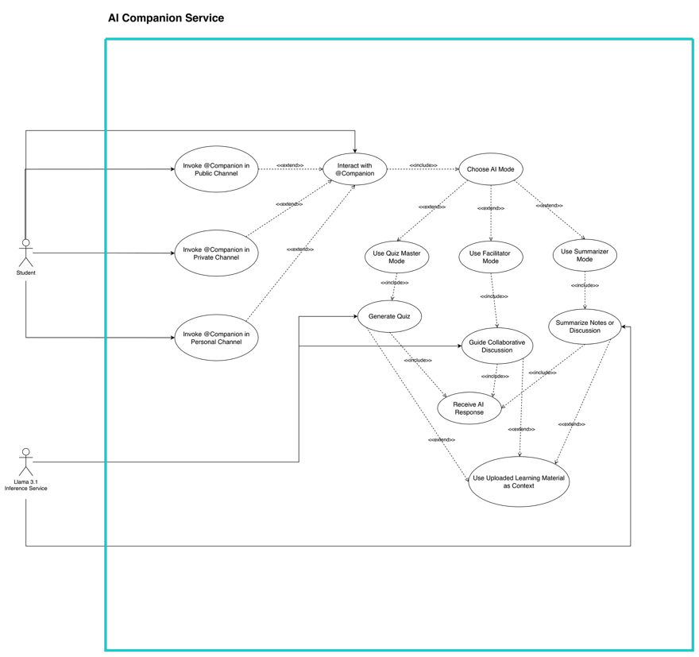
Figure 2: Channel and Collaboration Use Case Diagram
Use case / purpose: Shows how students interact with channels, discussions, messages, files, and AI support inside collaboration spaces.
Formal use case descriptions below correspond directly to the use cases shown in this diagram.

Use Case Description – Invoke @Companion in Public Channel
Use case name: | Invoke @Companion in Public Channel
Scenario: | A student summons the AI companion during a public-channel discussion.
Triggering event: | The student tags @Companion in a public channel.
Brief description: | Processes the tagged message using the selected AI mode and approved public-channel context.
Actors: | Student; Llama 3.1 Inference Service
Related use case: | Choose AI Mode; Receive AI Response; Use Uploaded Learning Material as Context
Stakeholders: | Channel members; Student; Platform owner
Preconditions: | The student is authenticated and has access to the public channel.
Postconditions: | The AI response is posted to the channel and visible to members.
Flow of activities: | Actor | System
Exception conditions: | 1. Open a public channel.  2. Optionally select an AI mode.  3. Tag @Companion and enter a request.  Exceptions: Unauthorised access, invalid request, no relevant context, model timeout, or moderation block. | 1. Validate membership and the tagged request.  2. Retrieve authorised channel context.  3. Generate a response using the local AI service.  4. Post the response in the channel.
Table 6: Use Case Description – Invoke @Companion in Public Channel

Use Case Description – Invoke @Companion in Private Channel
Use case name: | Invoke @Companion in Private Channel
Scenario: | An approved channel member summons the AI companion in a private channel.
Triggering event: | The student tags @Companion in a private channel.
Brief description: | Generates an AI response using only materials and messages authorised for that private channel.
Actors: | Student; Llama 3.1 Inference Service
Related use case: | Choose AI Mode; Receive AI Response; Use Uploaded Learning Material as Context
Stakeholders: | Private-channel members; Channel owner; Platform owner
Preconditions: | The student is authenticated and is an approved private-channel member.
Postconditions: | The AI response is posted only inside the private channel.
Flow of activities: | Actor | System
Exception conditions: | 1. Open a private channel.  2. Optionally select an AI mode.  3. Tag @Companion and enter a request.  Exceptions: Membership denied, restricted file access, unsafe request, or AI service failure. | 1. Verify private-channel membership.  2. Retrieve only authorised channel context.  3. Generate a local AI response.  4. Post the response inside the private channel.
Table 7: Use Case Description – Invoke @Companion in Private Channel

Use Case Description – Invoke @Companion in Personal Channel
Use case name: | Invoke @Companion in Personal Channel
Scenario: | A student asks the AI companion a question in a personal chat.
Triggering event: | The student opens Personal Chat and submits a prompt.
Brief description: | Creates a private one-to-one AI interaction using the student’s permitted learning materials.
Actors: | Student; Llama 3.1 Inference Service
Related use case: | Choose AI Mode; Receive AI Response; Use Uploaded Learning Material as Context
Stakeholders: | Student; Platform owner
Preconditions: | The student is authenticated.
Postconditions: | The response is displayed in the student’s personal chat history.
Flow of activities: | Actor | System
Exception conditions: | 1. Open Personal Chat.  2. Choose an AI mode if required.  3. Enter and submit a prompt.  Exceptions: Invalid input, unavailable model, no context, or safety policy violation. | 1. Validate the request.  2. Retrieve permitted personal context.  3. Generate the response locally.  4. Display and store the response metadata.
Table 8: Use Case Description – Invoke @Companion in Personal Channel

Use Case Description – Choose AI Mode
Use case name: | Choose AI Mode
Scenario: | A student chooses how the AI companion should support the learning activity.
Triggering event: | The student opens the AI mode selector.
Brief description: | Selects Quiz Master, Facilitator, or Summariser behaviour before the request is processed.
Actors: | Student
Related use case: | Use Quiz Master Mode; Use Facilitator Mode; Use Summariser Mode
Stakeholders: | Student; Channel members
Preconditions: | The student has opened a personal chat or an accessible channel.
Postconditions: | The selected mode is attached to the next AI request.
Flow of activities: | Actor | System
Exception conditions: | 1. Open the mode selector.  2. Choose Quiz Master, Facilitator, or Summariser.  3. Confirm the selection.  Exceptions: Mode unavailable or no mode selected; default companion behaviour is used. | 1. Display available modes.  2. Store the selected mode for the active interaction.  3. Adjust prompt construction and output rules.
Table 9: Use Case Description – Choose AI Mode

Use Case Description – Receive AI Response
Use case name: | Receive AI Response
Scenario: | A student receives an AI-generated answer after submitting a valid request.
Triggering event: | The local Llama service finishes generating a response.
Brief description: | Displays the response in the relevant public, private, or personal chat.
Actors: | Student; Llama 3.1 Inference Service
Related use case: | Invoke @Companion in Public Channel; Invoke @Companion in Private Channel; Invoke @Companion in Personal Channel
Stakeholders: | Student; Channel members; Platform owner
Preconditions: | A valid AI request has been accepted and processed.
Postconditions: | The response is displayed and appropriate metadata is stored.
Flow of activities: | Actor | System
Exception conditions: | 1. Wait for the response.  2. Read the generated answer.  3. Continue the discussion or submit another request.  Exceptions: Generation timeout, model error, unsafe output, or lost connection. | 1. Receive the model output.  2. Apply formatting and safety checks.  3. Post the answer to the correct chat context.  4. Store request/response metadata.
Table 10: Use Case Description – Receive AI Response

Figure 3. Note and Knowledge Graph Use Case Diagram
System area: Notes and Knowledge Graph | Suggested support: Database / AI
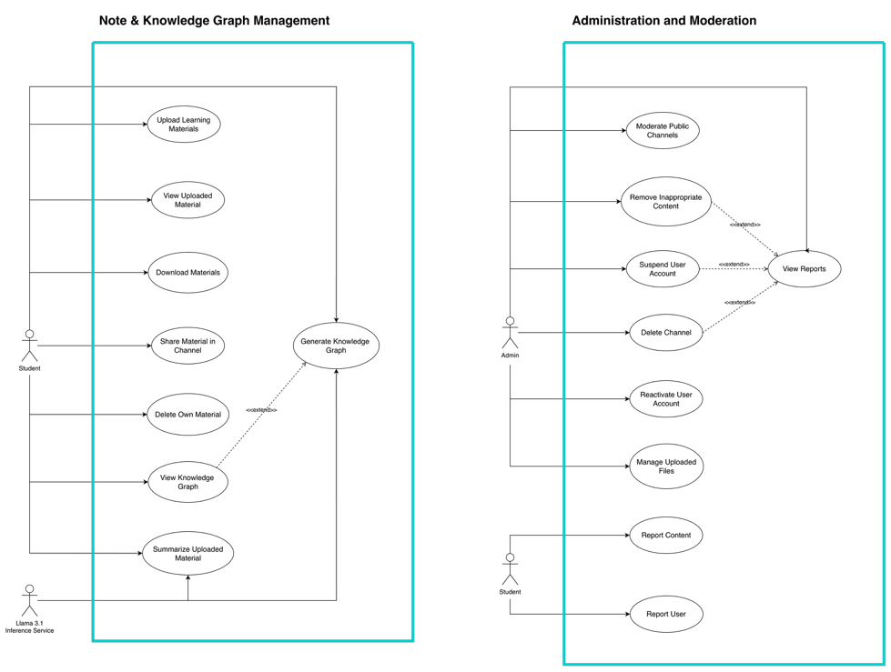
Figure 3: Note and Knowledge Graph Use Case Diagram
Use case / purpose: Shows how students upload or view learning materials and how the system supports knowledge graph-related functions.
Formal use case descriptions below correspond directly to the use cases shown in this diagram.

Use Case Description – Upload Learning Materials
Use case name: | Upload Learning Materials
Scenario: | A student uploads an approved PDF or image for personal or channel study use.
Triggering event: | The student selects Upload Learning Materials.
Brief description: | Validates, safety-checks, stores, and prepares the file for text extraction and retrieval.
Actors: | Student
Related use case: | View Uploaded Materials; Share Material in Channel; Generate Knowledge Graph
Stakeholders: | Student; Channel members; Platform administrator
Preconditions: | The student is authenticated and has upload permission.
Postconditions: | The accepted file is stored with metadata and is ready for downstream processing.
Flow of activities: | Actor | System
Exception conditions: | 1. Choose a PDF or image.  2. Select the destination context.  3. Submit the upload.  Exceptions: Invalid type, excessive size, explicit content, malware risk, duplicate file, or storage failure. | 1. Validate extension, size, signature, and permission.  2. Run image safety checks when applicable.  3. Store the file and metadata.  4. Start extraction/chunking/embedding processing.
Table 11: Use Case Description – Upload Learning Materials

Use Case Description – View Uploaded Materials
Use case name: | View Uploaded Materials
Scenario: | A student opens a list of learning materials available to them.
Triggering event: | The student selects Uploaded Materials or Notes.
Brief description: | Displays authorised personal and channel files with metadata.
Actors: | Student
Related use case: | Download Materials; Share Material in Channel; Search Own Materials
Stakeholders: | Student; Channel members
Preconditions: | The student is authenticated.
Postconditions: | The selected material or material list is displayed.
Flow of activities: | Actor | System
Exception conditions: | 1. Open the materials page.  2. Select a file or filter.  Exceptions: File unavailable, access denied, unsupported preview, or deleted material. | 1. Check access rights.  2. Retrieve authorised file metadata.  3. Display the material or preview.
Table 12: Use Case Description – View Uploaded Materials

Use Case Description – Share Material in Channel
Use case name: | Share Material in Channel
Scenario: | A student shares an existing authorised learning material with a channel.
Triggering event: | The student selects Share in Channel.
Brief description: | Links the material to a selected public or private channel without exposing it elsewhere.
Actors: | Student
Related use case: | Upload Learning Materials; View Uploaded Materials
Stakeholders: | Student; Channel members; Channel owner
Preconditions: | The student owns or may share the material and is a channel member.
Postconditions: | The material is visible to authorised members of the selected channel.
Flow of activities: | Actor | System
Exception conditions: | 1. Select a material.  2. Choose an accessible channel.  3. Confirm sharing.  Exceptions: No permission, channel unavailable, material removed, or duplicate share. | 1. Validate ownership and channel membership.  2. Create the channel-material association.  3. Notify or display the shared item in the channel.
Table 13: Use Case Description – Share Material in Channel

Use Case Description – View Knowledge Graph
Use case name: | View Knowledge Graph
Scenario: | A student visualises concepts and relationships derived from learning materials.
Triggering event: | The student selects View Knowledge Graph.
Brief description: | Loads a generated graph that links key concepts from authorised content.
Actors: | Student
Related use case: | Generate Knowledge Graph; Upload Learning Materials
Stakeholders: | Student; Channel members
Preconditions: | Relevant learning materials have been processed and a graph exists or can be generated.
Postconditions: | The graph is displayed and can be explored.
Flow of activities: | Actor | System
Exception conditions: | 1. Select a material or channel.  2. Open the knowledge graph.  3. Select nodes to inspect relationships.  Exceptions: No graph available, insufficient extracted concepts, or graph service failure. | 1. Check access rights.  2. Retrieve graph nodes and edges.  3. Render the graph and selected concept details.
Table 14: Use Case Description – View Knowledge Graph

Use Case Description – Generate Knowledge Graph
Use case name: | Generate Knowledge Graph
Scenario: | The system generates a concept graph from uploaded learning material.
Triggering event: | A student requests a knowledge graph or processing completes after upload.
Brief description: | Extracts concepts, identifies relationships, and stores graph nodes and edges.
Actors: | Student; Llama/AI Processing Service
Related use case: | Upload Learning Materials; View Knowledge Graph
Stakeholders: | Student; Channel members; Platform owner
Preconditions: | An authorised learning material has been successfully processed.
Postconditions: | A stored knowledge graph is linked to the source material or channel.
Flow of activities: | Actor | System
Exception conditions: | 1. Request graph generation or wait for automatic processing.  Exceptions: Insufficient content, extraction failure, duplicate graph, or service timeout. | 1. Retrieve extracted text/chunks.  2. Extract concepts and relationships.  3. Create graph nodes and edges.  4. Store the graph and mark it available.
Table 15: Use Case Description – Generate Knowledge Graph

Use Case Description – Moderate Public Channels
Use case name: | Moderate Public Channels
Scenario: | An administrator reviews public-channel activity for policy compliance.
Triggering event: | The administrator opens moderation tools or a report is received.
Brief description: | Allows review and moderation of public content while maintaining an audit trail.
Actors: | Admin
Related use case: | Review Inappropriate Content; Suspend User Account; Delete Channel
Stakeholders: | Students; Channel owners; Platform owner
Preconditions: | The administrator is authenticated with moderation permission.
Postconditions: | The moderation decision is applied and logged.
Flow of activities: | Actor | System
Exception conditions: | 1. Open moderation dashboard.  2. Review flagged channel or content.  3. Select an action.  Exceptions: Insufficient permission, report already resolved, unavailable content, or audit-log failure. | 1. Retrieve reports and relevant content.  2. Apply the authorised moderation action.  3. Record the action and notify affected users where appropriate.
Table 16: Use Case Description – Moderate Public Channels

Use Case Description – Manage User Accounts
Use case name: | Manage User Accounts
Scenario: | An administrator views and manages registered user accounts.
Triggering event: | The administrator opens Manage User Accounts.
Brief description: | Supports account review, suspension, reactivation, and other authorised administration.
Actors: | Admin
Related use case: | Suspend User Account; Reactivate User Account; Deactivate User Account
Stakeholders: | Students; Platform owner
Preconditions: | The administrator is authenticated and authorised.
Postconditions: | The selected account change is stored and audited.
Flow of activities: | Actor | System
Exception conditions: | 1. Search or select a user.  2. Review account details and status.  3. Choose an authorised account action.  Exceptions: User not found, protected account, invalid action, or database failure. | 1. Retrieve the user record.  2. Validate administrator permission.  3. Apply the status change.  4. Log the action and issue notification where needed.
Table 17: Use Case Description – Manage User Accounts

Use Case Description – Review Reports
Use case name: | Review Reports
Scenario: | An administrator reviews reports submitted about content, channels, or users.
Triggering event: | A new report is submitted or the administrator opens the reports queue.
Brief description: | Presents report details and supports a documented moderation decision.
Actors: | Admin
Related use case: | Report Content; Report User; Moderate Public Channels
Stakeholders: | Reporting student; Reported user; Channel owner; Platform owner
Preconditions: | At least one report exists and the administrator has moderation access.
Postconditions: | The report is resolved, escalated, or left pending with an audit record.
Flow of activities: | Actor | System
Exception conditions: | 1. Open the report queue.  2. Select a report.  3. Review evidence.  4. Choose resolve, dismiss, or escalate.  Exceptions: Missing evidence, duplicate report, unauthorised access, or content already deleted. | 1. Retrieve report details and related records.  2. Display evidence within permission limits.  3. Save the decision and audit information.  4. Notify relevant users if required.
Table 18: Use Case Description – Review Reports
Figure 4. Channel and Collaboration Management Use Case Diagram
System area: Channel and Collaboration | Suggested support: Frontend / Backend
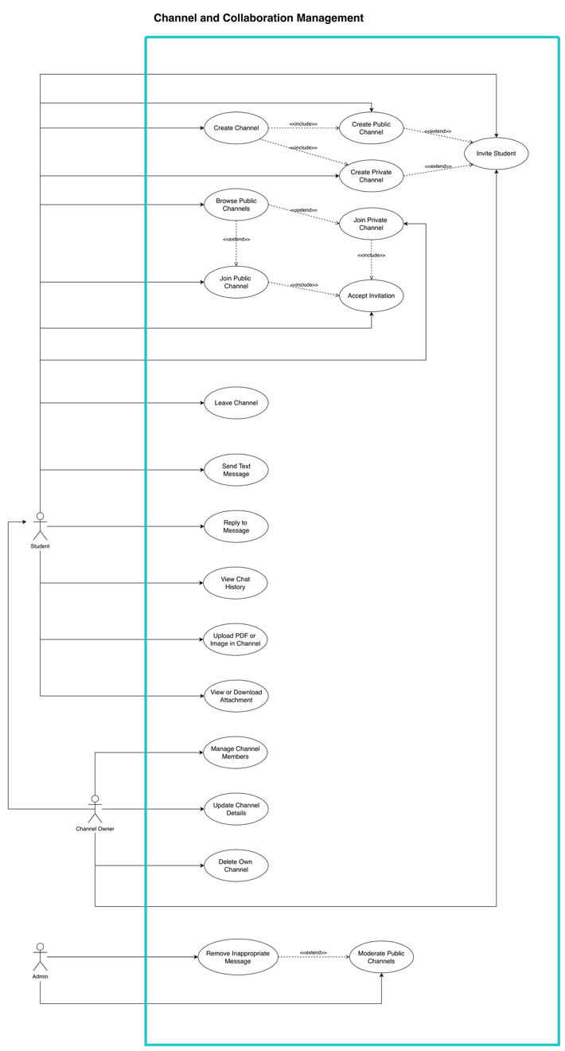
Figure 4: Channel and Collaboration Management Use Case Diagram
Use case / purpose: Shows how students create, join, and participate in public or private channels, exchange messages, upload learning materials, and use AI support.
Formal use case descriptions below correspond directly to the use cases shown in this diagram.

Use Case Description – Create Channel
Use case name: | Create Channel
Scenario: | A student creates a new public or private study channel.
Triggering event: | The student selects Create Channel.
Brief description: | Creates a channel with a name, description, visibility setting, and owner.
Actors: | Student
Related use case: | Create Public Channel; Create Private Channel; Manage Channel Members
Stakeholders: | Channel owner; Invited students; Platform owner
Preconditions: | The student is authenticated and allowed to create channels.
Postconditions: | The channel is created and the student becomes channel owner.
Flow of activities: | Actor | System
Exception conditions: | 1. Select Create Channel.  2. Enter channel details.  3. Choose public or private visibility.  4. Confirm creation.  Exceptions: Duplicate name, invalid details, account restriction, or database failure. | 1. Validate details and naming rules.  2. Create the channel record.  3. Assign the creator as owner.  4. Display the new channel.
Table 19: Use Case Description – Create Channel

Use Case Description – Join Channel
Use case name: | Join Channel
Scenario: | A student joins a public channel or requests/accepts access to a private channel.
Triggering event: | The student selects Join Channel or accepts an invitation.
Brief description: | Creates channel membership after validating visibility and access rules.
Actors: | Student; Channel Owner
Related use case: | Browse Public Channels; Join Public Channel; Join Private Channel
Stakeholders: | Student; Channel owner; Existing members
Preconditions: | The student is authenticated and is not already a member.
Postconditions: | A valid ChannelMember record is created or a private request remains pending.
Flow of activities: | Actor | System
Exception conditions: | 1. Select a channel or invitation.  2. Request or confirm joining.  Exceptions: Already a member, invitation expired, private access denied, channel full, or channel deleted. | 1. Check visibility and membership status.  2. Approve public access or validate private approval/invitation.  3. Create membership and display the channel.
Table 20: Use Case Description – Join Channel

Use Case Description – Send Text Message
Use case name: | Send Text Message
Scenario: | A channel member sends a text message to a public or private channel.
Triggering event: | The student enters text and selects Send.
Brief description: | Validates and stores the message, then displays it to authorised channel members.
Actors: | Student
Related use case: | Reply to Message; View Chat History; Invoke @Companion in Public Channel; Invoke @Companion in Private Channel
Stakeholders: | Channel members; Channel owner; Platform moderator
Preconditions: | The student is authenticated and is an active channel member.
Postconditions: | The message is stored and displayed in the channel.
Flow of activities: | Actor | System
Exception conditions: | 1. Open a channel.  2. Enter message text.  3. Select Send.  Exceptions: Access denied, empty/oversized message, unsafe content, or connection failure. | 1. Validate membership and message content.  2. Store the message with sender and timestamp.  3. Broadcast/display it to authorised members.
Table 21: Use Case Description – Send Text Message

Use Case Description – Upload PDF/Image in Channel
Use case name: | Upload PDF/Image in Channel
Scenario: | A channel member uploads a PDF or image into a public or private channel.
Triggering event: | The student selects the channel upload option.
Brief description: | Checks permission and file safety before storing and linking the file to the channel.
Actors: | Student
Related use case: | Upload Learning Materials; Share Material in Channel
Stakeholders: | Channel members; Channel owner; Platform moderator
Preconditions: | The student is authenticated and is an active channel member.
Postconditions: | The approved file is stored and linked to the channel.
Flow of activities: | Actor | System
Exception conditions: | 1. Open a channel.  2. Choose a PDF or image.  3. Submit the upload.  Exceptions: Unauthorised member, invalid/unsafe file, exceeded size, or storage failure. | 1. Validate channel membership.  2. Validate file type, size, signature, and safety.  3. Store the file and metadata.  4. Display the file in the channel.
Table 22: Use Case Description – Upload PDF/Image in Channel

Use Case Description – View Chat History
Use case name: | View Chat History
Scenario: | A channel member views previous messages and shared materials.
Triggering event: | The student opens an existing channel or scrolls to earlier messages.
Brief description: | Retrieves authorised message history in chronological order.
Actors: | Student
Related use case: | Send Text Message; Reply to Message
Stakeholders: | Channel members; Channel owner
Preconditions: | The student is authenticated and belongs to the channel.
Postconditions: | Available message history is displayed.
Flow of activities: | Actor | System
Exception conditions: | 1. Open a channel.  2. Scroll or request earlier messages.  Exceptions: Access denied, deleted messages, unavailable history, or network failure. | 1. Validate membership.  2. Retrieve paginated messages and linked materials.  3. Display history in chronological order.
Table 23: Use Case Description – View Chat History

Figure 37. User Session State Machine Diagram
System area: Frontend User Session | Suggested support: Cybersecurity / Frontend
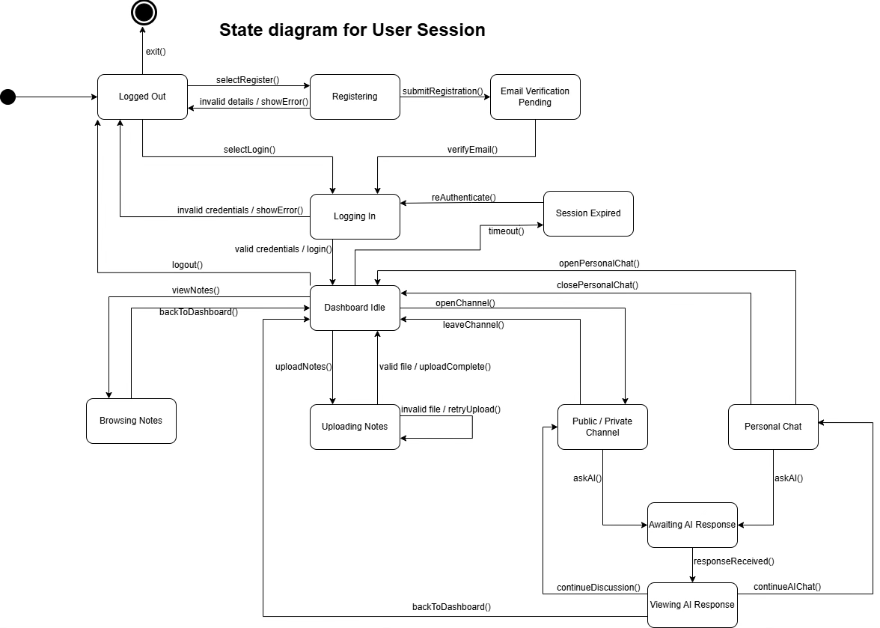
Figure 37: User Session State Machine Diagram
Use case / purpose: Shows how the frontend user interface moves between registration, email verification, login, dashboard, note browsing, note upload, public/private channels, personal chat, AI-response handling, session expiry, re-authentication, logout, and exit states.

5. Backend and API Layer
This section groups diagrams that describe server-side workflows, authentication services, file-processing logic, APIs, and backend service interactions.

Figure 5. Upload Learning Material and AI Processing Activity Diagram
System area: Backend / File Upload / RAG | Suggested support: Backend / AI
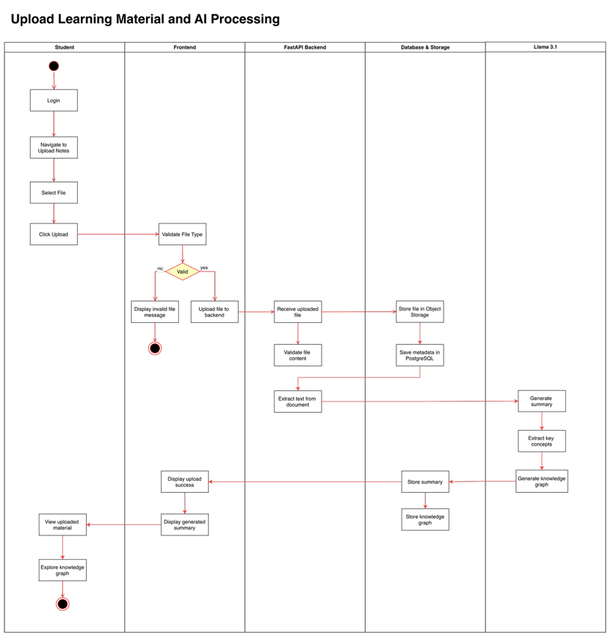
Figure 5: Upload Learning Material and AI Processing Activity Diagram
Use case / purpose: Shows the workflow for uploading learning material and preparing it for AI-assisted retrieval and processing.

Figure 7. User Authentication Activity Diagram
System area: Authentication | Suggested support: Cybersecurity
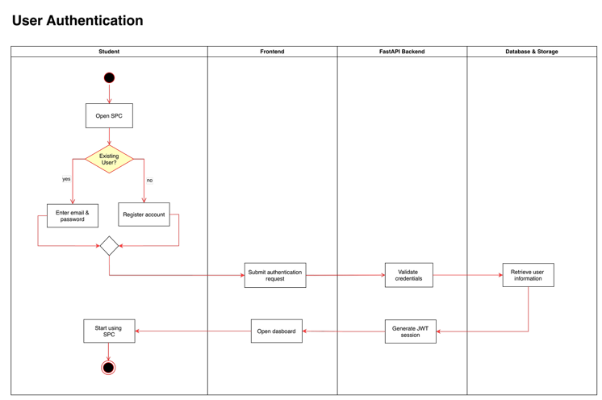
Figure 7: User Authentication Activity Diagram
Use case / purpose: Shows the login and authentication decision flow for valid and invalid user access.

Figure 11. SPC Authentication Sequence Diagram
System area: Authentication | Suggested support: Cybersecurity / Backend
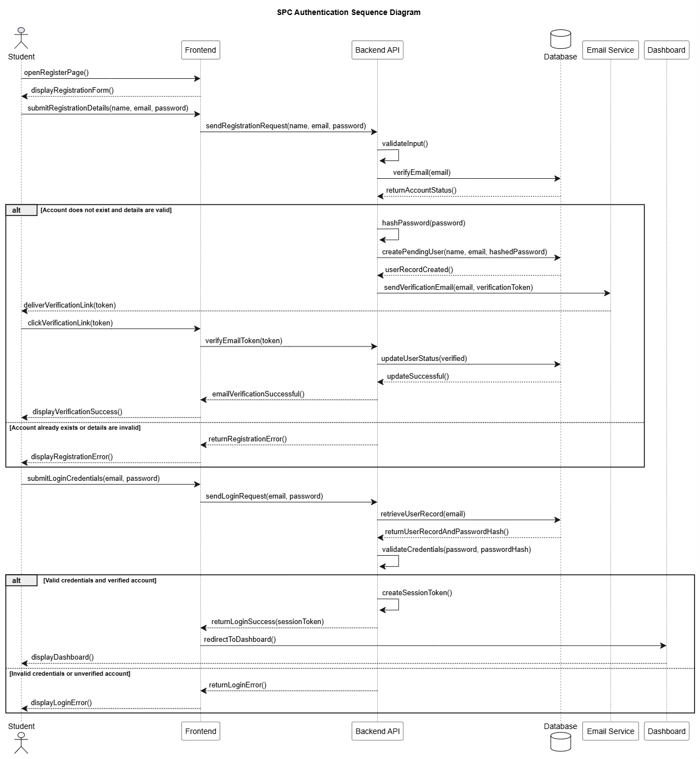
Figure 11: SPC Authentication Sequence Diagram
Use case / purpose: Shows the complete registration, email verification, credential validation, secure session-token creation, and dashboard access flow between the student, frontend, backend API, database, email service, and dashboard.

Figure 24. Backend Service Architecture Class Diagram
System area: Backend Architecture | Suggested support: Backend
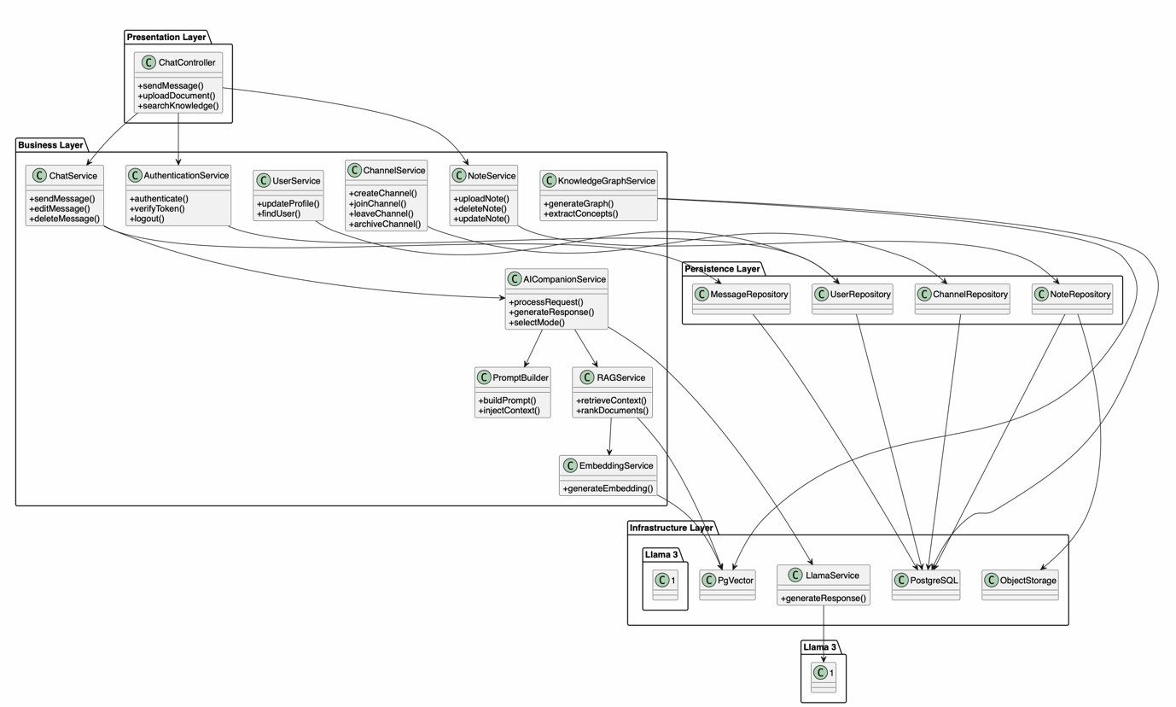
Figure 24: Backend Service Architecture Class Diagram
Use case / purpose: Shows backend service classes and how services connect to support application logic.

Figure 27. Collaboration Module Component Diagram
System area: Channel Collaboration | Suggested support: Backend / Frontend
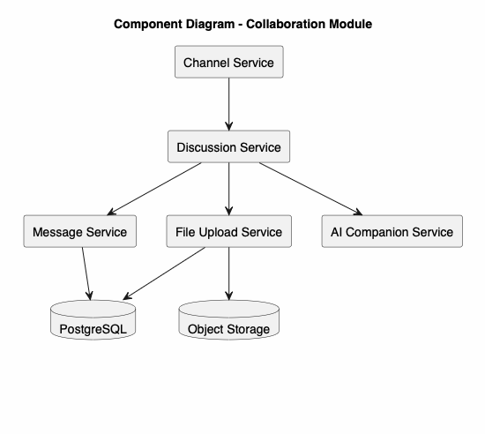
Figure 27: Collaboration Module Component Diagram
Use case / purpose: Shows channel, discussion, message, file upload, and AI companion services used in collaboration features.

Figure 34. RAG Processing Class Diagram
System area: RAG / Backend | Suggested support: AI / Backend
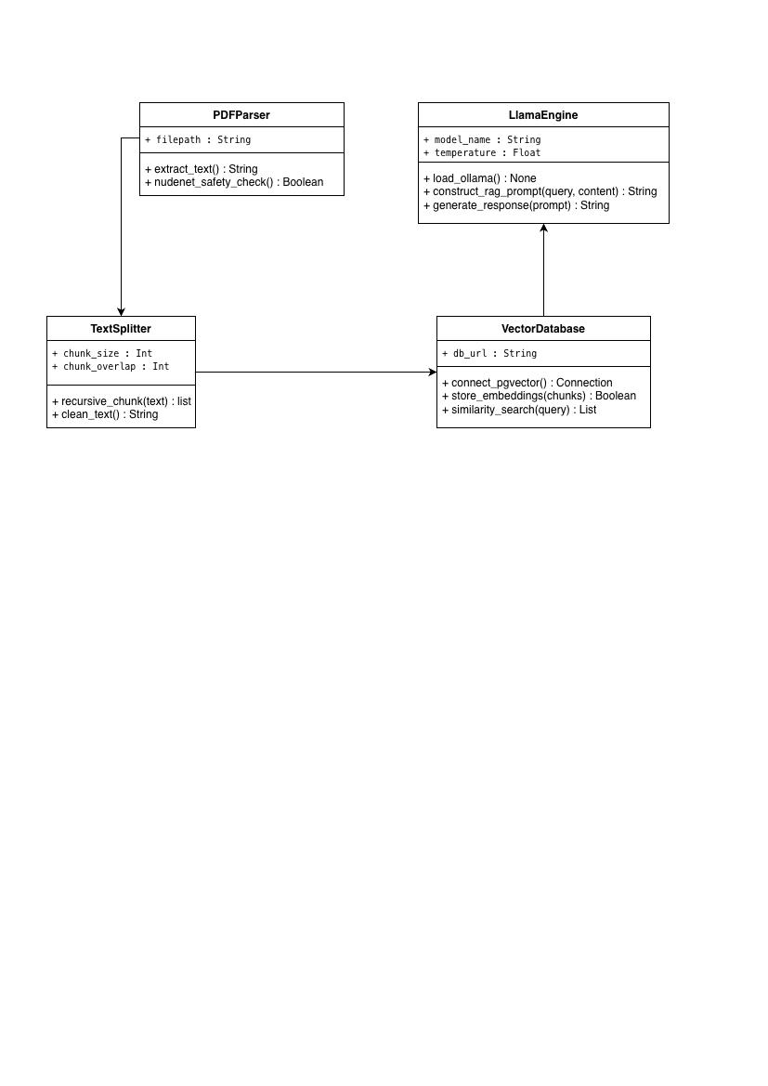
Figure 34: RAG Processing Class Diagram
Use case / purpose: Shows PDF parser, text splitter, vector database, and Llama engine classes used in the RAG workflow.

6. Database and Storage
This section groups diagrams that describe persistent user and channel data, learning materials, embeddings, PostgreSQL, pgvector, and object-storage relationships.

Figure 12. Upload PDF Notes and Generate Embeddings Sequence Diagram
System area: File Upload and RAG | Suggested support: Backend / Database / AI
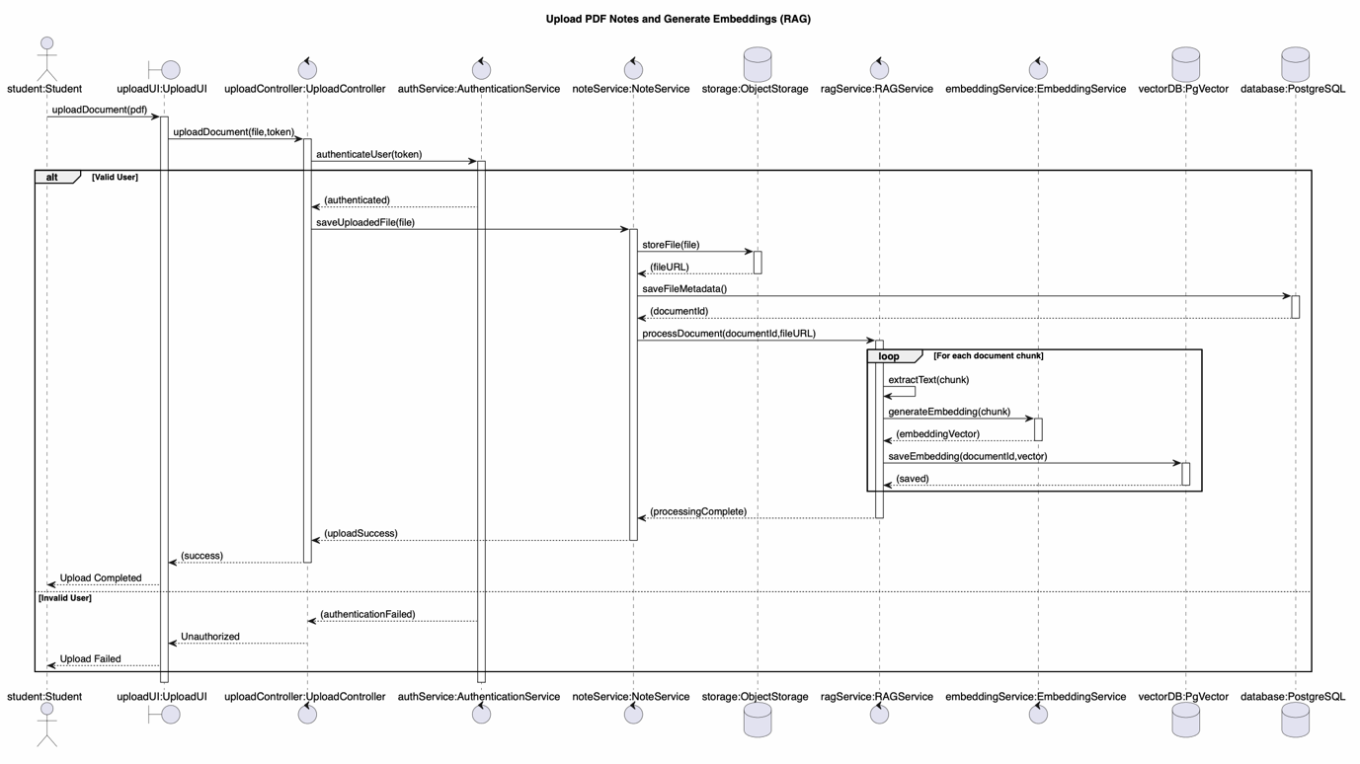
Figure 12: Upload PDF Notes and Generate Embeddings Sequence Diagram
Use case / purpose: Shows the sequence for uploading PDFs, validating files, extracting text, chunking content, and storing embeddings.

Figure 18. User Management Class Diagram
System area: User Management | Suggested support: Frontend / Backend / Cybersecurity
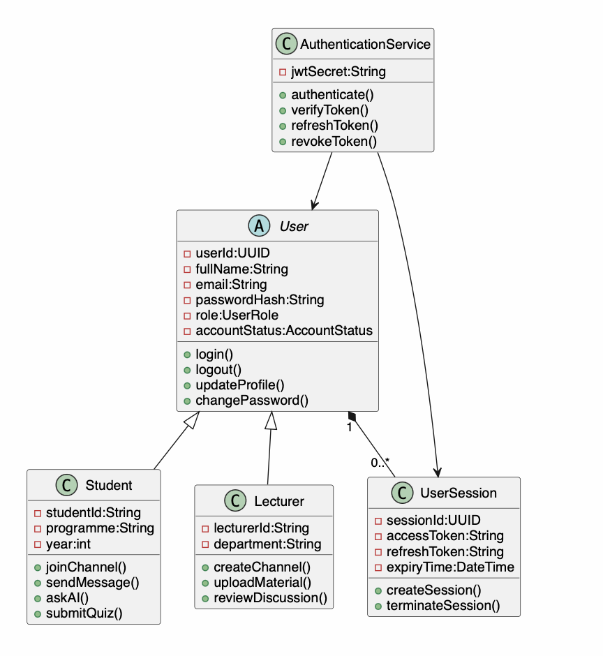
Figure 18: User Management Class Diagram
Use case / purpose: Shows user, student, lecturer, authentication service, and user session classes used for account and session management.

Figure 19. Channel and Collaboration Class Diagram
System area: Channel Management | Suggested support: Frontend / Backend / Database
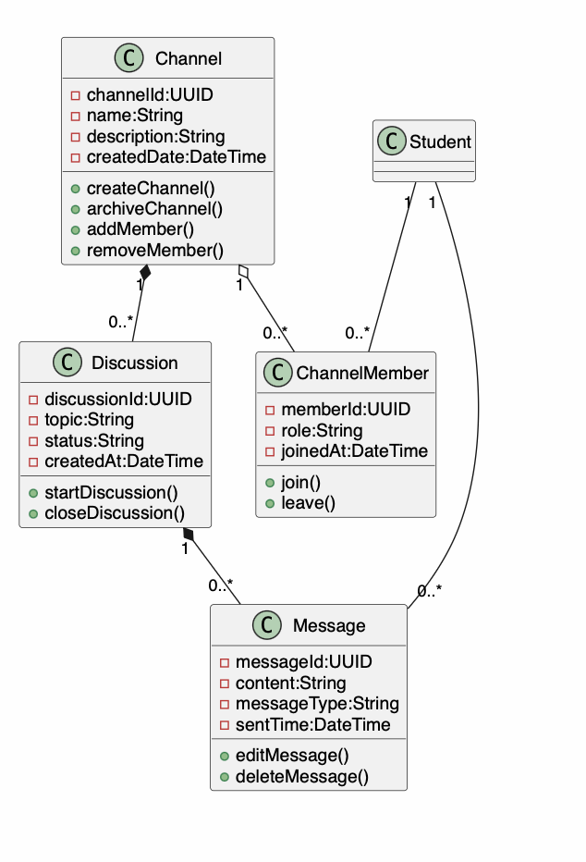
Figure 19: Channel and Collaboration Class Diagram
Use case / purpose: Shows channel, discussion, membership, message, and student relationships used for channel collaboration.

Figure 21. RAG Class Diagram
System area: RAG / Database | Suggested support: AI / Database
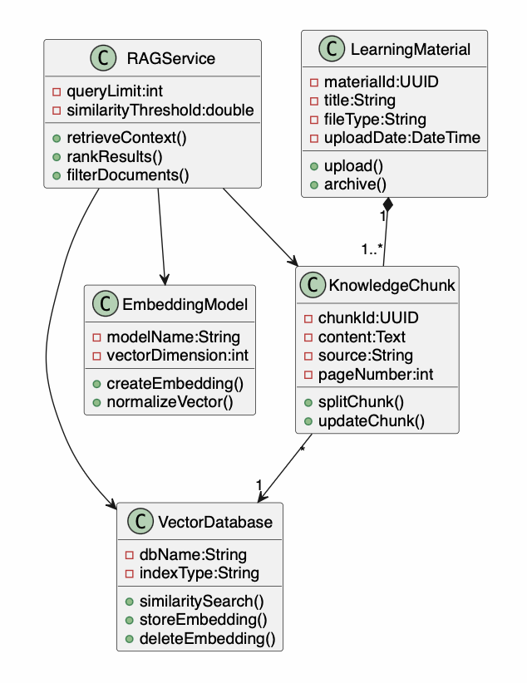
Figure 21: RAG Class Diagram
Use case / purpose: Shows learning material, knowledge chunks, embeddings, vector database, and RAG service classes.

Figure 23. Knowledge Graph Class Diagram
System area: Knowledge Graph | Suggested support: AI / Database
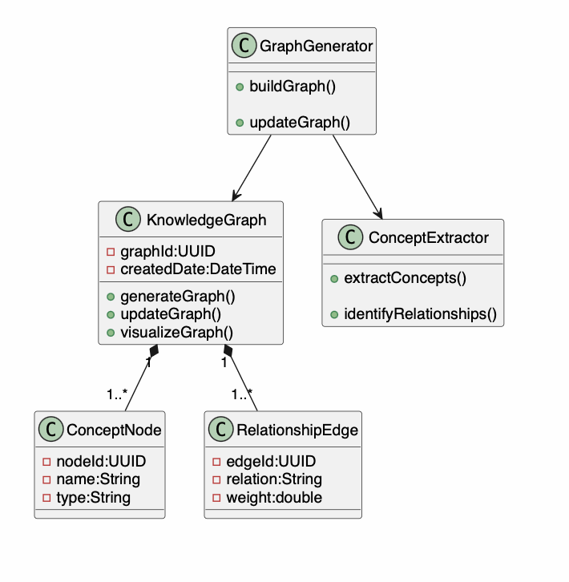
Figure 23: Knowledge Graph Class Diagram
Use case / purpose: Shows concept nodes, relationship edges, graph generation, and concept extraction components.

Figure 28. Knowledge Graph Component Diagram
System area: Knowledge Graph | Suggested support: AI / Database
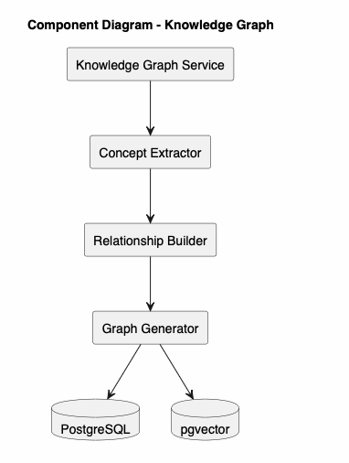
Figure 28: Knowledge Graph Component Diagram
Use case / purpose: Shows the knowledge graph service, concept extractor, relationship builder, graph generator, PostgreSQL, and pgvector.

7. AI, RAG and Knowledge Graph
This section groups diagrams that describe AI companion interactions, AI modes, prompt construction, retrieval-augmented generation, Llama 3.1 processing, and knowledge-graph generation.

Figure 6. AI Companion Interaction Activity Diagram
System area: AI Companion | Suggested support: AI / Backend
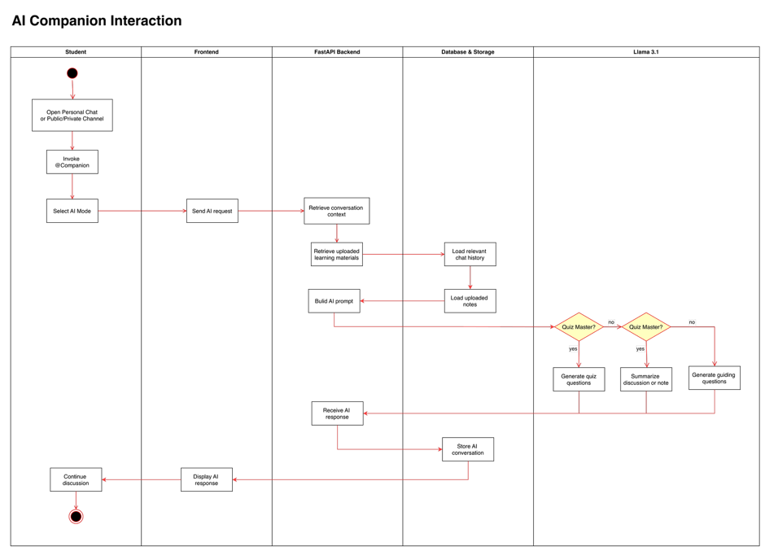
Figure 6: AI Companion Interaction Activity Diagram
Use case / purpose: Shows how an AI companion request is processed from student interaction through context retrieval and AI response generation.

Figure 8. Facilitator Mode Activity Diagram
System area: AI Modes | Suggested support: AI
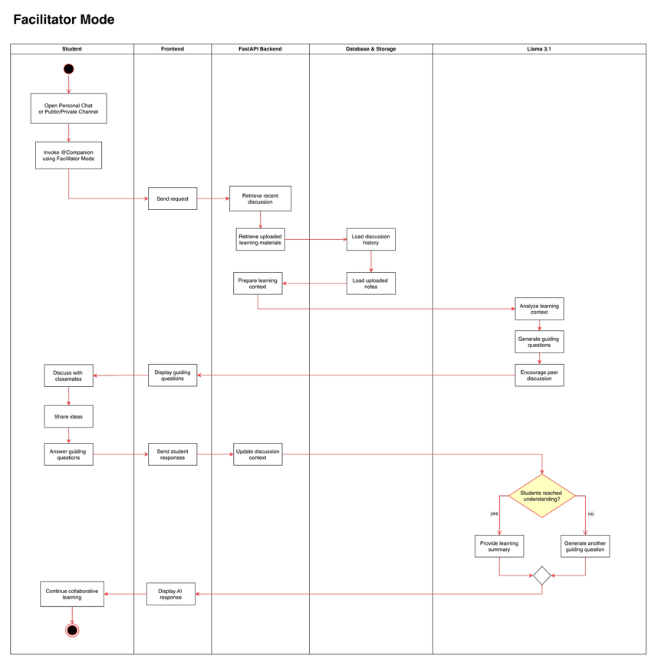
Figure 8: Facilitator Mode Activity Diagram
Use case / purpose: Shows the process flow for using the AI companion as a facilitator during study discussion.

Figure 9. Summariser Mode Activity Diagram
System area: AI Modes | Suggested support: AI
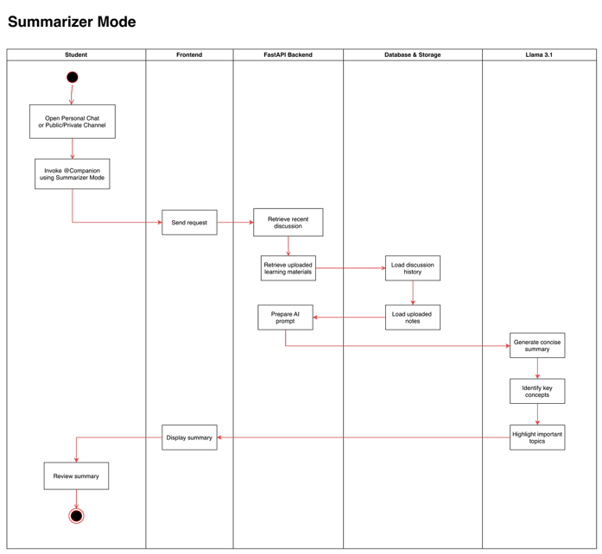
Figure 9: Summariser Mode Activity Diagram
Use case / purpose: Shows how the summariser mode receives learning material or context and produces a summary for the student.

Figure 10. Quiz Master Mode Activity Diagram
System area: AI Modes | Suggested support: AI
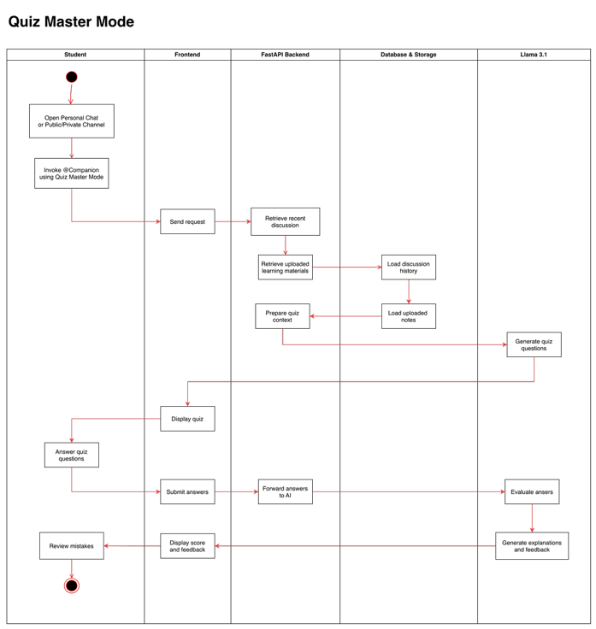
Figure 10: Quiz Master Mode Activity Diagram
Use case / purpose: Shows how the AI quiz mode generates questions, receives answers, and supports feedback.

Figure 13. Personal AI Chat with Llama 3.1 and RAG Sequence Diagram
System area: Personal AI Chat | Suggested support: AI / Backend
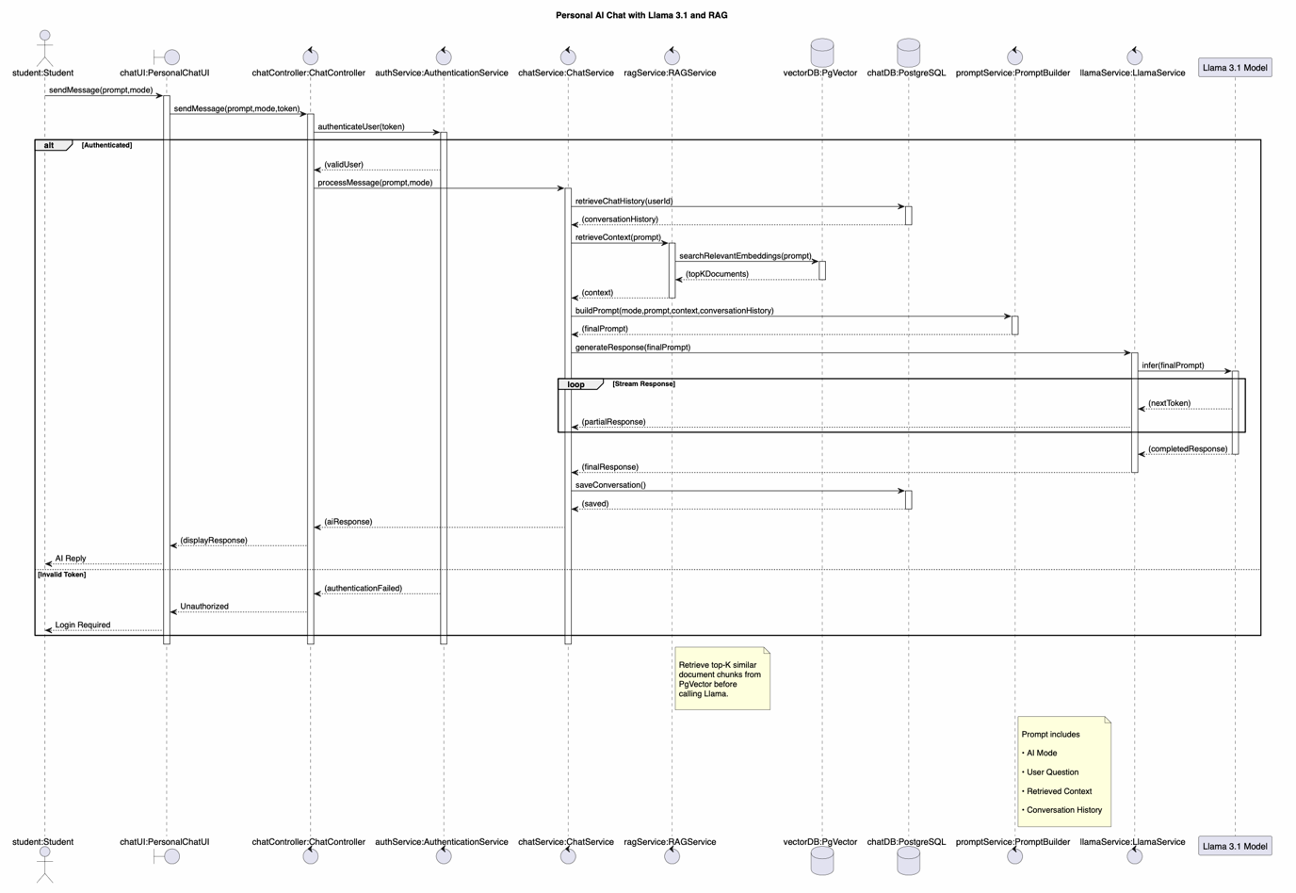
Figure 13: Personal AI Chat with Llama 3.1 and RAG Sequence Diagram
Use case / purpose: Shows how a personal AI chat request retrieves context, builds a prompt, calls Llama 3.1, and returns a response.

Figure 14. Quiz Master Mode Sequence Diagram
System area: AI Modes | Suggested support: AI
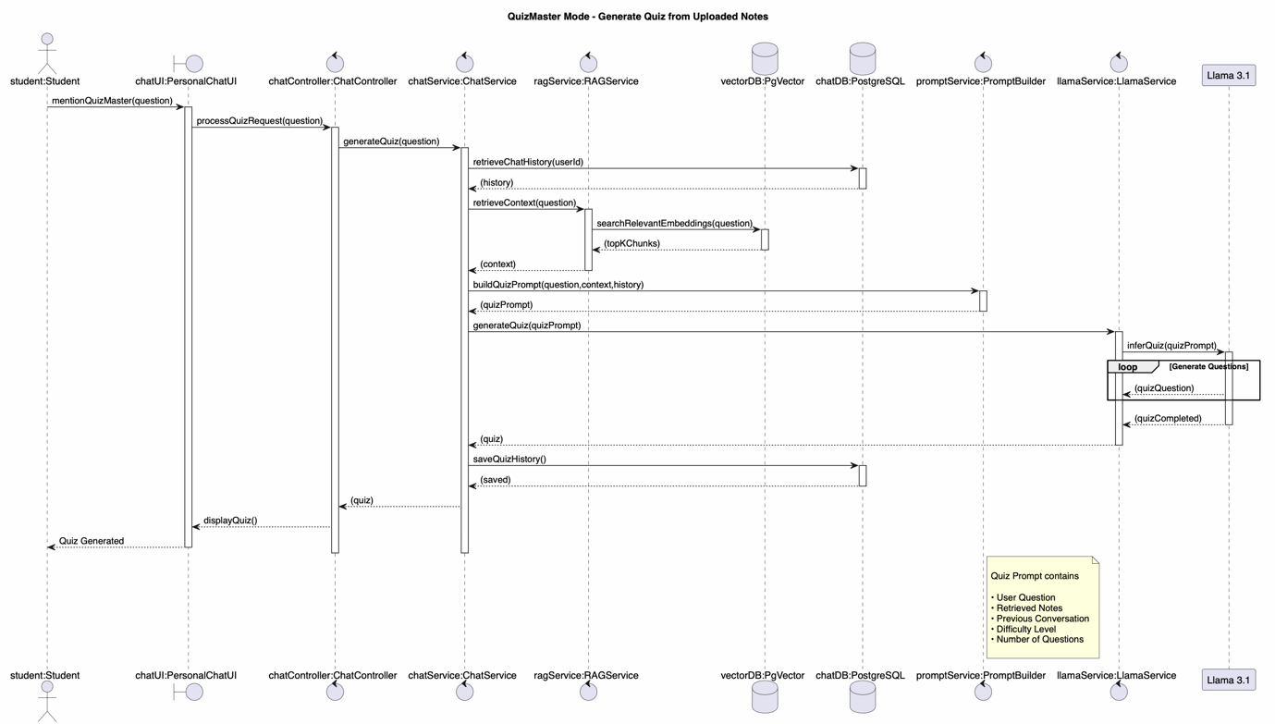
Figure 14: Quiz Master Mode Sequence Diagram
Use case / purpose: Shows the interaction flow when the student uses quiz master mode for revision and feedback.

Figure 15. Summariser Mode Sequence Diagram
System area: AI Modes | Suggested support: AI
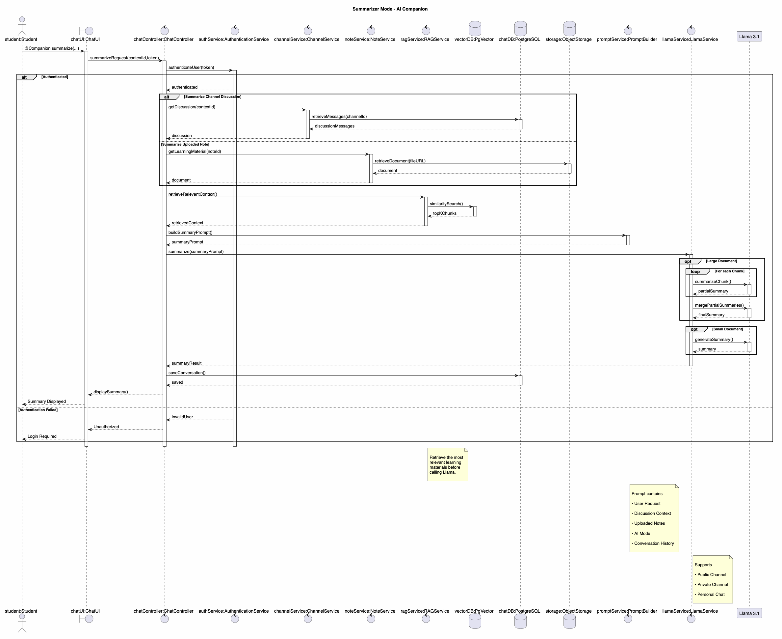
Figure 15: Summariser Mode Sequence Diagram
Use case / purpose: Shows the interaction flow for generating summaries from course material or selected context.

Figure 16. Facilitator Mode Sequence Diagram
System area: AI Modes | Suggested support: AI
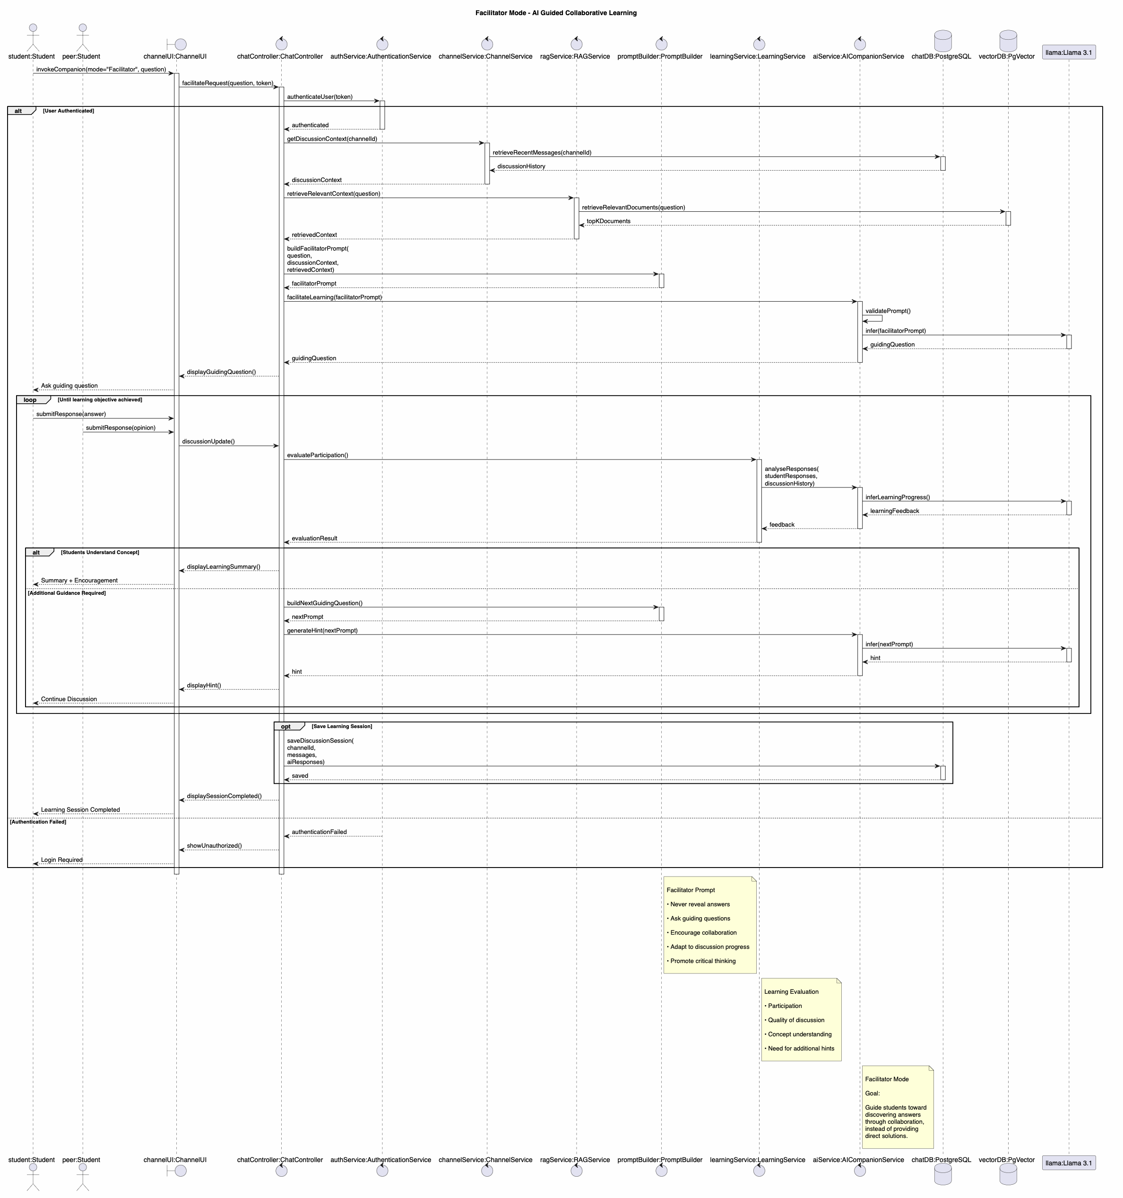
Figure 16: Facilitator Mode Sequence Diagram
Use case / purpose: Shows the sequence for AI-assisted discussion facilitation, including prompts and suggested guidance.

Figure 20. Companion and AI Request Processing Class Diagram
System area: AI Companion | Suggested support: AI / Backend
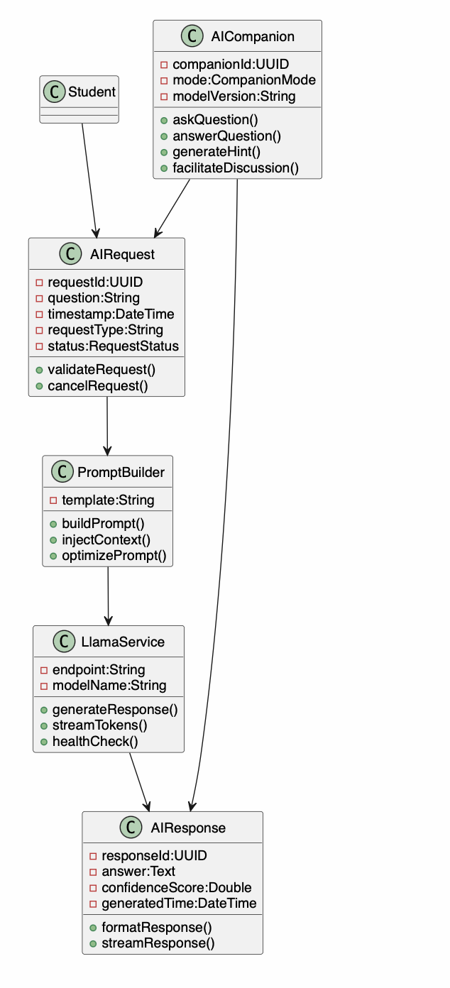
Figure 20: Companion and AI Request Processing Class Diagram
Use case / purpose: Shows how AI requests, prompt building, Llama service, and AI responses are structured.

Figure 22. AI Learning Companion Class Diagram
System area: AI Modes | Suggested support: AI
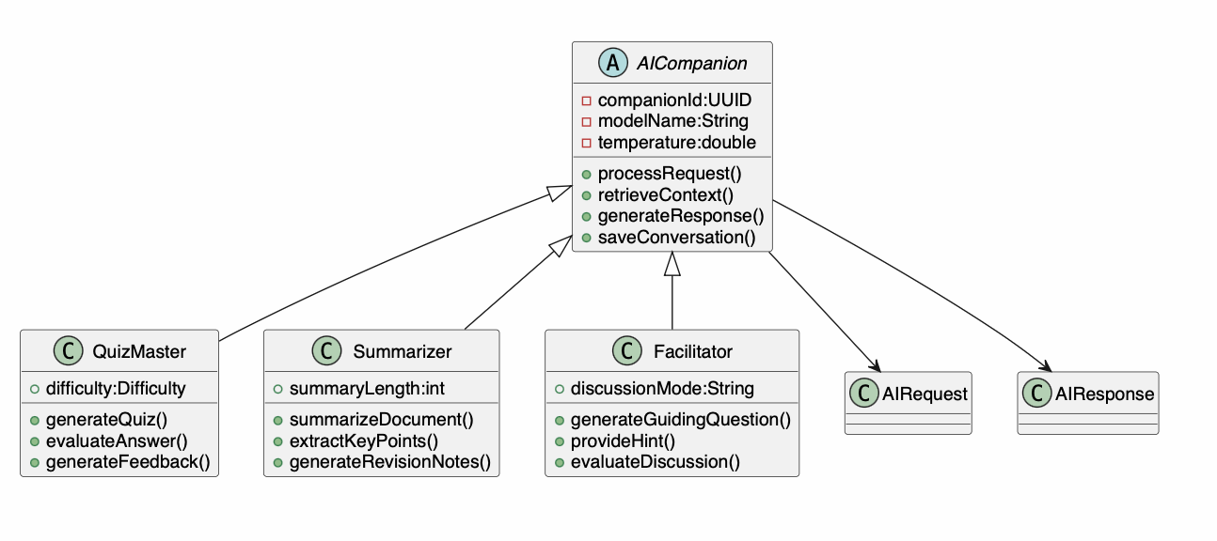
Figure 22: AI Learning Companion Class Diagram
Use case / purpose: Shows the relationship between AI companion and AI modes such as quiz master, summariser, and facilitator.

Figure 26. AI Companion Component Diagram
System area: AI Component Architecture | Suggested support: AI
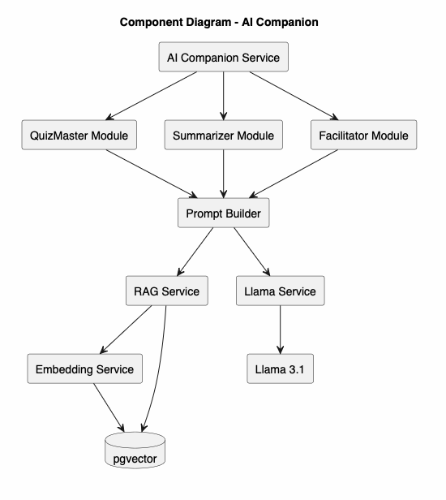
Figure 26: AI Companion Component Diagram
Use case / purpose: Shows the AI companion service, AI modes, prompt builder, RAG service, Llama service, embedding service, and pgvector.

Figure 29. RAG Pipeline Component Diagram
System area: RAG Pipeline | Suggested support: AI / Database
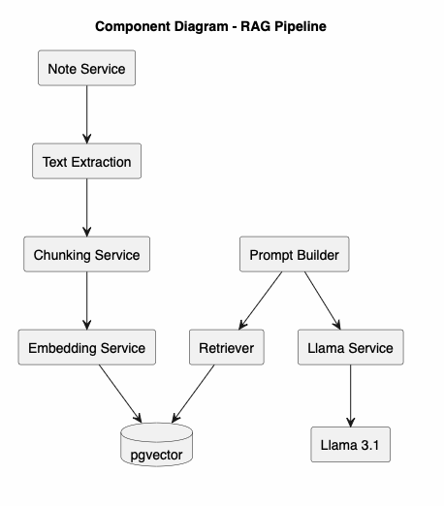
Figure 29: RAG Pipeline Component Diagram
Use case / purpose: Shows note service, text extraction, chunking, embedding, retriever, prompt builder, Llama service, and pgvector.

Figure 33. Secure Data Integration and RAG Integration Pipeline
System area: RAG / Cybersecurity | Suggested support: AI / Cybersecurity
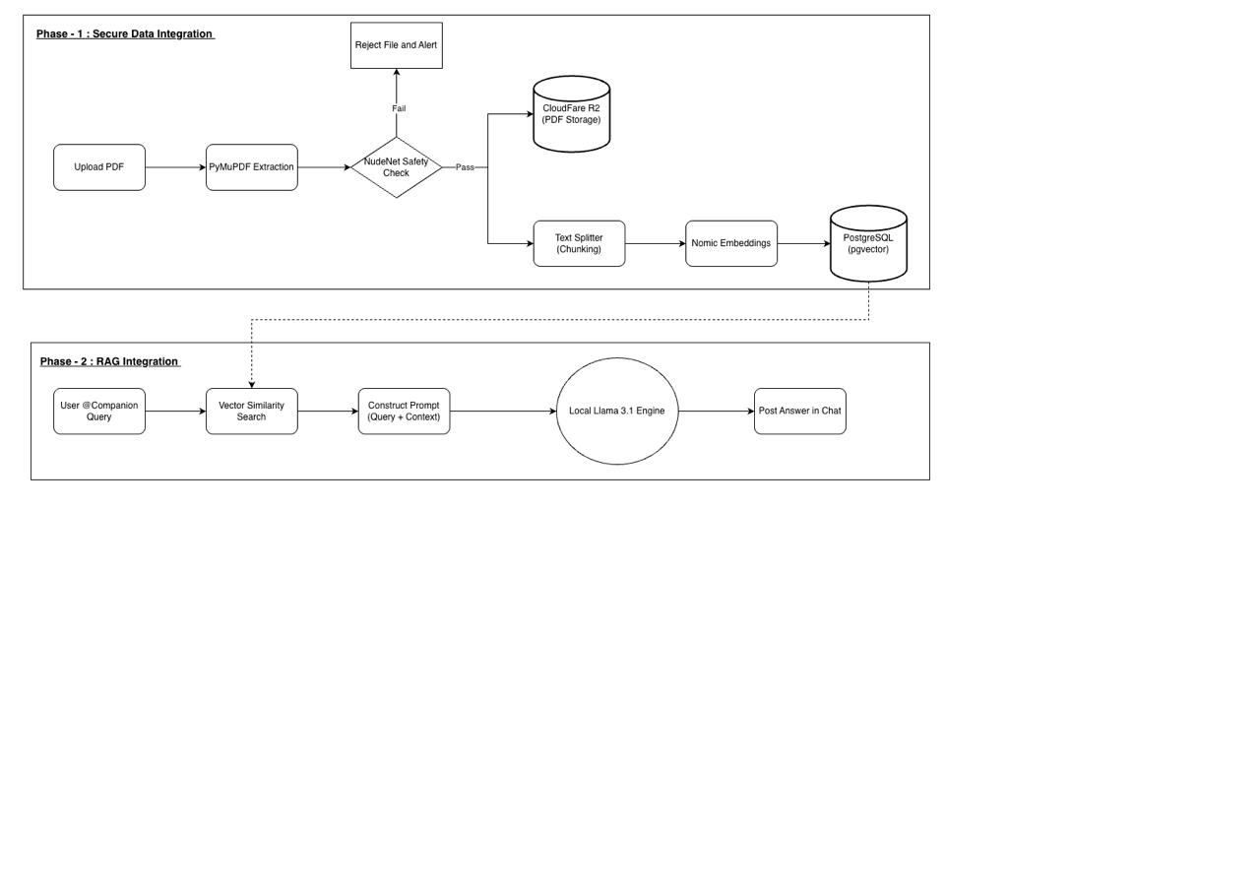
Figure 33: Secure Data Integration and RAG Integration Pipeline
Use case / purpose: Shows the two-phase pipeline from PDF upload and safety check to pgvector storage and local Llama 3.1 answer generation.

Figure 35. Event-Driven AI Chat Logic Activity Diagram
System area: AI Companion / Chat Logic | Suggested support: AI / Backend
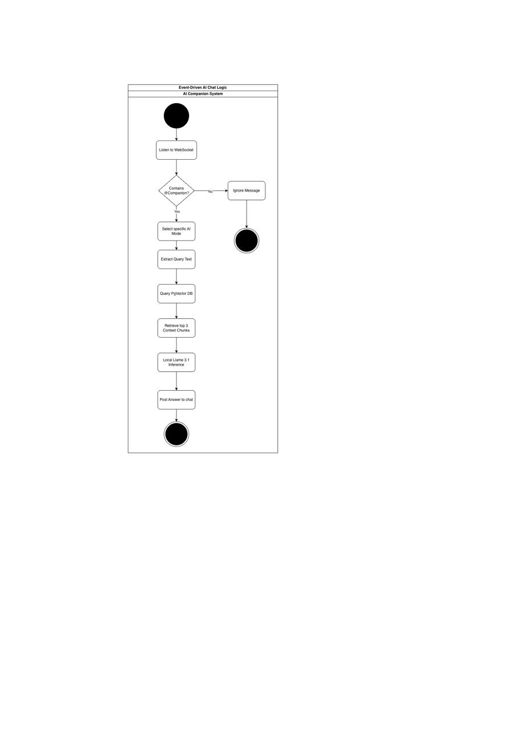
Figure 35: Event-Driven AI Chat Logic Activity Diagram
Use case / purpose: Shows how the system listens for @Companion, selects AI mode, retrieves context chunks, runs Llama 3.1 inference, and posts the answer.

8. Cybersecurity and Deployment
This section groups diagrams that describe secure request processing, authentication and authorisation controls, file-safety checks, development and cloud deployment, and production infrastructure.

Figure 30. Production Deployment Diagram
System area: Deployment | Suggested support: Backend / Cybersecurity
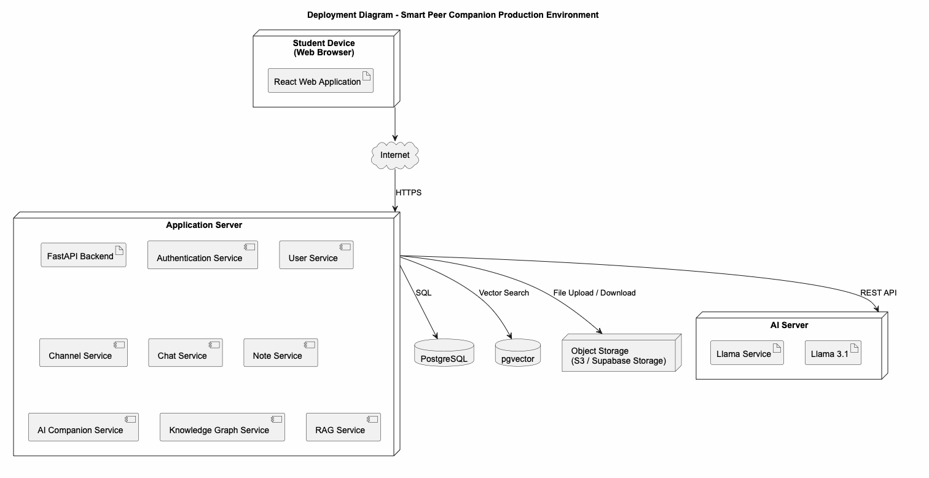
Figure 30: Production Deployment Diagram
Use case / purpose: Shows the production deployment environment with client, application server, database, object storage, and AI server.

Figure 31. Development Environment Deployment Diagram
System area: Development Deployment | Suggested support: Backend / AI
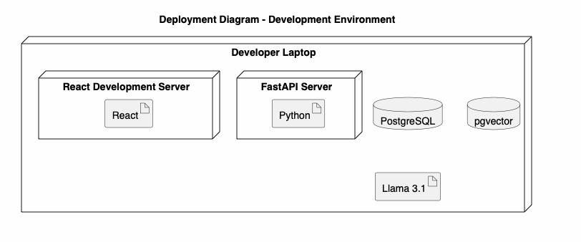
Figure 31: Development Environment Deployment Diagram
Use case / purpose: Shows the local development environment with React, FastAPI, PostgreSQL, pgvector, and Llama 3.1.

Figure 32. Cloud Deployment Diagram
System area: Cloud Deployment | Suggested support: Backend / Cybersecurity
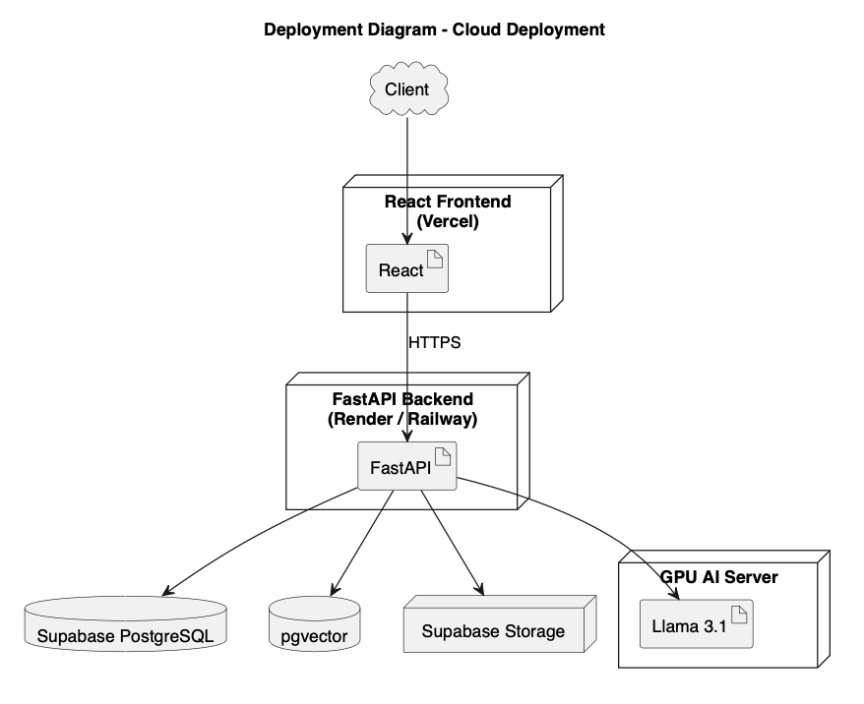
Figure 32: Cloud Deployment Diagram
Use case / purpose: Shows the proposed cloud deployment using React frontend, FastAPI backend, Supabase PostgreSQL/storage, pgvector, and GPU AI server.

Figure 36. Cybersecurity Control Flow Activity Diagram
System area: Cybersecurity | Suggested support: Cybersecurity / Backend
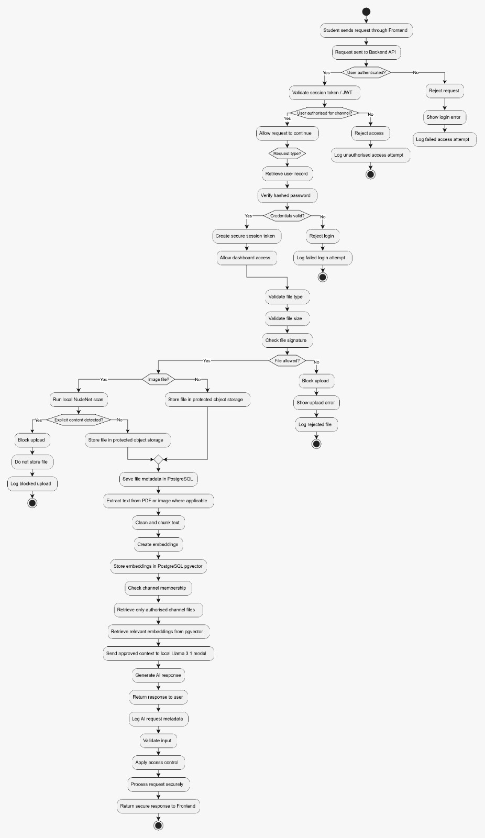
Figure 36: Cybersecurity Control Flow Activity Diagram
Use case / purpose: Shows the security controls for authentication, authorisation, file validation, NudeNet scanning, object storage, RAG isolation, and logging.

9. Full-Stack Architecture and UML Reference
This section contains the overall layered component view and the UML class-diagram arrow legend used throughout the design pack.

Figure 25. SPC Component Diagram
System area: Full Stack Architecture | Suggested support: Team
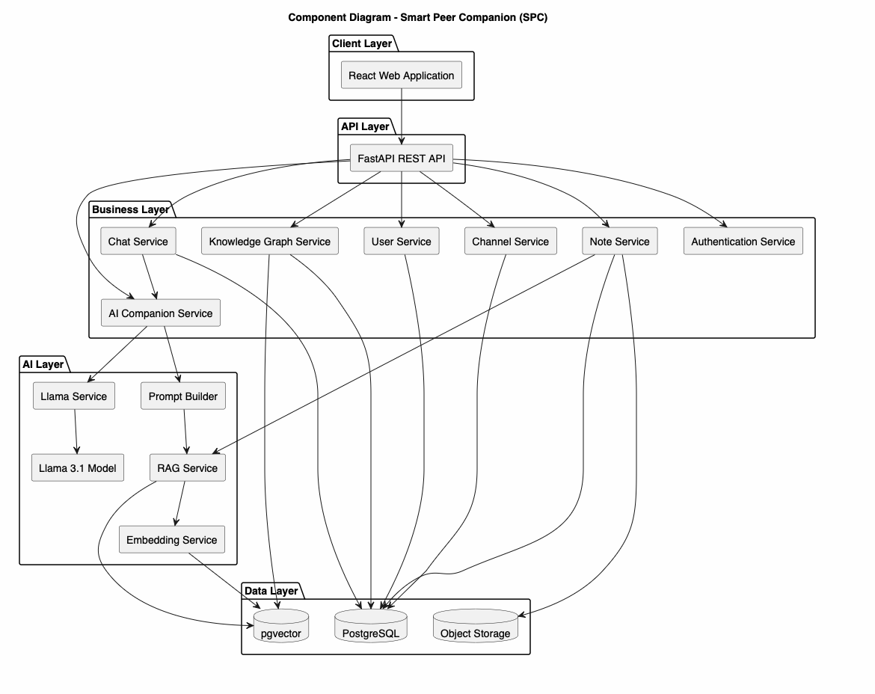
Figure 25: SPC Component Diagram
Use case / purpose: Shows the layered architecture across client, API, business, AI, and data layers.

Figure 17. Class Diagram Arrow Legend
System area: Documentation / UML Reference | Suggested support: Team
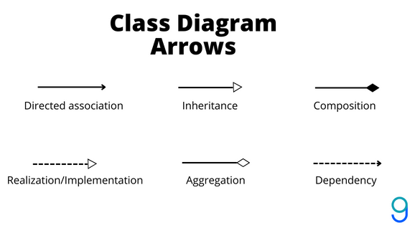
Figure 17: Class Diagram Arrow Legend
Use case / purpose: Provides the class diagram arrow notation used in the class diagrams, such as association, aggregation, composition, and dependency.

Appendix: Final Review Notes
Before final submission, the team should check that each diagram follows UML naming rules, guard conditions, arrow types, and the final feature scope approved by the project sponsors.
If clearer source images are available, replace the screenshots while keeping the same captions and descriptions.

