SMART PEER COMPANION

Backend Architecture Design
Secure document ingestion and grounded AI assistance on Hetzner Cloud

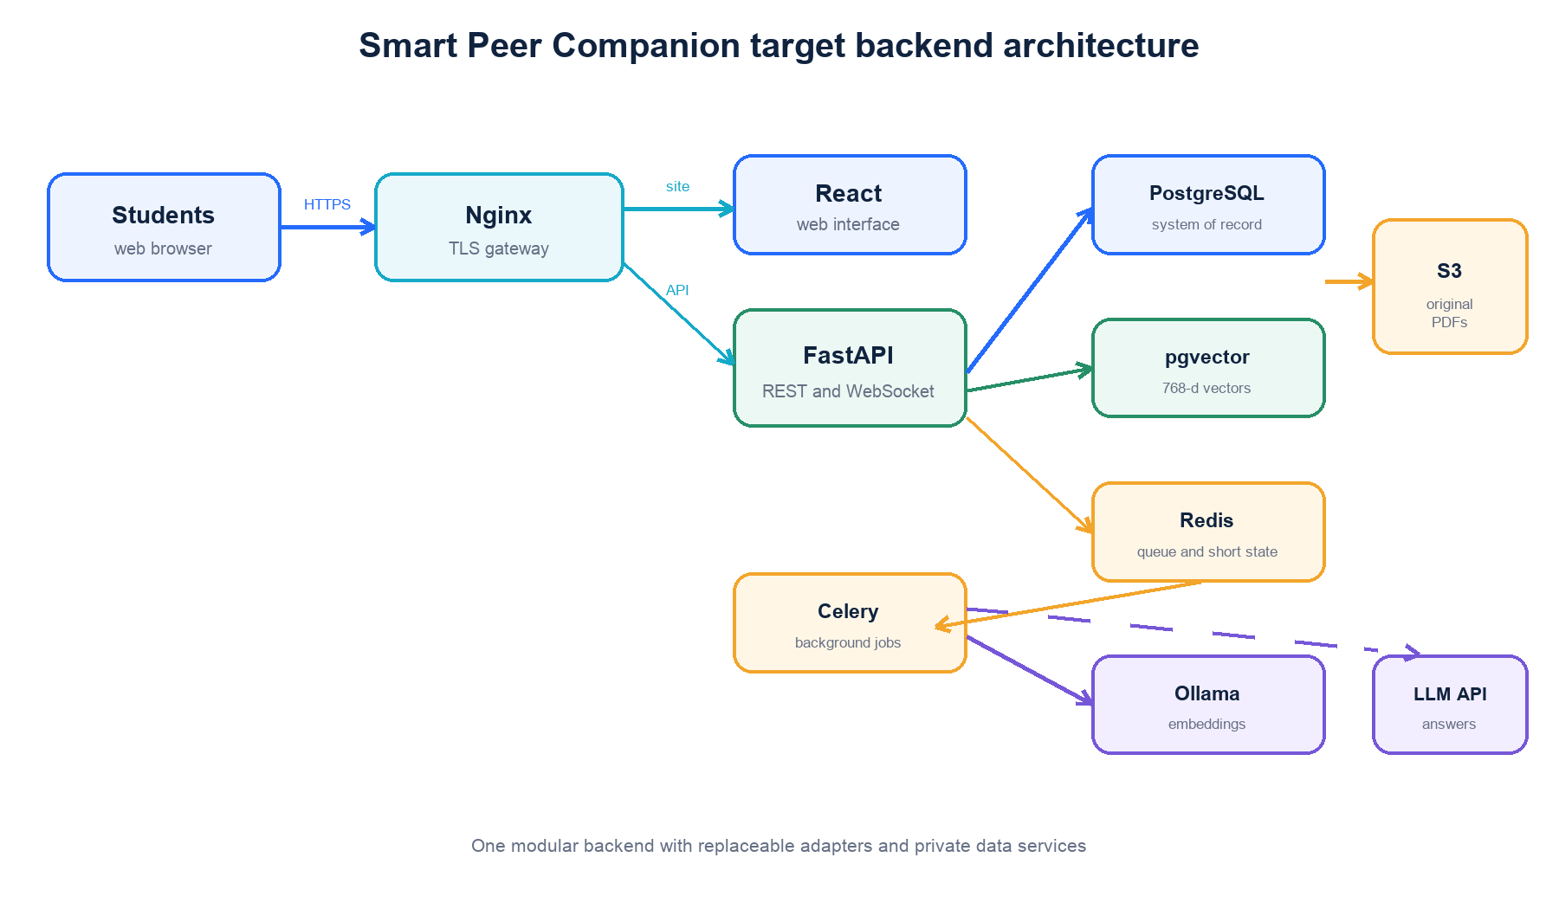
Figure 1. Proposed SPC backend services and external boundaries.
Architecture design for academic review
00 / PURPOSE AND ARCHITECTURAL POSITION

Purpose
This document defines the intended backend architecture for Smart Peer Companion. It describes the system boundaries, responsibilities, technologies, data flows, security controls and deployment model that guide implementation. The design supports authenticated students uploading study material and receiving answers grounded only in information they are permitted to access.
Architectural decision. SPC will be delivered as a domain-oriented modular monolith. FastAPI will expose versioned HTTP and WebSocket interfaces, PostgreSQL with pgvector will act as the system of record, Redis and Celery will coordinate short-lived state and background work, and original PDFs will be stored in private S3-compatible object storage. This structure keeps the first deployment manageable while preserving clear interfaces that can be separated into services later if scale requires it.

Design principles
- Authenticate every protected request and derive ownership from the authenticated identity.
- Keep business rules independent of FastAPI, SQLAlchemy, Redis, object-storage and AI SDKs.
- Persist durable state before scheduling background work.
- Filter retrieval by user, group and channel permissions before similarity search or model invocation.
- Treat generated answers as derived content and retain citations to the source chunks.
- Expose only Nginx to the public network and keep data services private.
- Use configuration and adapter interfaces so local and hosted providers can be exchanged safely.

Scope
The design covers authentication, permissions, note ingestion, personal AI conversations, study-group attachment scope, retrieval-augmented generation, background processing, realtime delivery, persistence, deployment and operations. Frontend component design and model-training activities are outside this backend architecture.
01 / SYSTEM CONTEXT AND QUALITY GOALS

System context
Students use a React web application to register, sign in, upload PDFs, organise personal conversations and ask questions. Nginx terminates HTTPS and routes browser traffic to the static frontend or FastAPI backend. FastAPI coordinates domain services and delegates persistence, object storage, background processing and AI operations through explicit interfaces.
Actor or system | Interaction with SPC | Trust boundary
Student | Uses the browser interface and supplies credentials, PDFs and questions | Untrusted client input
Frontend | Calls versioned APIs and opens authenticated WebSocket connections | Public application tier
FastAPI | Enforces identity, permissions and application use cases | Trusted backend tier
PostgreSQL and pgvector | Stores durable relational data and embeddings | Private data tier
Redis and Celery | Carry jobs, short-lived tickets, revocations and events | Private processing tier
S3-compatible storage | Stores original PDF objects outside the application container | External private data service
AI providers | Create embeddings and grounded answers from approved inputs | External processing boundary

Quality goals
Priority | Goal | Architectural response
1 | Privacy and isolation | Ownership checks in application services and scoped repository queries
2 | Reliability | Durable metadata, idempotent jobs, retries and transactional state changes
3 | Maintainability | Feature domains, clean interfaces and dependency injection
4 | Traceability | Request IDs, structured logs, job IDs, citations and audit events
5 | Deployability | Docker Compose, environment validation, health checks and controlled migrations
6 | Extensibility | Provider-neutral storage, inference and repository ports

02 / LOGICAL AND RUNTIME ARCHITECTURE

Service topology
Figure 2. Logical runtime architecture and service boundaries.
Component | Primary responsibility
Nginx | TLS termination, request routing, upload limits, WebSocket upgrades and security headers
React frontend | User interface and API client; it does not contain backend secrets
FastAPI backend | REST and WebSocket interfaces, validation, permissions and use-case coordination
PostgreSQL | Authoritative relational records for users, groups, channels, messages and attachments
pgvector | Embedding persistence and permission-scoped similarity search
Redis | Celery broker, bounded result state, WebSocket tickets, token revocations and event distribution
Celery workers | PDF extraction, chunking, embedding and other long-running or retryable tasks
S3-compatible storage | Private, encrypted and durable storage for original uploaded files
AI providers | Local or hosted embeddings and answer generation through backend adapters

03 / APPLICATION ARCHITECTURE

Domain oriented Clean Architecture
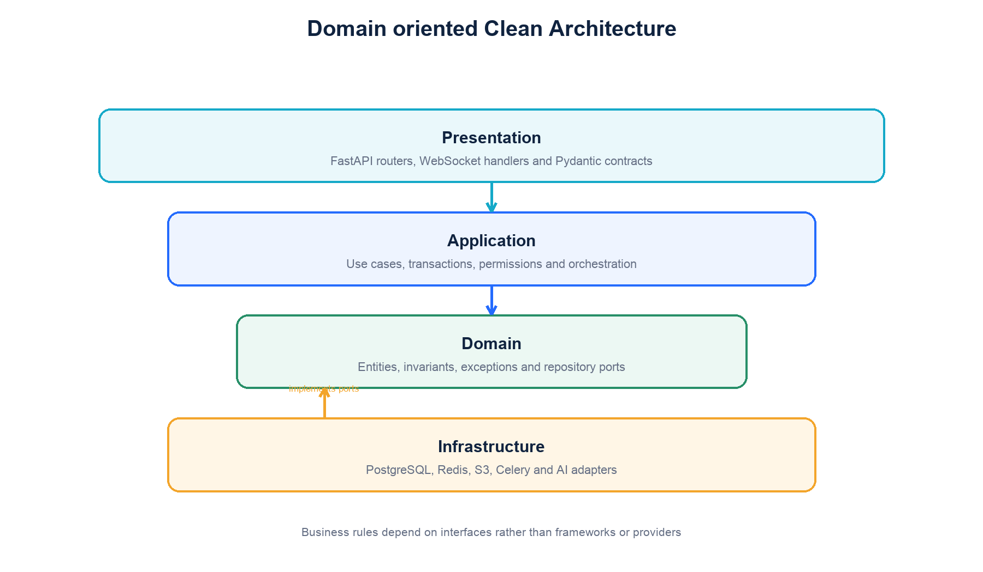
Figure 3. Dependency direction within each backend feature domain.
Each feature domain is organised into presentation, application, domain and infrastructure layers. Dependencies point towards the domain. Presentation code translates transport data into use-case calls; application services coordinate transactions and permissions; domain code expresses entities and interfaces; infrastructure adapters connect those interfaces to databases, queues, object storage and AI providers.
Backend/app/
api/ composition, shared dependencies and error mapping
core/ configuration, security, database and observability
domains/
auth/ registration, login, logout and identity
notes/ attachment lifecycle, storage and processing
chats/ conversations, messages and grounded questions
study_groups/ groups, memberships, invitations and channels
users/ profile and account management
knowledge_graph/ derived concept relationships
notifications/ user notification delivery
ai/ extraction, chunking, embeddings and answer adapters
workers/ Celery task entry points and event publication

Composition root
A central dependency module constructs repository, storage, queue, ticket, revocation, retrieval and AI adapters from validated configuration. Routers depend on application services rather than concrete infrastructure classes. Tests can select in-memory adapters, while local and hosted deployments select PostgreSQL, Redis and S3 adapters without changing business logic.
04 / API AND COMMUNICATION DESIGN

Interface conventions
- REST endpoints are versioned under /api/v1 and described through OpenAPI.
- JSON field names, status codes, validation rules and error envelopes are shared integration contracts.
- PDF uploads use multipart/form-data; the backend validates extension, media type, size and file signature.
- Long-running work returns 202 Accepted with a durable resource identifier and processing status.
- WebSockets use short-lived single-use tickets rather than long-lived access tokens in URLs.
- Every response and structured log carries a request identifier for troubleshooting.
API area | Representative operations | Protection
Authentication | Register, login, current user, logout and WebSocket ticket | Public registration and login; bearer token otherwise
Notes | Upload, list, retrieve, status and delete | Authenticated owner or permitted channel member
Personal chat | Create, list, rename, delete, history and ask | Authenticated conversation owner
Study groups | Create, join, invite, manage members and channels | Membership and role checks
Realtime | Processing updates and answer events | Single-use ticket plus resource authorization

Error contract
Expected failures use a stable structure containing an application error code, human-readable message, retryability indicator, optional details and request ID. Authentication failures return 401, permission failures return 403 or ownership-hiding 404 as defined by the contract, validation failures return 422, conflicts return 409 and accepted background work returns 202.
05 / IDENTITY PERMISSIONS AND SECURITY

Authentication design
Registration normalises identity data and stores an Argon2 password hash. Login issues a signed, expiring access token containing subject, role, token type, token identifier, issued-at and expiry claims. Protected dependencies validate the signature and required claims, confirm that the user is active and reject revoked token identifiers held in Redis until their original expiry.
Control | Design
Password handling | Argon2id hashing; plaintext passwords are never logged, returned or persisted
Access tokens | Short-lived signed JWTs with pinned algorithms and required claims
Logout | Redis revocation keyed by token identifier with expiry matching the token
WebSocket access | Opaque, single-use Redis ticket bound to user and short expiry
Roles | Student, administrator and group roles enforced by reusable dependencies and domain rules
Ownership | User identity is derived from authentication rather than accepted from client payloads
Secrets | Backend-only environment or secret-store values; never exposed through frontend build variables

Permission model
Personal notes and conversations are owned by one user. Study-group resources are governed by membership and channel permissions. Repository methods receive a scope object containing the authenticated user and, when relevant, group and channel identifiers. They return only records within that scope. The AI pipeline receives already-authorized chunks and never decides access.
06 / NOTE INGESTION AND OBJECT STORAGE

Attachment lifecycle
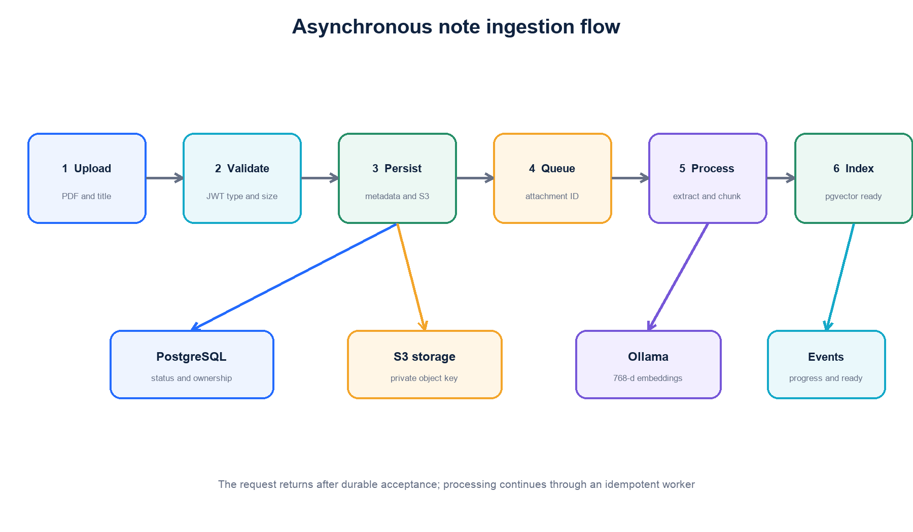
Figure 4. Durable asynchronous PDF ingestion flow.
The upload use case validates the request, creates an attachment record, writes the original PDF to private object storage and commits both the ownership metadata and initial queued state before publishing a processing job. The API returns the attachment identifier. A worker claims the job, changes the state to processing, extracts text, creates overlapping chunks, generates embeddings, persists the chunks and changes the attachment to ready. A terminal error records a safe error description and sets the state to failed.
State | Meaning | Allowed transition
queued | Metadata and object are durable; work awaits a worker | processing or failed
processing | A worker is extracting, chunking or embedding | ready or failed
ready | All searchable chunks and metadata are committed | deleted
failed | Processing ended safely with a recorded error | queued for an explicit retry or deleted
deleted | The attachment is unavailable and cleanup is scheduled | No user-visible transition

S3-compatible storage design
Original PDFs are stored through an AttachmentStorage interface backed by AWS S3 or another S3-compatible provider. The database stores only a provider-neutral object key, checksum, size and media type. Objects are private, encrypted at rest, transmitted through TLS and accessed by backend credentials with least privilege. Browser downloads use short-lived signed URLs or authenticated backend streaming. Bucket versioning, lifecycle rules and deletion jobs are configured according to retention policy.
Provider choice is a deployment decision. Promotional or education credits may reduce cost, but availability and duration are not architectural assumptions; the storage adapter must remain portable across AWS S3 and compatible services.

Object identity and integrity
- Object keys are generated by the backend and do not expose the original filename or user email.
- A recommended key shape is environment/user_id/attachment_id/version, with the bucket name supplied by configuration.
- The database records a checksum so processing workers can detect a missing, replaced or corrupted object.
- The original filename is retained as metadata for display and safe download headers, not as the storage key.
- Workers read objects with backend credentials; direct public bucket access is disabled.

Retention and deletion
Deleting an attachment first makes it unavailable through application permissions, then publishes an idempotent cleanup job. The job removes derived chunks and the object according to retention policy. Versioning and lifecycle rules prevent accidental immediate loss while ensuring that expired or deleted student material is not retained indefinitely.

Attachment scope
A library note has uploaded_by set and no channel identifier, so it appears in My Notes. An attachment posted to a personal conversation or study-group channel includes the appropriate channel and message identifiers and does not automatically appear in My Notes. All attachment types use the same storage pipeline and differ only in authorization scope and presentation.
07 / PERSONAL CHAT AND GROUNDED ANSWERS

Grounded question workflow
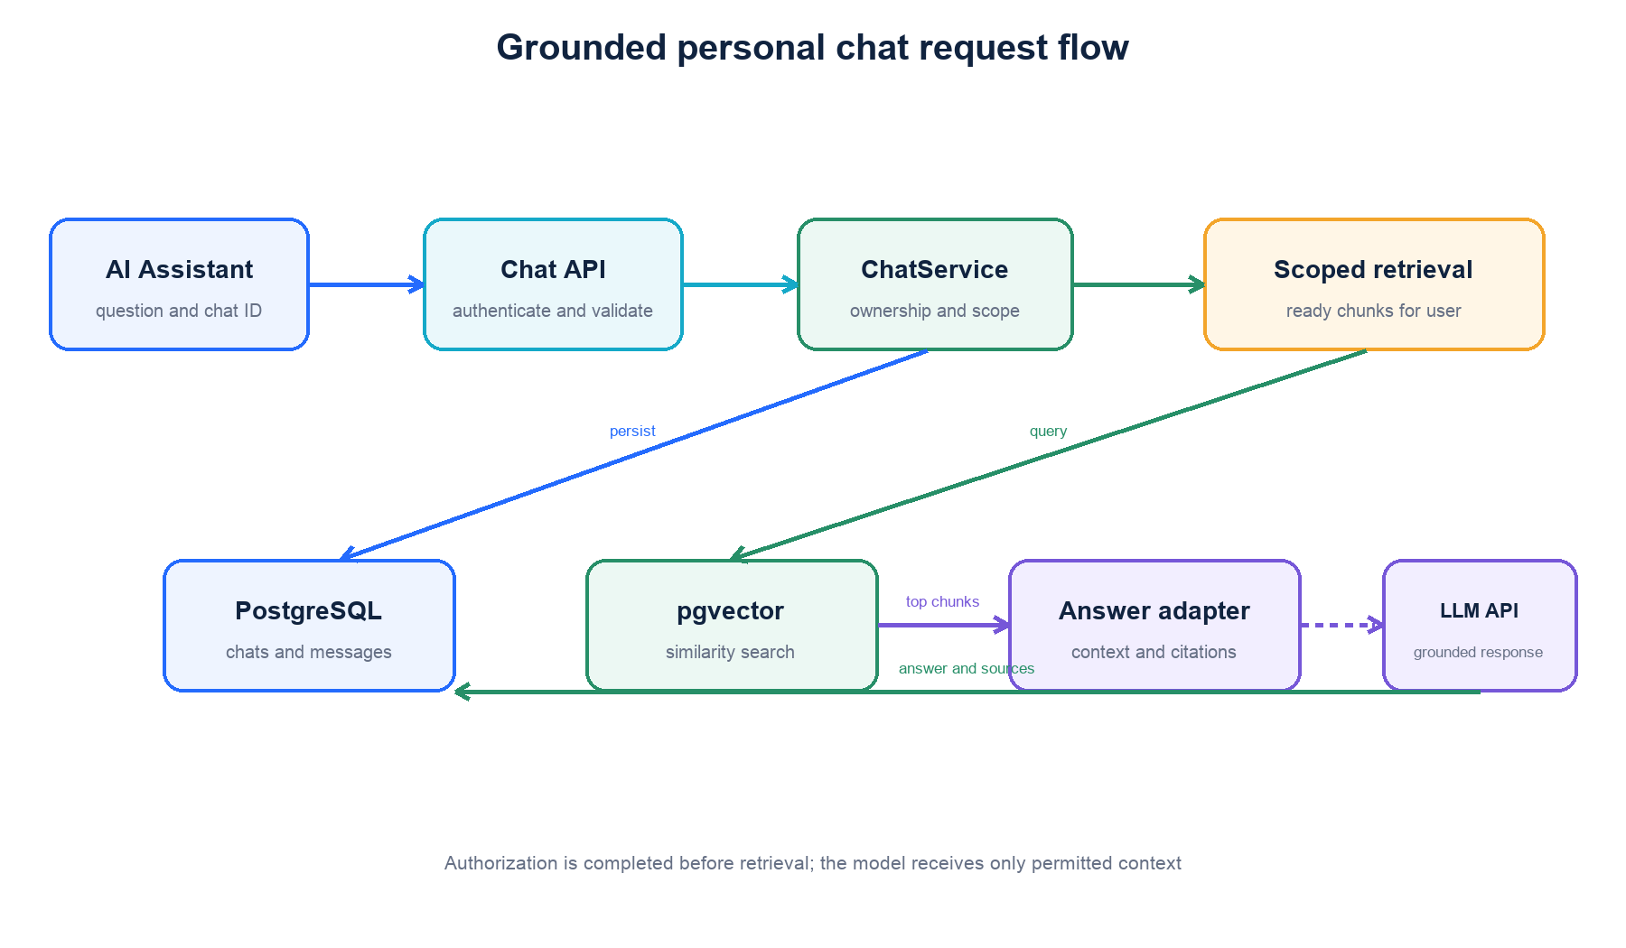
Figure 5. Permission-scoped retrieval and grounded answer generation.
The ChatService authenticates the caller, verifies conversation ownership and persists the user message. The retrieval repository selects only ready chunks within the permitted scope and performs similarity search using the question embedding. The answer adapter receives the top ranked chunks, constructs a bounded context and requests an answer from the configured model. The assistant message and source citations are stored atomically before the response is returned or streamed.
- If no authorized ready material exists, the use case fails without calling the language model.
- The prompt instructs the model to use supplied context and to state when the answer is absent.
- Citations reference persisted chunk and attachment identifiers that are revalidated before exposure.
- Conversation history is bounded or summarised before model calls to control latency, cost and token use.
- Personal AI chat is the initial scope; the same contracts extend to group channels with membership checks.
08 / DATA ARCHITECTURE

Persistence model
Entity | Key relationships and purpose
users | Account identity, password hash, role, status and lifecycle timestamps
groups | Personal, public or private study spaces with an owner and visibility rules
memberships | Many-to-many user-group relationship with role and membership status
channels | Conversation or study-group channel belonging to one group
messages | Ordered user or assistant content associated with a channel
attachments | Owner, optional channel and message, object key, file metadata and processing state
chunks | Attachment-linked text, page metadata and vector(768) embedding
ai responses | Model, request trace, sources and generated artifacts when auditability is required
audit events | Security and operational actions without sensitive payload content

Data integrity rules
- Emails are normalised and uniquely constrained.
- Foreign keys define deliberate cascade, restrict or anonymise behavior for every deletion path.
- Attachment progress is constrained to 0 through 100; processing errors and optional titles are nullable.
- Embedding dimension is fixed at 768 for the selected embedding model and versioned if the model changes.
- Repository transactions keep attachment status and chunk replacement consistent.
- Database migrations are ordered, reversible where practical and executed before compatible application rollout.

Account deletion
Account removal follows an explicit retention policy. Personal credentials and profile data are disabled and then deleted or anonymised. Personal conversations, notes, chunks and object-storage files are removed through queued cleanup. Shared-group content may be retained only when the policy requires continuity; retained records are reassigned to a controlled system identity or anonymised without permitting that identity to authenticate.
09 / BACKGROUND WORK EVENTS AND REALTIME

Celery processing model
FastAPI publishes a task only after the related database transaction commits. Celery tasks receive durable identifiers such as attachment_id rather than full files or authorization decisions. The worker reloads the attachment and object key, verifies that processing is still allowed, and performs idempotent chunk replacement. Retries use bounded exponential backoff and do not duplicate chunks or advance an invalid state transition.
Event | Producer | Consumers
attachment.queued | Upload use case | Celery worker and audit stream
attachment.progress | Processing worker | Status endpoint and WebSocket delivery
attachment.ready | Processing worker | Frontend notification and chat readiness
attachment.failed | Processing worker | Frontend notification and operations
chat.answer.started | Chat use case | WebSocket client
chat.answer.delta | Answer adapter | Authorized WebSocket client
chat.answer.completed | Chat use case | Client, history and audit stream

Realtime security
The browser requests a short-lived ticket over authenticated HTTPS, then opens a WebSocket through Nginx. The backend atomically consumes the ticket, binds the connection to one user and verifies ownership before joining resource-specific channels. Events contain resource identifiers and safe progress data, not raw document text. Disconnects remove subscriptions and clients recover missed state through REST.
10 / AI AND RETRIEVAL ARCHITECTURE

RAG pipeline
Stage | Responsibility | Output
Extraction | Read PDF text and page structure; apply image handling when approved | Structured page entries
Chunking | Split content with overlap and preserve page and attachment metadata | Searchable text chunks
Embedding | Generate versioned 768-dimensional vectors | Embedding per chunk
Indexing | Persist chunks and vectors transactionally | Ready attachment index
Retrieval | Apply authorization filters and vector similarity ranking | Top permitted chunks
Generation | Answer only from provided context and return citations | Assistant response and sources

Provider abstraction and governance
Embedding and answer generation are accessed through domain interfaces. Local Ollama and hosted OpenRouter-compatible APIs are infrastructure choices, not domain dependencies. Configuration records the selected model, embedding dimension, timeout and version. Only the minimum authorized context is sent to an external provider, and provider retention, regional processing and privacy terms must be approved before real student material is used.
The system records model and prompt versions for reproducibility. It does not present generated output as authoritative academic advice. The interface displays citations and reminds students to verify important information against source material.
11 / HETZNER DEPLOYMENT AND NETWORK SECURITY

Deployment topology
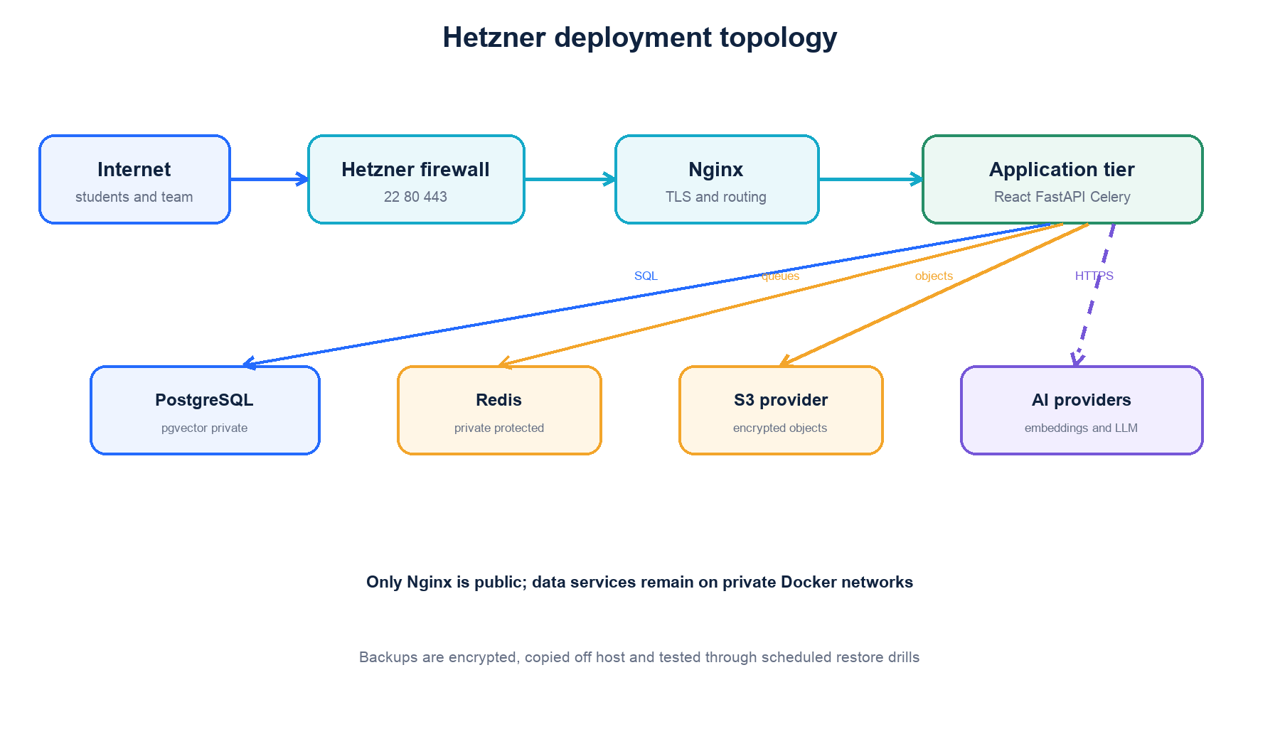
Figure 6. Proposed Hetzner deployment with private data services.
- Hetzner Cloud Firewall exposes SSH from approved administrator addresses and HTTP or HTTPS to users.
- Nginx terminates TLS, redirects HTTP to HTTPS, applies request limits and forwards trusted headers.
- FastAPI, Celery, PostgreSQL and Redis run on private Docker networks without public host ports.
- PostgreSQL uses a persistent encrypted volume and scheduled logical backups copied off the VM.
- Redis requires authentication, bounded persistence and memory policies appropriate to queues and ephemeral state.
- S3 access uses a dedicated least-privilege service identity restricted to the project bucket and prefix.
- External AI traffic leaves through controlled HTTPS egress and never contains credentials or unrelated documents.

Configuration and release
Local, test and staging environments use the same container images with separate validated configuration. Secrets are excluded from Git and rotated after exposure or team changes. Releases run database migrations before application activation, verify health endpoints and preserve named volumes. Rollback returns to a compatible application image without deleting database, Redis or object-storage data.
12 / RELIABILITY OBSERVABILITY AND OPERATIONS

Operational design
Concern | Design response
Health | Liveness for process state and readiness for required database and Redis dependencies
Logging | Structured JSON logs with request, user-safe, attachment, chat and job identifiers
Metrics | Request latency, error rate, queue depth, job duration, inference time and storage failures
Tracing | Correlation across Nginx, FastAPI, Celery and external inference calls
Backups | Daily database backups, object versioning or retention and periodic off-host copies
Recovery | Documented restore procedure with scheduled restore tests and recovery objectives
Capacity | Upload size limits, worker concurrency, database connection pools and provider rate limits

Failure handling
External inference, object storage and embedding calls use explicit timeouts and bounded retries. Database transactions do not remain open during slow network operations. A failed background job records a safe terminal state and can be retried without duplicating output. If realtime delivery fails, the browser recovers authoritative state through REST endpoints.
13 / VERIFICATION STRATEGY AND ARCHITECTURE DECISIONS

Testing strategy
Test level | Purpose
Unit | Verify domain invariants, services, token logic, adapters and state transitions in isolation
Contract | Verify request, response, error and event schemas shared with frontend and workers
Integration | Exercise PostgreSQL, pgvector, Redis and S3-compatible storage using real containers
Security | Prove cross-user and cross-group isolation, invalid token handling and upload validation
End to end | Register, upload, process, ask, cite, reload and delete through the deployed interface
Operational | Test migrations, backup restoration, worker retry, container restart and rollback

Key architecture decisions
Decision | Rationale
Modular monolith | Reduces deployment complexity while maintaining domain boundaries
PostgreSQL plus pgvector | Combines transactional records and scoped vector search in one operational database
S3-compatible original-file storage | Separates durable binary objects from containers and database rows
Redis plus Celery | Supports shared ephemeral state and durable retryable background execution
Backend-enforced authorization | Prevents clients and AI code from selecting their own access scope
Provider adapters | Allows local development and hosted deployment without rewriting domain services
REST plus selective WebSockets | Keeps resource operations simple while supporting live progress and answers

Acceptance criteria
The architecture is considered successfully implemented when durable user, note, chat and chunk data survive container replacement; every retrieval query is permission-scoped; background jobs are idempotent and observable; original PDFs are private and recoverable from object storage; cross-user security tests pass; and the Hetzner deployment exposes only HTTPS through Nginx with tested backup and restore procedures.

