SPC Backend Authentication Testing Record
Current evidence, execution guide, and integration testing plan
Record | Details
Project | Smart Peer Companion
Area | Backend authentication and API security
Contributor | Hein Myat Thu
Recorded | 12 September 2026
Current result | 20 automated tests passed locally

Purpose and current conclusion
This record documents the automated testing already completed for the SPC authentication backend, why local in-memory adapters are being used before the PostgreSQL integration is ready, how another team member can reproduce the tests, and which testing stages follow. The current authentication logic is suitable for local integration work: the verified suite contains 20 passing tests. It is not yet evidence that PostgreSQL, Redis, the frontend, Nginx, or the deployed Hetzner environment work together.

Testing progression
1 Local unit | 2 API security | 3 Service integration | 4 End to end | 5 Staging
Pure functions and services | FastAPI routes and error contracts | PostgreSQL and Redis adapters | Browser workflow across components | Hetzner, Nginx, HTTPS, and operations

Evidence from the current test run
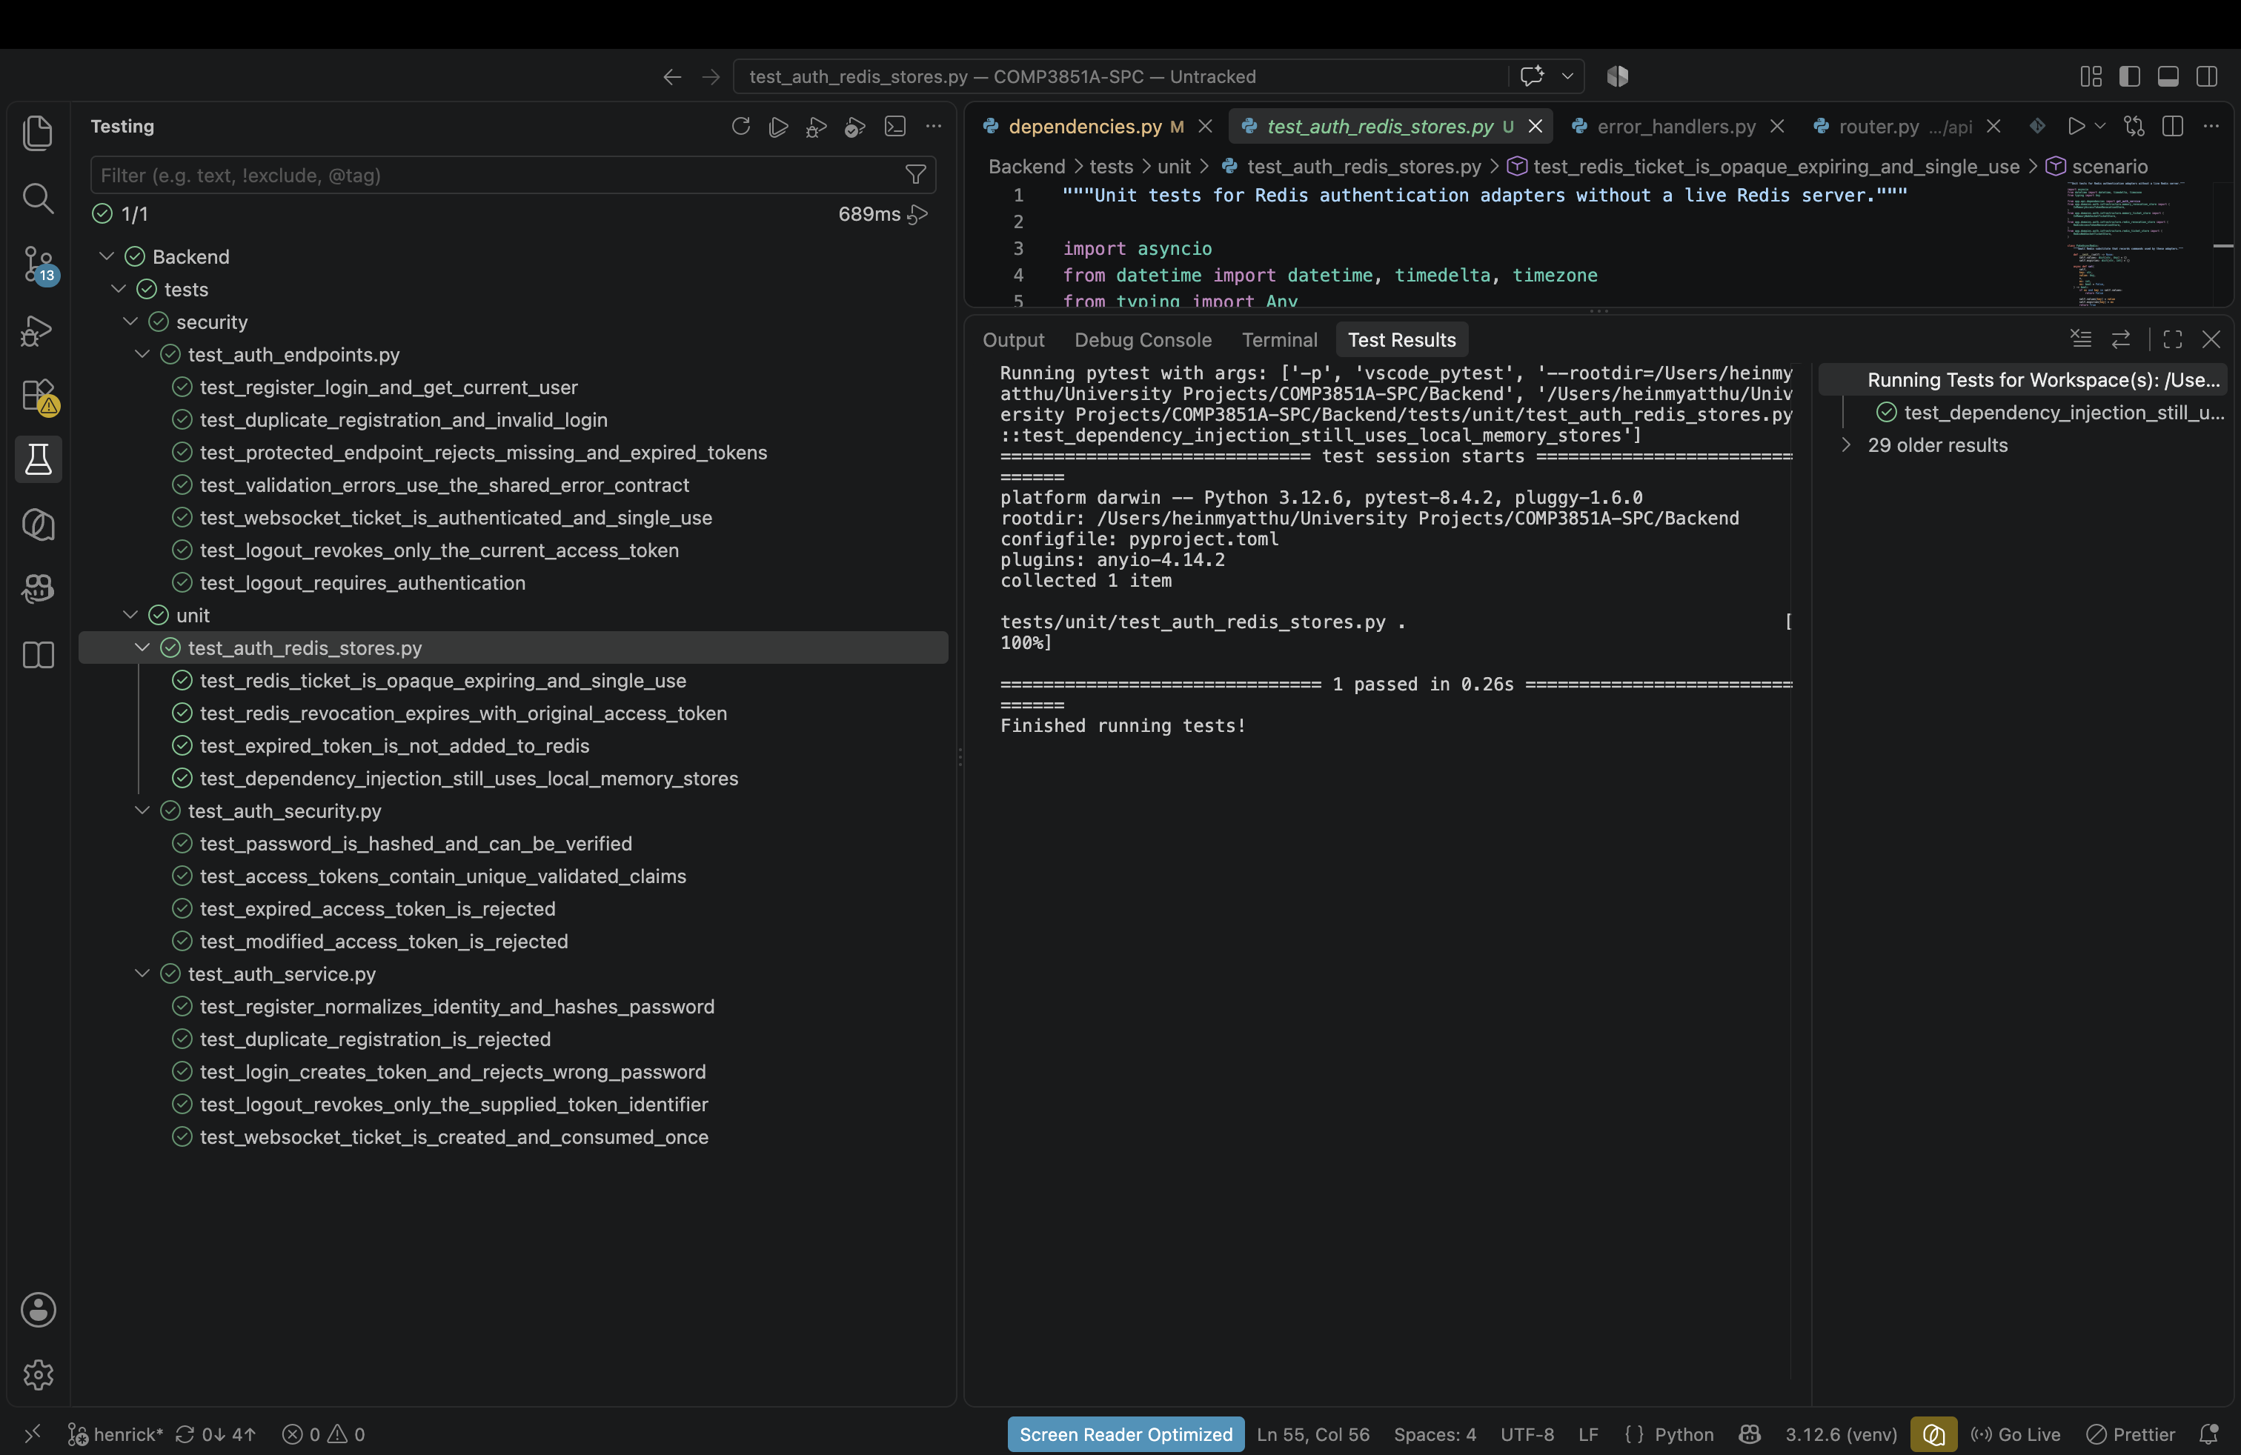
Figure 1 VS Code test discovery and a passing Redis-store unit test
The screenshot shows pytest discovery under the security and unit folders. The visible targeted Redis-store test passed, and the complete authentication suite was separately executed from the backend directory with 20 passing tests.

Tests completed
Test level | Location | Verified behaviour | Count
Unit security | tests/unit/test_auth_security.py | Argon2 hashing and verification; unique JWT claims; expired and modified token rejection | 4
Unit service | tests/unit/test_auth_service.py | Registration normalization; duplicate rejection; login; logout revocation; one-use ticket creation | 5
Unit Redis adapters | tests/unit/test_auth_redis_stores.py | Opaque expiring tickets; atomic one-use consumption; revocation expiry; local DI remains active | 4
API security and contract | tests/security/test_auth_endpoints.py | Register, login, current user, validation envelope, protected endpoints, ticket authorization, and logout | 7

Why in-memory adapters are used now
The authentication service depends on repository, ticket-store, and revocation-store contracts. During local development, dependency injection supplies in-memory implementations. This isolates application behaviour from unfinished database work and lets API routes be tested deterministically without PostgreSQL or Redis running.
- Each test receives isolated users and tickets, preventing test data from leaking between cases.
- Password hashing, JWT validation, authorization failures, and response schemas can be checked now.
- The test suite runs quickly and produces repeatable results for ongoing development.

Known limits of the local evidence
- In-memory users, tickets, and revocations disappear when the backend process restarts.
- Multiple backend processes would not share in-memory authentication state.
- Database constraints, transactions, connection failures, and migration correctness are not covered.
- The Redis adapters are unit tested with a controlled substitute; a live Redis integration test is still required.
- The actual chat WebSocket endpoint and AI event delivery are outside the completed authentication scope.

How to reproduce the tests

VS Code
1. Open the COMP3851A-SPC repository folder in VS Code.
2. Install the Microsoft Python extension if it is not already available.
3. Select the backend interpreter. On macOS use Backend/venv/bin/python; on Windows use Backend\venv\Scripts\python.exe.
4. Open the Testing view from the activity bar and press Refresh Tests.
5. Expand Backend, then tests, and run all tests or select one security or unit file.
6. Confirm that every selected test shows a green result. Open Test Results to investigate failures.

Terminal on macOS
cd "/path/to/COMP3851A-SPC/Backend"
python3 -m venv venv
source venv/bin/activate
python -m pip install -r requirements.txt
python -m pytest -q tests/unit tests/security

PowerShell on Windows
cd "C:\path\to\COMP3851A-SPC\Backend"
py -m venv venv
.\venv\Scripts\Activate.ps1
python -m pip install -r requirements.txt
python -m pytest -q tests/unit tests/security
If PowerShell blocks the activation script, the interpreter can be called directly: .\venv\Scripts\python.exe -m pytest -q tests/unit tests/security. Run commands from the Backend directory so Python can resolve the app package.

Next testing after database integration
After the database developer implements PostgreSQLAuthRepository and supplies the schema migrations, the next step is integration testing. The same behavioural expectations should be retained while dependency injection is overridden to use a dedicated PostgreSQL test database. The test database must be separate from local, staging, and production data.
Integration area | Required checks | Exit evidence
PostgreSQL authentication | Create and retrieve users; normalized-email uniqueness; password hash persistence; role and active-state mapping | Integration suite passes against a disposable test database
Database reliability | Rollback between tests; duplicate requests; failed transaction handling; migration up and clean initialization | No shared state or order-dependent test failures
Live Redis authentication | Ticket TTL; atomic single-use consumption; logout revocation shared between two service instances; expiry cleanup | Tests pass against the Compose Redis service
Frontend API contract | Request fields, bearer header, response shapes, validation errors, logout behaviour, and unauthorized redirects | Frontend services pass contract and component integration tests

End-to-end and staging testing
End-to-end testing starts only after the real frontend services, FastAPI endpoints, PostgreSQL persistence, note-processing boundary, and AI response path are connected. The immediate demonstration path is intentionally narrow.
1. Register a student and confirm that duplicate registration is rejected.
2. Log in and load the profile; reject missing or expired authentication.
3. Upload a supported note and confirm that only its owner can view it.
4. Ask a personal-chat question grounded in the student's uploaded notes.
5. Confirm that another account cannot access the student's notes, chat, or answer events.
6. Log out and confirm that the revoked token cannot call protected endpoints.

Hetzner staging acceptance
- Deploy only after local unit, security, and service-integration tests pass.
- Verify HTTPS, Nginx API routing, request identifiers, CORS policy, and WebSocket upgrade routing when chat begins.
- Run migrations before application smoke tests and confirm secrets are supplied through staging environment variables.
- Use test accounts and non-sensitive sample notes for demonstrations and staging checks.

Recommended testing-plan entries
Activity | Owner contribution | Timing
Authentication unit tests | Backend architect maintains security helpers, services, and adapter tests | Implemented; rerun on every auth change
Authentication API security tests | Backend architect maintains endpoint, validation, authorization, and logout cases | Implemented; rerun before integration
PostgreSQL integration tests | Backend architect and database developer connect the repository to a disposable test database | After PostgreSQLAuthRepository is implemented
Redis integration tests | Backend architect validates auth stores; Redis owner provides the live client and service | Before multi-process staging
Frontend contract and end-to-end tests | Frontend, backend, and testing-plan owners validate the agreed user workflow | After real services are connected
Staging smoke and security tests | Team validates Nginx, HTTPS, deployment configuration, permissions, and isolation | Before the live demonstration

Result recording checklist
- Record the date, branch or commit, environment, command, number passed, number failed, and any warning.
- Attach a screenshot or CI link for milestone runs, while keeping credentials and private data out of evidence.
- For every failure, record the affected requirement, defect owner, correction, and successful retest.
- Do not classify an in-memory unit or API test as PostgreSQL, Redis, end-to-end, or staging evidence.

