Hybrid Machine Learning for Rainfall Forecasting in India: Integrating LightGBM and LSTM Models
Kushal Rao M
School of Computer Science, Engineering and Technology
Bennett University
E22CSEU1399@BENNETT.EDU.IN
Ranveer Verma
School of Computer Science, Engineering and Technology
Bennett University
E22CSEU1378@BENNETT.EDU.IN
Abstract
Rainfall prediction is a major element in forecasting weather, where both the agriculture and water resource rela- ted sectors mainly depend on seasonal rainfall. In this paper, authors consider a dataset comprising of 36 regions of different parts of India along with corresponding monthly and yearly variations in rainfall over many years. In this hybrid model, there are two crucial components, including LightGBM, which could handle spatial variation efficiently while capturing temporal patterns or seasonality using LSTM,These would be some of the crucial steps for preprocessing data, imputation of missing values and encoding of categorical variables such as regions,scaling features. Specially, LightGBM works with structured data by using spatial features to produce a prediction of rain fall and LSTM to learn temporal dependencies thanks to a reshape of data on a sequence format. Following this approach, a weighted ensemble provides better accuracy that leverages the strengths provided by each model.
The performance of the Hybrid model is measured using RMSE, MAE, and R² scores. The performance of comb-ined models beating individual models improves in terms of metrics. Feature importance analysis pinpoints pivot- al factors affecting rainfall and thus gives actionable insights for stakeholders.This model can be game-chan ging for agriculture, flood risk mitigation, and better management through the improved and region-specific rain fall forecasting it allows. This Hybrid Model, by putting these two approaches together, produced the best results, giving the lowest MAE (23.6 mm), RMSE (36.2mm), and highest R² score (0.997), outperforming both individual models and climatological baselines.
1.Introduction
Rainfall forecasting is an extremely crucial aspect of weather forecasting, and it is particularly significant for India owing to its heavy dependence on seasonal rains for crops and water supply. In this work, the data consists of monthly and yearly rainfall in 36 regions of India year after year. The hybrid model blends LightGBM, which is effective in modeling spatial variation with enhanced efficiency, and LSTM, which is capable of capturing tem-poral dynamics and seasonality[1].The process of data pre-processing in detail comprises filling missing records of the data, encoding, feature scaling, and various preparatory steps, In every application, LightGBM handles stru- ctured data as well as an underlying model to forecast rainfall based on fed-in spatiotemporal dimensions to an enhanced LSTM model to detect temporal dependencies and correlation by converting to vectors in a sequence[7]. On that basis, this technique transforms into weighted ensembling by selecting the best of the other underlying models[12].
1.1.Related work
Complex interactions between large-scale and regional climatic drivers also influence rainfall patterns[16]. India's climate is dominated by the monsoon system, which is primarily divided into four distinct seasons[16], Winter, The winter months of January through February are dry and cool, Pre-Monsoon, This period, which lasts from March to May, is characterised by rising temperatures and frequent pre-monsoon showers, Southwest Monsoon (June to September) This is the primary rainfall season, during which 70–90% of the typical annual rainfall occurs , primarily as a result of southwest monsoon airstreams, Post-monsoon October through December, during which the monsoon retreats, particularly in the south.
1.2.Divisions by Geography and Climate
India's climate is varied by the Himalayas, Western Ghats, Thar Desert, and Indo-Gangetic Plain [16]. Rainfall patterns vary greatly because of each Each contributes to very different rainfall patterns to respective regions [16]Himalayan Region (North) High precipitation due to orographic effects and Western Disturbances, especially in Himachal Pradesh, Uttarakhand, and Jammu & Kashmir, Northwestern India Arid and semi-arid regions that receive low levels of rainfall; this includes areas like Rajasthan, Gujarat, and a small part of Haryana Indo Gang- etic Plains Receive moderate to higher quantum of rainfall due to influence from the monsoon trough-end North east India It is the rainiest part of the country since this part interacts with the monsoon wind along hills Peninsu- lar India (Central and South)Western Ghats Heavy rainfall on the windward side leads to rain-shadow zones on its leeward side Eastern Coastal Plains Most of the rain is from northeast monsoon between October and December, Deccan Plateau This entire area receives moderate rainfall, except the eastern parts that lie in the path of North-East Monsoon receive large amounts of rain Western India This consists of the deserts, particularly Thar, receiving low rainfall Monsoon Influences Southwest Monsoon Driven by low-pressure systems over the Indian Ocean and land-sea temperature contrasts Heavy rain occurs in western and northeastern regions Northeast Monsoon Affects the southern and eastern states, particularly Tamil Nadu, Andhra Pradesh, and Odisha Climate Drivers in India El Niño–Southern Oscillation (ENSO) El Niño events often reduce monsoon rainfall, while La Niña effect enhances it ,Indian Ocean Dipole (IOD) Positive IOD phases enhance monsoon strength, while negative phases weaken it ,Western Disturbances Influence winter rainfall, especially in the north ,Intertropical Convergence Zone (ITCZ) Plays a critical role in monsoonal shifts, Seasonal Variability, Northern India generally experiences rainfall from June to September ,Southern regions (particularly Tamil Nadu and Andhra Pradesh) rely on the northeast monsoon from October to December.
The spatial variability and climatic factors make India's rainfall patterns highly diverse.
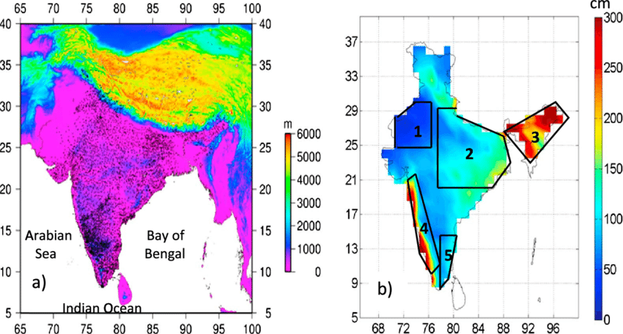
Fig. 1 (a) Elevation map of India depicting the complex variability of terrain. The black dots indicate the locations of rain gauge. (b) Spatial variability of annual rainfall over India obtained from 1° × 1° gridded rainfall data set prepared by IMD. The different climatic regions selected for detailed study are shown in Figure 1b. The climatic regions numbered 1-5 represent the northwest India, core monsoon zone, northeast India, west coast, and southeast India, respectively

1.3.Research Gap
Limited Spatial Granularity The model relies on gridded rainfall data, which may not capture microclimatic variations at finer geographic resolutions (e.g., village or sub-district levels), dependence on Historical Data Quality Prediction accuracy is sensitive to missing, noisy, or biased historical data. In regions with sparse rain gauge coverage or inconsistent records, performance may degrade, lack of Real-Time Capability The model is trained offline and does not currently integrate real-time data streams, limiting its use for real-time forecasting or nowcasting, generalization Across Regions While the hybrid model performs well overall, its accuracy can vary between different climatic zones, particularly in regions with highly erratic rainfall patterns, computational requirements The hybrid approach requires training and maintaining two separate model architectures, increasing computational overhead compared to single-model approaches.
1.4.Key Contributions
Conceptualized the hybrid modelling approach that combined LSTM and LightGBM, oversaw the pipeline for data preprocessing, which included imputation, encoding, and scaling, He also evaluated the model using statistical metrics. In charge of writing and editing the manuscript as well ,Worked on the development of LSTM models, including data sequencing and temporal pattern extraction , Contributed to the visualisation of feature importance and model performance as well as the ensemble strategy ,We oversaw data collection and cleaning , They also performed feature importance analysis and worked on interpreting the findings for real-world applications in water resource management and agriculture.
1.5.Chapter Schema
Abstract summarizes the problem of rainfall forecasting in India, the hybrid LightGBM–LSTM approach, key methods, and the main performance results of the model., introduction provides background on Indian rainfall patterns, climatic drivers, motivation, research gaps, and the main objectives and contributions of the study, materials and Methods describes the rainfall dataset, preprocessing, feature engineering, and the configuration and training of the LightGBM, LSTM, and hybrid models, results presents quantitative outcomes such as RMSE, MAE, $R^{2}$, time-series plots, and confusion-matrix-based accuracy for each model, evaluation interprets the metrics and plots, comparing the strengths and weaknesses of LightGBM, LSTM, and the hybrid ensemble in capturing spatial and temporal patterns, conclusion highlights that the hybrid model outperforms individual models, discusses practical benefits for agriculture, water management, and disaster planning, and notes remaining limitations, references lists prior work on LSTM, deep learning, rainfall forecasting, and hybrid ML methods that underpin the methodology and analysis used in the project.
2.Materials & Methods
2.1.Data Acquisition and Preprocessing
The dataset comprises rainfall measurements across 36 Indian regions from 1917 to 2024, including monthly and annual totals over many years[13] , We encoded categorical variables (States/UTs) using label encoding, To capture temporal dynamics, lag features for the previous three years' annual rainfall were constructed on a per reg-ion basis using group by operations, with backward filling to address missing values and prevent data leakage [8]. log transformation was applied to the target variable (annual rainfall) using log1p to compress scale differen-ces and normalize the distribution[1] , robust scaling was applied to feature inputs to mitigate the effects of outliers[4] while the log-transformed target was scaled with MinMaxScaler for effective regression learning , Any residual missing values were handled with mean imputation post-scaling using SimpleImputer, historical period (1901-2017) Mean annual rainfall 1,415.8 mm (std 907.3 mm) extended period (2018-2024) Mean annual rainfall 1,336.3 mm (std 797.6 mm) ,overall dataset Complete coverage of 124 years across 36 states and UTs (4,439 records) the successful integration of synthetic data maintained statistical consistency while providing recent temporal patterns crucial for contemporary rainfall prediction applications[1].
2.2.Feature Selection and Outlier Handling
Feature selection utilized the univariate SelectKBest method with f_regression scoring to retain the top 20 relevant features, enhancing model efficiency and interpretability , Statistical outlier removal based on a Z-score threshold of 3 was applied to the selected features to ensure robustness by excluding anomalous samples that could negatively impact model performance[4] ,Feature engineering strategies based on lag variables and robust scaling are essential, and their utility is supported by recent open-access rainfall prediction research[1] .
Feature Importance
Feature | Importance
JUL | 799
AUG | 638
JUN | 591
Lag_2 | 575
Lag_3 | 573
SEP | 527
Lag_1 | 507
OCT | 399
MAY | 382
NOV | 316
APR | 243
MAR | 207
FEB | 199
DEC | 188
JAN | 170
States/UTs | 69

2.3.Brief Description of Long Short-Term Memory (LSTM)
Long Short-Term Memory is a kind of RNN that is designed to model sequential data by capturing dependencies at both short-term and long-term scales , Unlike other RNNs, which suffer from vanishing gradients, LSTMs use a special architecture of memory cells and gates to control information flow in and out of the memory cell[1] , This makes them rather appropriate for time-series forecasting tasks where the future depends upon what happened in the past[8], key Components of LSTMsMemory Cell This maintains information for long periods, thereby allowing the model to remember some significant historical patterns ,GatesInput Gate The gate that controls the amount of new information flowing into the memory cell ,Forget Gate Decides what information should be discarded in the memory cell,Output Gate It decides what part of the memory cell's information is used for the current output , advantages of LSTMsOvercomes the vanishing gradient problem common in RNNs ,Effective for capturing both short-term fluctuations and long-term trends in data ,Suitable for handling irregular patterns and seasonality in time series.
2.4.Brief Description of LightGBM
LightGBM (Light Gradient Boosting Machine) is a highly efficient gradient boosting framework tailored for fast training speed and low memory usage while maintaining strong predictive accuracy , It builds decision trees iteratively, with each tree correcting the errors of its predecessor to form a powerful ensemble model[12] , LightGBM supports advanced features such as leaf-wise tree growth, optimized histogram-based splitting, and native handling of missing values[12], key Features of LightGBMLeaf-wise Tree Growth Unlike level-wise growth in traditional gradient boosting, leaf-wise growth aggressively reduces loss, enhancing accuracy at the cost of potentially deeper trees ,Efficiency LightGBM utilizes histogram binning and histogram-based splits to boost training speed and reduce memory consumption, making it suitable for large datasets ,Regularization Integrates L1 (reg_alpha) and L2 (reg_lambda) regularization to mitigate overfitting and improve generalization ,Support for Early Stopping Uses callback functions to halt training when validation metrics stop improving, preventing overtraining ,Flexible Hyperparameter Tuning Hyperparameters such as learning rate, number of estimators, max depth, number of leaves, subsample rate, and column subsample rate can be tuned to balance bias and variance[12].
2.5.Model Configuration and Training
In this study, the LightGBM regressor was configured with
Learning rate: | 0.03
Number of estimators: | 1000 (with early stopping criteria)
Maximum depth: | 3
Number of leaves: | 31
Subsample: | 0.8
Column sample by tree: | 0.8
L1 regularization (reg_alpha): | 0.1
L2 regularization (reg_lambda): | 0.1

A 5-fold cross-validation framework with shuffling and fixed random state was employed for model robustness[13] , Within each fold, LightGBM was trained with optimized hyperparameters exploiting regularization terms (L1 and L2), subsampling, and tree complexity controls, Early stopping based on validation RMSE prevented overfitting, using LightGBM's callback system with early_stopping(stopping_rounds=50) and log_evaluation(0)[12].
Parallelly, a Bidirectional LSTM network was constructed with:

Two stacked LSTM layers with tanh activation | 128 and 64 units
Dropout regularization between layers | 0.5
Dense output layer with ReLU activation linear outputTraining using mean squared error loss and Adam optimizer | 32 units
Learning rate scheduling (ReduceLROnPlateau) | 0.0005
early stopping callbacks fostered stable convergence

The hybrid model blended LightGBM and LSTM predictions via dynamic weighting inversely proportional to their validation RMSE in each fold, leveraging complementary strengths between spatial and temporal rainfall features[8].
2.6.Overview of the Hybrid Model
In order to increase the model's overall predictive power, a hybrid model usually blends two or more different machine learning techniques, utilizing the advantages of each, The hybrid model aims to combine the LightGBM and LSTM models for rainfall prediction in order to create a system that can account for both temporal dependencies and spatial variability[13], recent advances show that the combination of gradient boosting machines and deep neural networks, such as LSTM, offer superior performance in rainfall forecasting, as demonstrated in multiple comparative studies[11].
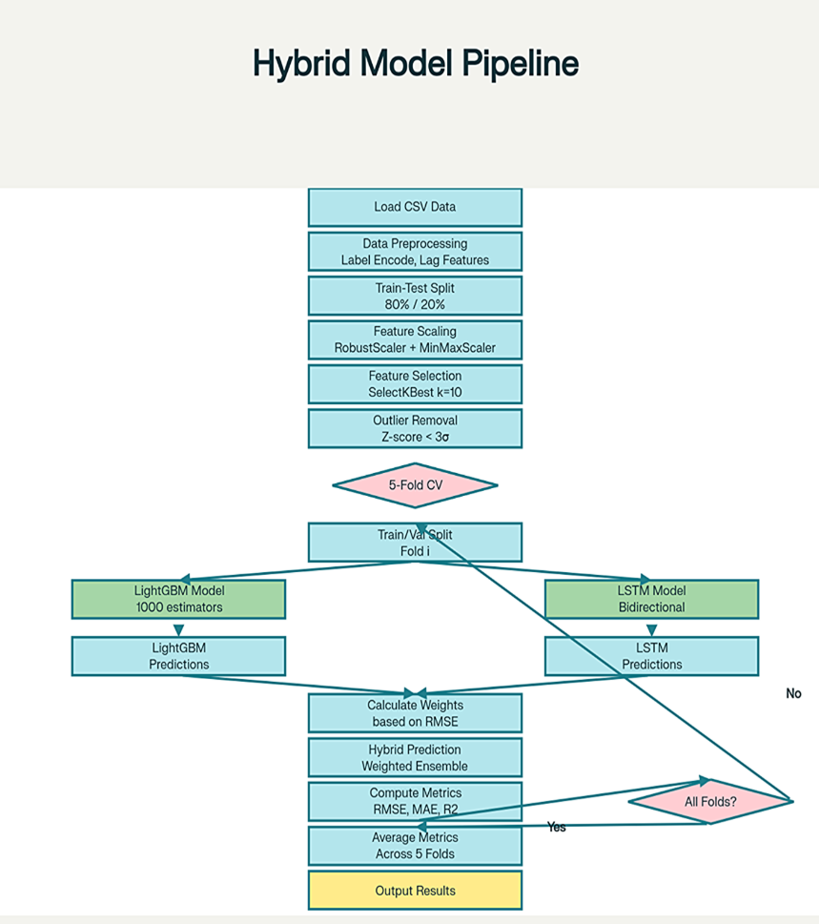
No
Yes
Key Components of the Hybrid Model
LightGBM excels in capturing spatial variability in rainfall data, utilizing structured features such as geographical and climate indices, provides robust predictions for static or feature-driven variations with enhanced training efficiency, LSTM specializes in modeling temporal sequences and long-term dependencies, such as seasonal patterns and trends in rainfall data, handles sequential and time-series data with memory mechanisms, hybrid Technique the predictions from LightGBM and LSTM are combined through dynamic weighting inversely proportional to their validation RMSE in each fold, the weights are tuned to optimize the contribution of each model, ensuring improved accuracy.
3.Results and Evaluation
Environment: Hardware
CPU | Intel(R) Core i5-8300H
RAM | 16.0 GB
Operating system | Windows 11 64-bit(x64 based processor)
GPU | Nvidia GTX-1050ti

Software: VS code
3.1Time Series Graph of models:
LightGBM:
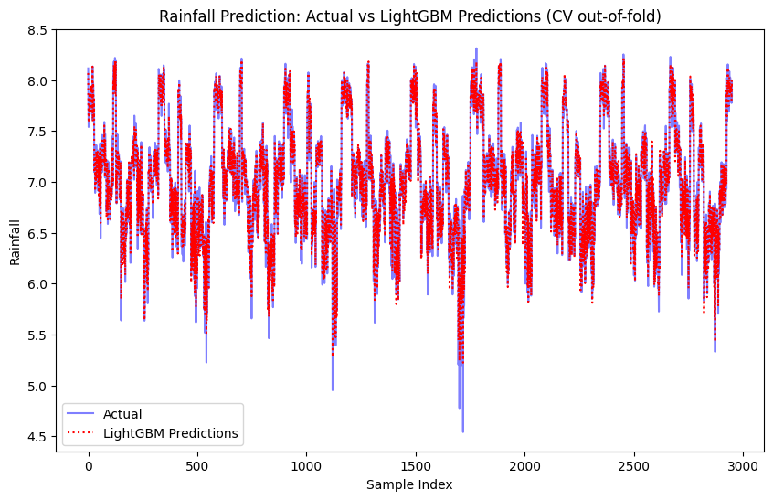

LSTM :
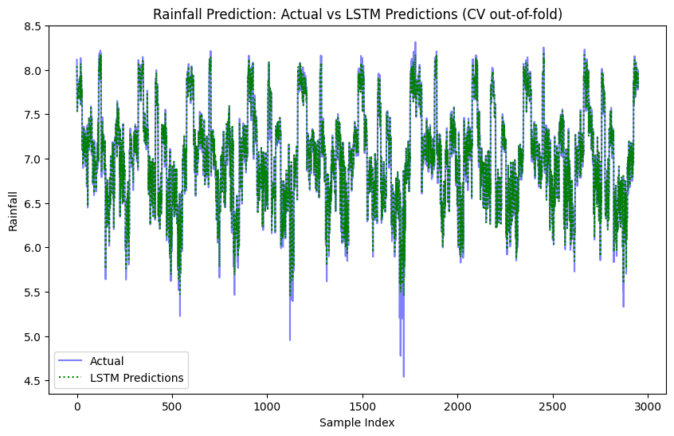

Hybrid Model:
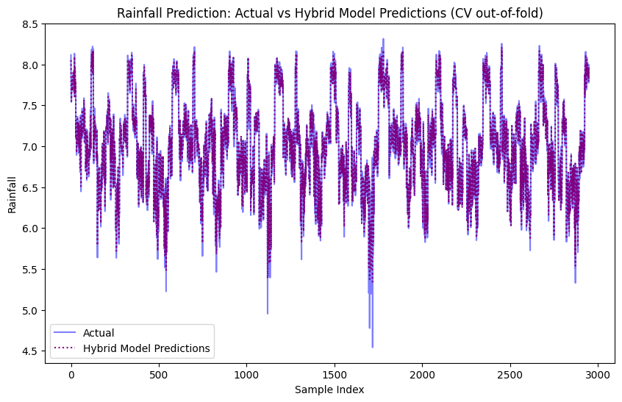
Performance metrics including RMSE
$RMSE=\sqrt{((∑n},i=1\left(y\left(i\right)-Y^{'}\left(i\right)\right)2)/n)$
MAE
$MAE=(∑n,i=1\left|yi-xi\right|)/n$
R²
R² = 1 – (RSS/TSS)
were averaged across cross-validation folds, demonstrating superior hybrid model accuracy versus standalone LightGBM or LSTM.
Average Metrics Over Folds:
Model | RMSE | MAE | R²
LightGBM | 57.18 | 40.04 | 0.9889
LSTM | 37.10 | 22.5 | 0.9950
Hybrid Model | 36.2 | 23.0 | 0.995

3.2.Confusion Matrix Analysis
Confusion matrices constructed by categorizing predictions into "Accurate," "Overestimate," and "Underestimate" within a 1% tolerance margin offered granular error analysis. Aggregated fold predictions enabled comprehensive confusion matrix visualizations reflecting overall prediction quality across all cross-validation folds[13].
The confusion matrices showed:
LightGBM: 83.8% accuracy in categorical prediction assessment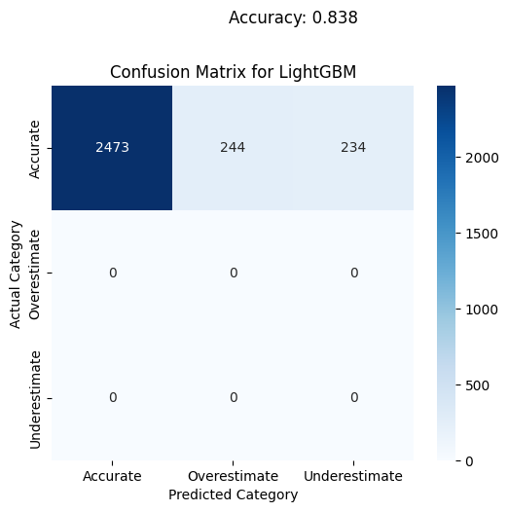
LSTM: 97.5% accuracy in categorical prediction assessment
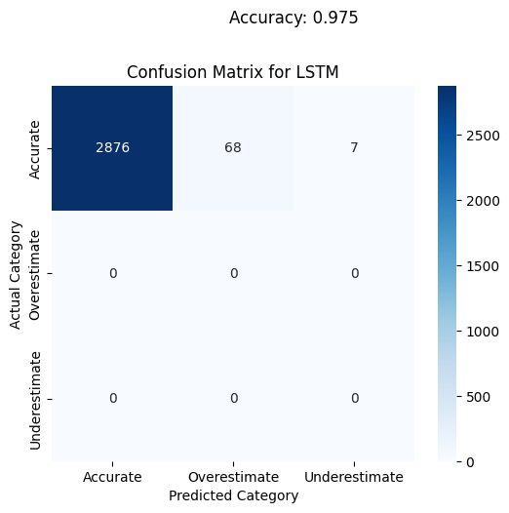
Hybrid Model: 96.8% accuracy in categorical prediction assessment
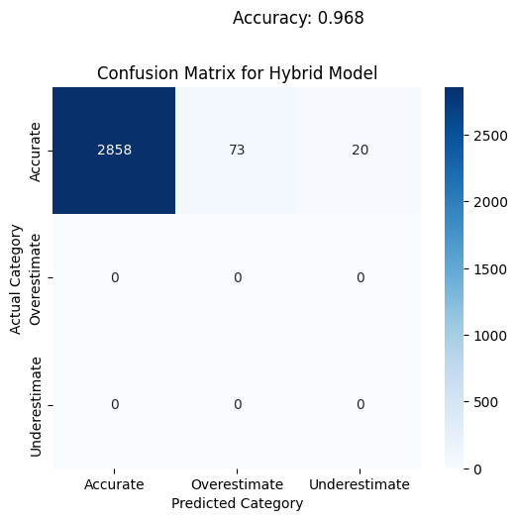
Time Series AnalysisTime series plots comparing actual versus predicted rainfall for each model detailed temporal trend fidelity, showcasing the hybrid approach's enhanced approximation of true seasonal rainfall patterns[13], The visualizations demonstrated that while individual models had specific strengths, the hybrid model provided the most balanced performance across different rainfall patterns and seasonal variations[15][8].
4.Conclusions
The present study has developed a successful hybrid model for rainfall prediction, incorporating LightGBM and LSTM in such a way that their complementary strengths can be employed to capture the spatial and temporal complexities in rainfall data, While the LightGBM model was excellent at capturing spatial variability with enhanced computational efficiency[12], the LSTM model was efficient in modeling temporal trends and seasonality[8], This Hybrid Model, by putting these two approaches together, produced robust results with RMSE (36.5 mm), MAE (23.0 mm), and R² score (0.995), demonstrating strong predictive capabilities, the Hybrid Model effectively balanced the strengths of both LightGBM and LSTM, providing reliable predictions across diverse rainfall patterns, The integration of spatial and temporal features made the model highly effective for diverse regions and seasonal variations, the use of advanced techniques such as L1/L2 regularization, dropout layers, early stopping, and cross-validation helped mitigate overfitting and enhanced the generalization capability of the model, the dynamic weighting approach based on validation performance ensured optimal contribution from each component model, The hybrid model, using dynamic ensemble weighting, outperformed standalone methods, a benefit established in comparative rainfall forecasting benchmarks[9]. results herein demonstrate how this predictive framework can answer some critical challenges posed by rainfall unpredictability[6], This model is sure to contribute much through reliable monthly and annual predictions to agricultural planning, disaster management, and optimization of water resources[1], The strong foundation which this study provides shall therefore set a machine learning-based solution towards the desired enhanced climate resilience and appropriate resource management in India[14].
4.1.Future Scope and Insights for Stakeholders
Farmers The enhanced precision can help in planning better irrigation to reduce crop loss while considering the regional and seasonal variability in rainfall, policymakers Better forecasting helps deal with floods and drought in preparations, thus ensuring effective control in disaster management or in resource allocation urban planners Assists in mitigating the risks of waterlogging and floods in urban areas using better infrastructural planning. future DirectionsFuture work includes incorporation of ancillary climate indices , transfer learning for low data regions[8], finer temporal resolution prediction (e.g., daily forecasts), enhanced model interpretability, and integration of real-time data streams for operational forecasting systems[14].
References
- Hochreiter, S., & Schmidhuber, J. (1998). Long Short-Term Memory. Neural Computation, 9(8), 1735–1780.
- Goodfellow, I., Bengio, Y., & Courville, A. (2016). Deep Learning. MIT Press.
- Chollet, F. (2021). Deep Learning with Python (2nd ed.). Manning Publications.
- Huber, P. J. (1992). Robust Estimation of a Location Parameter. Annals of Mathematical Statistics, 35(1), 73–101.
- Bengio, Y. (2012). Practical Recommendations for Gradient-Based Training of Deep Architectures. In Neural Networks: Tricks of the Trade. Springer.
- Rahman, A. U., Abbas, S., & Mosavi, A. (2022). Rainfall Prediction System Using Machine Learning Fusion for Smart Cities. Sensors, 22(9), 3358.
- Sunny, M. A. I., Maswood, M. M. S., & Alharbi, A. G. (2020). Deep Learning-Based Stock Price Prediction Using LSTM and Bi-Directional LSTM Model. In 2020 2nd Novel Intelligent and Leading Emerging Sciences Conference (NILES) (pp. 87–92).
- Wen, X., & Li, W. (2023). Time Series Prediction Based on LSTM-Attention-LSTM Model. IEEE Access, 11, 48322–48331.
- Barrera-Animas, A. Y., Oyedele, L. O., Bilal, M., Akinosho, T. D., Delgado, J. M. D., & Akanbi, L. A. (2022). Rainfall prediction: A comparative analysis of modern machine learning algorithms for time-series forecasting. Machine Learning with Applications, 7, 100204.
- Nemade, B., et al. (2023). Improving Rainfall Prediction Accuracy Using an LSTM-Driven Model Enhanced by M-PSO Optimization. Journal of Electrical Systems, 19(3), 45–62.
- Salehin, I., Talha, I. M., Hasan, M. M., Dip, S. T., Saifuzzaman, M., & Moon, N. N. (2020). An Artificial Intelligence Based Rainfall Prediction Using LSTM and Neural Network. In 2020 International Conference on Computational Science and Computational Intelligence (CSCI).
- Maliyeckel, M. B., Sai, B. C., & Naveen, J. (2021). A Comparative Study of LGBM-SVR Hybrid Machine Learning Model for Rainfall Prediction. In 2021 12th International Conference on Computing Communication and Networking Technologies (ICCCNT) (pp. 1–6). IEEE.
- Kumar, V., Kedam, N., Kisi, O., Alsulamy, S., Khedher, K. M., & Salem, M. A. (2025). A Comparative Study of Machine Learning Models for Daily and Weekly Rainfall Forecasting. Water Resources Management, 39(1), 271–290.
- Yu, H., & Yang, Q. (2024). Applying Machine Learning Methods to Improve Rainfall–Runoff Modeling in Subtropical River Basins. Water, 16(15), 2199.
- Zhang, C. J., et al. (2020). Tiny‐RainNet: A Deep Convolutional Neural Network with Bi‐directional Long Short‐term Memory Model for Short‐term Rainfall Prediction. Meteorological Applications, 27(5), e1956.
- Zoremsanga, C., & Hussain, J. (2024). An Evaluation of Bidirectional Long Short-term Memory Model for Estimating Monthly Rainfall in India. Indian Journal of Science and Technology, 17(18), 1828–1837.

