1. Build a responsive web application for shopping cart with registration, login, catalog and cart pages using CSS3 features, flex and grid.

Program:
cart.html
<!DOCTYPE html>
<html lang="en">
<head>
<meta charset="UTF-8">
<meta name="viewport" content="width=device-width, initial-scale=1.0">
<title>Cart</title>
<link rel="stylesheet" href="style.css">
</head>
<body>
<h1 class="page-title">Your Cart</h1>
<div class="cart-container">
<div class="cart-item">
<span>Product 1</span>
<span>$10.00</span>
</div>
<div class="cart-item">
<span>Product 3</span>
<span>$20.00</span>
</div>
<div class="cart-item">
<span>Product 4</span>
<span>$8.00</span>
</div>
</div>
<a href="catalog.html" class="cart-link">Back to Catalog</a>
</body>
</html>
catalog.html
<!DOCTYPE html>
<html lang="en">
<head>
<meta charset="UTF-8">
<meta name="viewport" content="width=device-width, initial-scale=1.0">
<title>Catalog</title>
<link rel="stylesheet" href="style.css">
</head>
<body>
<h1 class="page-title">Product Catalog</h1>
<div class="products-grid">
<div class="product-card">
<h3>Product 1</h3>
<p>Description: High-quality item for daily use.</p>
<p>Price: $10.00</p>
<button>Add to Cart</button>
</div>
<div class="product-card">
<h3>Product 2</h3>
<p>Description: Durable and affordable.</p>
<p>Price: $15.00</p>
<button>Add to Cart</button>
</div>
</div>
<a href="cart.html" class="cart-link">Go to Cart</a>
</body>
</html>
index.html
<!DOCTYPE html>
<html lang="en">
<head>
<meta charset="UTF-8">
<meta name="viewport" content="width=device-width, initial-scale=1.0">
<title>Catalog</title>
<link rel="stylesheet" href="style.css">
</head>
<body>
<h1 class="page-title">Product Catalog</h1>
<div class="products-grid">
<div class="product-card">
<h3>Product 1</h3>
<p>Description: High-quality item for daily use.</p>
<p>Price: $10.00</p>
<button>Add to Cart</button>
</div>
<div class="product-card">
<h3>Product 2</h3>
<p>Description: Durable and affordable.</p>
<p>Price: $15.00</p>
<button>Add to Cart</button>
</div>
</div>
<a href="cart.html" class="cart-link">Go to Cart</a>
</body>
</html>

register.html
<!DOCTYPE html>
<html lang="en">
<head>
<meta charset="UTF-8">
<meta name="viewport" content="width=device-width, initial-scale=1.0">
<title>Catalog</title>
<link rel="stylesheet" href="style.css">
</head>
<body>
<h1 class="page-title">Product Catalog</h1>
<div class="products-grid">
<div class="product-card">
<h3>Product 1</h3>
<p>Description: High-quality item for daily use.</p>
<p>Price: $10.00</p>
<button>Add to Cart</button>
</div>
<div class="product-card">
<h3>Product 2</h3>
<p>Description: Durable and affordable.</p>
<p>Price: $15.00</p>
<button>Add to Cart</button>
</div>
</div>
<a href="cart.html" class="cart-link">Go to Cart</a>
</body>
</html>
style.css
/* ---------- Global Styles ---------- */
body {
font-family: Arial, sans-serif;
margin: 0;
padding: 0;
background: #fff;
color: #000;
}
h1, h2, h3 {
margin: 0 0 10px 0;
}
a {
color: #000;
text-decoration: none;
}

.container {
display: flex;
justify-content: center;
align-items: center;
min-height: 100vh;
}
.form-box {
background: #f2f2f2;
padding: 20px;
border-radius: 8px;
width: 90%;
max-width: 400px;
display: flex;
flex-direction: column;
}
.form-box input {
margin: 8px 0;
padding: 10px;
border-radius: 4px;
border: 1px solid #000;
}
.form-box button {
padding: 10px;
background: #000;
color: #fff;
border: none;
border-radius: 4px;
cursor: pointer;
margin-top: 10px;
}
.form-box p {
text-align: center;
margin-top: 10px;
}
.page-title {
text-align: center;
margin: 20px 0;
}
.products-grid {
display: grid;
grid-template-columns: repeat(auto-fit, minmax(180px, 1fr));
gap: 15px;
padding: 0 15px 30px 15px;
}

.product-card {
background: #f2f2f2;
padding: 15px;
border-radius: 6px;
display: flex;
flex-direction: column;
}
.product-card h3 {
margin-bottom: 5px;
}
.product-card p {
margin-bottom: 8px;
}
.product-card button {
padding: 8px;
background: #000;
color: #fff;
border: none;
border-radius: 4px;
cursor: pointer;
margin-top: auto;
}
.cart-container {
max-width: 600px;
margin: 20px auto;
padding: 0 15px;
}

.cart-item {
display: flex;
justify-content: space-between;
background: #f2f2f2;
padding: 10px 15px;
margin-bottom: 10px;
border-radius: 6px;
}
.cart-link {
display: inline-block;
margin: 20px auto;
padding: 10px 15px;
background: #000;
color: #fff;
text-decoration: none;
border-radius: 4px;
text-align: center;
}
@media (max-width: 500px) {
.products-grid {
grid-template-columns: repeat(auto-fit, minmax(150px, 1fr));
}
.cart-item {
flex-direction: column;
gap: 5px;
align-items: flex-start;
}
}

Output:
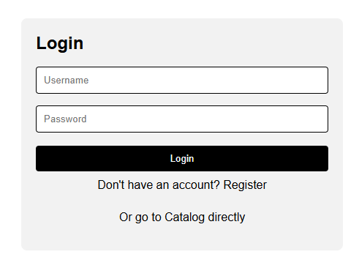
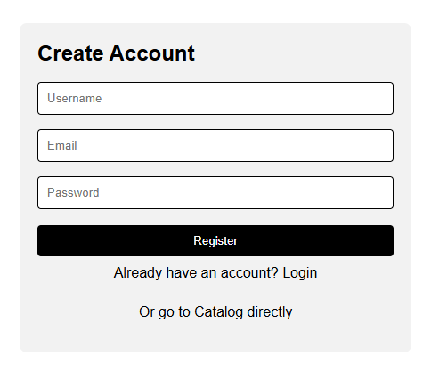



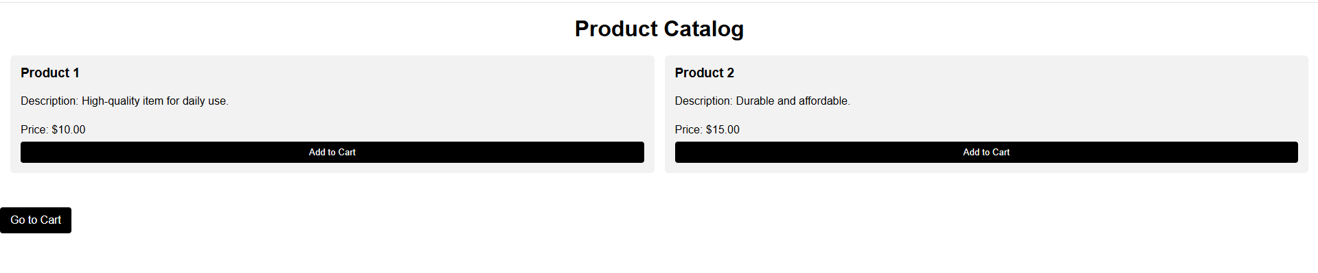

2. Make the above web application responsive web application using Bootstrap framework.

Program:
cart.html
<!DOCTYPE html>
<html lang="en">
<head>
<meta charset="UTF-8">
<meta name="viewport" content="width=device-width, initial-scale=1.0">
<title>Cart</title>
<link href="https://cdn.jsdelivr.net/npm/bootstrap@5.3.0-alpha1/dist/css/bootstrap.min.css" rel="stylesheet">
</head>
<body class="bg-light">
<div class="container mt-5">
<h1 class="text-center mb-4">Your Cart</h1>
<div class="list-group">
<div class="list-group-item d-flex justify-content-between align-items-center">
Product 1
<span>$10.00</span>
</div>
<div class="list-group-item d-flex justify-content-between align-items-center">
Product 3
<span>$20.00</span>
</div>
<div class="list-group-item d-flex justify-content-between align-items-center">
Product 4
<span>$8.00</span>
</div>
</div>
<div class="text-center mt-4">
<a href="catalog.html" class="btn btn-dark">Back to Catalog</a>
</div>
</div>
<script src="https://cdn.jsdelivr.net/npm/bootstrap@5.3.0-alpha1/dist/js/bootstrap.bundle.min.js"></script>
</body>
</html>

catalog.html
<!DOCTYPE html>
<html lang="en">
<head>
<meta charset="UTF-8">
<meta name="viewport" content="width=device-width, initial-scale=1.0">
<title>Catalog</title>
<link href="https://cdn.jsdelivr.net/npm/bootstrap@5.3.0-alpha1/dist/css/bootstrap.min.css" rel="stylesheet">
</head>
<body class="bg-light">
<div class="container mt-5">
<h1 class="text-center mb-4">Product Catalog</h1>
<div class="row row-cols-1 row-cols-md-2 row-cols-lg-3 g-4">
<div class="col">
<div class="card shadow-sm">
<div class="card-body">
<h5 class="card-title">Product 1</h5>
<p class="card-text">Description: High-quality item for daily use.</p>
<p class="card-text">Price: $10.00</p>
<button class="btn btn-dark w-100">Add to Cart</button>
</div>
</div>
</div>
<div class="col">
<div class="card shadow-sm">
<div class="card-body">
<h5 class="card-title">Product 2</h5>
<p class="card-text">Description: Durable and affordable.</p>
<p class="card-text">Price: $15.00</p>
<button class="btn btn-dark w-100">Add to Cart</button>
</div>
</div>
</div>
<div class="col">
<div class="card shadow-sm">
<div class="card-body">
<h5 class="card-title">Product 3</h5>
<p class="card-text">Description: Best seller product with premium quality.</p>
<p class="card-text">Price: $20.00</p>
<button class="btn btn-dark w-100">Add to Cart</button>
</div>
</div>
</div>
</div>
<div class="text-center mt-4">
<a href="cart.html" class="btn btn-dark">Go to Cart</a>
</div>
</div>
<script src="https://cdn.jsdelivr.net/npm/bootstrap@5.3.0-alpha1/dist/js/bootstrap.bundle.min.js"></script>
</body>
</html>
index.html
<!DOCTYPE html>
<html lang="en">
<head>
<meta charset="UTF-8">
<meta name="viewport" content="width=device-width, initial-scale=1.0">
<title>Login</title>
<link href="https://cdn.jsdelivr.net/npm/bootstrap@5.3.0-alpha1/dist/css/bootstrap.min.css" rel="stylesheet">
</head>
<body class="bg-light">
<div class="container d-flex justify-content-center align-items-center min-vh-100">
<div class="card p-4 w-100" style="max-width: 400px;">
<h2 class="text-center mb-3">Login</h2>
<form>
<input type="text" class="form-control mb-3" placeholder="Username">
<input type="password" class="form-control mb-3" placeholder="Password">
<button class="btn btn-dark w-100 mb-3">Login</button>
</form>
<p class="text-center"><a href="register.html">Register</a> | <a href="catalog.html">Catalog</a></p>
</div>
</div>
<script src="https://cdn.jsdelivr.net/npm/bootstrap@5.3.0-alpha1/dist/js/bootstrap.bundle.min.js"></script>
</body>
</html>

register.html
<!DOCTYPE html>
<html lang="en">
<head>
<meta charset="UTF-8">
<meta name="viewport" content="width=device-width, initial-scale=1.0">
<title>Register</title>
<link href="https://cdn.jsdelivr.net/npm/bootstrap@5.3.0-alpha1/dist/css/bootstrap.min.css" rel="stylesheet">
</head>
<body class="bg-light">
<div class="container d-flex justify-content-center align-items-center min-vh-100">
<div class="card p-4 w-100" style="max-width: 400px;">
<h2 class="text-center mb-3">Create Account</h2>
<form>
<input type="text" class="form-control mb-3" placeholder="Username">
<input type="email" class="form-control mb-3" placeholder="Email">
<input type="password" class="form-control mb-3" placeholder="Password">
<button class="btn btn-dark w-100 mb-3">Register</button>
</form>
<p class="text-center"><a href="index.html">Login</a> | <a href="catalog.html">Catalog</a></p>
</div>
</div>
<script src="https://cdn.jsdelivr.net/npm/bootstrap@5.3.0-alpha1/dist/js/bootstrap.bundle.min.js"></script>
</body>
</html>
Output:
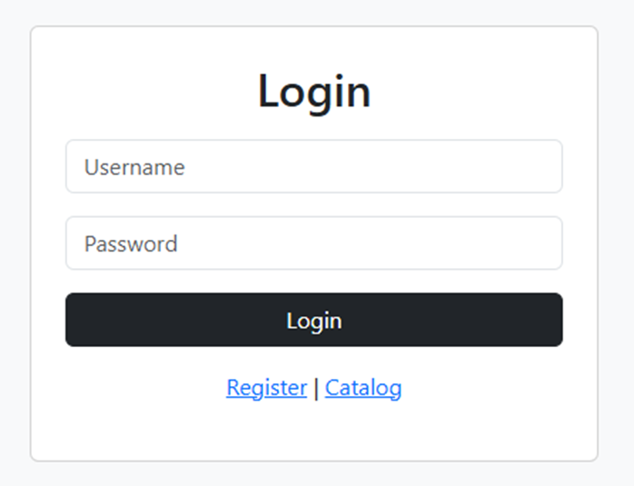
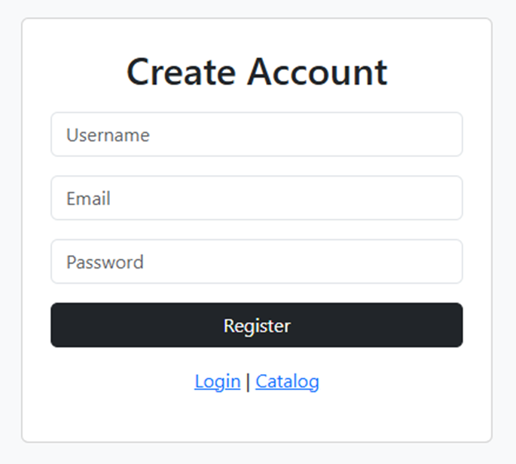

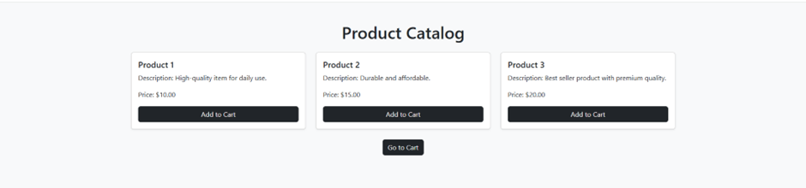

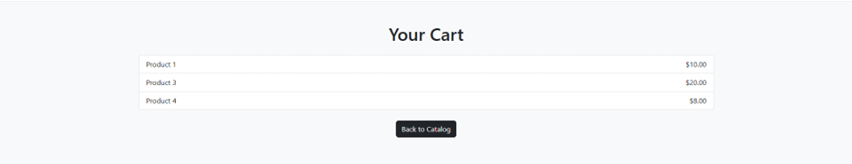

3. Use JavaScript for doing client – side validation of the pages implemented in experiment 1 and experiment 2.

Program:
index.html
<!DOCTYPE html>
<html lang="en">
<head>
<meta charset="UTF-8" />
<meta name="viewport" content="width=device-width, initial-scale=1.0" />
<title>Shopping Cart App</title>
<style>
* { box-sizing: border-box; font-family: Arial, sans-serif; }
body { margin: 0; background: #f4f4f4; }
/* Layout */
.container { max-width: 1100px; margin: auto; padding: 1rem; }
header { background: #222; color: #fff; padding: 1rem; display: flex; justify-content: space-between; }
header button { background: #fff; border: none; padding: 0.4rem 0.7rem; cursor: pointer; }
/* Forms */
form { max-width: 400px; margin: 2rem auto; background: #fff; padding: 1.5rem; border-radius: 5px; }
input { width: 100%; padding: 0.6rem; margin: 0.5rem 0; }
.error { color: red; font-size: 0.85rem; }
/* Catalog */
.grid { display: grid; grid-template-columns: repeat(auto-fit, minmax(200px, 1fr)); gap: 1rem; }
.card { background: #fff; padding: 1rem; border-radius: 5px; display: flex; flex-direction: column; }
.card button { margin-top: auto; }
/* Cart */
.cart { background: #fff; padding: 1rem; margin-top: 1rem; }
.cart-item { display: flex; justify-content: space-between; }
/* Utility */
.hidden { display: none; }
button { padding: 0.5rem; cursor: pointer; }
</style>
</head>
<body>
<header>
<div>My Shop</div>
<button onclick="logout()">Logout</button>
</header>

<!-- Registration -->
<form id="registerForm">
<h3>Register</h3>
<input id="rUser" placeholder="Username" />
<input id="rPass" type="password" placeholder="Password" />
<div class="error" id="rErr"></div>
<button type="submit">Register</button>
</form>
<!-- Login -->
<form id="loginForm" class="hidden">
<h3>Login</h3>
<input id="lUser" placeholder="Username" />
<input id="lPass" type="password" placeholder="Password" />
<div class="error" id="lErr"></div>
<button type="submit">Login</button>
</form>
<!-- Catalog -->
<div id="shop" class="container hidden">
<h2>Catalog</h2>
<div class="grid" id="products"></div>
<div class="cart">
<h3>Cart</h3>
<div id="cart"></div>
</div>
</div>
<script>
const products = [
{ id: 1, name: "Phone", price: 500 },
{ id: 2, name: "Laptop", price: 1000 },
{ id: 3, name: "Headphones", price: 150 }
];
let cart = [];
// Registration
registerForm.onsubmit = e => {
e.preventDefault();
if (!rUser.value || !rPass.value) {
rErr.textContent = "All fields required";
return;
}
localStorage.setItem("user", rUser.value);
localStorage.setItem("pass", rPass.value);
registerForm.classList.add("hidden");
loginForm.classList.remove("hidden");
};

// Login
loginForm.onsubmit = e => {
e.preventDefault();
if (lUser.value !== localStorage.getItem("user") || lPass.value !== localStorage.getItem("pass")) {
lErr.textContent = "Invalid credentials";
return;
}
loginForm.classList.add("hidden");
shop.classList.remove("hidden");
loadProducts();
};

function loadProducts() {
products.forEach(p => {
productsDiv = document.createElement("div");
productsDiv.className = "card";
productsDiv.innerHTML = `<h4>${p.name}</h4><p>₹${p.price}</p><button onclick="addToCart(${p.id})">Add</button>`;
document.getElementById("products").appendChild(productsDiv);
});
}

function addToCart(id) {
cart.push(products.find(p => p.id === id));
renderCart();
}

function renderCart() {
cartDiv.innerHTML = "";
cart.forEach(c => {
cartDiv.innerHTML += `<div class='cart-item'><span>${c.name}</span><span>₹${c.price}</span></div>`;
});
}

function logout() {
location.reload();
}
</script>
</body>
</html>

Output:
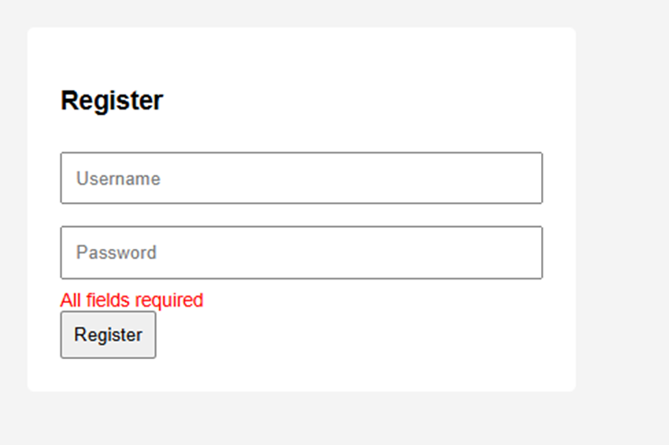
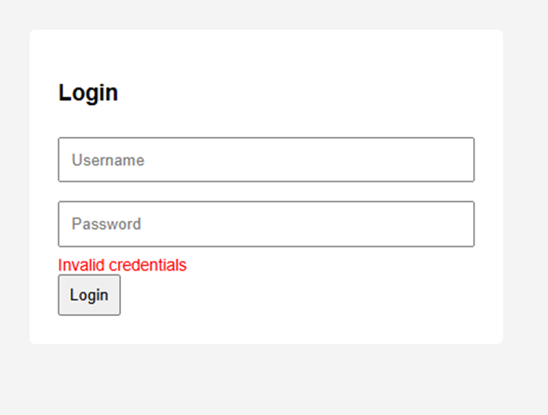
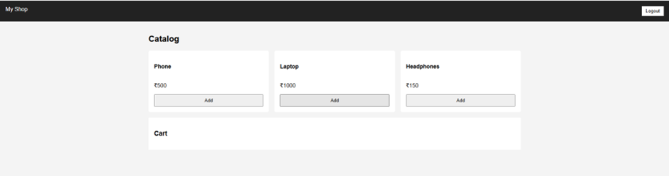
4. Explore the features of ES6 like arrow functions, callbacks, promises, async/await. Implement an application for reading the weather information from openweathermap.org and display the information in the form of a graph on the web page.

Program:
index.html
<!DOCTYPE html>
<html>
<head>
<title>Weather App</title>
<script src="https://cdn.jsdelivr.net/npm/chart.js"></script>
</head>
<body>
<h2>Weather Information</h2>
<input type="text" id="city" placeholder="Enter City">
<button onclick="getWeather()">Get Weather</button>
<canvas id="weatherChart" width="400" height="200"></canvas>
<script src="script.js"></script>
</body>
</html>
script.js
const apiKey = "YOUR_API_KEY"; // get from openweathermap.org
let chart;
const getWeather = async () => {
const city = document.getElementById("city").value;
const response = await fetch( `https://api.openweathermap.org/data/2.5/forecast?q=${city}&units=metric&appid=${apiKey}` );
const data = await response.json();
const temps = data.list.slice(0, 5).map(item => item.main.temp);
const times = data.list.slice(0, 5).map(item => item.dt_txt);
drawChart(times, temps);
};
const drawChart = (labels, data) => {
const ctx = document.getElementById("weatherChart").getContext("2d");
if (chart) chart.destroy();
chart = new Chart(ctx, {
type: "line",
data: {
labels: labels,
datasets: [{
label: "Temperature (°C)",
data: data,
borderWidth: 2 }] } });};

Output:
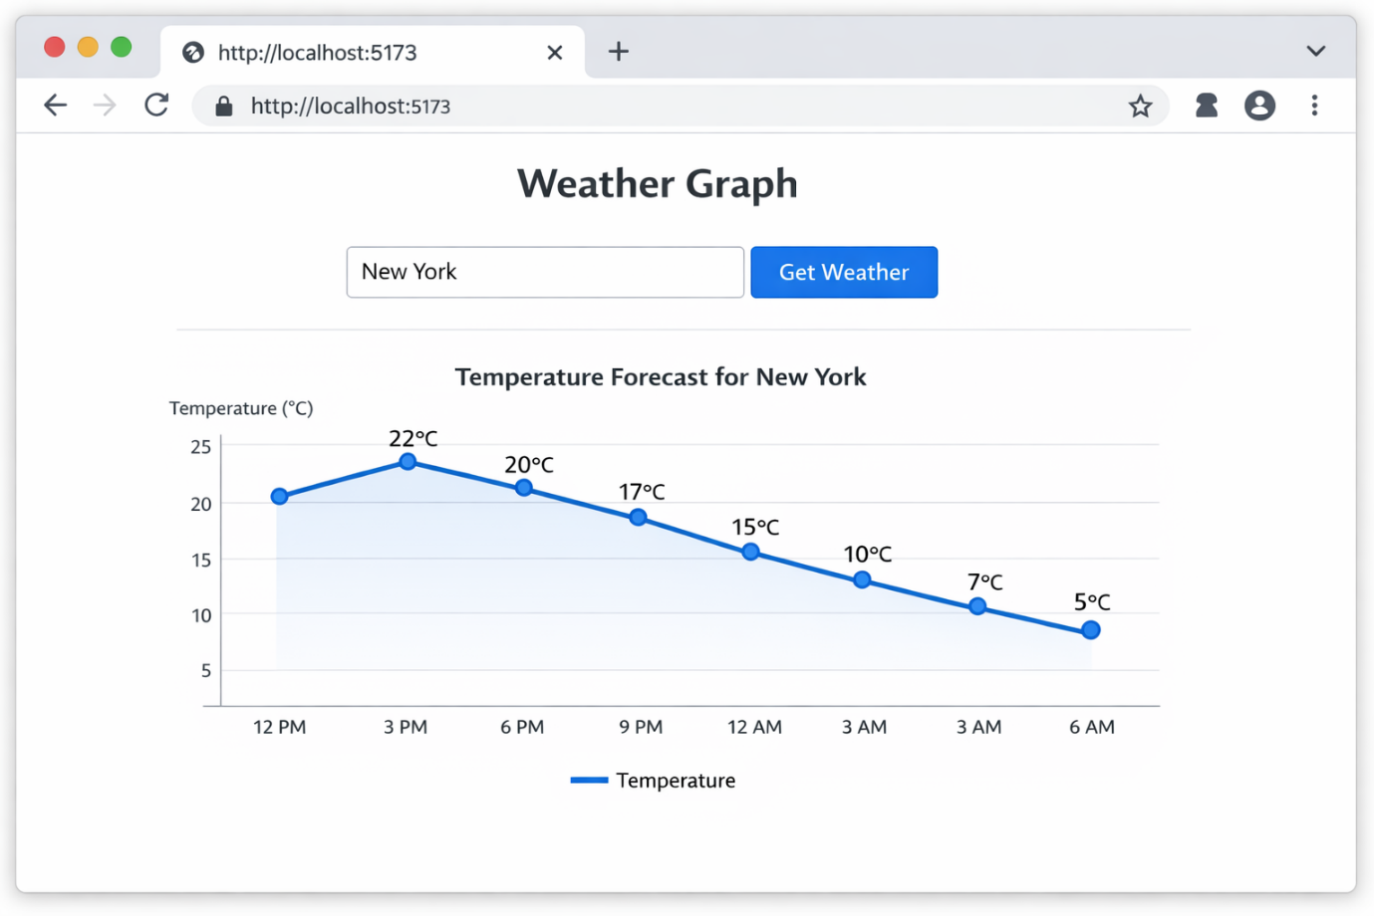

5. Develop a java standalone application that connects with the database (Oracle / mySql) and perform the CRUD operation on the database tables.

Program:
DBConnection.java
package mypack;
import java.sql.Connection;
import java.sql.DriverManager;
import java.sql.SQLException;
public class DBConnection {
private static final String URL = "jdbc:oracle:thin:system/vnrvjiet@localhost:1521/XEPDB1";
public static Connection getConnection() {
try {
System.out.println(" Connecting to Oracle 21c XE...");
Connection con = DriverManager.getConnection(URL);
System.out.println(" SUCCESS - Oracle Connected!");
System.out.println("Database: " + con.getCatalog());
return con;
} catch (SQLException e) {
System.err.println("FAILED: " + e.getMessage());
return null;
}
}

public static void main(String[] args) {
System.out.println("1. STARTING ORACLE TEST");
Connection con = getConnection();
if (con != null) {
System.out.println("2. ORACLE READY FOR CRUD!");
}
System.out.println("3. TEST COMPLETE");
}
}

StudentCRUD.java
package mypack;
import java.sql.*;
import java.util.Scanner;
public class StudentCRUD {
private static final String URL = "jdbc:oracle:thin:system/vnrvjiet@localhost:1521/XEPDB1";
public static void main(String[] args) {
Scanner sc = new Scanner(System.in);
createTable();
int choice;
do {
System.out.println("\n=== STUDENT CRUD ===");
System.out.println("1. CREATE 2. READ 3. UPDATE 4. DELETE 5. Exit");
System.out.print("Choose: ");
choice = sc.nextInt();
sc.nextLine(); // Clear buffer

switch (choice) {
case 1 -> createStudent(sc);
case 2 -> readStudents();
case 3 -> updateStudent(sc);
case 4 -> deleteStudent(sc);
case 5 -> System.out.println("Bye!");
default -> System.out.println("Invalid!");
}
} while (choice != 5);
sc.close();
}
public static void createTable() {
try (Connection con = DriverManager.getConnection(URL)) {
String sql = """
CREATE TABLE students (
id NUMBER GENERATED BY DEFAULT AS IDENTITY PRIMARY KEY,
name VARCHAR2(100),
age NUMBER,
course VARCHAR2(100)
)
""";
con.createStatement().execute(sql);
System.out.println("Table ready!");
} catch (SQLException e) {
System.out.println("Table exists OK");
}
}
public static void createStudent(Scanner sc) {
try (Connection con = DriverManager.getConnection(URL)) {
System.out.print("Name: ");
String name = sc.nextLine();
System.out.print("Age: ");
int age = Integer.parseInt(sc.nextLine());
System.out.print("Course: ");
String course = sc.nextLine();
String sql = "INSERT INTO students (name, age, course) VALUES (?, ?, ?)";
PreparedStatement ps = con.prepareStatement(sql);
ps.setString(1, name); ps.setInt(2, age); ps.setString(3, course);
ps.executeUpdate();
System.out.println("Added!");
} catch (Exception e) {
e.printStackTrace();
}
}
public static void readStudents() {
try (Connection con = DriverManager.getConnection(URL)) {
ResultSet rs = con.createStatement().executeQuery("SELECT * FROM students");
System.out.printf("%-5s %-15s %-5s %-15s%n", "ID", "NAME", "AGE", "COURSE");
System.out.println("----------------------------------------");
while (rs.next()) {
System.out.printf("%-5d %-15s %-5d %-15s%n",
rs.getInt("id"), rs.getString("name"), rs.getInt("age"), rs.getString("course"));
}
} catch (SQLException e) {
e.printStackTrace();
}
}
public static void updateStudent(Scanner sc) {
try (Connection con = DriverManager.getConnection(URL)) {
System.out.print("ID: ");
int id = Integer.parseInt(sc.nextLine());
System.out.print("New name: ");
String name = sc.nextLine();
PreparedStatement ps = con.prepareStatement("UPDATE students SET name = ? WHERE id = ?");
ps.setString(1, name); ps.setInt(2, id);
if (ps.executeUpdate() > 0) System.out.println("Updated!");
else System.out.println(“ Not found");
} catch (Exception e) {
e.printStackTrace();
}
}

public static void deleteStudent(Scanner sc) {
try (Connection con = DriverManager.getConnection(URL)) {
System.out.print("ID: ");
int id = Integer.parseInt(sc.nextLine());
PreparedStatement ps = con.prepareStatement("DELETE FROM students WHERE id = ?");
ps.setInt(1, id);
if (ps.executeUpdate() > 0) System.out.println("Deleted!");
else System.out.println(" Not found");
} catch (Exception e) {
e.printStackTrace();
}
}
}

Output:
1. Output of DBConnection.java
1. STARTING ORACLE TEST
Connecting to Oracle 21c XE...
SUCCESS - Oracle Connected!
Database: null
2. ORACLE READY FOR CRUD!
3. TEST COMPLETE

Output of StudentCRUD.java
First Run (Table Creation)
Table ready!

=== STUDENT CRUD ===
1. CREATE 2. READ 3. UPDATE 4. DELETE 5. Exit
Choose:

3. CREATE Operation (Insert Record)
Choose: 1
Name: Rajesh
Age: 21
Course: CSE
Added!

4. READ Operation (Display Records)
Choose: 2
ID NAME AGE COURSE
----------------------------------------
1 Rajesh 21 CSE

5. UPDATE Operation
Choose: 3
ID: 1
New name: Ramesh
Updated!
After Update (Read Again)
Choose: 2
ID NAME AGE COURSE
----------------------------------------
1 Ramesh 21 CSE

6. DELETE Operation
Choose: 4
ID: 1
Deleted!
After Delete (Read Again)
Choose: 2
ID NAME AGE COURSE
----------------------------------------

7. Exit Program
Choose: 5
Bye!

6. Create an xml for the bookstore. Validate the same using both DTD and XSD.

Program:
bookstore.dtd
<!ELEMENT bookstore (book+)>
<!-- Allow namespace attributes so DTD doesn't complain -->
<!ATTLIST bookstore
xmlns:xsi CDATA #IMPLIED
xsi:noNamespaceSchemaLocation CDATA #IMPLIED>
<!ELEMENT book (title, author, year, price)>
<!ATTLIST book category CDATA #REQUIRED>
<!ELEMENT title (#PCDATA)>
<!ELEMENT author (#PCDATA)>
<!ELEMENT year (#PCDATA)>
<!ELEMENT price (#PCDATA)>

bookstore.xml
<?xml version="1.0" encoding="UTF-8"?>
<!DOCTYPE bookstore SYSTEM "bookstore.dtd">
<bookstore xmlns:xsi="http://www.w3.org/2001/XMLSchema-instance"
xsi:noNamespaceSchemaLocation="bookstore.xsd">
<book category="programming">
<title>Java Fundamentals</title>
<author>James Gosling</author>
<year>2022</year>
<price>599.50</price>
</book>
<book category="database">
<title>Mastering MySQL</title>
<author>Michael Widenius</author>
<year>2021</year>
<price>450.00</price>
</book>
</bookstore>

bookstore.xsd
<?xml version="1.0" encoding="UTF-8"?>
<!DOCTYPE bookstore SYSTEM "bookstore.dtd">
<bookstore xmlns:xsi="http://www.w3.org/2001/XMLSchema-instance"
xsi:noNamespaceSchemaLocation="bookstore.xsd">
<book category="programming">
<title>Java Fundamentals</title>
<author>James Gosling</author>
<year>2022</year>
<price>599.50</price>
</book>
<book category="database">
<title>Mastering MySQL</title>
<author>Michael Widenius</author>
<year>2021</year>
<price>450.00</price>
</book>
</bookstore>

Output:

DTD Validation Output
DTD Validation Started...
No errors found.
XML is VALID according to DTD.

XSD Validation Output
XSD Validation Started...
Error: The document is not a valid XML Schema.
cvc-elt.1.a: Cannot find the declaration of element 'bookstore'.
Validation FAILED.

7.Design a Servlet-based controller that Connects the web application (Exercise 1) , Interacts with the database (Exercise 5)
cart.jsp
<%@ page import="java.util.*, model.CartItem" %>
<!DOCTYPE html>
<html>
<head>
<meta charset="UTF-8">
<title>Your Cart</title>
<style>
body{
margin:0;
font-family:'Segoe UI',sans-serif;
background:#f1f3f6;
}
.header{
background:#131921;
color:white;
padding:18px 40px;
display:flex;
justify-content:space-between;
align-items:center;
}
.header a{
color:white;
text-decoration:none;
margin-left:25px;
font-weight:500;
.cart-container{
width:80%;
margin:40px auto;
}
.cart-card{
background:white;
padding:25px;
border-radius:10px;
box-shadow:0 4px 12px rgba(0,0,0,0.08);
}
table{
width:100%;
border-collapse:collapse;
}
th{
text-align:left;
padding:12px;
border-bottom:2px solid #ddd;
}
td{
padding:14px 10px;
border-bottom:1px solid #eee;
}

.price{
color:#2ecc71;
font-weight:bold;
}
.btn{
padding:8px 14px;
border:none;
border-radius:6px;
cursor:pointer;
font-weight:600;
}
.remove{
background:#e74c3c;
color:white;
}
.shop{
background:#3498db;
color:white;
}
.checkout{
background:#f39c12;
color:white;
width:100%;
margin-top:20px;
padding:12px;
font-size:16px;
}
.total-box{
text-align:right;
margin-top:20px;
font-size:20px;
}
.empty{
text-align:center;
margin-top:100px;
}
.empty button{
padding:12px 20px;
font-size:16px;
}
</style>
</head>
<body>
<div class="header">
<h2>Shopping Cart</h2>

<div>
<a href="catalog.jsp">Products</a>
<a href="<%=request.getContextPath()%>/logout">Logout</a>
</div>
</div>
<%
List<CartItem> cart =
(List<CartItem>)session.getAttribute("cart");
if(cart != null && !cart.isEmpty()){
double total = 0;
%>
<div class="cart-container">
<div class="cart-card">
<table>
<tr>
<th>Product</th>
<th>Price</th>
<th>Action</th>
</tr>
<%
for(CartItem item : cart){
total += item.getPrice();
%>
<tr>
<td>
<b><%=item.getName()%></b><br>
ID: <%=item.getId()%>
</td>
<td class="price">
<%=item.getPrice()%>
</td>
<td>
<form action="remove-from-cart" method="post">
<input type="hidden" name="id"
value="<%=item.getId()%>">
<button class="btn remove">
Remove
</button>
</form>
</td>
</tr>
<% } %>
</table>
<div class="total-box">
Total: <span class="price">
<%=total%></span>
</div>
<button class="checkout">
Proceed to Checkout
</button>
</div>
</div>
<%
}else{
%>
<div class="empty">
<h1>Your Cart is Empty </h1>
<p>Add some products to see them here.</p>
<a href="catalog.jsp">
<button class="shop">
Start Shopping
</button>
</a>
</div>
<% } %>
</body>
</html>

catalog.jsp
<%@ page contentType="text/html; charset=UTF-8" %>
<!DOCTYPE html>
<html>
<head>
<meta charset="UTF-8">
<title>Product Catalog</title>
<style>
body{
margin:0;
font-family:Arial;
background:#f4f6f8;
}
.header{
display:flex;
justify-content:space-between;
align-items:center;
background:#222;
color:white;
padding:15px 30px;
}
.header a{
color:white;
text-decoration:none;
margin-left:20px;
}
.container{
display:grid;
grid-template-columns:repeat(auto-fit,minmax(250px,1fr));
gap:25px;
padding:40px;
}
.card{
background:white;
border-radius:10px;
padding:20px;
text-align:center;
box-shadow:0 4px 10px rgba(0,0,0,0.1);
}
.card h3{
margin-bottom:10px;
}

.price{
color:green;
font-size:20px;
margin-bottom:15px;
}
button{
background:#ff9800;
border:none;
padding:10px 20px;
color:white;
border-radius:5px;
cursor:pointer;
}
button:hover{
background:#e68900;
}
</style>
</head>
<body>
<div class="header">
<h2>Shopping Cart</h2>
<div>
<a href="cart.jsp">View Cart</a>
<a href="<%=request.getContextPath()%>/logout">
Logout
</a>
</div>
</div>
<div class="container">
<div class="card">
<h3>Laptop</h3>
<p class="price">₹55,000</p>
<form action="<%=request.getContextPath()%>/cart"
method="post">
<input type="hidden" name="id" value="101">
<input type="hidden" name="name" value="Laptop">
<input type="hidden" name="price" value="55000">
<button type="submit">
Add to Cart
</button>
</form>
</div>
<div class="card">
<h3>Smartphone</h3>
<p class="price">₹25,000</p>
<form action="<%=request.getContextPath()%>/cart"
method="post">
<input type="hidden" name="id" value="102">
<input type="hidden" name="name" value="Smartphone">
<input type="hidden" name="price" value="25000">
<button type="submit">
Add to Cart
</button>
</form>
</div><div class="card">
<h3>Headphones</h3>
<p class="price">₹3,000</p>
<form action="<%=request.getContextPath()%>/cart"
method="post">
<input type="hidden" name="id" value="103">
<input type="hidden" name="name" value="Headphones">
<input type="hidden" name="price" value="3000">
<button type="submit">
Add to Cart
</button>
</form>
</div>
<div class="card">
<h3>Smart Watch</h3>
<p class="price">₹5,000</p>
<form action="<%=request.getContextPath()%>/cart"
method="post">
<input type="hidden" name="id" value="104">
<input type="hidden" name="name" value="Smart Watch">
<input type="hidden" name="price" value="5000">
<button type="submit">
Add to Cart
</button>
</form>
</div>
</div>
</body>
</html>

index.jsp

<%@ page contentType="text/html; charset=UTF-8" %>

<!DOCTYPE html>
<html>
<head>
<meta charset="UTF-8">
<title>Shopping Cart</title>

<style>

body{
margin:0;
font-family:'Segoe UI',sans-serif;
}

/* NAVBAR */
.navbar{
background:#131921;
color:white;
padding:18px 40px;
display:flex;
justify-content:space-between;
align-items:center;
}

.navbar a{
color:white;
text-decoration:none;
margin-left:25px;
font-weight:500;
}

/* HERO SECTION */
.hero{
height:90vh;
background:linear-gradient(to right,#4facfe,#00f2fe);
display:flex;
justify-content:center;
align-items:center;
text-align:center;
color:white;
}

.hero h1{
font-size:52px;
margin-bottom:10px;
}

.hero p{
font-size:20px;
margin-bottom:30px;
}

/* BUTTONS */
.btn{
padding:14px 26px;
border:none;
border-radius:8px;
cursor:pointer;
font-size:16px;
margin:10px;
}

.login{
background:#f39c12;
color:white;
}

.register{
background:#2ecc71;
color:white;
}

.shop{
background:#ffffff;
color:#333;
font-weight:bold;
}
</style>
</head>
<body>
<!-- NAVBAR -->
<div class="navbar">
<h2> ShoppingCart</h2>
<div>
<a href="login.jsp">Login</a>
<a href="register.jsp">Register</a>
</div>
</div>
<!-- HERO -->
<div class="hero">
<div>
<h1>Welcome to ShoppingCart</h1>
<p>
Your one-stop destination for the best products at unbeatable prices.
</p>
<a href="products">
<button class="btn shop">
Start Shopping
</button>
</a>

<br>
<a href="login.jsp">
<button class="btn login">
Login
</button>
</a>
<a href="register.jsp">
<button class="btn register">
Register
</button>
</a>
</div>
</div>
</body>
</html>

login.jsp

<%@ page contentType="text/html; charset=UTF-8" %>
<!DOCTYPE html>
<html>
<head>
<meta charset="UTF-8">
<title>Login</title>
<link rel="stylesheet" href="style.css">
</head>

<body>

<div class="container">

<form class="form-box"
action="<%=request.getContextPath()%>/login"
method="post">

<h2>Login</h2>

<!-- ERROR BOX -->
<%
if(request.getParameter("error") != null){
%>
<div style="
background:#e74c3c;
color:white;
padding:12px;
margin-bottom:15px;
border-radius:6px;
text-align:center;
font-weight:600;">
Invalid Email or Password!
</div>
<% } %>

<!-- SUCCESS AFTER REGISTRATION -->
<%
if(request.getParameter("registered") != null){
%>
<div style="
background:#2ecc71;
color:white;
padding:12px;
margin-bottom:15px;
border-radius:6px;
text-align:center;
font-weight:600;">
Registration successful! Please login.
</div>
<% } %>

<!-- LOGOUT -->
<%
if(request.getParameter("logout") != null){
%>
<div style="
background:#3498db;
color:white;
padding:12px;
margin-bottom:15px;
border-radius:6px;
text-align:center;
font-weight:600;">
Logged out successfully!
</div>
<% } %>
<input type="email"
name="email"
placeholder="Enter Email"
required>
<input type="password"
name="password"
placeholder="Enter Password"
required>
<button type="submit">Login</button>
<p>
Don't have an account?
<a href="register.jsp">Register</a>
</p>
</form>
</div>
<!-- REAL POPUP ALERTS -->
<%
if(request.getParameter("error") != null){
%>
<script>
alert("Invalid Email or Password!");
</script>
<% } %>
<%
if(request.getParameter("registered") != null){
%>
<script>
alert("Registration Successful! Please login.");
</script>
<% } %>
<%
if(request.getParameter("logout") != null){
%>
<script>
alert("Logged out successfully!");
</script>
<% } %>
</body>
</html>

register.jsp

<%@ page contentType="text/html; charset=UTF-8" %>
<!DOCTYPE html>
<html>
<head>
<meta charset="UTF-8">
<title>Register</title>
<link rel="stylesheet" href="style.css">
</head>
<body>
<div class="container">

<form class="form-box"
action="<%=request.getContextPath()%>/register"
method="post">
<h2>Create Account</h2>
<!-- ERROR POPUP -->
<%
if(request.getParameter("error") != null){
%>
<div style="
background:#e74c3c;
color:white;
padding:12px;
margin-bottom:15px;
border-radius:6px;
text-align:center;
font-weight:600;">
Registration Failed! Email may already exist.
</div>
<% } %>

<input type="text"
name="name"
placeholder="Username"
required>
<input type="email"
name="email"
placeholder="Email"
required>
<input type="password"
name="password"
placeholder="Password"
required>
<button type="submit">Register</button>
<p>
Already have an account?
<a href="login.jsp">Login</a>
</p>
</form>
</div>
</body>
</html>

style.css
/* ---------- Global Styles ---------- */
body {
font-family: Arial, sans-serif;
margin: 0;
padding: 0;
background: #fff;
color: #000;
}

h1, h2, h3 {
margin: 0 0 10px 0;
}

a {
color: #000;
text-decoration: none;
}

/* ---------- Forms (Login/Register) ---------- */
.container {
display: flex;
justify-content: center;
align-items: center;
min-height: 100vh;
}

.form-box {
background: #f2f2f2;
padding: 20px;
border-radius: 8px;
width: 90%;
max-width: 400px;
display: flex;
flex-direction: column;
}

.form-box input {
margin: 8px 0;
padding: 10px;
border-radius: 4px;
border: 1px solid #000;
}

.form-box button {
padding: 10px;
background: #000;
color: #fff;
border: none;
border-radius: 4px;
cursor: pointer;
margin-top: 10px;
}

.form-box p {
text-align: center;
margin-top: 10px;
}

/* ---------- Catalog Page ---------- */
.page-title {
text-align: center;
margin: 20px 0;
}

.products-grid {
display: grid;
grid-template-columns: repeat(auto-fit, minmax(180px, 1fr));
gap: 15px;
padding: 0 15px 30px 15px;
}

.product-card {
background: #f2f2f2;
padding: 15px;
border-radius: 6px;
display: flex;
flex-direction: column;
}

.product-card h3 {
margin-bottom: 5px;
}

.product-card p {
margin-bottom: 8px;
}

.product-card button {
padding: 8px;
background: #000;
color: #fff;
border: none;
border-radius: 4px;
cursor: pointer;
margin-top: auto;
}

/* ---------- Cart Page ---------- */
.cart-container {
max-width: 600px;
margin: 20px auto;
padding: 0 15px;
}

.cart-item {
display: flex;
justify-content: space-between;
background: #f2f2f2;
padding: 10px 15px;
margin-bottom: 10px;
border-radius: 6px;
}

.cart-link {
display: inline-block;
margin: 20px auto;
padding: 10px 15px;
background: #000;
color: #fff;
text-decoration: none;
border-radius: 4px;
text-align: center;
}

/* ---------- Responsive ---------- */
@media (max-width: 500px) {
.products-grid {
grid-template-columns: repeat(auto-fit, minmax(150px, 1fr));
}

.cart-item {
flex-direction: column;
gap: 5px;
align-items: flex-start;
} }

Output:
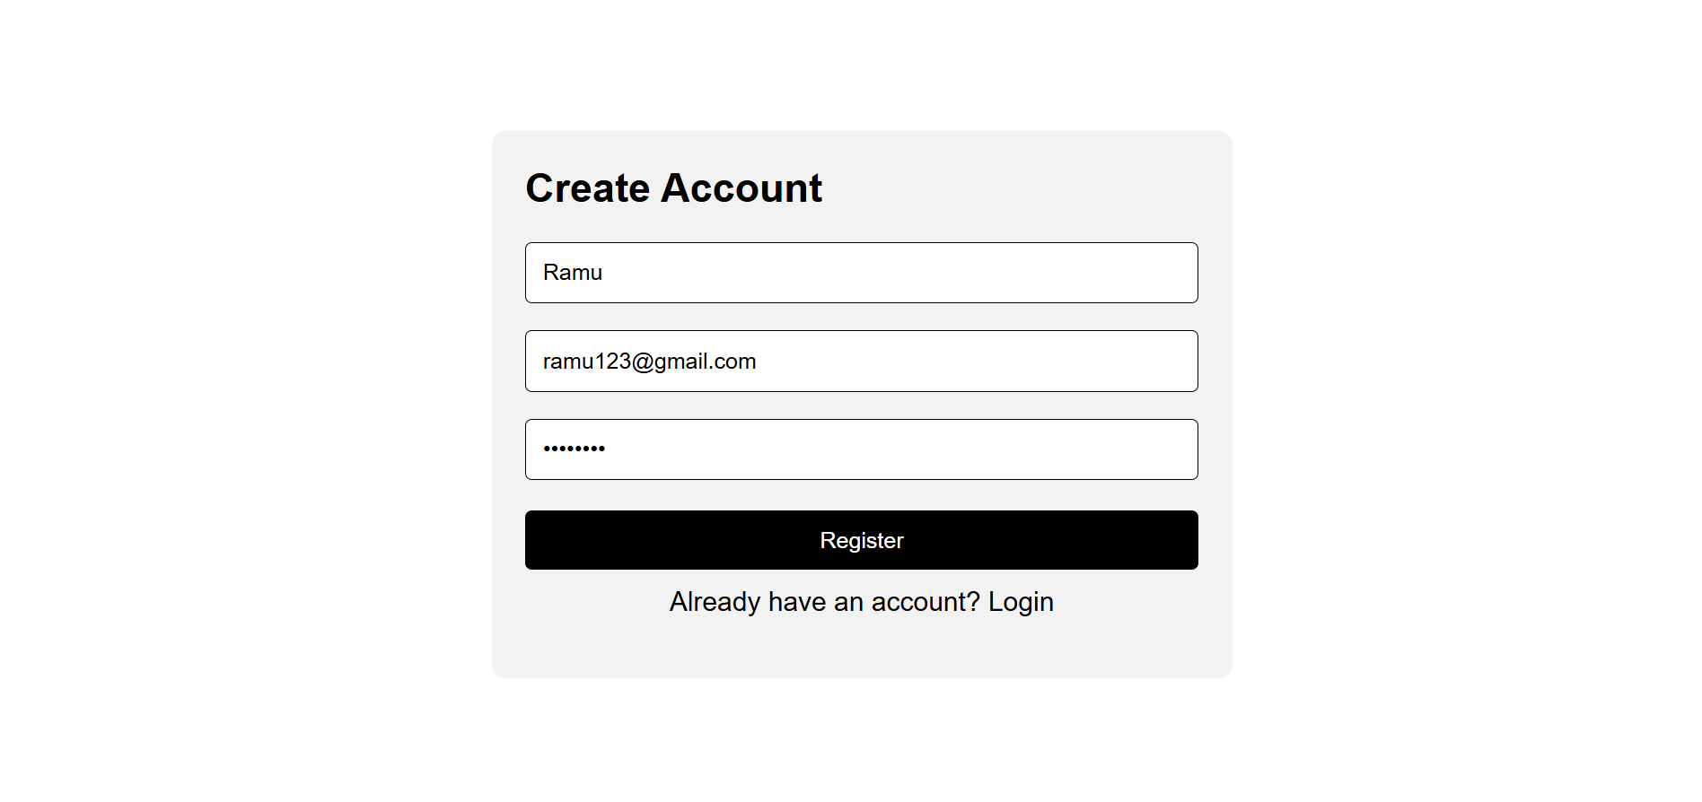
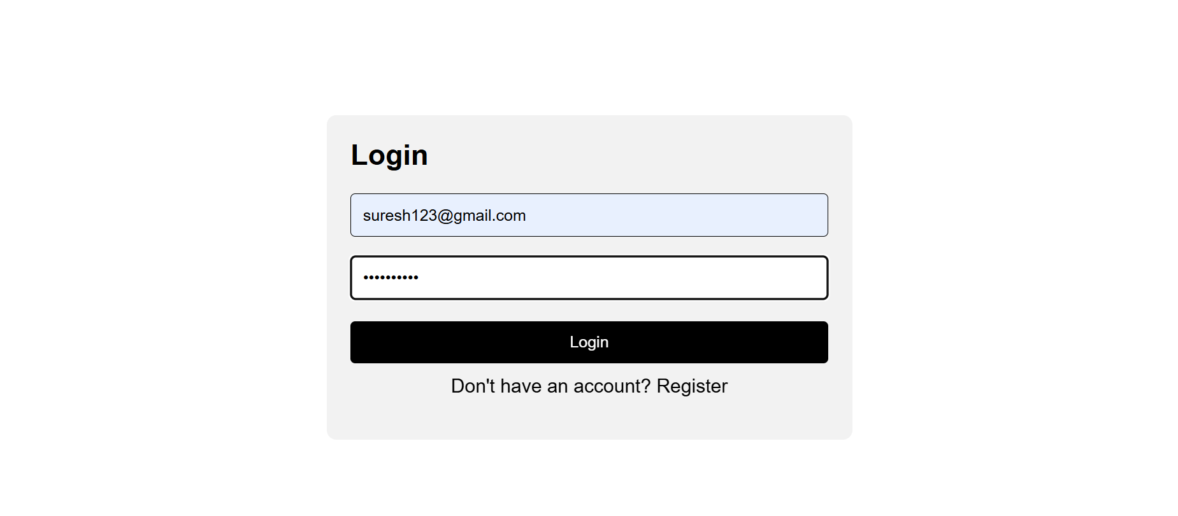
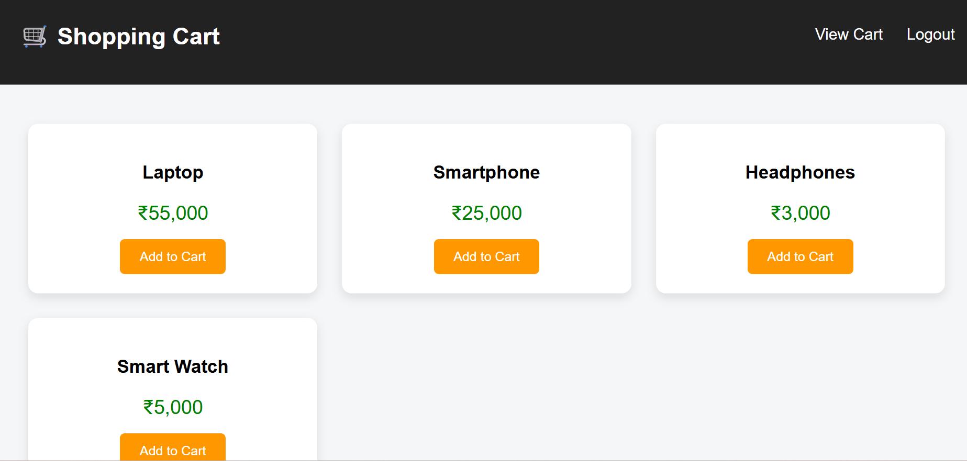

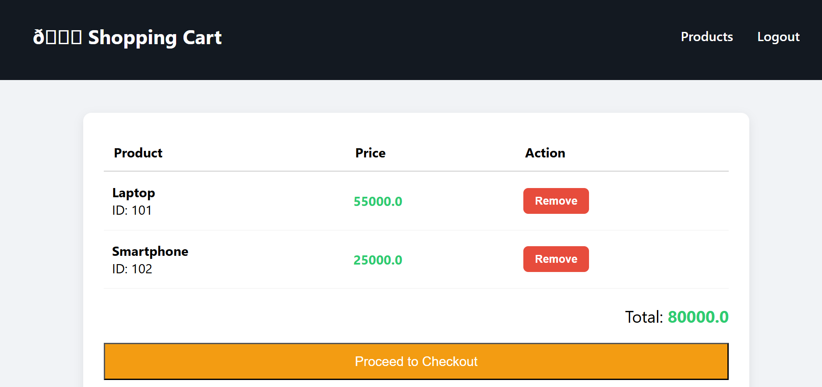
8. Maintaining the transactional history of any user is very important. Explore the various session tracking mechanism (Cookies, HTTP Session)

Program:

index.html (Login Page)
<!DOCTYPE html>
<html>
<head>
<title>Login</title>
</head>
<body>
<h2>Login Page</h2>
<form action="login" method="post">
Username: <input type="text" name="username" required><br><br>
<input type="submit" value="Login">
</form>
</body>
</html>

LoginServlet.java (Creates Session + Cookie)

package com.example;
import java.io.*;
import javax.servlet.*;
import javax.servlet.http.*;
public class LoginServlet extends HttpServlet {
protected void doPost(HttpServletRequest request, HttpServletResponse response)
throws ServletException, IOException {
String user = request.getParameter("username");
// Create HTTP Session
HttpSession session = request.getSession();
session.setAttribute("user", user);
// Create Cookie
Cookie cookie = new Cookie("username", user);
cookie.setMaxAge(60 * 60); // 1 hour
response.addCookie(cookie);
response.sendRedirect("dashboard");
}
}

DashboardServlet.java (Read Session + Cookie)

package com.example;
import java.io.*;
import javax.servlet.*;
import javax.servlet.http.*;

public class DashboardServlet extends HttpServlet {
protected void doGet(HttpServletRequest request, HttpServletResponse response)
throws ServletException, IOException {
response.setContentType("text/html");
PrintWriter out = response.getWriter();
// Get Session
HttpSession session = request.getSession(false);
String user = (String) session.getAttribute("user");
// Get Cookies
Cookie[] cookies = request.getCookies();
String cookieUser = "";
if (cookies != null) {
for (Cookie c : cookies) {
if (c.getName().equals("username")) {
cookieUser = c.getValue();
}
}
}
out.println("<h2>Welcome " + user + "</h2>");
out.println("<h3>Session User: " + user + "</h3>");
out.println("<h3>Cookie User: " + cookieUser + "</h3>");
out.println("<a href='logout'>Logout</a>");
}
}

LogoutServlet.java (Invalidate Session)

package com.example;
import java.io.*;
import javax.servlet.*;
import javax.servlet.http.*;
public class LogoutServlet extends HttpServlet {
protected void doGet(HttpServletRequest request, HttpServletResponse response)
throws ServletException, IOException {
HttpSession session = request.getSession(false);
if (session != null) {
session.invalidate();
}
response.setContentType("text/html");
PrintWriter out = response.getWriter();
out.println("<h2>You are logged out</h2>");
out.println("<a href='index.html'>Login Again</a>");
}
}

web.xml

<web-app xmlns="http://xmlns.jcp.org/xml/ns/javaee" version="3.1">
<servlet>
<servlet-name>LoginServlet</servlet-name>
<servlet-class>com.example.LoginServlet</servlet-class>
</servlet>
<servlet-mapping>
<servlet-name>LoginServlet</servlet-name>
<url-pattern>/login</url-pattern>
</servlet-mapping>
<servlet>
<servlet-name>DashboardServlet</servlet-name>
<servlet-class>com.example.DashboardServlet</servlet-class>
</servlet>
<servlet-mapping>
<servlet-name>DashboardServlet</servlet-name>
<url-pattern>/dashboard</url-pattern>
</servlet-mapping>
<servlet>
<servlet-name>LogoutServlet</servlet-name>
<servlet-class>com.example.LogoutServlet</servlet-class>
</servlet>
<servlet-mapping>
<servlet-name>LogoutServlet</servlet-name>
<url-pattern>/logout</url-pattern>
</servlet-mapping>
</web-app>

Output:

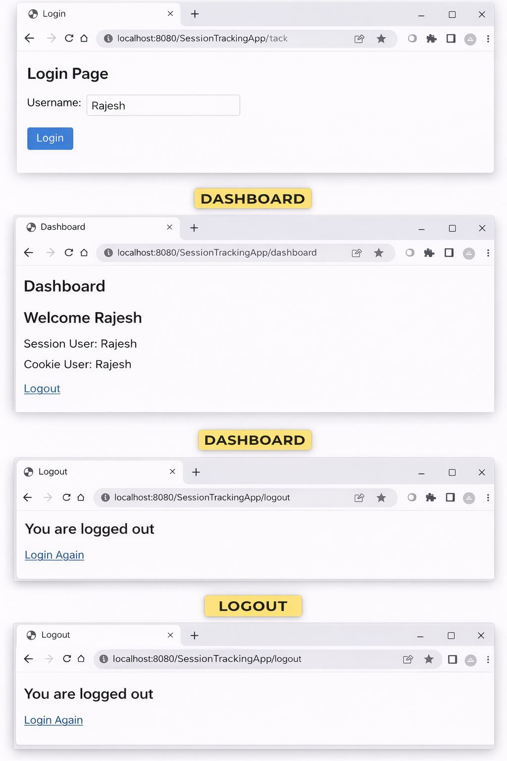

9. Create a custom server using http module and explore the other modules of Node JS like OS, path, event.

const http = require("http");
const os = require("os");
const path = require("path");
const EventEmitter = require("events");
const eventEmitter = new EventEmitter();
eventEmitter.on("request_received", (url) => {
console.log(`Event Triggered: Request received for ${url}`);});
const server = http.createServer((req, res) => {
eventEmitter.emit("request_received", req.url);
res.writeHead(200, { "Content-Type": "application/json" });
if (req.url === "/") {
res.end(JSON.stringify({ message: "Welcome to Custom Node Server" })); }
else if (req.url === "/os") {
res.end(JSON.stringify({
platform: os.platform(),vs
cpu_arch: os.arch(),
cpus: os.cpus().length,
free_memory: os.freemem(),
total_memory: os.totalmem(),
uptime: os.uptime() })); }
else if (req.url === "/path") {
const filePath = path.join(__dirname, "files", "demo.txt");
res.end(JSON.stringify({
joined_path: filePath,
dirname: __dirname,
ext: path.extname(filePath),
basename: path.basename(filePath) })); }
else if (req.url === "/event") {
eventEmitter.emit("custom_event", "Hello Event!");
eventEmitter.once("custom_event", (msg) => {
console.log("Custom Event Fired:", msg); });
res.end(JSON.stringify({ message: "Custom event triggered" })); }
else {
res.writeHead(404);
res.end(JSON.stringify({ error: "Route not found" })); }});
const PORT = 3000;
server.listen(PORT, () => {
console.log(`Server running at http://localhost:${PORT}`);});

Output: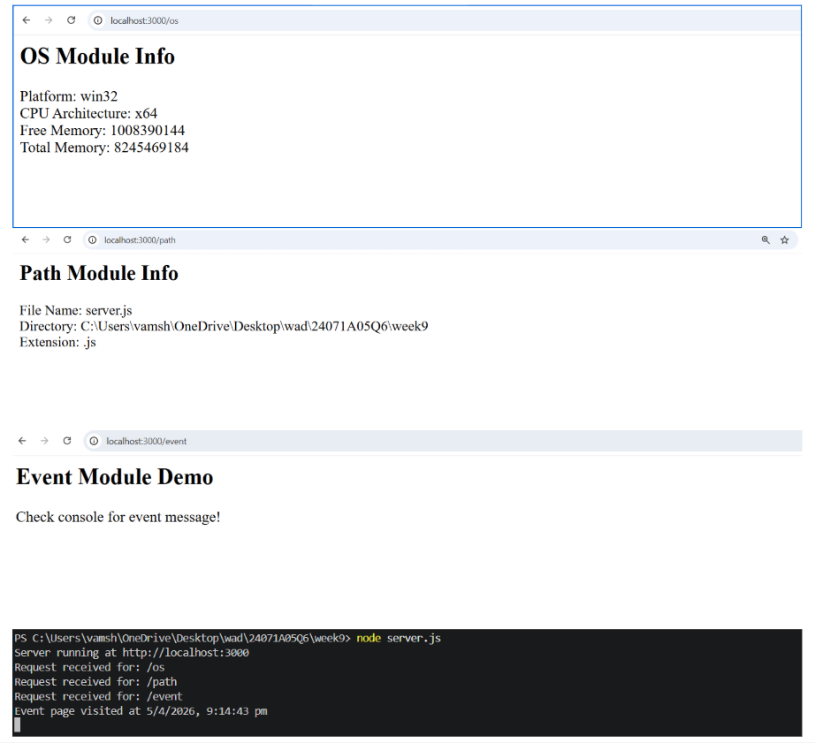
10. Develop an express web application that can interact with REST API to perform
CRUD operations on student data. (Use Postman)

Program:
const express = require("express");
const app = express();
app.use(express.json());
const BASE_URL = "https://jsonplaceholder.typicode.com/users";
app.post("/students", async (req, res) => {
try {
const response = await fetch(BASE_URL, {
method: "POST",
headers: {
"Content-Type": "application/json"
},
body: JSON.stringify(req.body)
});
const data = await response.json();
res.json({
message: "Student created",
data
});
} catch (err) {
res.status(500).json({ error: err.message });
}
});
app.get("/students", async (req, res) => {
try {
const response = await fetch(BASE_URL);
const data = await response.json();
res.json(data);
} catch (err) {
res.status(500).json({ error: err.message });
}
});
app.get("/students/:id", async (req, res) => {
try {
const response = await fetch(`${BASE_URL}/${req.params.id}`);
const data = await response.json();
res.json(data);
} catch (err) {
res.status(500).json({ error: err.message });
}
});
app.put("/students/:id", async (req, res) => {
try {
const response = await fetch(`${BASE_URL}/${req.params.id}`, {
method: "PUT",
headers: {
"Content-Type": "application/json"
},
body: JSON.stringify(req.body)
});
const data = await response.json();
res.json({
message: "Student updated",
data
});
} catch (err) {
res.status(500).json({ error: err.message });
}
});
app.delete("/students/:id", async (req, res) => {
try {
await fetch(`${BASE_URL}/${req.params.id}`, {
method: "DELETE"
});
res.json({
message: "Student deleted"
});
} catch (err) {
res.status(500).json({ error: err.message });
}
});
const PORT = 3000;
app.listen(PORT, () => {
console.log(`Server running on http://localhost:${PORT}`);
}
);

Output:
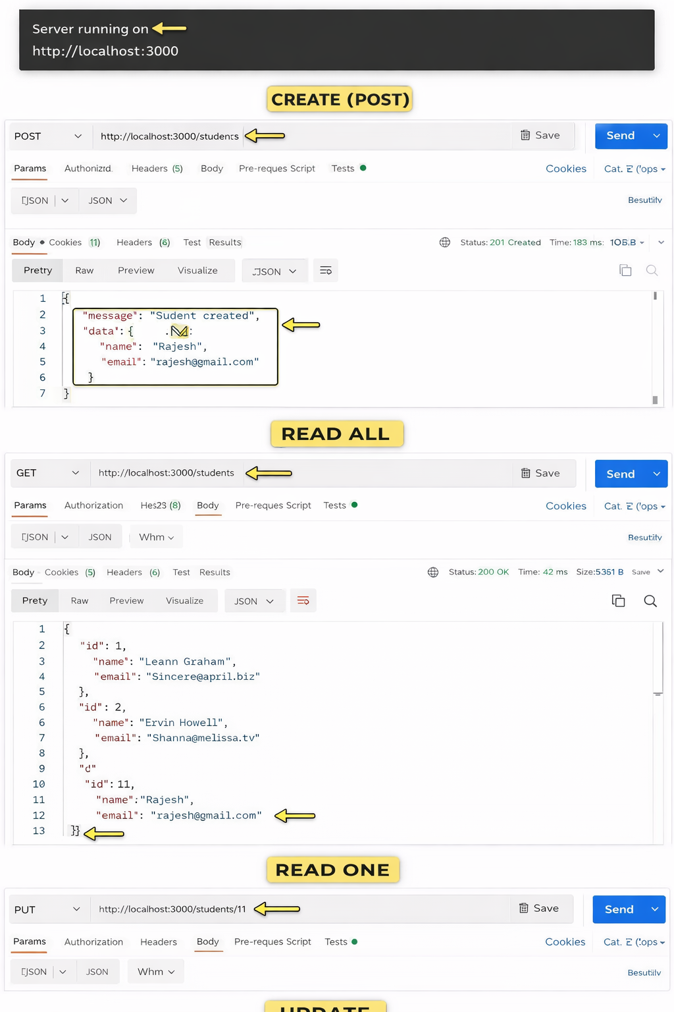

11. For the above application create authorized end points using JWT (JSON Web Token).

Program:
const express = require("express");
const jwt = require("jsonwebtoken");
const app = express();
app.use(express.json());
const BASE_URL = "https://jsonplaceholder.typicode.com/users";
const SECRET = "mysecretkey";
const USER = {
username: "admin",
password: "1234"
};
function authenticateToken(req, res, next) {
const authHeader = req.headers["authorization"];
const token = authHeader && authHeader.split(" ")[1];
if (!token) return res.status(401).json({ error: "Token required" });
jwt.verify(token, SECRET, (err, user) => {
if (err) return res.status(403).json({ error: "Invalid token" });
req.user = user;
next();
});
}
app.post("/login", (req, res) => {
const { username, password } = req.body;
if (username !== USER.username || password !== USER.password) {
return res.status(401).json({ error: "Invalid credentials" });
}
const token = jwt.sign({ username }, SECRET, { expiresIn: "1h" });
res.json({ message: "Login successful", token });
});
app.post("/students", authenticateToken, async (req, res) => {
try {
const response = await fetch(BASE_URL, {
method: "POST",
headers: { "Content-Type": "application/json" },
body: JSON.stringify(req.body)
});
const data = await response.json();
res.json({ message: "Created", data });
} catch (err) {
res.status(500).json({ error: err.message });
}
});
app.get("/students", authenticateToken, async (req, res) => {
try {
const response = await fetch(BASE_URL);
const data = await response.json();
res.json(data);
} catch (err) {
res.status(500).json({ error: err.message });
}
});
app.get("/students/:id", authenticateToken, async (req, res) => {
try {
const response = await fetch(`${BASE_URL}/${req.params.id}`);
const data = await response.json();
res.json(data);
} catch (err) {
res.status(500).json({ error: err.message });
}
});
app.put("/students/:id", authenticateToken, async (req, res) => {
try {
const response = await fetch(`${BASE_URL}/${req.params.id}`, {
method: "PUT",
headers: { "Content-Type": "application/json" },
body: JSON.stringify(req.body)
});
const data = await response.json();
res.json({ message: "Updated", data });
} catch (err) {
res.status(500).json({ error: err.message });
}});
app.delete("/students/:id", authenticateToken, async (req, res) => {
try {
await fetch(`${BASE_URL}/${req.params.id}`, {
method: "DELETE"
});
res.json({ message: "Deleted" });
} catch (err) {
res.status(500).json({ error: err.message });
}});
const PORT = 3000;
app.listen(PORT, () => {
console.log(`Server running on http://localhost:${PORT}`);
});
Output:
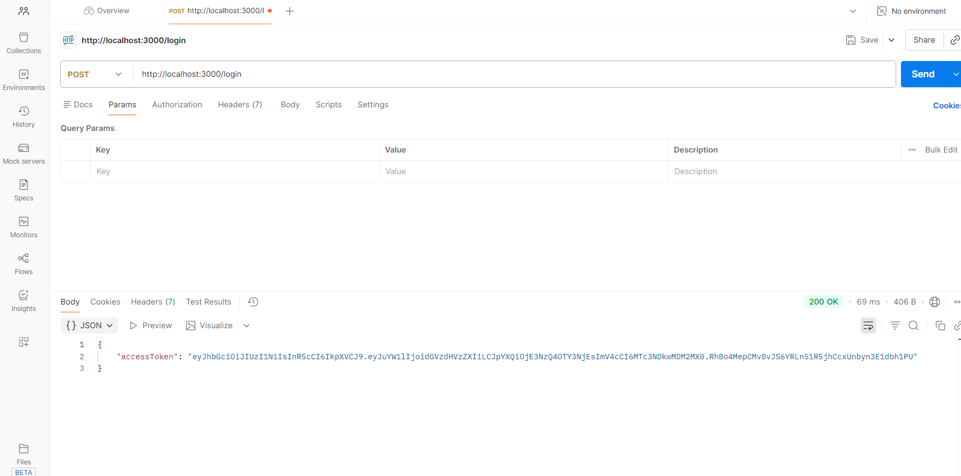
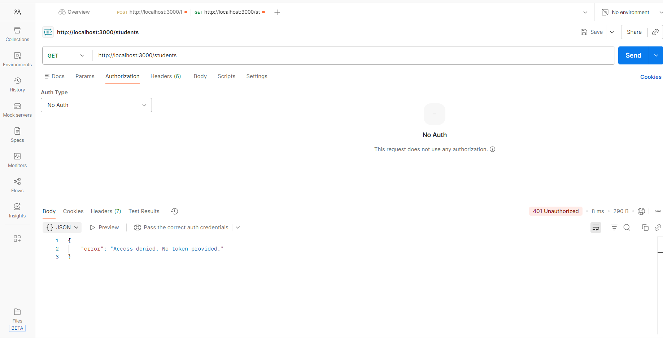



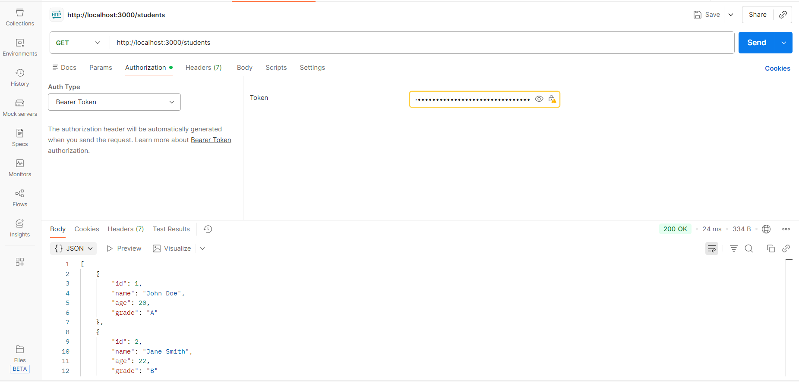
12. Create a react application for the student management system having
registration, login, contact, about pages and implement routing to navigate
through these pages.

import React from "react";
import { BrowserRouter as Router, Routes, Route, Link } from "react-router-dom";
import "bootstrap/dist/css/bootstrap.min.css";
function Navbar() {
return (
<nav className="navbar navbar-expand-lg navbar-dark bg-dark">
<div className="container">
<Link className="navbar-brand" to="/">SMS</Link>
<div className="collapse navbar-collapse">
<ul className="navbar-nav ms-auto">
<li className="nav-item"><Link className="nav-link" to="/">Home</Link></li>
<li className="nav-item"><Link className="nav-link" to="/register">Register</Link></li>
<li className="nav-item"><Link className="nav-link" to="/login">Login</Link></li>
<li className="nav-item"><Link className="nav-link" to="/contact">Contact</Link></li>
<li className="nav-item"><Link className="nav-link" to="/about">About</Link></li>
</ul>
</div>
</div>
</nav>
);
}
function Home() {
return (
<div className="container mt-5 text-center">
<h1 className="mb-3">Student Management System</h1>
<p className="lead">Manage students efficiently with a simple UI</p>
</div>
);
}
function Register() {
return (
<div className="container mt-5">
<div className="card shadow p-4 mx-auto" style={{ maxWidth: "400px" }}>
<h3 className="mb-3 text-center">Register</h3>
<form>
<div className="mb-3">
<input type="text" className="form-control" placeholder="Name" />
</div>
<div className="mb-3">
<input type="email" className="form-control" placeholder="Email" />
</div>
<div className="mb-3">
<input type="password" className="form-control" placeholder="Password" />
</div>
<button className="btn btn-success w-100">Register</button>
</form>
</div>
</div>
);
}
function Login() {
return (
<div className="container mt-5">
<div className="card shadow p-4 mx-auto" style={{ maxWidth: "400px" }}>
<h3 className="mb-3 text-center">Login</h3>
<form>
<div className="mb-3">
<input type="email" className="form-control" placeholder="Email" />
</div>
<div className="mb-3">
<input type="password" className="form-control" placeholder="Password" />
</div>
<button className="btn btn-primary w-100">Login</button>
</form>
</div>
</div>
);
}
function Contact() {
return (
<div className="container mt-5">
<div className="card shadow p-4">
<h3>Contact Us</h3>
<p>Email: support@sms.com</p>
<p>Phone: +91 9876543210</p>
</div>
</div>
);
}
function About() {
return (
<div className="container mt-5">
<div className="card shadow p-4">
<h3>About</h3>
<p>This is a simple Student Management System UI built using React and Bootstrap.</p>
</div>
</div>
);
}
export default function App() {
return (
<Router>
<Navbar />
<Routes>
<Route path="/" element={<Home />} />
<Route path="/register" element={<Register />} />
<Route path="/login" element={<Login />} />
<Route path="/contact" element={<Contact />} />
<Route path="/about" element={<About />} />
</Routes>
</Router>
);
}

Output:
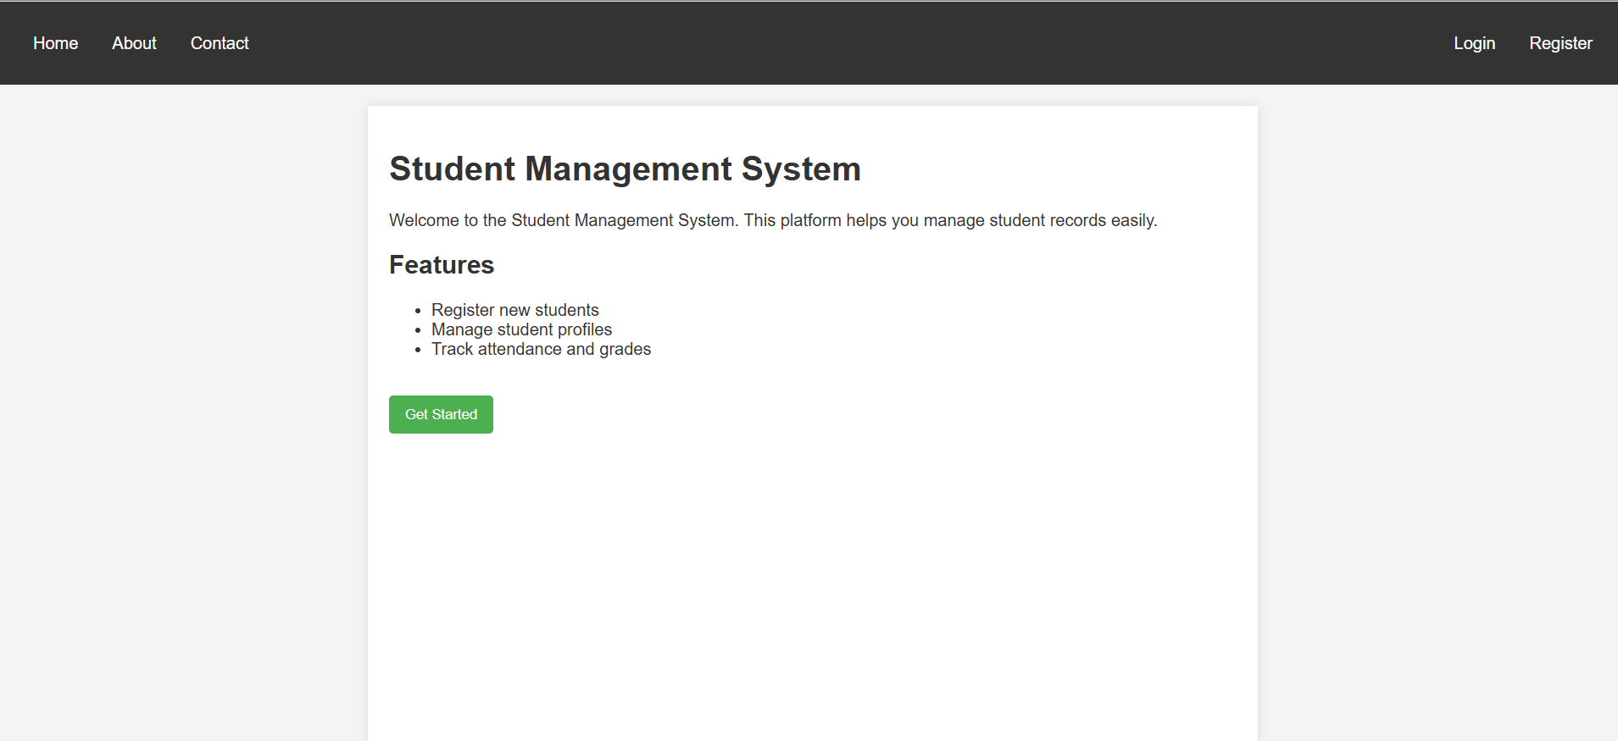
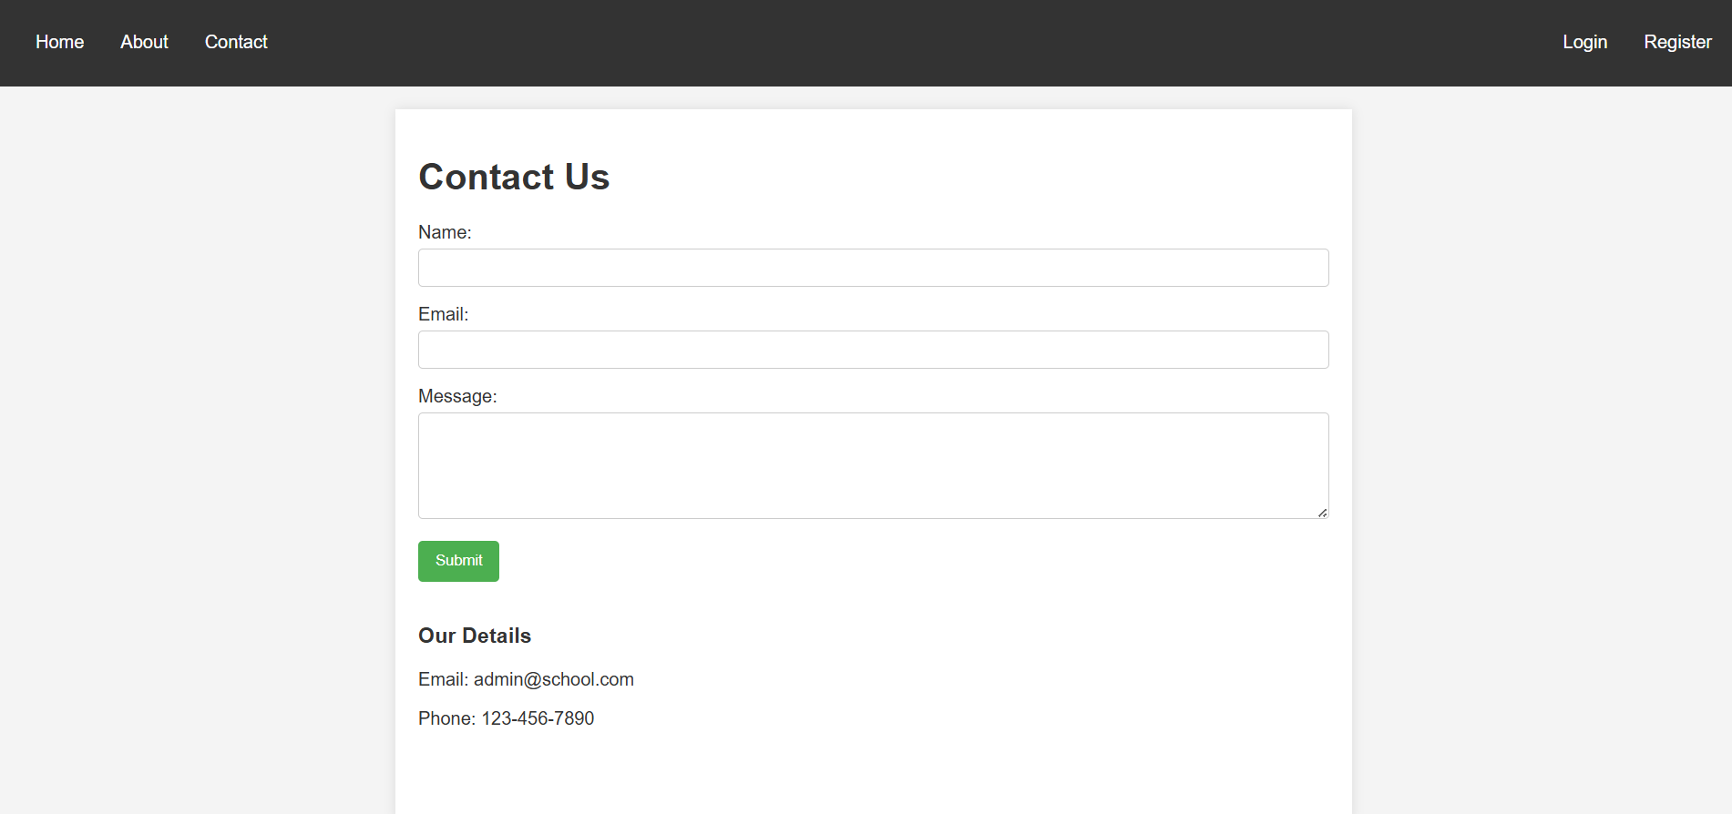

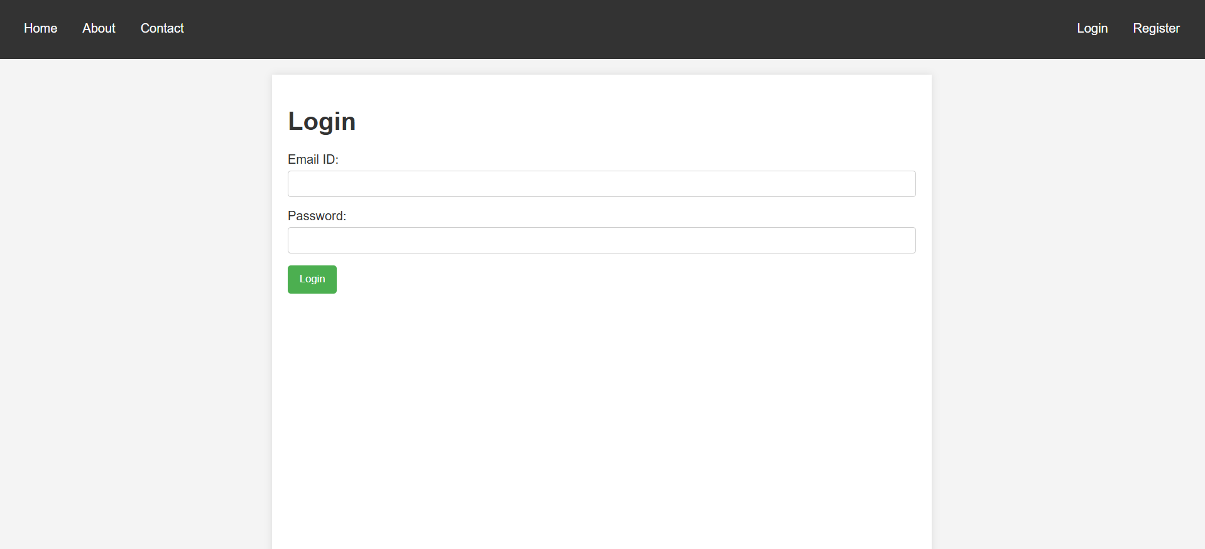

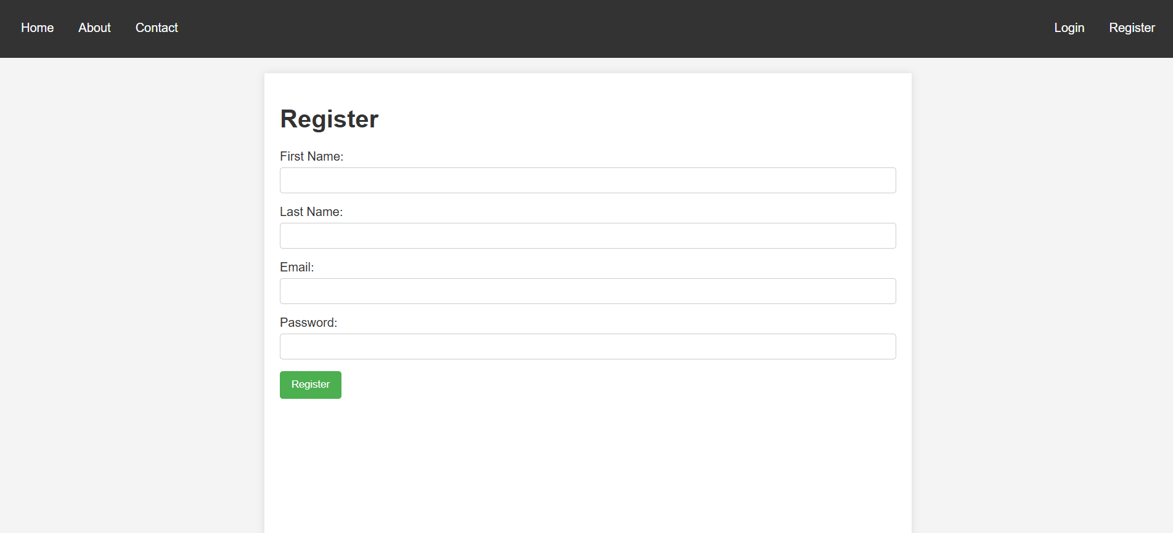

13. Create a service in react that fetches the weather information from openweathermap.org and the display the current and historical weather information using graphical representation using chart.js

Program:
WeatherChat.jsx
import {
Chart as ChartJS,
LineElement,
CategoryScale,
LinearScale,
PointElement,
} from "chart.js";
import { Line } from "react-chartjs-2";

ChartJS.register(LineElement, CategoryScale, LinearScale, PointElement);

function WeatherChart({ data }) {
if (!data) return null;

const labels = data.list.map(item =>
new Date(item.dt * 1000).toLocaleDateString()
);

const temps = data.list.map(item => item.main.temp);

const chartData = {
labels,
datasets: [
{
label: "Temperature (°C)",
data: temps,
borderColor: "blue",
fill: false,
},
],
};

return <Line data={chartData} />;
}

export default WeatherChart;

WeatherApp.jsx
import { useState } from "react";
import { getCurrentWeather, getHistoricalWeather } from "./services/weatherService";
import WeatherChart from "./components/WeatherChart";

function WeatherApp() {
const [city, setCity] = useState("");
const [current, setCurrent] = useState(null);
const [history, setHistory] = useState(null);

const fetchWeather = async () => {
const currentData = await getCurrentWeather(city);
setCurrent(currentData);

const { coord } = currentData;
const historyData = await getHistoricalWeather(coord.lat, coord.lon);
setHistory(historyData);
};

return (
<div style={{ textAlign: "center" }}>
<h2>Weather Dashboard</h2>

<input
type="text"
placeholder="Enter city"
value={city}
onChange={(e) => setCity(e.target.value)}
/>
<button onClick={fetchWeather}>Search</button>

{current && (
<div>
<h3>{current.name}</h3>
<p>Temperature: {current.main.temp} °C</p>
<p>Condition: {current.weather[0].description}</p>
</div>
)}
<WeatherChart data={history} />
</div>
);
}
export default WeatherApp;

Output:
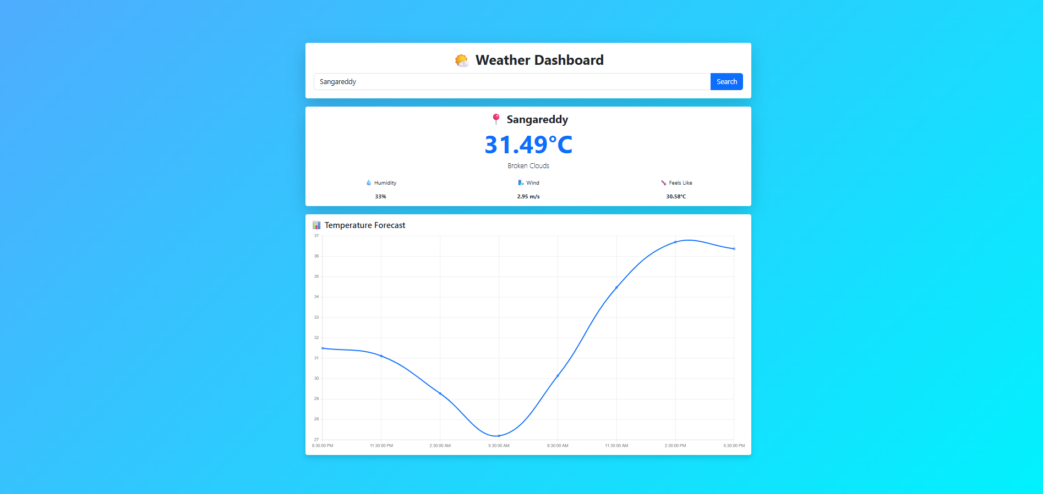
14. Create a TODO application in react with necessary components and deploy it into github.

Program:
TodoInput.jsx
import { useState } from "react";
function TodoInput({ addTodo }) {
const [text, setText] = useState("");
const [dueDate, setDueDate] = useState("");
const handleSubmit = (e) => {
e.preventDefault();
if (!text.trim()) return;
addTodo({
id: Date.now(),
text,
completed: false,
dueDate,
});
setText("");
setDueDate("");
};
return (
<form onSubmit={handleSubmit} className="mb-3">
<div className="row g-2">
<div className="col-12">
<input
className="form-control"
type="text"
placeholder="Enter task"
value={text}
onChange={(e) => setText(e.target.value)}
/>
</div>
<div className="col-8">
<input
className="form-control"
type="date"
value={dueDate}
onChange={(e) => setDueDate(e.target.value)}
/>
</div>
<div className="col-4 d-grid">
<button className="btn btn-primary" type="submit">
Add
</button>
</div>
</div>
</form>
);}

export default TodoInput;
TodoItem.jsx
import { useState } from "react";

function TodoItem({ todo, toggleTodo, deleteTodo, updateTodo }) {
const [isEditing, setIsEditing] = useState(false);
const [newText, setNewText] = useState(todo.text);
const [newDate, setNewDate] = useState(todo.dueDate || "");
const today = new Date().toISOString().split("T")[0];
const isOverdue =
!todo.completed &&
todo.dueDate &&
todo.dueDate < today;
const handleUpdate = () => {
updateTodo(todo.id, newText, newDate);
setIsEditing(false);
};
return (
<div
className={`d-flex justify-content-between align-items-center p-2 mb-2 rounded ${
isOverdue ? "bg-danger-subtle" : "bg-light"
}`}
>
{isEditing ? (
<div className="d-flex gap-2 w-100">
<input
className="form-control"
value={newText}
onChange={(e) => setNewText(e.target.value)}
/>
<input
className="form-control"
type="date"
value={newDate}
onChange={(e) => setNewDate(e.target.value)}
/>
<button className="btn btn-success" onClick={handleUpdate}>
Save
</button>
</div>
) : (
<>
<span
onClick={() => toggleTodo(todo.id)}
style={{
cursor: "pointer",
textDecoration: todo.completed
? "line-through"
: "none",
}}
className={isOverdue ? "text-danger" : ""}
>
{todo.text}
{todo.dueDate && ` (Due: ${todo.dueDate})`}
</span>

<div className="btn-group">
<button
className="btn btn-sm btn-warning"
onClick={() => setIsEditing(true)}
>
Edit
</button>
<button
className="btn btn-sm btn-danger"
onClick={() => deleteTodo(todo.id)}
>
Delete
</button>
</div>
</>
)}
</div>
);}

export default TodoItem;
TodoList.jsx
import TodoItem from "./TodoItem";
function TodoList({ todos, toggleTodo, deleteTodo, updateTodo }) {
return (
<div>
{todos.map((todo) => (
<TodoItem
key={todo.id}
todo={todo}
toggleTodo={toggleTodo}
deleteTodo={deleteTodo}
updateTodo={updateTodo}
/>
))}
</div>
);}
export default TodoList;
App.jsx
import { useState } from "react";
import TodoInput from "./components/TodoInput";
import TodoList from "./components/TodoList";
function App() {
const [todos, setTodos] = useState([]);
const addTodo = (todo) => {
setTodos([...todos, todo]);
};
const toggleTodo = (id) => {
setTodos(
todos.map((todo) =>
todo.id === id
? { ...todo, completed: !todo.completed }
: todo
) ); };

const deleteTodo = (id) => {
setTodos(todos.filter((todo) => todo.id !== id));
};
const updateTodo = (id, newText, newDate) => {
setTodos(
todos.map((todo) =>
todo.id === id
? { ...todo, text: newText, dueDate: newDate }
: todo
) ); };
return (
<div className="container d-flex justify-content-center align-items-center min-vh-100">
<div className="card shadow p-4" style={{ width: "500px" }}>
<h2 className="text-center mb-4">Todo App</h2>

<TodoInput addTodo={addTodo} />

<TodoList
todos={todos}
toggleTodo={toggleTodo}
deleteTodo={deleteTodo}
updateTodo={updateTodo}
/>
</div>
</div>
);}
export default App;

Output:

