HDip in Creative Multimedia Programing

Ashley Mc Inerney

K00243715

SeARCH ENGINE OPTIMIZATION REPORT

Evolving Web Technologies – Assignment 2 – 30%

1. **INTRODUCTION:**

According to the website, *Search Engine Land*, **SEO (Search Engine Optimization)** ‘is the process of getting traffic from the “free,” “organic,” “editorial” or “natural” search results on search engines’ such as, Google, Yahoo and Bing (*2019*). SEO helps get the most out a website by employing and executing concepts that help generate traffic towards a site. Additionally, through using keywords, terms and phrases, making a site search engine friendly, and marketing the uniqueness of a site can make a big difference to a website (*Moz, 2019*).

This report aims to outline the progress made in optimizing the website, *‘***GREAT CREATIVE LIGHTHOUSE DESIGNS OF THE WORLD’** with the keywords, ‘**creative-digital–media**.

Sites of interest for this report are:

GitHub: <https://k00243715.github.io/creative_digital_media/>

Word Press blog: <https://k00243715collegeblog.home.blog/>

1. **CONTENT GENERATION:**

The following screen grab is a list of all the contents for the website:

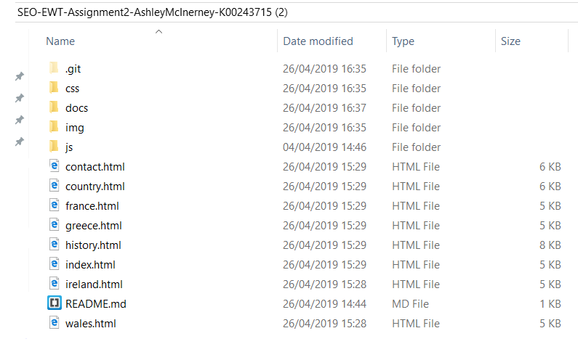

The website is stored on a **GitHub** Repository and has an associated repository files in the lighthouse websites folder, as seen above.

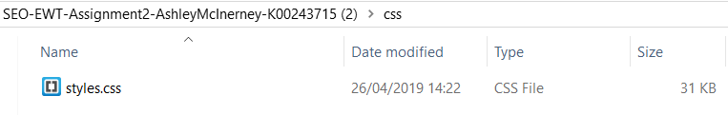Additionally, there is a **styles.css** file located in the CSS folder, as seen below:

1. **KEYWORD RESEARCH, TARGETTING, SEO ACTIONS & META TAGS:**
2. **TITLE TAG:**

One of the first tactics to help generate traffic to the site was to try to incorporate the keywords into the **<title> tag** in the <head> section of every web page. This was done to improve the optimization of the lighthouse website, as according to *Search Engine Watch*, **‘t**he [title tag](https://searchenginewatch.com/2016/05/16/how-to-write-meta-title-tags-for-seo-with-good-and-bad-examples/#checklist) is one of the first things that [users](https://searchenginewatch.com/2018/12/21/guide-google-analytics-confusing-terms/) notice in the SERPs. It is the title of your page that offers a preview of what your content is about. It’s important as it shows up in the search results, but it’s also pulled out to show up as anchor text and a title in social shares’ (*Litsa et al., 2019*). See example below:



The message that was strong during the research of SEO techniques was that the **clearer** and more **descriptive** the better for the site. As a result, the <title> tag was incorporated into all pages to try to give the website a good chance of being targeted and found when being searched for by a user.

1. **META DESCRIPTION:**

 Furthermore, the **meta description** was integrated into the websites <head> section to add SEO value and bring users to the page. The meta tag is the short descriptive writing piece that appears under the <title> tag in the webpage and on the search engine site (*Litsa et al., 2019*). The example of this on the lighthouse website pages can be seen here:

The meta description provides an accurate explanation, while incorporating the targeted keywords assigned to this project.

The take away message in reference to meta tags was to provide a lot more details about what the content of the website, bearing in mind to keep it appealing, concise and relevant *(Litsa et al., 2019).*

1. **ROBOTS META TAG:**

According to the website, *Search Engine Watch*, the inclusion of ‘robots meta tag informs search engines which pages on your site should be indexed’ (*Litsa et al., 2019*). It was noted that robot meta tags were included to prevent a search engine from indexing a whole site or section of a site. The instruction was meant for the search engine not to index a page or follow links, for example:

<meta name="robots" content="noindex, nofollow" />

Additionally, one could tell the crawler to follow and index a page, with replace the robots tag with this:

<meta name="robots" content="index, follow" />

The lighthouse website had some pages that has less content than others do, and it was not necessary for them to be indexed by the crawler, yet they were still important to the site. In the examples below, pages that were thin in content contained the tag ‘**noindex’**, while pages with larger content were tagged as ‘**index’**. The inclusion of both kinds of robot tags was included in the <head> section.

(robot tag with with index or noindex from lighthouse site)

1. **HEADER TAGS**
2. **SEO ACTIONS & RESULTS:**
3. **LESSONS LEARNED & CONCLUSION:**

**REFERENCES**

1. Think Business. (2019). *A beginner's guide to SEO | Think Business*. [online] Available at: https://www.thinkbusiness.ie/articles/beginners-guide-to-seo/ [Accessed 26 Apr. 2019].
2. Moz. (2019). *The Beginner's Guide to SEO: Search Engine Optimization*. [online] Available at: https://moz.com/beginners-guide-to-seo [Accessed 26 Apr. 2019].
3. Patel, N. (2019). *7 Essential HTML Tags that Separate SEO Pros from the Rookies*. [online] Neil Patel. Available at: https://neilpatel.com/blog/html-tags-for-seo/ [Accessed 24 Apr. 2019].
4. Litsa, T., Abbott, N., Morabito, J., Balkhi, S. and Barker, S. (2019). *A quick and easy guide to meta tags in SEO - Search Engine Watch*. [online] Search Engine Watch. Available at: https://searchenginewatch.com/2018/04/04/a-quick-and-easy-guide-to-meta-tags-in-seo/ [Accessed 24 Apr. 2019].
5. Search Engine Land. (2019). *What Is SEO / Search Engine Optimization? - Search Engine Land*. [online] Available at: https://searchengineland.com/guide/what-is-seo [Accessed 24 Apr. 2019].