**Site Testing Report**

**K00243720**

On deployment of my News Website for Evolving Web Technologies to Github, as part of the H.Dip in Creative Multimedia Programming, I tested the site under a number of headings, as outlined in this document.

**Documentation testing**

I first compared the requirements of the project brief to the overall finished product to see if they aligned. The website is coded in HTML5, with the contained articles following the structure of headline, text, image, author and date using the correct syntax.

The site is coded as mobile-first, so all base code is for 380px. There are three break points at 540px, 980px and 1200px, as per the requirement of the brief. The max-width is set to 1360px to keep the overall shape of the site intact at higher screen widths.

Included across the site are branding, navigation, a search bar, footer and ads, with contents including a homepage and login/sign-up areas, along with the ability to view full articles and all news. To this end, the requirements of the brief have been met.

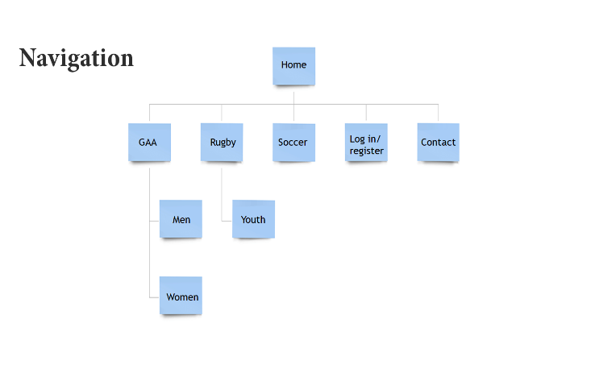I also revisited my wireframes and Photoshop files submitted at the design phase to see how closely the final product resembles them.

There was a slight change from the original navigation plan in that I excluded a sub-head under rugby (youth) but added another button in the menu for All News.

There were some changes to the overall design of the site but, for the most part, it is fairly close to my original plans. The biggest changes I made to the navigation on the original mobile site plans is that the drop-down no longer has sub-menus, the search bar is no longer a drop-down menu but rather part of the header and the social media icons are now in the footer. The desktop site has changed in that I used a portrait advert instead of landscape, meaning the grids are shaped in a different pattern as a result. I also moved the ‘Latest News’ section up to the header area and make it a ticker tape instead.

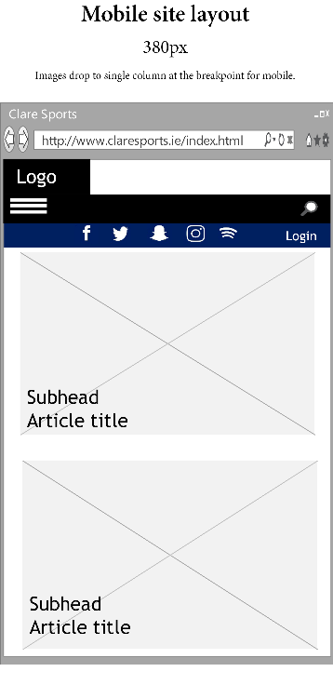 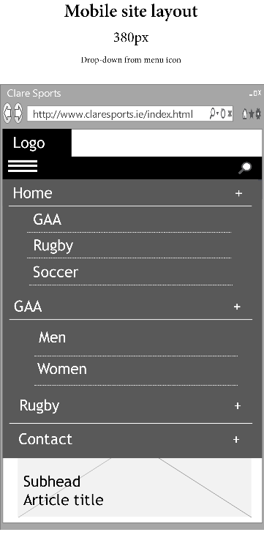 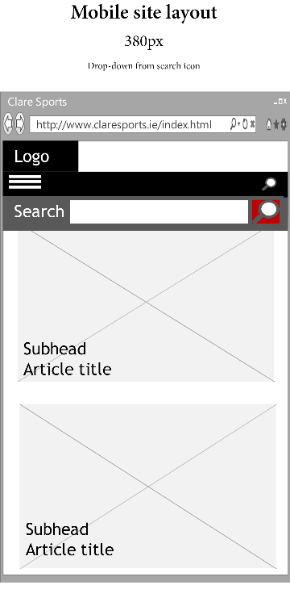

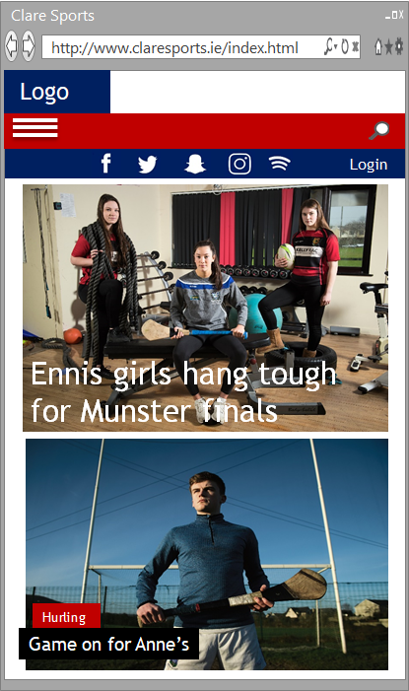 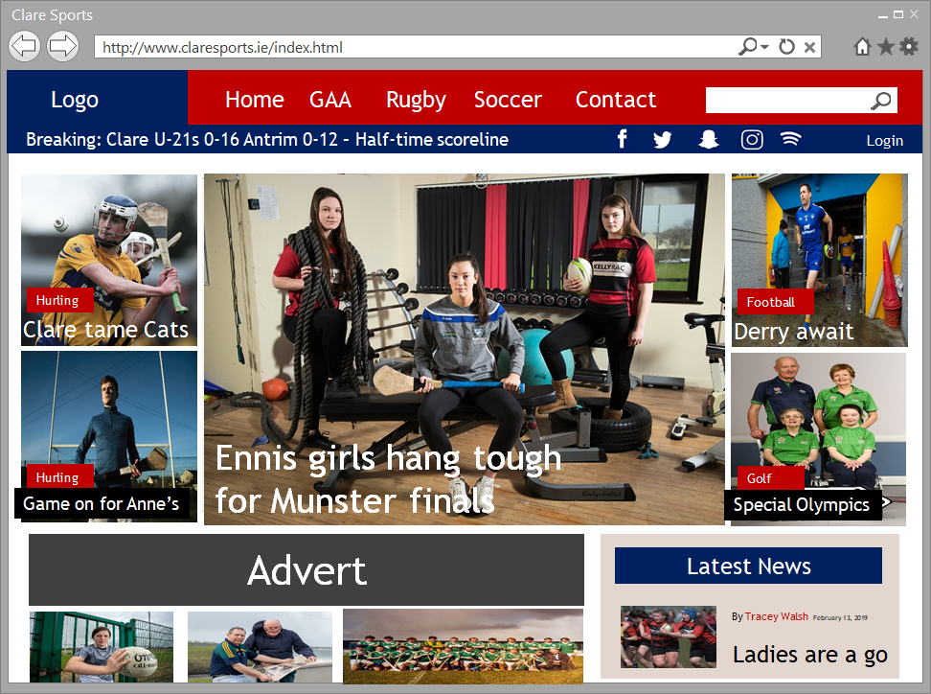

**The original design plans**

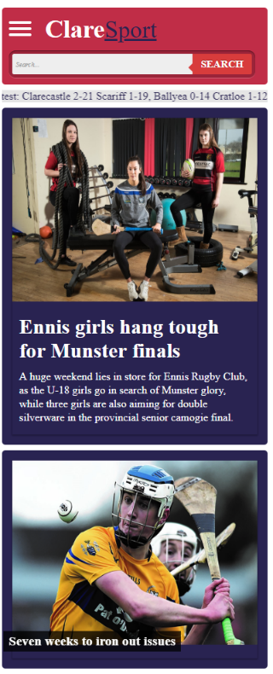 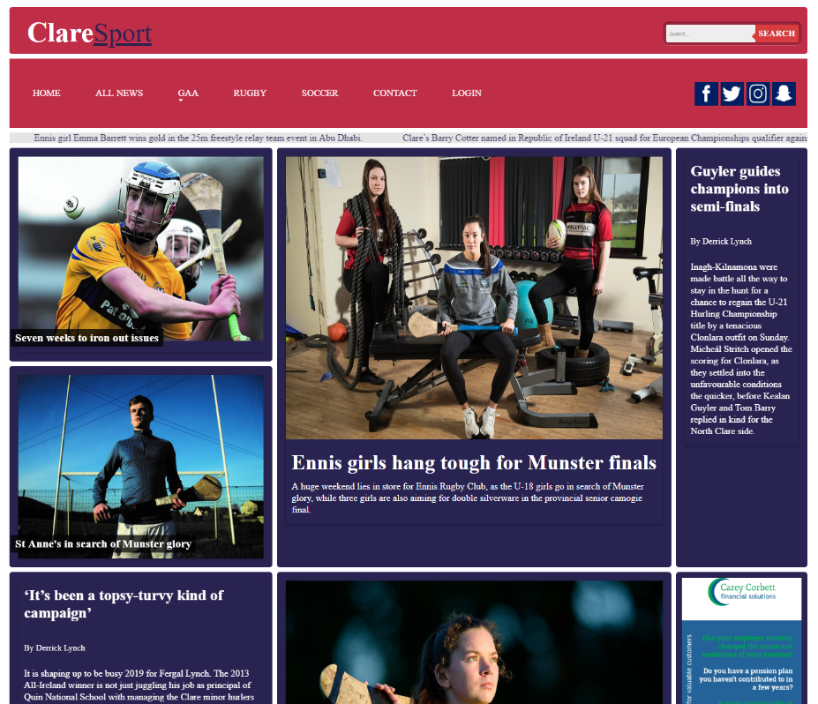

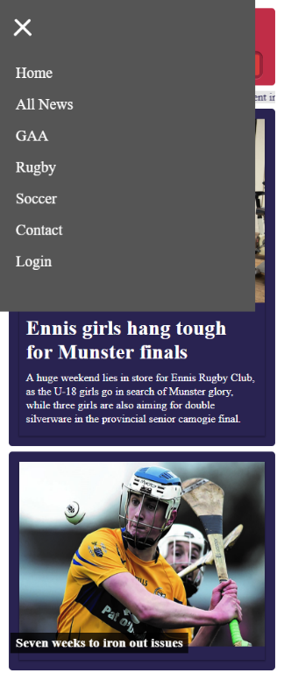 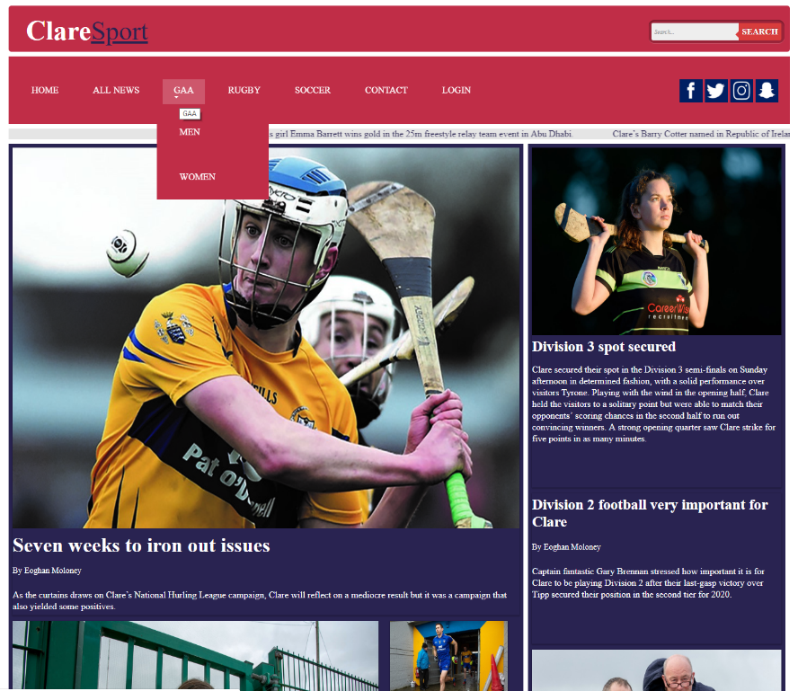

**The website**

**Functionality testing – Validation, Links, Forms**

**Validation**

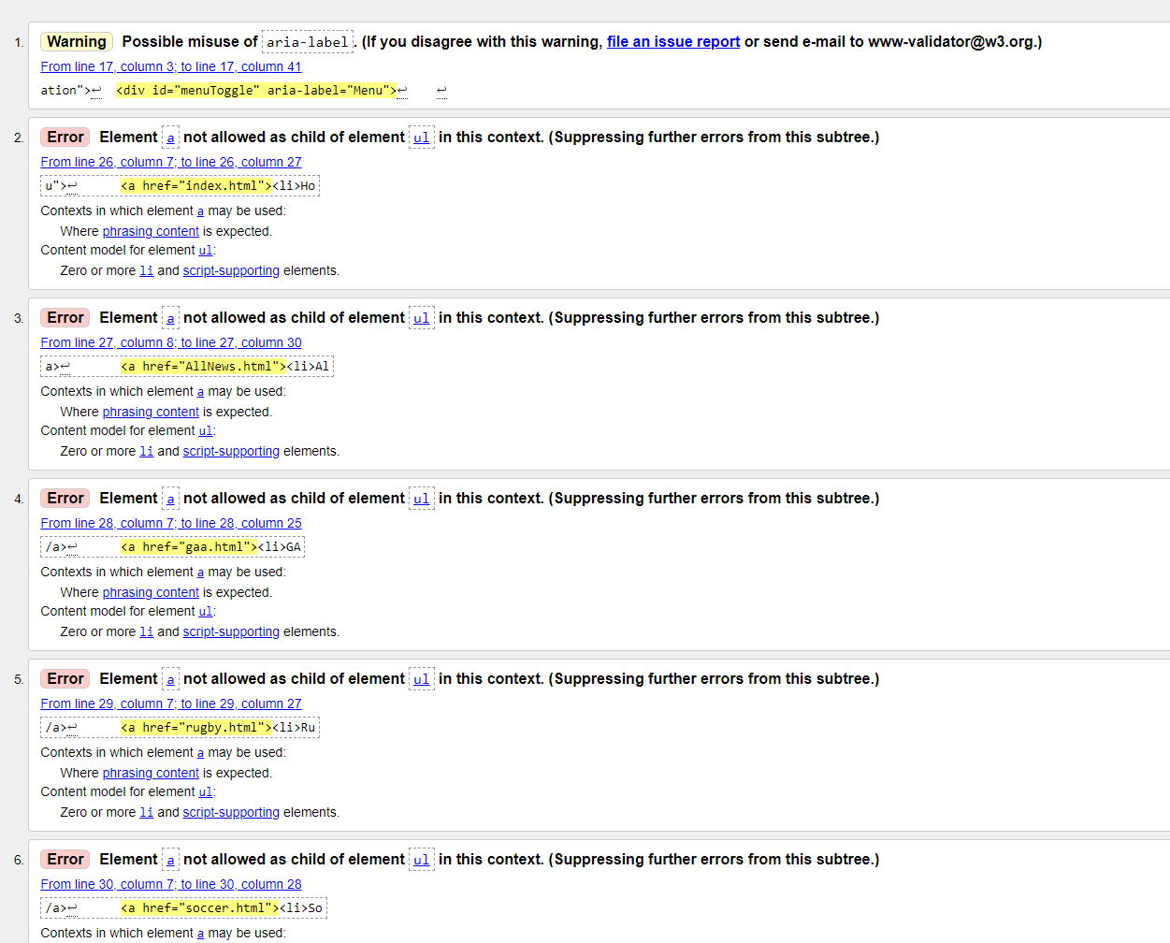I validated all of my website pages’ code on http://validator.w3.org/ and I was fairly pleased that there were few errors in my HTML. I could easily fix most of the errors, except in the navigation hamburger menu. I followed a tutorial on the creation of hamburger menus on Medium (as outlined in my Readme) and, unfortunately, in the validation process, there were a number of errors in the code. I tried a number of ways to try to fix these errors but time was against me and I had to revert to the original coding. In a future process, I would endeavour to fix these errors in full.

My CSS, on the other hand, had a number of syntax errors but these were easily rectified and so the site has a clean bill of health there.

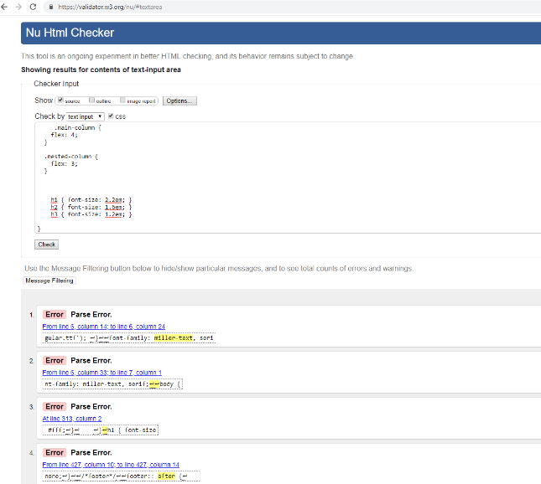 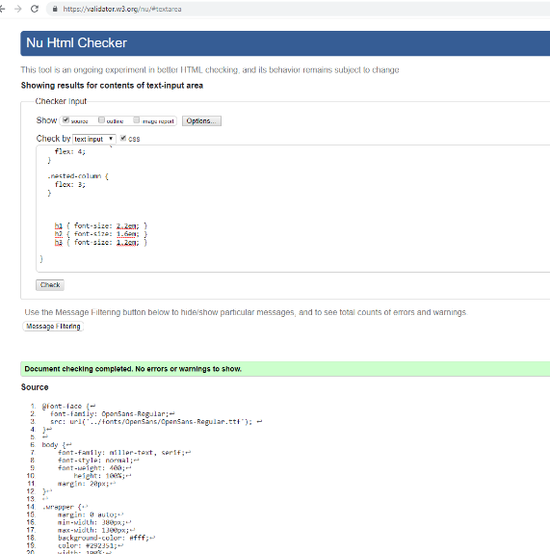

**Usability testing**

On deployment of my News Website for Evolving Web Technologies to Github, as part of the H.Dip in Creative Multimedia Programming, I tested the site under a number of headings, as outlined in this document.

**Compatibility testing**

On deployment of my News Website for Evolving Web Technologies to Github, as part of the H.Dip in Creative Multimedia Programming, I tested the site under a number of headings, as outlined in this document.

**Performance testing**

On deployment of my News Website for Evolving Web Technologies to Github, as part of the H.Dip in Creative Multimedia Programming, I tested the site under a number of headings, as outlined in this document.