Website 1:

<https://www.bungie.net/>

Bungie.net is my first website I have used to research my project. It is a type of news website that gives weekly updates to changes coming to destiny 2, an online game playable across all gaming platforms. What I always see about the website initially is the faded navigation bar and rolling images as a background on the main page. It is definitely something I will be using on the news website I am developing. Another thing I enjoy about the website is the websites home page layout using a lot of spacing and different sectioning. The initial thing you see at first is the trailer for the upcoming expansion for the game which would be the advertising of it of course.

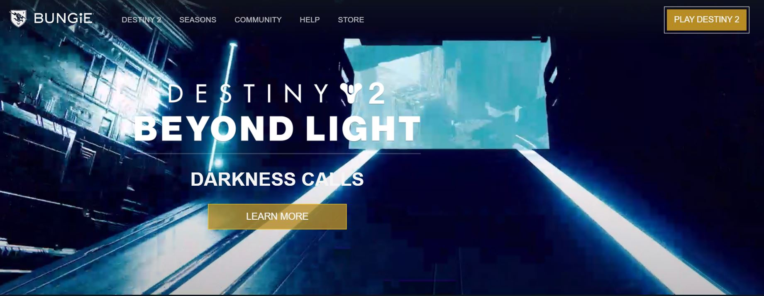

(Concept I will definitely be using on the site)

The second section of the websites home is the featured section that explains a lot of in game events that are coming and going from the game like the upcoming season of the hunt and just past festival of the lost. The layout in this section is all a block layout.

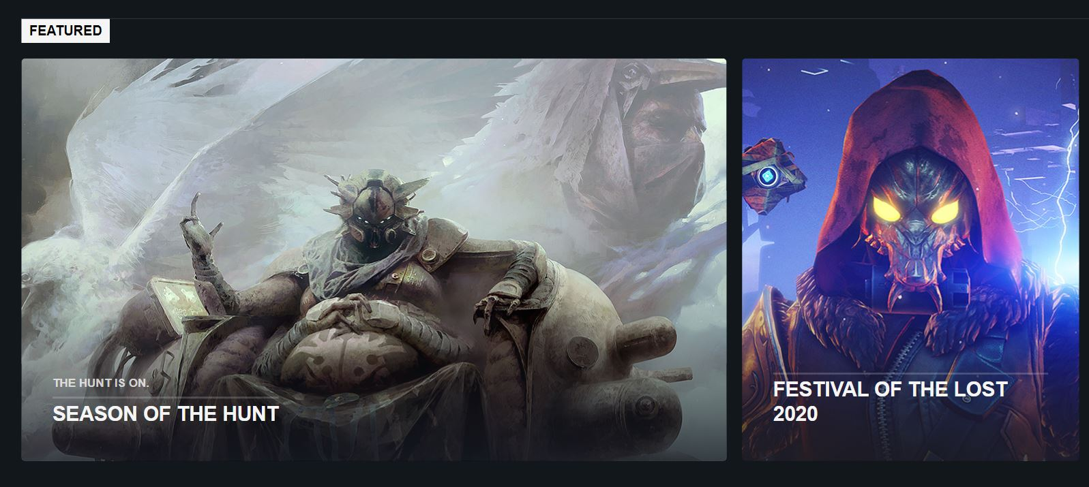

All images have links that will bring them to different sections of the website. The most important one is at the top with the biggest image, This week at bungie. Its what everyone goes to every Thursday as it shows the weekly updates coming to the game.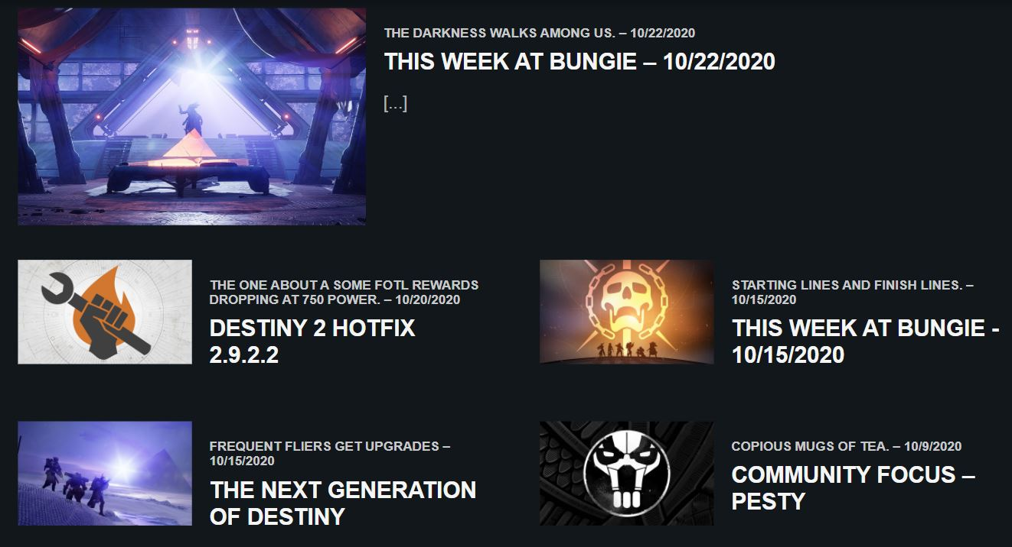

The idea of the sites news and updates etc, is good, the layout of it having a lot of spacing, limited text that has been date stamped to let people know its relevancy, and the imagery and concept art that would bring the people into the game and website. I know that I will definitely be using this layout on the site.The only problem I have is the websites social and account section on the website has been cut in half and doesn’t fit in the sites page on the website. 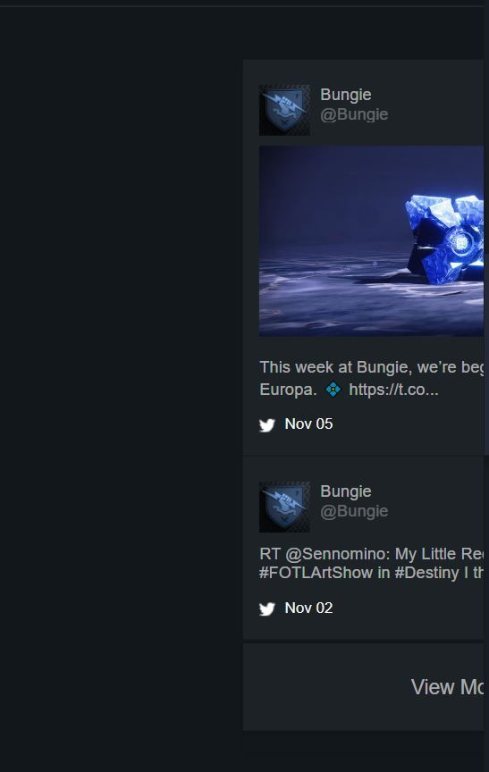I will be trying to avoid this problem when developing my website. I might add a social section to the website but it isn’t a necessity for it so I will see when it comes to it.

Website 2:

<https://www.arsenal.com/>

The official arsenal site is the second site I have decided to research. Straight off the bat it shows a lot of different links, a lot of images, adds and colours. The problem I have with this site instantly is theres too much going on the site. The red and white compliment each other because that is the clubs main colours so it has to be used really. The navigation bar is a lot better on bungie than it is on the arsenal website. It uses a lot clutter on it on the navigation bar and its blocked in style compared to the faded bungie style nav bar.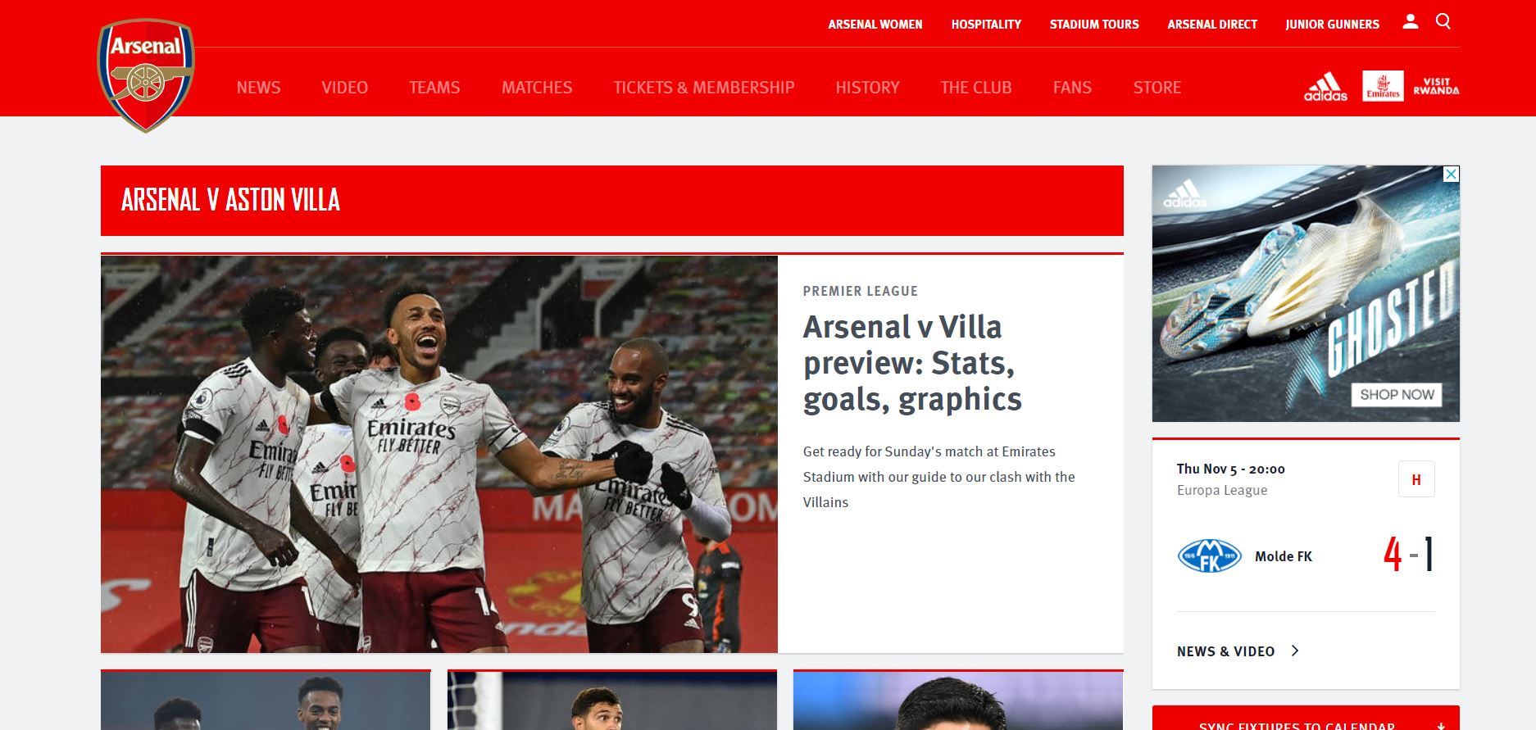

I just don’t like it because for some reason I feel there’s too much going on the site. I do like the concept and I probably will use arsenal for news concept of my site because it gives a lot updated news on the club that will help me update the site as much and regular as possible. I like that it gets continuous match scores and results and new signings and stories going on behind closed doors in the club.

From my research of my two mot used frequent website I might use something more closer to the side of the bungie website but keeping everything close together like the arsenal site but not as much so I can make it very minimalistic with the limited text and large spacing on the site. I am focusing on using a easy website with easy usability and hard to get lost in with the home page being the main focus. No crazy fonts I want my website to be gaming related so I can see myself using a faded kind of style in the text with a blocked font style similar to the layout.