Game Design Doc

Overview
You are an eco-engineer who must repair damaged/ faulty environmental equipment such as Solar panels. You will completer minigames to restore this equipment and start saving the environment with clean energy.
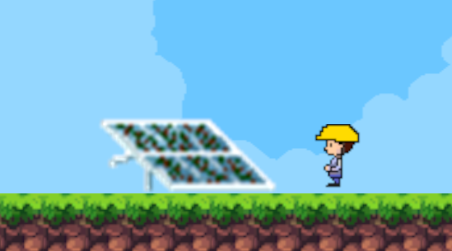
1. Game Design with Sprites

Eco-Engineer Simulator

Target
United Nations SDG 7 – Affordable and Clean Energy

Core Concept
This game will aim to teach kids/ teenagers about the different ways to achieve clean energy and to show what an Eco-Engineer does. This will include cleaning dirty solar panels, rewiring wind turbines, and installing renewable energy sources to locations without them.

Target Audience
Lower Secondary School student. (1st to 3rd Years.)

Platforms
This will be a Mobile Game made using Unity engine.

Intended Impact
The intended impact is to inform students about different Ecological Equipment and the impact they have on the planet. I also hope to inspire students to think about Ecological Engineering as a potential career in the future.

Chosen SDG and Overview
The SDG I have chosen is Goal 7: Affordable and Clean Energy. This goal is dedicated to ensuring access to affordable, reliable, sustainable and modern energy for all. Renewable energy sources are becoming cheaper, more reliable and more efficient every day. The planet is very reliant on fossil fuels which are unsustainable and bad for the planet. We have to change the way we produce and consume energy as fast as possible to counter climate change, one of the biggest threats to our survival.
Some of the targets include Ensuring universal access to modern energy by 2030, increase global percentage of renewable energy, double the improvement in energy efficiency, etc.
One way we can achieve this goal is to use solar energy sources. Install solar panels in your home for your heating and electricity. Use solar technology – radio, charger, lights etc. These are the equipment you will be looking at in my game as an eco-engineer. You will be restoring and repairing faulty energy sources and supplying sources to locations without them.

Game Concept
You are an eco-engineer who must repair damaged/ faulty environmental equipment such as Solar panels. You will complete minigames to restore this equipment and start saving the environment with clean energy.
If your task is to clean a Solar Panel, you will travel to the solar panel and click on it. This will open a minigame that requires cleaning the dust off the panel with touch controls. Oncle completed you will have restored the panel to its full capability. There will be a pop up to tell you the impact of Solar Panels on the planet. Then you may be tasked to write some code to detect when the solar panel is dirty again. This will teach the players small aspects of coding such as writing if statements.

Low Level Prototype
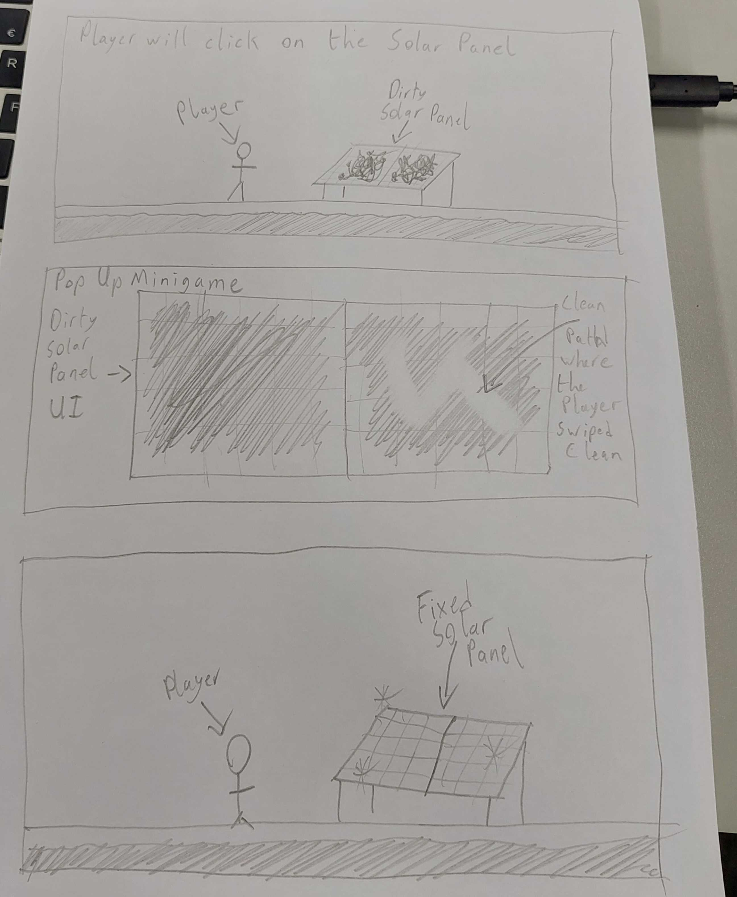
2. Paper Prototype of the game

