Q1) Configure Self-hosted integration runtime to Extract the data from your local server and load it into azure DB

ANS:

Step 1: Installed and configured a self-hosted integration runtime on your local server directly from azure Data Factory Integration Runtime.

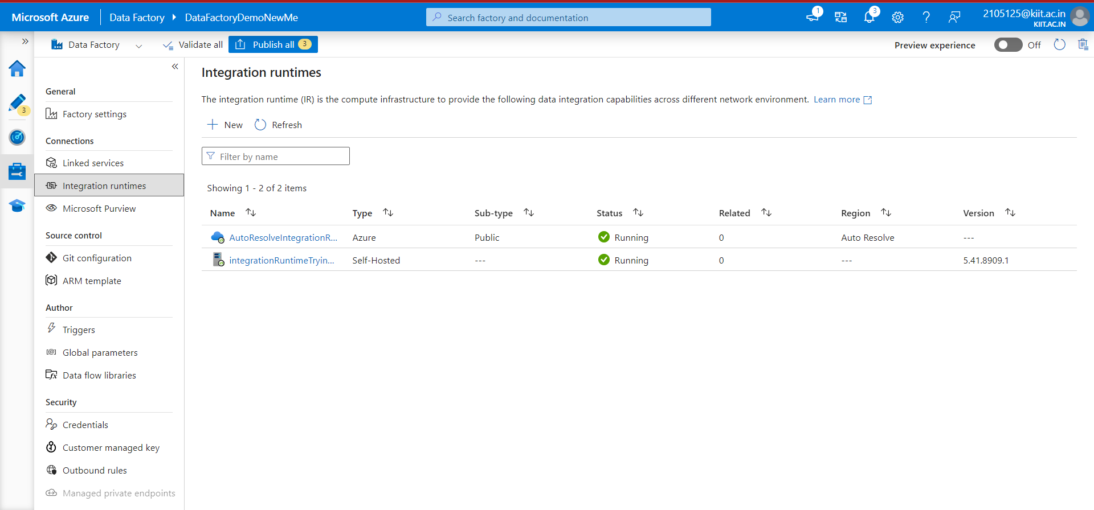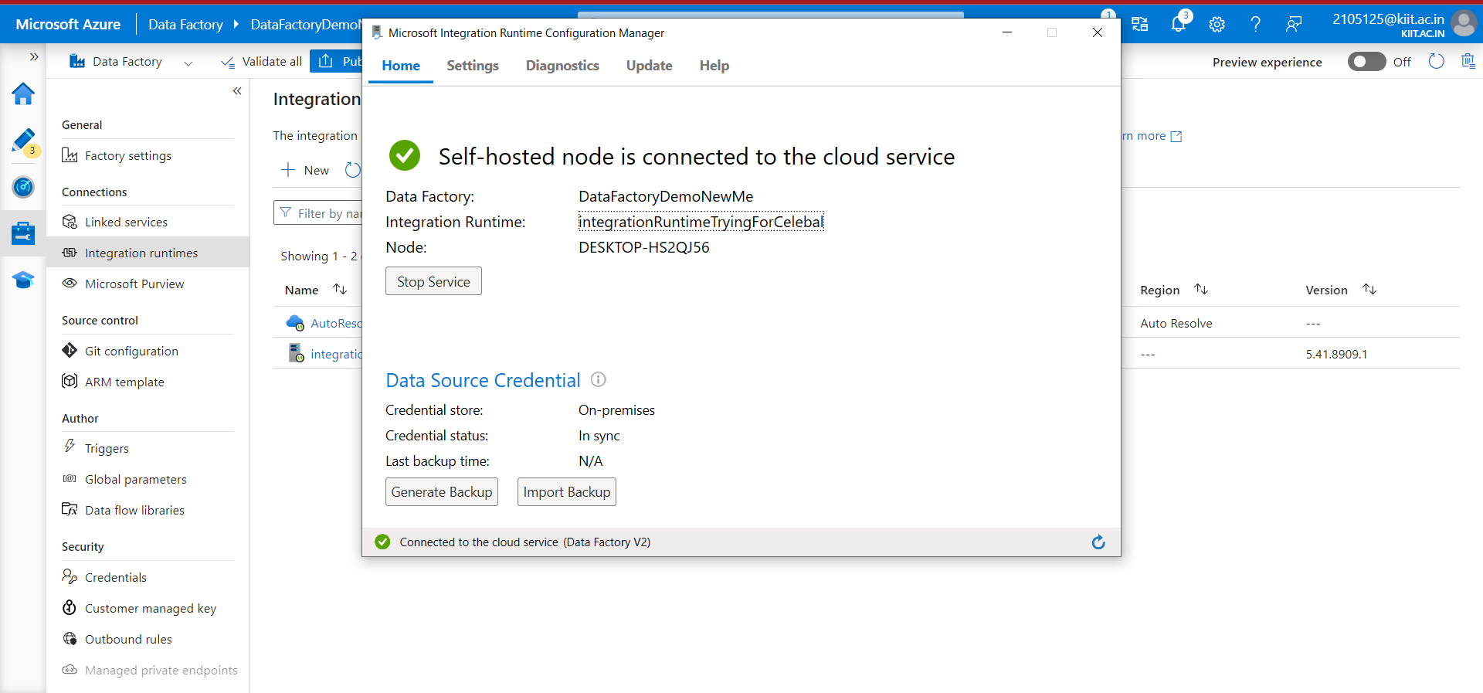

Step 2) Connect your local DB

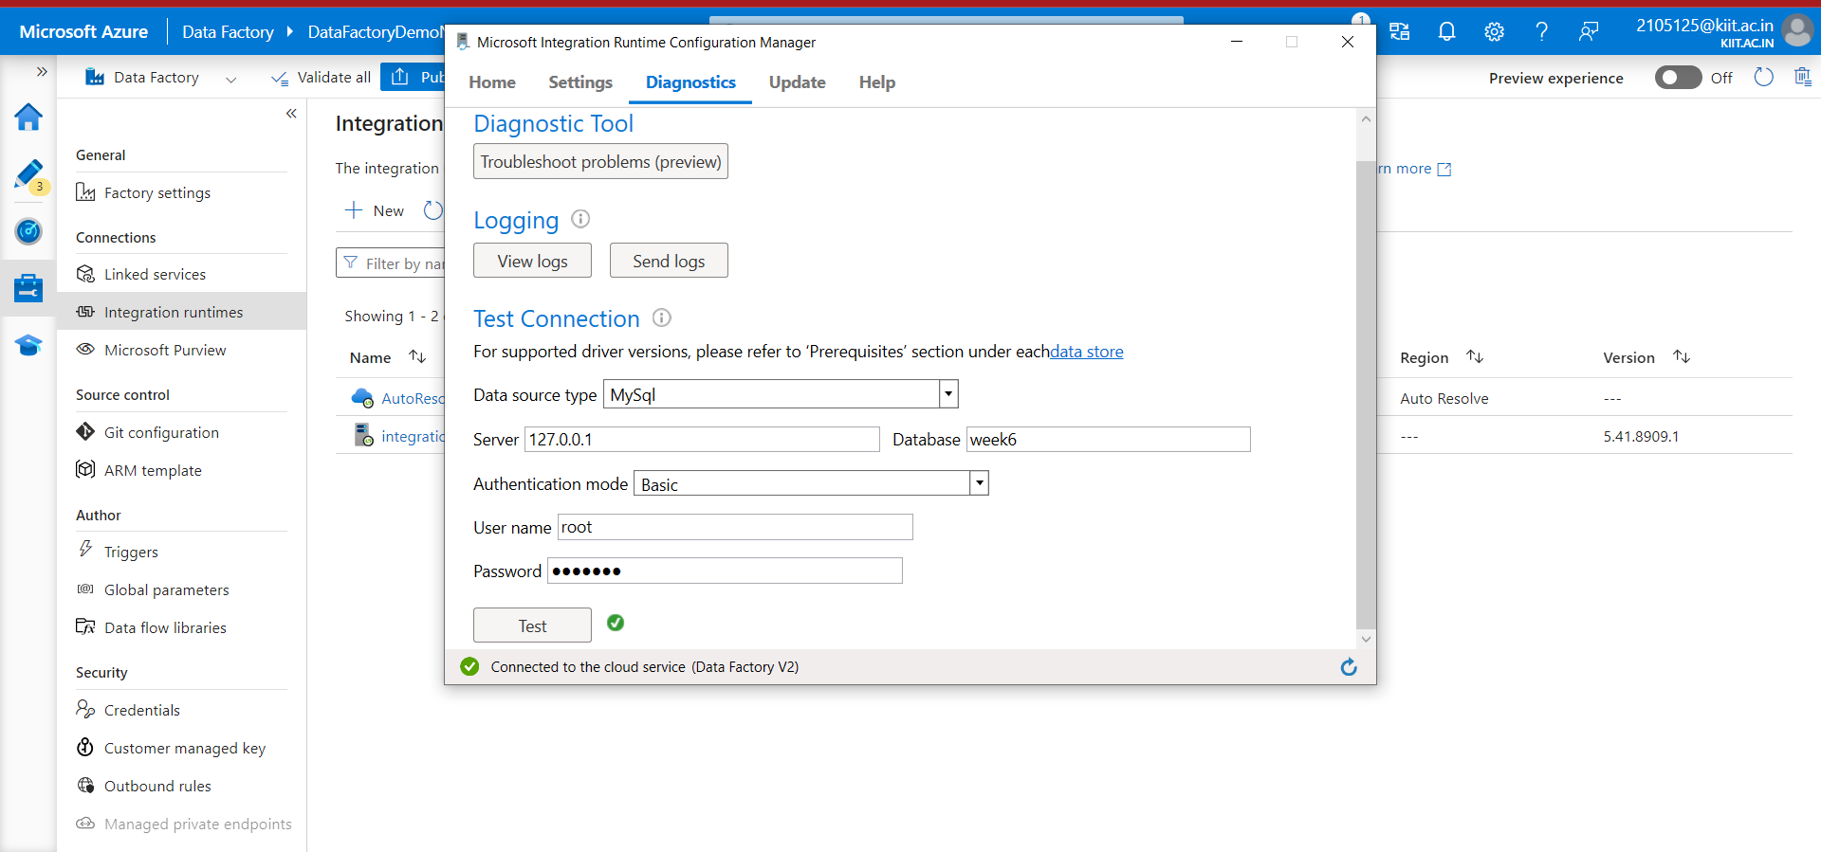

Step 3) Create Linked service from integrated runtime with azure data factory

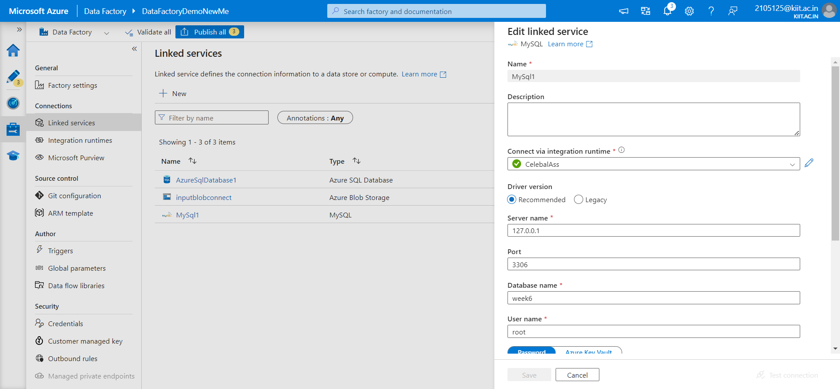

Step 4) Create Databases for both local server and sql server in azure

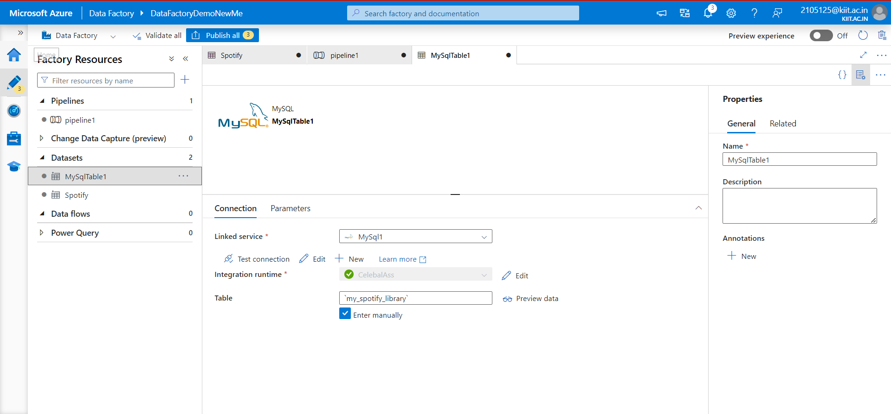

Step 5 )Create a new pipeline in Azure Data Factory.

Add a copy activity to the pipeline.

Configure the copy activity to use the MySQL dataset as the source and the Azure SQL Database dataset as the sink.

Map the columns between the source and destination as needed.

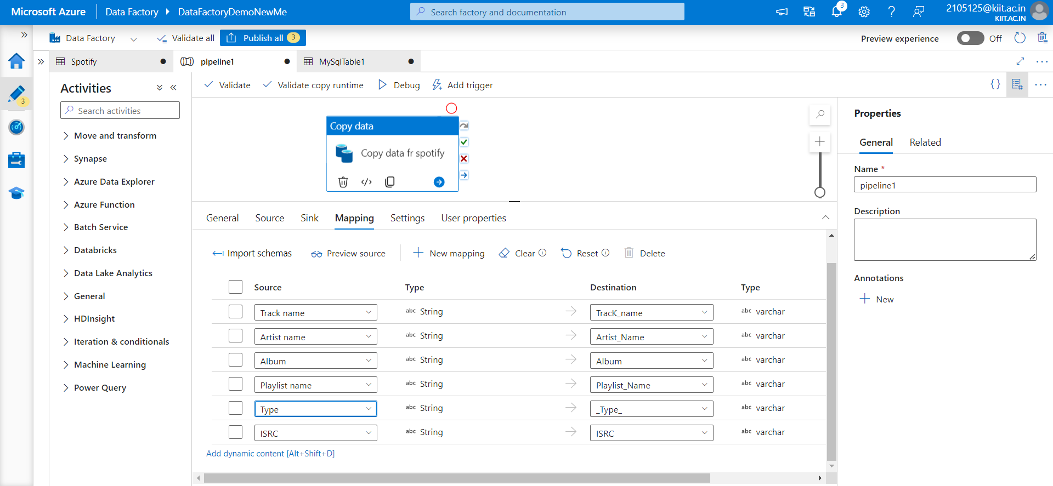

Step 6) Test the pipeline

