**Issue #3**

|  |  |
| --- | --- |
| ID number | #3 |
| Name | Payments details- system allows to insert only 3 digits CVC number when user use American Express card |
| Reporter | Kamil Lisowicz |
| Submit Date | 24/02/2020 |
| Summary | When I insert American Express number into “card number” field, system allows to click next when I fill CVC by only 3 digits (American Express Card use 4 digits CVC number) |
| URL | https://pluto-customer-web-app-staging.herokuapp.com/payment-cards |
| Screenshot |  |
| Platform | MacBook Pro, PC |
| Operating System | OS X 10.15, Windows 10 |
| Browser | Chrome 79, Opera 66, Firefox 52 |
| Severity | Low |
| Assigned to | / |
| Priority | Low |

**Description**

When I insert American Express number into “card number” field, system allows to click next when I fill CVC by only 3 digits (American Express Card use 4 digits CVC number)

**Steps to reproduce**

1. On main page click “Single trip cover”
2. On “Some details…” page, fill required fields, choose “Just me” checkbox, click next
3. On “A bit about you” page, fill required fields, click next
4. Choose eg. “the Last minute special”
5. Select quote, eg. “Pluto Standard Single Trip”
6. On “Optional extras” click Next
7. On “Details…” click Next
8. Accept policies, click “Proccest to payment”
9. Choose Card
10. Fill fields by eg. Values  
    -Card number: 3782 822463 10005  
    -exp. Date: 12/22  
    -CVC: 123  
    -Post Code: 22222

**Expected result**

Button “Next” should be disabled, American Express card use 4 digits CVC number  
  
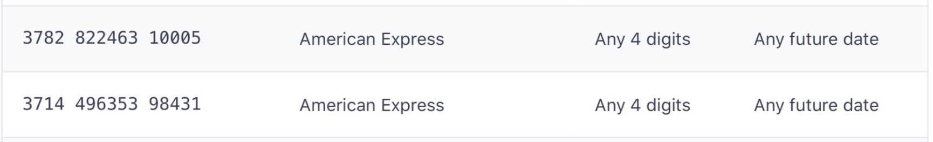

**Actual result**

System allows user to click next