**INSTALLING VBOX**

**STEP 1: To download and install Virtual Box navigate to the VirtualBox website:** [**www.virtualbox.org**](http://www.virtualbox.org#)

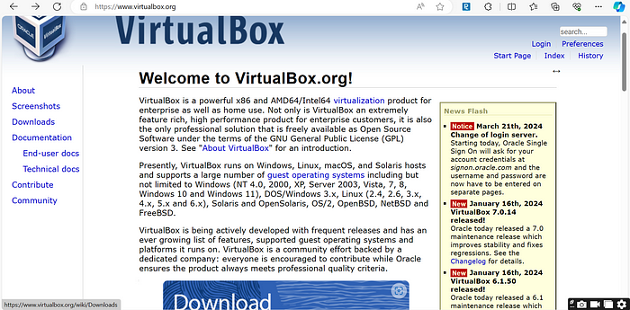

**STEP 2: Scroll down the homepage and locate the “Download VirtualBox 7.0” button then click on it.  
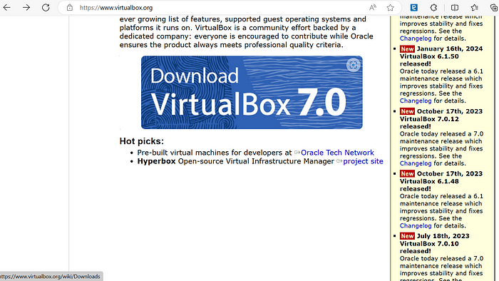**

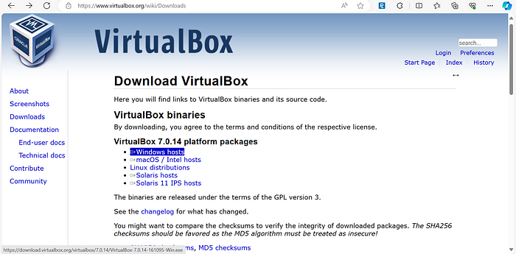**STEP 3: Depending on your operating system (e.g., Windows, macOS, Linux), select the appropriate version to download. Since I’m using Windows, I clicked on the “Windows hosts”.**

**STEP 4: Once the download is complete, navigate to your download directory and open the VirtualBox**

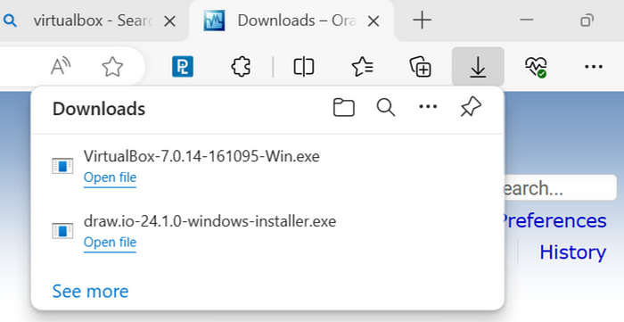

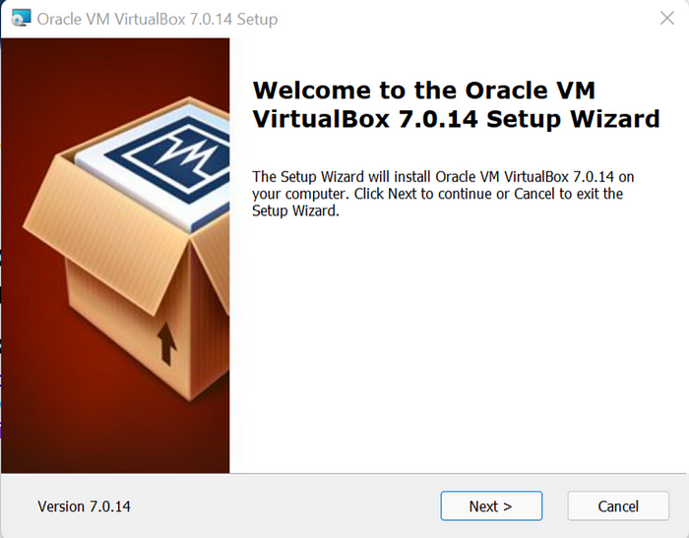**STEP 5: Begin the installation process by following the prompts provided by the installer. Click “Next” to proceed.**

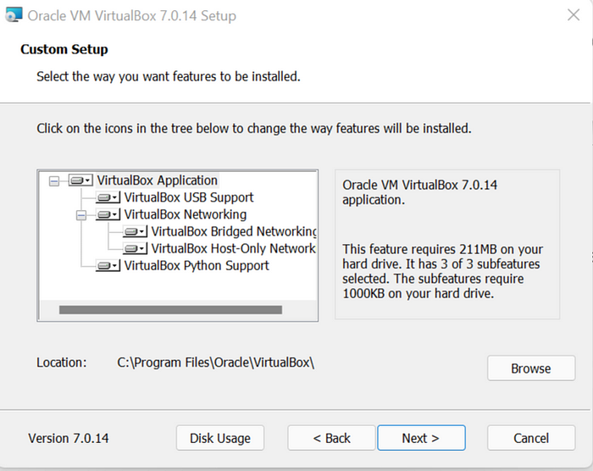**STEP 6: You’ll be presented with options to customize the installation (this is optional); Also, you can change where you want the virtual box to be installed for example, if you do not have enough space in the “C:” drive you can always install it in a different drive. But for the walkthrough, we would go with the default and click“Next”.**

**STEP 7: You’ll be presented with the “warning network interfaces” Do not panic, just click “yes” to install the needed dependencies.** 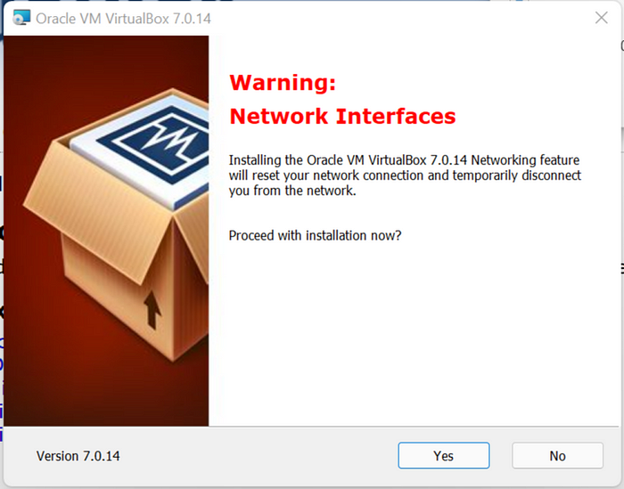

**STEP 8: Continue with the installation by clicking “Yes” to confirm the installation process.**

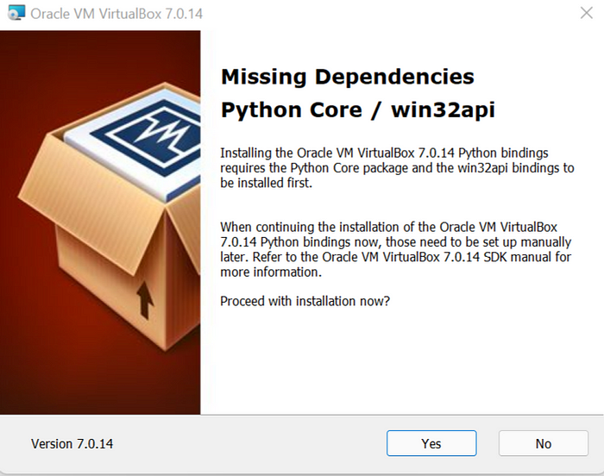

**STEP 9: Complete the installation by clicking “Install”.**

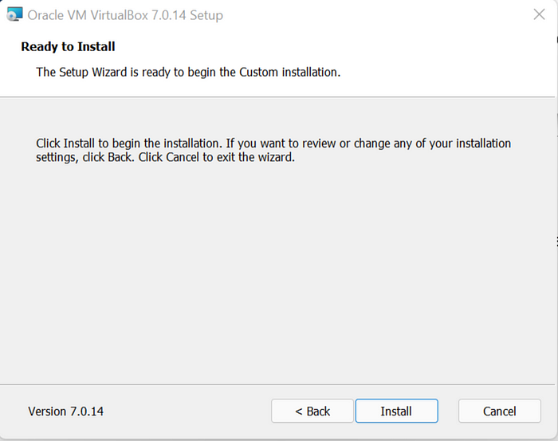

**STEP 10: After the installer completes the necessary steps and the installation is complete, click “Finish” and VirtualBox will automatically launch, ready for you to start using.**

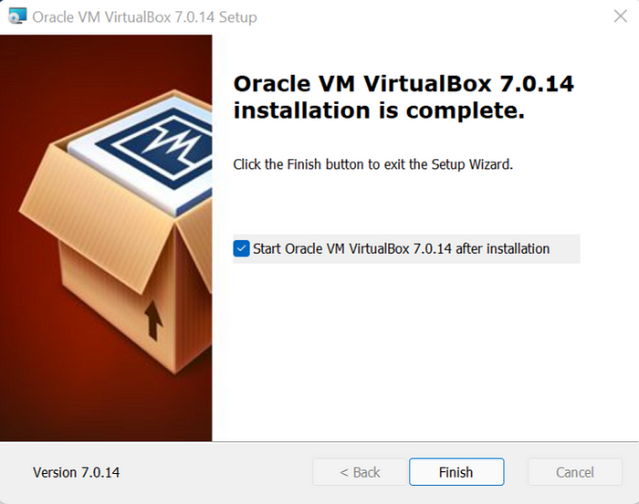

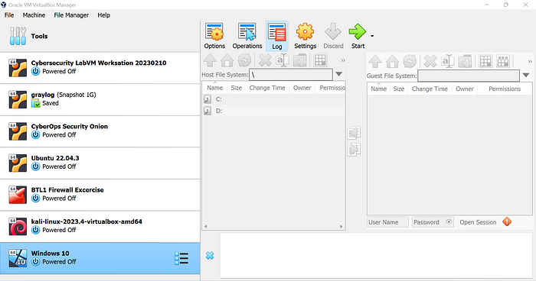

**INSTALLING WIN-10 IN VBOX**

**1. Download the Windows 10 ISO**

**First, head over to the Windows 10 download page If you are a Windows user. Microsoft will prompt you to download the Media Creation Tool before allowing you to download an OS image. You can use this tool to create an ISO file locally, or you can follow these additional instructions to download the ISO manually without being forced to grab the tool first.**

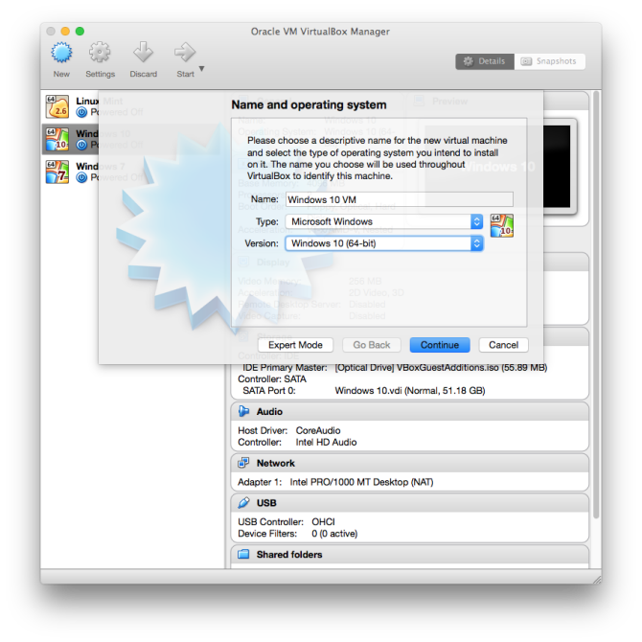

**2. Create a new virtual machine**

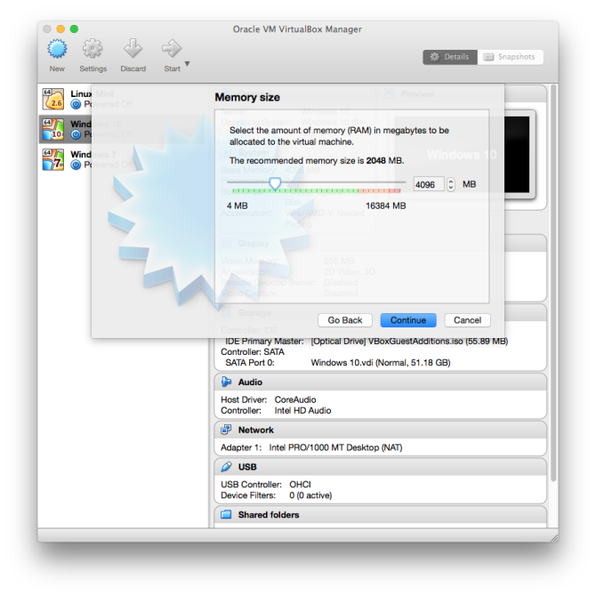**Go to the VirtualBox website and download the latest version of Oracle's free, open-source software. Go through the installation process, and then launch the application. Press the "New" button, and name your virtual machine. Make sure your "Type" is set to "Microsoft Windows" and your "Version" is set to "Windows 10." Make sure you match the x64 version with a 64-bit VM and the x86 version with a 32-bit VM.**

**3. Allocate RAM**

**Now, you must decide how much RAM you want to allocate for this VM. For the x86 version, you'll need at least 1GB of RAM. For the x64 version, you'll need 2GB. Whatever you decide, just make sure you stay in the green. If you allocate too much RAM, you'll end up with serious performance issues.**

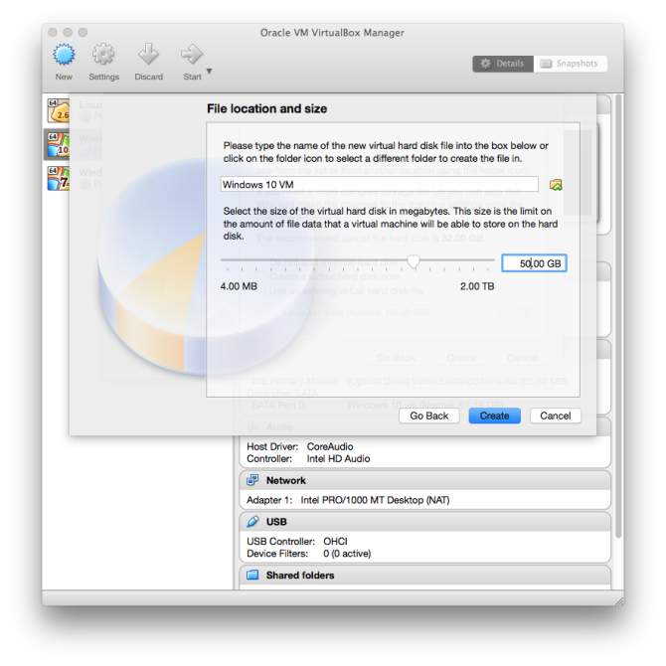

**4. Create a virtual drive**

**Next, you need to create a virtual drive. Microsoft says that 16GB is the minimum space needed for the 32-bit version, but 20GB is required for the 64-bit version. A 50GB can be a good virtual desktop, but feel free to make it as large as you need. Just be sure you have enough space on your actual hard drive to handle the size of your virtual drive. Depending on what you intend to do with the OS, you may want to allocate more or less storage. Applications installed to a VM should be assumed to require the same amount of "real" storage that their standard installations would.**

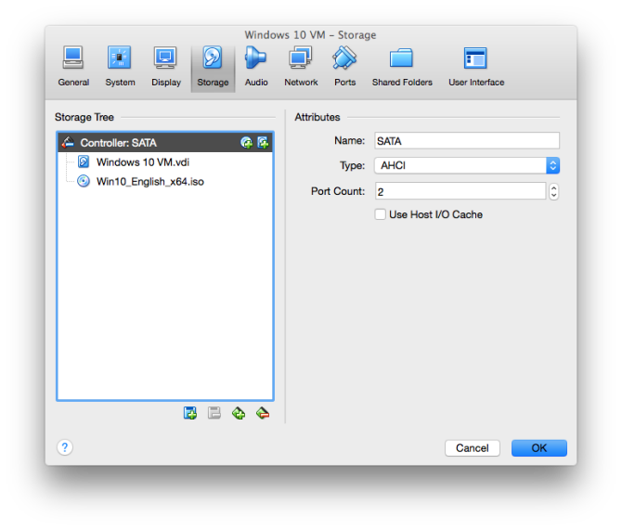

**5. Locate the Windows 10 ISO**

**Now, go into the settings for this virtual machine and navigate to the "Storage" tab. Click the disc icon with a green plus next to "Controller: SATA." Click "Choose disk" and locate the Windows 10 ISO you downloaded earlier.**

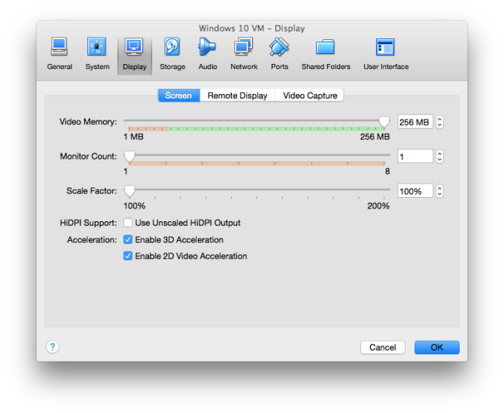

**6. Configure video settings**

**Before you jump in and start installing Windows 10, move over to the "Display" tab. You can configure how much video memory you will allocate to the virtual machine, but stay in the green. You can also toggle on 3D acceleration if you like.**

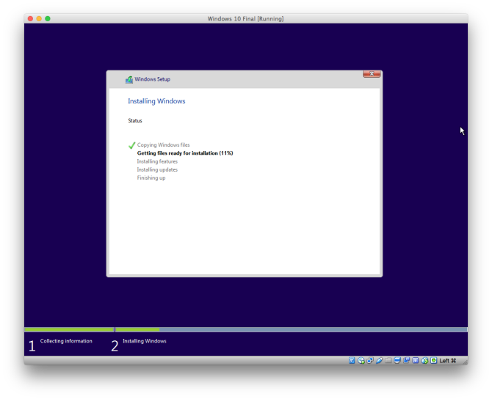

**7. Launch the installer**

**After that setup, press the "Start" button in VirtualBox and begin the Windows 10 installation process. Follow the instructions on the screen, and you're well on your way.**

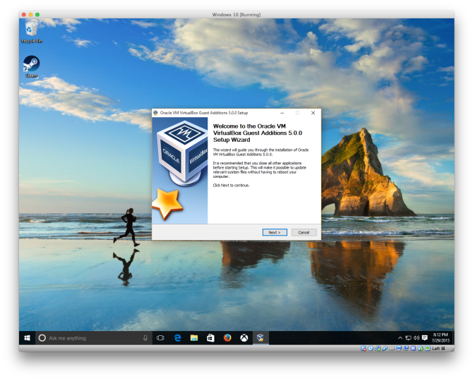

**8. Install VirtualBox guest additions**

**Once you're at the Windows 10 desktop, you'll need to install all of the proper drivers for VirtualBox. In the VirtualBox UI, select "Devices," then select "Insert Guest Additions CD image." Navigate to that disc image in Windows Explorer and run the installer. Once you've gone through the entire process, you must reboot the VM.**

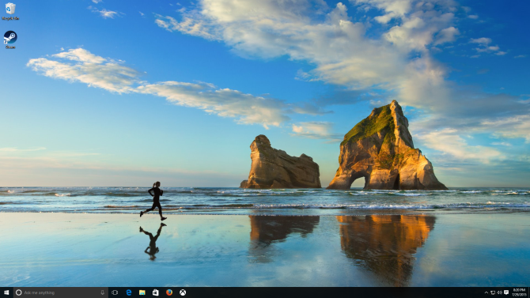

**9. You're ready to rock**

**Back at the desktop, you can finally use full-screen mode at the proper resolution. In the VirtualBox menu, select "View" and "Switch to Fullscreen." For the most part, this is now the same experience you'd have running it natively. Enjoy yourself, and feel free to poke around all the new features.**