**Title:** Hospital Management System Database Design and Implementation Report

By,

Krunal Upadhyay

**Abstract**

This report presents the design and implementation of a database for a hospital management system. The database aims to streamline hospital operations by managing patients, doctors, departments, appointments, prescriptions, medical records, billing, and room assignments. The methods employed include conceptual modelling, logical and physical design, and the use of SQL Server Management Studio for implementation. Results include a robust, normalized database schema and sample data population for testing. Conclusions highlight the database's ability to improve hospital efficiency and data accessibility.

**Introduction**

**Background:** Hospitals manage large volumes of data across multiple operations, such as patient care, staff management, and billing. A well-designed database ensures seamless data management, reducing errors and improving operational efficiency.

**Objectives:**

1. To create a relational database that manages key hospital operations.
2. To ensure data consistency, integrity, and scalability.
3. To populate the database with synthetic data for testing.
4. To enable insightful queries and reporting.

**Overview of Methods:** This report details the steps taken to conceptualize, design, and implement the database. It includes the use of entity-relationship diagrams (ERDs) to establish relationships, structured query language (SQL) for database creation and data insertion, and business questions to validate functionality.

**Methodology**

**Steps Taken:**

1. **Requirement Analysis:**
   * Defined key entities: Patient, Doctor, Department, Appointment, Medical Record, Prescription, Medicine, Billing, Room, Room Assignment, and Staff.
   * Identified relationships and constraints, including primary keys, foreign keys, and unique constraints.
2. **Conceptual Design:** Created a high-level ERD to define entities and relationships.

1. **Logical Design:** Normalized tables to ensure data integrity and avoid redundancy.
2. **Physical Design:** Translated the logical design into SQL schema using SQL Server Management Studio.

1. **DDL of Hospital:** Created the database, tables with constraints and below following screenshots are the queries constructed for DDL.

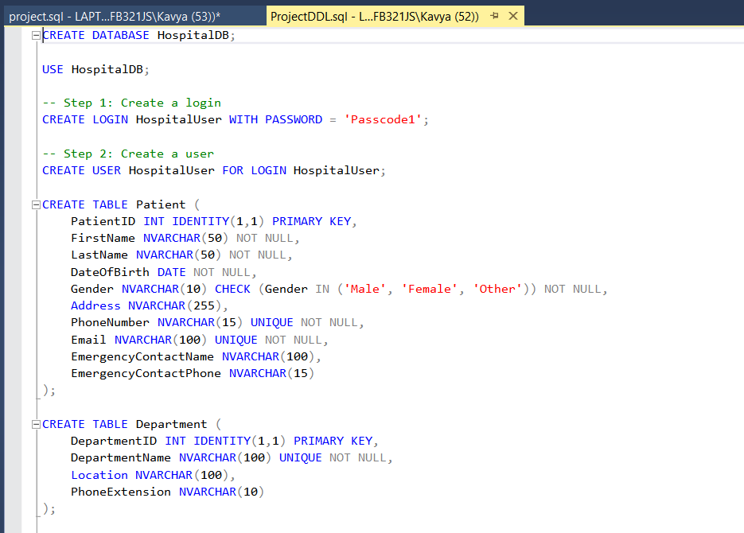

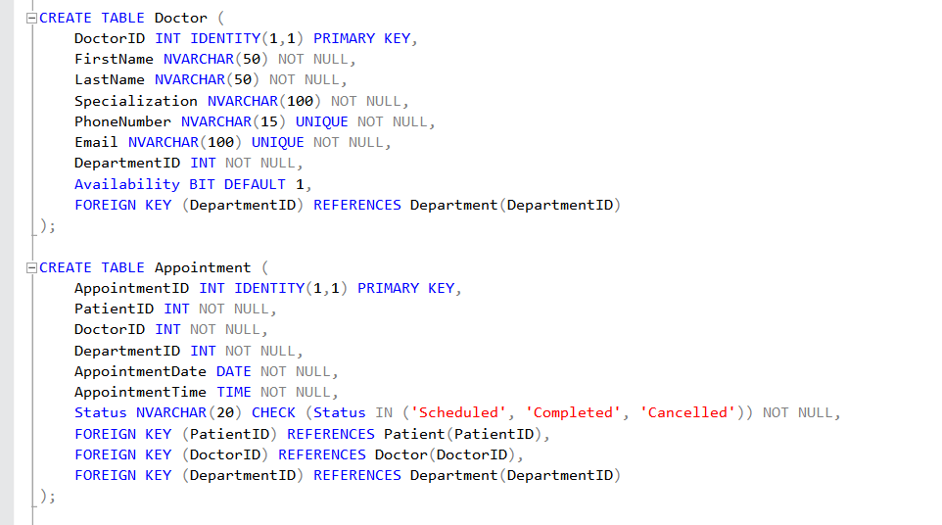

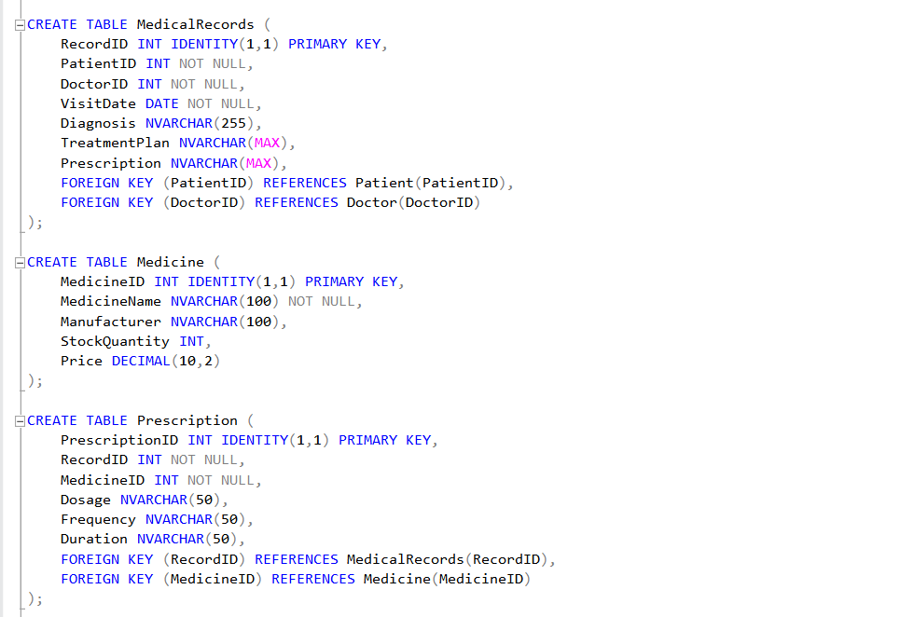

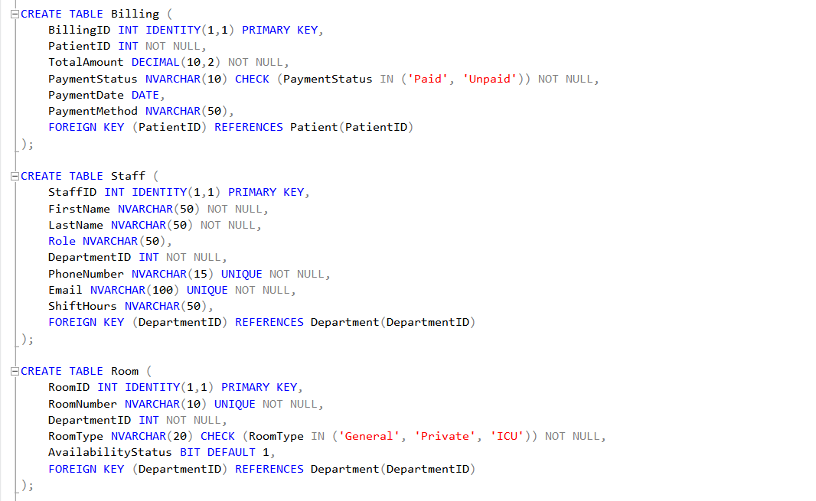

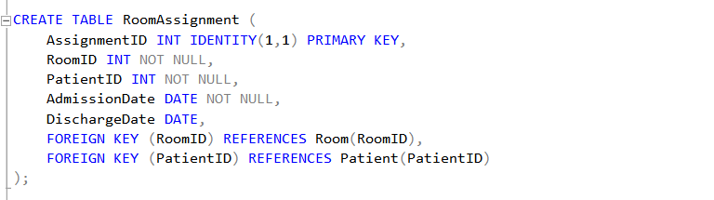

1. **Database Authorization:**

This has the implementation database authorization rules and roles. Both ways of granting the permissions and assigning the role for type of actions is done as shown ih the image.

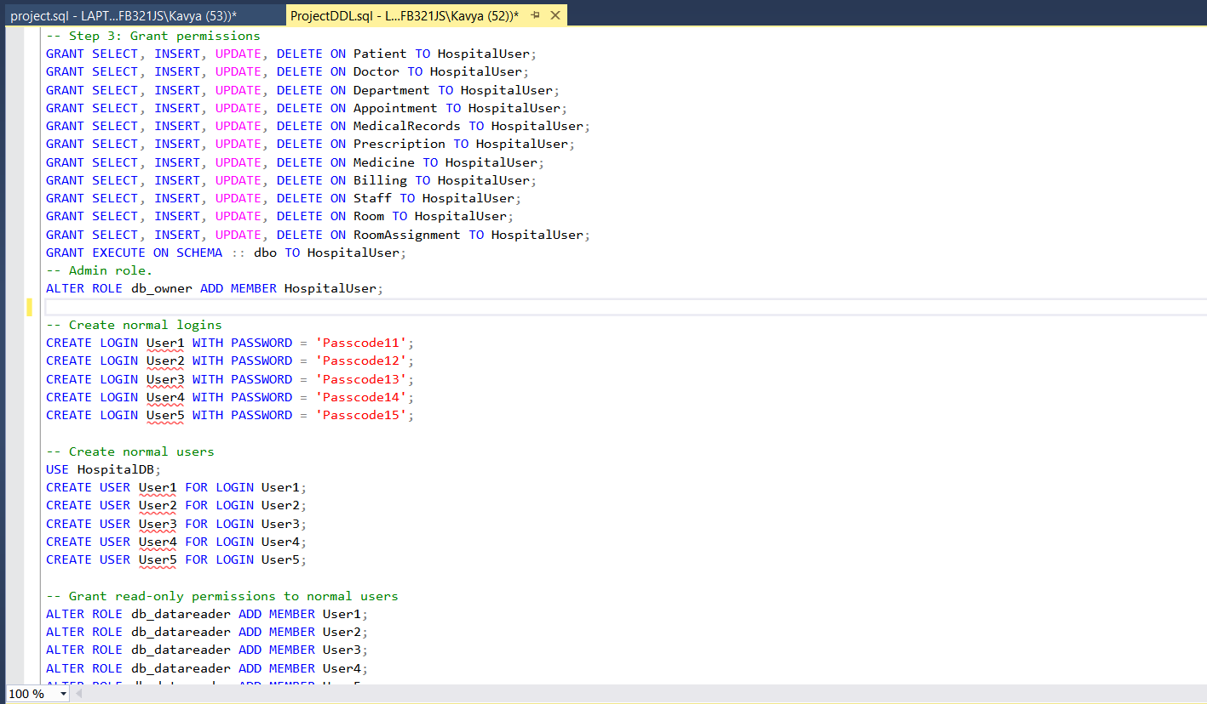

1. **Data Population:** Used Python and Faker library to generate synthetic data and populate tables.

1. **Query Development and Result:**

**Database Design:**

* **Tables Created:** 11 tables (Patient, Doctor, Department, Appointment, Medical Record, Prescription, Medicine, Billing, Room, RoomAssignment, and Staff).
* **Relationships:** Implemented one-to-one, one-to-many, and many-to-many relationships.
* **Constraints:** Enforced primary keys, foreign keys, and unique constraints.

**Sample Data:**

|  |  |
| --- | --- |
| **Table Name** | **No. of Records** |
| Patient | 100 |
| Doctor | 20 |
| Department | 5 |
| Appointment | 500 |
| Medical Records | 500 |
| Prescription | 100 |
| Medicine | 50 |
| Billing | 500 |
| Staff | 50 |
| Room | 20 |

**Database Authorization**

Developed and tested SQL queries to answer business questions and validate database functionality.

User1 with data read role cannot update the table values and tested it as shown below.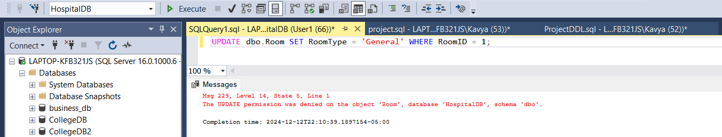HospitalUser with db onwer role can update the table values and tested it as shown below.

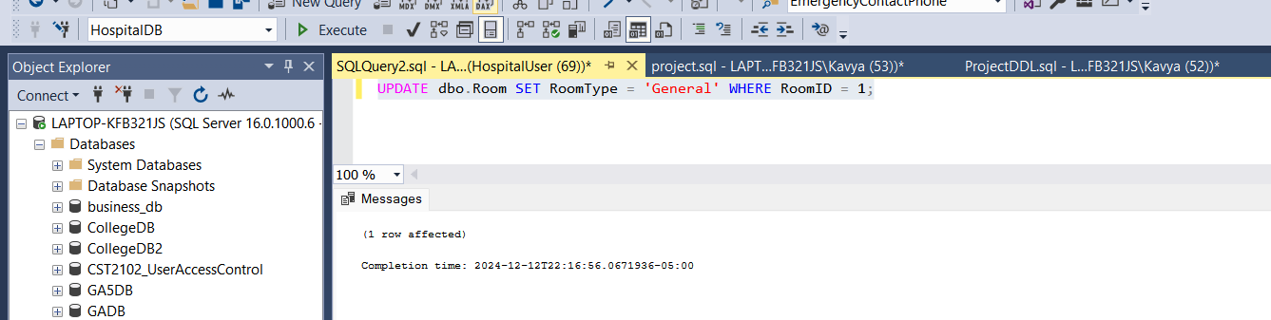

**General Queries:** Select query of all the tables.

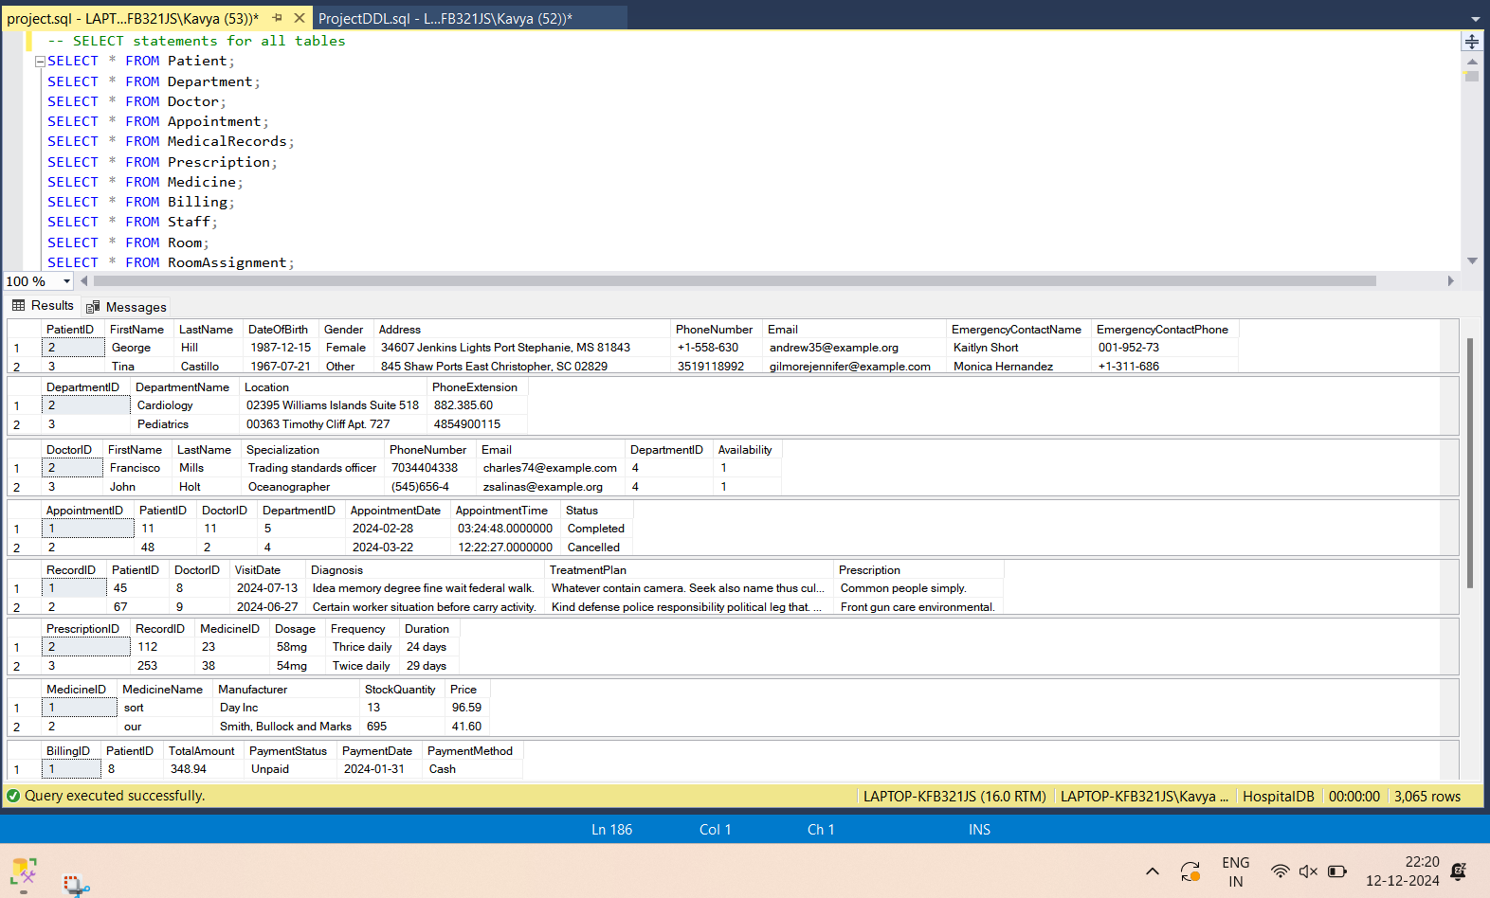

**Business Queries:**

1. Average Number of Appointments per Patient in the Last 6 Months

Insight: Determines the average number of visits per patient.

Usefulness: Helps identify patient engagement and healthcare needs

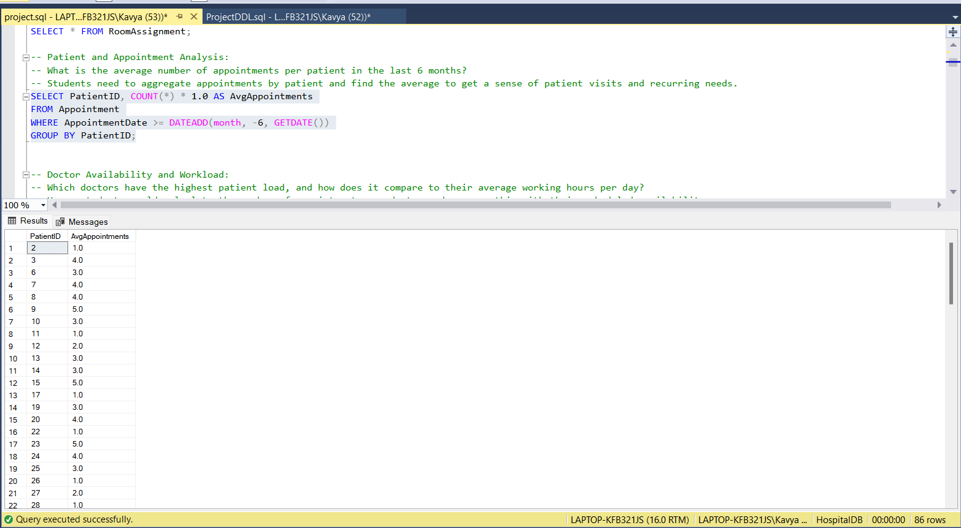

1. Doctor Availability and Workload

Insight: Shows doctor workload and compares it with their working hours.

Usefulness: Assists in balancing doctor schedules and managing workloads.

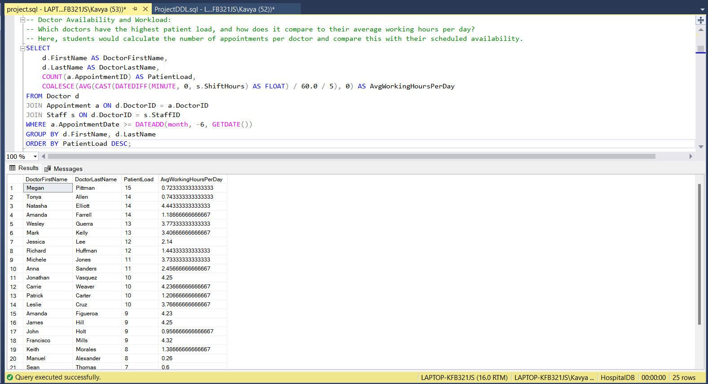

1. Total Revenue Generated from Different Departments Over the Past Quarter

Insight: Identifies revenue generation by department.

Usefulness: Aids in financial planning and resource allocation.

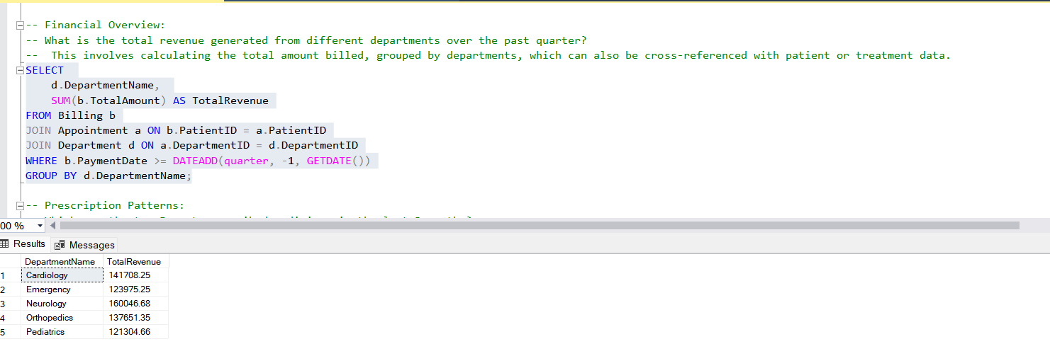

1. Top 5 Most Prescribed Medicines in the Last 3 Months

Insight: Highlights the most commonly prescribed medicines.

Usefulness: Informs inventory management and procurement strategies.

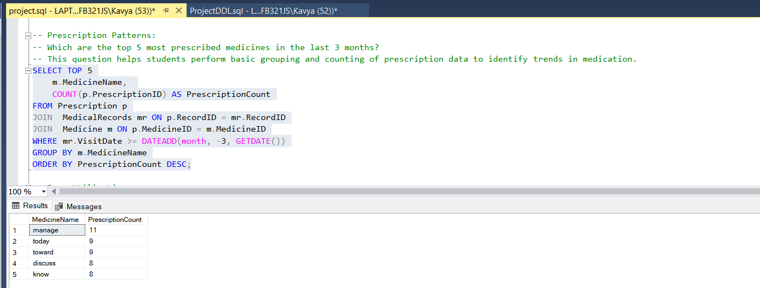

1. Percentage of Rooms Occupied in the Last Month (ICU, General, Private)

Insight: Shows room occupancy rates.

Usefulness: Helps optimize room allocation and availability.

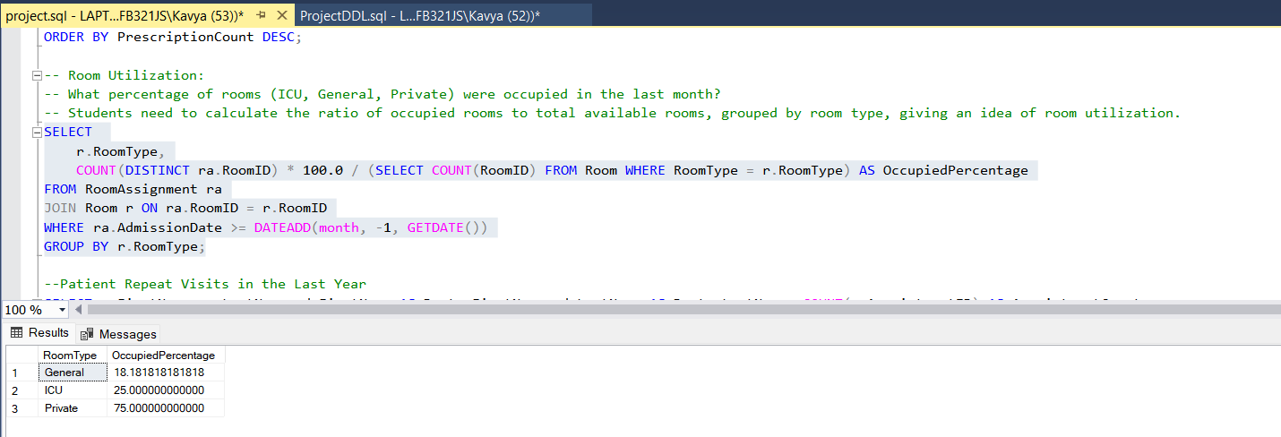

1. Patient Repeat Visits in the Last Year

Insight: Identifies patients with multiple visits.

Usefulness: Helps monitor patient follow-up and chronic care management.

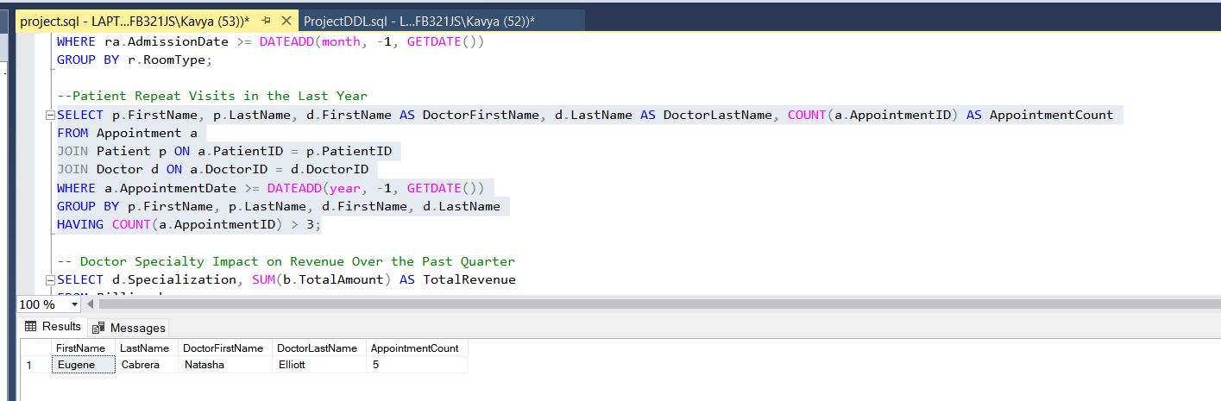

1. Doctor Specialty Impact on Revenue Over the Past Quarter

Insight: Shows revenue generated by different doctor specialties.

Usefulness: Guides strategic planning for specialized services.

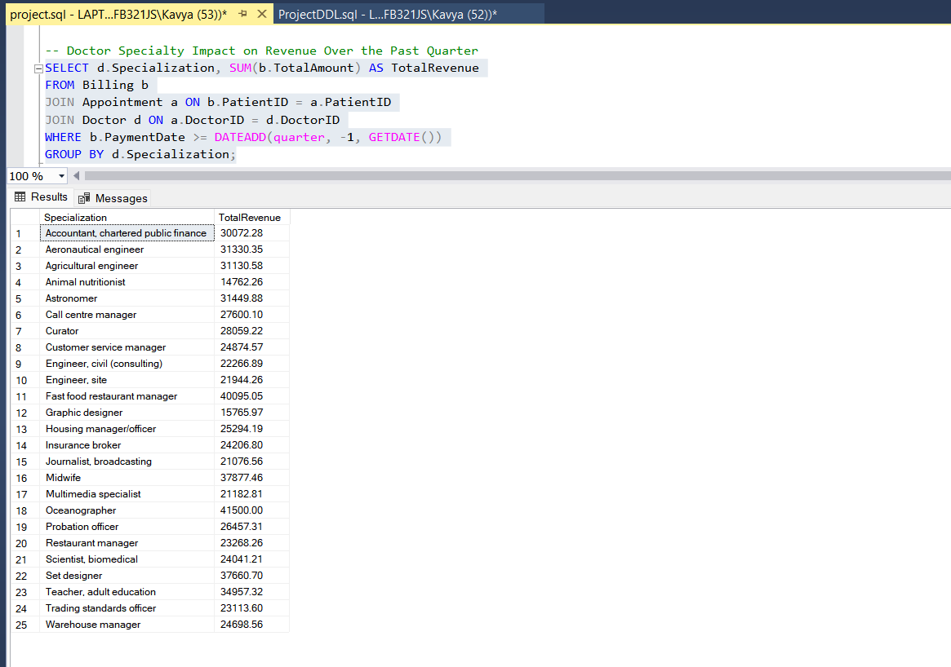

1. Distribution of Patients by Age Group

Insight: Provides demographic information about patient age groups.

Usefulness: Helps in tailoring services and marketing strategies.

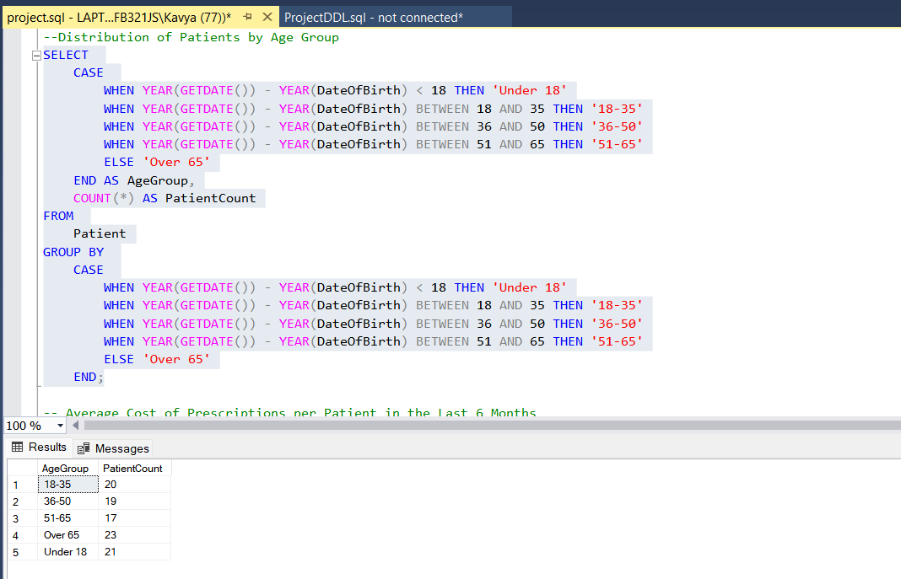

1. Average Cost of Prescriptions per Patient in the Last 6 Months

Insight: Calculates average prescription costs for patients.

Usefulness: Aids in financial planning and patient cost management.

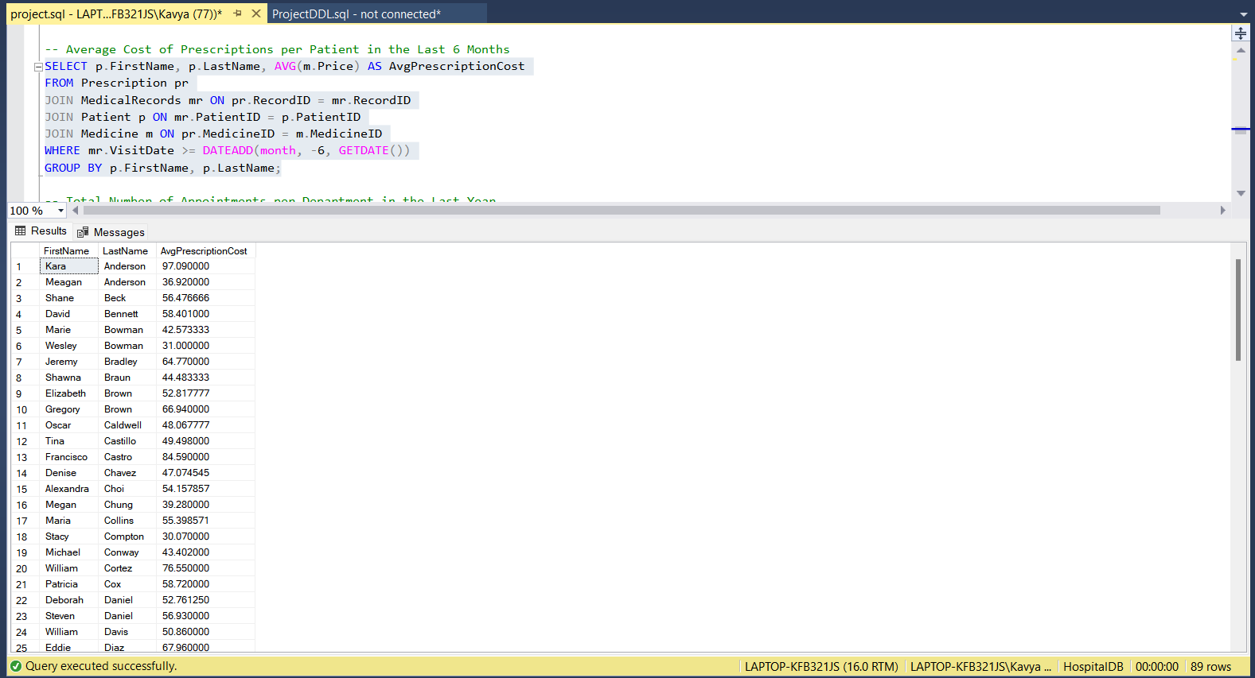

1. Total Number of Appointments per Department in the Last Year

Insight: Shows the volume of appointments per department.

Usefulness: Helps manage departmental workloads and resources.

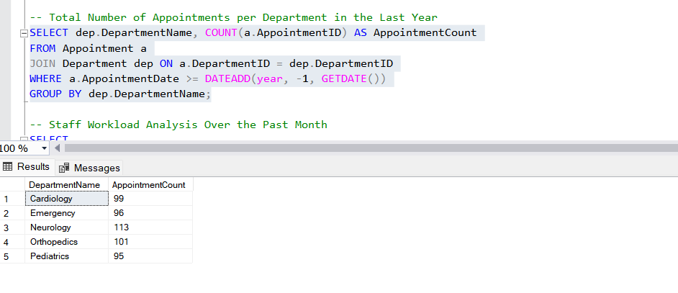

1. Staff Workload Analysis Over the Past Month

Insight: Analyzes average working hours by department.

Usefulness: Ensures optimal staff allocation and management.

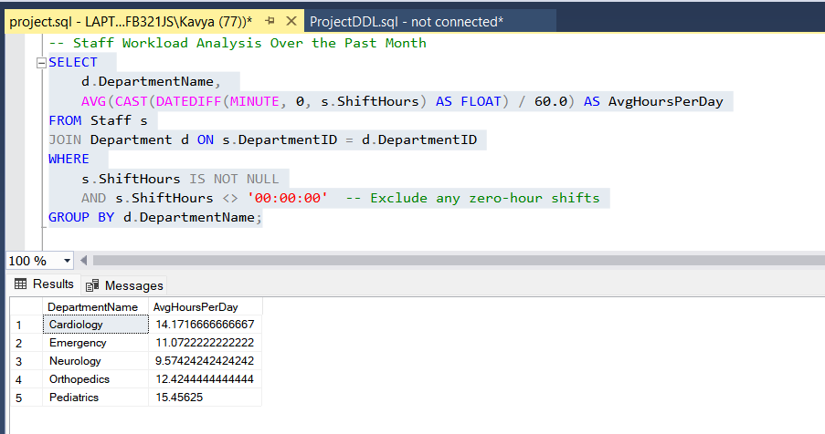

1. Revenue by Payment Method Over the Past Quarter

Insight: Shows revenue generated by different payment methods.

Usefulness: Informs financial strategy and payment method optimization.

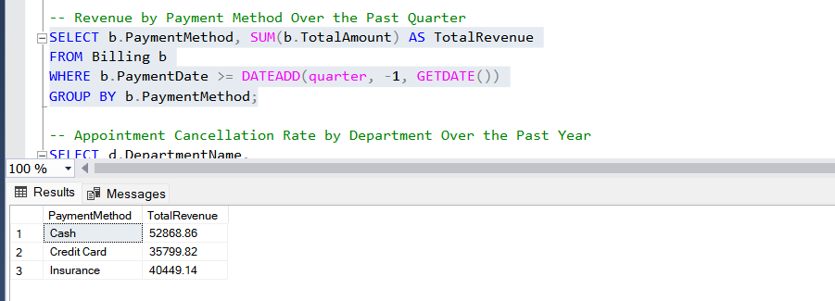

1. Appointment Cancellation Rate by Department Over the Past Year

Insight: Calculates the cancellation rate for appointments by department.

Usefulness: Helps improve appointment scheduling and patient management

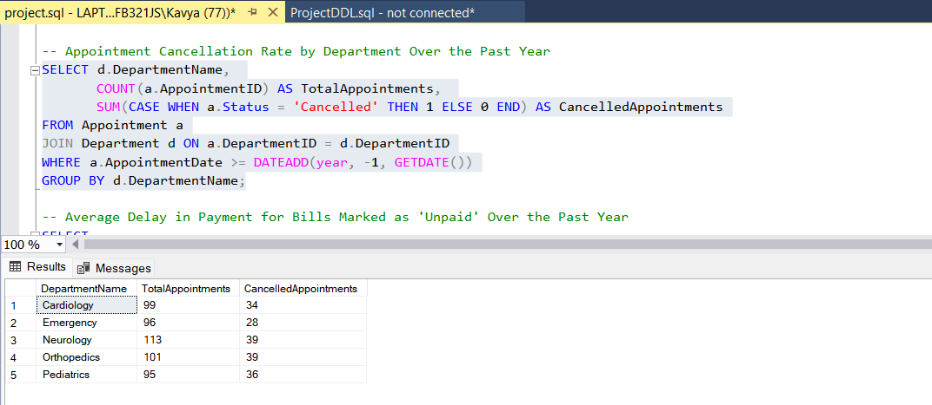

1. Average Delay in Payment for Bills Marked as 'Unpaid' Over the Past Year

Insight: Identifies average delays in payment by department.

Usefulness: Enhances billing processes and cash flow management.

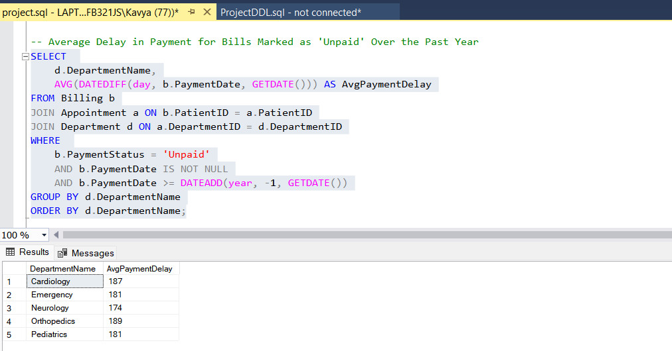

1. Average Length of Stay for Patients in the Hospital, Broken Down by Room Type, Over the Past Year

Insight: Determines the average duration of patient stays by room type.

Usefulness: Helps in resource planning and capacity management to optimize room utilization.

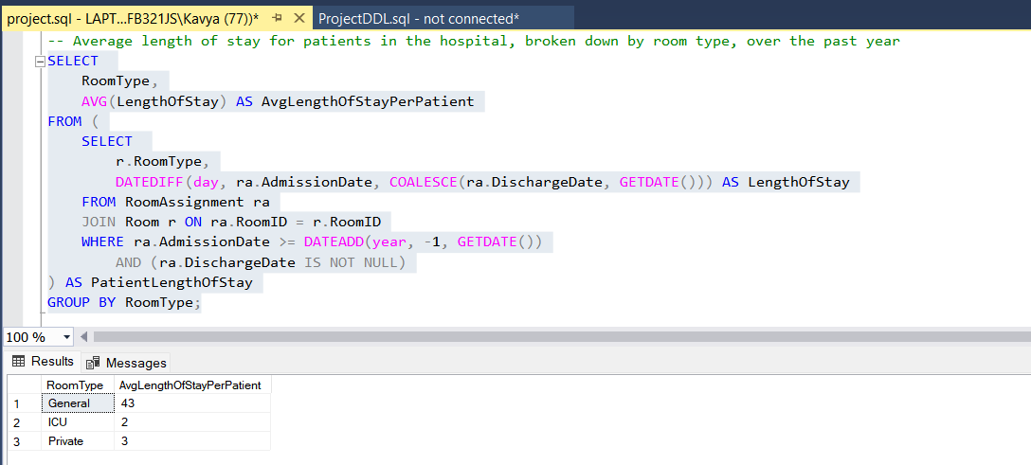

**Visualizations in Power BI:**

1. **Hospital Management Analytic Dashboard**

The presented dashboard provides an overview of key metrics within the hospital management system, focusing on patient appointments, prescriptions, revenue distribution, room utilization, and department-specific data. This visualization aids in understanding operational patterns and supports decision-making for enhanced hospital management.

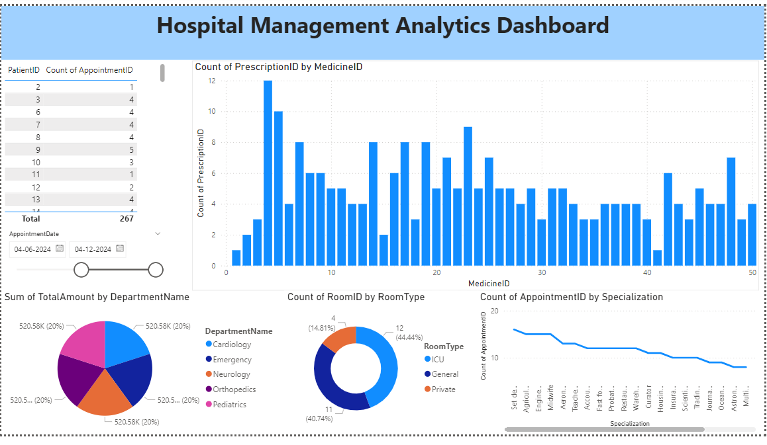

This dashboard offers valuable insights into hospital operations:

* **Patient Engagement:** Tracking appointments helps monitor repeat visits and assess patient satisfaction.
* **Inventory Management:** Prescription trends provide actionable data for managing medicine stocks.
* **Revenue Distribution:** Department-specific revenue highlights areas of growth and potential investment.
* **Room Optimization:** Room occupancy rates guide resource allocation to meet patient demand effectively.
* **Specialization Impact:** Analysing appointment trends by specialization aids in resource planning and marketing strategies.

**Key Insights**

1. **Patient Appointments**
   1. A detailed table shows the count of appointments for each patient over a defined time range.
   2. A total of 267 appointments were recorded, illustrating the engagement of patients with the hospital.
2. **Prescription Distribution**
   1. The bar chart highlights the frequency of prescriptions for various medicines (MedicineID).
   2. This data helps identify the most prescribed medications and supports inventory management.
3. **Revenue by Department**
   1. The pie chart provides a breakdown of total revenue generated by each department, with contributions from Cardiology, Emergency, Neurology, Orthopaedics, and Paediatrics.
   2. Each department contributes equally (20%) to the total revenue, indicating balanced performance across departments.
4. **Room Utilization by Type**
   1. The donut chart shows the count and percentage of rooms utilized by type: ICU, General, and Private.
   2. General rooms account for the highest utilization (44.44%), followed by Private (40.74%) and ICU (14.81%).
5. **Appointment Trends by Specialization**
   1. A line chart displays the count of appointments categorized by doctor specialization.
   2. The trend helps identify which specializations receive the highest patient engagement.

**Findings:**

* **Appointments per Patient:** The varying count of appointments per patient highlights differences in healthcare needs and engagement. This can guide personalized care strategies to improve patient outcomes.
* **Prescriptions and Medicines:** Frequent prescriptions of certain medicines indicate their critical role in treatments. Ensuring adequate stock of these medicines is crucial for uninterrupted patient care.
* **Department Revenue:** Balanced revenue distribution across departments reflects consistent utilization of hospital services. However, exploring opportunities to optimize performance in lower-revenue departments could further enhance efficiency.
* **Room Allocation:** General rooms are in high demand, followed by private and ICU rooms. Proper resource planning and room management strategies can help prevent overcrowding and improve patient satisfaction.
* **Doctor Specializations:** Specializations with higher appointment counts indicate popular or critical services. Expanding capacity or resources for these specialties could improve service quality and availability.

The dashboard serves as an efficient tool for hospital administrators, offering a holistic view of operational metrics. By leveraging these insights, the hospital can optimize resources, improve patient care, and streamline operations for sustained growth.

1. **Payment and Appointment Overview:**

Hospitals handle a significant volume of financial transactions and patient appointments daily. Understanding patterns in payment methods, payment statuses, and appointment outcomes is critical for ensuring smooth operations and financial stability. This report highlights the key insights extracted from the hospital management dashboard, which visualizes financial and operational data to support informed decision-making.

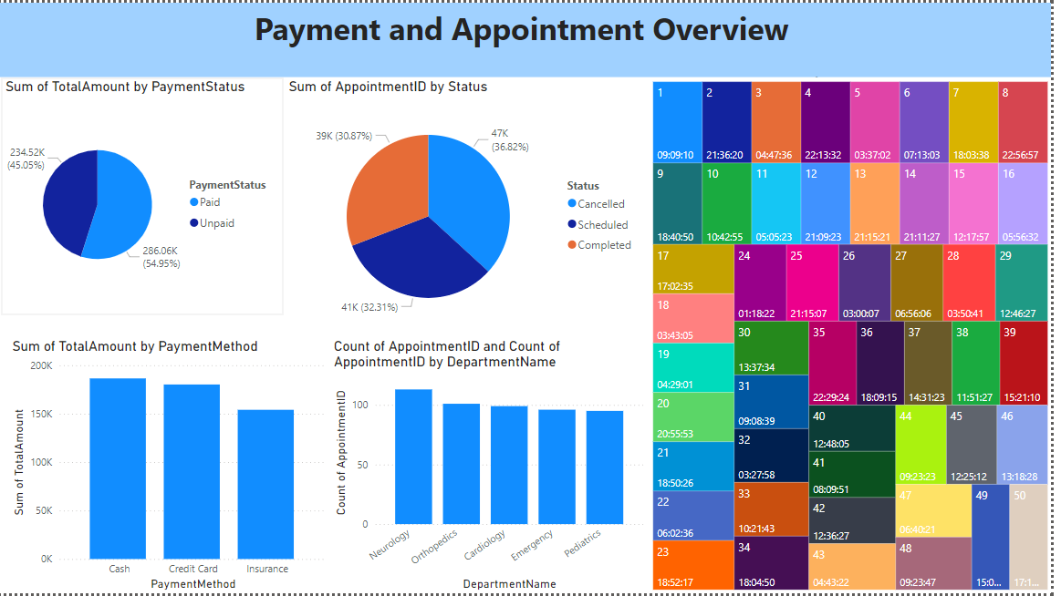

The dashboard comprises visualizations that depict:

* **Payment Status Distribution:** Pie chart showing percentages of "Paid" vs. "Unpaid" transactions.
* **Appointment Status Distribution:** Pie chart visualizing the proportion of canceled, scheduled, and completed appointments.
* **Payment Method Analysis:** Bar chart comparing total revenue generated by different payment methods (e.g., cash, credit card, and insurance).
* **Departmental Appointment Distribution:** Bar chart showing the count of appointments across key departments such as Neurology, Orthopaedics, Cardiology, Emergency, and Pediatrics.
* **Additional Visualization:** Heat map-style distribution representing appointment timing patterns.

**Key Insights:**

1. **Payment Status:**
   1. 54.95% of transactions are marked as "Paid," while 45.05% are "Unpaid."
   2. **Implication:** A significant portion of unpaid bills suggests a need for improved billing follow-ups or payment support systems.
2. **Appointment Status:**
   1. 36.82% of appointments were completed, 30.87% were scheduled, and 32.31% were cancelled.
   2. **Implication:** The high cancellation rate highlights potential issues in appointment scheduling, patient availability, or service delays.
3. **Payment Methods:**
   1. Payments are evenly distributed across cash, credit card, and insurance, with each method generating substantial revenue.
   2. **Implication:** Diversification of payment options is effective in catering to patient preferences.
4. **Departmental Appointment Distribution:**
   1. Departments like Neurology and Orthopaedics lead in appointment counts, with similar levels observed across other departments.
   2. **Implication:** These insights can guide resource allocation and ensure balanced staff availability.
5. **Timing Patterns:**
   1. Heat map data provides an overview of appointment timings, identifying peak and low-traffic hours for better scheduling and operational planning.
   2. **Implication:** Helps optimize workforce allocation and service delivery efficiency.

**Findings:**

* **Payment Status:** A high unpaid rate may require enhancements in the billing and payment reminder processes. Implementing automated systems for reminders could improve revenue recovery.
* **Cancellations:** Understanding the root causes of appointment cancellations—such as patient no-shows, scheduling conflicts, or delays—is essential for addressing this issue.
* **Payment Methods:** The diverse use of payment methods showcases financial flexibility, but ensuring smooth transaction processes across all methods is necessary to maintain patient satisfaction.

The dashboard provides actionable insights into payment trends, appointment statuses, and departmental performance, helping hospital management make data-driven decisions. Key areas of focus include addressing unpaid bills, optimizing appointment workflows, and enhancing departmental efficiency. Future steps could involve integrating these insights into predictive models to anticipate financial and operational challenges.

**Discussion**

1. The database efficiently handles complex relationships, such as many-to-many interactions between patients and doctors through appointments.
2. Data normalization ensures minimal redundancy and optimal storage.
3. The design supports scalability for future additions, such as advanced billing systems or integration with hospital management software.

**Conclusion**

The hospital management system database successfully meets the objectives of efficient data organization and operational support. Key insights from queries demonstrate its potential for improving hospital workflows and decision-making. Future work includes integrating real-time dashboards and expanding functionality for patient self-service portals.

**References**

1. Elmasri, R., & Navathe, S. B. (2016). *Fundamentals of Database Systems*. Pearson.
2. Silberschatz, A., Korth, H. F., & Sudarshan, S. (2020). *Database System Concepts*. McGraw-Hill.
3. Python Faker Library Documentation. Available at: [https://faker.readthedocs.io/]
4. SQL Server Management Studio Documentation. Available at: [<https://docs.microsoft.com/en-us/sql/ssms/>]