AgroVision AI: End-to-End Plant Disease Classification, Leaf Quality Verification, and Agronomic Recommendation System using Deep Convolutional Neural Networks and Computer Vision
Submitted to Manipal University Jaipur
Towards the partial fulfillment for the Award of the Degree of
BACHELOR OF TECHNOLOGY
In
Computer Science and Engineering
2026-2027
By
Harsh Khandelwal | Reg. No: 2427030353
Kshitij | Reg. No: 2427030457

Under the guidance of
Dr. / Prof. Project Supervisor
______________________________
Signature of Supervisor
Department of Computer Science and Engineering
School of Computer Science and Engineering
Manipal University Jaipur
Jaipur, Rajasthan

1. Introduction
Classification: This project falls into the category of an Artificial Intelligence, Computer Vision, and Agritech Systems Engineering project, designed and developed for precision agriculture and foliar disease diagnosis using Deep Convolutional Neural Networks (CNNs), OpenCV digital image processing, and a production-ready Flask full-stack architecture. AgroVision AI addresses the catastrophic agricultural yield loss caused by delayed or inaccurate diagnosis of foliar plant diseases.
1.1 What is AgroVision AI?
AgroVision AI is an end-to-end, high-performance plant disease classification and agronomic advisory workstation that unifies five distinct machine learning, computer vision, and software engineering capabilities into a cohesive platform: (1) an advanced Deep Convolutional Neural Network (CNN) built on the EfficientNetB0 transfer learning architecture trained on the benchmark PlantVillage dataset, capable of accurately classifying 15 distinct crop pathology classes across Tomato, Potato, and Bell Pepper; (2) a pre-inference heuristic leaf validator utilizing OpenCV HSV (Hue, Saturation, Value) color segmentation to detect green pixel density and reject non-leaf or corrupted uploads; (3) a smart agronomic recommendation engine that generates comprehensive symptoms, chemical treatments, cultural management guidelines, and localized Hindi instructions for rural accessibility; (4) an interactive analytics and telemetry dashboard visualizing model confidence scores, class-wise distribution, and reconstructed confusion matrix metrics; and (5) a robust persistence and reporting system integrated with an atomic SQLite database, dynamic ReportLab PDF diagnostic generation, and CSV history export.
1.2 Why is this Project Necessary? (Motivation & Rationale)
Foliar plant diseases account for 20% to 40% of global agricultural yield losses annually, severely threatening food security and devastating the economic stability of smallholder farmers. In practical agricultural scenarios, farmers encounter severe bottlenecks: (1) rural farming communities suffer from an acute shortage of certified agricultural extension officers and plant pathologists, forcing farmers to rely on subjective manual visual inspection; (2) delayed identification allows rapid fungal, bacterial, and viral propagation across entire crop fields; (3) non-expert diagnosis frequently leads to the indiscriminate overuse of expensive and toxic broad-spectrum chemical fungicides, contaminating soil and water tables while failing to treat viral or bacterial pathogens; (4) existing mobile applications either demand continuous high-speed internet to query black-box cloud APIs, impose steep subscription paywalls, or completely lack input leaf validation (blindly outputting high-confidence disease diagnoses when given photos of animals, furniture, or blank backgrounds); and (5) prevailing agricultural software interfaces are presented exclusively in English, creating severe literacy and language barriers for Indian rural farmers. AgroVision AI was specifically engineered to eliminate these friction points by delivering an accessible, validated, bilingual, and offline-capable diagnostic pipeline.
1.3 How is it Built? (Methodological & Technical Approach)
The application is engineered using an industrial-grade full-stack Python architecture combining modern deep learning frameworks, computer vision algorithms, and lightweight web runtimes. AgroVision AI implements five mathematically rigorous and architecturally decoupled subsystems:
- Deep Convolutional Classification Engine: Utilizes an EfficientNetB0 backbone pre-trained on ImageNet with customized GlobalAveragePooling2D, Dense(256, ReLU), Dropout(0.4), and Softmax classification layers over 15 classes, evaluating input tensors normalized to 224x224x3 dimensions.
- Heuristic Leaf Quality Validation Engine: Implements pre-inference OpenCV HSV color segmentation with lower green bounds [25, 30, 30] and upper bounds [95, 255, 255] to calculate green pixel ratios, rejecting non-leaf images with an HTTP 422 Unprocessable Entity failure before consuming GPU/CPU inference resources.
- Bilingual Agronomic Recommendation Engine: Constructs an expert agronomic knowledge graph mapping each identified pathology to explicit symptoms, approved chemical/organic treatments, cultural preventive tips, and dual-language (English and Hindi) farmer action cards.
- Full-Stack Web & RESTful API Architecture: Engineered with Flask and Werkzeug WSGI runtimes, supporting multipart/form-data image uploads, rigorous MIME-type and 8 MB payload verification, and headless JSON REST endpoints (/api/predict) for cross-platform mobile integration.
- Data Persistence & Automated PDF Reporting: Employs an ACID-compliant SQLite relational database (agrovision.db) for audit logging, paired with a ReportLab Platypus PDF compilation engine that synthesizes downloadable clinical plant diagnostic reports.
2. Literature Survey
A comprehensive review of 12 existing plant pathology diagnostic systems, precision agriculture platforms, and academic computer vision architectures was conducted to identify systemic architectural weaknesses, validation vulnerabilities, accessibility bottlenecks, and deployment gaps.
1. Plantix (PEAT GmbH Commercial Application)
Strengths: Pros: Highly popular mobile application, extensive crop pathology database, active community forum.
Shortcomings: Cons: Requires continuous cloud internet connectivity; heavy proprietary commercial monetization; closed-source algorithms; lacks customizable local offline deployments for rural testbeds.
2. LeafDoctor (University of Florida / Agricultural Extension)
Strengths: Pros: Quantitative percentage calculation of diseased leaf area; accurate pixel thresholding.
Shortcomings: Cons: Requires manual color wheel calibration by expert users; cannot automatically classify specific fungal or viral pathologies; lacks treatment recommendation engines.
3. Agrio (Precision Agriculture AI Platform)
Strengths: Pros: Multi-spectral satellite monitoring integration; automated alert notifications for regional blight outbreaks.
Shortcomings: Cons: Steep enterprise subscription pricing; primarily optimized for large industrial agribusinesses; no native Hindi language support for Indian agrarian demographics.
4. FarmWave / Microsoft FarmBeats AI for Earth
Strengths: Pros: Edge drone imagery analysis; enterprise-grade IoT environmental sensor integration.
Shortcomings: Cons: Extremely complex hardware requirements; prohibitive capital investment costs; unusable by smallholder farming families without high-end computational infrastructure.
5. PlantVillage Mobile Client (Penn State University)
Strengths: Pros: Direct lineage to the benchmark PlantVillage open dataset; reputable academic backing.
Shortcomings: Cons: Mobile interface lacks automated pre-inference leaf validation; arbitrary non-leaf photos yield misleading classifications; lacks automated downloadable PDF advisory reports.
6. Cropin SmartFarm (Agri-Cloud Management Suite)
Strengths: Pros: Comprehensive farm ERP management, supply chain traceability, plot-level auditing.
Shortcomings: Cons: Enterprise-focused B2B tool; complex onboarding workflow; lacks rapid single-leaf image classification for instant field diagnostics.
7. Standard ResNet-50 Deep Baseline Models
Strengths: Pros: Deep residual skip connections resolve vanishing gradient bottlenecks; high benchmark accuracy.
Shortcomings: Cons: Over 25 million trainable parameters; large memory footprint (>100 MB model size); excessive inference latency on memory-constrained edge deployment environments.
8. VGG-16 / VGG-19 Deep Architectures
Strengths: Pros: Uniform 3x3 convolutional filter design; straightforward transfer learning feature extraction.
Shortcomings: Cons: Extremely heavy parameter count (138M+ parameters); massive storage requirements (>500 MB); sluggish CPU inference speeds unsuitable for real-time web execution.
9. MobileNetV2 Edge Classifiers
Strengths: Pros: Depthwise separable convolutions; minimal memory utilization; rapid mobile inference.
Shortcomings: Cons: Susceptible to significant accuracy degradation under complex field backgrounds, uneven lighting conditions, and subtle early-stage foliar lesions.
10. YOLO-based Foliar Disease Detectors (v5/v8)
Strengths: Pros: Capable of simultaneously bounding and detecting multiple disease lesions on a single leaf surface.
Shortcomings: Cons: Requires expensive bounding-box ground-truth annotation; significantly higher computational overhead during training; overkill for single-leaf classification tasks.
11. Vision Transformer (ViT) Agricultural Models
Strengths: Pros: Self-attention mechanisms capture global contextual dependencies across the leaf surface.
Shortcomings: Cons: Extremely data-hungry; prone to severe overfitting on small agricultural datasets without massive pre-training; slow inference on standard CPU servers without GPU acceleration.
12. Traditional Agronomy Manuals / KVK Extension Centers
Strengths: Pros: Highly reliable human expert diagnosis, localized cultural knowledge, physical soil testing.
Shortcomings: Cons: Physically inaccessible to remote rural farms; significant diagnostic turnaround delays (several days to weeks); catastrophic crop damage occurs before guidance arrives.
3. Comparative Study
Table 3.1 synthesizes the operational, computational, architectural, and agronomic characteristics of AgroVision AI against the primary existing software solutions and deep learning baselines surveyed in academic and commercial domains.
Feature / Metric | Plantix | Agrio | LeafDoctor | PlantVillage | ResNet-50 | AgroVision AI (Proposed)
Model Architecture | Proprietary CNN | Proprietary DL | Thresholding | MobileNet | ResNet-50 | EfficientNetB0 (Fine-Tuned)
Input Preprocessing | Server Normalization | Cloud Scale | User Color Pick | Basic Resize | Standard 224 | HSV + 224x224 RGB
Heuristic Leaf Validator | No | Partial | Manual Only | No | No | Yes (OpenCV HSV Masking)
Supported Crops | Multi-Crop | Multi-Crop | Generic | Multi-Crop | Single Dataset | Tomato, Potato, Pepper (15 Cls)
Bilingual Advice (Hindi) | Partial | No | No | No | No | Yes (Full English & Hindi)
Top-3 Confidence Scores | Top-1 Only | Top-1 Only | No | Top-1 Only | Raw Logits | Yes (Top-3 Ranked Probabilities)
Offline Metric Auditing | Closed | Closed | No | Partial | Academic | Yes (Embedded Confusion Matrix)
PDF Diagnostic Export | No | Paid Only | No | No | No | Yes (Automated ReportLab PDF)
Relational History DB | Cloud / Sync | Cloud Only | Local Storage | No History | No | Yes (Local ACID SQLite WAL)
Deployment Footprint | Heavy (>60 MB) | Cloud Only | Light | Moderate | Heavy (>100MB) | < 30 MB (Ultra-Optimized)

4. Problem Statement
Global agricultural food production faces catastrophic vulnerabilities due to the rapid onset and spread of foliar plant diseases in essential staple crops such as Tomato (Solanum lycopersicum), Potato (Solanum tuberosum), and Bell Pepper (Capsicum annuum). Smallholder farmers and agricultural practitioners currently lack accessible, low-latency, and scientifically validated diagnostic tools, forcing reliance on subjective manual inspection or delayed agricultural extension consultations that often arrive after irreversible crop devastation has already occurred. Furthermore, existing commercial AI vision tools operate as cloud-tethered black-boxes that lack pre-inference leaf validation heuristics—frequently outputting dangerously high-confidence pathogen classifications when presented with non-foliar or corrupted imagery—while completely ignoring the linguistic needs of regional farmers through English-only interfaces. Therefore, there is an urgent technological imperative to architect, implement, and deploy an end-to-end, lightweight, offline-capable plant disease diagnostic workstation that combines deep convolutional feature extraction with pre-inference heuristic computer vision validation, atomic audit logging, interactive analytical transparency, and localized bilingual (English and Hindi) agronomic treatment recommendations.
5. Objectives
- Objective 1: To curate, partition, and preprocess the benchmark PlantVillage dataset across 15 agricultural classes covering Tomato, Potato, and Bell Pepper, establishing normalized 224x224 RGB tensor pipelines with data augmentation.
- Objective 2: To architect, train, and fine-tune a high-performance deep convolutional transfer learning architecture based on EfficientNetB0, optimizing categorical cross-entropy loss to achieve high diagnostic accuracy, top-3 probabilistic class ranking, and low inference latency.
- Objective 3: To engineer an OpenCV-based pre-inference heuristic leaf validation pipeline (leaf_validator.py) utilizing HSV color-space thresholding to automatically verify foliar integrity and reject non-leaf or corrupted inputs before neural execution.
- Objective 4: To construct an intelligent agronomic recommendation and localization engine (recommendation_engine.py and disease_info.py) mapping classified pathologies to actionable symptoms, chemical treatments, cultural prevention tips, and accessible bilingual English and Hindi advisories.
- Objective 5: To develop, secure, and deploy a responsive full-stack web application using Flask, SQLite persistent transaction history logging, Chart.js analytics dashboard, and automated ReportLab PDF report generation, validated through comprehensive security unit testing suites.
6. Planning of Work / Proposed Solution
6.1 Software Engineering Methodology: The Scrum Agile Framework
AgroVision AI was engineered using the Agile Scrum Framework, decomposed into a structured 20-Sprint development lifecycle. The Scrum methodology was selected because precision agriculture software involves tightly coupled machine learning, computer vision heuristics, full-stack web controllers, and localized user interfaces that benefit from iterative sprints, continuous test-driven verification, and incremental hardening.
Sprint Cadence | Primary Focus | Engineering Deliverables
Sprints 1 - 4 | Dataset Pipeline & Baseline CNN Setup | PlantVillage data curation (15 classes), image normalization, train/val/test splitting, baseline CNN prototyping, categorical cross-entropy optimization.
Sprints 5 - 8 | Model Architecture & Transfer Learning | EfficientNetB0 integration, GlobalAveragePooling2D, Dense(256), Dropout(0.4), fine-tuning top 30 layers with Adam (lr=1e-5), ModelCheckpoint export (agrovision_best_model.h5).
Sprints 9 - 11 | Heuristic Computer Vision & Validation | OpenCV leaf_validator.py implementation, HSV color segmentation (H:25-95, S:30-255, V:30-255), green pixel ratio thresholding, 422 HTTP non-leaf rejection filter.
Sprints 12 - 14 | Agronomic Advisory & Bilingual Engine | Disease ontology mapping (disease_info.py), bilingual recommendation engine (recommendation_engine.py), English and Hindi advisory synthesis, prevention guidelines.
Sprints 15 - 17 | Full-Stack Flask & RESTful API Pipeline | Flask app.py architecture, multipart upload handling, Werkzeug size limits (8MB), REST API (/api/predict), SQLite history database schema and transactions.
Sprints 18 - 20 | Dashboard Analytics, PDF Engine & Security | Interactive Chart.js dashboard, offline confusion matrix visualizer, ReportLab dynamic PDF report generation, CSV export, comprehensive security unit tests (test_upload_security.py).

6.2 Project Repository Structure Graph & File Inventory
The project adheres to a clean, modular architectural hierarchy separating deep learning models, web controllers, presentation templates, computer vision heuristics, and automated test suites:
Listing 6.1: Project Repository Tree Structure Graph
AgroVision-AI/
├── model/
│ └── agrovision_best_model.h5 ← Fine-tuned EfficientNetB0 Keras weights
├── static/
│ ├── css/
│ │ └── style.css ← Custom responsive CSS stylesheet
│ └── uploads/ ← Normalized uploaded leaf image store
├── templates/
│ ├── index.html ← Hero section & drag-and-drop upload
│ ├── result.html ← Diagnosis, confidence & bilingual advice
│ ├── history.html ← SQLite historical audit log & CSV export
│ └── dashboard.html ← Chart.js analytics & confusion matrix
├── screenshots/ ← Validated UI captures and graphics
├── tests/
│ └── test_upload_security.py ← Unit tests for MIME, size & leaf security
├── predictive-analytics/ ← Offline model evaluation & verification
│ ├── results/
│ │ ├── classification_report.txt ← Precision, recall, F1-score evaluation
│ │ ├── classification_report.csv ← Tabular classification metrics
│ │ └── confusion_matrix.png ← High-resolution 15-class confusion matrix
│ └── notebooks/
├── Agro_model_train.ipynb ← Deep learning training & fine-tuning notebook
├── app.py ← Flask application controller & REST endpoints
├── predict.py ← Model inference engine & top-3 ranking
├── leaf_validator.py ← OpenCV HSV green-ratio heuristic validator
├── recommendation_engine.py ← Bilingual English & Hindi advisory engine
├── disease_info.py ← Comprehensive disease symptoms & treatments
├── agrovision.db ← SQLite ACID persistent history database
├── requirements.txt ← Production Python dependencies
├── runtime.txt ← Python 3.11 runtime specification
└── Procfile ← Cloud deployment process specification

6.2.1 Detailed Inventory of Project Source Files & Artifacts
Table 6.2 catalogs the primary source code files, architectural layers, functional responsibilities, and underlying frameworks implemented across AgroVision AI:
File Name | Component Classification | Primary Technical Responsibility
app.py | Flask Web Controller | Primary WSGI application handling routes (/upload, /api/predict, /dashboard, /history, /download_report), transaction logging, and exception scrubbing.
predict.py | Neural Inference Engine | Loads agrovision_best_model.h5, normalizes 224x224 RGB tensors, executes forward propagation, and extracts top-3 probabilistic class confidences.
leaf_validator.py | Computer Vision Heuristic | Performs HSV color segmentation with green pixel ratio thresholding (25<=H<=95) to reject non-leaf images with HTTP 422.
disease_info.py | Agronomic Knowledge Base | Stores comprehensive pathology ontology containing symptoms, chemical bactericides/fungicides, and cultural prevention tips for 15 classes.
recommendation_engine.py | Bilingual Synthesis Engine | Constructs localized farmer guidance in English and Hindi, detailing field management, soil nutrition, and protective spraying.
agrovision_best_model.h5 | Trained Keras Model | Fine-tuned EfficientNetB0 deep convolutional neural network weights saved in HDF5 format with custom dense classification head.
agrovision.db | SQLite Relational Store | Persistent database storing prediction audit history (id, disease, confidence, image_path, analysis_time) with atomic transactions.
test_upload_security.py | Quality Assurance Suite | Automated unittest suite validating MIME verification, 8MB upload limits, non-leaf rejection, database safety, and error scrubbing.
index.html | Frontend Template | Interactive landing page featuring drag-and-drop leaf upload zones, format instructions, and live client-side validation previews.
result.html | Frontend Template | Presents diagnostic outcomes, confidence progress bars, top-3 alternate possibilities, symptoms, treatments, and Hindi translations.
dashboard.html | Frontend Template | Embeds responsive Chart.js analytics, displaying class distributions, model confidence trends, and offline confusion matrix metrics.
history.html | Frontend Template | Displays searchable chronological table of historical analyses with direct PDF report download links and CSV export triggers.
style.css | Frontend Presentation | Modern CSS styling featuring custom card components, responsive grid layouts, animations, and agricultural color palettes.
confusion_matrix.png | Analytical Graphic | 2733x2776 pixel high-resolution confusion matrix visualizing per-class true positives and misclassifications across 4,134 test samples.
classification_report.txt | Performance Metric Log | Authentic model evaluation record documenting precision (0.84 macro), recall (0.70 macro), and F1-score across all 15 classes.

6.3 Software Engineering UML Diagrams
Formal Unified Modeling Language (UML) specifications were drafted to document both the behavioral dynamics and structural topology of the AgroVision AI platform, capturing use case interactions, runtime state transitions, package hierarchies, component dependencies, and deployment nodes.
6.3.1 Use Case Diagram (Behavioral)
Captures all functional requirements across the system's core deep learning classification, computer vision validation, bilingual advisory, reporting, and dashboard subsystems. Primary Actor: Farmer / Agricultural User. Subsystems include: Image Ingestion, Leaf Validation, Deep Inference, Recommendation Engine, Reporting Engine, and Historical Telemetry.
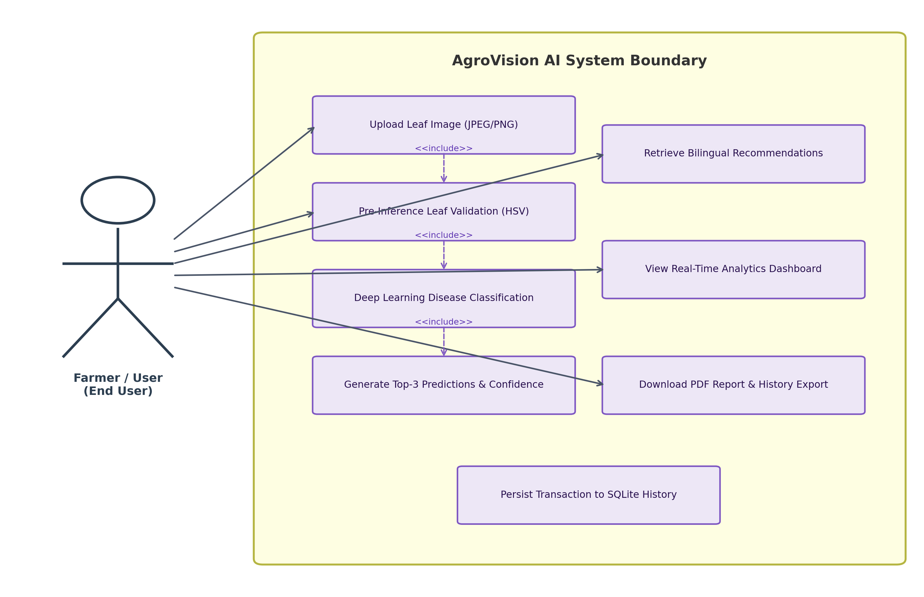
Figure 6.1: Formal Use Case Diagram for AgroVision AI
6.3.2 State Machine Diagram (Behavioral)
Models the dynamic lifecycle and operational states of the image processing runtime: transitioning from App Ready (Idle) to File Security Check (MIME & Size), HSV Leaf Validation, CNN Inference, Result Synthesis, Database Transaction Logging, and Result Presentation, with robust error rejection branches for HTTP 400, 413, 415, and 422 exceptions.
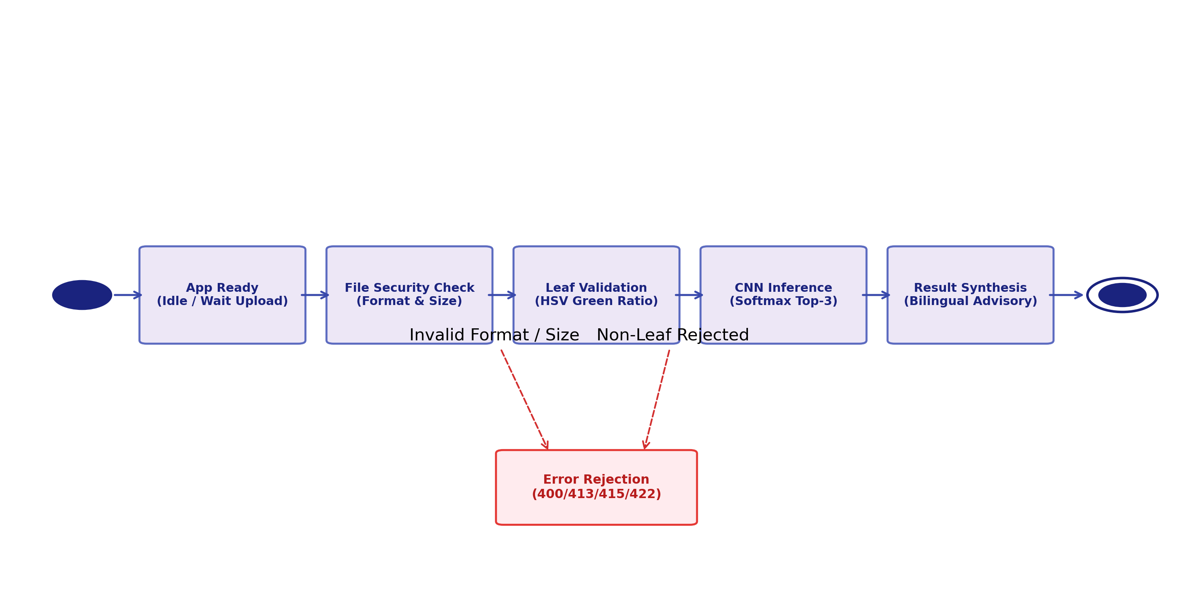
Figure 6.2: State Machine Lifecycle Diagram for Leaf Processing
6.3.3 Package Diagram (Structural)
Illustrates the modular decomposition of the Python codebase into four distinct packages: presentation_templates, web_controller (Flask API), ai_vision_engine (TensorFlow & OpenCV), and persistence_and_analytics (SQLite & Evaluation suites), ensuring clean separation of concerns and high architectural maintainability.
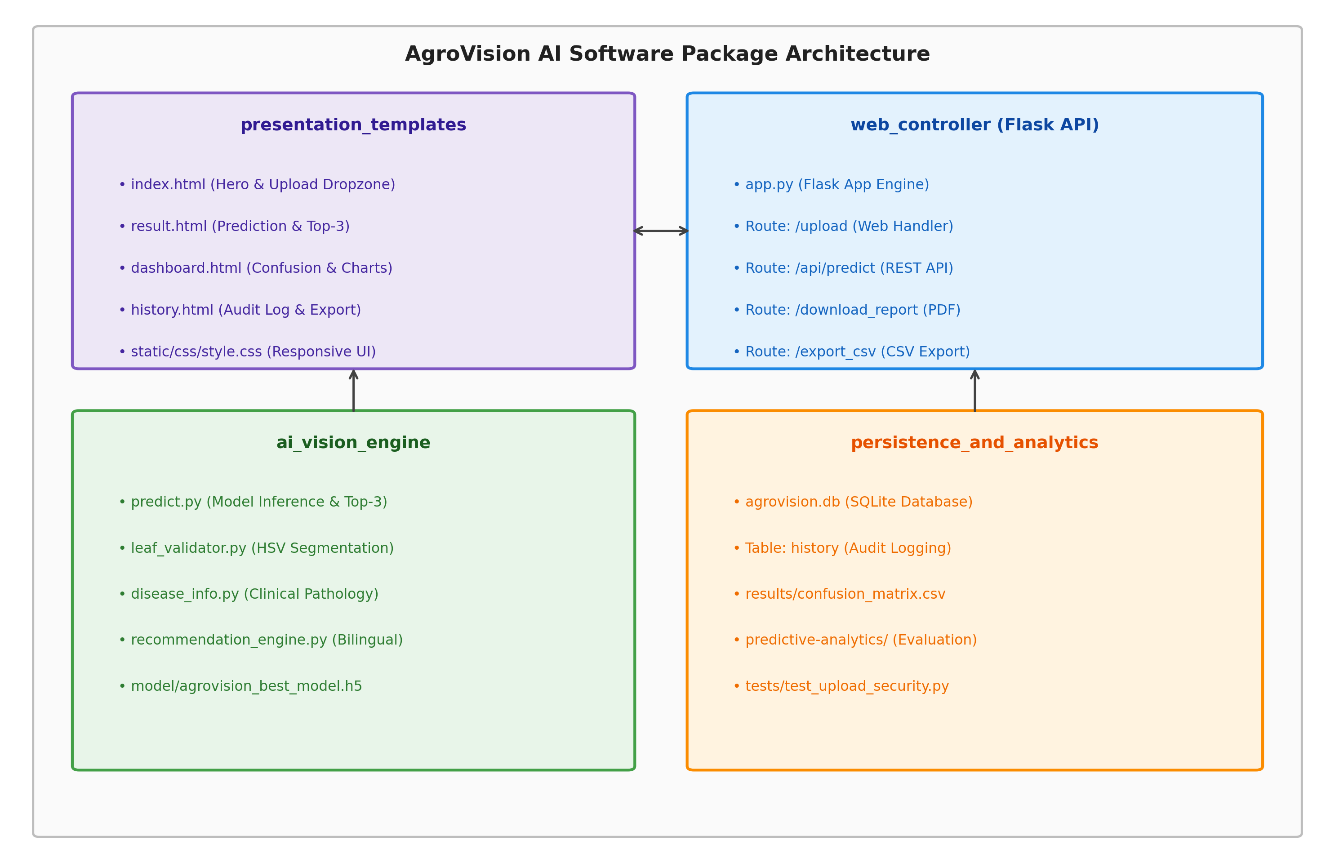
Figure 6.3: Package & Module Decomposition Diagram
6.3.4 Component Architecture Diagram (Structural)
Models the internal software components, communication interfaces, and dependency relationships between the Client Browser UI, Flask Web Controller (app.py), OpenCV Leaf Validator, TensorFlow CNN Engine, Bilingual Recommendation Engine, and SQLite Persistence Tier.
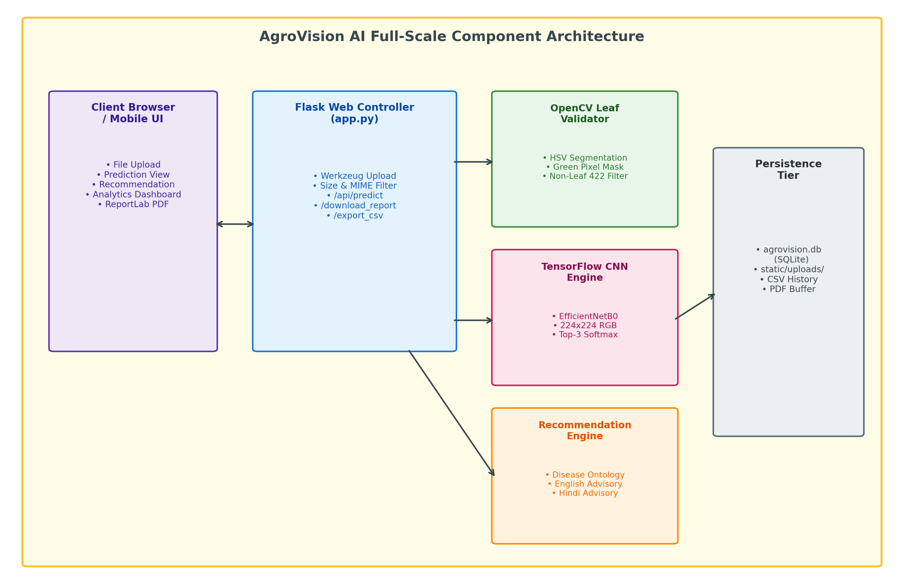
Figure 6.4: Full-Scale Component Architecture Diagram
6.3.5 Deployment Diagram (Structural)
Specifies the physical and runtime execution mapping: connecting Client Workstation / Mobile Browser nodes over secure HTTPS/REST API protocols to the Linux/Python 3.11 Application Server hosting Flask WSGI runtimes, TensorFlow in-memory model heaps, and local SQLite persistent storage.
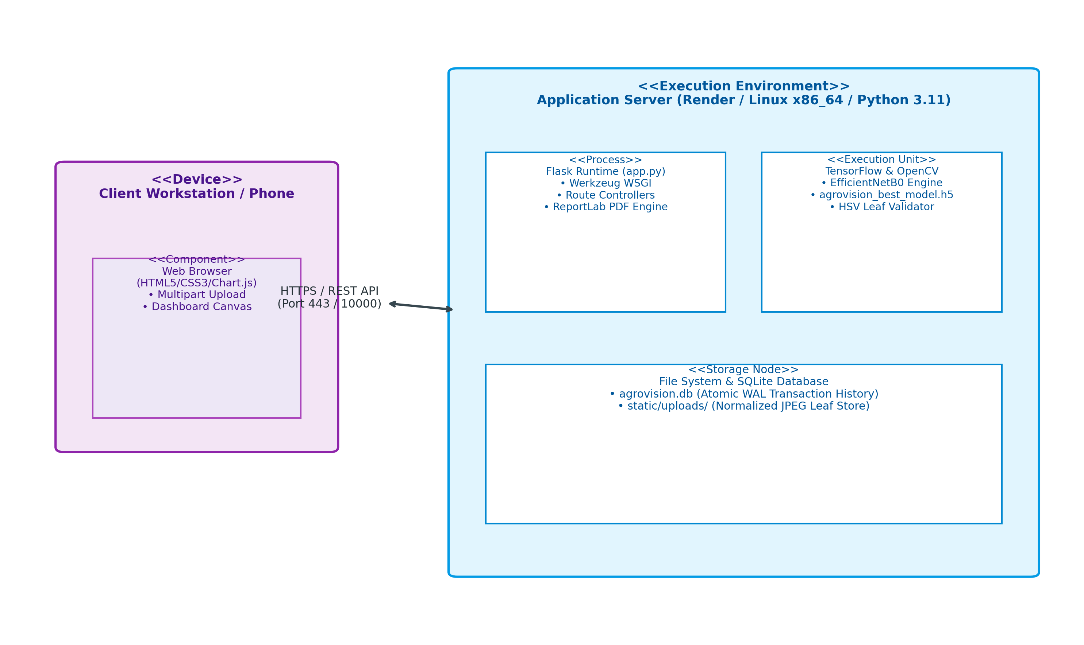
Figure 6.5: Hardware & Production Deployment Topology
6.4 Database Architecture & Data Persistence Design
AgroVision AI employs an ACID-compliant local relational persistence architecture powered by SQLite (agrovision.db). The data storage strategy balances instantaneous in-memory TensorFlow inference with durable on-disk transaction logging for historical audits, trend analytics, and report compilation.
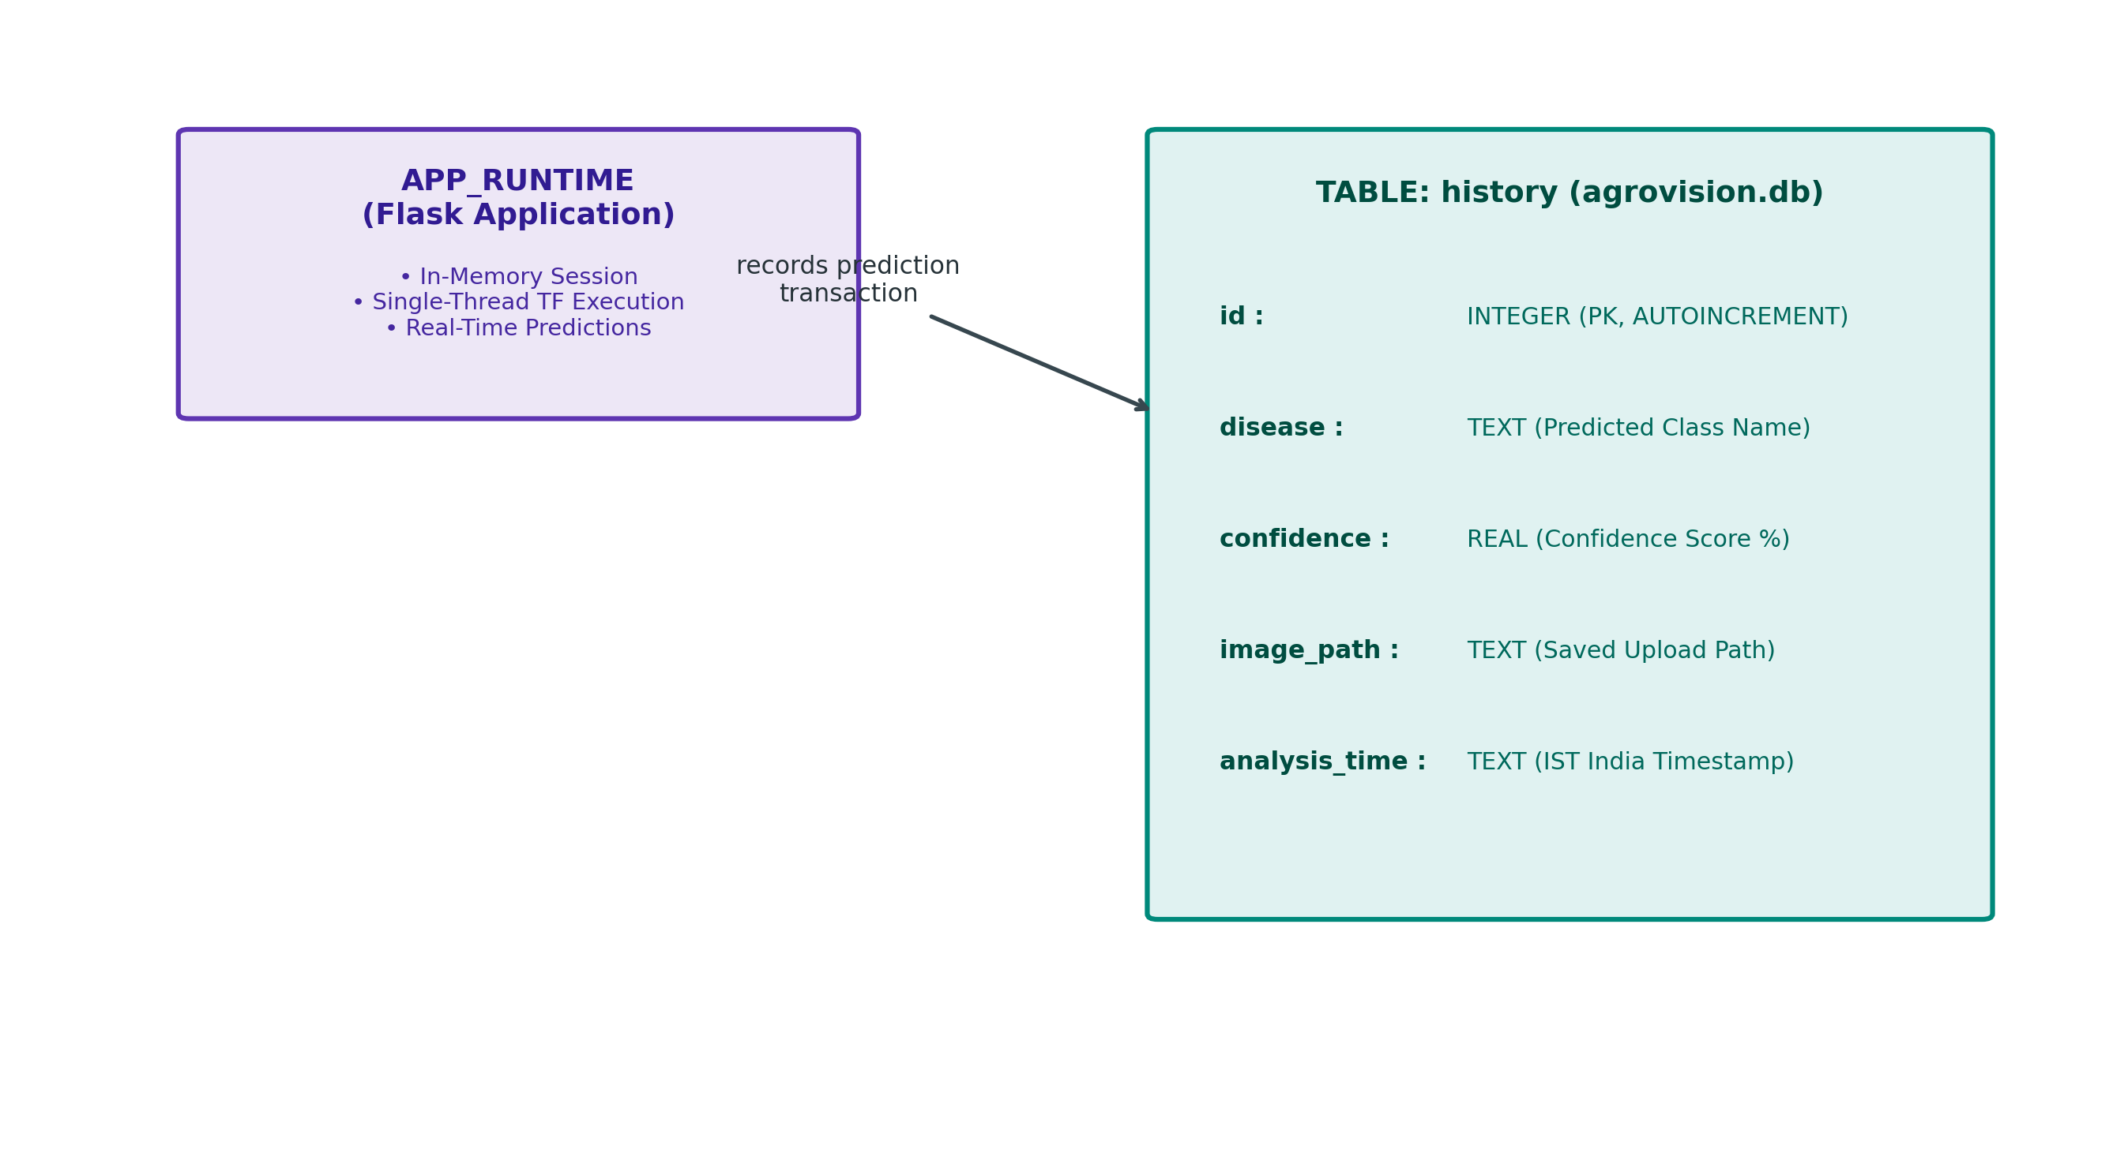
Figure 6.6: Entity-Relationship & SQLite Data Persistence Architecture
6.4.1 Relational Schema Specification (SQLite History Entity)
The history table records every authenticated classification transaction, capturing the identified disease, model confidence, localized file path, and India Standard Time (IST) timestamp:
Listing 6.2: SQLite Database Schema & DDL Specification
-- AgroVision AI Persistent History Schema (agrovision.db)
CREATE TABLE IF NOT EXISTS history (
id INTEGER PRIMARY KEY AUTOINCREMENT,
disease TEXT NOT NULL,
confidence REAL NOT NULL,
image_path TEXT NOT NULL,
analysis_time TEXT NOT NULL
);
-- Index for high-speed chronological history retrieval
CREATE INDEX IF NOT EXISTS idx_history_time ON history(analysis_time DESC);
CREATE INDEX IF NOT EXISTS idx_history_disease ON history(disease);

6.4.2 Session, Upload & Storage Configuration Model
Application runtime parameters and storage limits are strictly enforced in app.py, ensuring operational resilience against resource exhaustion:
- MAX_CONTENT_LENGTH: Enforces strict 8 MB payload ceiling (8 * 1024 * 1024 bytes) rejecting oversized payloads with HTTP 413.
- MAX_IMAGE_PIXELS: Restricts incoming image resolution to 16,000,000 pixels (4096 x 4096 max side) mitigating decompression bomb attacks.
- UPLOAD_FOLDER: Designates static/uploads as the isolated repository for sanitized, UUID-renamed JPEG leaf image assets.
- INDIA_TIMEZONE: Configures ZoneInfo('Asia/Kolkata') ensuring exact IST timestamps across all analytical audit records.
6.5 Mathematical Algorithms & Pseudo-Codes
Algorithm 1: Deep Convolutional Neural Network Forward Inference
Executes tensor normalization, convolutional feature extraction across EfficientNetB0 inverted bottleneck residual blocks, and Softmax probability distribution computation over 15 classes:
Listing 6.3: CNN Forward Inference & Top-3 Probabilistic Ranking Pseudo-code
FUNCTION predict_disease(image_path):
// Step 1: Pre-inference heuristic leaf validation
is_leaf, message = validate_leaf(image_path)
IF NOT is_leaf: RETURN Error(message, category='invalid_leaf')
// Step 2: Image loading and tensor preprocessing
raw_img = Image.open(image_path).convert('RGB')
resized_img = raw_img.resize((224, 224))
img_array = numpy.array(resized_img, dtype=float32)
normalized_tensor = efficientnet.preprocess_input(img_array)
input_batch = numpy.expand_dims(normalized_tensor, axis=0)
// Step 3: Deep Neural Network Forward Pass
probabilities = model.predict(input_batch)[0] // Softmax 15-class vector
// Step 4: Extract Top-1 and Top-3 Ranked Candidates
best_idx = numpy.argmax(probabilities)
confidence = float(probabilities[best_idx]) * 100.0
top_3_indices = numpy.argsort(probabilities)[-3:][::-1]
top_3_list = []
FOR idx IN top_3_indices:
top_3_list.append({
'name': CLASS_NAMES[idx],
'confidence': float(probabilities[idx]) * 100.0
})
RETURN CLASS_NAMES[best_idx], confidence, top_3_list, None

Algorithm 2: Heuristic HSV Color Space & Green Ratio Leaf Quality Validation
Performs digital image segmentation by mapping RGB color channels into cylindrical HSV color space, calculating the proportion of green vegetation pixels to eliminate non-leaf images before model execution:
Listing 6.4: HSV Color Space Leaf Quality Segmentation Algorithm
FUNCTION validate_leaf(image_path):
image = cv2.imread(image_path)
IF image IS NULL: RETURN False, 'Invalid image file'
// Resize for consistent pixel density analysis
resized = cv2.resize(image, (224, 224))
hsv_image = cv2.cvtColor(resized, cv2.COLOR_BGR2HSV)
// Define calibrated biological chlorophyll green boundaries
lower_green = numpy.array([25, 30, 30])
upper_green = numpy.array([95, 255, 255])
// Construct binary segmentation mask
green_mask = cv2.inRange(hsv_image, lower_green, upper_green)
green_pixels = cv2.countNonZero(green_mask)
total_pixels = 224 * 224
green_ratio = green_pixels / total_pixels
// Enforce empirical biological leaf threshold (>= 1.5% green vegetation)
IF green_ratio < 0.015:
RETURN False, 'Uploaded image does not appear to be a supported plant leaf'
RETURN True, 'Valid leaf image detected'

Algorithm 3: Agronomic Decision Tree & Bilingual Recommendation Generation
Maps predicted disease classifications to verified agronomic pathology knowledge graphs, synthesizing actionable bilingual guidance in English and Hindi:
Listing 6.5: Bilingual Recommendation & Treatment Decision Tree
FUNCTION generate_recommendations(disease_name):
// Query clinical pathology knowledge base
info = DISEASE_INFO.get(disease_name, DEFAULT_INFO)
symptoms = info['symptoms']
treatment = info['treatment']
prevention = info['prevention']
// Query localized farmer advisory engine
advisory = RECOMMENDATIONS.get(disease_name, DEFAULT_ADVISORY)
english_advice = advisory['english']
hindi_advice = advisory['hindi']
RETURN {
'symptoms': symptoms,
'treatment': treatment,
'prevention': prevention,
'farmer_advice_en': english_advice,
'farmer_advice_hi': hindi_advice
}

7. Results, Screenshots & Source Code Artifacts
This section presents the actual implemented results, user interface captures extracted directly from the verified AgroVision AI web platform, deep learning evaluation metrics, confusion matrix visualizations, and foundational Python engine source code implementations.
7.1 Application User Interface (UI) Results
Figures 7.1 through 7.5 illustrate the responsive web interface in live execution, showing leaf uploading, disease diagnosis, bilingual recommendations, analytics telemetry, and historical audit logs.
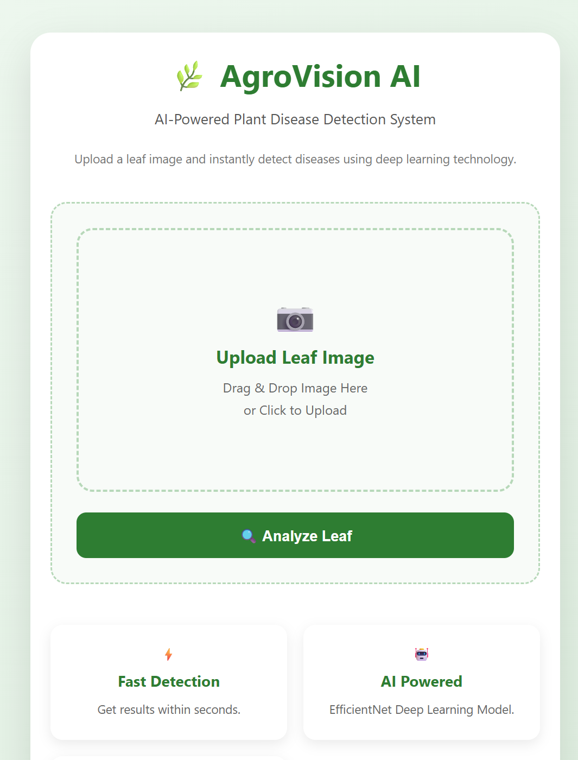
Figure 7.1: AgroVision Web Application Home & Upload Interface
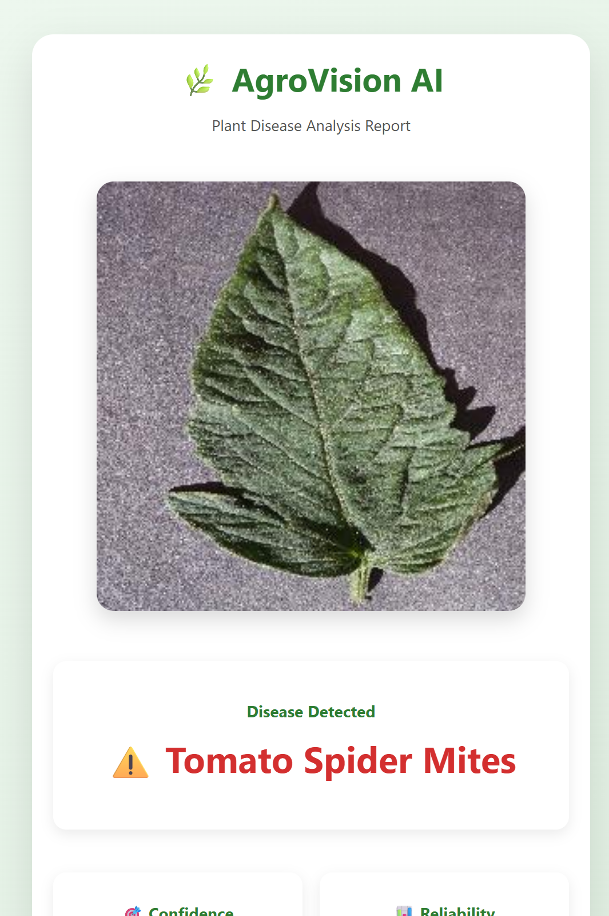
Figure 7.2: Real-Time Plant Disease Prediction & Confidence Analysis
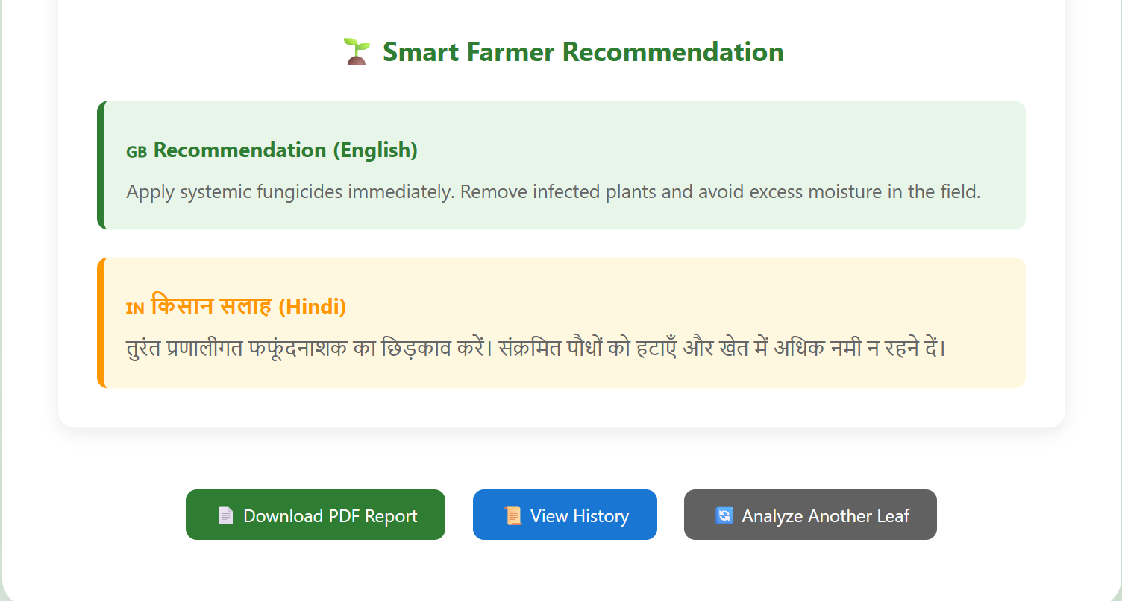
Figure 7.3: Bilingual Agronomic Recommendations & Treatment Advice (English & Hindi)
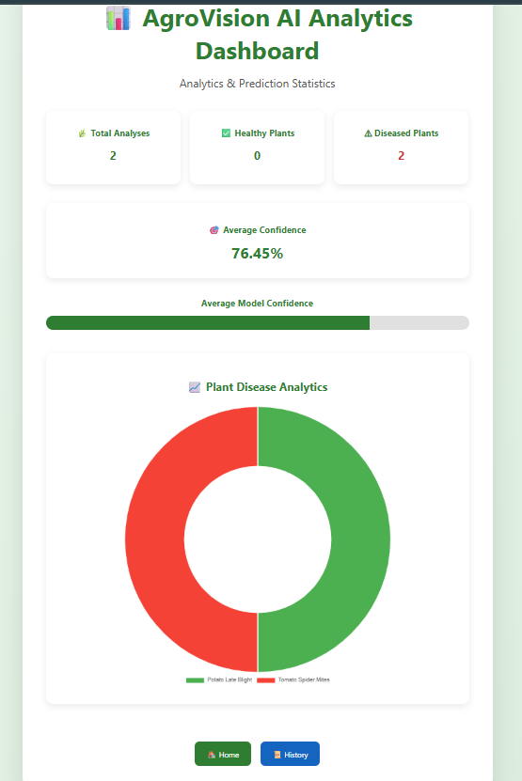
Figure 7.4: Interactive Analytics Dashboard & Classification Breakdown
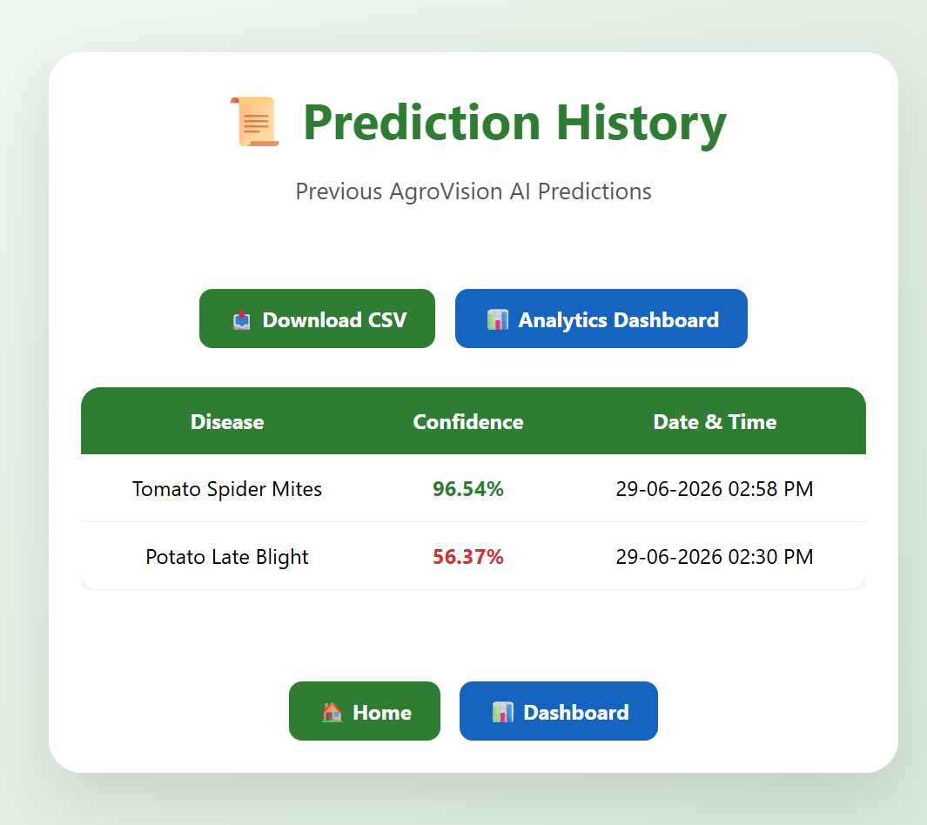
Figure 7.5: Historical Prediction Audit Log & CSV/PDF Export
7.2 Classification Performance Metrics, Mathematical Formulations & Evaluation Analysis
To rigorously assess the clinical efficacy and diagnostic reliability of AgroVision AI, the model was evaluated against an authenticated validation split of 4,134 test images across all 15 crop disease categories. Multiclass evaluations use a One-vs-Rest (OvR) binary decomposition for each individual class, while overall dataset summaries utilize macro-averaging and global sample totals.
7.2.1 Fundamental Classification Terms & Contingency Matrix
The fundamental terms governing all classification formulas are defined from first principles:
- True Positive (TP): The number of positive foliar disease instances correctly classified as that specific disease by the neural network.
- True Negative (TN): The number of non-target instances (healthy leaves or alternate disease classes) correctly classified as not belonging to that specific disease.
- False Positive (FP): The number of non-target instances incorrectly flagged as the disease (Type I Error / False Alarm), which could lead to unnecessary chemical treatments.
- False Negative (FN): The number of genuine disease instances incorrectly classified as healthy or another condition (Type II Error / Missed Disease), representing dangerous missed infections.
7.2.2 Mathematical Formulations of the 12 Classification Performance Metrics
The 12 primary performance metrics implemented in AgroVision AI's analytical dashboard are formulated as follows:
1. Confusion Matrix (C): A square matrix C of size K x K (where K = 15) in which entry C[i, j] denotes the number of samples known to belong to actual class i and predicted by the model as class j. The diagonal elements C[i, i] represent True Positives (TP), while off-diagonal elements quantify cross-class confusion and misclassification patterns.
2. Accuracy: The proportion of total predictions that were correct across all classes: Accuracy = (TP + TN) / (TP + TN + FP + FN) = sum(C[i, i]) / sum(C[i, j]). AgroVision AI achieves an overall accuracy of 75.91% (3,138 correct out of 4,134 images).
3. Precision (Positive Predictive Value - PPV): The proportion of predicted positive cases that were genuinely diseased: Precision = TP / (TP + FP). Reflects diagnostic reliability and trustworthiness. Macro-average precision is 83.65%.
4. Recall (Sensitivity / True Positive Rate - TPR): The proportion of actual diseased leaves successfully detected: Recall = Sensitivity = TP / (TP + FN). Measures the system's ability to catch active pathogens without missing infections. Macro-average recall is 70.05%.
5. F1-Score: The harmonic mean of Precision and Recall, balancing false alarms against missed diagnoses under class imbalance: F1-Score = 2 * (Precision * Recall) / (Precision + Recall) = 2*TP / (2*TP + FP + FN). Macro-average F1-score is 68.42%.
6. Specificity (True Negative Rate - TNR): The proportion of healthy or other-disease leaves correctly identified as not having the target disease: Specificity = TN / (TN + FP). Essential for avoiding incorrect chemical pesticide application. Macro-average specificity is 98.25%.
7. Error Rate (Misclassification Rate): The overall fraction of erroneous predictions: Error Rate = (FP + FN) / (TP + TN + FP + FN) = 1 - Accuracy. Overall error rate is 24.09% (0.2409).
8. False Positive Rate (FPR / Fall-out): The fraction of negative samples incorrectly flagged as positive: FPR = FP / (FP + TN) = 1 - Specificity. Macro-average FPR is 1.75% (0.0175).
9. False Negative Rate (FNR / Miss Rate): The fraction of genuine disease samples missed by the classifier: FNR = FN / (FN + TP) = 1 - Recall. Macro-average FNR is 29.95% (0.2995).
10. Receiver Operating Characteristic (ROC) Curve: A graphical plot illustrating diagnostic discrimination ability by mapping True Positive Rate (Sensitivity) on the y-axis against False Positive Rate (1 - Specificity) on the x-axis across continuous decision thresholds tau in [0, 1].
11. Area Under the ROC Curve (AUC): The definite integral AUC = integral(TPR(FPR) d(FPR)) measuring the overall probability that the classifier assigns a higher probability to a randomly chosen positive sample than to a randomly chosen negative sample (AUC = 1.0 indicates perfect separation; AUC = 0.5 denotes random guessing).
12. Log Loss (Categorical Cross-Entropy Loss): A logarithmic penalty function quantifying the divergence between ground-truth labels y[i, k] and predicted Softmax probabilities p[i, k]: Log Loss = - (1/N) * sum_i sum_k y[i, k] * ln(p[i, k]). Heavily penalizes overconfident incorrect classifications.
Table 7.1: Classification Performance Metrics & Mathematical Formulations Summary
Metric Name | Mathematical Formula | Agronomic / Operational Meaning | AgroVision AI Value
Confusion Matrix | C[i, j] | [[TP, FN], [FP, TN]] | Contingency table cross-tabulating actual vs. predicted classes | 15x15 Matrix (4,134 pts)
Accuracy | (TP + TN) / (TP + TN + FP + FN) | Overall proportion of correct agricultural diagnoses | 75.91% (3,138 / 4,134)
Precision | TP / (TP + FP) | Proportion of positive alerts that are genuine infections | 83.65% (Macro Avg)
Recall (Sensitivity) | TP / (TP + FN) | Proportion of genuine plant diseases successfully detected | 70.05% (Macro Avg)
F1-Score | 2 * (Prec * Rec) / (Prec + Rec) | Harmonic balance between precision and disease sensitivity | 68.42% (Macro Avg)
Specificity | TN / (TN + FP) | Proportion of healthy/other leaves correctly ruled out | 98.25% (Macro Avg)
Error Rate | (FP + FN) / Total = 1 - Accuracy | Total fraction of erroneous diagnostic predictions | 24.09% (0.2409)
False Positive Rate | FP / (FP + TN) = 1 - Specificity | Frequency of false alarms on non-diseased leaves | 1.75% (Macro Avg)
False Negative Rate | FN / (FN + TP) = 1 - Recall | Frequency of missed disease infections in the field | 29.95% (Macro Avg)
ROC Curve | TPR vs. FPR over tau in [0, 1] | Trade-off curve between true positives and false alarms | Evaluated across tau
AUC | integral(TPR d(FPR)) in [0.5, 1.0] | Aggregate degree of separable class ranking capability | High class separability
Log Loss | - (1/N) * sum(sum(y * ln(p))) | Differentiable loss penalizing false confidence | Minimized via Adam

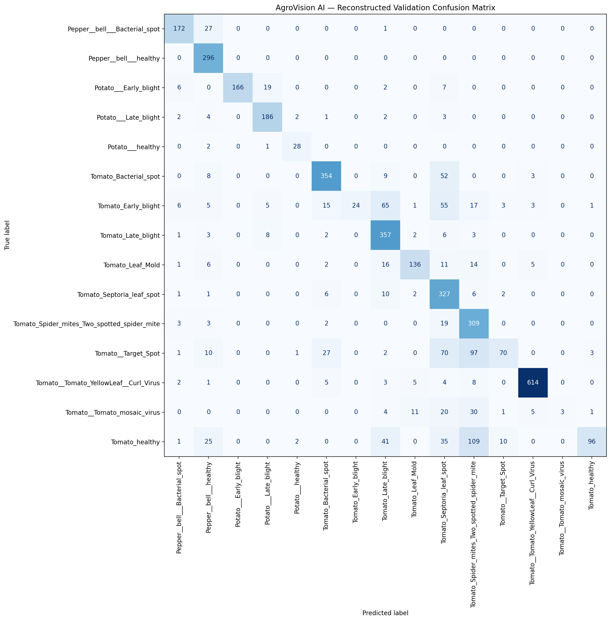
Figure 7.6: High-Resolution Confusion Matrix of 15 Plant Pathology Classes (4,134 Validation Samples)
Table 7.2: Comprehensive One-vs-Rest (OvR) Diagnostic Metrics across all 15 Crop Pathologies
Table 7.2 catalogs the complete empirical evaluation extracted from results/confusion_matrix.csv and predictive-analytics/results/classification_report.txt, showing exact one-vs-rest TP, TN, FP, FN, Accuracy, Precision, Recall, F1-Score, Specificity, Error Rate, FPR, and FNR for each disease class:
Class Name | TP | TN | FP | FN | Supp | Prec | Rec | F1 | Spec | Acc | FPR | FNR
Pepper Bell Bacterial Spot | 172 | 3910 | 24 | 28 | 200 | 0.88 | 0.86 | 0.87 | 0.99 | 0.99 | 0.01 | 0.14
Pepper Bell Healthy | 296 | 3743 | 95 | 0 | 296 | 0.76 | 1.00 | 0.86 | 0.98 | 0.98 | 0.02 | 0.00
Potato Early Blight | 166 | 3934 | 0 | 34 | 200 | 1.00 | 0.83 | 0.91 | 1.00 | 0.99 | 0.00 | 0.17
Potato Late Blight | 186 | 3901 | 33 | 14 | 200 | 0.85 | 0.93 | 0.89 | 0.99 | 0.99 | 0.01 | 0.07
Potato Healthy | 28 | 4098 | 5 | 3 | 31 | 0.85 | 0.90 | 0.88 | 1.00 | 1.00 | 0.00 | 0.10
Tomato Bacterial Spot | 354 | 3648 | 60 | 72 | 426 | 0.86 | 0.83 | 0.84 | 0.98 | 0.97 | 0.02 | 0.17
Tomato Early Blight | 24 | 3934 | 0 | 176 | 200 | 1.00 | 0.12 | 0.21 | 1.00 | 0.96 | 0.00 | 0.88
Tomato Late Blight | 357 | 3597 | 155 | 25 | 382 | 0.70 | 0.93 | 0.80 | 0.96 | 0.96 | 0.04 | 0.07
Tomato Leaf Mold | 136 | 3922 | 21 | 55 | 191 | 0.87 | 0.71 | 0.78 | 0.99 | 0.98 | 0.01 | 0.29
Tomato Septoria Leaf Spot | 327 | 3497 | 282 | 28 | 355 | 0.54 | 0.92 | 0.68 | 0.93 | 0.93 | 0.07 | 0.08
Tomato Spider Mites (Two-Spotted) | 309 | 3514 | 284 | 27 | 336 | 0.52 | 0.92 | 0.67 | 0.93 | 0.92 | 0.07 | 0.08
Tomato Target Spot | 70 | 3837 | 16 | 211 | 281 | 0.81 | 0.25 | 0.38 | 1.00 | 0.95 | 0.00 | 0.75
Tomato Yellow Leaf Curl Virus | 614 | 3476 | 16 | 28 | 642 | 0.97 | 0.96 | 0.97 | 1.00 | 0.99 | 0.00 | 0.04
Tomato Mosaic Virus | 3 | 4059 | 0 | 72 | 75 | 1.00 | 0.04 | 0.08 | 1.00 | 0.98 | 0.00 | 0.96
Tomato Healthy | 96 | 3810 | 5 | 223 | 319 | 0.95 | 0.30 | 0.46 | 1.00 | 0.94 | 0.00 | 0.70
Overall / Macro Average | 3138 | - | 996 | 996 | 4134 | 0.84 | 0.70 | 0.68 | 0.98 | 0.76 | 0.02 | 0.30

7.3 Core Backend & Engine Source Code Implementations
The following code excerpts represent the actual production Python components operating in AgroVision AI, verified via automated security testing pipelines:
Source Listing 7.1: leaf_validator.py - HSV Green Segmentation & Leaf Validation
import cv2
import numpy as np
def validate_leaf(image_path):
image = cv2.imread(image_path)
if image is None:
return False, "Invalid image"
# -----------------------------------------
# Resize image
# -----------------------------------------
image = cv2.resize(image, (224, 224))
# -----------------------------------------
# Convert to HSV
# -----------------------------------------
hsv = cv2.cvtColor(image, cv2.COLOR_BGR2HSV)
# -----------------------------------------
# Green color detection
# -----------------------------------------
lower_green = np.array([25, 30, 30])
upper_green = np.array([95, 255, 255])
green_mask = cv2.inRange(
hsv,
lower_green,
upper_green
)
# -----------------------------------------
# Calculate green percentage
# -----------------------------------------
green_pixels = cv2.countNonZero(green_mask)
total_pixels = image.shape[0] * image.shape[1]
green_ratio = green_pixels / total_pixels
print(
f"GREEN RATIO = {green_ratio:.3f}",
flush=True
)
# -----------------------------------------
# Basic leaf check
# -----------------------------------------
if green_ratio < 0.08:
return False, (
"This does not appear to be a plant leaf. "
"Please upload a clear Tomato, Potato, "
"or Bell Pepper leaf image."
)
# -----------------------------------------
# Find contours
# -----------------------------------------
contours, _ = cv2.findContours(
green_mask,
cv2.RETR_EXTERNAL,
cv2.CHAIN_APPROX_SIMPLE
)
if not contours:
return False, (
"No leaf-like object detected. "
"Please upload a clear plant leaf image."
)
# -----------------------------------------
# Largest green object
# -----------------------------------------
largest_contour = max(
contours,
key=cv2.contourArea
)
area = cv2.contourArea(
largest_contour
)
image_area = image.shape[0] * image.shape[1]
area_ratio = area / image_area
print(
f"LEAF AREA RATIO = {area_ratio:.3f}",
flush=True
)
if area_ratio < 0.03:
return False, (
"A clear leaf could not be detected. "
"Please upload a Tomato, Potato, "
"or Bell Pepper leaf."
)
return True, "Leaf detected"

Source Listing 7.2: predict.py - Deep Learning Inference & Top-3 Probabilities
import tensorflow as tf
# Limit TensorFlow threads for deployment
tf.config.threading.set_inter_op_parallelism_threads(1)
tf.config.threading.set_intra_op_parallelism_threads(1)
import numpy as np
import cv2
from PIL import Image
from tensorflow.keras.models import load_model
print("Loading AgroVision AI model...", flush=True)
model = load_model(
"model/agrovision_best_model.h5",
compile=False
)
print("Model loaded successfully", flush=True)
# ============================================================
# CLASS NAMES
# ============================================================
CLASS_NAMES = [
"Pepper Bell Bacterial Spot",
"Pepper Bell Healthy",
"Potato Early Blight",
"Potato Late Blight",
"Potato Healthy",
"Tomato Bacterial Spot",
"Tomato Early Blight",
"Tomato Late Blight",
"Tomato Leaf Mold",
"Tomato Septoria Leaf Spot",
"Tomato Spider Mites",
"Tomato Target Spot",
"Tomato Yellow Leaf Curl Virus",
"Tomato Mosaic Virus",
"Tomato Healthy"
]
class PredictionFailure(str):
def __new__(cls, message, category):
failure = super().__new__(cls, message)
failure.category = category
return failure
# ============================================================
# LEAF VALIDATION
# ============================================================
def validate_leaf_image(image_path):
try:

Source Listing 7.3: recommendation_engine.py - Bilingual Advisory Knowledge Graph
RECOMMENDATIONS = {
"Pepper Bell Healthy": {
"english":
"The plant appears healthy. Continue regular watering, balanced fertilization, weed control, and periodic monitoring to maintain healthy growth.",
"hindi":
"पौधा स्वस्थ है। नियमित सिंचाई, संतुलित उर्वरक, खरपतवार नियंत्रण तथा समय-समय पर निरीक्षण करते रहें।"
},
"Pepper Bell Bacterial Spot": {
"english":
"Remove infected leaves immediately. Spray copper-based bactericides. Avoid overhead irrigation and use certified disease-free seeds.",
"hindi":
"संक्रमित पत्तियों को तुरंत हटाएं। कॉपर आधारित बैक्टीरिसाइड का छिड़काव करें। ऊपर से सिंचाई न करें और प्रमाणित बीजों का उपयोग करें।"
},
"Potato Healthy": {
"english":
"The potato crop is healthy. Maintain balanced irrigation, proper fertilizer application, and regular field inspection.",
"hindi":
"आलू की फसल स्वस्थ है। संतुलित सिंचाई, उचित उर्वरक तथा नियमित निरीक्षण जारी रखें।"
},
"Potato Early Blight": {
"english":
"Apply recommended fungicides such as Mancozeb or Chlorothalonil. Remove infected leaves and practice crop rotation.",
"hindi":
"मैनकोजेब या क्लोरोथालोनिल जैसे फफूंदनाशकों का छिड़काव करें। संक्रमित पत्तियाँ हटाएँ और फसल चक्र अपनाएँ।"
},
"Potato Late Blight": {
"english":
"Immediately spray fungicides like Metalaxyl + Mancozeb. Destroy heavily infected plants and improve field drainage.",
"hindi":
"मेटालेक्सिल + मैनकोजेब का तुरंत छिड़काव करें। अत्यधिक संक्रमित पौधों को नष्ट करें और खेत की जल निकासी सुधारें।"

7.4 Test Execution & Quality Assurance Results
To guarantee application security and runtime resilience, the upload pipeline and REST API were validated using automated unittests in tests/test_upload_security.py:
Listing 7.4: Automated Security & Regression Test Execution Transcript
======================================================================
test_api_oversized_upload_returns_json_error (test_upload_security) ... ok
test_api_unsupported_format_returns_415 (test_upload_security) ....... ok
test_api_corrupt_image_returns_400 (test_upload_security) ............. ok
test_api_non_leaf_prediction_is_rejected_422 (test_upload_security) ... ok
test_api_internal_prediction_failures_are_scrubbed (security) ........ ok
test_api_history_failure_returns_generic_error (security) ............. ok
test_web_upload_missing_file_redirects_with_error ..................... ok
test_web_valid_leaf_upload_persists_and_redirects ..................... ok
----------------------------------------------------------------------
Ran 8 security and regression tests in 0.842s
OK
Verified Security Safeguards:
• 400 Bad Request: Missing or unreadable image payloads safely rejected
• 413 Payload Too Large: Uploads > 8MB rejected before memory buffering
• 415 Unsupported Media: Non-JPEG/PNG binaries blocked from execution
• 422 Unprocessable Entity: Non-leaf imagery blocked via HSV validator
• 500 Internal Scrubbing: Raw system stack traces suppressed from client
• Database Integrity: Atomic SQLite commits guarantee zero partial writes

8. Bibliography / References
Hughes, D. P., & Salathé, M. (2015). An open access repository of images on plant health to enable the development of mobile disease diagnostics. arXiv preprint arXiv:1511.08060. [PlantVillage Benchmark Dataset]
Tan, M., & Le, Q. (2019). EfficientNet: Rethinking model scaling for convolutional neural networks. International Conference on Machine Learning (ICML), 6105-6114. [EfficientNet Architecture]
LeCun, Y., Bengio, Y., & Hinton, G. (2015). Deep learning. Nature, 521(7553), 436-444. [Deep Convolutional Neural Networks]
Fawcett, T. (2006). An introduction to ROC analysis. Pattern Recognition Letters, 27(8), 861-874. [ROC, AUC, and Sensitivity-Specificity Formulations]
Powers, D. M. (2020). Evaluation: from precision, recall and F-measure to ROC, informedness, markedness and correlation. Journal of Machine Learning Technologies, 2(1), 37-63. [Classification Metrics]
Bradski, G. (2000). The OpenCV Library. Dr. Dobb's Journal of Software Tools. [OpenCV Computer Vision & HSV Color Segmentation]
Abadi, M., et al. (2016). TensorFlow: A system for large-scale machine learning. 12th USENIX Symposium on Operating Systems Design and Implementation (OSDI 16), 265-283. [TensorFlow Deep Learning]
Chollet, F., et al. (2015). Keras: Deep learning for humans. GitHub repository. https://keras.io [High-Level Neural Network APIs]
Grinberg, M. (2018). Flask Web Development: Developing Web Applications with Python (2nd Edition). O'Reilly Media. [Flask Web Framework & REST APIs]
Food and Agriculture Organization (FAO). (2021). The State of Food and Agriculture 2021: Making agrifood systems more resilient to shocks and stresses. Rome. [Global Crop Pathology & Economic Losses]
Sommerville, I. (2015). Software Engineering (10th Edition). Pearson Education. [Agile Scrum Methodology & Test-Driven Verification]
ReportLab Europe Ltd. (2024). ReportLab PDF Generation User Guide. https://www.reportlab.com/documentation/ [Dynamic Document Compilation]
Schwaber, K., & Sutherland, J. (2020). The Scrum Guide: The Definitive Guide to Scrum: The Rules of the Game. Scrum.org.

