This homework consists of two parts:

Part 1: Homography estimation

Part 2: Fundamental matrix estimation

**Part 1: Homography matrix estimation and Image stitching**

In this part, we first calculated the Homography matrix using RANSAC method.

For this, we first extracted key points from 2 images. We did this using the harris corner detection algorithms.

Following are the input images and their detected corners:

**Original images:**

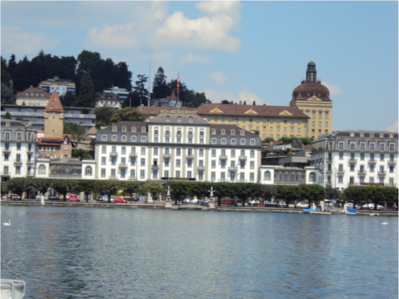 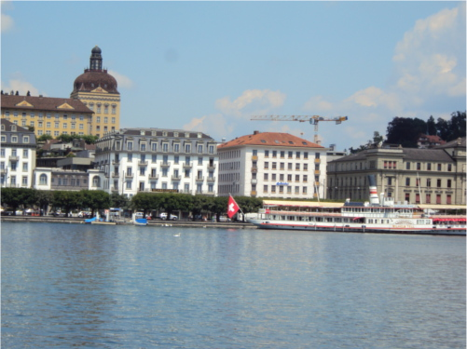

**Detected corners:**

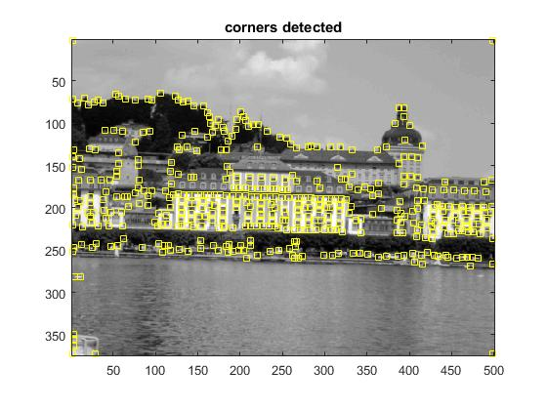 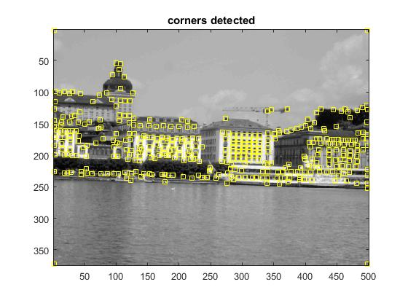

After detecting the corners, we now calculated distances between each point in the first image with each point in the second image.

Thus, we get a distance matrix out of which I selected 150 putative matches to be used in the RANSAC algorithm implementation.

RANSAC algorithm:

I selected 4 random samples out of the 150 putative matches and constructed the ‘A’ matrix using the formula below:

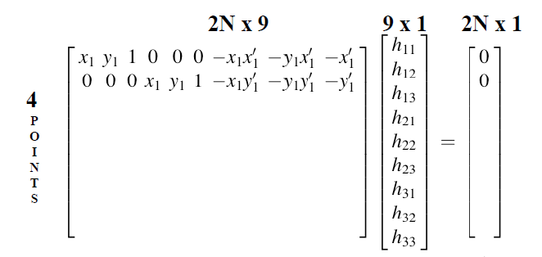

After applying SVD to this, extracting the last vector of V, and reshaping it into 3x3 matrix I get the tentative H matrix.

Now I compute the new xi’, yi’ points from xi, yi and then compute the error between the actual xi’, yi’ and the calculated xi’, yi’.

I find the inliers by considering those points whose errors are below the threshold decided by me. For this project, I chose the threshold to be 1.

I keep repeating the whole procedure for about 1000 iterations to maximize the number of inliers I get from each H matrix and extract the best H matrix which will give me the maximum number of inliers.

After the RANSAC method I get about 57 inliers out of the 150 matches.

The following is the representation of the inliers I found:

Inlier matches:

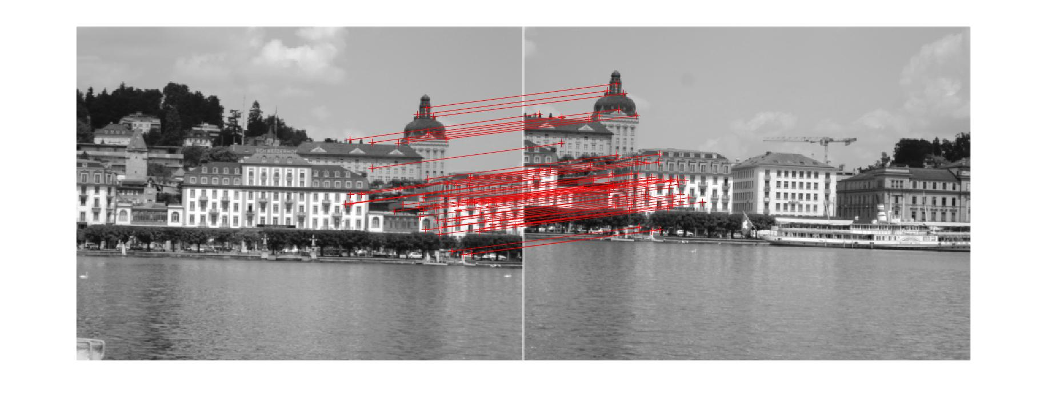

Once we get the best H matrix , we compute the transformation matrix by simply calculating the new corners of the image and passing it with the old corners to the maketform function in matlab.

Now based on this transformation matrix we construct the warped image and finally stitch both the images in a single bigger image.

Final output:

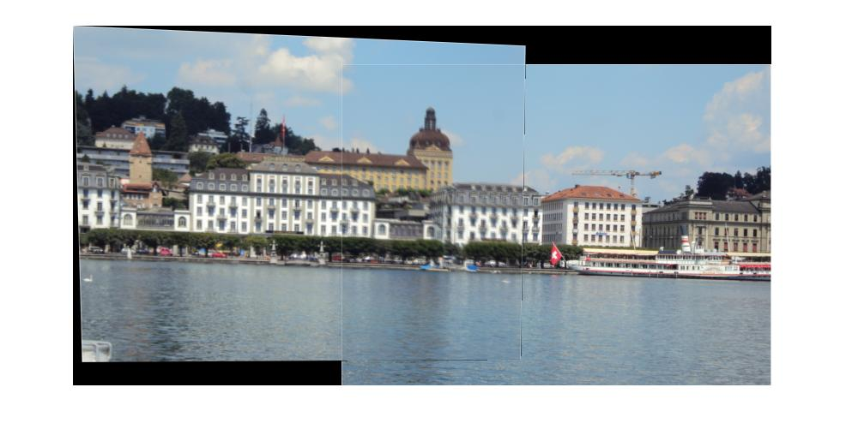

Image stiching for multiple images:

The logic written for stiching 2 images can be extended for stiching more than 2 images.

The function written for imagestiching is **imagestiching(img1path, img2path)**

So If I want to stitch 3 images I simply call

**imagestiching(imagestiching(img1path, img2path), img3path)**

Thus by chaining like this I was able to stitch 3 images. Couple of examples are displayed below:

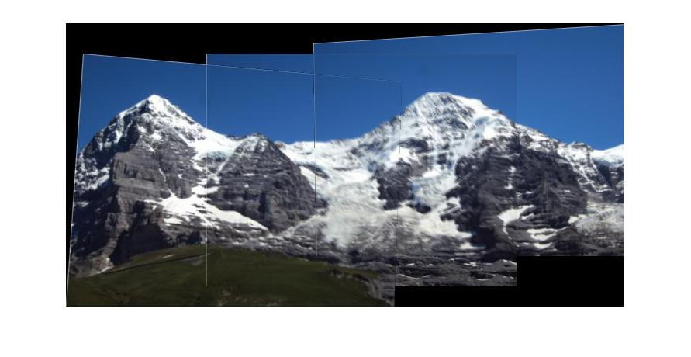



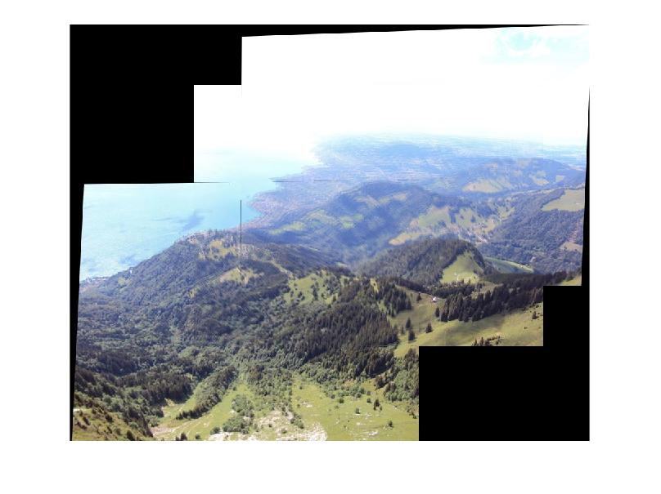

This algo can be further enhanced if we take the best possible pairs of images simply by finding the number of inliers between them. This can be very similar to the matrix chaining problem in algorithms.

The only limitation of the homography estimation method above is we get some blurred areas and non uniform gains because of movements in the camera position over other axis.

This can be solved by applying gain compensation and multiband blending techniques.

Part 2: Fundamental matrix estimation

For estimating the fundamental matrix I implemented the unnormalized 8-point algorithm and the normalized 8 point algorithm and got the following results:

1. Unnormalized 8-point algorithm: (House image)

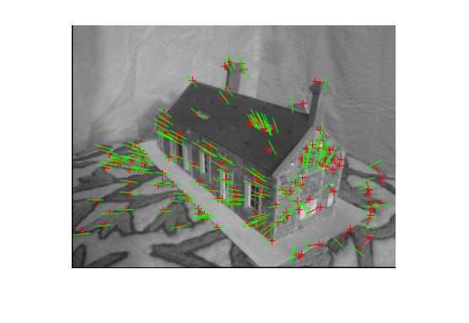

Average distance 1: 0.000742

Average distance 2: 42.899319

1. Normalized 8 – point algorithm :

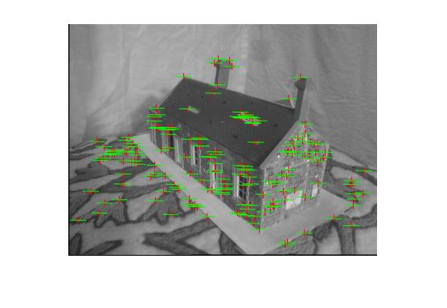

Average distance 1: 0.000004

Average distance 2: 0.138488

Thus you can notice that the residual error greatly reduces when we use the normalized 8-point algorithm.

I used the **fit_ fundamental** function to carry out both these methods where the parameter norm decideds whether we want to normalize the points or not.

After this, I implemented the RANSAC algorithm for finding out the F matrix.

First I found the matches using the harris corner detection method same as for homography estimation.

The threshold for this algorithm was 0.0001.

Following is the output from RANSAC:

**Inliers:**

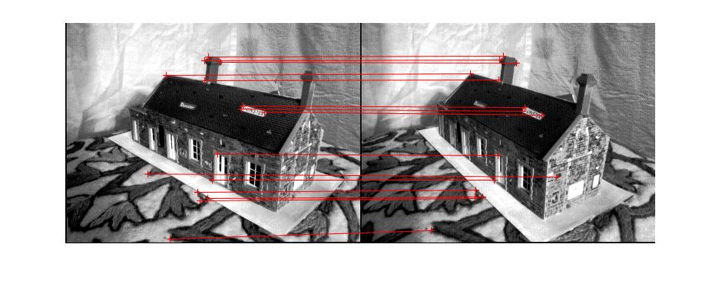

**Output:**

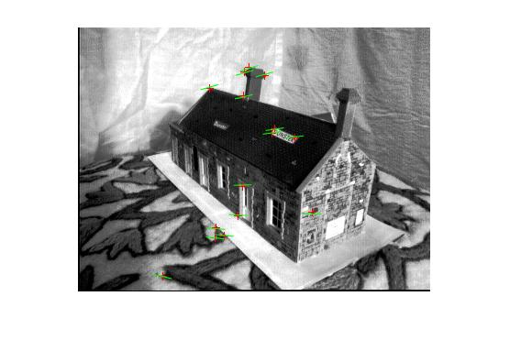

Average Distance 1: 0.149991

Average Distance 2: 99.675337

Matrix triangulation :

The following is the output of plotting the camera traigulation and the camera centers.

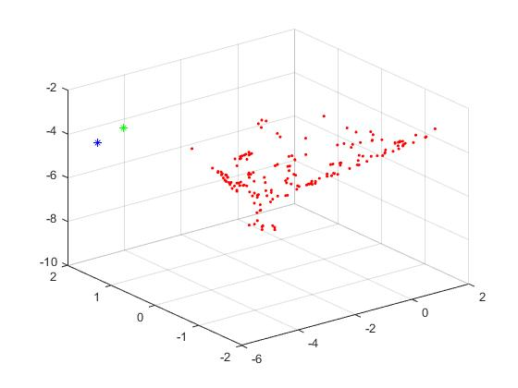

The green and the blue points are the camera centers of 1st and 2nd image respectively.

References:

1. <http://www.cs.cmu.edu/~16385/Slides/11.4_Triangulation.pdf>
2. <http://www.cse.psu.edu/~rtc12/CSE486/lecture20.pdf>
3. <http://www.cse.psu.edu/~rtc12/CSE486/lecture16.pdf>
4. <http://matthewalunbrown.com/papers/ijcv2007.pdf>
5. <https://ublearns.buffalo.edu/bbcswebdav/pid-4302493-dt-content-rid-16661678_1/courses/2179_10783_PsC/lec16_epipolar.pdf>