Steps for running the php files

Pre-requisites: xampp, Google chrome to be installed and working.

1) Start xampp control panel

2) Start Apache web server

3) Start MYSQL database server

4) Start Google chrome and run the php files in it

Details for above steps :

Starting xampp control panel and the required services:

1. Go to C:/xampp
2. Find xampp Control file in that folder
3. Start it , it should look something like this

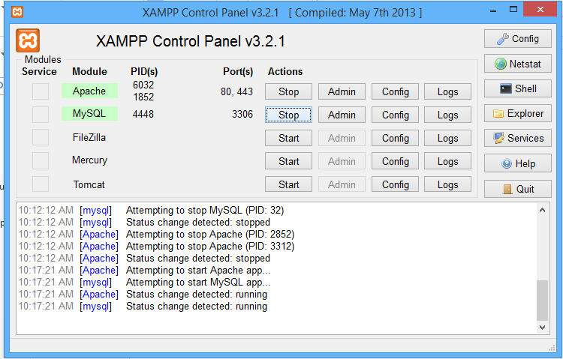

1. Now as seen in the above picture click the ‘Start” button next to Apache and MySQL so that it looks like above , now minimize this app.

Running our project files

1. First unzip the folder “visualbookmark” to C:/xampp/htdocs/ .
2. Now Start Google chrome and type localhost in the address bar and you’ll see something like this :

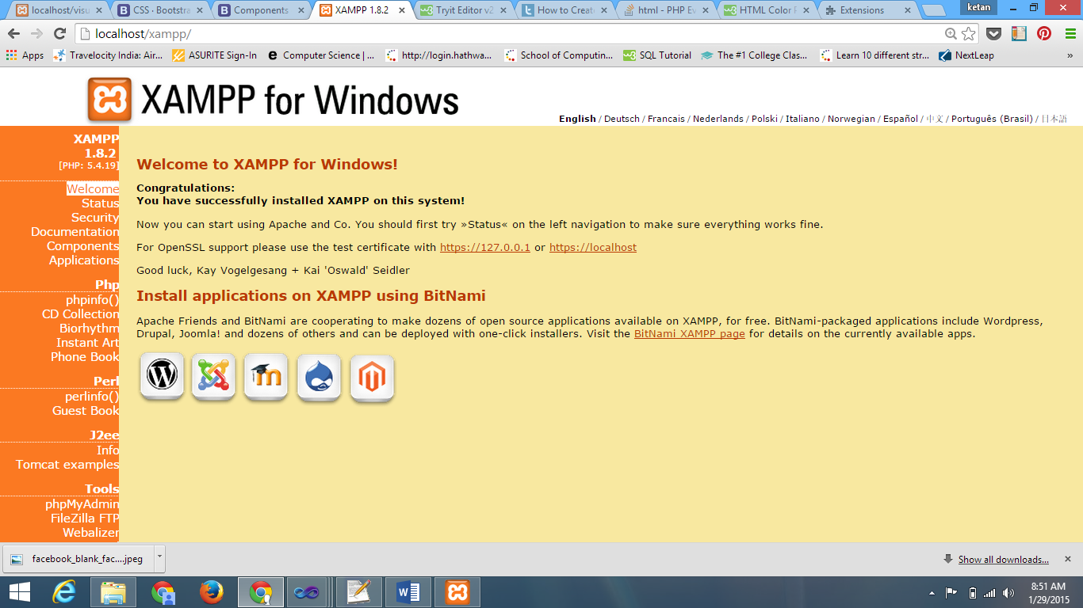

1. Click on phpMyAdmin on the bottom left corner of the page

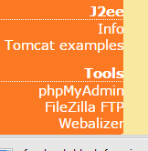

4)you’ll see the below page

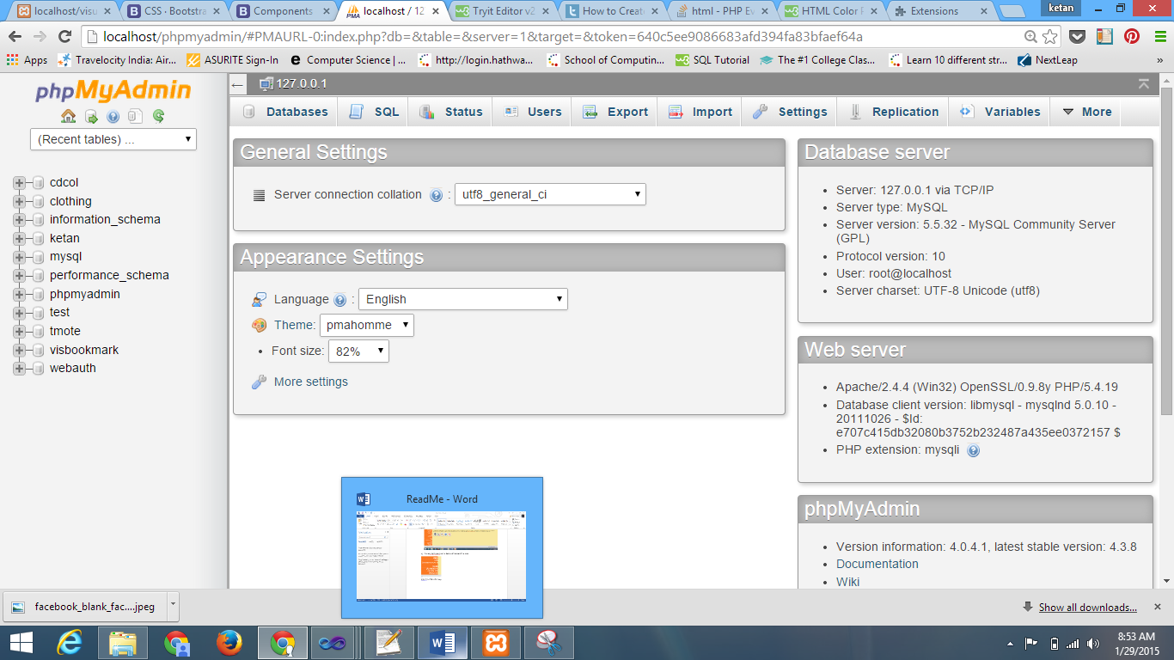

1. Click on Import which is on the top tab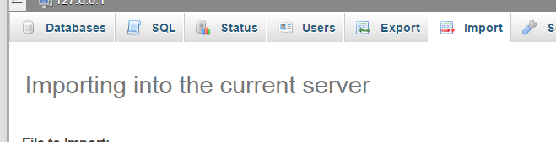
2. Click on ‘choosefile’ button

Browse and find the visbookmark.sql file located at C:/xampp/htdocs/ketan/Database

Now click go

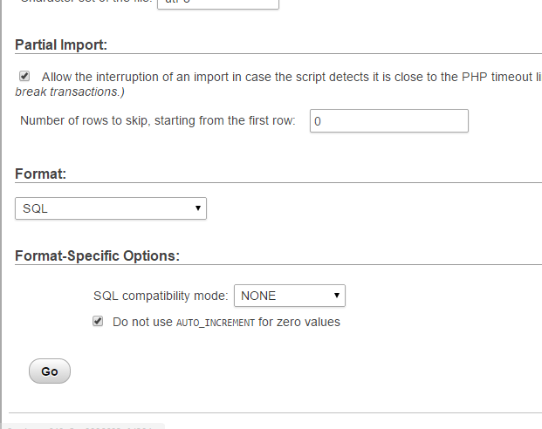

1. Now you see visbookmark on the leftside

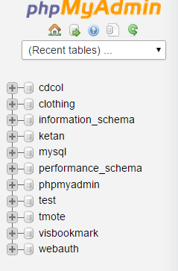

1. Click on visbookmark and you’ll see the table created ‘login’

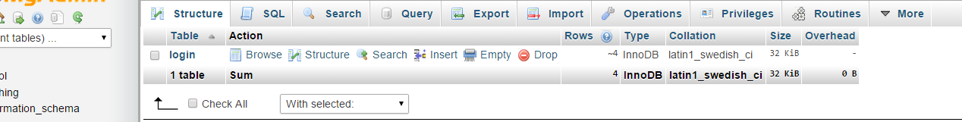

1. Click on login and you’ll see the contents
2. Now open a new tab in chrome and keep the above table tab opened only
3. Type localhost/visualbookmark/login.php in the address bar and you should be able to see the below page

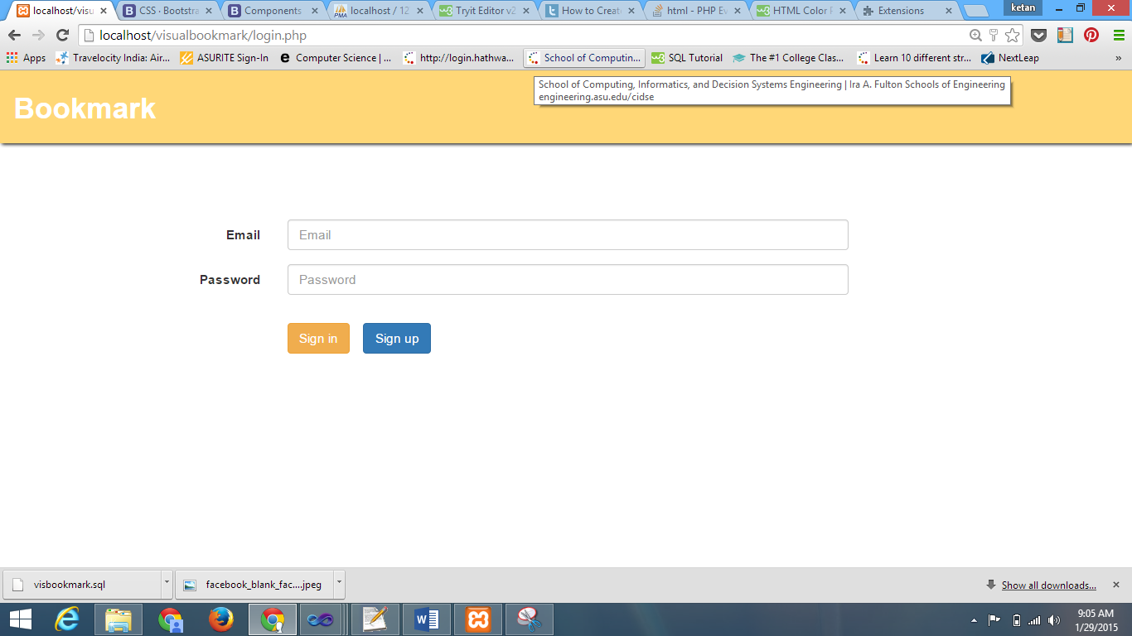

1. Now you can follow normal login steps
2. Demonstrate to the teacher by typing wrong password worn email id
3. When you click on sign up the below page will appear
4. 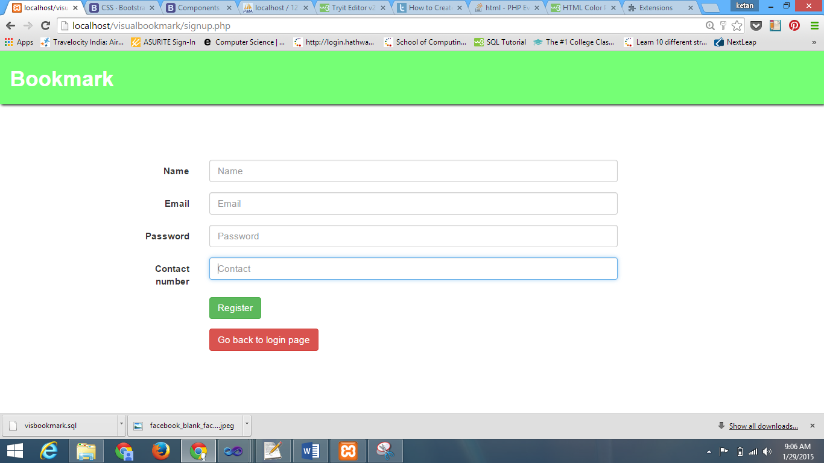

15)When you enter all valid info the pag will tell you you have successfully registered

Now go to the table tab and refresh it you will see a new entry added there with the details which you just entered.

Implementing the plugin

1)Go to Google chrome settings and click on extensions

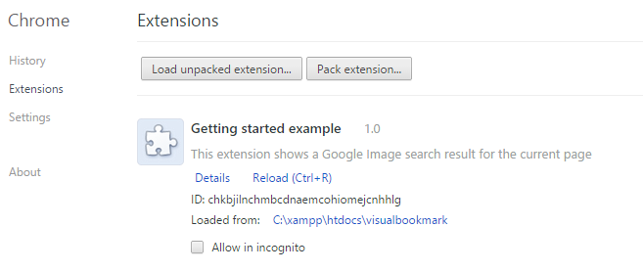

2) Now click on Load unpacked extension button and then select the folder C:/xampp/htdocs/visualbookmark

3) Now open any website and demonstrate how the screenshot and url of that website is retrieved by clicking on plugin button on the topmost right corner

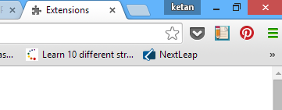 the pencil-and-note type symbol is our plugin .

All the best………..

Prerequisite : both the laptops should be connected to a common network or common WIFI

Step 1: Start the xammp server in any one laptop which contains our projects’ files

Step 2: Open the webpage in this laptop first and see if everything’s working fine.

Step 3: Start command prompt in first laptop

Step 4: Type ipconfig.

Step 5: If you are connected to same wifi see the ip address under wireless network. If the computers are connected with the same LAN cable see the ip address under Ethernet port or local area connection. Note this ip address.

Step 6: Start the second laptop and directly start the browser.

Step 7: typethe ipaddress followed by the folder name of our project and then name of php file.

Eg. 192.168.10.3/visualbookmark/login.php

And done everything should work properly.