Pre-requisites :

1 xampp server

2 Visual studio

Step 1 : Before starting the software you should start the xampp server if xampp server not present then install it first

Step 2 : Now after installation there will be a folder created named “xampp” in C drive and icon created on the desktop. If the orange color icon is not created go to C://ProgramFiles//xampp and search for the file named “xampp Control Panel “ and double click it.

Step 3 : Now the following window will appear

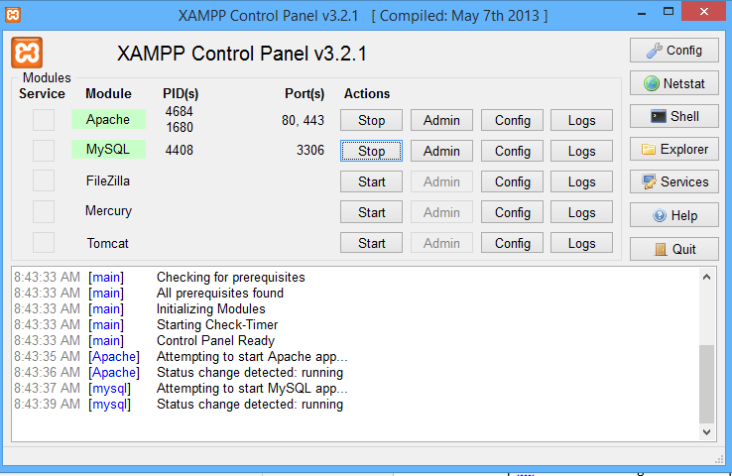

Press Start button next to Apache and the MySQL since these are the two services required to communicate with the database.

Step 4 : Now Start “Google chrome” or “ Internet Explore” and type “localhost/phpmyadmin”.

The following screen will appear

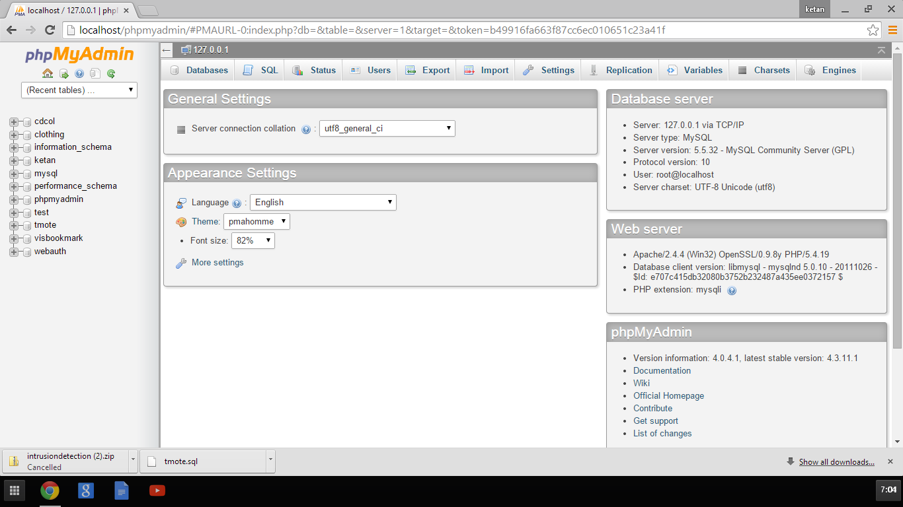

List of databasess

Step5 : The left side of the screen shows the databases present in our computer

We are going to use the databse named ‘tmote’ for out project.

Check if tmote is present in the list. If present click on it if not present directly go to Step 7 :

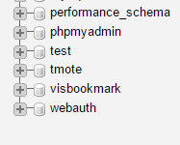

Then click on Operations button present on top

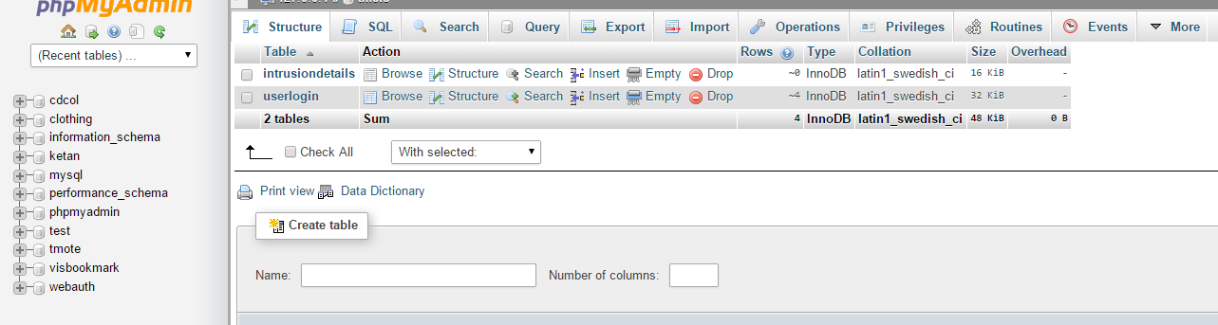

Step 6 : Then Click on Remove database

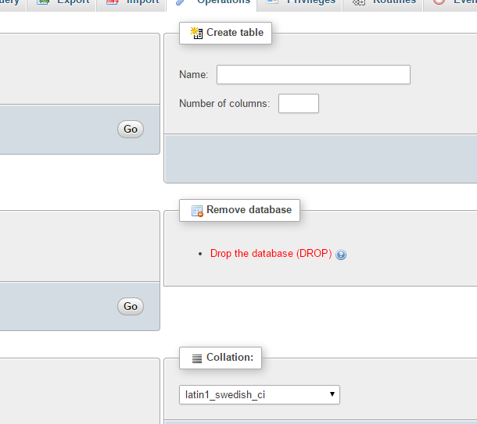

Step 7 : Now click on Import

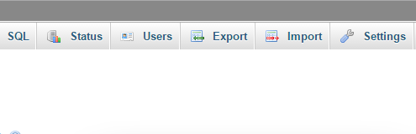

The following screen will appear

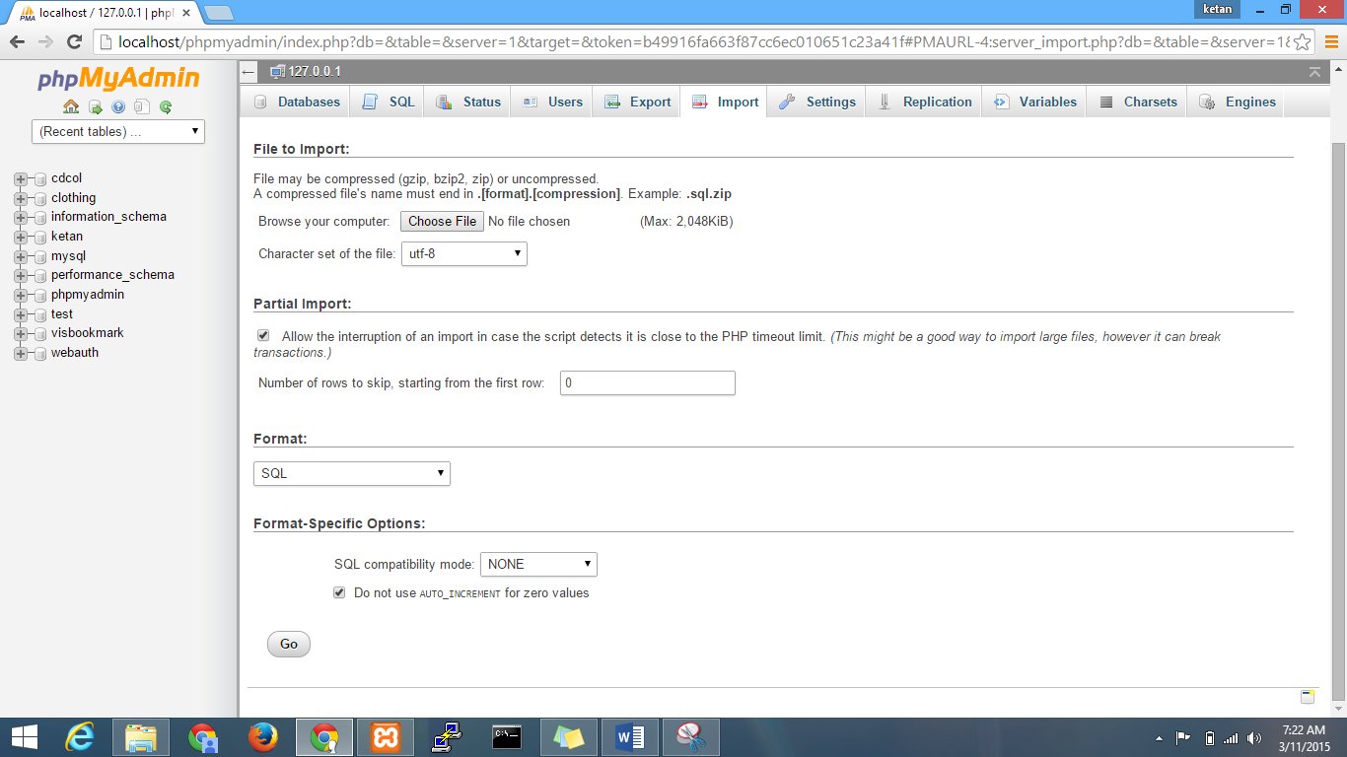

Click on choose file and the browse for the file tmote.sql present in the project folder that I sent

Then after choosing the tmote.sql file Click on Go.

And the database is created.

Step 8 : Now for first time login to work the tables in the databse should be empty

Click on + sign on the left of tmote on the left side of the screen.

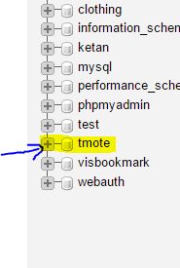 and following will appear 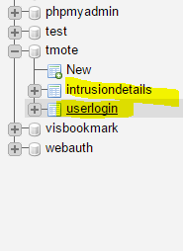

First click on intrusiondetails and the Click on Operation button on the top.

You’ll see the following screen

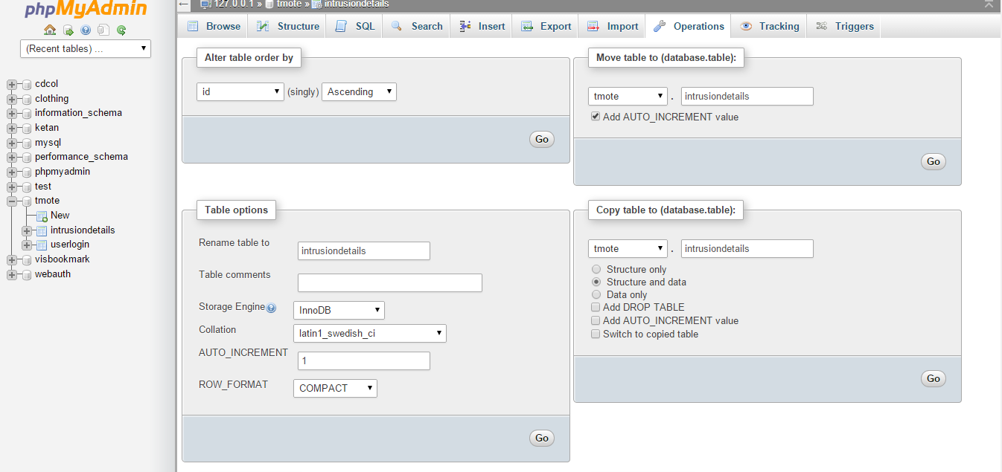

Scroll down you’ll find the following

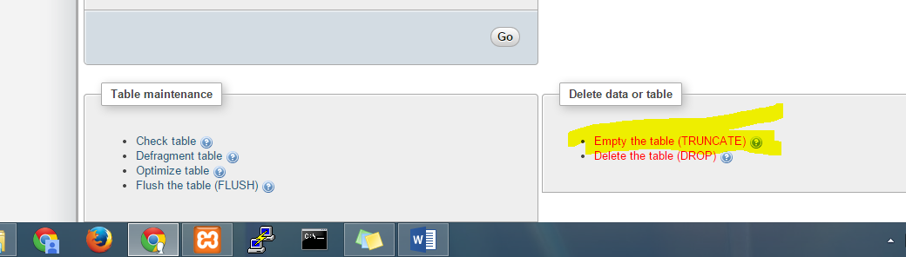

Now Click on Empty the table

Repeat these steps with userlogin table.

Now start the software and ready to execute.