🦷
BELLEVILLE DENTAL
Technical Documentation
Website Codebase · v1.0 · March 2026

React + TypeScript · Vite · Tailwind CSS · React Router · GSAP

Est. 1998 | 456 Belleville Avenue, NJ 07109 | info@bellevilledental.com

Table of Contents

1. Project Overview ......... 3
2. Tech Stack & Dependencies ......... 3
3. Project Structure ......... 4
4. Application Architecture ......... 4
5. Routing & Navigation Flow ......... 5
6. Component Reference ......... 6
6.1 App.tsx — Root Component ......... 6
6.2 Navbar.tsx — Navigation Bar ......... 6
6.3 Footer.tsx — Footer Ticker ......... 7
6.4 PageTransition.tsx — Animated Wrapper ......... 7
6.5 ScrollToTop.tsx — Route Scroll Reset ......... 7
7. Page Reference ......... 8
7.1 Home.tsx — Landing Page ......... 8
7.2 Product.tsx — Products Catalogue ......... 8
7.3 Research.tsx — Research Hub ......... 9
7.4 PatientEducationPreview.tsx ......... 9
7.5 ProfessionalEducation.tsx ......... 10
7.6 Gallery.tsx — Image Gallery ......... 10
7.7 Contact.tsx — Contact Forms ......... 11
8. Utility Modules ......... 11
8.1 images.ts — Asset Registry ......... 11
8.2 index.ts — scrollToSection() ......... 12
9. State Management ......... 12
10. Animations & UX ......... 13
11. Application Flowcharts ......... 13
12. Data Models ......... 16
13. Styling Guide ......... 17
14. Known Limitations & Future Recommendations ......... 18

1. Project Overview

Belleville Dental is a full-featured dental clinic website built as a React single-page application (SPA). The site serves both patients and dental professionals, offering educational resources, product browsing, research highlights, gallery viewing, and multi-mode contact forms — all wrapped in polished, animated UI.

Project Summary
Client: Belleville Dental Clinic, Est. 1998
Address: 456 Belleville Avenue, Belleville, NJ 07109
Contact: (973) 555-0123 | info@bellevilledental.com
Hours: Mon–Fri 8AM–7PM · Sat 9AM–3PM · 24/7 Emergency
Version: 1.0 (March 2026)
Framework: React 18 + TypeScript

The application is structured around seven public-facing routes. The shared Navbar and Footer persist across all routes. GSAP-powered page transitions, scroll-reveal animations, and Tailwind CSS utility classes deliver a modern, responsive experience across mobile, tablet, and desktop viewports.

2. Tech Stack & Dependencies

Package | Category | Usage
React 18 | UI library | Core framework
TypeScript | Typed superset of JS | Type safety across all files
Vite | Build tool / dev server | Fast HMR and bundling
React Router v6 | Client-side routing | BrowserRouter + Routes
Tailwind CSS v4 | Utility-first CSS | All component styling
GSAP | Animation library | PageTransition fade-in
Lucide React | Icon library | Contact, Education icons
react-icons/fa6 | Font Awesome icons | FaTooth navbar logo
shadcn/ui | UI component system | index.css theme tokens
tw-animate-css | Tailwind animation plugin | Custom keyframes

All CSS custom properties (--background, --foreground, --primary, etc.) are defined in index.css using the @theme inline directive, enabling consistent theming across the application including dark mode support via the .dark class.

3. Project Structure

File Tree
src/
├── main.tsx Entry point — mounts BrowserRouter + App
├── App.tsx Root component — Navbar, Routes, Footer
├── index.css Global styles, Tailwind config, CSS vars
├── images.ts Centralised asset imports
├── index.ts Utility: scrollToSection()
├── Pages/
│ ├── Home.tsx Landing page (Hero, Stats, Mission…)
│ ├── Product.tsx Product catalogue with ratings
│ ├── Research.tsx Research bento grid
│ ├── PatientEducationPreview.tsx Patient education cards
│ ├── ProfessionalEducation.tsx Pro resources & courses
│ ├── Gallery.tsx Image gallery + lightbox
│ └── Contact.tsx Multi-mode contact form
└── Components/
├── Navbar.tsx Fixed top navigation
├── Footer.tsx Footer + live ticker
├── PageTransition.tsx GSAP route transition
├── ScrollToTop.tsx Auto-scroll on route change
└── HomeComponents/ Sub-components for Home page
├── Hero.tsx
├── About.tsx
├── Mission.tsx
├── Services.tsx
├── Stats.tsx
└── Testimonials.tsx

4. Application Architecture

The application follows a flat page-based architecture inside a single BrowserRouter context. All persistent UI (Navbar, Footer) is rendered outside the Routes tree so it survives page navigations without unmounting.

Render Order (top → bottom)
1. <BrowserRouter> — Provides routing context (main.tsx)
2. <ScrollToTop> — Resets scroll on every pathname change
3. <Navbar> — Fixed header, always visible
4. <PageTransition> — GSAP fade wrapper, re-triggers on pathname
5. <Routes> — Active page component rendered here
6. <FooterTicker> — Sticky footer with live clock/geo

There is no global state manager (Redux / Zustand / Context). Each page manages its own local state with React's useState and useEffect hooks. The only cross-cutting state is the visitor counter, which uses localStorage for persistence.

5. Routing & Navigation Flow

Routes are declared in App.tsx. The navItems array in Home.tsx is the single source of truth for all navigation entries and is consumed by both Navbar and Footer.

Route Path | Component
Path | Component Rendered
/ | <Home /> — Landing page with all homepage sub-sections
/products | <Product /> — Filterable product catalogue
/research | <Research /> — Bento-grid research card layout
/patient-education | <PatientEducationPreview /> — Patient topic cards
/professional-education | <ProfessionalEducation /> — Pro resource library
/gallery | <Gallery /> — Masonry gallery with lightbox modal
/contact | <Contact /> — Enquiry / Complaint / Appointment forms

Special case — About Us: The "About Us" nav item has no dedicated route. Clicking it navigates to "/" then uses a 120 ms setTimeout to scroll the DOM to the #about section after the Home page mounts.

Hash navigation: ScrollToTop skips the scroll reset when the URL contains a hash fragment, delegating control to the browser's native anchor behaviour.

6. Component Reference

6.1 App.tsx — Root Component
App.tsx is the application shell. It composes all persistent and routed elements in the correct render order.
Import path | ./App.tsx
Props | None — it is the root consumer
Dependencies | React Router (Routes, Route), all Pages, Navbar, Footer, ScrollToTop, PageTransition
Key behaviour | Wraps all Routes inside <PageTransition> so every navigation triggers a GSAP fade-in

6.2 Navbar.tsx — Navigation Bar
A fixed top navigation bar with scroll-aware background, desktop link list, mobile hamburger menu, and a localStorage-backed visitor counter.

Position | fixed top-0, z-index 50
Scroll threshold | window.scrollY > 50 triggers backdrop-blur + light bg
Active indicator | Underline on the currently selected nav item
Mobile breakpoint | lg (1024 px) — hamburger replaces link list below this
Visitor counter | Reads bellevilleVisitorCount from localStorage, increments on mount
About Us behaviour | Navigates to '/' then setTimeout(120ms) to scroll #about
State | activeSection (string), mobileMenuOpen (bool), scrolled (bool), visitorCount (number)

navItems — Exported from Home.tsx
{ label:'Home', id:'home', path:'/' }
{ label:'Professional Education',id:'professional', path:'/professional-education' }
{ label:'Patient Education', id:'patient', path:'/patient-education' }
{ label:'Research', id:'research', path:'/research' }
{ label:'Products', id:'products', path:'/products' }
{ label:'Gallery', id:'gallery', path:'/gallery' }
{ label:'About Us', id:'about', path:'' }
{ label:'Contact Us', id:'contact', path:'/contact' }

6.3 Footer.tsx (FooterTicker) — Footer
A full-width footer with four columns (branding, quick links, sitemap, social) plus a horizontally scrolling ticker showing live date, time, and geolocation.

Live clock | Updates every 1 second via setInterval in useEffect
Geolocation | navigator.geolocation.getCurrentPosition — falls back to text message on deny
Ticker animation | Tailwind animate-marquee class (custom keyframe in index.css, duration 40 s)
Quick Links | Iterates navItems.slice(1), calls scrollToSection() on click
Background | bg-sky-950 (dark navy)

6.4 PageTransition.tsx — Animated Wrapper
A thin HOC that wraps the <Routes> output. On every location.pathname change it fires a GSAP fromTo animation: opacity 0 → 1, y 20 → 0, 0.55 s, power2.out.

Library | GSAP (GreenSock Animation Platform)
Trigger | useEffect dependency on location.pathname
Initial style | style={{ opacity: 0 }} — prevents FOUC
Props | children: ReactNode

6.5 ScrollToTop.tsx — Route Scroll Reset
A renderless component that calls window.scrollTo({ top:0, behavior:'instant' }) whenever the pathname changes, unless a hash is present in the URL.

Type | Renderless (returns null)
Trigger | useEffect on [pathname, hash]
Hash guard | Skips reset when hash is truthy — allows /#about anchor jumps
Behaviour | 'instant' (not 'smooth') to avoid visual lag on route transitions

7. Page Reference

7.1 Home.tsx — Landing Page
The root route '/'. Composes six sub-components that each handle their own sections. navItems is declared and exported from this file.

Sub-components rendered (in order) | Hero, Stats, Mission, Services, About, Testimonials
Scroll anchor IDs | #home, #about
Exports | navItems[] — used by Navbar and Footer
Styling | min-h-screen bg-white font-sans

7.2 Product.tsx — Products Catalogue
Displays 8 dental products in a responsive grid with category filtering, display star ratings, and interactive user rating capability.

Route | /products
State | products[], selectedCategory, hoverRating, hoveredProductId
Categories | All | Toothpaste | Brushes | Kids | Electrical
Product interface | id, name, category, image (imported), description, price, rating, totalRatings
Rating logic | Weighted average: (rating × totalRatings + newRating) / (totalRatings + 1)
Image source | Imported via images.ts → ProductImages[]
Scroll animation | useScrollReveal({ childSelector:'.reveal-item', stagger:0.1 })
Background | Linear gradient white → sky-300

Products Catalogue (8 items)
Toothpaste: Colgate Total Advanced ($4.99) | Sensodyne Rapid Relief ($5.49)
Electrical: Oral-B Pro 1000 ($49.99) | Philips Sonicare DiamondClean ($89.99) | Waterpik ($69.99)
Kids: Crest Kids Sparkle Gel ($3.49) | Tom's of Maine Natural Kids ($4.29)
Brushes: Reach Soft Bristle 4-pack ($6.99)

7.3 Research.tsx — Research Hub
A bento-grid layout presenting 8 research topics across 3 visual section groups. Cards use varied layouts (featured hero, horizontal split, dark overlay, and standard).

Route | /research
Data | researchItems[] — defined locally, images from ResearchImages[]
Card layouts | Featured (col-span-2 row-span-2), Horizontal split, Standard, Dark overlay
Section groups | 3 <section> sub-grids: 4 cols, md:grid-cols-4
Images source | ResearchImages[] from images.ts (caries, sugar, regenerative, teledentistry, bioprinting, microbiome, nanotech, vr)

Research Topics (8 items)
1. AI in Early Caries Detection — 94% accuracy via deep learning
2. Impact of Sugar Taxes on Oral Health — 12% drop in childhood cavities
3. Regenerative Dentistry Breakthrough — stem cell enamel restoration
4. Tele-dentistry During Pandemics — 67% reduction in emergency visits
5. 3D Bioprinting Implants — 40% faster osseointegration
6. Microbiome Therapy — probiotic suppression of cariogenic pathogens
7. Nanotech Restoration — biomimetic nanomaterials rebuild enamel
8. VR in Dental Psychology — 50%+ reduction in patient stress markers

7.4 PatientEducationPreview.tsx — Patient Education
An interactive card library of 8 dental health topics for patients, filterable by category. Cards are collapsible (accordion) showing summary on click.

Route | /patient-education
State | activeCategory (string), openId (number|null)
Categories | All | Prevention | Hygiene | Life Stages | Cosmetic | General
Card variants | Featured (full-width dark hero), Dark, Wide (2-col), Standard
Toggle behaviour | Clicking 'Read More' expands detail text; only one card open at a time
CTA Banner | Bottom gradient banner linking to /contact#contact

Patient Topics (8 items)
Prevention: Tooth Decay & How to Prevent It (featured) | Dental Care During Pregnancy
Hygiene: Recognising Gum Disease | Proper Brushing Technique
Life Stages: Oral Health for Kids | Dental Care During Pregnancy
Cosmetic: Understanding Teeth Whitening
General: Dental Anxiety | What to Do in a Dental Emergency

7.5 ProfessionalEducation.tsx — Professional Resources
A resource library for dental professionals with 7 courses, documents, video libraries, and community resources. Filterable by resource type.

Route | /professional-education
State | active (string category filter)
Categories | All | Course | Document | Video Library | Resource | Community
Card variants | Featured (col-span-3 hero), Dark, Wide (2-col), Standard
CTA Banner | Join 1,200+ professionals — Get Full Access button
Resource interface | id, title, type, tag, description, meta, icon, dark?, wide?, featured?

Professional Resources (7 items)
Courses: Advanced Orthodontics Certification (40 CE, featured) | Implantology Masterclass (28 CE) | Radiograph Interpretation (12 CE)
Documents: Clinical Guidelines PDF Library (120+ docs, updated March 2026)
Video Library: Faculty Lecture Series (200+ hours)
Resources: Case Studies Database (400+ cases)
Community: Monthly Journal Club (free for members)

7.6 Gallery.tsx — Image Gallery
A responsive image grid with hover overlay and a full-screen lightbox modal. Currently uses placeholder images from picsum.photos.

Route | /gallery
State | selectedGalleryImage (string|null)
Grid | 1 → 2 → 3 → 5 cols (responsive)
Image count | 10 images (picsum.photos placeholders)
Hover effect | scale-110 + gradient overlay showing 'View full size →'
Lightbox | Fixed overlay (bg-black/90, z-100), click-outside to close
Image size | 600×400 px per card

7.7 Contact.tsx — Contact Forms
A multi-mode contact section with three form types selectable via card toggles: General Enquiry, Complaint, and Appointment Booking.

Route | /contact
Modes | enquiry | complaint | appointment
State | mode, submitted (bool), form (object with 9 fields)
Common fields | name, email, phone
Enquiry fields | subject, message
Complaint fields | subject, urgency (low/medium/high), message
Appointment fields | service (8 options), date (date picker), time (11 slots), message
Submit behaviour | Sets submitted=true, shows success message, resets form after 3.5 s
Info panel | Address, Phone, Email, Hours, Emergency 24/7 indicator
Services available | General Check-up, Whitening, Implants, Invisalign, Cosmetic, Emergency, X-Ray, Other

8. Utility Modules

8.1 images.ts — Asset Registry
Central module that imports and exports all static image assets, preventing scattered relative import paths across page components.

Default export | ProductImages[] — ordered array of 8 product images
Named export | ResearchImages[] — ordered array of 8 research images
Product image files | colegate.jpg, Oral-B-electric.avif, crest.jpg, phillips.jpg, sensodyne.jpg, softBristle.jpg, waterpik.avif, maine.jpg
Research image files | caries.jpg, sugar.jpg, regenerative.jpg, teledentistry.jpg, bioPrint.avif, bioTherapy.png, nanotech.png, vr.png
Asset directory | src/assets/content/ (products/ and Research/ subdirectories)

8.2 index.ts — scrollToSection()
A reusable utility function that smoothly scrolls to a DOM element by ID, accounting for the 80 px fixed navbar height.

Function signature | scrollToSection({ id: string }): void
Offset | 80 px subtracted from element top position to clear the fixed navbar
Scroll behaviour | window.scrollTo({ top: offsetPosition, behavior: 'smooth' })
Usage | Imported and called in Footer.tsx quick-links; Navbar uses inline equivalent

9. State Management

The application uses local component state exclusively. There is no global state management library. Below is a summary of all meaningful state across the application.

Component | State Variable | Purpose
Navbar | scrolled | Toggles backdrop-blur style
Navbar | activeSection | Highlights active nav link
Navbar | mobileMenuOpen | Shows/hides mobile drawer
Navbar | visitorCount | localStorage-persisted visit count
Footer | currentDate / currentTime | Live clock display in ticker
Footer | location | Geolocation string for ticker
Product | products[] | Product data + live ratings
Product | selectedCategory | Filter state
Product | hoverRating / hoveredProductId | Star hover preview state
PatientEducation | activeCategory | Topic filter
PatientEducation | openId | Currently expanded accordion card
ProfessionalEd | active | Resource type filter
Gallery | selectedGalleryImage | Lightbox open state
Contact | mode | Form mode: enquiry/complaint/appointment
Contact | submitted | Shows success screen
Contact | form | All form field values (9 fields)

10. Animations & UX

Page transition | GSAP fromTo: opacity 0→1, y 20→0, 0.55 s, power2.out on every route change
Scroll reveal | useScrollReveal hook (lib/useScrollReveal) — IntersectionObserver-based, stagger 0.1 s per .reveal-item
Product hover | Image scale-110 (500 ms transition) on card hover
Gallery hover | scale-110 + gradient overlay fade-in on hover
Research cards | translate-y-2 lift + shadow deepening on hover
Education cards | Width-expanding underline (w-8 → w-full, 500 ms)
Navbar | 500 ms ease-in-out transition on bg/text colour when scrolled
Footer ticker | CSS animate-marquee: 40 s linear infinite marquee scroll
Background decor | Pulsing blurred circles (animate-pulse) on Products, Contact, Research sections
Star rating | hover:scale-110 on interactive rating buttons
CTA buttons | translate-x-1 / translate-x-2 on group hover for directional call-to-action

11. Application Flowcharts

The following flowcharts use standard flowchart notation:
- Rounded pill / oval = Terminal (Start / End)
- Rectangle = Process / Action
- Rectangle with double side lines = Sub-process / Called routine
- Parallelogram = Input / Output (user action)
- Diamond = Decision (Yes / No branch)

11.1 User Navigation Flow
Shows how a user navigates from initial page load through the application, including the special handling for the 'About Us' anchor link.

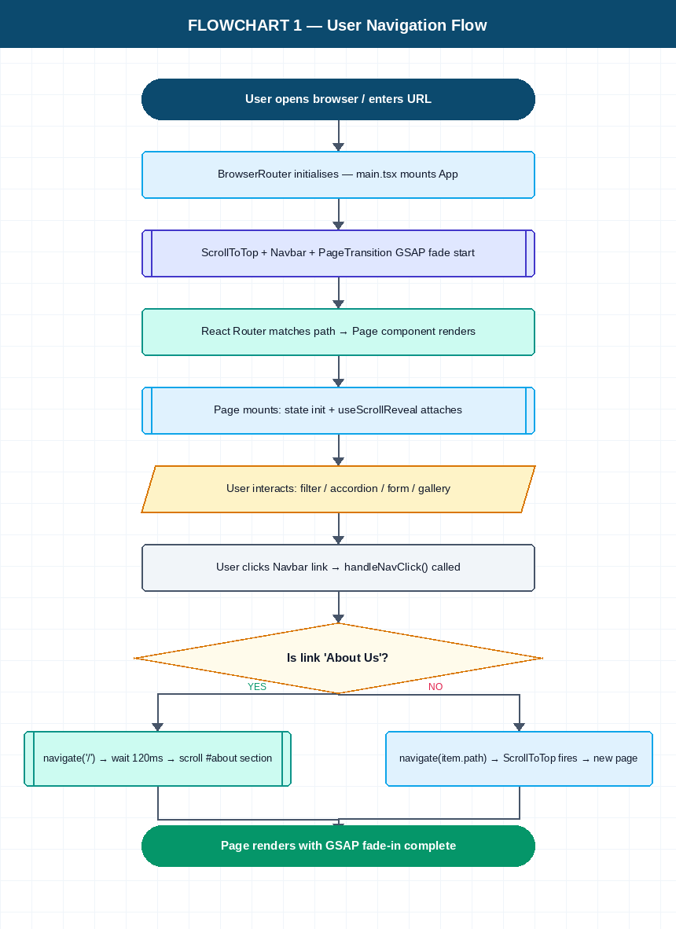

11.2 Contact Form Submission Flow
Covers the full lifecycle of a contact form submission — from mode selection through the three form variants (Enquiry, Complaint, Appointment), validation, success display, and auto-reset.

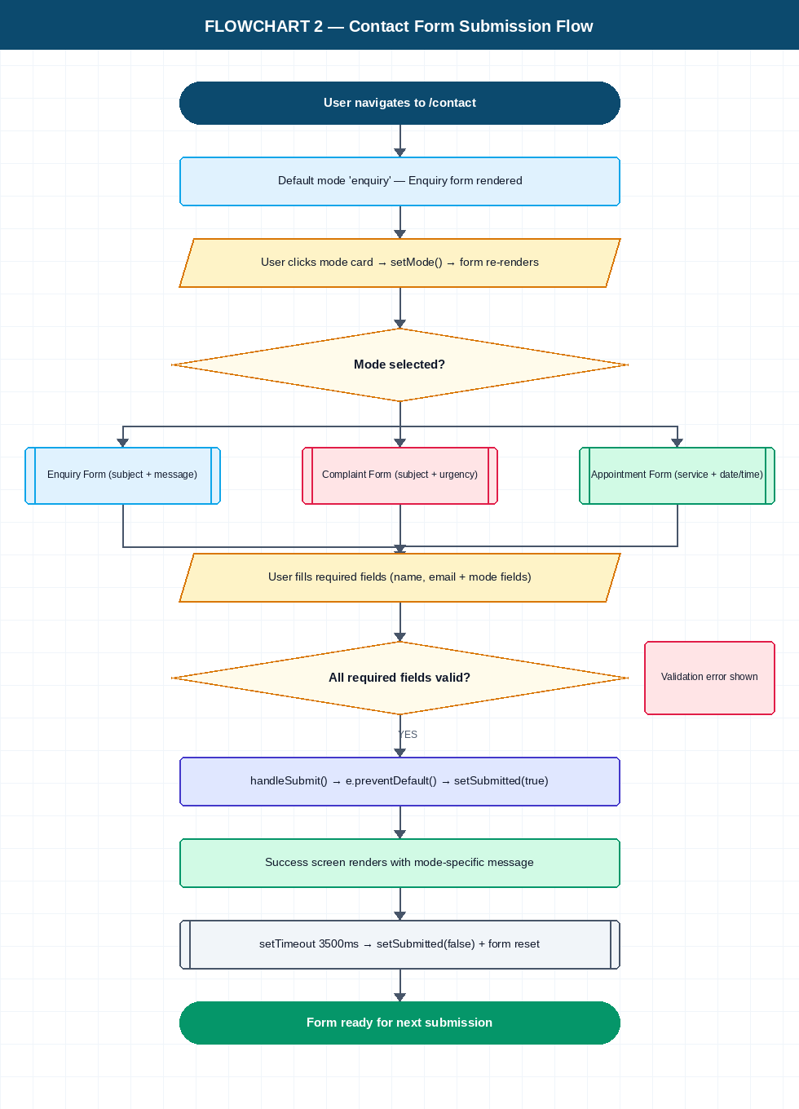

11.3 Product Rating Flow
Illustrates the interactive star rating mechanism — hover preview state, click handling, weighted average calculation, and the immutable state update pattern.

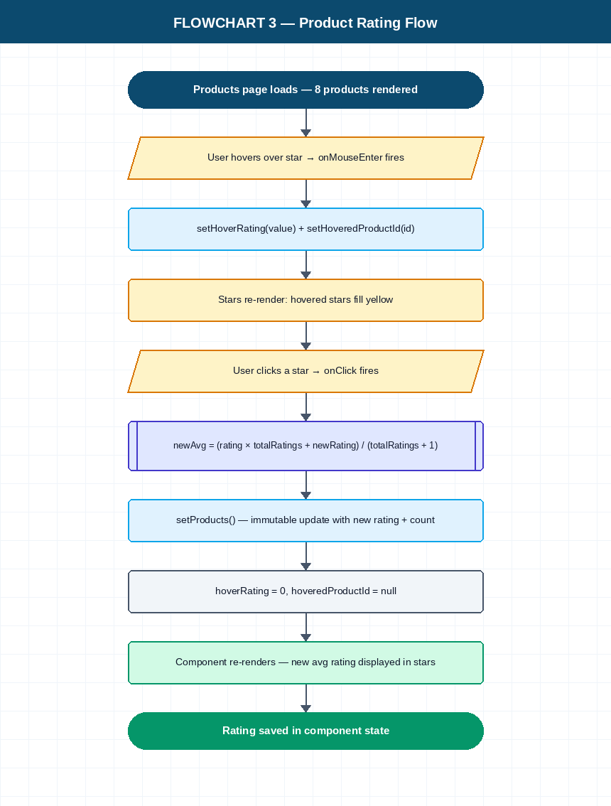

11.4 Gallery Lightbox Flow
Describes the image gallery interaction — hover overlay, lightbox open, and the two close paths (✕ button or backdrop click) that both converge on clearing selectedGalleryImage state.

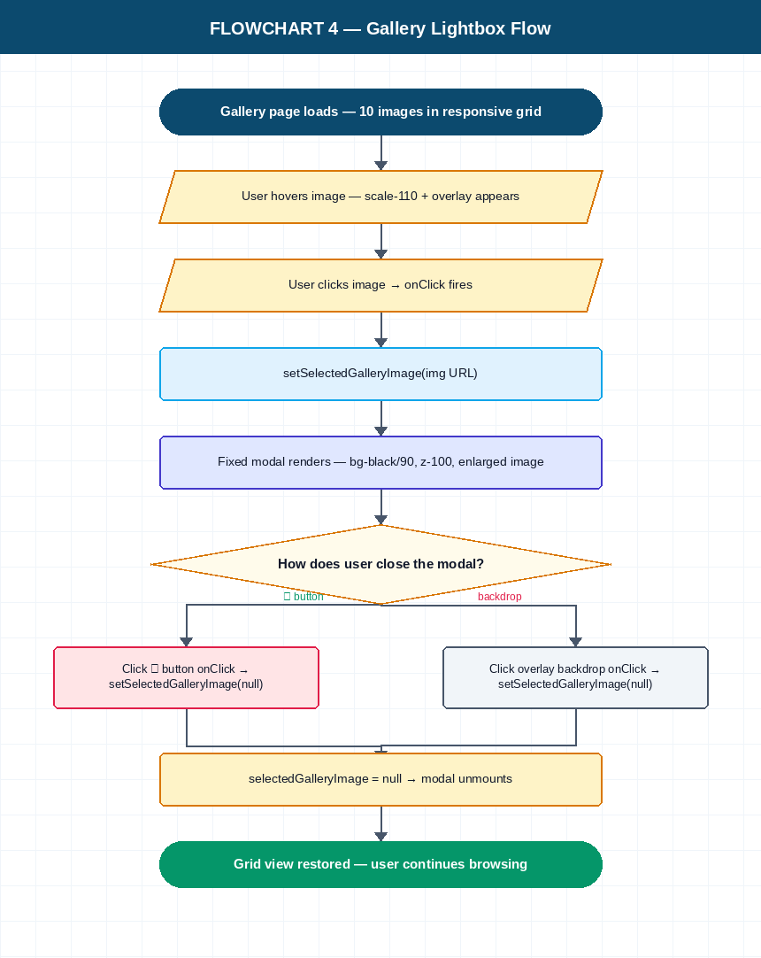

12. Data Models

12.1 Product Interface
id | number — Unique product identifier
name | string — Display name of the product
category | string — 'Toothpaste' | 'Electrical' | 'Kids' | 'Brushes'
image | string — Imported image path from images.ts
description | string — Short marketing description
price | number — USD price
rating | number — Aggregate rating (1–5, 1 decimal)
totalRatings | number — Count of ratings received

12.2 PatientTopic Interface
id | number — Unique topic identifier
title | string — Topic heading
content | string — Summary text (shown in card body)
detail | string — Extended text (shown on accordion expand)
icon | React.ReactElement — Lucide icon component
tag | string — Display pill tag (e.g. 'Prevention', 'Emergency')
category | string — Filter category
featured? | boolean — Renders as full-width hero card
dark? | boolean — Renders with dark gradient background
wide? | boolean — Renders as 2-column-wide card

12.3 ProfessionalResource Interface
id | number
title | string — Resource name
type | string — 'Course' | 'Document' | 'Video Library' | 'Resource' | 'Community'
tag | string — Sub-label (e.g. 'CE Credits', 'Reference')
description | string — Resource description
meta | string — Metadata (credits, duration, document count)
icon | React.ReactElement — Lucide icon
featured? | boolean — Full-width hero card
dark? | boolean — Dark gradient card
wide? | boolean — Two-column card

12.4 ResearchItem Interface
id | number
title | string — Research title
summary | string — One-line finding summary
image | string — Image path from ResearchImages[]

12.5 ContactForm State Object
name | string — Enquiry / Complaint / Appointment
email | string — All modes
phone | string — All modes (optional)
subject | string — Enquiry + Complaint modes
message | string — All modes
service | string — Appointment mode only
date | string — Appointment mode only (ISO date)
time | string — Appointment mode only (e.g. '10:00 AM')
urgency | string — Complaint mode only: 'low' | 'medium' | 'high'

12.6 ModeConfig Interface (Contact)
id | Mode — 'enquiry' | 'complaint' | 'appointment'
label | string — Button label text
icon | React.ReactNode — Lucide icon
tagline | string — Subtitle text
badge | string — Active state pill text
color / activeColor | string — Tailwind colour classes
activeBg / activeBorder | string — Active state background and border classes

13. Styling Guide

13.1 Colour Palette
Token | Tailwind Class | Usage
Sky Dark | sky-950 / sky-900 | Primary headings, navbar, footer bg
Sky | sky-600 / sky-500 | Accents, links, active states, CTA buttons
Sky Light | sky-50 / sky-100 | Hover backgrounds, card tints
Emerald | emerald-600 / emerald-500 | Patient education accents, success states
Indigo | indigo-600 / indigo-900 | Research cards dark variant, Pro Ed accents
Slate | slate-500 / slate-400 | Body text, secondary labels
Rose | rose-600 | Complaint mode accent
Amber | amber-600 | Professional Resource — Resource type pill
White | white | Card backgrounds, overlay button text

13.2 Typography Scale
Page hero headings | text-5xl md:text-6xl lg:text-7xl — gradient clip
Section headings | text-5xl font-bold text-sky-950
Card headings | text-xl to text-3xl font-bold / font-extrabold
Body text | text-sm to text-lg text-slate-500 / text-slate-600
Labels / badges | text-[10px] tracking-widest uppercase font-bold
Navbar brand | text-2xl font-bold text-sky-900
Footer ticker | text-sm font-mono tracking-widest

13.3 Layout Conventions
Max content width | max-w-7xl mx-auto px-6
Section vertical padding | py-28 to py-36 (lg: py-36 to py-40)
Card border radius | rounded-[2rem] for main cards, rounded-3xl for gallery
Card shadows | shadow-xl, shadow-2xl on hover
Grid systems | grid-cols-1 → sm:2 → md:4 → lg:3/4 (varies per page)
Responsive breakpoints | sm:640, md:768, lg:1024, xl:1280
Z-index layers | Navbar z-50, gallery modal z-100, GSAP wrapper default

13.4 Custom CSS (index.css)
animate-fade-in | fadeIn keyframe: opacity 0→1 + translateY 48→0, 1.2 s
animate-marquee | marquee keyframe: translateX 0 → -50%, 40 s linear infinite
@custom-variant dark | Targets .dark class for dark mode
@theme inline | Maps CSS vars to Tailwind colour tokens
CSS variable scope | :root (light) and .dark (dark) blocks define all design tokens

14. Known Limitations & Future Recommendations

14.1 Known Limitations
- No backend / API integration — contact form submissions are client-only (no emails sent).
- Product ratings are stored in component state only — ratings reset on page refresh.
- Gallery uses picsum.photos placeholder images — not actual clinical photography.
- Visitor counter uses localStorage — clears on browser data wipe and increments on every mount (not unique visitors).
- Footer console.log() calls (activeSection, mobileMenuOpen) present in production build — should be removed.
- useScrollReveal hook is imported but not included in the provided codebase — likely in src/lib/.
- No 404 / Not Found route defined in App.tsx.
- No accessibility (a11y) audit performed — interactive elements may lack ARIA labels.

14.2 Recommended Improvements
- Connect contact form to a backend service (e.g. Resend, EmailJS, or a custom Node.js API endpoint).
- Persist product ratings to localStorage or a database (Supabase / Firebase) to survive refreshes.
- Replace picsum.photos gallery images with actual clinical before/after photographs.
- Add a <Route path='*'> catch-all to render a friendly 404 page.
- Implement React.lazy() + Suspense for code-splitting heavier pages (Research, ProfessionalEducation).
- Add ARIA roles and labels to all interactive card buttons for screen-reader accessibility.
- Replace the localStorage visitor counter with a real analytics integration (e.g. Plausible, Google Analytics 4).
- Extract inline product/research data into separate /data/ JSON or TypeScript files for easier content management.
- Add unit tests (Vitest + Testing Library) for the rating logic and form state management.
- Consider a CMS (Contentful, Sanity) to allow clinic staff to update research articles and patient topics without code changes.

End of Document — Belleville Dental Technical Documentation v1.0

