

**WKSS Web Application**

**USER GUIDE**

**(V1.0)**

Contents

**Chapter 1: Introduction1**

How to Use the guide2

Introducing the WKSS Web Application3

What’s in this release3

**Chapter 2: Super Admin Features4**

Available Menus and Actions5

**Chapter 3: Company Admin Features4**

Available Menus and Actions5

**Appendix**

# Introduction

Welcome to the WKSS Web Application. This section introduces you to the documentation and to the WKSS Web Application. Topics include:

**• How to Use This Guide**

**• Introducing the Web Application**

**• What’s in This Release?**

## How to Use This Guide

The Web Application Guide is for Super Admins and Company Admins responsible for managing users, Company Hierarchical Structure, and monitoring the Safety Categories.

This is a feature-based guide to help you set up the Companies, Company Admins and Workers quickly and easily.

## Introducing the Web Application

The WKSS Web Application allows Super Admins and Company Admins to manage users and worker and easily view Records created using the WKKS Mobile Application.

## What’s in This Release

The following features are described as user flows in this User Guide:

* Super Admin features
  + Creating new Companies
  + Managing Companies
  + Creating new Company Admins
  + Creating new Workers
  + Viewing Records
  + Exporting PDFs of different forms
* Company Admin Features
  + Creating new Company Admins
  + Creating new Workers
  + Viewing Records
  + Exporting PDFs of different forms
  + Changing the Company Logo

# Super Admin Features

## Login Page

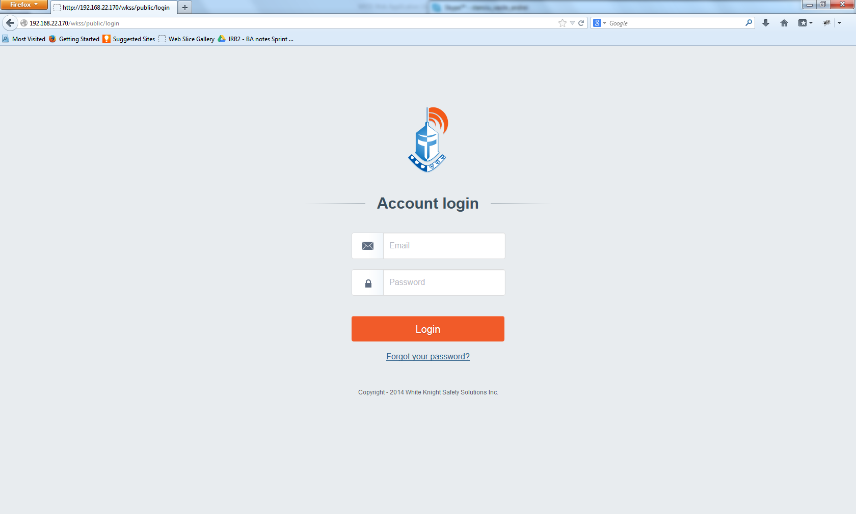

From here any user Super Admin or Company Admin can login into the WKSS Web Application.

Page actions:

* Login to the WKSS Web Application using valid credentials
* Use the Forgot Password functionality: A user can change his/hers password by following the Password recovery Flow. Click the “Forgot your password” link will take the user to the Recover Password screen. Upon entering a registered email, an email will be sent to the user’s inbox with a Password Reset link. At this point the user can set a new password.

***Note: Tokens for workers cannot be changed.***

## Available Menus and Actions for a Super Admin

## Management menu

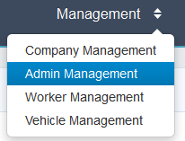From here the Super Admin can perform the following actions:

* Go to Company Management Page
* Go to Admin Management Page
* Go to Worker Management Page
* Go to Vehicle Management Page

## Company Management Page

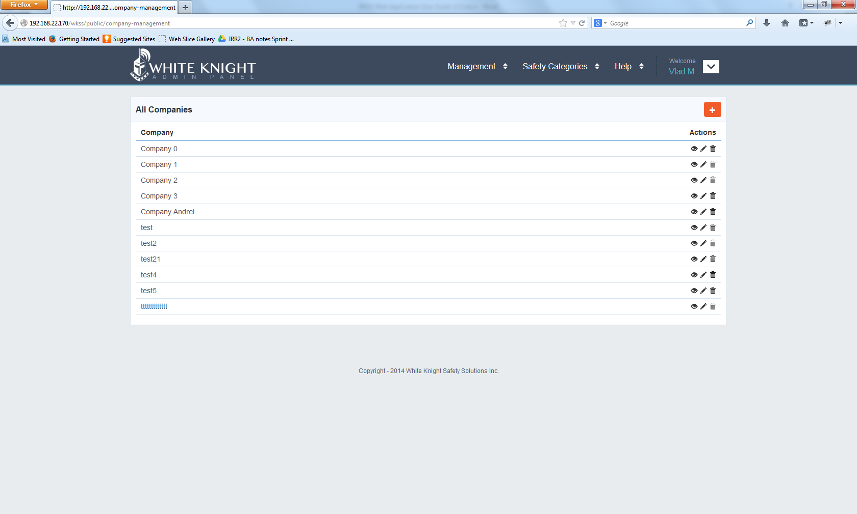

On this page the Super Admin can add new companies or modify existing ones.

Page Actions:

* Add new Companies – using the “+”button
* Edit available Companies - using the “pencil” button
* View existing companies – using the “eye” button
* Navigate to other WKSS Web Application pages using the available drop-down menus
* Log out – using the Logout menu option from the User Menu

## Admin Management Page

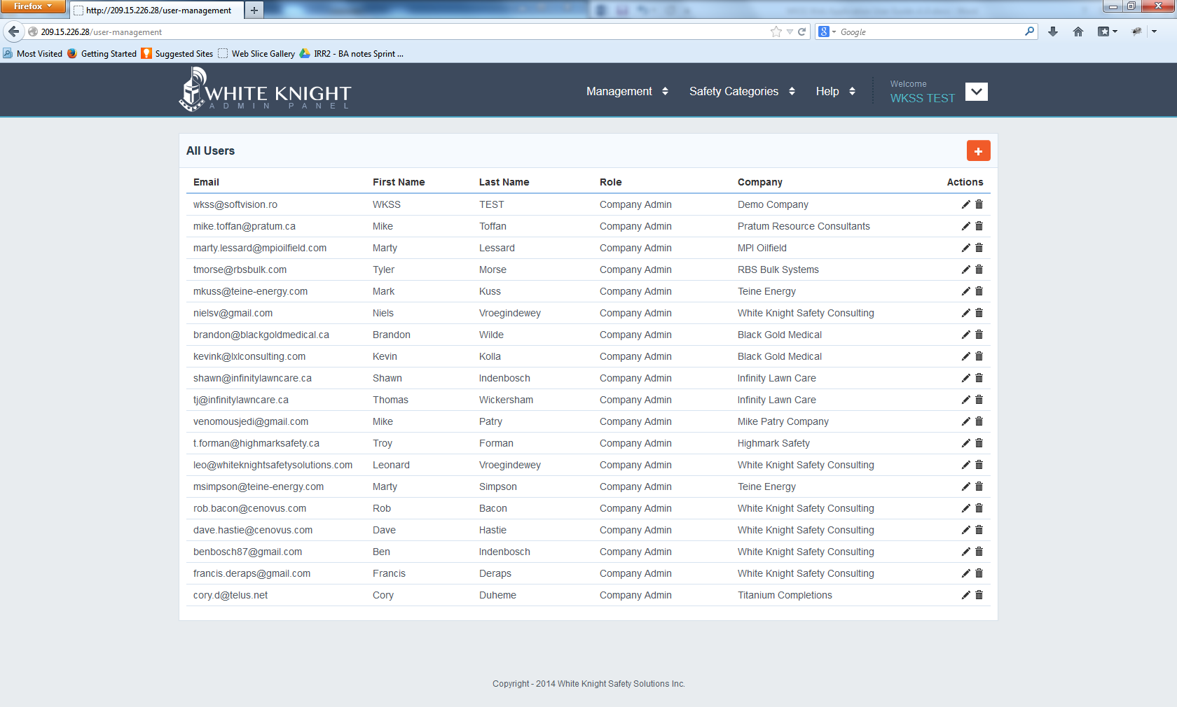

From the Admin Page the Super Admin can add and edit Company Admins for existing Companies in the system.

Page Actions:

* Add new Admins (Company Admins, Account Managers and Health and Safety Accounts) – using the “+”button
* Edit available Admins (Company Admins, Account Managers and Health and Safety Accounts) - using the “pencil” button
* Navigate to other WKSS Web Application pages using the available drop-down menus
* Log out – using the Logout menu option from the User Menu

## Worker Management Page

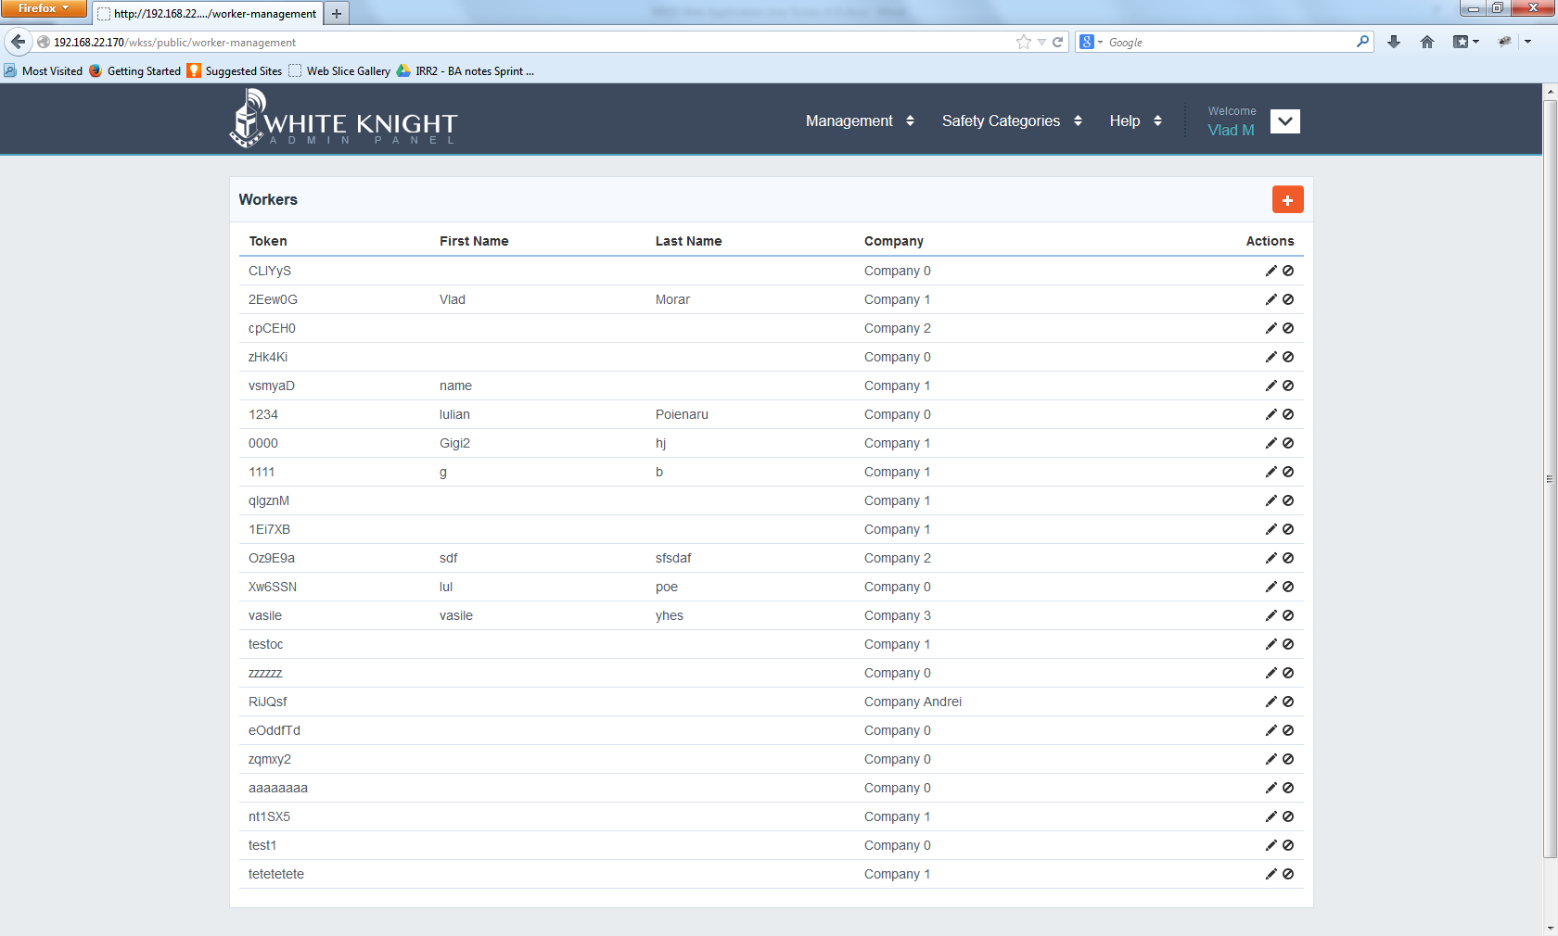

From the Worker Page the Super Admin can add and edit Workers for existing Projects in the system.

Page Actions:

* Add new Workers – using the “+”button
* Edit available Workers - using the “pencil” button
* Navigate to other WKSS Web Application pages using the available drop-down menus
* Log out – using the Logout menu option from the User Menu

## Vehicle Management Page

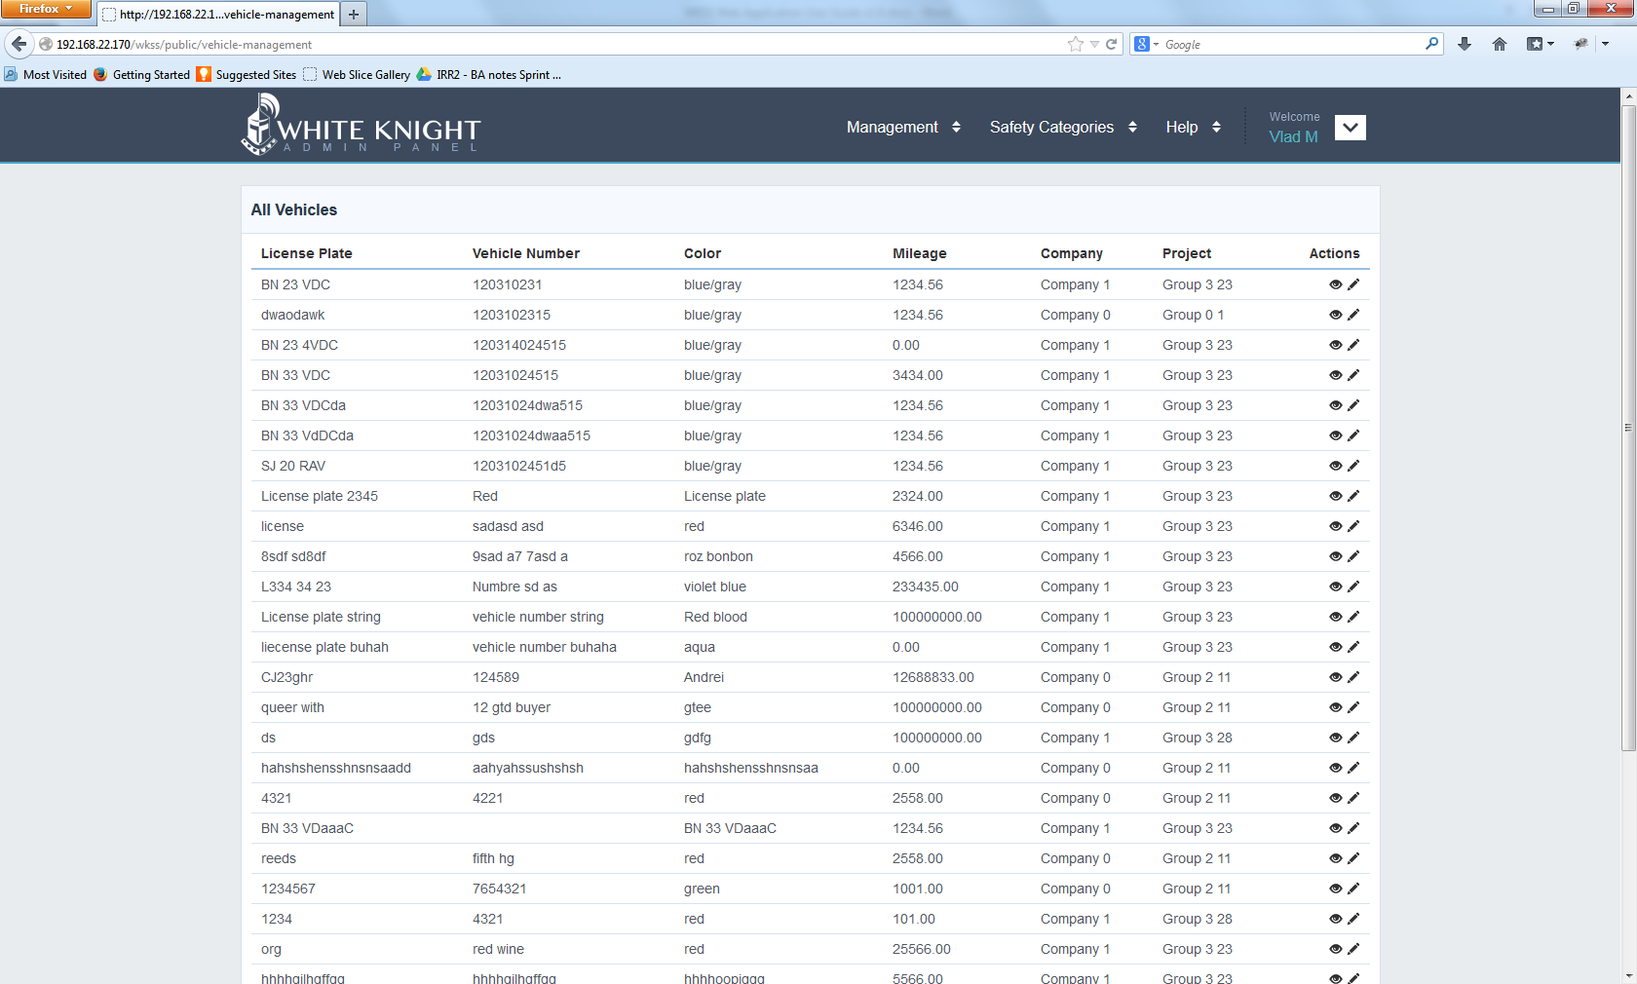

From the Vehicle Page the Super Admin can View existing Vehicles along with their Inspections (if available).

Page Actions:

* Edit existing Vehicles – using the “pencil” button
* View available Vehicles - using the ”eye” button
* View available Inspections for Vehicles – navigate through Inspections for a vehicle by clicking an Inspection when viewing a Vehicle.
* Navigate to other WKSS Web Application pages using the available drop-down menus
* Log out – using the Logout menu option from the User Menu

## Safety Categories Menu

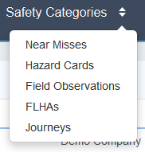

From here the Super Admin can perform the following actions:

* Go to Near Misses Page
* Go to Hazard Cards Page
* Go to Field Observations Page
* Go to FHLAs Page
* Go to Journeys Page

## Near Misses Page

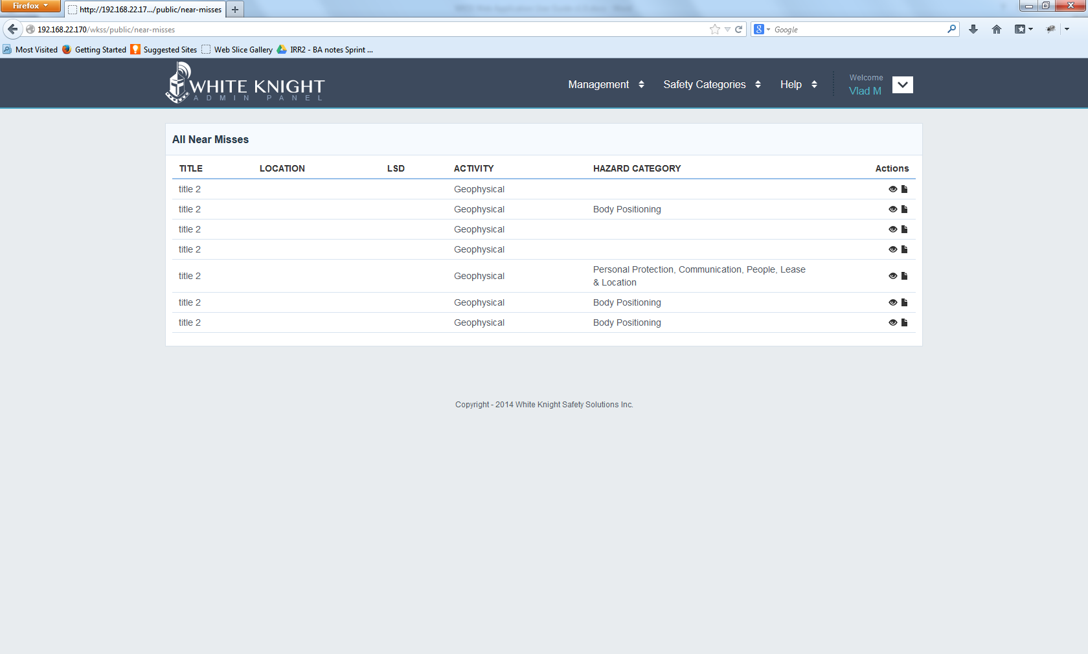

From the Near Misses Page the Super Admin can View existing Near Misses that are created by Workers from all available Companies.

Page Actions:

* View existing Near Misses - using the ”eye” button
* Export as PDF existing Near Misses – using the “file” button
* Navigate to other WKSS Web Application pages using the available drop-down menus
* Log out – using the Logout menu option from the User Menu

## Hazard Cards page

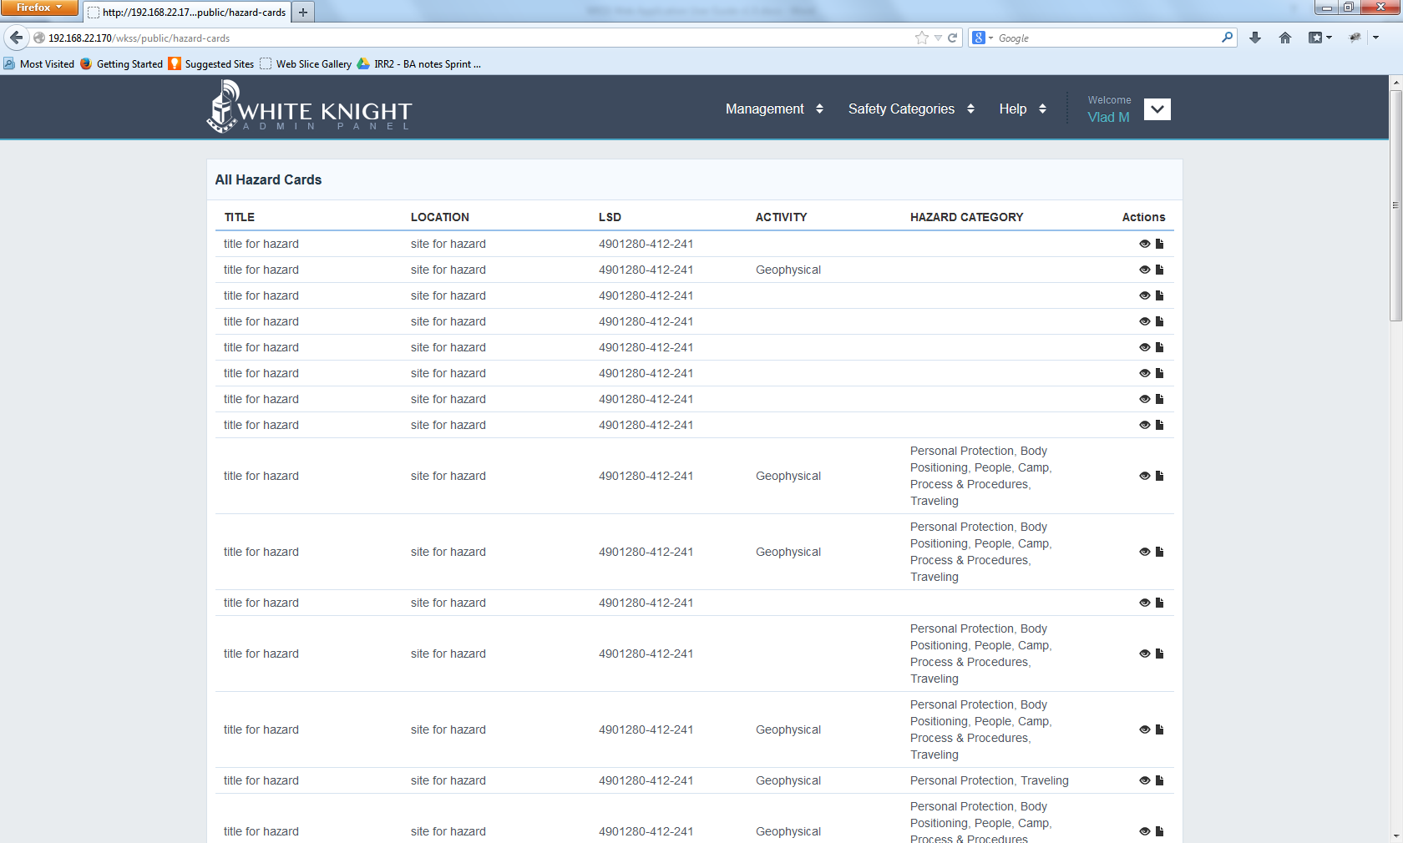

From the Hazard Cards Page the Super Admin can View existing Hazard Cards that are created by Workers from all available Companies.

Page Actions:

* View existing Hazard Cards - using the ”eye” button
* Export as PDF existing Hazard Cards – using the “file” button
* Navigate to other WKSS Web Application pages using the available drop-down menus
* Log out – using the Logout menu option from the User Menu

## Field Observations Page

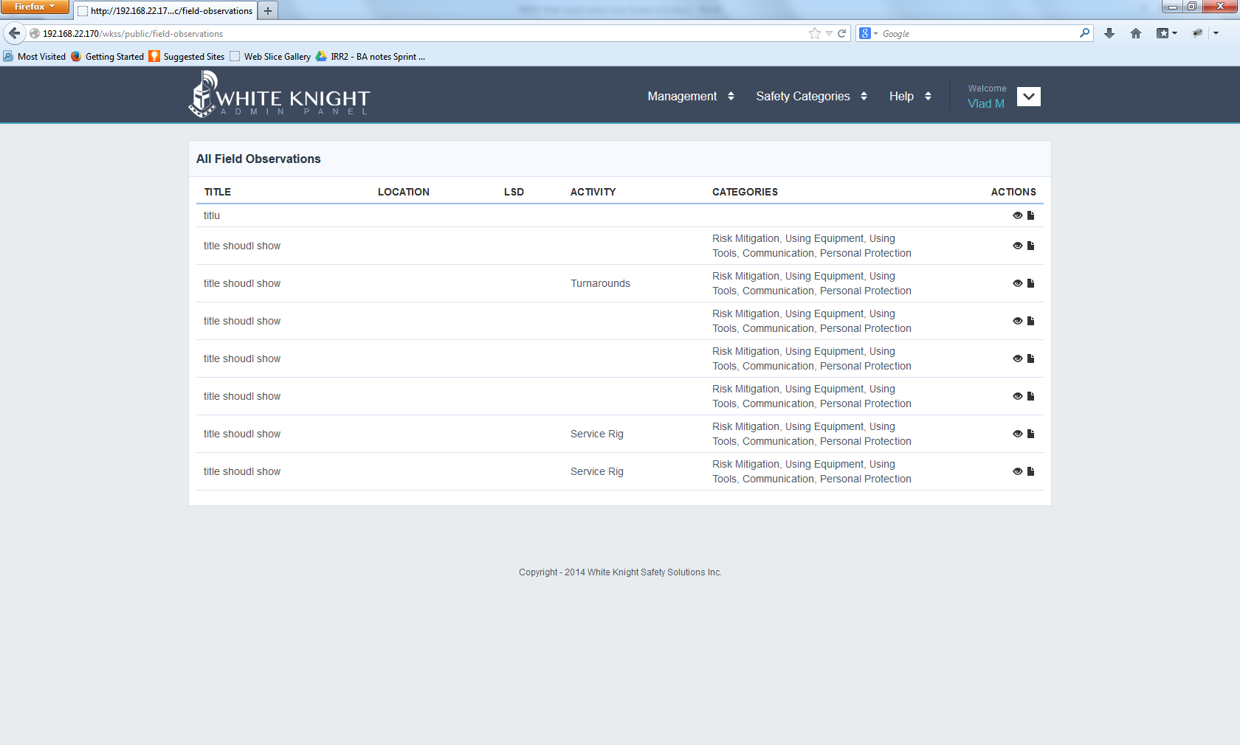

From the Field Observations Page the Super Admin can View existing Field Observations that are created by Workers from all available Companies.

Page Actions:

* View existing Field Observations - using the ”eye” button
* Export as PDF existing Field Observations – using the “file” button
* Navigate to other WKSS Web Application pages using the available drop-down menus
* Log out – using the Logout menu option from the User Menu

## FLHAs Page

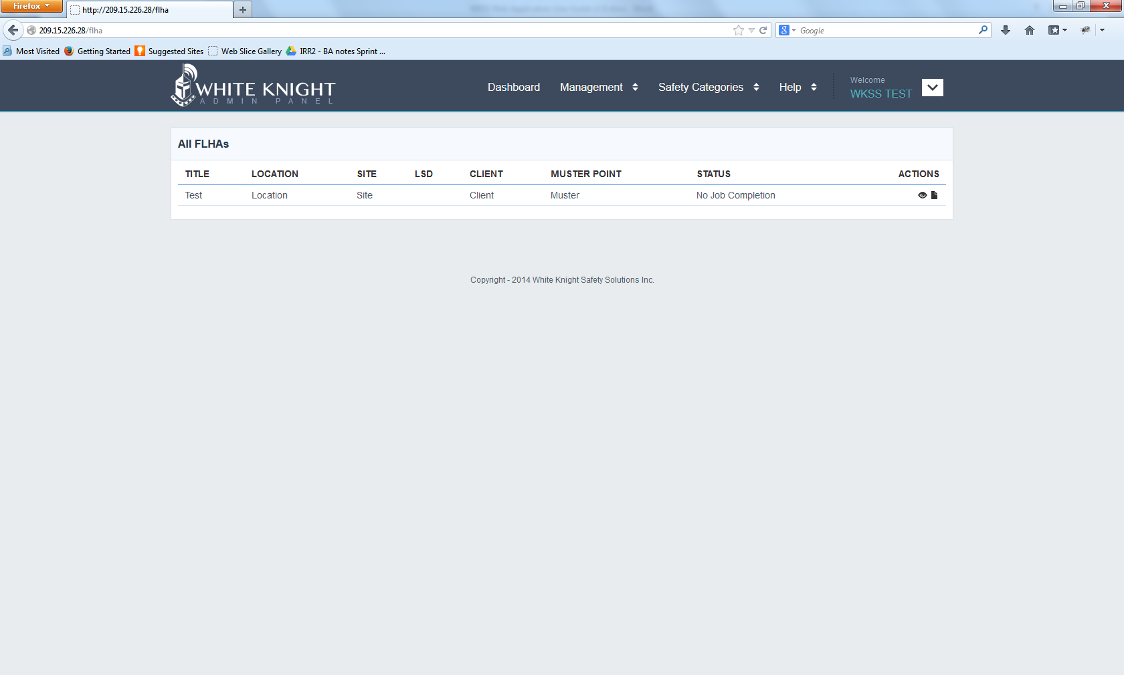

From the FLHAs Page the Super Admin can View existing FLHAs that are created by Workers from all available Companies.

Page Actions:

* View existing FLHAs - using the ”eye” button
* Export as PDF existing FLHAs – using the “file” button
* Navigate to other WKSS Web Application pages using the available drop-down menus
* Log out – using the Logout menu option from the User Menu

## Journeys Page

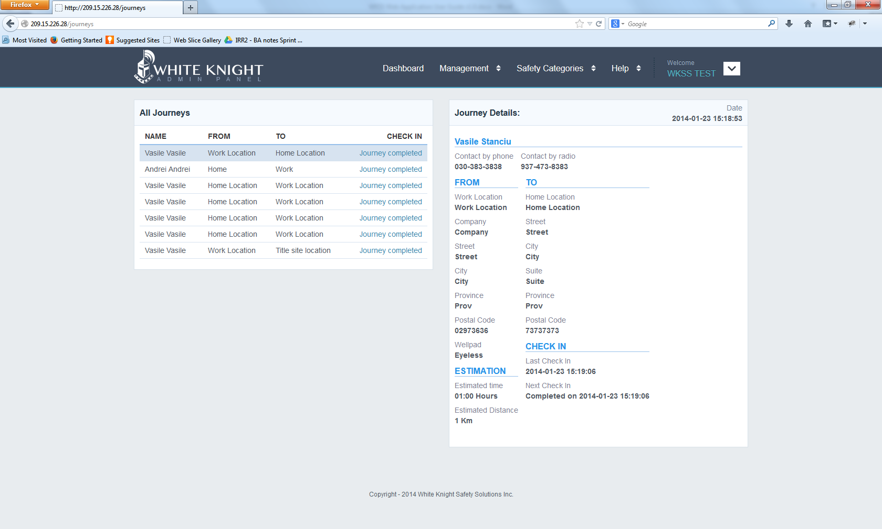

From the Journeys Page the Super Admin can View existing Journeys that are created by Workers from all available Companies.

Page Actions:

* View existing Journeys - using the ”eye” button
* Export as PDF existing Journeys – using the “file” button
* Navigate to other WKSS Web Application pages using the available drop-down menus
* Log out – using the Logout menu option from the User Menu

### Help Menu

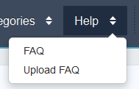

From here the Super Admin can perform the following actions:

* Go to FAQ Page
* Go to FAQ Upload Page

## FAQ Page

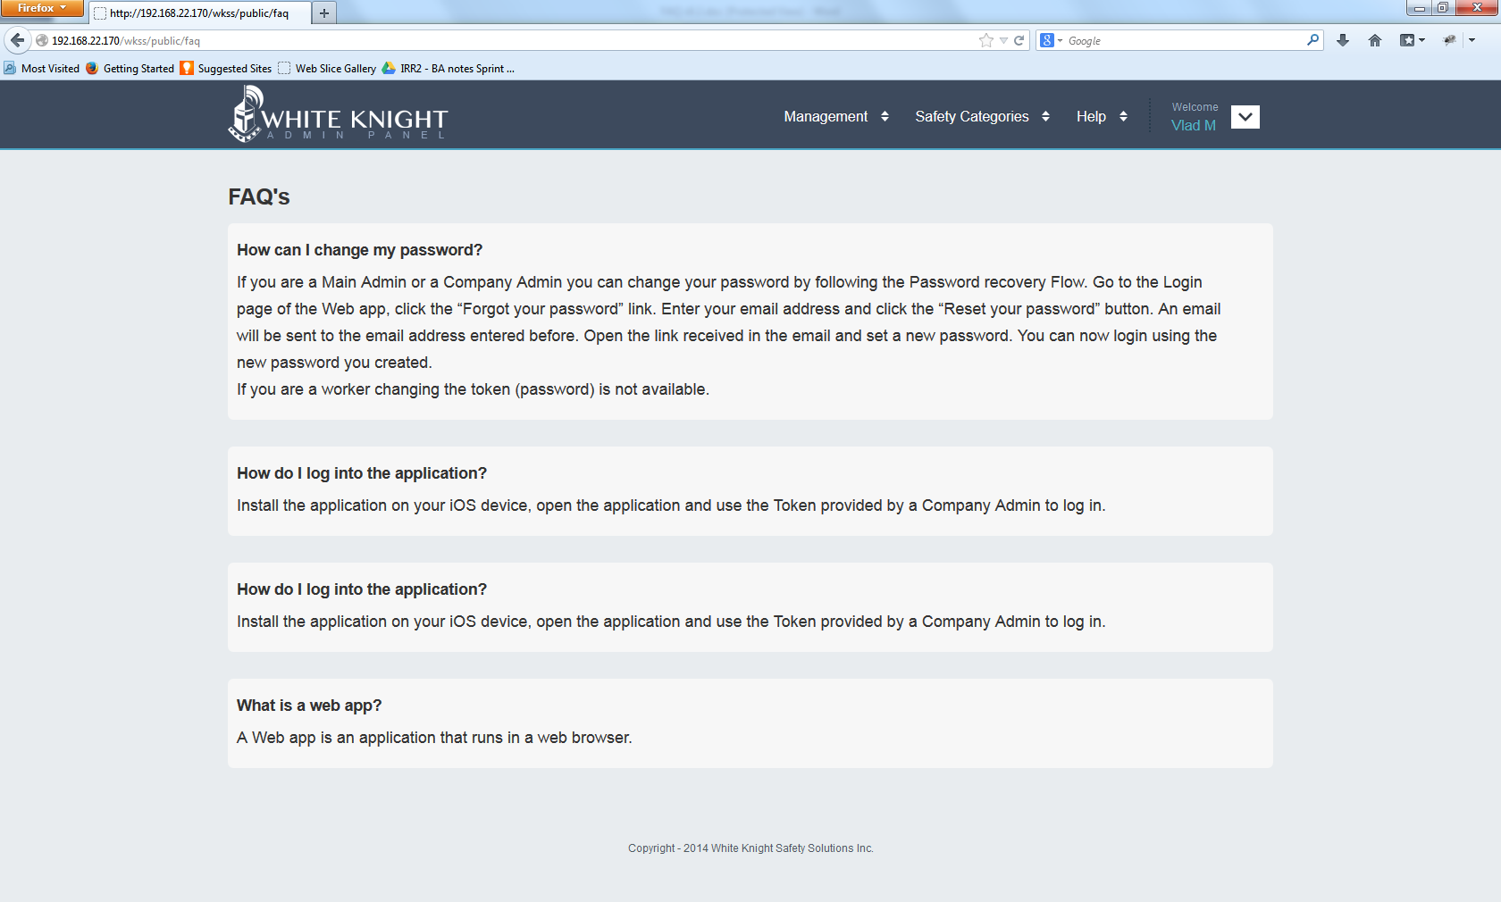

The FAQ page contains a list of frequently asked questions and answers to help any user find solutions in using the WKSS Web Application.

Page actions:

* View available FAQs
* Navigate to other WKSS Web Application pages using the available drop-down menus
* Log out – using the Logout menu option from the User Menu

## Add FAQ

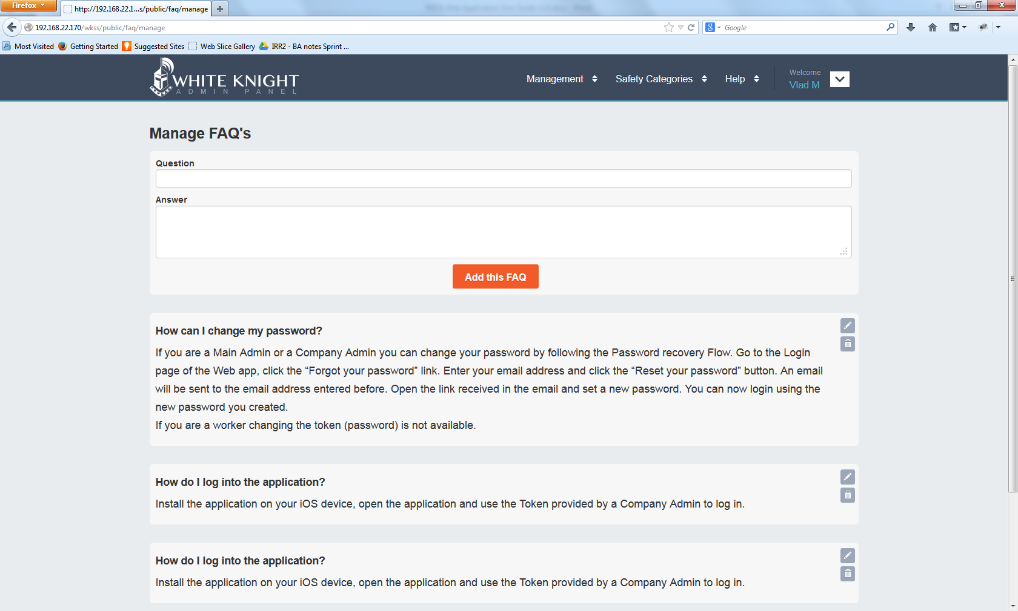

The Add FAQ page allows the Super Admin to add individually frequently asked questions and answers to help any user find solutions in using the WKSS Web Application. ***This functionality will only be available for Super Admins.***

Page actions:

* Add new FAQs
* View available FAQs
* Navigate to other WKSS Web Application pages using the available drop-down menus
* Log out – using the Logout menu option from the User Menu

# Super Admin Main User Flows

## Creating the Company Organizational structure

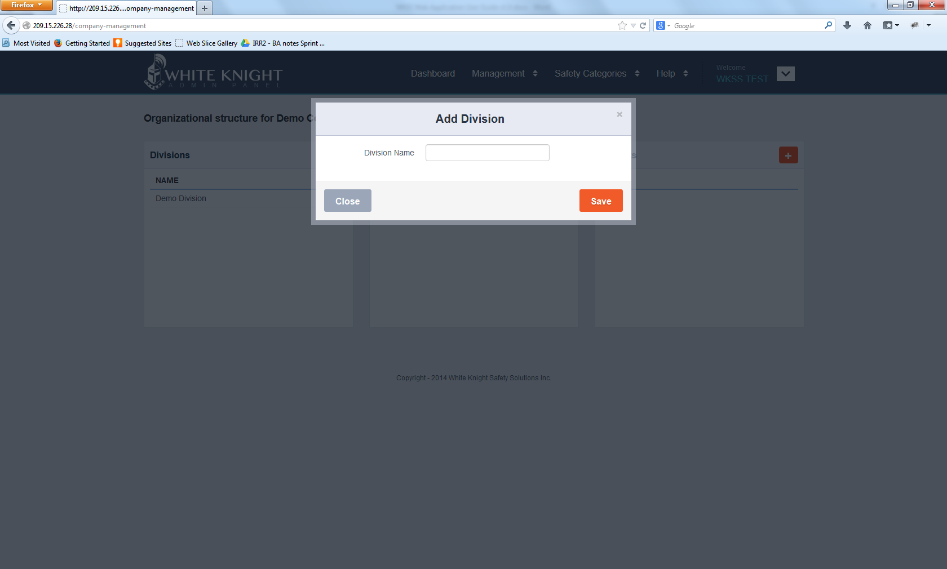

Create a new organizational structure for a given Company: Go to Company Management Page and from there, create the company organizational structure: Division Business Unit, Project.

Deleting a Division that has set an organizational tree will result in an error. Only when subsequent items to a Division are deleted, the Division itself can be deleted from the system. This also applies for Business Units and Projects.

Deleting a Division that has set an organizational tree will result in an error. Only when subsequent items to a Division are deleted, the Division itself can be deleted from the system.

# Company Admin Features

## Dashboard

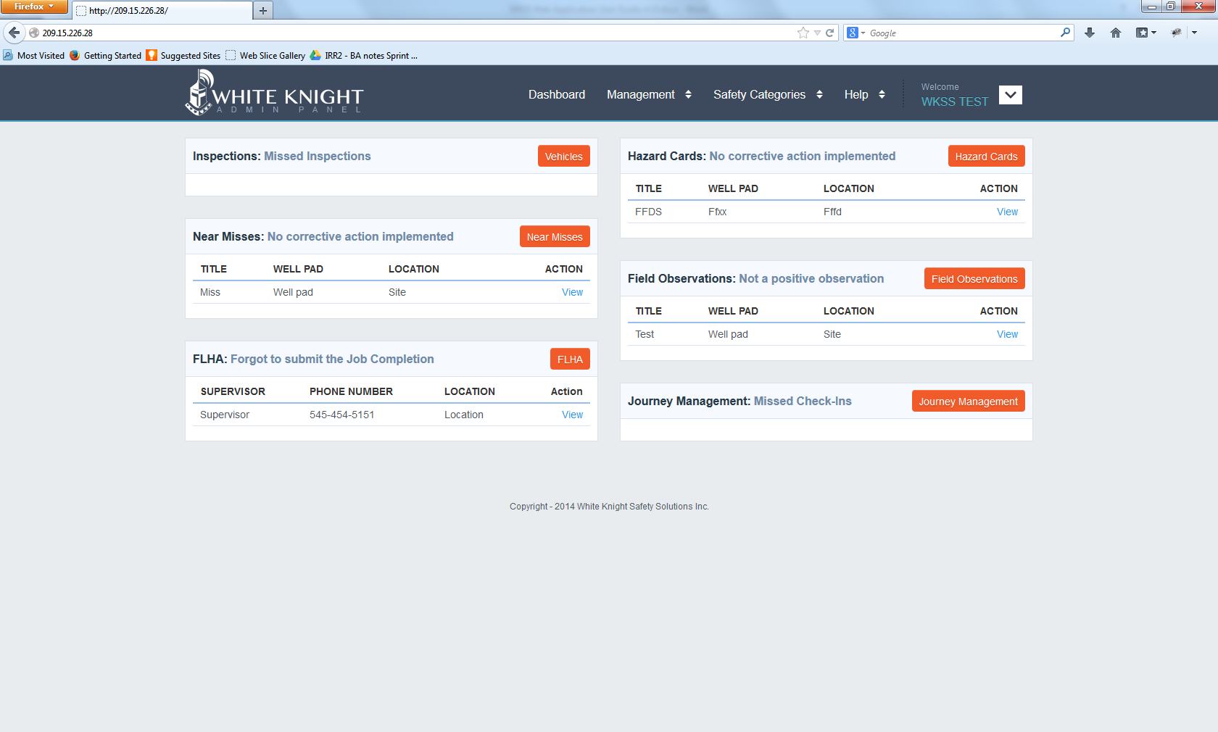

The Dashboard is the default landing page for a Company User. On this page the following items are displayed:

* Inspections Island – shows the latest Missed Inspections
* Near Misses Island – shows the latest Near Misses that have no corrective action implemented
* FLHAs Island – shows the latest FLHAs that have missing Job Completion submissions.
* Hazard Cards Island - shows the latest Hazard Cards that have no corrective action implemented
* Field Observations Island - shows the latest Field Observations that have no positive observations
* Journey Management Island – shown the latest Journeys that have Missed Check-ins

## Company Admin Menus and Actions

The same Functionalities are available in this release for a Company Admin as a Super admin with the following differences/limitations:

1. All records that are created by Company Workers will be available to a Company Admin. Company Admins do not have the rights to see other Companies records like Super Admins do.
2. Super Admins do not have the Dashboard islands
3. Super Admins can see records that are created by Workers from all available Companies.

## Company Admin Main User Flows

Please refer to the Super Admins User Flows. Version 1.0 of the application delivers the same functionally on both account types with some restrictions as follows:

* *Super Admins can Create Companies where Company Admins cannot*
* *Super Admins can add or modify FAQ items – please see FAQ section above where Company users cannot*

# Appendix

*[TBA]*