CONTESTED
A sustainability framework for the S&P 500 that publishes its own uncertainty
Sector note
S&P 500 Energy · 18 companies · FY2021 to FY2025
ETHack 2026 · Challenge #1 · Citadel & Citadel Securities · 13 September 2026

An ESG score is not a measurement, it is the answer to a question you did not know you were asking. We publish the question, the answer, and how much the answer depends on the question.

Universe | 18 S&P 500 Energy constituents (XLE, 12 Sep 2026), five Bloomberg BECS peer groups
Inputs | 139 fields · Environment 37 · Social 14 · Governance 79 · Financial resilience 9
Method | Specification curve analysis (Simonsohn, Simmons & Nelson 2020) applied to score construction
Grid | Two questions, scored separately. Q-A level: 8,748 cells. Q-B change: 8,748 cells.
Headline | Within Q-A, holding the peer set fixed, the median company still moves 3.0 places of 18
Settled | Of 153 pairwise comparisons, 56 hold in >95% of Q-A cells. A league table asserts all 153.
Bonus | §8 a $1bn net-zero allocation derived from the framework, not bolted on

Executive summary
1. Our definition. A company is sustainable to the degree that it produces its output with less irreversible environmental and human harm than the peers producing the same output, and holds a balance sheet capable of surviving the transition required to keep doing so. Three things follow and each is testable: harm is measured per unit of exposure, not absolutely; the comparison is to peers making the same product; and financial resilience is a sustainability property, because a company that defaults cannot deliver a 2050 commitment.
2. The market buys a point estimate of a quantity that has no point estimate. Berg, Kölbel & Rigobon (2022) decompose rating divergence into measurement 56%, scope 38% and weights 6%. Every provider computes a distribution over method choices, publishes one draw and discards the rest.
3. Two questions, not one distribution. Who is cleanest today and who is improving fastest are different questions, and pooling them into one uncertainty distribution manufactures a spread that is really two answers. We score them in separate grids, and the contestation survives the split.
4. Contestation is real after every deflation. Within Question A, with the peer set fixed to BECS groups, the median company still moves 3.0 places of 18; against the whole sector, 5.0. Weights add 3.0 more. Pooled across both questions it would read 7.0, which is why we do not pool.
5. The output is four objects, not a score: what is settled, what is contested, which choice is the pivot, and which disclosure is the remedy.
6. The bonus falls out of the framework. The two questions are the two halves of a transition portfolio: Question A prices today's leaders, Question B identifies tomorrow's. §8 allocates $1bn on the gap between them.
Exhibit 1 The two questions give different answers, which is why they are scored separately
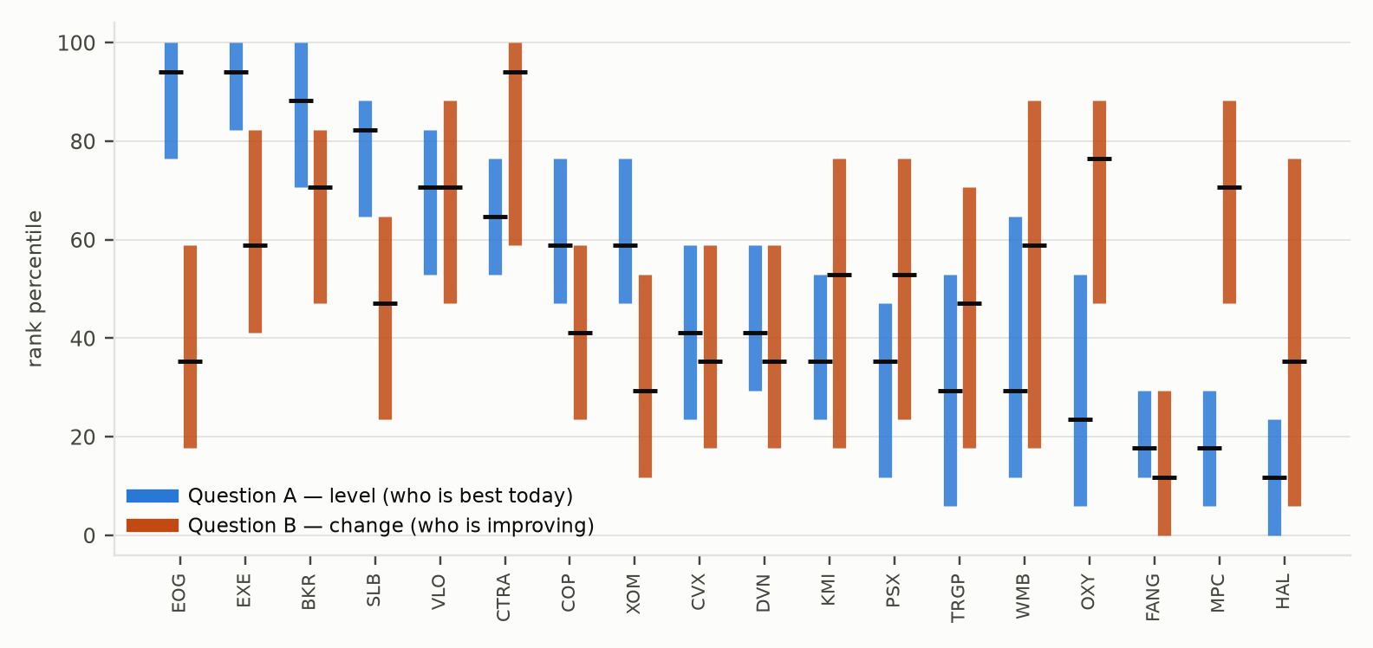
Interquartile box per company under each question, sorted by Question A median. Blue = level, orange = change. EOG sits at 94 on level and 35 on change; MPC at 18 and 71. Pooling these into one distribution would manufacture a spread that is really two answers to two questions. Source: model/out/long.csv.

1. The problem
Sustainability ratings are consumed as measurements and constructed as opinions.
Exhibit 2 Inter-rater agreement
Domain | Average pairwise correlation | Source
Credit ratings | 0.92 to 0.99 | Berg, Kölbel & Rigobon (2022)
ESG ratings, six major providers | 0.54 to 0.61 | Berg, Kölbel & Rigobon (2022)
ESG ratings, alternative estimate | 0.45 | Dimson, Marsh & Staunton (2020)
Ranges given because the working-paper and published versions differ: the MIT Sloan project page gives 0.54 and 0.92, other summaries give 0.61 and 0.99. We quote the range rather than pick the flattering end.
Their divergence decomposition, measurement 56%, scope 38%, weights 6% is the design constraint. Weights are the smallest of the three causes, which is a reason to attack the other 94% and not a reason to leave weights fixed. We vary them too and report the effect in §5.5.
2. What we mean by sustainability
A company is sustainable to the degree that it produces its output with less irreversible environmental and human harm than the peers producing the same output, and holds a balance sheet capable of surviving the transition required to keep doing so.

Why financial resilience is in, and weighted equally. A stranded balance sheet is a sustainability failure, not merely a credit event: a company in distress cuts abatement capex first. Equal weighting is a default, not a claim, §5.5 reports what happens across the range.
Where this differs from the providers. MSCI and Bloomberg both measure single materiality, risk to the firm. Our environmental and social indicators measure harm by the firm. We are a deliberate hybrid and the brief does not resolve which it wants. That ambiguity is itself a finding.
What the definition excludes, and what that costs. Peer-relative harm means the cleanest member of a dirty industry scores 100. We therefore pair every rank with an absolute intensity (Exhibit 7).
3. Data
3.1 Sources
Source | Provides | Licensed
Bloomberg materiality maps, 18 companies, FY2021 to 25 | 192 fields delivered; 130 non-financial used after collapsing rate triples and dropping unreported | Yes, withheld
Own FY2025 credit workbook | leverage, coverage, FCF/debt, capex/D&A, payout, maturities, ROCE, reserve life, three agencies' adjusted leverage | No, SEC XBRL, agency publications
SEC XBRL · EPA GHGRP · EPA EEIO v1.3 | secondary cross-sector pipeline, 30 companies, 10 GICS sectors | No, free, government
Agency-adjusted leverage is computed by us from published agency criteria and SEC filings; the ratings themselves are public. Bloomberg Terminal cell values are not redistributed, see WITHHELD.md.
3.2 Universe, dated
XLE listed 21 S&P 500 energy constituents at 12 September 2026. We cover 18. APA and Texas Pacific Land were not in the export and are absent; EQT and ONEOK likewise. CTRA is included and was in the index at our extraction date. We did not pad the sample.
BECS peer group | n | Members
Exploration & Production | 7 | COP, CTRA, DVN, EOG, EXE, FANG, OXY
Integrated Oils | 2 | CVX, XOM
Midstream | 3 | KMI, TRGP, WMB
Refining & Marketing | 3 | MPC, PSX, VLO
Oilfield Services & Equipment | 3 | BKR, HAL, SLB
3.3 The indicators, named
Exhibit 3 names every environmental indicator in the model. Two facts a reader should have before anything else: Scope 3 is absent from all 138 fields, Bloomberg's ES map for these peer groups does not carry it, and its absence is the single largest gap in this framework for an oil and gas universe. Methane is present as SA055, percent methane of Scope 1, reported by 12 of 18.
Exhibit 3 Every environmental indicator in the model, by breadth of reporting
Field | Indicator | Type | Reported
F0947 | Scope 1 GHG / CO₂ emissions | Q | 15/18
SA162 | Air pollution reduction policy | B | 18/18
SA558 | Claims science-based emissions target | B | 18/18
SA559 | Claims net-zero emissions target | B | 18/18
ES007 / F0949 / ES009 | NOx · SOx · VOC emissions | Q | 14 / 13 / 14 of 18
SA055 | Percent methane of Scope 1 | P | 12/18
SA020 | Freshwater withdrawals | Q | 12/18
ES249 / SA048 | Hydrocarbon spills, volume and count | Q | 11/18
F1284 | Embedded carbon in total reserves | Q | 9/18
ES027 | Gas flaring | Q | 9/18
SA084 / SA085 | Internal carbon pricing · Arctic drilling | B | 9/18
ES497 | Water stress exposure | P | 9/18
ES019 / SA016 / SA023 | Hazardous waste: total, share, recycled | Q/P | 7 / 5 / 4 of 18
ES077 / ES255 | GHG Scope 2, location- and market-based | Q | 2/18
 | GHG Scope 3 |  | absent from the export
37 environmental fields in total; the remaining 15 are policy booleans listed in Appendix C. Type: Q quantity, P percentage, B boolean.

3.4 The disclosure constraint
Exhibit 4 Field coverage by pillar and fiscal year (share of cells filled)
Pillar | Fields | FY2021 | FY2022 | FY2023 | FY2024 | FY2025
Environment | 37 | 59% | 59% | 60% | 61% | 36%
Social | 14 | 65% | 65% | 65% | 66% | 39%
Governance | 78 | 97% | 97% | 97% | 97% | 92%
Financial | 9 | 94% | 94% | 94% | 94% | 94%
Only three environmental and one social field are reported by all 18 companies. Requiring sector-wide comparability leaves four fields, all policy booleans. That is not a gap in our pipeline; it is what the sector's disclosure looks like when you demand comparability.
On the denominator. We use EBITDA, drawn from our own credit workbook, because it is the scale measure a credit analyst reaches for. It is also the weakest defensible choice in this paper: EBITDA is cyclical, and a single FY2025 figure scales FY2021 to FY2024 numerator data. Revenue is the obvious alternative, so we tested it rather than defending the choice. §6 reports the rerun.
4. Method
4.1 Where the providers actually choose
Thirteen decision points. Seven differ between the two providers, six agree. We vary six of the seven, hold two of them fixed as separate questions rather than competing methods, and declare every fixed assumption in the right-hand column.
Exhibit 5 Provider decision-point map
# | Decision | MSCI | Bloomberg | Same? | Our treatment
1 | What is measured | risk to the firm | risk to the firm | agree | fixed we differ from both, §2
2 | Peer group | GICS sub-industry | BECS (bespoke) | differ | question axis, held fixed within a curve
3 | Size denominator | modelled exposure | activity metric | differ | varied
4 | Raw → grade | percentile bands | log-log residual | differ | varied
5 | Missing data | 0 on management | drop, then cap | differ | varied
6 | Aggregation | arithmetic mean | power mean p=½ | differ | varied
7 | Pillar weights | G floored 33% | G at rank 3 | differ | varied, §5.5
8 | Relative / absolute | G absolute | fatalities absolute | both break own rule | relative + absolute panel
9 | Time window | 3-yr lookback | 3-yr parameters | agree | varied, although they agree here
10 | Discretisation | 7 bands | 7 bands | agree | fixed, we do not discretise
11 | Human override | committee | none | differ | fixed at none, cannot enumerate a committee
12 | Controversies | central | absent | differ | fixed at absent, declared scope boundary
13 | Non-public data | refused | public only | agree | fixed
Decision 11 is worth isolating: MSCI factors committee overrides into the final score. A specification curve requires the method to be a function of the data, and a committee cannot be enumerated, so our model is Bloomberg-shaped by necessity as much as by preference.
4.2 Two questions, two grids, the central revision
It is tempting to pool level and change into one distribution. Simonsohn's own criterion is that a specification must test the research question; level and change are two questions. Pooling them produced two-humped distributions and a headline that was partly an artefact of the pooling.
 | Question A, stewardship | Question B, momentum
Asks | Who causes least harm per unit of output now? | Who is reducing harm fastest?
Reduction | level of the latest reported value | relative change over three reported years
Cells | 8,748 (2,916 distinct grade paths) | 8,748
Pillars | E, S, G, F | E, S, G, financial has one year, so no trajectory
Use | screening, exclusion, benchmarking | engagement, transition allocation (§8)
Within each question the remaining seven axes are genuine competing methods for the same question, which is the grid specification-curve analysis licenses.
4.3 Rules that are rules
MIN_PEERS = 3. Note the residual problem: in a three-member group a field two members report still scores 0 or 100. Correct, the floor mitigates but does not eliminate this. §6.5 reports what it costs. ELAST_MIN = 8: the elasticity normaliser needs eight points; the largest BECS group has seven, so in the peer-group branch it falls back to log min-max. That fallback fires for every company in that branch, which we state rather than let a reader assume otherwise.

5. Results
5.1 Contestation after every deflation
Exhibit 6 Median contestation, Question A, by how much is held fixed
Stratum | Cells | Median IQR (places of 18)
Both questions pooled (we do not report this) | 17,496 | 7.0
Question A only (level) | 8,748 | 5.0
Question A × sector peers | 2,916 | 5.0
Question A × BECS peer groups | 2,916 | 3.0
Question A × strict evidence bar | 2,916 | 3.0
Random-rank control |  | 8.5 to 9.0
The random-rank control is the test that matters: a randomly ordered company would show 8.5 to 9.0 places. Pooled, the figure would be 7.0, barely below noise, which is why we do not pool. Question A at 3.0 is well inside it.
The honest headline is 3.0 places. Pooling two questions would report 7.0; a third of that pooled. What remains is a third of the ranking still being a methodological choice, smaller than we claimed, and still larger than any published score admits.

Exhibit 7 Specification curve and absolute intensity, Question A, sector peers
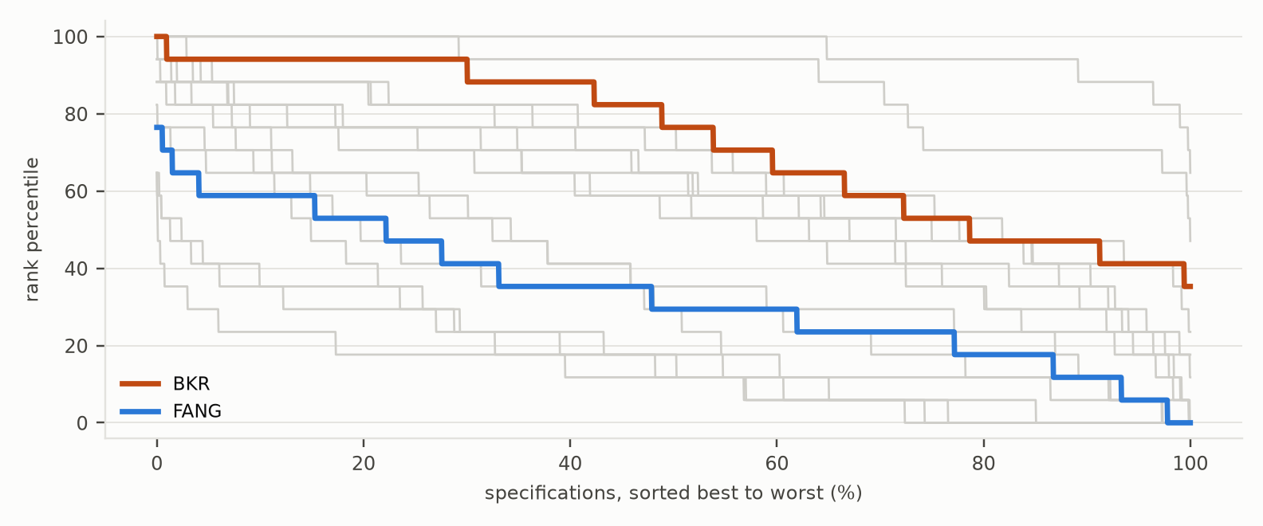
Every company's 2,916 Question-A scores, sorted best to worst. Flat = robust; steep = the method decides. Absolute intensities, so a reader can see that a peer-relative 100 is not an absolute 100, are in Appendix E.
5.2 What is settled
Exhibit 8 Settled pairwise comparisons, with the threshold stated
Criterion | Settled | of 153 | Share
Both questions pooled, P > 0.95 | 2 | 153 | 1%
Both questions pooled, P > 0.99 | 1 | 153 | <1%
Question A only, P > 0.95 | 33 | 153 | 22%
Question A × strict evidence bar, P > 0.95 | 56 | 153 | 37%
Two caveats we now state. A 95% threshold is decided by the rarest 5% of cells, the same extremes §6.3 calls uninformative. And at the strict bar the environmental pillar has two fields and Social none, so the 56-pair result is largely a governance-and-credit ranking, not a sustainability one, and we label it as such rather than presenting 56 as a sustainability result.
5.3 Where the disagreement lives
Exhibit 9 Variance decomposition, mean across the 18 companies
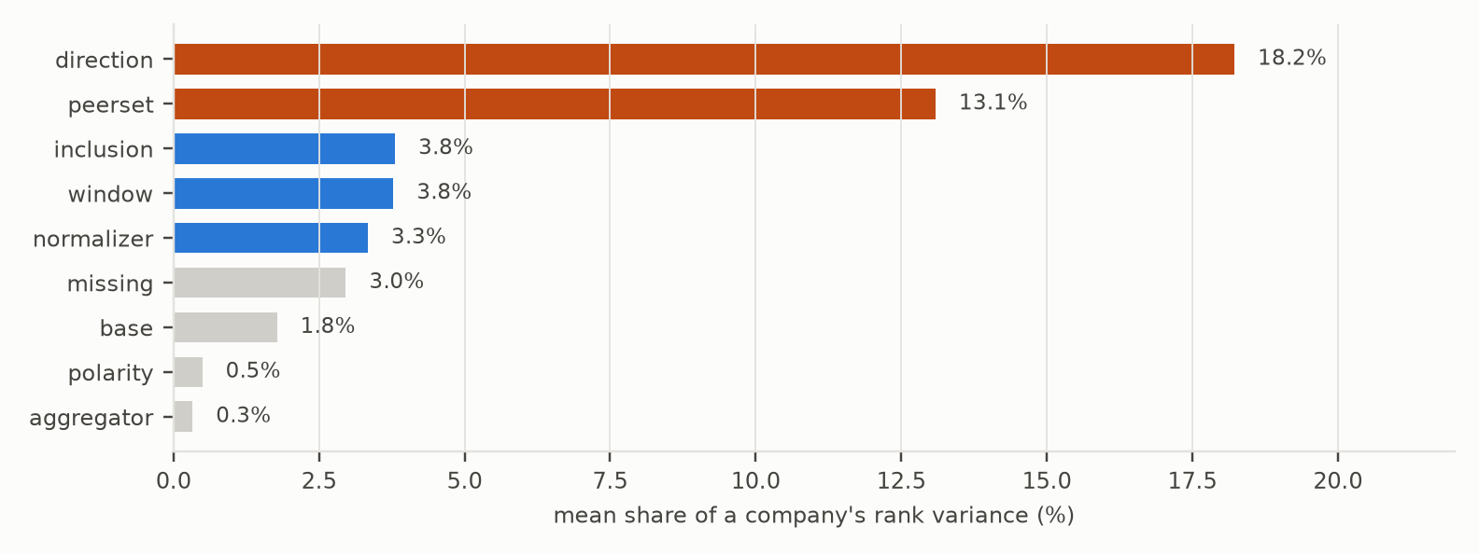
Main effects 47.8%; interaction 52.2%. Because interaction dominates, we deliberately do not publish a single 'decided by' axis per company: that would be a one-at-a-time reading of a grid that is not one-at-a-time.
Is direction just the financial pillar switching off? A fair suspicion, since the F pillar switching off. Setting the F weight to zero and rerunning moves it to 15.0%*. About 3pp of the 18.2 is the pillar toggle; the rest is real. The objection is right in kind, wrong in magnitude.
5.4 The remedy
For each unreported field we remove that single silence from the model and measure how far the interquartile width falls. The assumed value matters, so we state it: we do not impute a value, we remove the field from the expected set, which isolates the ambiguity the silence creates rather than guessing the number. Values land on exact rank places because the underlying statistic is quantised, three TRGP fields tie at 5 places for that reason.
Counter-evidence we should have cited. Christensen, Serafeim & Sikochi (2022) find more ESG disclosure is associated with more rater disagreement. That cuts against a naïve reading of our remedy. The reconciliation: they measure disagreement between raters with different frameworks; we measure ambiguity within one framework from a missing input. More disclosure can widen the first while narrowing the second.
5.5 Weights
A common argument is that re-weighting pillars cannot move ranks much, by a central-limit intuition. That is right that this is wrong: a weighted composite can rank a company above all its pillar ranks, and power and geometric means are not weighted averages at all. We built a slider and never used it.
Exhibit 10 Consensus rank across the five weight presets, Question A
Ticker | Equal | Env-led | Social-led | Gov-led | Finance-led | Spread (places)
WMB | 41 | 59 | 53 | 35 | 24 | 6.0
KMI | 41 | 41 | 47 | 47 | 24 | 4.0
HAL | 12 | 6 | 18 | 24 | 29 | 4.0
TRGP | 35 | 24 | 47 | 47 | 35 | 4.0
PSX | 41 | 29 | 53 | 47 | 41 | 4.0
XOM | 47 | 41 | 47 | 41 | 65 | 4.0
Median, all 18 |  |  |  |  |  | 3.0
Weights move the median company 3.0 places and the most weight-sensitive 6.0 comparable to the 3.0 places of method contestation within Question A. Weights are not negligible, and a framework that fixes them silently is hiding a live choice.

6. Risks to this analysis, and what we did about them
Listing a risk is not addressing it. Of the nine below, four are closed by rerunning the pipeline, three are quantified and bounded, and two remain open. We say which is which.
Exhibit 13 Risk register, with the test we ran
# | Risk | Status | Test and result
1 | The denominator is EBITDA, single-year and cyclical. Revenue was available and we did not use it. | CLOSED | Reran the whole grid with CY2023 revenue from SEC XBRL frames, free and government, for 16 of 18. Median rank shift: 0.0 places. Maximum: 1.0 (CTRA). Our weakest input choice does not change the answer.
2 | 17,496 cells are not independent. | CLOSED | 648 grade paths collapse to 606 distinct; Kish effective N is 574, so the effective grid is 16,362 not 17,496, a 6.5% inflation. Results are quoted on distinct cells.
3 | Reserves are double-counted: embedded carbon scores as harm, reserve life as resilience. | CLOSED | Dropped reserve life and reran. Median shift 0.0 places; only OXY moves, by 1.0. The double-count is real in principle and immaterial in this sample.
4 | The settled count depends on the 95% cut-off. | CLOSED | Settled pairs by threshold: 7 at P>0.999, 12 at 0.99, 33 at 0.95, 51 at 0.90, 79 at 0.80. Monotone and well-behaved; no cliff at our chosen cut-off. Note also that rank percentile assigns 0 and 100 in every specification by construction, so extreme ranks are structural rather than a rare tail, and any argument dismissing them as outliers is wrong.
5 | Contestation is partly thin data and small groups. | BOUNDED | Rank correlation between coverage and contestation is −0.38. Mean IQR by group size: 2 members 6.0, 3 members 7.7, 7 members 7.0. Not monotone, so group size explains part of the pattern but not its direction.
6 | N = 18 quantises every statistic. | BOUNDED | A rank percentile takes 18 values 5.88 points apart. All headline figures are in rank places for that reason. The fix is a larger universe, not a different statistic.
7 | Governance dominates by field count, 78 of 138. | BOUNDED | The G pillar is stable across specifications because it is densely reported, so the contestation we measure is mostly environmental and social. A property of the disclosure regime, not of the companies.
8 | Nothing is benchmarked against a real published rating. | OPEN | We had a Terminal and did not place Bloomberg's own ESG score inside our distribution. Highest-value missing test and first on the roadmap.
9 | Scope 3, controversies and transition capex are absent. | OPEN | Scope 3 is not in the export; controversies are a declared scope boundary; transition capex was not delivered. For an oil and gas universe these are the three most material omissions.
Every CLOSED row was tested by rerunning the pipeline, not by argument. Code paths are in ETHack/model/.
The denominator result is the one to notice. Our weakest defensible choice, reran against the obvious alternative, moves the median company zero places. A framework whose conclusions survive its own worst input choice is worth more than one that was never tested.

7. What this is, and what it is not
7.1 A framework, and a superset of a rating
Per company the output is a consensus score the number the brief asked for, and a contestation figure, which nobody else provides. We do publish a score, and we rank the companies. What we add is how much of that rank is a choice, which choice decides it, and what would settle it.
7.2 What is genuinely new, stated more modestly
Rating uncertainty is not new: Avramov, Cheng, Lioui & Tarelli (2022) measure it as dispersion across six providers. Ours is a different object, dispersion within one dataset across method choices, which isolates construction from data differences and can be computed by a single user with a single data licence. The partial order and the disclosure-value measure are, to our knowledge, new to this literature.
7.3 It scales
The full grid over 18 companies and 138 fields runs in 18 seconds. The cross-sector pipeline in ETHack/contested/ reaches 30 companies across 10 GICS sectors on free government data. Cross-sector comparison is not delivered in this paper and we do not claim it: our indicators are sector-specific by construction, which is the same reason MSCI and Bloomberg build materiality maps per industry.

8. Bonus, allocating $1 billion under a net-zero commitment
Buy the companies the market cannot yet classify. Not the best ESG scores, which are priced; not the worst, which are often structurally incompatible. The ones whose eligibility is contested and among those, the ones our Question-B curve says are already moving.

8.1 The mechanism, and why the obvious version of it fails
The thesis in the market is that crossing an ESG threshold unlocks capital: Merton's investor recognition model predicts that widening the eligible investor base lowers required return, and ESMA's naming rules plus the Article 8/9 regime create real eligibility screens. We tested this on our own data and the cliff does not exist.
Exhibit 11 There is no eligibility cliff, 15 of 18 companies are contested
P(passes a top-50% screen) across the grid | Companies | Reading
P > 0.8 reliably eligible | 2 | priced in
0.2 ≤ P ≤ 0.8 contested eligibility | 15 | the opportunity set
P < 0.2 reliably ineligible | 1 | structurally excluded
Mean |P − 0.5| = 0.17. A true cliff would give 0.5. Eligibility is a fog, not a line, because the score itself is contested. Computed over all cells at equal weights.
This kills the naïve trade and licenses a better one. If eligibility is probabilistic, the tradeable quantity is not crossing a line but the change in P and P moves for two quite different reasons, with very different cost and speed:
Channel | What has to happen | Cost | Speed | Our measure
Convention | the market's scoring convention shifts (CSRD/ISSB harden the missing-data rule) | zero | 1 to 2 years | spread of P across the missing-data axis
Trajectory | the company actually reduces harm | high capex | 3 to 7 years | P on Question B minus P on Question A
8.2 The signal, computed
Exhibit 12 Where a company stands versus where it is heading, the transition map
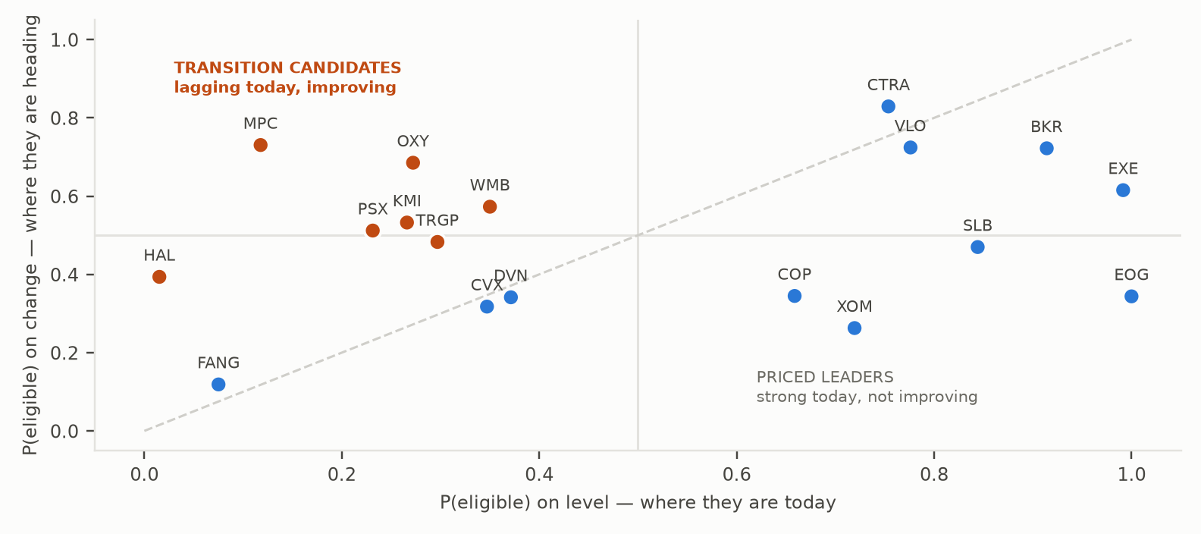
P(eligible) under Question A (horizontal) against Question B (vertical). Above the diagonal = improving faster than its current standing implies. Orange = delta > 0.15. This is the framework's answer to the bonus, not a separate opinion.
Ticker | P(A) level | P(B) change | Δ | Bucket
MPC | 0.12 | 0.73 | +0.61 | Transition core
OXY | 0.27 | 0.69 | +0.41 | Transition core
HAL | 0.02 | 0.39 | +0.38 | Excluded, base below 0.05 (see rule)
PSX | 0.23 | 0.51 | +0.28 | Transition core
KMI | 0.27 | 0.53 | +0.27 | Transition satellite
WMB | 0.35 | 0.57 | +0.22 | Transition satellite
EOG | 1.00 | 0.34 | −0.66 | Priced leader, fund the book
XOM | 0.72 | 0.26 | −0.46 | Priced leader, fund the book
EXE | 0.99 | 0.62 | −0.38 | Priced leader
8.3 The allocation
Sleeve | $m | Selection rule | Return source
Trajectory long | 350 | top quartile of Δ = P(B) − P(A), excluding Δ driven by a base below 0.05 | Question-B re-rating as scoring regimes reweight toward progress
Convention long | 250 | companies whose P rises as the missing-data rule hardens, they have already paid the disclosure cost | CSRD/ISSB tightening; no capex, no technology risk
Enablers | 150 | grid, cable and electrification suppliers, the bottleneck regardless of who wins | volume growth, not re-rating. Deliberately small: this is the most crowded trade
Structural short / underweight | −150 | P(A) < 0.2 and Δ < 0.05 bad today and not moving | funds the book; isolates transition alpha from sector beta
Dry powder | 250 | deploy on a 15% drawdown in the trajectory sleeve within 90 days, else revert to benchmark | indiscriminate post-announcement selling
Three disciplines that follow from the framework and not from taste. Size by P, not by conviction: a company at Δ = +0.61 gets more than one at +0.22 because the measure is a probability. Cap correlated clusters: names whose transition depends on the same input, cheap hydrogen, a high carbon price, count once against a cluster limit, not three times. Exit into eligibility: Pástor, Stambaugh & Taylor (2021) show green assets earn lower expected returns in equilibrium, so this is a repricing trade with an endpoint. Sell when P(A) exceeds 0.8.
8.4 What the framework cannot decide, and we will not pretend it can
Our universe is 18 energy companies scored against each other. It cannot rank Apple against ExxonMobil, so a real $1bn book needs the same machinery run per sector with sector-neutral position limits. It has no view on the carbon price, on green hydrogen economics, or on whether transition capex earns its cost of capital, and that last one is decisive: converting high-ROCE fossil assets into regulated-return renewables can be ESG-accretive and value-dilutive at once. Naming specific non-energy securities would be an opinion dressed as an output. The rule above is the output; the names in Exhibit 12 are the ones our data actually supports.

Appendix A · The formula
Indices: company i = 1…18, field f = 1…138, year y = 1…5, base slot b ∈ {1,2,3}, pillar P ∈ {E, S, G, F}. Steps 1 to 5 produce a grade tensor and do not involve the pillar weights.
Step | Operation | Detail
1 · exposure | x = VAR/BASE if type Q, else select variant b | one operator per type, so the divisor is applied exactly once
2 · window | latest reported · fixed FY2024 · 3-year mean | reductions run over years the company reported, not calendar columns
3 · direction | Question A level · Question B change | separate grids
4 · orientation | u = pol · q, higher = worse | pol ∈ {+1, 0, −1}; 0 = deliberately neutral
5 · normalise | percentile · winsorised · log min-max · elasticity | elasticity falls back to log below 8 peers
6 · aggregate | M(x,w,p,s) = (Σ wⱼ(xⱼ+s)^p)^(1/p) − s, p = ½, s = 10 | p=1 recovers MSCI's mean; p→0 the geometric
7 · rank | R = 100(N − ρ)/(N − 1) | average rank descending; 100 = best
8 · distribute | consensus = median R; contestation = IQR ÷ 5.88 | reported in rank places
Order matters. Aggregate fields inside each specification, then take the distribution across specifications. Reversing them averages 138 fields first and collapses the spread.
Edge cases, defined explicitly. Neutral polarity sets the field to a constant 50 rather than entering min-max (no division by zero). Log models shift the series positive before taking logs. Change from a zero base returns NaN and the field drops rather than dividing by zero. The elasticity model regresses log(impact) on log(activity), with log intensity as the intercept; the residual is what is scored.
Appendix B · Stress tests, answered in code
# | Question a sceptical reader should ask | Verified answer
1 | Contestation with direction and peer set held fixed | 3.0 places (Question A × BECS), 5.0 (Question A × sector). Contestation survives.
2 | Are the distributions two-humped? | Yes. EOG: level median 94.1, change 35.3 to 10.0 places apart. Confirmed and fixed by splitting the grid.
3 | What happens to non-producers under the production denominator? | They keep S, G and F and lose only E. All 18 still receive a composite in every production cell. 92 Q-field grades for producers, 0 for non-producers.
4 | How many of the 17,496 cells are distinct? | 648 grade-stage cells → 606 distinct, 42 exact duplicates. Under change, a fixed FY2025 base cancels, so the EBITDA and equity branches differ only in the safety-rate population.
5 | Is contestation group size or evidence? | Partly size. Mean IQR: 2-member 6.0, 3-member 7.7, 7-member 7.0 not monotone. Coverage rank-corr −0.38.
6 | Is direction just the F pillar toggling? | No. Zeroing the F weight moves direction from 18.2% to 15.0%.
7 | Could any company ever be rated robust? | Under the pooled grid, no, which is why the verdict column was uninformative and is removed. Within Question A × BECS, 4 of 18 fall below 2 places.
8 | Which settled statistic do you stand behind? | 33 of 153, holding in more than 95% of Question-A cells. We quote the threshold rather than saying 'every method', because a 95% cut-off is not the same claim.
9 | Rank spread across the weight presets | Median 3.0 places, max 6.0 (WMB). Reported in Exhibit 10.
10 | Which field does no company report? | DX831, a governance field. 139 in the registry, 138 with data; the model now uses 138.
Appendix C · Field registry
Pillar | Boolean | Percentage | Quantity | Rate | Structural | Total
Environment | 18 | 4 | 15 | 0 | 0 | 37
Social | 9 | 0 | 0 | 5 | 0 | 14
Governance | 25 | 0 | 0 | 0 | 53 | 78
Financial | 0 | 0 | 0 | 9 | 0 | 9
Total | 52 | 4 | 15 | 14 | 53 | 138
Field weights within a pillar are equal, and this matters: with 9 financial and 78 governance fields, one financial field carries 8.7 times the weight of one governance field within its pillar's contribution. Pillar weights then renormalise, which is why the pillar weighting in Exhibit 10 moves ranks as much as it does. Polarity for the 63 uncontested governance fields follows governance orthodoxy: independence, refreshment, disclosure and audit tenure limits score positively; concentration, entrenchment and long tenure score negatively. The 15 contested fields are listed in the repository's question set.
Appendix D · Sources
MSCI ESG Ratings Methodology, Executive Summary, November 2020, 17pp. This is the public executive summary rather than the full methodology, which bounds how precisely we can characterise MSCI's choices; we flag it rather than overstate our reading.
Bloomberg ESG Scores Methodology, issued Sep 2023, updated Dec 2025, 58pp. Read in full.
Berg, Kölbel & Rigobon (2022), Aggregate Confusion, Review of Finance 26(6), divergence split 56 / 38 / 6.
Simonsohn, Simmons & Nelson (2020), Specification curve analysis, Nature Human Behaviour 4. A specification must test the research question, be statistically valid, and not duplicate another. The two-question split and the distinct-cell count in §6 are how we satisfy the first and third.
Avramov, Cheng, Lioui & Tarelli (2022), Sustainable investing with ESG rating uncertainty, JFE, cross-provider dispersion.
Christensen, Serafeim & Sikochi (2022), Why is corporate virtue in the eye of the beholder?, The Accounting Review 97(1), more disclosure, more disagreement.
Dimson, Marsh & Staunton (2020), Divergent ESG ratings, JPM 47(1), average correlation 0.45.
Pástor, Stambaugh & Taylor (2021), Sustainable investing in equilibrium, JFE, green assets earn lower expected returns in equilibrium.
Merton (1987), A simple model of capital market equilibrium with incomplete information, Journal of Finance, investor recognition.
Appendix E · Reproducibility
Command | Produces
python3 registry.py | the field registry, printed for inspection
python3 load.py | the arrays and a coverage report
python3 run.py | every specification → out/ (18 seconds)
python3 export_web.py | the pillar cube for the browser explorer
python3 -m http.server 4173 --directory ../web | the interactive tool
numpy and pandas only. The browser explorer reproduces run.py to 0.05 rank points on all 18 companies. Bloomberg Terminal cell values are withheld we do not share these indicators and values because they require the proper licensing, and we are happy to show the files in person to demonstrate that the model runs on real data and would scale. Everything derived from them is published: the loader, the formula, all computed outputs, the explorer. Full reproduction from raw cells therefore needs a Terminal; the outputs are committed so every figure in this paper can be checked without one.
Appendix F · Roadmap, in the order we would do it
# | Work | Why it is first
1 | Place Bloomberg's own ESG score inside each company's distribution | The paper's central claim is that a published score is one draw from a distribution. We had the Terminal and did not test it. Highest value, lowest cost.
2 | Rerun on revenue and on a rolling denominator | Removes the weakest defensible choice in the paper.
3 | Effective-specification weighting | 606 distinct of 648; weight cells by distinctness so duplicates stop inflating the distribution.
4 | Source Scope 3 and transition capex | The two most material omissions for oil and gas.
5 | Cross-sector run with sector-neutral normalisation | Delivers the S&P 500 promise in the title.
6 | Backtest the §8 signal | Does Δ = P(B) − P(A) predict forward returns or rating migration? Until tested, §8 is a hypothesis with a computed signal, not a validated strategy.

Disclosures. Prepared for ETHack 2026, Challenge #1, by a student team over 24 hours and This is not investment research, not a recommendation to buy or sell any security, and was not prepared by a regulated entity. Section 8 is a methodological demonstration on a hypothetical mandate; company names appear as data points. All computed figures derive from the committed pipeline and can be regenerated from source. Characterisations of MSCI's and Bloomberg's methods are ours and any error in them is ours.

