**1.**

**Default.aspx :**

<%@ Page Language="VB" AutoEventWireup="false" CodeFile="Default.aspx.vb" Inherits="_Default" %>

<!DOCTYPE html>

<html xmlns="http://www.w3.org/1999/xhtml">

<head runat="server">

<title>Untitled Page</title>

<script type="text/javascript">

</script>

<script type="text/javascript">

function LabelOver()

{

document.getElementById("lbl1").style.backgroundColor = "yellow";

}

function LabelOut() {

document.getElementById("lbl1").style.backgroundColor = "pink";

}

</script>

<%--//The getElementById() method returns the element that has the Id attributes--%>

</head>

<body>

<form id="form1" runat="server">

<div>

<asp:Label ID="lbl1" runat="server" Text="Hello Everyone" BackColor="LightBlue" BorderColor="Black" BorderStyle="Solid" BorderWidth="3px" Font-Bold="true"></asp:Label>

</div>

</form>

</body>

</html>

**Designing form :**

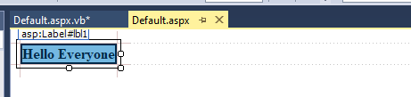

**Default.aspx.vb :**

Partial Class _Default

Inherits System.Web.UI.Page

Protected Sub Page_Load(sender As Object, e As EventArgs) Handles Me.Load

Try

'control.Attributes.Add method is used to add the client side attribute of the control not the server side property.

lbl1.Attributes.Add("onmouseover", "LabelOver();")

lbl1.Attributes.Add("onmouseleave", "LabelOut();")

Catch ex As Exception

Response.Write("DefaultPage_load Event")

End Try

End Sub

End Class

**Output:**

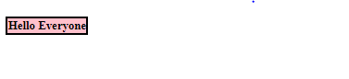

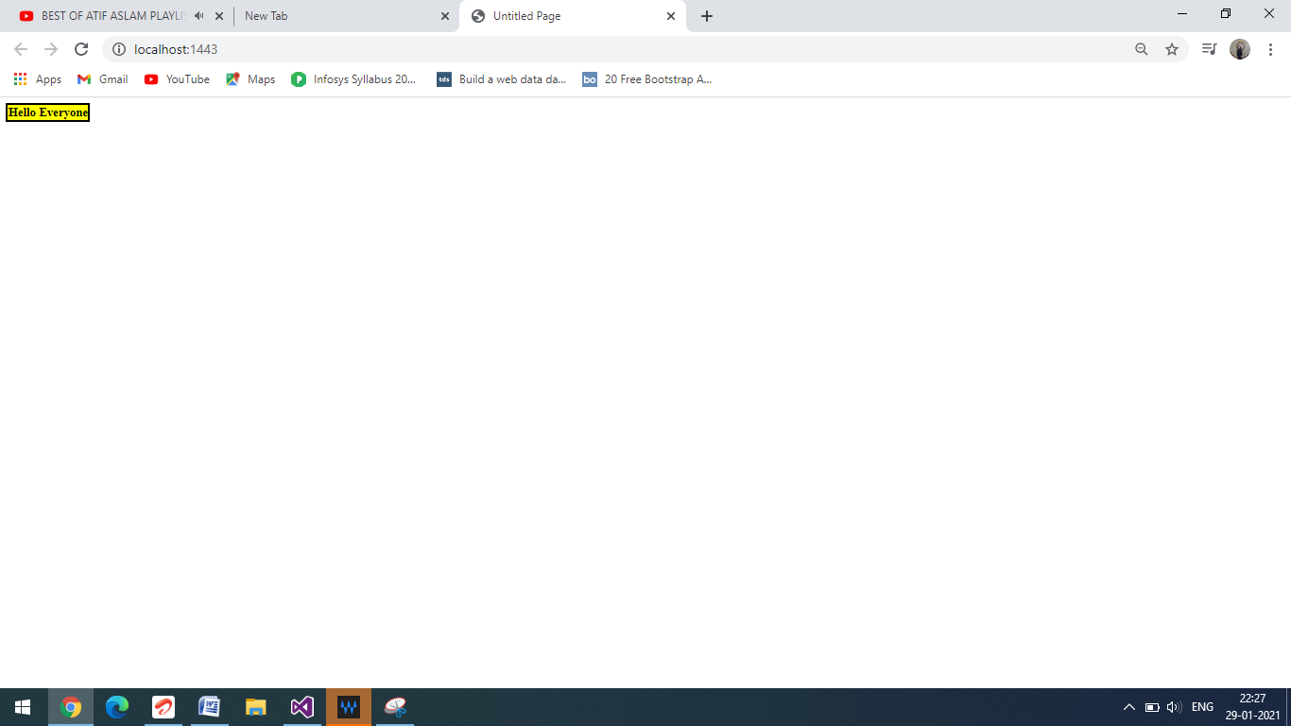

**2 :**

<%@ Page Language="VB" AutoEventWireup="false" CodeFile="Default.aspx.vb" Inherits="_Default" %>

<!DOCTYPE html>

<html xmlns="http://www.w3.org/1999/xhtml">

<head runat="server">

<title></title>

</head>

<body>

<form id="form1" runat="server">

<div>

<asp:Table ID="Table1" runat="server" Width="425px" HorizontalAlign="Center" Height="77px" Font-Bold="True" Font-Size="Large">

<asp:TableRow runat="server">

<asp:TableCell runat="server" ColumnSpan="2">

<img src="score_card_logo.png" width="87" height="87"/>

</asp:TableCell>

<asp:TableCell runat="server" ColumnSpan="2" Font-Bold="True" HorizontalAlign="Center" VerticalAlign="Middle">Sponcept( 164/8) Vs NEO( 12-02-17 <br> 11:00 AM ) </br>

</asp:TableCell>

</asp:TableRow>

<asp:TableRow runat="server">

<asp:TableCell runat="server" ColumnSpan="2" HorizontalAlign="Center" RowSpan="5" VerticalAlign="Middle"><br /></asp:TableCell>

<asp:TableCell runat="server" ColumnSpan="2" HorizontalAlign="Center" VerticalAlign="Middle">Sponcept Vs NEO</asp:TableCell>

<asp:TableCell runat="server" ColumnSpan="2" HorizontalAlign="Center" RowSpan="5" VerticalAlign="Middle"><br /></asp:TableCell>

</asp:TableRow>

<asp:TableRow runat="server">

<asp:TableCell runat="server" ColumnSpan="2" HorizontalAlign="Center" RowSpan="5" VerticalAlign="Middle">@ ABR Sports, One Day Match, 20 Overs <br>Innings 1 Complete</br> </asp:TableCell>

</asp:TableRow>

</asp:Table>

</div>

<asp:Table ID="Table2" runat="server" HorizontalAlign="Center" Width="535px">

<asp:TableHeaderRow runat="server" BackColor="#669000">

<asp:TableCell>Sponcept Innings</asp:TableCell>

<asp:TableCell><i></i></asp:TableCell>

<asp:TableCell>R</asp:TableCell>

<asp:TableCell>B</asp:TableCell>

<asp:TableCell>4s</asp:TableCell>

<asp:TableCell>6s</asp:TableCell>

</asp:TableHeaderRow>

<asp:TableRow runat="server">

<asp:TableCell>Jibin</asp:TableCell>

<asp:TableCell>(runout Dennis King)</asp:TableCell>

<asp:TableCell>16</asp:TableCell>

<asp:TableCell>14</asp:TableCell>

<asp:TableCell>3</asp:TableCell>

<asp:TableCell>0</asp:TableCell>

</asp:TableRow>

<asp:TableRow runat="server">

<asp:TableCell>Ankit</asp:TableCell>

<asp:TableCell>(c Abishek , b Mahesh)</asp:TableCell>

<asp:TableCell>5</asp:TableCell>

<asp:TableCell>6</asp:TableCell>

<asp:TableCell>1</asp:TableCell>

<asp:TableCell>0</asp:TableCell>

</asp:TableRow>

<asp:TableRow runat="server">

<asp:TableCell>Arindam</asp:TableCell>

<asp:TableCell>(c tHitakrup , b Dennis King)</asp:TableCell>

<asp:TableCell>0</asp:TableCell>

<asp:TableCell>2</asp:TableCell>

<asp:TableCell>0</asp:TableCell>

<asp:TableCell>0</asp:TableCell>

</asp:TableRow>

<asp:TableRow runat="server">

<asp:TableCell>Rishi</asp:TableCell>

<asp:TableCell>(c tHitakrup , b Karthik Ramaswamy)</asp:TableCell>

<asp:TableCell>14</asp:TableCell>

<asp:TableCell>20</asp:TableCell>

<asp:TableCell>2</asp:TableCell>

<asp:TableCell>0</asp:TableCell>

</asp:TableRow>

<asp:TableRow runat="server">

<asp:TableCell>Tarun P</asp:TableCell>

<asp:TableCell>(b Karthik Ramaswamy)</asp:TableCell>

<asp:TableCell>43</asp:TableCell>

<asp:TableCell>26</asp:TableCell>

<asp:TableCell>5</asp:TableCell>

<asp:TableCell>2</asp:TableCell>

</asp:TableRow>

<asp:TableRow runat="server">

<asp:TableCell>Ajay</asp:TableCell>

<asp:TableCell>(st tHitakrup , b Suraj)</asp:TableCell>

<asp:TableCell>19</asp:TableCell>

<asp:TableCell>28</asp:TableCell>

<asp:TableCell>1</asp:TableCell>

<asp:TableCell>0</asp:TableCell>

</asp:TableRow>

<asp:TableRow runat="server">

<asp:TableCell>Pratik</asp:TableCell>

<asp:TableCell>(lbw Abhishek)</asp:TableCell>

<asp:TableCell>23</asp:TableCell>

<asp:TableCell>13</asp:TableCell>

<asp:TableCell>3</asp:TableCell>

<asp:TableCell>1</asp:TableCell>

</asp:TableRow>

<asp:TableRow runat="server">

<asp:TableCell>Ankur</asp:TableCell>

<asp:TableCell>not out</asp:TableCell>

<asp:TableCell>17</asp:TableCell>

<asp:TableCell>7</asp:TableCell>

<asp:TableCell>3</asp:TableCell>

<asp:TableCell>0</asp:TableCell>

</asp:TableRow>

<asp:TableRow runat="server">

<asp:TableCell>Tarun H</asp:TableCell>

<asp:TableCell>(run out Shivkumar Ejipura)</asp:TableCell>

<asp:TableCell>5</asp:TableCell>

<asp:TableCell>4</asp:TableCell>

<asp:TableCell>1</asp:TableCell>

<asp:TableCell>0</asp:TableCell>

</asp:TableRow>

<asp:TableRow runat="server">

<asp:TableCell>Deep</asp:TableCell>

<asp:TableCell>not out</asp:TableCell>

<asp:TableCell>0</asp:TableCell>

<asp:TableCell>0</asp:TableCell>

<asp:TableCell>0</asp:TableCell>

<asp:TableCell>0</asp:TableCell>

</asp:TableRow>

<asp:TableRow runat="server">

<asp:TableCell><br /></asp:TableCell>

<asp:TableCell>Extras</asp:TableCell>

<asp:TableCell>22</asp:TableCell>

<asp:TableCell><br /></asp:TableCell>

<asp:TableCell><br /></asp:TableCell>

<asp:TableCell><br /></asp:TableCell>

</asp:TableRow>

<asp:TableRow runat="server">

<asp:TableCell><br /></asp:TableCell>

<asp:TableCell><br /></asp:TableCell>

<asp:TableCell>---</asp:TableCell>

<asp:TableCell><br /></asp:TableCell>

<asp:TableCell><br /></asp:TableCell>

<asp:TableCell><br /></asp:TableCell>

</asp:TableRow>

<asp:TableRow runat="server">

<asp:TableCell><br /></asp:TableCell>

<asp:TableCell>Total</asp:TableCell>

<asp:TableCell>164</asp:TableCell>

<asp:TableCell><br /></asp:TableCell>

<asp:TableCell><br /></asp:TableCell>

<asp:TableCell><br /></asp:TableCell>

</asp:TableRow>

</asp:Table>

<asp:Table ID="Table3" runat="server" HorizontalAlign="Center" Width="560px">

<asp:TableHeaderRow runat="server" BackColor="#669000">

<asp:TableCell>Bowling</asp:TableCell>

<asp:TableCell>O</asp:TableCell>

<asp:TableCell>M</asp:TableCell>

<asp:TableCell>R</asp:TableCell>

<asp:TableCell>W</asp:TableCell>

<asp:TableCell>Eco</asp:TableCell>

</asp:TableHeaderRow>

<asp:TableRow runat="server">

<asp:TableCell>Mikka</asp:TableCell>

<asp:TableCell>4.0</asp:TableCell>

<asp:TableCell>0</asp:TableCell>

<asp:TableCell>31</asp:TableCell>

<asp:TableCell>1</asp:TableCell>

<asp:TableCell>7.75</asp:TableCell>

</asp:TableRow>

<asp:TableRow runat="server">

<asp:TableCell>Dennis King</asp:TableCell>

<asp:TableCell>4.0</asp:TableCell>

<asp:TableCell>0</asp:TableCell>

<asp:TableCell>27</asp:TableCell>

<asp:TableCell>1</asp:TableCell>

<asp:TableCell>6.75</asp:TableCell>

</asp:TableRow>

<asp:TableRow runat="server">

<asp:TableCell>Abhishek</asp:TableCell>

<asp:TableCell>2.0</asp:TableCell>

<asp:TableCell>0</asp:TableCell>

<asp:TableCell>26</asp:TableCell>

<asp:TableCell>1</asp:TableCell>

<asp:TableCell>18</asp:TableCell>

</asp:TableRow>

<asp:TableRow runat="server">

<asp:TableCell>Karthik Ramaswamy</asp:TableCell>

<asp:TableCell>4.0</asp:TableCell>

<asp:TableCell>0</asp:TableCell>

<asp:TableCell>18</asp:TableCell>

<asp:TableCell>2</asp:TableCell>

<asp:TableCell>4.5</asp:TableCell>

</asp:TableRow>

<asp:TableRow runat="server">

<asp:TableCell>Ullas</asp:TableCell>

<asp:TableCell>4.0</asp:TableCell>

<asp:TableCell>0</asp:TableCell>

<asp:TableCell>24</asp:TableCell>

<asp:TableCell>0</asp:TableCell>

<asp:TableCell>6</asp:TableCell>

</asp:TableRow>

<asp:TableRow runat="server">

<asp:TableCell>Suraj</asp:TableCell>

<asp:TableCell>2.0</asp:TableCell>

<asp:TableCell>0</asp:TableCell>

<asp:TableCell>17</asp:TableCell>

<asp:TableCell>1</asp:TableCell>

<asp:TableCell>8.5</asp:TableCell>

</asp:TableRow>

</asp:Table>

</form>

</body>

</html>

Designing Form :

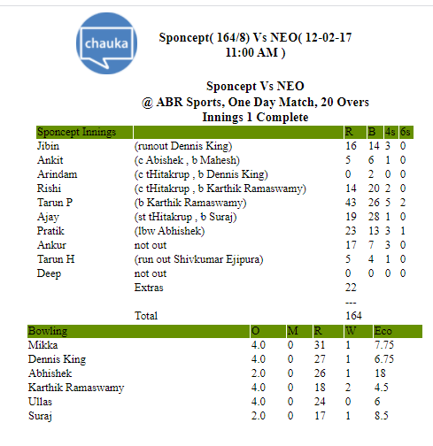

**Question-3**

<%@ Page Language="VB" AutoEventWireup="false" CodeFile="Default.aspx.vb" Inherits="_Default" %>

<!DOCTYPE html>

<html xmlns="http://www.w3.org/1999/xhtml">

<head runat="server">

<title></title>

</head>

<body style="width: 1258px; height: 686px;">

<form id="form2" runat="server">

<div>

<asp:Table ID="Table2" runat="server" BorderStyle="Solid" CellSpacing="3"

GridLines="Both" Height="1%" HorizontalAlign="Center" Width="99%" style="margin-right: 42px">

<asp:TableRow ID="TableRow5" runat="server" BorderStyle="Solid" BorderWidth="3px" VerticalAlign="Top">

<asp:TableCell ID="TableCell1" runat="server" Width="20%">

<img src="ro1.jfif" />

</asp:TableCell>

<asp:TableCell runat="server" ColumnSpan="9" Width="80%" ForeColor="RosyBrown">

<center>

<h1>Rose Flower School</h1>

<h3>Sarkhej-Gandhinager Road</h3>

<h4>Ahmedabad</h4>

</center>

</asp:TableCell>

</asp:TableRow>

<asp:TableRow runat="server" BorderColor="Black" BorderStyle="Solid"

BorderWidth="1px">

<asp:TableCell runat="server" Width="20%">Roll Number</asp:TableCell>

<asp:TableCell runat="server" Width="20%" ColumnSpan="2">68</asp:TableCell>

<asp:TableCell runat="server" Width="10%">G.R. No</asp:TableCell>

<asp:TableCell runat="server" Width="50%" ColumnSpan="6">1868</asp:TableCell>

</asp:TableRow>

<asp:TableRow runat="server">

<asp:TableCell runat="server" Width="20%">Name </asp:TableCell>

<asp:TableCell runat="server" ColumnSpan="8" Width="80%"> Purvangi Koshti</asp:TableCell>

</asp:TableRow>

<asp:TableRow runat="server">

<asp:TableCell runat="server" Width="20%">Standard</asp:TableCell>

<asp:TableCell runat="server" ColumnSpan="9" Width="80%">IX</asp:TableCell>

</asp:TableRow>

<asp:TableRow runat="server" BorderStyle="Solid" BorderWidth="1px">

<asp:TableHeaderCell ID="TableHeaderCell1" Rowspan="2" >Subject Details</asp:TableHeaderCell>

<asp:TableHeaderCell ID="TableHeaderCell2" Width="20%" ColumnSpan="2">1st Internel</asp:TableHeaderCell>

<asp:TableHeaderCell ID="TableHeaderCell3" Width="20%" ColumnSpan="2">2st internel</asp:TableHeaderCell>

<asp:TableHeaderCell ID="TableHeaderCell4" Width="20%" ColumnSpan="2">Final Exam</asp:TableHeaderCell>

<asp:TableHeaderCell ID="TableHeaderCell5" Width="20%" ColumnSpan="2">Total</asp:TableHeaderCell>

</asp:TableRow>

<asp:TableRow runat="server">

<asp:TableCell runat="server">Maximum Mark</asp:TableCell>

<asp:TableCell runat="server">Scored Marks</asp:TableCell>

<asp:TableCell runat="server">Maximum Mark</asp:TableCell>

<asp:TableCell runat="server">Scored Marks</asp:TableCell>

<asp:TableCell runat="server">Maximum Mark</asp:TableCell>

<asp:TableCell runat="server">Scored Marks</asp:TableCell>

<asp:TableCell runat="server">Maximum Mark</asp:TableCell>

<asp:TableCell runat="server">Scored Marks</asp:TableCell>

</asp:TableRow>

<asp:TableRow runat="server">

<asp:TableCell runat="server" Text="Maths"></asp:TableCell>

<asp:TableCell runat="server" Text="50"></asp:TableCell>

<asp:TableCell runat="server" text="47"></asp:TableCell>

<asp:TableCell runat="server" Text="70"></asp:TableCell>

<asp:TableCell runat="server" Text="60"></asp:TableCell>

<asp:TableCell runat="server" Text="100"></asp:TableCell>

<asp:TableCell runat="server" Text="87"></asp:TableCell>

<asp:TableCell runat="server" Text="230"></asp:TableCell>

<asp:TableCell runat="server" Text="194"></asp:TableCell>

</asp:TableRow>

<asp:TableRow ID="TableRow6" runat="server">

<asp:TableCell ID="TableCell12" runat="server" Text="Science"></asp:TableCell>

<asp:TableCell runat="server" Text="50"></asp:TableCell>

<asp:TableCell runat="server" text="41"></asp:TableCell>

<asp:TableCell runat="server" Text="70"></asp:TableCell>

<asp:TableCell runat="server" Text="66"></asp:TableCell>

<asp:TableCell runat="server" Text="100"></asp:TableCell>

<asp:TableCell runat="server" Text="77"></asp:TableCell>

<asp:TableCell runat="server" Text="230"></asp:TableCell>

<asp:TableCell runat="server" Text="184"></asp:TableCell>

</asp:TableRow>

<asp:TableRow ID="TableRow7" runat="server">

<asp:TableCell ID="TableCell3" runat="server" Text="English"></asp:TableCell>

<asp:TableCell runat="server" Text="50"></asp:TableCell>

<asp:TableCell runat="server" text="33"></asp:TableCell>

<asp:TableCell runat="server" Text="70"></asp:TableCell>

<asp:TableCell runat="server" Text="53"></asp:TableCell>

<asp:TableCell runat="server" Text="100"></asp:TableCell>

<asp:TableCell runat="server" Text="63"></asp:TableCell>

<asp:TableCell runat="server" Text="230"></asp:TableCell>

<asp:TableCell runat="server" Text="149"></asp:TableCell>

</asp:TableRow>

<asp:TableRow ID="TableRow8" runat="server">

<asp:TableCell ID="TableCell4" runat="server" Text="Social Secince"></asp:TableCell>

<asp:TableCell runat="server" Text="50"></asp:TableCell>

<asp:TableCell runat="server" text="37"></asp:TableCell>

<asp:TableCell runat="server" Text="70"></asp:TableCell>

<asp:TableCell runat="server" Text="63"></asp:TableCell>

<asp:TableCell runat="server" Text="100"></asp:TableCell>

<asp:TableCell runat="server" Text="87"></asp:TableCell>

<asp:TableCell runat="server" Text="230"></asp:TableCell>

<asp:TableCell runat="server" Text="187"></asp:TableCell>

</asp:TableRow>

<asp:TableRow ID="TableRow9" runat="server">

<asp:TableCell ID="TableCell5" runat="server" Text="Computer"></asp:TableCell>

<asp:TableCell runat="server" Text="50"></asp:TableCell>

<asp:TableCell runat="server" text="43"></asp:TableCell>

<asp:TableCell runat="server" Text="70"></asp:TableCell>

<asp:TableCell runat="server" Text="64"></asp:TableCell>

<asp:TableCell runat="server" Text="100"></asp:TableCell>

<asp:TableCell runat="server" Text="85"></asp:TableCell>

<asp:TableCell runat="server" Text="230"></asp:TableCell>

<asp:TableCell runat="server" Text="192"></asp:TableCell>

</asp:TableRow>

<asp:TableRow ID="TableRow10" runat="server">

<asp:TableCell ID="TableCell6" runat="server" Text="Sanskrit"></asp:TableCell>

<asp:TableCell runat="server" Text="50"></asp:TableCell>

<asp:TableCell runat="server" text="40"></asp:TableCell>

<asp:TableCell runat="server" Text="70"></asp:TableCell>

<asp:TableCell runat="server" Text="60"></asp:TableCell>

<asp:TableCell runat="server" Text="100"></asp:TableCell>

<asp:TableCell runat="server" Text="80"></asp:TableCell>

<asp:TableCell runat="server" Text="230"></asp:TableCell>

<asp:TableCell runat="server" Text="180"></asp:TableCell>

</asp:TableRow>

<asp:TableRow ID="TableRow11" runat="server">

<asp:TableCell ID="TableCell7" runat="server" Text="GrandTotal"></asp:TableCell>

<asp:TableCell runat="server" Text="300"></asp:TableCell>

<asp:TableCell runat="server" text="241"></asp:TableCell>

<asp:TableCell runat="server" Text="420"></asp:TableCell>

<asp:TableCell runat="server" Text="366"></asp:TableCell>

<asp:TableCell runat="server" Text="600"></asp:TableCell>

<asp:TableCell runat="server" Text="479"></asp:TableCell>

<asp:TableCell runat="server" Text="1220"></asp:TableCell>

<asp:TableCell runat="server" Text="1086"></asp:TableCell>

</asp:TableRow>

<asp:TableRow ID="TableRow12" runat="server">

<asp:TableCell ID="TableCell8" runat="server" Text="Percentage"></asp:TableCell>

<asp:TableCell runat="server" ColumnSpan="8" Text="89.01%"></asp:TableCell>

</asp:TableRow>

<asp:TableRow ID="TableRow1" runat="server">

<asp:TableCell ID="TableCell9" runat="server" Text="Grade"></asp:TableCell>

<asp:TableCell runat="server" ColumnSpan="8" Text="Distniction"></asp:TableCell>

</asp:TableRow>

<asp:TableRow ID="TableRow14" runat="server" BorderStyle="Solid" BorderWidth="3px" VerticalAlign="Top">

<asp:TableCell ID="TableCell10" runat="server" Width="10%">

<img src="image1-q3.JPG" />

</asp:TableCell>

<asp:TableCell runat="server" columnspan="2" Width="10%" ForeColor="RosyBrown">

<img src="image2-q3.JPG" />

</asp:TableCell>

<asp:TableCell runat="server" ColumnSpan="6" Width="20%" ForeColor="RosyBrown">

<img src="i3-q3.jpg" />

</asp:TableCell>

</asp:TableRow>

</asp:Table>

</div>

</form>

</body>

</html>

**Output:**

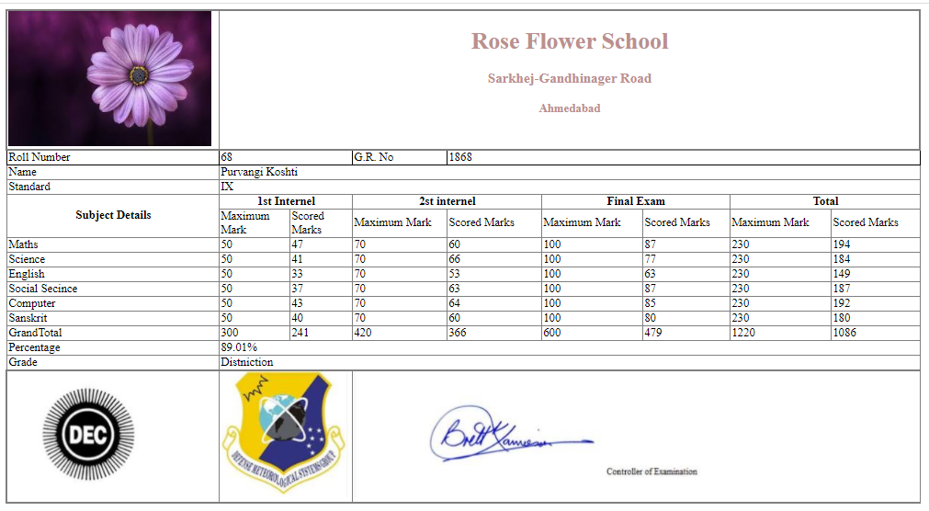

**Question-4**

**Default.aspx :**

<%@ Page Language="VB" AutoEventWireup="false" CodeFile="Default.aspx.vb" Inherits="_Default" %>

<!DOCTYPE html>

<html xmlns="http://www.w3.org/1999/xhtml">

<head runat="server">

<title></title>

<style type="text/css">

.auto-style1 {

width: 295px;

}

.auto-style2 {

width: 295px;

height: 26px;

}

.auto-style3 {

height: 26px;

}

.auto-style4 {

width: 305px;

}

.auto-style5 {

width: 305px;

height: 26px;

}

</style>

</head>

<body>

<form id="form1" runat="server">

<div>

<asp:Panel ID="Panel1" runat="server" BorderStyle="Solid" Font-Bold="False" Font-Names="Franklin Gothic Demi Cond" Font-Overline="False" Font-Underline="False" GroupingText=" Personal Details" HorizontalAlign="Center" Width="865px">

<table style="width:100%;">

<tr>

<td class="auto-style1">Name </td>

<td>

<asp:TextBox ID="TextBox1" runat="server" Width="154px"></asp:TextBox>

</td>

</tr>

<tr>

<td class="auto-style1">Email</td>

<td>

<asp:TextBox ID="TextBox2" runat="server" TextMode="Email" Width="149px"></asp:TextBox>

</td>

</tr>

<tr>

<td class="auto-style1">Mobile </td>

<td>

<asp:TextBox ID="TextBox3" runat="server" width="145px"></asp:TextBox>

</td>

</tr>

<tr>

<td class="auto-style1">Address</td>

<td>

<asp:TextBox ID="TextBox4" runat="server" TextMode="MultiLine"></asp:TextBox>

</td>

</tr>

<tr>

<td class="auto-style1">Gender</td>

<td>

<asp:RadioButton ID="RadioButton2" runat="server" GroupName="Gender" Text="Male" />

<asp:RadioButton ID="RadioButton3" runat="server" GroupName="Gender" Text="Female" />

</td>

</tr>

</table>

</asp:Panel>

</div>

<asp:Panel ID="Panel2" runat="server" BorderStyle="Solid" Font-Bold="False" Font-Names="Franklin Gothic Demi Cond" Font-Overline="False" Font-Underline="False" GroupingText=" Education Details" HorizontalAlign="Left" Width="864px">

<table style="width:100%;">

<tr>

<td class="auto-style4">SSC</td>

<td>

<asp:TextBox ID="TextBox5" runat="server" Width="154px"></asp:TextBox>

</td>

</tr>

<tr>

<td class="auto-style5">HSC</td>

<td class="auto-style3">

<asp:TextBox ID="TextBox6" runat="server" Width="154px"></asp:TextBox>

</td>

</tr>

<tr>

<td class="auto-style4">Graducation</td>

<td>

<asp:DropDownList ID="DropDownList1" runat="server" Height="16px" Width="159px">

<asp:ListItem>B.com</asp:ListItem>

<asp:ListItem>BCA</asp:ListItem>

<asp:ListItem>B.A.</asp:ListItem>

<asp:ListItem>BBA</asp:ListItem>

<asp:ListItem>B.sc</asp:ListItem>

</asp:DropDownList>

<asp:TextBox ID="TextBox7" runat="server" style="margin-left: 19px" Width="145px"></asp:TextBox>

</td>

</tr>

<tr>

<td class="auto-style4">Post Graducation</td>

<td>

<asp:DropDownList ID="DropDownList2" runat="server" Height="16px" Width="159px">

<asp:ListItem>M.com</asp:ListItem>

<asp:ListItem>MCA</asp:ListItem>

<asp:ListItem>M.A.</asp:ListItem>

<asp:ListItem>MBA</asp:ListItem>

<asp:ListItem>M.sc</asp:ListItem>

<asp:ListItem>Other</asp:ListItem>

</asp:DropDownList>

<asp:TextBox ID="TextBox14" runat="server" style="margin-left: 19px" Width="141px"></asp:TextBox>

</td>

</tr>

</table>

</asp:Panel>

<asp:Panel ID="Panel3" runat="server" BorderStyle="Solid" Font-Bold="False" Font-Names="Franklin Gothic Demi Cond" Font-Overline="False" Font-Underline="False" GroupingText="Work Experience" HorizontalAlign="Center" Width="865px">

<table style="width:100%;">

<tr>

<td class="auto-style1">COMPANY 1</td>

<td>

<asp:TextBox ID="TextBox10" runat="server" Width="154px"></asp:TextBox>

</td>

</tr>

<tr>

<td class="auto-style2">COMPANY 2</td>

<td class="auto-style3">

<asp:TextBox ID="TextBox11" runat="server" Width="149px"></asp:TextBox>

</td>

</tr>

<tr>

<td class="auto-style1">COMPANY 3</td>

<td>

<asp:TextBox ID="TextBox12" runat="server" Width="145px"></asp:TextBox>

</td>

</tr>

<tr>

<td class="auto-style1">COMPANY 4</td>

<td>

<asp:TextBox ID="TextBox13" runat="server" style="margin-left: 0px" Width="142px"></asp:TextBox>

</td>

</tr>

</table>

</asp:Panel>

</form>

</body>

</html>

**Designing Form:**

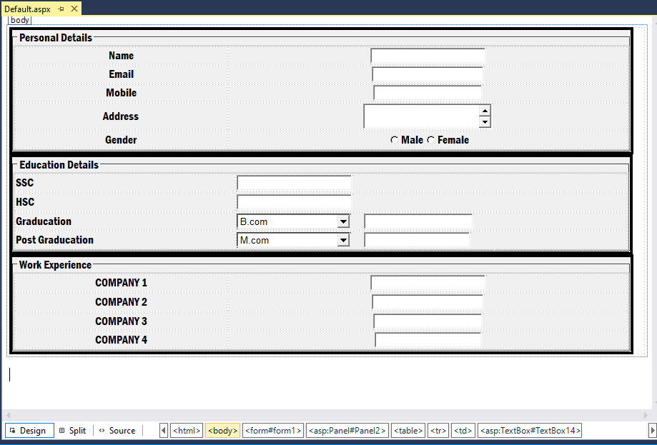

**Output:**

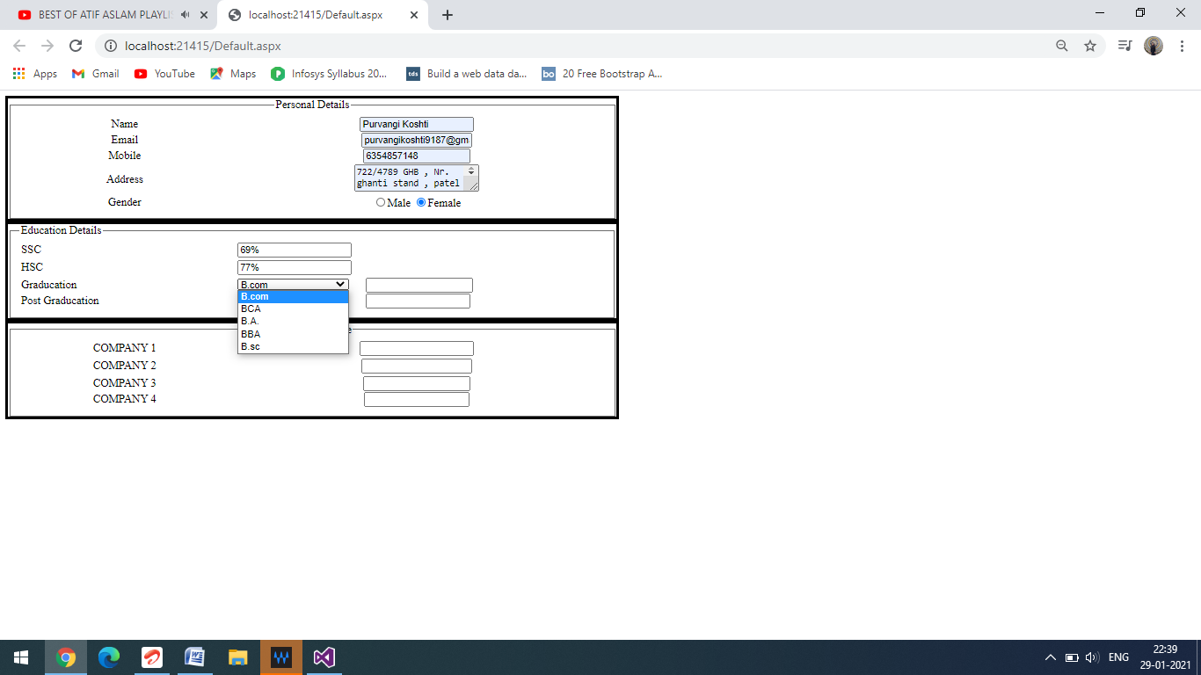

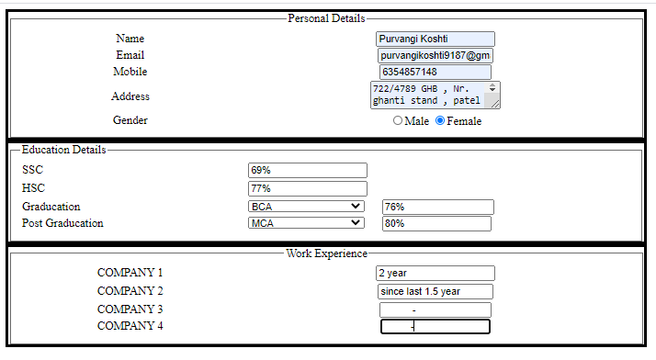

**5. Create web page which will ask payment detail of customer purchase, this detail either in Cash or Credit/Debit card or by Cheque. According to the payment mode panel control will display and accept payment detail and display all that detail in next page using label control.**

**Default.aspx:**

<%@ Page Language="VB" AutoEventWireup="false" CodeFile="Default.aspx.vb" Inherits="_Default" %>

<!DOCTYPE html>

<html xmlns="http://www.w3.org/1999/xhtml">

<head runat="server">

<title></title>

<style type="text/css">

.auto-style1 {

width: 100%;

height: 419px;

}

.auto-style3 {

width: 196px;

}

.auto-style5 {

width: 343px;

}

.auto-style7 {

width: 251px;

}

.auto-style9 {

width: 253px;

}

.auto-style11 {

width: 219px;

}

.auto-style14 {

width: 343px;

height: 254px;

}

.auto-style15 {

height: 254px;

}

</style>

</head>

<body>

<form id="form1" runat="server">

<div>

<h2>Select the Payment Mode</h2></div>

<table class="auto-style1">

<tr>

<td class="auto-style3">

<asp:LinkButton ID="LinkButton1" runat="server">Cash On Delievery</asp:LinkButton>

<br />

<br />

<asp:LinkButton ID="LinkButton4" runat="server">Credit Card</asp:LinkButton>

<br />

<br />

<asp:LinkButton ID="LinkButton3" runat="server">Debit Card</asp:LinkButton>

<br />

<br />

<asp:LinkButton ID="LinkButton2" runat="server">Cheque</asp:LinkButton>

</td>

<td>

<table style="width:100%;">

<tr>

<td class="auto-style14">

<asp:Panel ID="Panel1" runat="server" BorderStyle="Solid" GroupingText="Payment Details" Font-Names="Calisto MT" Height="244px" Width="342px">

<h4> &nbsp;&nbsp;&nbsp;&nbsp;&nbsp;&nbsp;&nbsp;&nbsp;&nbsp;&nbsp;&nbsp;&nbsp;&nbsp;&nbsp;&nbsp;&nbsp; Pay Using Cash On Delivery</h4>

<table style="width:88%; height246px: ; margin-top: 0px;">

<tr>

<td>Amount Payable on Delivery: Rs. 3990<br /> </td>

</tr>

<tr>

<td>Contact Number for Delivery:<br /><br />

9909958444</td>

</tr>

</table>

<br />

&nbsp;&nbsp;&nbsp;&nbsp;&nbsp;&nbsp;&nbsp;&nbsp;&nbsp;&nbsp;&nbsp;&nbsp;&nbsp;&nbsp;&nbsp;&nbsp;&nbsp;&nbsp;&nbsp;<br />

<br />

<br />

</asp:Panel>

</td>

<td class="auto-style15">

<asp:Panel ID="Panel4" runat="server" GroupingText="Payment Details" HorizontalAlign="Center" Font-Names="Calisto MT" Height="245px" Width="339px" BorderStyle="Solid">

<h4>Pay Using Credit Card</h4>

<table style="width:100%;">

<tr>

<td class="auto-style7">Card Number:</td>

<td>

<asp:TextBox ID="TextBox1" runat="server"></asp:TextBox>

</td>

</tr>

<tr>

<td class="auto-style7">Expiry Date:(Valid Through) </td>

<td>

<asp:TextBox ID="TextBox2" runat="server"></asp:TextBox>

</td>

</tr>

<tr>

<td class="auto-style7">CVV:</td>

<td>

<asp:TextBox ID="TextBox3" runat="server"></asp:TextBox>

</td>

</tr>

<tr>

<td class="auto-style7">Name On Card:</td>

<td>

<asp:TextBox ID="TextBox4" runat="server"></asp:TextBox>

</td>

</tr>

</table>

<asp:Button ID="Button1" runat="server" BackColor="#FF9900" ForeColor="White" Height="29px" style="margin-left: 3px; margin-top: 0px;" Text="Payment Order" Width="134px" />

<br />

<br />

<br />

</asp:Panel>

</td>

</tr>

<tr>

<td class="auto-style5">

<asp:Panel ID="Panel3" runat="server" GroupingText="Payment Details" HorizontalAlign="Center" Font-Names="Calisto MT" Height="305px" style="margin-top: 0px" Width="344px" BorderStyle="Solid">

<br />

<h4>Pay Using Debit Card</h4>

<table style="width:100%;">

<tr>

<td class="auto-style9">Card Number:</td>

<td>

<asp:TextBox ID="TextBox5" runat="server"></asp:TextBox>

</td>

</tr>

<tr>

<td class="auto-style9">Expiry Date:(Valid Through)</td>

<td>

<asp:TextBox ID="TextBox6" runat="server"></asp:TextBox>

</td>

</tr>

<tr>

<td class="auto-style9">CVV:</td>

<td>

<asp:TextBox ID="TextBox7" runat="server"></asp:TextBox>

</td>

</tr>

<tr>

<td class="auto-style9">Name On Card:</td>

<td>

<asp:TextBox ID="TextBox8" runat="server"></asp:TextBox>

</td>

</tr>

<tr>

<td class="auto-style9">Issue Bank Name:</td>

<td>

<asp:TextBox ID="TextBox9" runat="server"></asp:TextBox>

</td>

</tr>

</table>

<br />

<asp:Button ID="Button2" runat="server" BackColor="#FF9900" ForeColor="White" Text="Payment Order" Height="29px" />

<br />

<br />

</asp:Panel>

</td>

<td>

<asp:Panel ID="Panel2" runat="server" GroupingText="Payment Details" HorizontalAlign="Center" Font-Names="Calisto MT" Height="302px" style="margin-top: 0px" Width="344px" BorderStyle="Solid">

<br />

<h4>Pay Using Cheque</h4>

<table style="width:100%;">

<tr>

<td class="auto-style11">Cheque Number:</td>

<td>

<asp:TextBox ID="TextBox10" runat="server"></asp:TextBox>

</td>

</tr>

<tr>

<td class="auto-style11">Issue Bank Name:</td>

<td>

<asp:TextBox ID="TextBox11" runat="server"></asp:TextBox>

</td>

</tr>

<tr>

<td class="auto-style11">Issue Date:</td>

<td>

<asp:TextBox ID="TextBox12" runat="server"></asp:TextBox>

</td>

</tr>

<tr>

<td class="auto-style11">Account Holder Name:</td>

<td>

<asp:TextBox ID="TextBox13" runat="server"></asp:TextBox>

</td>

</tr>

</table>

<br />

<br />

<asp:Button ID="Button3" runat="server" BackColor="#FF9900" ForeColor="White" Text="Payment Order" Height="29px" Width="134px" />

<br />

</asp:Panel>

</td>

</tr>

</table>

</td>

</tr>

</table>

</form>

</body>

</html>

**Designing Form:**

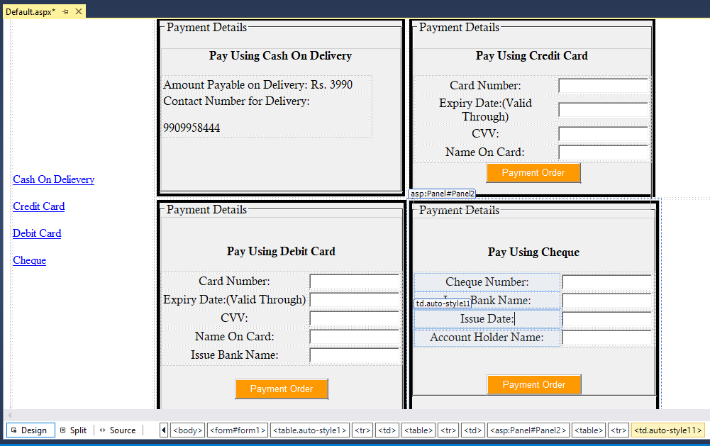

**Default.aspx.vb:**

Partial Class _Default

Inherits System.Web.UI.Page

Protected Sub LinkButton1_Click(sender As Object, e As EventArgs) Handles LinkButton1.Click

Try

If Panel2.Visible = True Or Panel3.Visible = True Or Panel4.Visible = True Then

Panel2.Visible = False

Panel3.Visible = False

Panel4.Visible = False

End If

Panel1.Visible = True

Catch ex As Exception

End Try

End Sub

Protected Sub LinkButton2_Click(sender As Object, e As EventArgs) Handles LinkButton2.Click

Try

If Panel1.Visible = True Or Panel3.Visible = True Or Panel4.Visible = True Then

Panel1.Visible = False

Panel3.Visible = False

Panel4.Visible = False

End If

Panel2.Visible = True

Catch ex As Exception

End Try

End Sub

Protected Sub LinkButton3_Click(sender As Object, e As EventArgs) Handles LinkButton3.Click

Try

If Panel2.Visible = True Or Panel1.Visible = True Or Panel4.Visible = True Then

Panel2.Visible = False

Panel1.Visible = False

Panel4.Visible = False

End If

Panel3.Visible = True

Catch ex As Exception

End Try

End Sub

Protected Sub LinkButton4_Click(sender As Object, e As EventArgs) Handles LinkButton4.Click

Try

If Panel1.Visible = True Or Panel2.Visible = True Or Panel3.Visible = True Then

Panel1.Visible = False

Panel2.Visible = False

Panel3.Visible = False

End If

Panel4.Visible = True

Catch ex As Exception

End Try

End Sub

Protected Sub Button3_Click(sender As Object, e As EventArgs) Handles Button3.Click

Try

Dim cookie3 As New HttpCookie("Cheque")

cookie3.Values("cardno") = TextBox10.Text

cookie3.Values("bank") = TextBox11.Text

cookie3.Values("issueDate") = TextBox12.Text

cookie3.Values("accountholder") = TextBox13.Text

Response.Cookies.Add(cookie3)

Response.Redirect("DisplayForm.aspx")

Catch ex As Exception

End Try

End Sub

Protected Sub Button2_Click(sender As Object, e As EventArgs) Handles Button2.Click

Try

Dim cookie2 As New HttpCookie("DebitCard")

cookie2.Values("cardno") = TextBox5.Text

cookie2.Values("expdate") = TextBox6.Text

cookie2.Values("cvvno") = TextBox7.Text

cookie2.Values("cardholder") = TextBox8.Text

cookie2.Values("bank") = TextBox9.Text

Response.Cookies.Add(cookie2)

Response.Redirect("DisplayForm.aspx")

Catch ex As Exception

End Try

End Sub

Protected Sub Button1_Click(sender As Object, e As EventArgs) Handles Button1.Click

Try

Dim cookie1 As New HttpCookie("CreditCard")

cookie1.Values("cardno") = TextBox1.Text

cookie1.Values("expdate") = TextBox2.Text

cookie1.Values("cvvno") = TextBox3.Text

cookie1.Values("cardholder") = TextBox4.Text

Response.Cookies.Add(cookie1)

Response.Redirect("DisplayForm.aspx")

Catch ex As Exception

End Try

End Sub

Protected Sub Page_Load(sender As Object, e As EventArgs) Handles Me.Load

End Sub

End Class

**DisplayForm.apsx:**

<%@ Page Language="VB" AutoEventWireup="false" CodeFile="DisplayForm.aspx.vb" Inherits="DisplayForm" %>

<!DOCTYPE html>

<html xmlns="http://www.w3.org/1999/xhtml">

<head runat="server">

<title></title>

</head>

<body>

<form id="form1" runat="server">

<div>

<asp:Label ID="Label1" runat="server" Text="Label"></asp:Label>

</div>

</form>

</body>

</html>

**Designing of DisplayForm.aspx:**

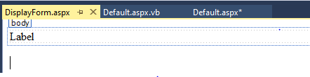

**DisplayForm.aspx.vb:**

Partial Class DisplayForm

Inherits System.Web.UI.Page

Protected Sub Page_Load(sender As Object, e As EventArgs) Handles Me.Load

Try

Dim str As String, str1 As String, str2 As String, str3 As String, str4 As String

If Not Request.Cookies("CreditCard") Is Nothing Then

str = Request.Cookies("CreditCard").Values("cardno").ToString

str1 = Request.Cookies("CreditCard").Values("expdate").ToString

str2 = Request.Cookies("CreditCard").Values("cvvno").ToString

str3 = Request.Cookies("CreditCard").Values("cardholder").ToString

Label1.Text = "Card No :" + str + "<br>" + "Card Holder :" + str3 + "<br>" + "CVV :" + str2 + "<br>" + "Expiery Date :" + str1

ElseIf Not Request.Cookies("DebitCard") Is Nothing Then

str = Request.Cookies("DebitCard").Values("cardno").ToString

str1 = Request.Cookies("DebitCard").Values("expdate").ToString

str2 = Request.Cookies("DebitCard").Values("cvvno").ToString

str3 = Request.Cookies("DebittCard").Values("cardholder").ToString

str4 = Request.Cookies("DebittCard").Values("bank").ToString

Label1.Text = "Card No :" + str + "<br>" + "Card Holder :" + str3 + "<br>" + "CVV :" + str2 + "<br>" + "Expiery Date :" + str1 + "<br>" + "Bank Name :" + str4

ElseIf Not Request.Cookies("Cheque") Is Nothing Then

str = Request.Cookies("Cheque").Values("cardno").ToString

str1 = Request.Cookies("Cheque").Values("bank").ToString

str2 = Request.Cookies("Cheque").Values("issuedate").ToString

str3 = Request.Cookies("Cheque").Values("accountholder").ToString

Label1.Text = "Card No :" + str + "<br>" + "Bank :" + str1 + "<br>" + "Issue Date :" + str2 + "<br>" + "Account Holder :" + str3

End If

Catch ex As Exception

End Try

End Sub

End Class

**Output:**

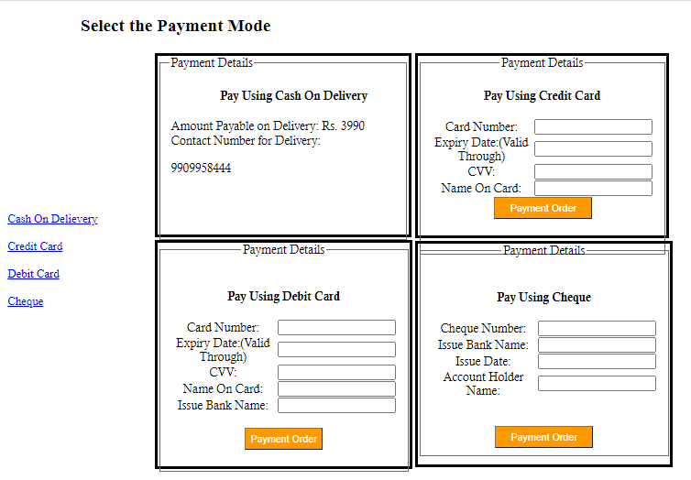

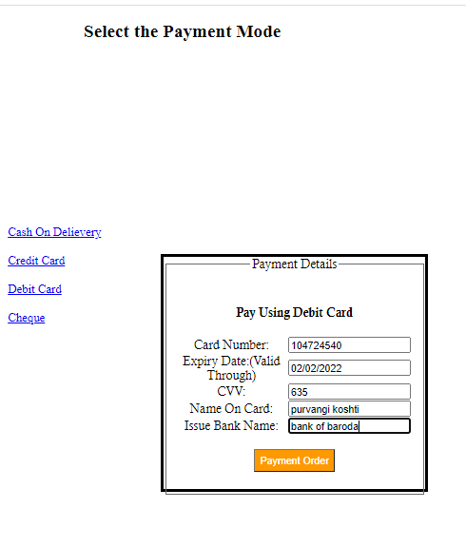

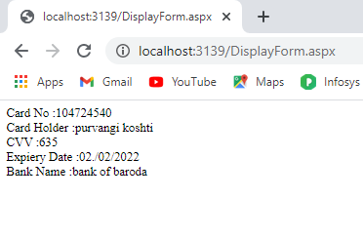

**6. Create an application which count the total number of users visited the page. (Using global.asax).**

**default.aspx:**

<%@ Page Language="VB" AutoEventWireup="false" CodeFile="Default.aspx.vb" Inherits="_Default" %>

<!DOCTYPE html>

<html xmlns="http://www.w3.org/1999/xhtml">

<head runat="server">

<title></title>

</head>

<body>

<form id="form1" runat="server">

<div>

</div>

</form>

</body>

</html>

**Default.aspx.vb:**

Partial Class _Default

Inherits System.Web.UI.Page

Protected Sub Page_Load(sender As Object, e As EventArgs) Handles Me.Load

Response.Write("Page is Visited " + Application("Cnt").ToString + " times")

End Sub

End Class

**Global.aspx:**

<%@ Application Language="VB" %>

<script runat="server">

Sub Application_Start(ByVal sender As Object, ByVal e As EventArgs)

' Code that runs on application startup

Application("Cnt") = 0

End Sub

Sub Application_End(ByVal sender As Object, ByVal e As EventArgs)

' Code that runs on application shutdown

End Sub

Sub Application_Error(ByVal sender As Object, ByVal e As EventArgs)

' Code that runs when an unhandled error occurs

End Sub

Sub Session_Start(ByVal sender As Object, ByVal e As EventArgs)

' Code that runs when a new session is started

Application("Cnt")=CInt(Application("Cnt"))+1

End Sub

Sub Session_End(ByVal sender As Object, ByVal e As EventArgs)

' Code that runs when a session ends.

' Note: The Session_End event is raised only when the sessionstate mode

' is set to InProc in the Web.config file. If session mode is set to StateServer

' or SQLServer, the event is not raised.

End Sub

</script>

**Output:**

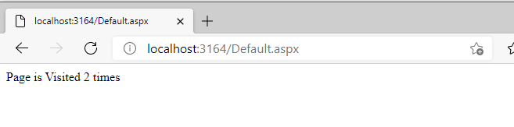

**7. Write ASP.NET code having two buttons like (1) Enable/Disable textbox (2) Show/Hide textbox and one text box, and apply proper logic to enable/disable, show/hide textbox as per user click on particular button.**

**default.asp:**

<%@ Page Language="VB" AutoEventWireup="false" CodeFile="show_hide.aspx.vb" Inherits="show_hide" %>

<!DOCTYPE html>

<html xmlns="http://www.w3.org/1999/xhtml">

<head runat="server">

<title></title>

</head>

<body>

<form id="form1" runat="server">

<asp:TextBox ID="TextBox1" runat="server" Height="27px" style="margin-left: 316px" Width="251px"></asp:TextBox>

<div>

<br />

<asp:Button ID="Button1" runat="server" BackColor="#CCFF66" Height="33px" style="margin-left: 251px" Text="Show/Hide" Width="167px" BorderStyle="Dotted" />

<asp:Button ID="Button2" runat="server" BackColor="#CCFF66" Height="34px" style="margin-left: 85px" Text="Enable/Disable" Width="165px" BorderStyle="Dotted" />

</div>

</form>

</body>

</html>

**Designing Form:**

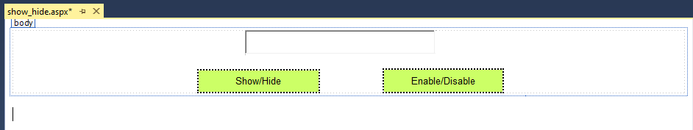

**Output:**







**8. Create a RadioButtonList that displays the names of some fruits in two columns. When the user selects an option from the list or clicks on a button, the label displays the fruit selected by the user.**

**Default.aspx:**

<%@ Page Language="VB" AutoEventWireup="false" CodeFile="Default.aspx.vb" Inherits="_Default" %>

<!DOCTYPE html>

<html xmlns="http://www.w3.org/1999/xhtml">

<head runat="server">

<title></title>

<style type="text/css">

.auto-style1 {

width: 485px;

}

</style>

</head>

<body>

<form id="form1" runat="server">

<div style="height: 147px; width: 494px">

<table style="width: 99%;">

<tr>

<td class="auto-style1">&nbsp;&nbsp;&nbsp;&nbsp;&nbsp;&nbsp;&nbsp;&nbsp;&nbsp;&nbsp;&nbsp;&nbsp; Select Fruit---&gt;</td>

<td >

<asp:RadioButtonList ID="RadioButtonList1" runat="server" RepeatColumns="2" Width="251px">

<asp:ListItem>Apple</asp:ListItem>

<asp:ListItem>Banana</asp:ListItem>

<asp:ListItem>Mango</asp:ListItem>

<asp:ListItem>Grapes</asp:ListItem>

<asp:ListItem>Orange</asp:ListItem>

<asp:ListItem>Watermelon</asp:ListItem>

</asp:RadioButtonList>

</td>

</tr>

<tr>

<td colspan="2">

</td>

</tr>

<tr>

<td class="auto-style1" >

<asp:Label ID="Label1" runat="server" ></asp:Label>

</td>

<td>

<asp:Button ID="Button1" runat="server" Text="Show Fruit" style="margin-left: 88px" Width="112px" BackColor="#FFFF66" />

</td>

</tr>

</table>

</div>

</form>

</body>

</html>

**Designing Form:**

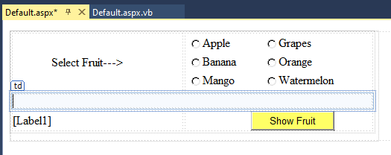

**Default.aspx.vb:**

Partial Class _Default

Inherits System.Web.UI.Page

Protected Sub RadioButtonList1_SelectedIndexChanged(sender As Object, e As EventArgs) Handles RadioButtonList1.SelectedIndexChanged

Try

Label1.Text = "You have selectecd " & RadioButtonList1.SelectedItem.Text

Catch ex As Exception

End Try

End Sub

Protected Sub Button1_Click(sender As Object, e As EventArgs) Handles Button1.Click

Try

Label1.Text = "You have selectecd " & RadioButtonList1.SelectedItem.Text

Catch ex As Exception

End Try

End Sub

End Class

**Output:**

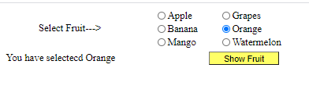

**9. Write ASP.NET code that uploads only GIF file with size more than 30 KB, into “product-image” folder and display it in an image box on the same page.**

**Default.aspx:**

<%@ Page Language="VB" AutoEventWireup="false" CodeFile="Default.aspx.vb" Inherits="_Default" %>

<!DOCTYPE html>

<html xmlns="http://www.w3.org/1999/xhtml">

<head runat="server">

<title></title>

<style type="text/css">

.auto-style1 {

width: 323px;

}

.auto-style2 {

width: 405px;

}

.auto-style3 {

width: 465px;

}

.auto-style4 {

width: 440px;

}

</style>

</head>

<body>

<form id="form1" runat="server">

<table style="width: 59%; height: 114px;">

<tr>

<td class="auto-style4">Select the file -->&nbsp;</td>

<td class="auto-style3"

&nbsp;</td>

<asp:FileUpload ID="FileUpload1" runat="server" BorderColor="#000099" BorderStyle="Solid" BorderWidth="2px" />

<td class="auto-style2">

<asp:Button ID="Button1" runat="server" BorderStyle="Solid" Height="23px" Text="Upload" Width="93px" />

</td>

</tr>

<tr>

<td class="auto-style1" colspan="3">

<center><asp:Image ID="Image1" runat="server" /></center>

</td>

</tr>

</table>

</form>

</body>

</html>

**Designing form :**

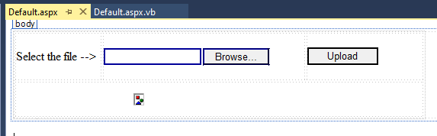

**Default.aspx.vb:**

Partial Class _Default

Inherits System.Web.UI.Page

Protected Sub Button1_Click(sender As Object, e As EventArgs) Handles Button1.Click

Try

Dim filename As String

If FileUpload1.HasFile = True And FileUpload1.FileContent.Length >= (30 * 1024) And System.IO.Path.GetExtension(FileUpload1.FileName) = ".GIF" Or System.IO.Path.GetExtension(FileUpload1.FileName) = ".gif" Then

filename = FileUpload1.FileName

'returns the physical file path that corresponds to the specific file

'Server.Mapath(".") returns the current physical directory

'

filename = Server.MapPath("~/ProductImage/" + filename)

FileUpload1.SaveAs(filename)

Dim filepath As String

filepath = System.IO.Path.GetFileName(filename)

filepath = "ProductImage/" + filepath

Image1.ImageUrl = filepath

Else

Image1.ImageUrl = " "

MsgBox("Please select the file")

End If

Catch ex As Exception

End Try

End Sub

End Class

**Output:**

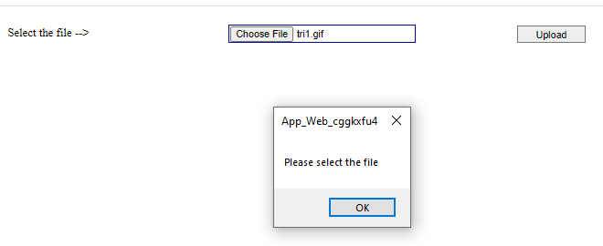

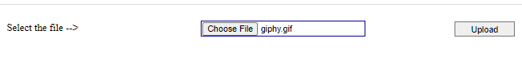

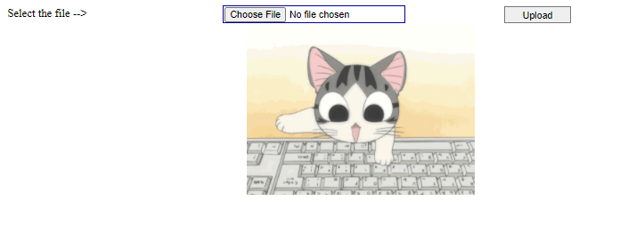

**10. Create a new Web form which allows the client to enter student information such as name, email address, sex and telephone number. The page also provides a submit button, which when clicked, will add this information to a TextBox which will also be displayed on the same page.**

**Default.aspx:**

<%@ Page Language="VB" AutoEventWireup="false" CodeFile="Default.aspx.vb" Inherits="_Default" %>

<!DOCTYPE html>

<html xmlns="http://www.w3.org/1999/xhtml">

<head runat="server">

<title></title>

<style type="text/css">

.auto-style1 {

width: 111px;

}

</style>

</head>

<body>

<form id="form2" runat="server">

<div>

<table border="1" style="border-style: solid; border-color: inherit; border-width: medium; height: 302px; width: 368px;">

<tr>

<td class="auto-style1">Name:</td>

<td>

<asp:TextBox ID="TextBox1" runat="server" Width="173px"></asp:TextBox>

</td>

</tr>

<tr>

<td class="auto-style1">Address:</td>

<td>

<asp:TextBox ID="TextBox2" runat="server" TextMode="MultiLine"></asp:TextBox>

</td>

</tr>

<tr>

<td class="auto-style1">Gender:</td>

<td>

<asp:RadioButton ID="RadioButton1" runat="server" GroupName="Gender" Text="Male" />

<asp:RadioButton ID="RadioButton2" runat="server" GroupName="Gender" Text="Female" />

</td>

</tr>

<tr>

<td class="auto-style1">Phone:</td>

<td>

<asp:TextBox ID="TextBox3" runat="server" Width="174px"></asp:TextBox>

</td>

</tr>

<tr>

<td class="auto-style1">E-Mail:</td>

<td>

<asp:TextBox ID="TextBox4" runat="server" Width="175px"></asp:TextBox>

</td>

</tr>

<tr style="text-align:center">

<td colspan="3">

<asp:Button ID="Button1" runat="server" Text="SUBMIT" />

</td>

</tr>

<tr style="text-align:center">

<td colspan="3">

<asp:TextBox ID="TextBox5" runat="server" Height="50px" TextMode="MultiLine" Width="243px"></asp:TextBox>

</td>

</tr>

</table>

</div>

</form>

</body>

</html>

**Designing form:**

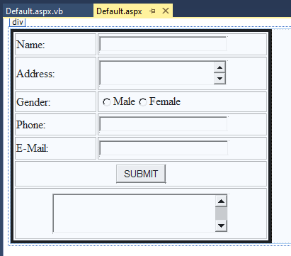

**Default.aspx.vb:**

Partial Class _Default

Inherits System.Web.UI.Page

Protected Sub Button1_Click(sender As Object, e As EventArgs) Handles Button1.Click

Try

Dim gen As String

If RadioButton1.Checked = True Then

gen = "Male"

Else

gen = "Female"

End If

TextBox5.Text = "Name: " & TextBox1.Text & ControlChars.CrLf & "Address :" + TextBox2.Text & ControlChars.CrLf & "Gender: " & gen & ControlChars.CrLf &"Phone: " & TextBox3.Text & ControlChars.CrLf & "Email: " & TextBox4.Text

Catch ex As Exception

End Try

End Sub

End Class

**Output:**

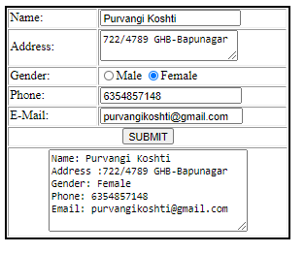

**12.Write an ASP.net app to change the bgcolor of webpage on the basis of selected colors from dropdownlist control.**

**Default.aspx:**

<%@ Page Language="VB" AutoEventWireup="false" CodeFile="Default.aspx.vb" Inherits="_Default" %>

<!DOCTYPE html>

<html xmlns="http://www.w3.org/1999/xhtml">

<head runat="server">

<title></title>

</head>

<body id="body1" runat="server">

<form id="form1" runat="server">

<div>

<h4>Select Color :</h4>

<asp:DropDownList ID="DropDownList1" runat="server" Width="171px" Height="19px" AutoPostBack="True">

<asp:ListItem>SELECT</asp:ListItem>

<asp:ListItem>RED</asp:ListItem>

<asp:ListItem>BLUE</asp:ListItem>

<asp:ListItem>MAGENTA</asp:ListItem>

<asp:ListItem>CYAN</asp:ListItem>

<asp:ListItem>ORANGE</asp:ListItem>

<asp:ListItem>PINK</asp:ListItem>

</asp:DropDownList>

</div>

</form>

</body>

</html>

**Designing Form :**

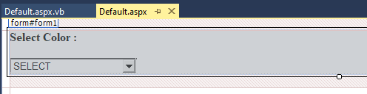

**Default.aspx.vb:**

Partial Class _Default

Inherits System.Web.UI.Page

Protected Sub Page_Load(sender As Object, e As EventArgs) Handles Me.Load

Try

If DropDownList1.SelectedItem.Text = "SELECT" Then

body1.Attributes.Add("bgcolor", "White")

Else

body1.Attributes.Add("bgcolor", DropDownList1.SelectedItem.Text)

End If

Catch ex As Exception

End Try

End Sub

End Class

**Output:**

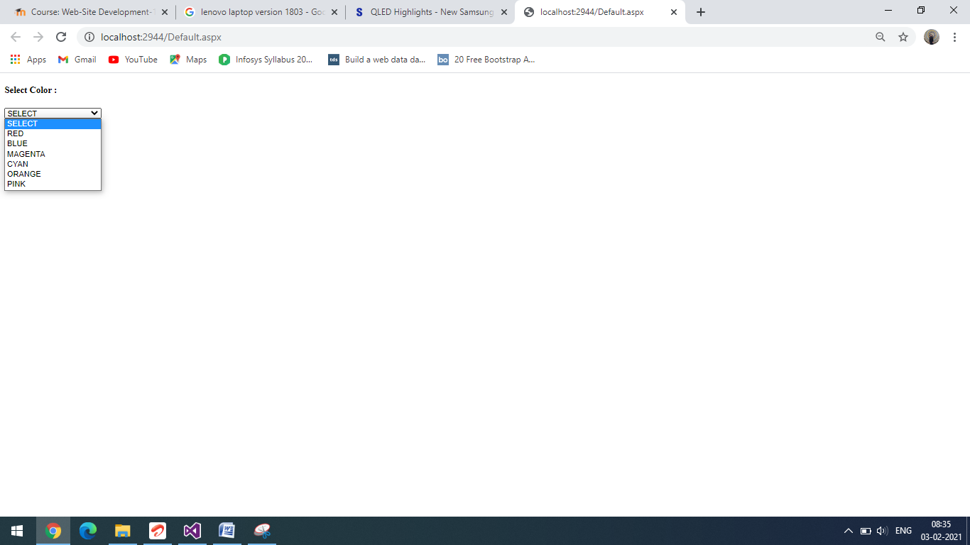

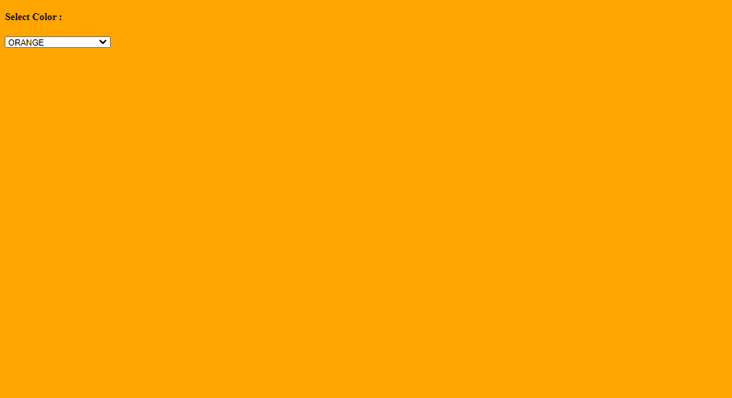

**13.** **Design a class file having two methods to do sum and multiplication, which takes two arguments. Design a web page having two textboxes to take integer number from the user. Place two buttons to invoke sum and multiplication method. Print the resultant value in the label control placed on the web page. (Use of App_code directory).**

**Default.aspx.vb:**