PAGE1------------------—----------------------—----------------------—----------------------—----------------------
PID Application
In this training, you will learn:
- What a PID is
- What problems it solves
- How it actually works
- How to implement it in your system
- How to tune the system
- How to model and implement it to MATLAB

PAGE2------------------—----------------------—----------------------—----------------------—----------------------
Who i am
A master 1 student sipnom about drones .
I have a experience in electronics, embedded systems , robotics , and other fields
And i will share it in this formation




PAGE3------------------—----------------------—----------------------—----------------------—----------------------

A PID (Proportional–Integral–Derivative) controller is a control algorithm used to automatically keep a system at a desired value called the setpoint.
In simple terms, a PID continuously:
- Measures the current value of a system (temperature, speed, position, etc.).
- Compare it with the desired value.
- Adjusts the control signal to reduce the difference (called the error).
This process happens repeatedly in a feedback loop, allowing the system to automatically correct itself.
PID controllers are extremely common in real systems, for example:
- Temperature control (ovens, incubators, 3D printers)
- Motor speed control (robots, drones, CNC machines)
- Position control (servo systems)
- Flight stabilization (quadcopters)
- Industrial process control

PAGE4------------------—----------------------—----------------------—----------------------—----------------------

What Problems Does a PID Solve?

You have an LED and an LDR sensor.
You want the LED brightness to reach a desired setpoint (a target light level measured by the LDR).
The system must:
- Reach the setpoint as fast as possible
- Maintain the setpoint precisely
- Avoid large deviations, since the system cannot tolerate very high or very low values.

PAGE5------------------—----------------------—----------------------—----------------------—----------------------
You currently think about something like this
if (measured_value < setpoint) {
Turn on ;
}
Else {
turn off;]

As you see this did not work very well . . .

PAGE6------------------—----------------------—----------------------—----------------------—----------------------
Many systems cannot naturally stay at the desired value (setpoint). Disturbances and system dynamics can cause errors.
A PID controller automatically corrects this error and improves the system behavior.
PID mainly solves three problems:
- Slow response: helps the system reach the target faster
- Steady-state error: eliminates the difference between the target and the final value
- Oscillations: stabilizes the system and reduces overshoot
Result: a system that is faster, more accurate, and more stable.

PAGE6------------------—----------------------—----------------------—----------------------—----------------------

How Does PID Actually Work?
A PID controller works by continuously calculating the error between the desired value (setpoint) and the measured value.
error = setpoint - measured_value
Then it computes the control signal using three terms:
U(t) is the output (the value that we are going to feed to the system)
e(t) is the error
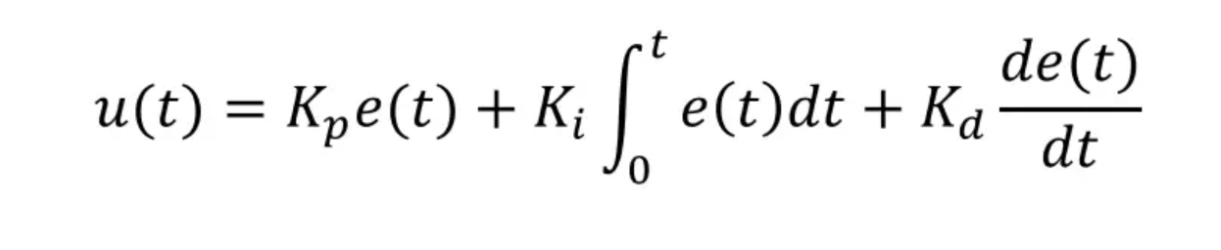
Proportional (P)
- Reacts to the current error.
- Larger error → stronger correction.
Integral (I)
- Reacts to the accumulated past error.
- Eliminates steady-state error.
Derivative (D)
- Reacts to how fast the error is changing.
- Reduces overshoot and improves stability.

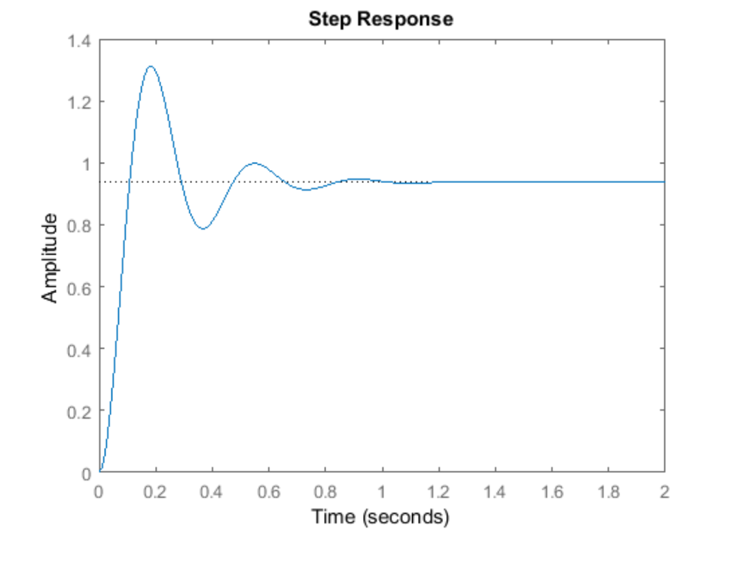

PAGE6------------------—----------------------—----------------------—----------------------—----------------------

How to Implement PID in Your System
It depends on whether the PID controller is implemented in hardware or software.
- Hardware PID: commonly used in industrial controllers (PLCs, dedicated control modules).
- Software PID: implemented inside a microcontroller or computer.
Software PID is widely used in robotics, drones, and embedded systems.
In this training, we will learn how to implement a PID controller in software.

This is how to code the pid :
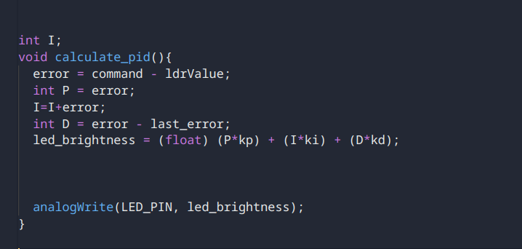

Yes this its that simple . . .

PAGE7------------------—----------------------—----------------------—----------------------—----------------------
How to tune your system

- Kp​ (Proportional): increases the reaction to the error → makes the system faster, but too much can cause instability.
- Ki​ (Integral): removes steady-state error and helps the system reach the exact setpoint.
- Kd​ (Derivative): reduces overshoot and oscillations, improving stability.

This site allows you to example a PID tunning


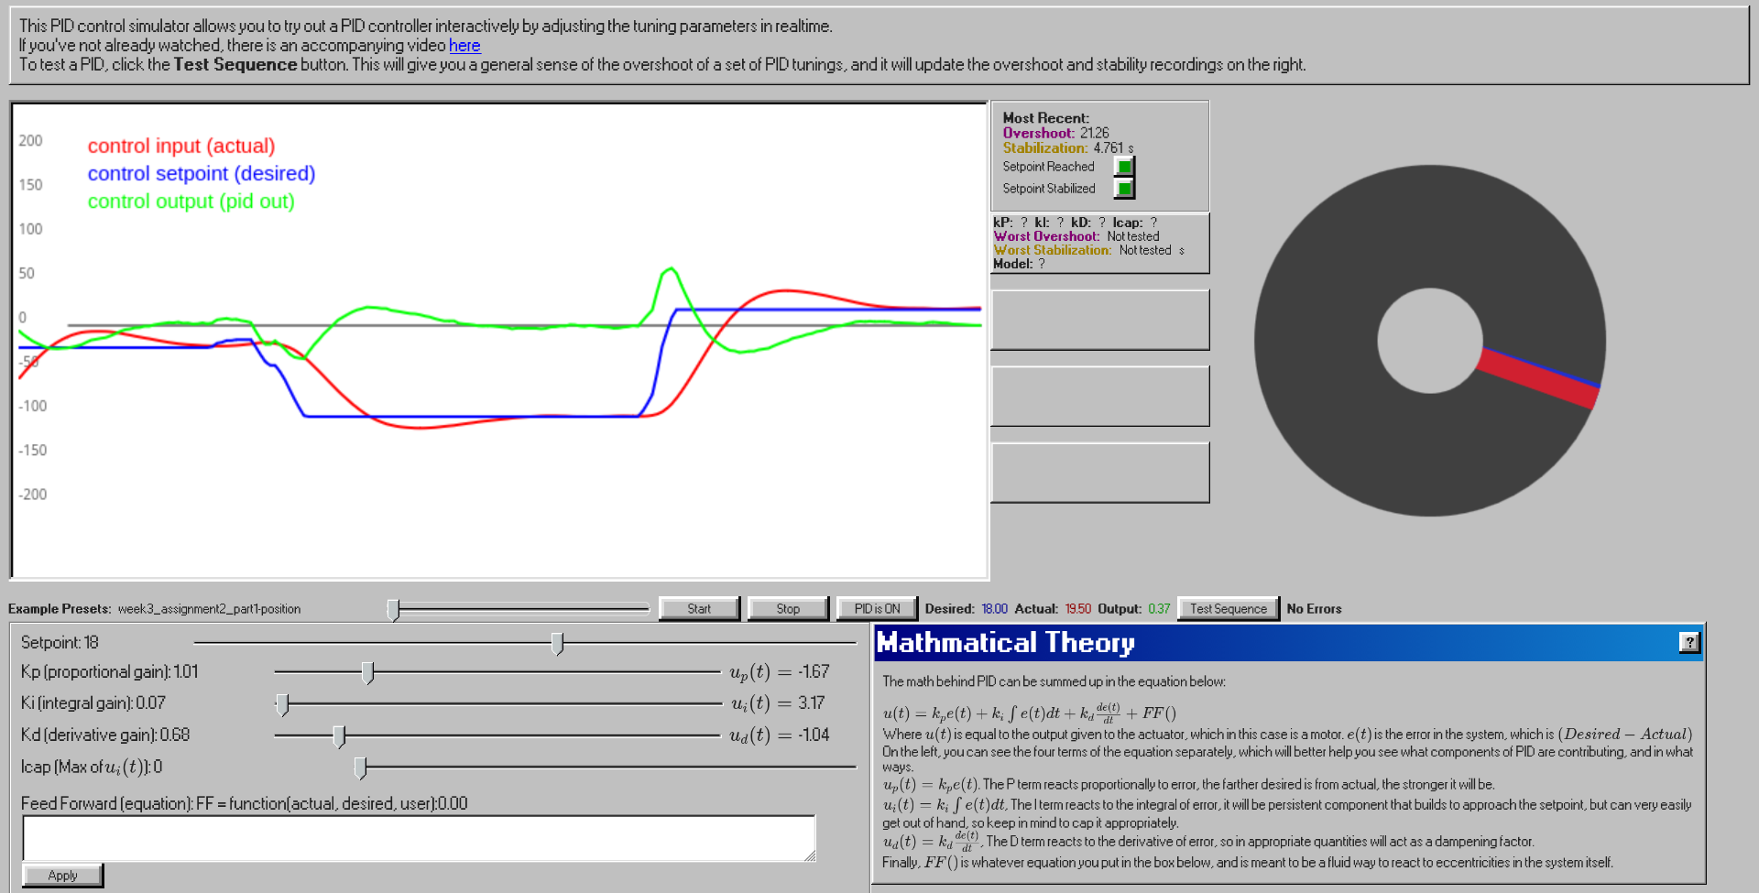

PAGE8------------------—----------------------—----------------------—----------------------—----------------------

How to Model and Implement It in MATLAB
First, we need to identify the system transfer function.
Steps followed:
- Apply an input step
  - I wrote a program that increases the LED command from 0 to 255 (maximum).
- Collect system data
  - The script recorded the LDR sensor values over time.
- Analyze the response
  - I exported the data and used Python to visualize the system response.
- Approximate the system model
  - Using Desmos, I found an approximate mathematical function describing the system behavior.
- Convert to transfer function
  - I applied the Laplace transform to obtain the system transfer function.
- Implement the model in MATLAB
  - The transfer function was implemented in MATLAB.
- Tune the PID controller
  - I used MATLAB’s PID autotuner to compute the optimal (K_p), (K_i), and (K_d) based on the system constraints.
- Apply the parameters to the real system
  - The calculated PID values were implemented in the original code, producing similar results in the real system.
PAGE9------------------—----------------------—----------------------—----------------------—----------------------
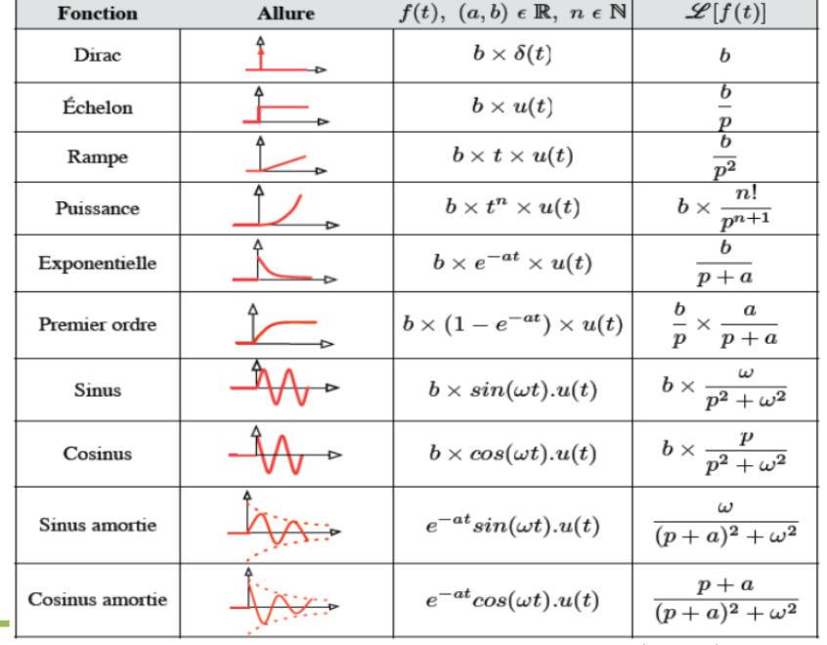
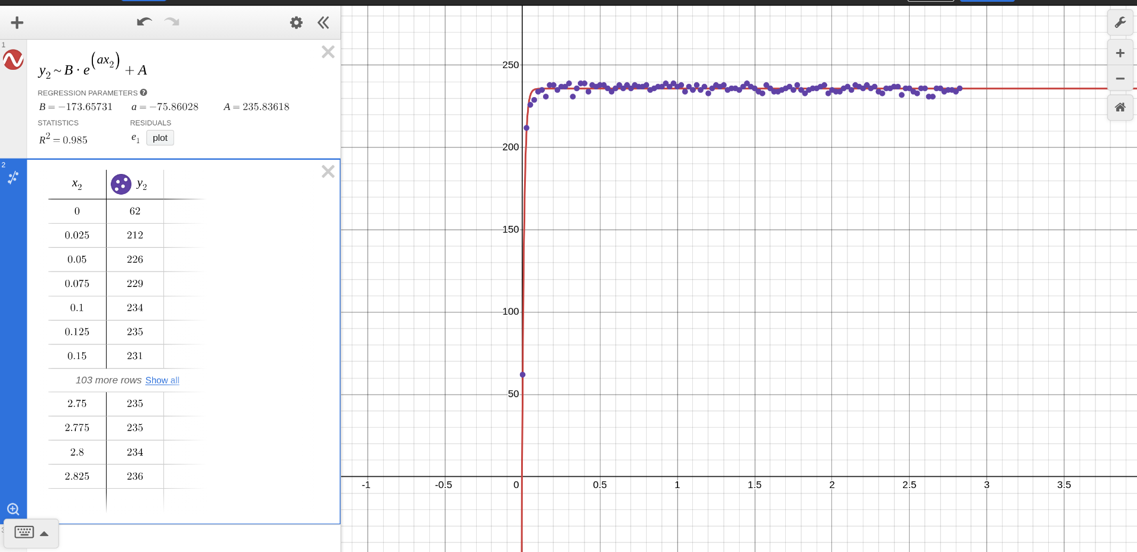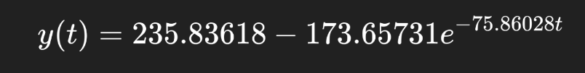
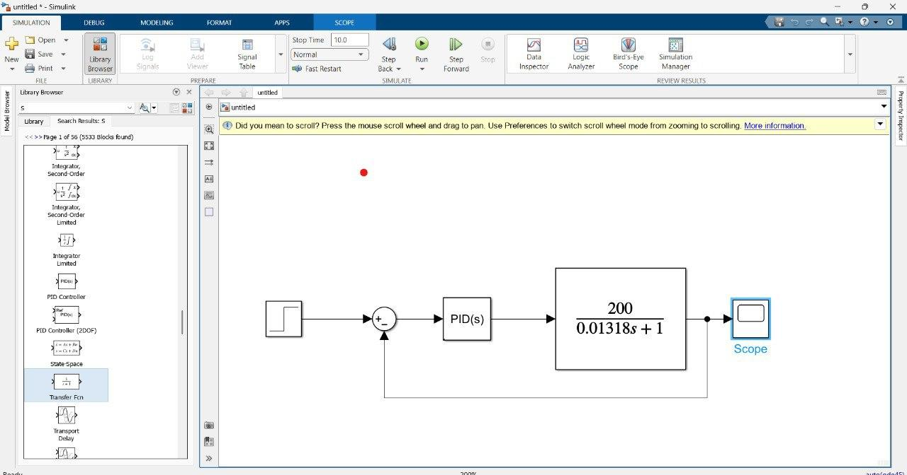

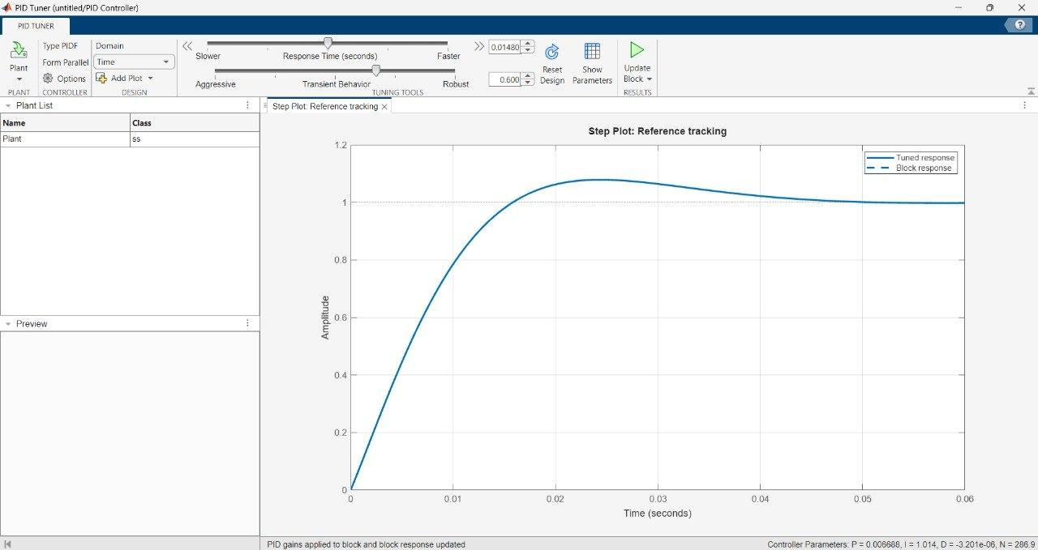
Its all about approximation !!

PAGE10------------------—----------------------—----------------------—----------------------—--------------------
Any questions !!
Thanks for participating

