**INT-404**

**(Artificial intelligence)**

**Project: -Neural Network Functioning**

**Section-K18HK**

**Submitted by**

**Rajat Maheshwari(11807504)**

**Ajit singh(11802801)**

**Gautam Madiratta(11810844)**

**Hritik(11804224)**

**Github link:-** <https://github.com/Rajat72/NeuralNetwork>

**ABSTRACT**

We worked on A real life prototype Inspired from cockroaches, as cockroach runs away from light so does our neural bot. this bot can have application for all botanical gardens and pharmaceutical companies.

In botanical gardens it can use with a pot mount on it, as some of the plants fade away(burn) in presence of excessive sunlight.

In pharmaceutical companies it(algorithm) can be deployed to transport medicines that can’t bear excessive sunlight and heat. As temperature may cause unwanted reaction or dampen the effect of medicine

Or even for a far stretch that we came up, these kind of bots can hide well in shadows and can be used as spy bots for espionage and other activities.

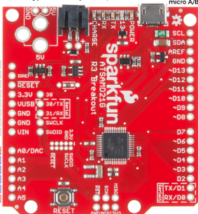**INTRODUCTION**

Hardware:-

1)SAMD21:-Microcontroller

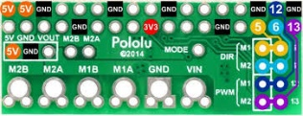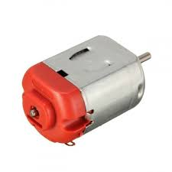2)DRV8835:-Dual Motor driver

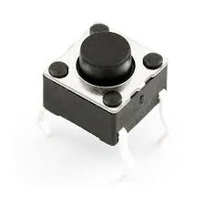3)MOTOR(2):-MOTION

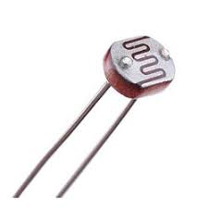4)Button(2):-Interrupt

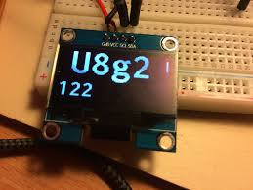5)PhotoResistor(4):-Sensor

6)U8G2:-Monochromatic display

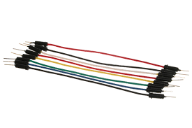7)Jumper wires:-for conncection

8)breadboard/solder:-Circuit formation

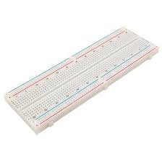

9)Arduino Mega(SAMD21 library was not available in proteus):-Largest flash memory in open source Mirco-Controller, so it can easily replace any micro-controller**.**

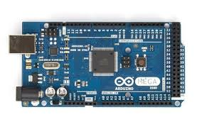

**Techniques used:-**

1)Backpropagation

2)gradient descent with momentum

3)neural network

4)sigmoid function for Activation function

5)Accumulator for total weighted inputs of neurons

**Literature**

1)MIT PRESS: Machine learning

2) <https://automatetheboringstuff.com/>

3)Python documentation

**Methodology**

1)self taken heuristic for driving of motor

(100 for full forward,50 for stationary position, and 0 for full backward)

2)Calibrated 4 input node with correspondence of 5 hidden node to give output over 2 nodes(motor)

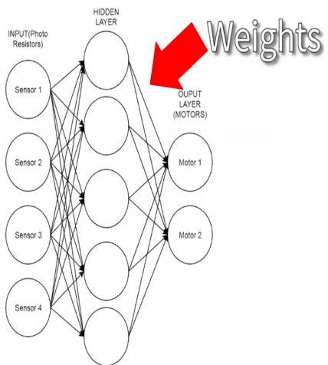

**Results**

1)Training of neural network from randomized initial node and random association after every iteration

2)A neural bot who behaves like a cockroach

3)Graph of gradient decent slowly comes down to minimum threshold of error specified

**Conclusion**

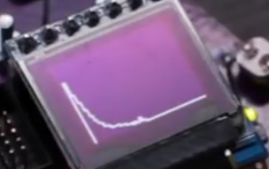1)Backpropagation and training of neural network take significant amount of time

2)Neural bot behaves differently every time after training

**References**

1)<http://robotics.hobbizine.com/arduinoann.html>

2)<https://www.youtube.com/watch?v=7FMGXCAwbnc&t=421s>