Tinkercad hardware simulation:  
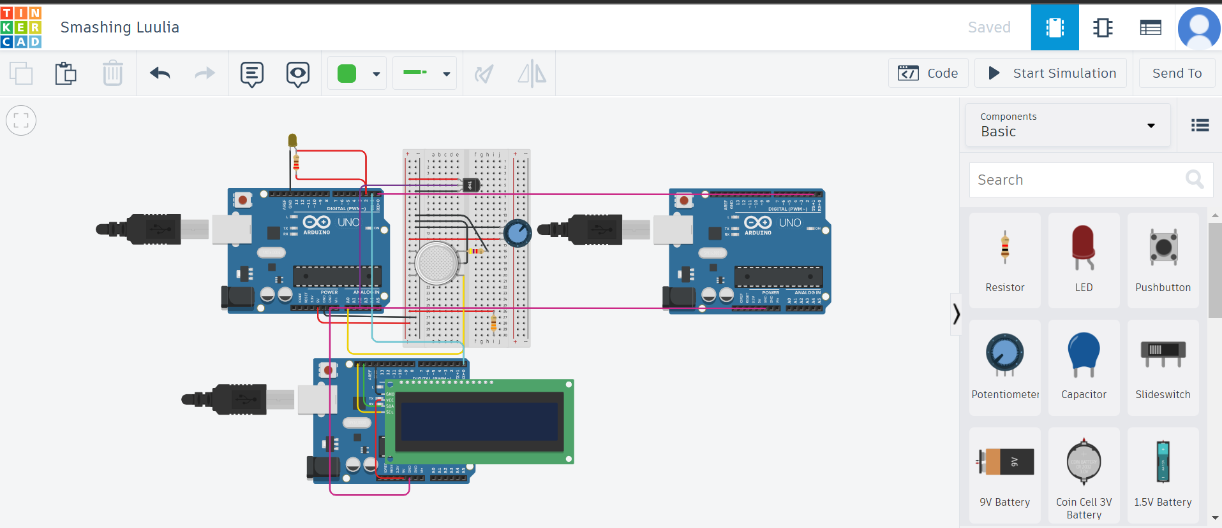

Our SIH project statement was to provide software solutions to manual shift logging and enhancing worker safety,  
Hence to improve worker safety we designed versatile hardware units called nodes, each node can be connected to multiple nodes, in the above scenario the two highly collected Arduinos form a single node where each Arduino helps share the power load, and the third Arduino showcases the connective capabilities of these nodes  
What do these nodes do?  
Just Like how nodes in a graph can be utilised to map shortest paths between two points the relative positions and environmental conditions at each node will be utilised to detect accidents and remove damaged pathways, using the data from the nodes a server application will carefully move each worker to safety avoiding compromised sections of the mine   
These nodes combined with machine learning can also be used for predicting future values of certain physical quantities saving cost by preventing machinery damage as much as possible  
They are highly versatile and cannot only be equipped with a range of sensors but also a range of actuators to guide the miners out or towards safety in case of emergency