Project hardware photos:

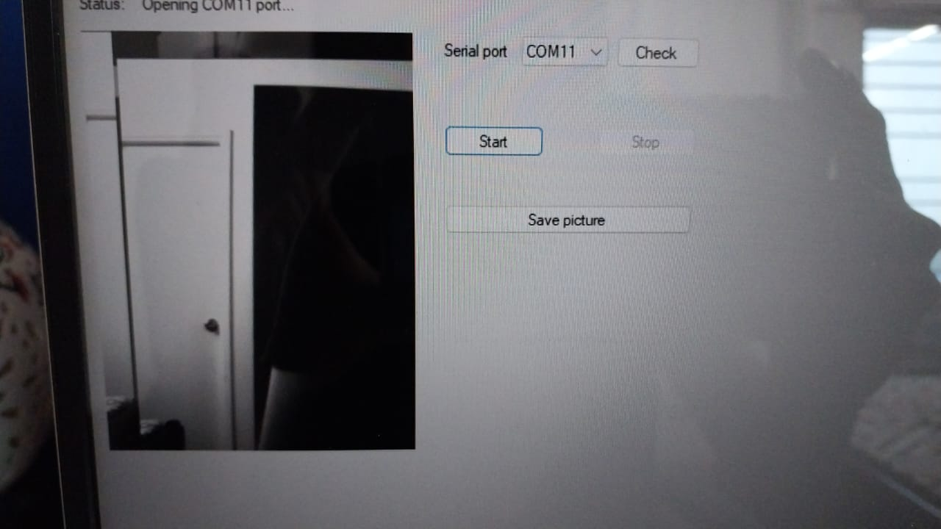

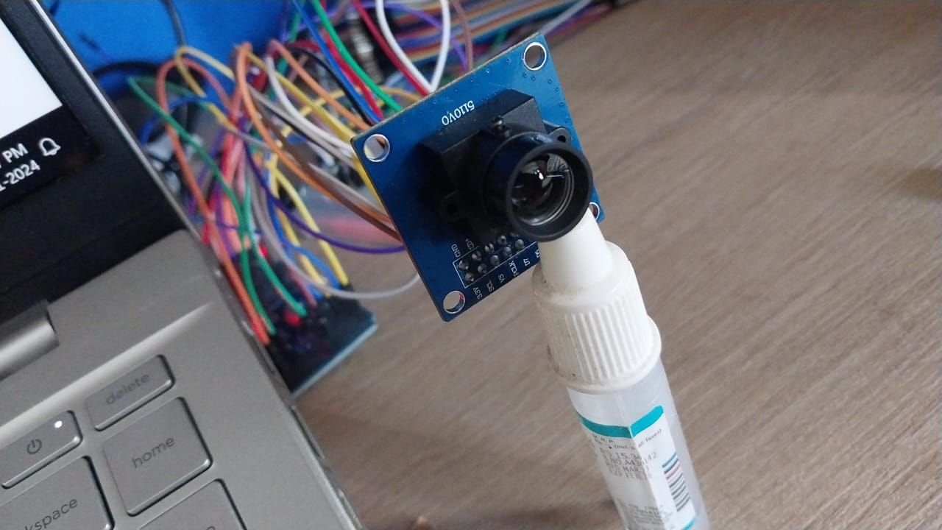

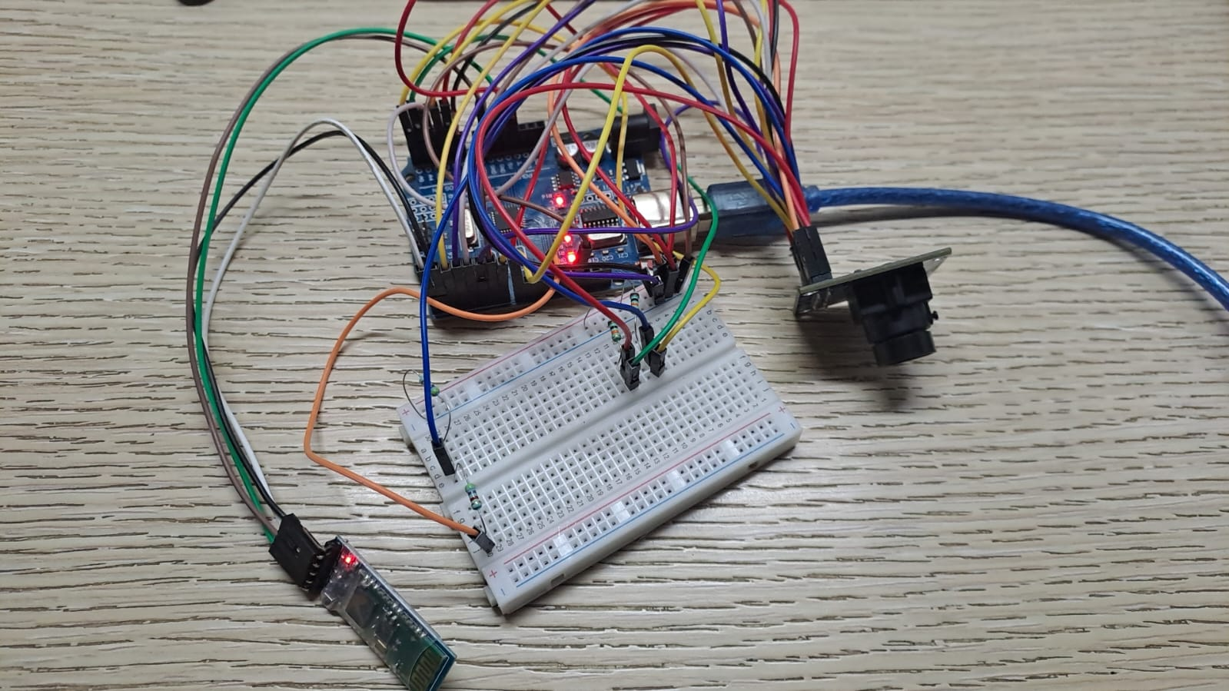

Circuit connections: (base)  
(circuit digest)  
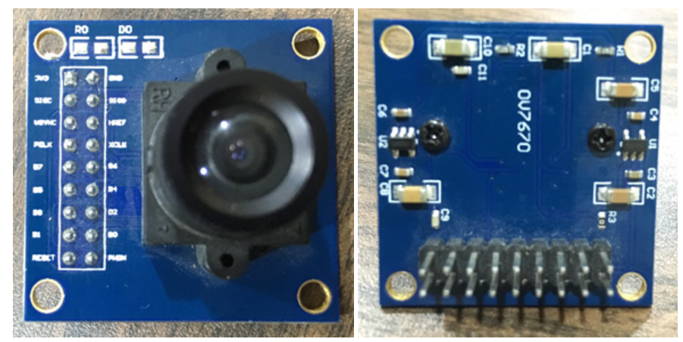

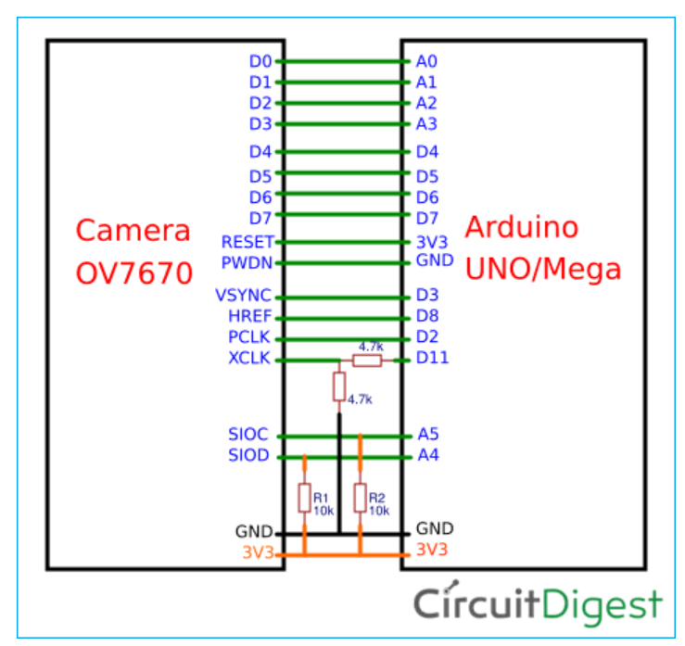

The overall hardware can be extended with HC05 bluetooth module:  
therefore the connections would be as follows:  
wearable device (glass) (Bluetooth) ->mobile phone (user) <->cloud

But since Arduino might not be able to support such a diverse connection we use a low energy connection scheme:  
wearable device -> computer -> cloud ->phone app->user

Base code: (circuit digest)  
#include <stdint.h>

#include <avr/io.h>

#include <util/twi.h>

#include <util/delay.h>

#include <avr/pgmspace.h>

#define F_CPU 16000000UL

#define vga   0

#define qvga  1

#define qqvga   2

#define yuv422  0

#define rgb565  1

#define bayerRGB  2

#define camAddr_WR  0x42

#define camAddr_RD  0x43

/* Registers */

#define REG_GAIN    0x00  /* Gain lower 8 bits (rest in vref) */

#define REG_BLUE    0x01  /* blue gain */

#define REG_RED       0x02  /* red gain */

#define REG_VREF    0x03  /* Pieces of GAIN, VSTART, VSTOP */

#define REG_COM1    0x04  /* Control 1 */

#define COM1_CCIR656  0x40    /* CCIR656 enable */

#define REG_BAVE    0x05  /* U/B Average level */

#define REG_GbAVE   0x06  /* Y/Gb Average level */

#define REG_AECHH   0x07  /* AEC MS 5 bits */

#define REG_RAVE    0x08  /* V/R Average level */

#define REG_COM2    0x09  /* Control 2 */

#define COM2_SSLEEP         0x10  /* Soft sleep mode */

#define REG_PID           0x0a  /* Product ID MSB */

#define REG_VER           0x0b  /* Product ID LSB */

#define REG_COM3    0x0c  /* Control 3 */

#define COM3_SWAP         0x40  /* Byte swap */

#define COM3_SCALEEN          0x08  /* Enable scaling */

#define COM3_DCWEN          0x04  /* Enable downsamp/crop/window */

#define REG_COM4    0x0d  /* Control 4 */

#define REG_COM5    0x0e  /* All "reserved" */

#define REG_COM6    0x0f  /* Control 6 */

#define REG_AECH    0x10  /* More bits of AEC value */

#define REG_CLKRC   0x11  /* Clocl control */

#define CLK_EXT           0x40  /* Use external clock directly */

#define CLK_SCALE   0x3f  /* Mask for internal clock scale */

#define REG_COM7    0x12  /* Control 7 */ //REG mean address.

#define COM7_RESET          0x80  /* Register reset */

#define COM7_FMT_MASK         0x38

#define COM7_FMT_VGA          0x00

#define COM7_FMT_CIF          0x20  /* CIF format */

#define COM7_FMT_QVGA         0x10  /* QVGA format */

#define COM7_FMT_QCIF         0x08  /* QCIF format */

#define COM7_RGB          0x04  /* bits 0 and 2 - RGB format */

#define COM7_YUV          0x00  /* YUV */

#define COM7_BAYER          0x01  /* Bayer format */

#define COM7_PBAYER         0x05  /* "Processed bayer" */

#define REG_COM8    0x13  /* Control 8 */

#define COM8_FASTAEC          0x80  /* Enable fast AGC/AEC */

#define COM8_AECSTEP          0x40  /* Unlimited AEC step size */

#define COM8_BFILT    0x20  /* Band filter enable */

#define COM8_AGC    0x04  /* Auto gain enable */

#define COM8_AWB    0x02  /* White balance enable */

#define COM8_AEC    0x01  /* Auto exposure enable */

#define REG_COM9    0x14  /* Control 9- gain ceiling */

#define REG_COM10   0x15  /* Control 10 */

#define COM10_HSYNC         0x40  /* HSYNC instead of HREF */

#define COM10_PCLK_HB         0x20  /* Suppress PCLK on horiz blank */

#define COM10_HREF_REV          0x08  /* Reverse HREF */

#define COM10_VS_LEAD         0x04  /* VSYNC on clock leading edge */

#define COM10_VS_NEG          0x02  /* VSYNC negative */

#define COM10_HS_NEG          0x01  /* HSYNC negative */

#define REG_HSTART    0x17  /* Horiz start high bits */

#define REG_HSTOP   0x18  /* Horiz stop high bits */

#define REG_VSTART    0x19  /* Vert start high bits */

#define REG_VSTOP   0x1a  /* Vert stop high bits */

#define REG_PSHFT   0x1b  /* Pixel delay after HREF */

#define REG_MIDH    0x1c  /* Manuf. ID high */

#define REG_MIDL    0x1d  /* Manuf. ID low */

#define REG_MVFP    0x1e  /* Mirror / vflip */

#define MVFP_MIRROR         0x20  /* Mirror image */

#define MVFP_FLIP   0x10  /* Vertical flip */

#define REG_AEW           0x24  /* AGC upper limit */

#define REG_AEB           0x25    /* AGC lower limit */

#define REG_VPT           0x26  /* AGC/AEC fast mode op region */

#define REG_HSYST   0x30  /* HSYNC rising edge delay */

#define REG_HSYEN   0x31  /* HSYNC falling edge delay */

#define REG_HREF    0x32  /* HREF pieces */

#define REG_TSLB    0x3a  /* lots of stuff */

#define TSLB_YLAST    0x04  /* UYVY or VYUY - see com13 */

#define REG_COM11   0x3b  /* Control 11 */

#define COM11_NIGHT         0x80  /* NIght mode enable */

#define COM11_NMFR          0x60  /* Two bit NM frame rate */

#define COM11_HZAUTO          0x10  /* Auto detect 50/60 Hz */

#define COM11_50HZ          0x08  /* Manual 50Hz select */

#define COM11_EXP   0x02

#define REG_COM12   0x3c  /* Control 12 */

#define COM12_HREF          0x80  /* HREF always */

#define REG_COM13   0x3d  /* Control 13 */

#define COM13_GAMMA         0x80  /* Gamma enable */

#define COM13_UVSAT         0x40  /* UV saturation auto adjustment */

#define COM13_UVSWAP          0x01  /* V before U - w/TSLB */

#define REG_COM14   0x3e  /* Control 14 */

#define COM14_DCWEN         0x10  /* DCW/PCLK-scale enable */

#define REG_EDGE    0x3f  /* Edge enhancement factor */

#define REG_COM15   0x40  /* Control 15 */

#define COM15_R10F0         0x00  /* Data range 10 to F0 */

#define COM15_R01FE         0x80  /*      01 to FE */

#define COM15_R00FF         0xc0  /*      00 to FF */

#define COM15_RGB565          0x10  /* RGB565 output */

#define COM15_RGB555          0x30  /* RGB555 output */

#define REG_COM16   0x41  /* Control 16 */

#define COM16_AWBGAIN         0x08  /* AWB gain enable */

#define REG_COM17   0x42  /* Control 17 */

#define COM17_AECWIN          0xc0  /* AEC window - must match COM4 */

#define COM17_CBAR          0x08  /* DSP Color bar */

/*

* This matrix defines how the colors are generated, must be

* tweaked to adjust hue and saturation.

*

* Order: v-red, v-green, v-blue, u-red, u-green, u-blue

* They are nine-bit signed quantities, with the sign bit

* stored in0x58.Sign for v-red is bit 0, and up from there.

*/

#define REG_CMATRIX_BASE  0x4f

#define CMATRIX_LEN           6

#define REG_CMATRIX_SIGN  0x58

#define REG_BRIGHT    0x55  /* Brightness */

#define REG_CONTRAS         0x56  /* Contrast control */

#define REG_GFIX    0x69  /* Fix gain control */

#define REG_REG76   0x76  /* OV's name */

#define R76_BLKPCOR         0x80  /* Black pixel correction enable */

#define R76_WHTPCOR         0x40  /* White pixel correction enable */

#define REG_RGB444          0x8c  /* RGB 444 control */

#define R444_ENABLE         0x02  /* Turn on RGB444, overrides 5x5 */

#define R444_RGBX   0x01  /* Empty nibble at end */

#define REG_HAECC1    0x9f  /* Hist AEC/AGC control 1 */

#define REG_HAECC2    0xa0  /* Hist AEC/AGC control 2 */

#define REG_BD50MAX         0xa5  /* 50hz banding step limit */

#define REG_HAECC3    0xa6  /* Hist AEC/AGC control 3 */

#define REG_HAECC4    0xa7  /* Hist AEC/AGC control 4 */

#define REG_HAECC5    0xa8  /* Hist AEC/AGC control 5 */

#define REG_HAECC6    0xa9  /* Hist AEC/AGC control 6 */

#define REG_HAECC7    0xaa  /* Hist AEC/AGC control 7 */

#define REG_BD60MAX         0xab  /* 60hz banding step limit */

#define REG_GAIN    0x00  /* Gain lower 8 bits (rest in vref) */

#define REG_BLUE    0x01  /* blue gain */

#define REG_RED           0x02  /* red gain */

#define REG_VREF    0x03  /* Pieces of GAIN, VSTART, VSTOP */

#define REG_COM1    0x04  /* Control 1 */

#define COM1_CCIR656          0x40  /* CCIR656 enable */

#define REG_BAVE    0x05  /* U/B Average level */

#define REG_GbAVE   0x06  /* Y/Gb Average level */

#define REG_AECHH   0x07  /* AEC MS 5 bits */

#define REG_RAVE    0x08  /* V/R Average level */

#define REG_COM2    0x09  /* Control 2 */

#define COM2_SSLEEP         0x10  /* Soft sleep mode */

#define REG_PID           0x0a  /* Product ID MSB */

#define REG_VER           0x0b  /* Product ID LSB */

#define REG_COM3    0x0c  /* Control 3 */

#define COM3_SWAP         0x40  /* Byte swap */

#define COM3_SCALEEN          0x08  /* Enable scaling */

#define COM3_DCWEN          0x04  /* Enable downsamp/crop/window */

#define REG_COM4    0x0d  /* Control 4 */

#define REG_COM5    0x0e  /* All "reserved" */

#define REG_COM6    0x0f  /* Control 6 */

#define REG_AECH    0x10  /* More bits of AEC value */

#define REG_CLKRC   0x11  /* Clocl control */

#define CLK_EXT           0x40  /* Use external clock directly */

#define CLK_SCALE   0x3f  /* Mask for internal clock scale */

#define REG_COM7    0x12  /* Control 7 */

#define COM7_RESET          0x80  /* Register reset */

#define COM7_FMT_MASK         0x38

#define COM7_FMT_VGA          0x00

#define COM7_FMT_CIF          0x20  /* CIF format */

#define COM7_FMT_QVGA         0x10  /* QVGA format */

#define COM7_FMT_QCIF         0x08  /* QCIF format */

#define COM7_RGB    0x04  /* bits 0 and 2 - RGB format */

#define COM7_YUV    0x00  /* YUV */

#define COM7_BAYER          0x01  /* Bayer format */

#define COM7_PBAYER         0x05  /* "Processed bayer" */

#define REG_COM8    0x13  /* Control 8 */

#define COM8_FASTAEC          0x80  /* Enable fast AGC/AEC */

#define COM8_AECSTEP          0x40  /* Unlimited AEC step size */

#define COM8_BFILT    0x20  /* Band filter enable */

#define COM8_AGC    0x04  /* Auto gain enable */

#define COM8_AWB    0x02  /* White balance enable */

#define COM8_AEC    0x01  /* Auto exposure enable */

#define REG_COM9    0x14  /* Control 9- gain ceiling */

#define REG_COM10   0x15  /* Control 10 */

#define COM10_HSYNC         0x40  /* HSYNC instead of HREF */

#define COM10_PCLK_HB         0x20  /* Suppress PCLK on horiz blank */

#define COM10_HREF_REV          0x08  /* Reverse HREF */

#define COM10_VS_LEAD           0x04  /* VSYNC on clock leading edge */

#define COM10_VS_NEG          0x02  /* VSYNC negative */

#define COM10_HS_NEG          0x01  /* HSYNC negative */

#define REG_HSTART    0x17  /* Horiz start high bits */

#define REG_HSTOP   0x18  /* Horiz stop high bits */

#define REG_VSTART    0x19  /* Vert start high bits */

#define REG_VSTOP   0x1a  /* Vert stop high bits */

#define REG_PSHFT   0x1b  /* Pixel delay after HREF */

#define REG_MIDH    0x1c  /* Manuf. ID high */

#define REG_MIDL    0x1d  /* Manuf. ID low */

#define REG_MVFP    0x1e  /* Mirror / vflip */

#define MVFP_MIRROR         0x20  /* Mirror image */

#define MVFP_FLIP   0x10  /* Vertical flip */

#define REG_AEW           0x24  /* AGC upper limit */

#define REG_AEB           0x25  /* AGC lower limit */

#define REG_VPT           0x26  /* AGC/AEC fast mode op region */

#define REG_HSYST   0x30  /* HSYNC rising edge delay */

#define REG_HSYEN   0x31  /* HSYNC falling edge delay */

#define REG_HREF    0x32  /* HREF pieces */

#define REG_TSLB    0x3a  /* lots of stuff */

#define TSLB_YLAST    0x04  /* UYVY or VYUY - see com13 */

#define REG_COM11   0x3b  /* Control 11 */

#define COM11_NIGHT         0x80  /* NIght mode enable */

#define COM11_NMFR          0x60  /* Two bit NM frame rate */

#define COM11_HZAUTO          0x10  /* Auto detect 50/60 Hz */

#define COM11_50HZ          0x08  /* Manual 50Hz select */

#define COM11_EXP   0x02

#define REG_COM12   0x3c  /* Control 12 */

#define COM12_HREF          0x80  /* HREF always */

#define REG_COM13   0x3d  /* Control 13 */

#define COM13_GAMMA         0x80  /* Gamma enable */

#define COM13_UVSAT         0x40  /* UV saturation auto adjustment */

#define COM13_UVSWAP          0x01  /* V before U - w/TSLB */

#define REG_COM14   0x3e  /* Control 14 */

#define COM14_DCWEN         0x10  /* DCW/PCLK-scale enable */

#define REG_EDGE    0x3f  /* Edge enhancement factor */

#define REG_COM15   0x40  /* Control 15 */

#define COM15_R10F0         0x00  /* Data range 10 to F0 */

#define COM15_R01FE         0x80  /*      01 to FE */

#define COM15_R00FF         0xc0  /*      00 to FF */

#define COM15_RGB565          0x10  /* RGB565 output */

#define COM15_RGB555          0x30  /* RGB555 output */

#define REG_COM16   0x41  /* Control 16 */

#define COM16_AWBGAIN         0x08  /* AWB gain enable */

#define REG_COM17   0x42  /* Control 17 */

#define COM17_AECWIN          0xc0  /* AEC window - must match COM4 */

#define COM17_CBAR          0x08  /* DSP Color bar */

#define CMATRIX_LEN             6

#define REG_BRIGHT    0x55  /* Brightness */

#define REG_REG76   0x76  /* OV's name */

#define R76_BLKPCOR         0x80  /* Black pixel correction enable */

#define R76_WHTPCOR         0x40  /* White pixel correction enable */

#define REG_RGB444          0x8c  /* RGB 444 control */

#define R444_ENABLE         0x02  /* Turn on RGB444, overrides 5x5 */

#define R444_RGBX   0x01  /* Empty nibble at end */

#define REG_HAECC1    0x9f  /* Hist AEC/AGC control 1 */

#define REG_HAECC2    0xa0  /* Hist AEC/AGC control 2 */

#define REG_BD50MAX         0xa5  /* 50hz banding step limit */

#define REG_HAECC3    0xa6  /* Hist AEC/AGC control 3 */

#define REG_HAECC4    0xa7  /* Hist AEC/AGC control 4 */

#define REG_HAECC5    0xa8  /* Hist AEC/AGC control 5 */

#define REG_HAECC6    0xa9  /* Hist AEC/AGC control 6 */

#define REG_HAECC7    0xaa  /* Hist AEC/AGC control 7 */

#define REG_BD60MAX         0xab  /* 60hz banding step limit */

#define MTX1            0x4f  /* Matrix Coefficient 1 */

#define MTX2            0x50  /* Matrix Coefficient 2 */

#define MTX3            0x51  /* Matrix Coefficient 3 */

#define MTX4            0x52  /* Matrix Coefficient 4 */

#define MTX5            0x53  /* Matrix Coefficient 5 */

#define MTX6            0x54  /* Matrix Coefficient 6 */

#define REG_CONTRAS         0x56  /* Contrast control */

#define MTXS            0x58  /* Matrix Coefficient Sign */

#define AWBC7           0x59  /* AWB Control 7 */

#define AWBC8           0x5a  /* AWB Control 8 */

#define AWBC9           0x5b  /* AWB Control 9 */

#define AWBC10            0x5c  /* AWB Control 10 */

#define AWBC11            0x5d  /* AWB Control 11 */

#define AWBC12            0x5e  /* AWB Control 12 */

#define REG_GFI           0x69  /* Fix gain control */

#define GGAIN           0x6a  /* G Channel AWB Gain */

#define DBLV            0x6b  

#define AWBCTR3           0x6c  /* AWB Control 3 */

#define AWBCTR2           0x6d  /* AWB Control 2 */

#define AWBCTR1           0x6e  /* AWB Control 1 */

#define AWBCTR0           0x6f  /* AWB Control 0 */

struct regval_list{

  uint8_t reg_num;

  uint16_t value;

};

const struct regval_list qvga_ov7670[] PROGMEM = {

  { REG_COM14, 0x19 },

  { 0x72, 0x11 },

  { 0x73, 0xf1 },

  { REG_HSTART, 0x16 },

  { REG_HSTOP, 0x04 },

  { REG_HREF, 0xa4 },

  { REG_VSTART, 0x02 },

  { REG_VSTOP, 0x7a },

  { REG_VREF, 0x0a },

  { 0xff, 0xff }, /* END MARKER */

};

const struct regval_list yuv422_ov7670[] PROGMEM = {

  { REG_COM7, 0x0 },  /* Selects YUV mode */

  { REG_RGB444, 0 },  /* No RGB444 please */

  { REG_COM1, 0 },

  { REG_COM15, COM15_R00FF },

  { REG_COM9, 0x6A }, /* 128x gain ceiling; 0x8 is reserved bit */

  { 0x4f, 0x80 },   /* "matrix coefficient 1" */

  { 0x50, 0x80 },   /* "matrix coefficient 2" */

  { 0x51, 0 },    /* vb */

  { 0x52, 0x22 },   /* "matrix coefficient 4" */

  { 0x53, 0x5e },   /* "matrix coefficient 5" */

  { 0x54, 0x80 },   /* "matrix coefficient 6" */

  { REG_COM13, COM13_UVSAT },

  { 0xff, 0xff },   /* END MARKER */

};

const struct regval_list ov7670_default_regs[] PROGMEM = {//from the linux driver

  { REG_COM7, COM7_RESET },

  { REG_TSLB, 0x04 }, /* OV */

  { REG_COM7, 0 },  /* VGA */

  /*

  * Set the hardware window.  These values from OV don't entirely

  * make sense - hstop is less than hstart.  But they work...

  */

  { REG_HSTART, 0x13 }, { REG_HSTOP, 0x01 },

  { REG_HREF, 0xb6 }, { REG_VSTART, 0x02 },

  { REG_VSTOP, 0x7a }, { REG_VREF, 0x0a },

  { REG_COM3, 0 }, { REG_COM14, 0 },

  /* Mystery scaling numbers */

  { 0x70, 0x3a }, { 0x71, 0x35 },

  { 0x72, 0x11 }, { 0x73, 0xf0 },

  { 0xa2,/* 0x02 changed to 1*/1 }, { REG_COM10, 0x0 },

  /* Gamma curve values */

  { 0x7a, 0x20 }, { 0x7b, 0x10 },

  { 0x7c, 0x1e }, { 0x7d, 0x35 },

  { 0x7e, 0x5a }, { 0x7f, 0x69 },

  { 0x80, 0x76 }, { 0x81, 0x80 },

  { 0x82, 0x88 }, { 0x83, 0x8f },

  { 0x84, 0x96 }, { 0x85, 0xa3 },

  { 0x86, 0xaf }, { 0x87, 0xc4 },

  { 0x88, 0xd7 }, { 0x89, 0xe8 },

  /* AGC and AEC parameters.  Note we start by disabling those features,

  then turn them only after tweaking the values. */

  { REG_COM8, COM8_FASTAEC | COM8_AECSTEP },

  { REG_GAIN, 0 }, { REG_AECH, 0 },

  { REG_COM4, 0x40 }, /* magic reserved bit */

  { REG_COM9, 0x18 }, /* 4x gain + magic rsvd bit */

  { REG_BD50MAX, 0x05 }, { REG_BD60MAX, 0x07 },

  { REG_AEW, 0x95 }, { REG_AEB, 0x33 },

  { REG_VPT, 0xe3 }, { REG_HAECC1, 0x78 },

  { REG_HAECC2, 0x68 }, { 0xa1, 0x03 }, /* magic */

  { REG_HAECC3, 0xd8 }, { REG_HAECC4, 0xd8 },

  { REG_HAECC5, 0xf0 }, { REG_HAECC6, 0x90 },

  { REG_HAECC7, 0x94 },

  { REG_COM8, COM8_FASTAEC | COM8_AECSTEP | COM8_AGC | COM8_AEC },

  { 0x30, 0 }, { 0x31, 0 },//disable some delays

  /* Almost all of these are magic "reserved" values.  */

  { REG_COM5, 0x61 }, { REG_COM6, 0x4b },

  { 0x16, 0x02 }, { REG_MVFP, 0x07 },

  { 0x21, 0x02 }, { 0x22, 0x91 },

  { 0x29, 0x07 }, { 0x33, 0x0b },

  { 0x35, 0x0b }, { 0x37, 0x1d },

  { 0x38, 0x71 }, { 0x39, 0x2a },

  { REG_COM12, 0x78 }, { 0x4d, 0x40 },

  { 0x4e, 0x20 }, { REG_GFIX, 0 },

  /*{0x6b, 0x4a},*/{ 0x74, 0x10 },

  { 0x8d, 0x4f }, { 0x8e, 0 },

  { 0x8f, 0 }, { 0x90, 0 },

  { 0x91, 0 }, { 0x96, 0 },

  { 0x9a, 0 }, { 0xb0, 0x84 },

  { 0xb1, 0x0c }, { 0xb2, 0x0e },

  { 0xb3, 0x82 }, { 0xb8, 0x0a },

  /* More reserved magic, some of which tweaks white balance */

  { 0x43, 0x0a }, { 0x44, 0xf0 },

  { 0x45, 0x34 }, { 0x46, 0x58 },

  { 0x47, 0x28 }, { 0x48, 0x3a },

  { 0x59, 0x88 }, { 0x5a, 0x88 },

  { 0x5b, 0x44 }, { 0x5c, 0x67 },

  { 0x5d, 0x49 }, { 0x5e, 0x0e },

  { 0x6c, 0x0a }, { 0x6d, 0x55 },

  { 0x6e, 0x11 }, { 0x6f, 0x9e }, /* it was 0x9F "9e for advance AWB" */

  { 0x6a, 0x40 }, { REG_BLUE, 0x40 },

  { REG_RED, 0x60 },

  { REG_COM8, COM8_FASTAEC | COM8_AECSTEP | COM8_AGC | COM8_AEC | COM8_AWB },

  /* Matrix coefficients */

  { 0x4f, 0x80 }, { 0x50, 0x80 },

  { 0x51, 0 },    { 0x52, 0x22 },

  { 0x53, 0x5e }, { 0x54, 0x80 },

  { 0x58, 0x9e },

  { REG_COM16, COM16_AWBGAIN }, { REG_EDGE, 0 },

  { 0x75, 0x05 }, { REG_REG76, 0xe1 },

  { 0x4c, 0 },     { 0x77, 0x01 },

  { REG_COM13, /*0xc3*/0x48 }, { 0x4b, 0x09 },

  { 0xc9, 0x60 },   /*{REG_COM16, 0x38},*/

  { 0x56, 0x40 },

  { 0x34, 0x11 }, { REG_COM11, COM11_EXP | COM11_HZAUTO },

  { 0xa4, 0x82/*Was 0x88*/ }, { 0x96, 0 },

  { 0x97, 0x30 }, { 0x98, 0x20 },

  { 0x99, 0x30 }, { 0x9a, 0x84 },

  { 0x9b, 0x29 }, { 0x9c, 0x03 },

  { 0x9d, 0x4c }, { 0x9e, 0x3f },

  { 0x78, 0x04 },

  /* Extra-weird stuff.  Some sort of multiplexor register */

  { 0x79, 0x01 }, { 0xc8, 0xf0 },

  { 0x79, 0x0f }, { 0xc8, 0x00 },

  { 0x79, 0x10 }, { 0xc8, 0x7e },

  { 0x79, 0x0a }, { 0xc8, 0x80 },

  { 0x79, 0x0b }, { 0xc8, 0x01 },

  { 0x79, 0x0c }, { 0xc8, 0x0f },

  { 0x79, 0x0d }, { 0xc8, 0x20 },

  { 0x79, 0x09 }, { 0xc8, 0x80 },

  { 0x79, 0x02 }, { 0xc8, 0xc0 },

  { 0x79, 0x03 }, { 0xc8, 0x40 },

  { 0x79, 0x05 }, { 0xc8, 0x30 },

  { 0x79, 0x26 },

  { 0xff, 0xff }, /* END MARKER */

};

void error_led(void){

  DDRB |= 32;//make sure led is output

  while (1){//wait for reset

    PORTB ^= 32;// toggle led

    _delay_ms(100);

  }

}

void twiStart(void){

  TWCR = _BV(TWINT) | _BV(TWSTA) | _BV(TWEN);//send start

  while (!(TWCR & (1 << TWINT)));//wait for start to be transmitted

  if ((TWSR & 0xF8) != TW_START)

    error_led();

}

void twiWriteByte(uint8_t DATA, uint8_t type){

  TWDR = DATA;

  TWCR = _BV(TWINT) | _BV(TWEN);

  while (!(TWCR & (1 << TWINT))) {}

  if ((TWSR & 0xF8) != type)

    error_led();

}

void twiAddr(uint8_t addr, uint8_t typeTWI){

  TWDR = addr;//send address

  TWCR = _BV(TWINT) | _BV(TWEN);    /* clear interrupt to start transmission */

  while ((TWCR & _BV(TWINT)) == 0); /* wait for transmission */

  if ((TWSR & 0xF8) != typeTWI)

    error_led();

}

voidwriteReg(uint8_t reg, uint8_t dat){

  //send start condition

  twiStart();

  twiAddr(camAddr_WR, TW_MT_SLA_ACK);

  twiWriteByte(reg, TW_MT_DATA_ACK);

  twiWriteByte(dat, TW_MT_DATA_ACK);

  TWCR = (1 << TWINT) | (1 << TWEN) | (1 << TWSTO);//send stop

  _delay_ms(1);

}

static uint8_t twiRd(uint8_t nack){

  if (nack){

    TWCR = _BV(TWINT) | _BV(TWEN);

    while ((TWCR & _BV(TWINT)) == 0); /* wait for transmission */

    if ((TWSR & 0xF8) != TW_MR_DATA_NACK)

      error_led();

    return TWDR;

  }

  else{

    TWCR = _BV(TWINT) | _BV(TWEN) | _BV(TWEA);

    while ((TWCR & _BV(TWINT)) == 0); /* wait for transmission */

    if ((TWSR & 0xF8) != TW_MR_DATA_ACK)

      error_led();

    return TWDR;

  }

}

uint8_t rdReg(uint8_t reg){

  uint8_t dat;

  twiStart();

  twiAddr(camAddr_WR, TW_MT_SLA_ACK);

  twiWriteByte(reg, TW_MT_DATA_ACK);

  TWCR = (1 << TWINT) | (1 << TWEN) | (1 << TWSTO);//send stop

  _delay_ms(1);

  twiStart();

  twiAddr(camAddr_RD, TW_MR_SLA_ACK);

  dat = twiRd(1);

  TWCR = (1 << TWINT) | (1 << TWEN) | (1 << TWSTO);//send stop

  _delay_ms(1);

  return dat;

}

void wrSensorRegs8_8(const struct regval_list reglist[]){

  uint8_t reg_addr, reg_val;

  const struct regval_list *next = reglist;

  while ((reg_addr != 0xff) | (reg_val != 0xff)){

    reg_addr = pgm_read_byte(&next->reg_num);

    reg_val = pgm_read_byte(&next->value);

   writeReg(reg_addr, reg_val);

    next++;

  }

}

void setColor(void){

  wrSensorRegs8_8(yuv422_ov7670);

 // wrSensorRegs8_8(qvga_ov7670);

}

void setResolution(void){

 writeReg(REG_COM3, 4); // REG_COM3 enable scaling

  wrSensorRegs8_8(qvga_ov7670);

}

void camInit(void){

 writeReg(0x12, 0x80);

  _delay_ms(100);

  wrSensorRegs8_8(ov7670_default_regs);

 writeReg(REG_COM10, 32);//PCLK does not toggle on HBLANK.

}

void arduinoUnoInut(void) {

  cli();//disable interrupts

    /* Setup the 8mhz PWM clock

  * This will be on pin 11*/

  DDRB |= (1 << 3);//pin 11

  ASSR &= ~(_BV(EXCLK) | _BV(AS2));

  TCCR2A = (1 << COM2A0) | (1 << WGM21) | (1 << WGM20);

  TCCR2B = (1 << WGM22) | (1 << CS20);

  OCR2A = 0;//(F_CPU)/(2*(X+1))

  DDRC &= ~15;//low d0-d3 camera

  DDRD &= ~252;//d7-d4 and interrupt pins

  _delay_ms(3000);

    //set up twi for 100khz

  TWSR &= ~3;//disable prescaler for TWI

  TWBR = 72;//set to 100khz

    //enable serial

  UBRR0H = 0;

  UBRR0L = 1;//0 = 2M baud rate. 1 = 1M baud. 3 = 0.5M. 7 = 250k 207 is 9600 baud rate.

  UCSR0A |= 2;//double speed aysnc

  UCSR0B = (1 << RXEN0) | (1 << TXEN0);//Enable receiver and transmitter

  UCSR0C = 6;//async 1 stop bit 8bit char no parity bits

}

void StringPgm(const char * str){

  do{

      while (!(UCSR0A & (1 << UDRE0)));//wait for byte to transmit

      UDR0 = pgm_read_byte_near(str);

      while (!(UCSR0A & (1 << UDRE0)));//wait for byte to transmit

  } while (pgm_read_byte_near(++str));

}

static void captureImg(uint16_t wg, uint16_t hg){

  uint16_t y, x;

  StringPgm(PSTR("*RDY*"));

  while (!(PIND & 8));//wait for high

  while ((PIND & 8));//wait for low

    y = hg;

  while (y--){

        x = wg;

      //while (!(PIND & 256));//wait for high

    while (x--){

      while ((PIND & 4));//wait for low

            UDR0 = (PINC & 15) | (PIND & 240);

          while (!(UCSR0A & (1 << UDRE0)));//wait for byte to transmit

      while (!(PIND & 4));//wait for high

      while ((PIND & 4));//wait for low

      while (!(PIND & 4));//wait for high

    }

    //  while ((PIND & 256));//wait for low

  }

    _delay_ms(100);

}

void setup(){

  arduinoUnoInut();

  camInit();

  setResolution();

  setColor();

 writeReg(0x11, 10); //Earlier it had the value:writeReg(0x11, 12); New version works better for me :) !!!!

}

void loop(){

  captureImg(320, 240);

}