**On-the-Job Training Information Management System**

A Capstone Project

Presented to the Faculty of the College of Computer and Information Sciences,

Polytechnic University of the Philippines

Taguig City Branch

In Partial Fulfilment of the Requirements for the Degree

Bachelor of Science in Information Technology

.

**Cruz, Frances Anees T.**

**Garcia, Roderick B.**

**Lagan, Yoan Marvic J.**

**Pablo, Maria Arabella C.**

**June 2023**

**Philippine Copyright 2024**

by the Author

and the

College of Computer and Information Sciences

Polytechnic University of the Philippines – Taguig City Branch

All rights reserved. Portions of this manuscript may be reproduced with proper referencing and due acknowledgment of the author.

**CERTIFICATION**

This capstone project, TITLE OF CAPSTONE PROJECT (IN ALL CAPS, ITALICIZED, AND IN BOLD FACE) prepared and submitted by NAME OF RESEARCHER in partial fulfilment of the requirements for the degree, BACHELOR OF SCIENCE IN INFORMATION TECHNOLOGY has been examined and recommended for Oral Examination.

Evaluation Committee

NAME OF ADVISER, Ph.D.

Adviser

| NAME OF EVALUATOR  Member | NAME OF EVALUATOR  Member |
| --- | --- |

NAME OF EVALUATOR/FACULTY IN-CHARGE

Member

-------------------------------------------------------------------------------------------------------

APPROVAL

Approved by the Panel on Oral Examination on (date of oral defense) with the grade of ______.

NAME OF PANEL CHAIR, Ph.D.

Chair

| NAME OF EVALUATOR  Member | NAME OF EVALUATOR  Member |
| --- | --- |

Accepted in partial fulfilment of the requirements for the degree Bachelor of Science in Information Technology.

MARISSA B. FERRER, DEM, RPsy.

Director

**CERTIFICATION OF ORIGINALITY**

This is to certify that the research work presented in this capstone project, COMPLETE TITLE OF THE CAPSTONE PROJECT for the degree Bachelor of Science in Information Technology at the Polytechnic University of the Philippines embodies the result of original and scholarly work carried out by the undersigned. This capstone project does not contain words or ideas taken from published sources or written works that have been accepted as basis for the award of a degree from any other higher education institution, except where proper referencing and acknowledgement were made.

|  | (Wet Signature)  **NAME OF RESEARCHERS**  Researchers  _________________________  Date Signed (date, month, year) |
| --- | --- |

**ABSTRACT**

Title : Title of Capstone Project

Researcher : LN, FN MI

Degree : Bachelor of Science in Information Technology

Institution : Polytechnic University of the Philippines – Taguig

Year : Year Graduated

Adviser : Name of Adviser

(Note: Abstract should be double-spaced, and not more than 250 words)

Keywords : At least five (5) keywords must be given

**EXECUTIVE SUMMARY**

SAMPLE ONLY. The project is about scheduling and monitoring truck bodies in production. The main problem stems from late delivery of finished units due to factors that comprises it. The main objective of the study is to develop a system that will improve the current manual process regarding their monitoring and scheduling of the stages of works that is done and delays of the units that must be delivered on time. The plant manager and the admin will manage this system, which has the capability of creating job order/s, assign work order/s, update and monitor stage and status of the current job order. The system will generate reports and display status.

The Truck Body Production Scheduling and Monitoring System consists of 5 users, the plant manager, agent, admin officer, production head, and the quality assurance. The plant manager and the admin officer has the capability of monitoring everything that is happening in the production. They can also add/create/update job orders. The agent is capable only for adding job order. The production head is in charge of updating production stages and statuses, and manage reports. The quality assurance is responsible for inspecting the final product and must ensure that it observes the quality standards.

The project team was able to gather data needed through the help of previews research documents/ projects. The team also conducted client interviews and consultations to adviser and faculty-in-charge for proper guidance in the project development. Moreover, the project team constructed survey questionnaires to be answered by the target users of the project. As a result of that, the team gathered essential response that is valuable in improving the project or in conducting revisions.

Based on the overall result of the survey, the system meets the clients’ needs and give them a useful system that helps their job more productive and more organized. This will give more focus on the innovation of the system. However, there are some things that can be improved for similar projects in the future.

**TABLE OF CONTENTS**

|  |  | | | **Page** |
| --- | --- | --- | --- | --- |
| **Title Page** | | | | i |
| **Certification and Approval Sheet** | | | | ii |
| **Certification of Originality** | | | | iii |
| **Abstract** | | | | iv |
| **Executive Summary** | | | |  |
| **Table of Contents** | | | |  |
| **List of Tables** | | | |  |
| **List of Figures** | | | |  |
| **CHAPTER 1 – INTRODUCTION** | | | |  |
| **1.1** | **Project Context** | | |  |
|  | 1.1.1 Theoretical Framework  1.1.2 Conceptual Framework | | |  |
| **1.2** | **Technical Background** | | |  |
| 1.2.1 | | Equipment/Hardware | |  |
| 1.2.2 | | Software | |  |
| 1.2.3 | | Peopleware/Manpower | |  |
| 1.2.4 | | Network Infrastructure/Architecture | |  |
| 1.2.5 | | Storage, Backup and Recovery Procedure | |  |
| 1.2.6 | | Security Procedures | |  |
| 1.2.7 | | Policies and Procedures | |  |
| **1.3** | **Problem Analysis** | | |  |
| 1.3.1 | | Fishbone Diagram | |  |
| 1.3.2 | | Problem and Solution Statement | |  |
| 1.3.3 | | Problem-Requirements Matrix | |  |
| **1.4** | **Purpose and Description** | | |  |
| **1.5** | **Specific Objectives** | | |  |
| **1.6** | **Scope and Limitations** | | |  |
| **CHAPTER 2 – REVIEW OF RELATED LITERATURE, STUDIES, SYSTEMS & SYNTHESIS** | | | |  |
| **CHAPTER 3 – METHODOLOGY** | | | |  |
| **3.1** | **Requirements Analysis** | | |  |
| 3.1.1 | | Requirements – Features Matrix | |  |
| 3.1.2 | | Use Case Diagram | |  |
| 3.1.3 | | Use Case Report | |  |
| **3.2** | **Design Specifications** | | |  |
| 3.2.1 | | Activity Diagram | |  |
| 3.2.2 | | GUI Design | |  |
| 3.2.3 | | Database Schema | |  |
| 3.2.4 | | Data Dictionary | |  |
| **3.3** | **Development Methodology** | | |  |
| 3.3.1 | | Process Model | |  |
| 3.3.2 | | Development Tools | |  |
| **3.4** | **Test Methodology/Procedures**  **3.4.1** Testing Techniques  **3.4.2** Method | | |  |
| **3.5** | **System Requirements** | | |  |
| **3.6** | **Quality Plan** | | |  |
| **3.7** | **Evaluation Plan** | | |  |
| **CHAPTER 4 – RESULTS AND DISCUSSION** | | | |  |
| **CHAPTER 5 – CONCLUSION AND RECOMMENDATION** | | | |  |
| **REFERENCES** | | | |  |
| **APPENDICES** | | | |  |
| Appendix A | | | Data Gathering Instrument |  |
| Appendix B | | | Client Forms and Reports |  |
| Appendix C | | | Evaluation Tools, Test Documents and Test Results |  |
| Appendix D | | | User’s Manual |  |
| Appendix E | | | Sample Generated Outputs |  |
| Appendix F | | | Ethics Clearance |  |
| Appendix G | | | Proofreader’s Certificate |  |
| Appendix H | | | Curriculum Vitae |  |

**LIST OF TABLES**

[Table 1. Peopleware/Manpower](https://docs.google.com/document/d/1VuMjGu33zuv9YyroYTUIy_WImw66oEQACN8OoiY_g48/edit#heading=h.1fob9te) 9

[Table 2. Problem Requirements - Matrix](https://docs.google.com/document/d/1VuMjGu33zuv9YyroYTUIy_WImw66oEQACN8OoiY_g48/edit#heading=h.3znysh7) 17

Table [3. Requirements – Features Matrix](https://docs.google.com/document/d/1VuMjGu33zuv9YyroYTUIy_WImw66oEQACN8OoiY_g48/edit#heading=h.1fob9te) 24

Table [4. Event Decomposition](https://docs.google.com/document/d/1VuMjGu33zuv9YyroYTUIy_WImw66oEQACN8OoiY_g48/edit#heading=h.3znysh7) 27

Table [5. Use Case Report – Manage Accounts](https://docs.google.com/document/d/1VuMjGu33zuv9YyroYTUIy_WImw66oEQACN8OoiY_g48/edit#heading=h.1fob9te) 33

Table [6. Use Case Report – Create Job Order](https://docs.google.com/document/d/1VuMjGu33zuv9YyroYTUIy_WImw66oEQACN8OoiY_g48/edit#heading=h.3znysh7) 34

Table [7. Use Case Report – Unit Verification](https://docs.google.com/document/d/1VuMjGu33zuv9YyroYTUIy_WImw66oEQACN8OoiY_g48/edit#heading=h.1fob9te) 35

Table [8. Use Case Report – Assign Work Order](https://docs.google.com/document/d/1VuMjGu33zuv9YyroYTUIy_WImw66oEQACN8OoiY_g48/edit#heading=h.3znysh7) 36

Table [9. Use Case Report – Update Production Stages](https://docs.google.com/document/d/1VuMjGu33zuv9YyroYTUIy_WImw66oEQACN8OoiY_g48/edit#heading=h.1fob9te) 37

Table [10. Use Case Report – Generate Reports](https://docs.google.com/document/d/1VuMjGu33zuv9YyroYTUIy_WImw66oEQACN8OoiY_g48/edit#heading=h.3znysh7) 38

Table [11. Development Tools](https://docs.google.com/document/d/1VuMjGu33zuv9YyroYTUIy_WImw66oEQACN8OoiY_g48/edit#heading=h.3znysh7) 81

Table [12. Likert Scale](https://docs.google.com/document/d/1VuMjGu33zuv9YyroYTUIy_WImw66oEQACN8OoiY_g48/edit#heading=h.3znysh7) 92

Table [13. Reliability](https://docs.google.com/document/d/1VuMjGu33zuv9YyroYTUIy_WImw66oEQACN8OoiY_g48/edit#heading=h.3znysh7) 93

Table [14. Functionality](https://docs.google.com/document/d/1VuMjGu33zuv9YyroYTUIy_WImw66oEQACN8OoiY_g48/edit#heading=h.3znysh7) 92

Table [15. Reliability](https://docs.google.com/document/d/1VuMjGu33zuv9YyroYTUIy_WImw66oEQACN8OoiY_g48/edit#heading=h.3znysh7) 93

Table [16. Usability](https://docs.google.com/document/d/1VuMjGu33zuv9YyroYTUIy_WImw66oEQACN8OoiY_g48/edit#heading=h.3znysh7) 94

Table [17. Efficiency](https://docs.google.com/document/d/1VuMjGu33zuv9YyroYTUIy_WImw66oEQACN8OoiY_g48/edit#heading=h.3znysh7) 95

Table [18. Maintainability](https://docs.google.com/document/d/1VuMjGu33zuv9YyroYTUIy_WImw66oEQACN8OoiY_g48/edit#heading=h.3znysh7) 96

Table [19. Portability](https://docs.google.com/document/d/1VuMjGu33zuv9YyroYTUIy_WImw66oEQACN8OoiY_g48/edit#heading=h.3znysh7) 97

Table [20. Usefulness](https://docs.google.com/document/d/1VuMjGu33zuv9YyroYTUIy_WImw66oEQACN8OoiY_g48/edit#heading=h.3znysh7) 98

Table [21. Satisfaction](https://docs.google.com/document/d/1VuMjGu33zuv9YyroYTUIy_WImw66oEQACN8OoiY_g48/edit#heading=h.3znysh7) 99

Table [22. Ease of Learning](https://docs.google.com/document/d/1VuMjGu33zuv9YyroYTUIy_WImw66oEQACN8OoiY_g48/edit#heading=h.3znysh7) 100

Table [23. Overall Result](https://docs.google.com/document/d/1VuMjGu33zuv9YyroYTUIy_WImw66oEQACN8OoiY_g48/edit#heading=h.3znysh7) 101

Table [24. Test Case 1- Registrtion Module](https://docs.google.com/document/d/1VuMjGu33zuv9YyroYTUIy_WImw66oEQACN8OoiY_g48/edit#heading=h.3znysh7) 117

Table [25. Test Case 2 - Login Module](https://docs.google.com/document/d/1VuMjGu33zuv9YyroYTUIy_WImw66oEQACN8OoiY_g48/edit#heading=h.3znysh7) 119

Table [26. Test Case 3 – Login Module](https://docs.google.com/document/d/1VuMjGu33zuv9YyroYTUIy_WImw66oEQACN8OoiY_g48/edit#heading=h.3znysh7) 120

Table [27. Test Case 4 – Add Vehicle (Agent)](https://docs.google.com/document/d/1VuMjGu33zuv9YyroYTUIy_WImw66oEQACN8OoiY_g48/edit#heading=h.3znysh7) 121

Table [28. Test Case 5 – Add Client on Add Vehicle Modal (Agent) Module](https://docs.google.com/document/d/1VuMjGu33zuv9YyroYTUIy_WImw66oEQACN8OoiY_g48/edit#heading=h.3znysh7) 122

Table [29. Test Case 6 – Issue Job Order (Agent)](https://docs.google.com/document/d/1VuMjGu33zuv9YyroYTUIy_WImw66oEQACN8OoiY_g48/edit#heading=h.3znysh7) 125

Table [30. Test Case 7 – Issue Job Order (Agent)](https://docs.google.com/document/d/1VuMjGu33zuv9YyroYTUIy_WImw66oEQACN8OoiY_g48/edit#heading=h.3znysh7) 128

Table [31. Test Case 8 – Unit Verifiction (Admin Officer) Module](https://docs.google.com/document/d/1VuMjGu33zuv9YyroYTUIy_WImw66oEQACN8OoiY_g48/edit#heading=h.3znysh7) 131

Table [32. Test Case 9 – Production Head Module](https://docs.google.com/document/d/1VuMjGu33zuv9YyroYTUIy_WImw66oEQACN8OoiY_g48/edit#heading=h.3znysh7) 133

Table [33. Test Case 10 – Production Head Module](https://docs.google.com/document/d/1VuMjGu33zuv9YyroYTUIy_WImw66oEQACN8OoiY_g48/edit#heading=h.3znysh7) 134

Table [34. Test Case 11 – Production Head Module](https://docs.google.com/document/d/1VuMjGu33zuv9YyroYTUIy_WImw66oEQACN8OoiY_g48/edit#heading=h.3znysh7) 136

Table [35. Test Case 12 – QualityControl Module](https://docs.google.com/document/d/1VuMjGu33zuv9YyroYTUIy_WImw66oEQACN8OoiY_g48/edit#heading=h.3znysh7) 139

Table [36. Test Case 13 – Report Module](https://docs.google.com/document/d/1VuMjGu33zuv9YyroYTUIy_WImw66oEQACN8OoiY_g48/edit#heading=h.3znysh7) 140

Table [37. Test Case 14 – QR Code Module](https://docs.google.com/document/d/1VuMjGu33zuv9YyroYTUIy_WImw66oEQACN8OoiY_g48/edit#heading=h.3znysh7) 142

Table [38. Test Case 15 – Admin Module](https://docs.google.com/document/d/1VuMjGu33zuv9YyroYTUIy_WImw66oEQACN8OoiY_g48/edit#heading=h.3znysh7) 143

Table [39. Test Case 16 – Admin Module](https://docs.google.com/document/d/1VuMjGu33zuv9YyroYTUIy_WImw66oEQACN8OoiY_g48/edit#heading=h.3znysh7) 145

Table [40. Test Case 17 – Admin Module](https://docs.google.com/document/d/1VuMjGu33zuv9YyroYTUIy_WImw66oEQACN8OoiY_g48/edit#heading=h.3znysh7) 147

Table [41 Test Case 18 – Admin Module](https://docs.google.com/document/d/1VuMjGu33zuv9YyroYTUIy_WImw66oEQACN8OoiY_g48/edit#heading=h.3znysh7) 149

Table [42. Test Case 19 – Admin Module](https://docs.google.com/document/d/1VuMjGu33zuv9YyroYTUIy_WImw66oEQACN8OoiY_g48/edit#heading=h.3znysh7) 151

Table [43. Test Case 20 – Admin Module](https://docs.google.com/document/d/1VuMjGu33zuv9YyroYTUIy_WImw66oEQACN8OoiY_g48/edit#heading=h.3znysh7) 153

Table [44. Test Case 21 – Admin Module](https://docs.google.com/document/d/1VuMjGu33zuv9YyroYTUIy_WImw66oEQACN8OoiY_g48/edit#heading=h.3znysh7) 155

Table [45. Test Case 22 – Admin Module](https://docs.google.com/document/d/1VuMjGu33zuv9YyroYTUIy_WImw66oEQACN8OoiY_g48/edit#heading=h.3znysh7) 157

Table [46. Test Case 23 – Admin Module](https://docs.google.com/document/d/1VuMjGu33zuv9YyroYTUIy_WImw66oEQACN8OoiY_g48/edit#heading=h.3znysh7) 159

Table [47. Test Case 24 – Admin Module](https://docs.google.com/document/d/1VuMjGu33zuv9YyroYTUIy_WImw66oEQACN8OoiY_g48/edit#heading=h.3znysh7) 161

Table [48. Test Case 25 – Admin Module](https://docs.google.com/document/d/1VuMjGu33zuv9YyroYTUIy_WImw66oEQACN8OoiY_g48/edit#heading=h.3znysh7) 163

Table [49. Test Case 26 – Admin Module](https://docs.google.com/document/d/1VuMjGu33zuv9YyroYTUIy_WImw66oEQACN8OoiY_g48/edit#heading=h.3znysh7) 165

Table [50. Test Case 27 – Admin Module](https://docs.google.com/document/d/1VuMjGu33zuv9YyroYTUIy_WImw66oEQACN8OoiY_g48/edit#heading=h.3znysh7) 167

Table [51. Test Case 28 – Admin Module](https://docs.google.com/document/d/1VuMjGu33zuv9YyroYTUIy_WImw66oEQACN8OoiY_g48/edit#heading=h.3znysh7) 169

Table [52. Test Case 29 – Generic Features Module](https://docs.google.com/document/d/1VuMjGu33zuv9YyroYTUIy_WImw66oEQACN8OoiY_g48/edit#heading=h.3znysh7) 171

**LIST OF FIGURES**

[Figure 1. Context Diagram](https://docs.google.com/document/d/1VuMjGu33zuv9YyroYTUIy_WImw66oEQACN8OoiY_g48/edit#heading=h.1fob9te) 15

[Figure 2. Data Flow Diagram Level 1](https://docs.google.com/document/d/1VuMjGu33zuv9YyroYTUIy_WImw66oEQACN8OoiY_g48/edit#heading=h.3znysh7) 16

Figure [3. Data Flow Diagram Level 2](https://docs.google.com/document/d/1VuMjGu33zuv9YyroYTUIy_WImw66oEQACN8OoiY_g48/edit#heading=h.1fob9te) 18

Figure [4. Fishbone Diagram](https://docs.google.com/document/d/1VuMjGu33zuv9YyroYTUIy_WImw66oEQACN8OoiY_g48/edit#heading=h.3znysh7) 19

Figure [5. System Use Case Diagram](https://docs.google.com/document/d/1VuMjGu33zuv9YyroYTUIy_WImw66oEQACN8OoiY_g48/edit#heading=h.1fob9te) 32

Figure [6. Detailed Use Case Diagram – Manage Accounts](https://docs.google.com/document/d/1VuMjGu33zuv9YyroYTUIy_WImw66oEQACN8OoiY_g48/edit#heading=h.3znysh7) 33

Figure [7. Detailed Use Case Diagram – Create Job Order](https://docs.google.com/document/d/1VuMjGu33zuv9YyroYTUIy_WImw66oEQACN8OoiY_g48/edit#heading=h.1fob9te) 34

Figure [8. Detailed Use Case Diagram – Unit Verification](https://docs.google.com/document/d/1VuMjGu33zuv9YyroYTUIy_WImw66oEQACN8OoiY_g48/edit#heading=h.3znysh7) 34

Figure [9. Detailed Use Case Diagram – Assign Work Order](https://docs.google.com/document/d/1VuMjGu33zuv9YyroYTUIy_WImw66oEQACN8OoiY_g48/edit#heading=h.1fob9te) 35

Figure [10. Detailed Use Case Diagram – Update Production Stages](https://docs.google.com/document/d/1VuMjGu33zuv9YyroYTUIy_WImw66oEQACN8OoiY_g48/edit#heading=h.3znysh7) 35

[Figure 11. Detailed Use Case Diagram – Generate Reports](https://docs.google.com/document/d/1VuMjGu33zuv9YyroYTUIy_WImw66oEQACN8OoiY_g48/edit#heading=h.1fob9te) 36

[Figure 12. Activity Diagram: Manage Accounts](https://docs.google.com/document/d/1VuMjGu33zuv9YyroYTUIy_WImw66oEQACN8OoiY_g48/edit#heading=h.1fob9te) 43

[Figure 13. Activity Diagram: Create Job Order](https://docs.google.com/document/d/1VuMjGu33zuv9YyroYTUIy_WImw66oEQACN8OoiY_g48/edit#heading=h.1fob9te) 44

[Figure 14. Activity Diagram: Unit Verification](https://docs.google.com/document/d/1VuMjGu33zuv9YyroYTUIy_WImw66oEQACN8OoiY_g48/edit#heading=h.1fob9te) 45

[Figure 15. Activity Diagram: Assign Work Order](https://docs.google.com/document/d/1VuMjGu33zuv9YyroYTUIy_WImw66oEQACN8OoiY_g48/edit#heading=h.1fob9te) 46

[Figure 16. Activity Diagram: Update Production Stages](https://docs.google.com/document/d/1VuMjGu33zuv9YyroYTUIy_WImw66oEQACN8OoiY_g48/edit#heading=h.1fob9te) 47

[Figure 17. Activity Diagram: Generate Reports](https://docs.google.com/document/d/1VuMjGu33zuv9YyroYTUIy_WImw66oEQACN8OoiY_g48/edit#heading=h.1fob9te) 48

[Figure 18. Class Diagram – Manage Accounts](https://docs.google.com/document/d/1VuMjGu33zuv9YyroYTUIy_WImw66oEQACN8OoiY_g48/edit#heading=h.1fob9te) 49

[Figure 19. Class Diagram – Create Job Order](https://docs.google.com/document/d/1VuMjGu33zuv9YyroYTUIy_WImw66oEQACN8OoiY_g48/edit#heading=h.1fob9te) 49

[Figure 20. Class Diagram – Unit Verification](https://docs.google.com/document/d/1VuMjGu33zuv9YyroYTUIy_WImw66oEQACN8OoiY_g48/edit#heading=h.1fob9te) 50

[Figure 21. Class Diagram – Assign Work Order](https://docs.google.com/document/d/1VuMjGu33zuv9YyroYTUIy_WImw66oEQACN8OoiY_g48/edit#heading=h.1fob9te) 51

[Figure 22. Class Diagram – Update Production Stages and Status](https://docs.google.com/document/d/1VuMjGu33zuv9YyroYTUIy_WImw66oEQACN8OoiY_g48/edit#heading=h.1fob9te) 52

[Figure 23. Class Diagram – Generate Reports](https://docs.google.com/document/d/1VuMjGu33zuv9YyroYTUIy_WImw66oEQACN8OoiY_g48/edit#heading=h.1fob9te) 53

[Figure 24. GUI Design – Homepage](https://docs.google.com/document/d/1VuMjGu33zuv9YyroYTUIy_WImw66oEQACN8OoiY_g48/edit#heading=h.1fob9te) 54

[Figure 25. GUI Design – Login](https://docs.google.com/document/d/1VuMjGu33zuv9YyroYTUIy_WImw66oEQACN8OoiY_g48/edit#heading=h.1fob9te) 54

[Figure 26. GUI Design – Register](https://docs.google.com/document/d/1VuMjGu33zuv9YyroYTUIy_WImw66oEQACN8OoiY_g48/edit#heading=h.1fob9te) 55

[Figure 27. GUI Design – Dashboard (Agent)](https://docs.google.com/document/d/1VuMjGu33zuv9YyroYTUIy_WImw66oEQACN8OoiY_g48/edit#heading=h.1fob9te) 55

[Figure 28: GUI Design – Vehicle Chassis (Agent)](https://docs.google.com/document/d/1VuMjGu33zuv9YyroYTUIy_WImw66oEQACN8OoiY_g48/edit#heading=h.1fob9te) 56

[Figure 29. GUI Design – Job Order (Agent) …...](https://docs.google.com/document/d/1VuMjGu33zuv9YyroYTUIy_WImw66oEQACN8OoiY_g48/edit#heading=h.1fob9te) 56

[Figure 30. GUI Design – Work Order (Agent)](https://docs.google.com/document/d/1VuMjGu33zuv9YyroYTUIy_WImw66oEQACN8OoiY_g48/edit#heading=h.1fob9te) 57

[Figure 31. GUI Design – Manage Clients (Agent)](https://docs.google.com/document/d/1VuMjGu33zuv9YyroYTUIy_WImw66oEQACN8OoiY_g48/edit#heading=h.1fob9te) 57

[Figure 32. GUI Design – Dashboard (Admin Officer)](https://docs.google.com/document/d/1VuMjGu33zuv9YyroYTUIy_WImw66oEQACN8OoiY_g48/edit#heading=h.1fob9te) 58

[Figure 33. GUI Design – Vehicles (Admin Officer)](https://docs.google.com/document/d/1VuMjGu33zuv9YyroYTUIy_WImw66oEQACN8OoiY_g48/edit#heading=h.1fob9te) 58

[Figure 34. GUI Design – Job Order (Admin Officer)](https://docs.google.com/document/d/1VuMjGu33zuv9YyroYTUIy_WImw66oEQACN8OoiY_g48/edit#heading=h.1fob9te) 59

[Figure 35. GUI Design – Work Order (Admin Officer)](https://docs.google.com/document/d/1VuMjGu33zuv9YyroYTUIy_WImw66oEQACN8OoiY_g48/edit#heading=h.1fob9te) 59

[Figure 36. GUI Design – Dashboard (Production Head)](https://docs.google.com/document/d/1VuMjGu33zuv9YyroYTUIy_WImw66oEQACN8OoiY_g48/edit#heading=h.1fob9te) 60

[Figure 37. GUI Design – Job Order (Production Head)](https://docs.google.com/document/d/1VuMjGu33zuv9YyroYTUIy_WImw66oEQACN8OoiY_g48/edit#heading=h.1fob9te) 60

[Figure 38. GUI Design – Work Order (Production Head)](https://docs.google.com/document/d/1VuMjGu33zuv9YyroYTUIy_WImw66oEQACN8OoiY_g48/edit#heading=h.1fob9te) 61

[Figure 39. GUI Design – Contractor (Production Head)](https://docs.google.com/document/d/1VuMjGu33zuv9YyroYTUIy_WImw66oEQACN8OoiY_g48/edit#heading=h.1fob9te) 61

[Figure 40. GUI Design – Vehicles (Production Head)](https://docs.google.com/document/d/1VuMjGu33zuv9YyroYTUIy_WImw66oEQACN8OoiY_g48/edit#heading=h.1fob9te) 62

[Figure 41. GUI Design – Dashboard (Quality Control)](https://docs.google.com/document/d/1VuMjGu33zuv9YyroYTUIy_WImw66oEQACN8OoiY_g48/edit#heading=h.1fob9te) 62

[Figure 42. GUI Design – Work Stage Update (Quality Control)](https://docs.google.com/document/d/1VuMjGu33zuv9YyroYTUIy_WImw66oEQACN8OoiY_g48/edit#heading=h.1fob9te) 63

[Figure 43. GUI Design – Job Order (Quality Control)](https://docs.google.com/document/d/1VuMjGu33zuv9YyroYTUIy_WImw66oEQACN8OoiY_g48/edit#heading=h.1fob9te) 63

[Figure 44. GUI Design – Job Order (Quality Control)](https://docs.google.com/document/d/1VuMjGu33zuv9YyroYTUIy_WImw66oEQACN8OoiY_g48/edit#heading=h.1fob9te) 64

[Figure 45. GUI Design – Dashboard (Admin)](https://docs.google.com/document/d/1VuMjGu33zuv9YyroYTUIy_WImw66oEQACN8OoiY_g48/edit#heading=h.1fob9te) 64

[Figure 46. GUI Design – Users (Admin)](https://docs.google.com/document/d/1VuMjGu33zuv9YyroYTUIy_WImw66oEQACN8OoiY_g48/edit#heading=h.1fob9te) 65

[Figure 47. GUI Design – Vehicles (Admin)](https://docs.google.com/document/d/1VuMjGu33zuv9YyroYTUIy_WImw66oEQACN8OoiY_g48/edit#heading=h.1fob9te) 65

[Figure 48. GUI Design – Vehicle Body Type (Admin)](https://docs.google.com/document/d/1VuMjGu33zuv9YyroYTUIy_WImw66oEQACN8OoiY_g48/edit#heading=h.1fob9te) 66

[Figure 49. GUI Design – Vehicle Body Specifications (Admin)](https://docs.google.com/document/d/1VuMjGu33zuv9YyroYTUIy_WImw66oEQACN8OoiY_g48/edit#heading=h.1fob9te) 66

[Figure 50. GUI Design – Vehicle Chassis Type (Admin)](https://docs.google.com/document/d/1VuMjGu33zuv9YyroYTUIy_WImw66oEQACN8OoiY_g48/edit#heading=h.1fob9te) 67

[Figure 51. GUI Design – Job Order (Admin)](https://docs.google.com/document/d/1VuMjGu33zuv9YyroYTUIy_WImw66oEQACN8OoiY_g48/edit#heading=h.1fob9te) 67

[Figure 52. GUI Design – Job Order Type (Admin)](https://docs.google.com/document/d/1VuMjGu33zuv9YyroYTUIy_WImw66oEQACN8OoiY_g48/edit#heading=h.1fob9te) 68

[Figure 53. GUI Design – Work Order (Admin)](https://docs.google.com/document/d/1VuMjGu33zuv9YyroYTUIy_WImw66oEQACN8OoiY_g48/edit#heading=h.1fob9te) 68

[Figure 54. GUI Design – Work Stages (Admin)](https://docs.google.com/document/d/1VuMjGu33zuv9YyroYTUIy_WImw66oEQACN8OoiY_g48/edit#heading=h.1fob9te) 69

[Figure 55. GUI Design – Work Sub Stages (Admin)](https://docs.google.com/document/d/1VuMjGu33zuv9YyroYTUIy_WImw66oEQACN8OoiY_g48/edit#heading=h.1fob9te) 69

[Figure 56. GUI Design – Vehicle Body Type Stages (Admin)](https://docs.google.com/document/d/1VuMjGu33zuv9YyroYTUIy_WImw66oEQACN8OoiY_g48/edit#heading=h.1fob9te) 70

[Figure 57. GUI Design – Job Order Plan (Admin)](https://docs.google.com/document/d/1VuMjGu33zuv9YyroYTUIy_WImw66oEQACN8OoiY_g48/edit#heading=h.1fob9te) 70

[Figure 58. GUI Design – Work Stage Update (Admin)](https://docs.google.com/document/d/1VuMjGu33zuv9YyroYTUIy_WImw66oEQACN8OoiY_g48/edit#heading=h.1fob9te) 71

[Figure 59. GUI Design – Report (Admin)](https://docs.google.com/document/d/1VuMjGu33zuv9YyroYTUIy_WImw66oEQACN8OoiY_g48/edit#heading=h.1fob9te) 71

[Figure 60. Database Schema](https://docs.google.com/document/d/1VuMjGu33zuv9YyroYTUIy_WImw66oEQACN8OoiY_g48/edit#heading=h.1fob9te) 72

[Figure 61. Process Model – Incremental Development](https://docs.google.com/document/d/1VuMjGu33zuv9YyroYTUIy_WImw66oEQACN8OoiY_g48/edit#heading=h.1fob9te) 84

**Chapter 1**

**INTRODUCTION**

**1.1. PROJECT CONTEXT**

On-the-job training (OJT) is a vital aspect of students' journey to graduation, requiring completion of indicated hours to apply their college learnings and experiences. This program, facilitated by companies, professors, and supervisors, acts as a bridge between academic skills and the professional world. Ellie Richards(2023) emphasizes that OJT offers practical job experience, enabling students to fulfill their responsibilities, engage in meetings, collaborate, and attend industry-specific seminars, thereby gaining a deeper understanding of their field. Effective documentation and monitoring of each student's progress are crucial to reap the benefits of OJT, and a centralized system can help minimize risks associated with manual data collection.

Polytechnic University of the Philippines Taguig Branch is one of the universities that has gone through a manual process of tracking on-the-job training requirements of students. Previously, there had been difficulty in notifying the students when their physical documents or requirements for OJT are ready for pick up at the OJT coordinator’s office. To resolve this problem the OJT Information System at PUP Taguig Branch offers several benefits, including efficient tracking of OJT requirements through centralized documents, automated alerts to inform students when their documents are ready for pick up, reducing delays and enhancing communication. reduced administrative workload with automation, enhanced data accuracy and security through digital storage, valuable insights from reporting and analytics, seamless communication between stakeholders, and improved student experience with streamlined processes. Overall, the system empowers PUPT Taguig Branch to optimize its OJT program, benefiting both students and staff with a more effective and fulfilling experience.

With this in mind, the researchers aim to improve the program to include more functions and be more user-friendly. This website is utilized as a tool for online monitoring of college students' internships. This tool will be used to quickly assess the demands and development of a student intern regarding their position at the organization they are working with. The specific intern status can be checked and tracked by the supervisors, the director of academic programs, and the training participant.

**1.1.1. Theoretical Framework**

Kathryn Halili stated in her study entitled, “School To Work Transition In On-The Job Training Facilitated By OJT Monitoring” conducted under MFI Technological Institute, that an important phase of adjustment occurs when a person moves from their educational life to their working life. Programs for learners to help them transition from school to job are available. The On the Job Training (OJT) program is one illustration of such a program. The students in OJT are exposed to challenges, difficulties, and contentious circumstances, according to past experiences. The situations the students are in have the potential to make or break them. As individuals put the lessons they acquired into practice at this level or stage of their lives, they require help and direction.

This system can receive files from students, transmit attachments, and display student profiles, which may include a flag indicating if a specific student has previously met a set of requirements. A report that comprises the student's fundamental details, the demands made, and the status of their internship may also be provided through this system.

The fundamental theories of the present study are as follows:

1. Information System Theory

According to the article, which was discussed on the website Anandavala.info, "Information System Theory framework could provide a coherent unified conceptual foundation for science, spirituality, and engineering or any conceptual framework attempting to represent, comprehend, and interact with any aspect of reality." System Matrix Notation, on the other hand, combines ideas from system theory, linear algebra, probability theory, information theory, computer science, metaphysics, quantum physics, group theory, and ancient wisdom. It can be implemented as a software application and function as a technological extension of our own universe or as artificial universes in which we can interact. In essence, IST offers a system theoretic metaphysics of the nature of reality, but SMN are the ones who give us the technology itself.

2. Training Monitoring Theory

A system that will act as a tool to help teachers track students' progress and satisfy their needs must be designed for schools to succeed from having well-equipped students. R. D. A. Pablo II mentioned Gambetta (2007) in his article. Having a built-in and reliable monitoring system is a requirement for the most successful training programs, as the more frequently something is monitored, the more accurate and useful the information produced. Monitoring will help you to reconcile the training that needs to be scheduled with what has already been completed, thus the information gathered must be clear and simple so that it can be simply evaluated and modifications can be made as needed.

**1.1.2. Conceptual Framework**

The researchers used the IPO (Input Process Output) chart to present and describe the study.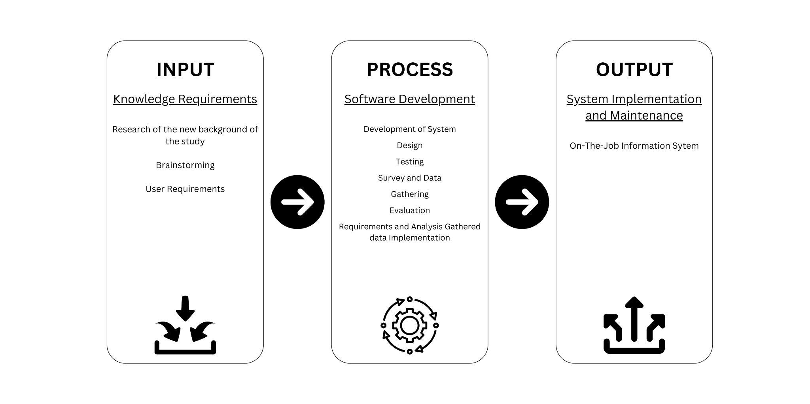

Figure 1. Input-Process-Output Diagram of the study

The system begins with comprehending the context of the investigation. The researchers will also compile all of the user's requirements. After learning the user's requirements, the system is then developed. The client was given the opportunity to offer suggestions, make comments, and make requests regarding the system's development and design. There are also suggestions and advice from the researcher. The researcher will begin coding the system in response to the client's requests once the requirements and design are at least partially finalized. The researcher will also construct the system's structure and add certain features. The researcher will go through a pre-defense where the system will be reviewed by a panelist for adjustments and improvements after extensive consultation with the adviser. The complete design and construction will then be checked for functionality. Following the testing, the researchers will launch a poll to collect information on the system's target users' experiences. The researchers will revise and polish the system in light of the findings. The leader of the university's internship program will then install the outcome, an On-The-Job Information Management System.

**1.2. TECHNICAL BACKGROUND**

**1.2.1. Equipment/ Hardware**

Previously PUP - Taguig Coordinator only uses Google Drive and prints physical copies of documents in monitoring and passing the requirements for OJT. Devices and equipment can be Desktop, Laptop, Cellular Phone and Printer. With the existing OJT Information Management System, devices are still the same.

**1.2.2. Software**

**Table 1.**

**Operating System**

| **SOFTWARE** |
| --- |
| Windows |
| Mac |
| Android |
| IOS |

Table 1. The table shows the available operating system that is used by PUP-Taguig. In the current OJT Information System, the software used is optimized for different operating systems. Windows users can access the system through web browsers compatible with Windows OS. Similarly, macOS users can access it through web browsers suitable for Mac computers. For Android and iOS users, they can access the system through web browsers on their respective devices. Since the system is a web-based application, it can be accessed directly through web URLs. By utilizing platform-specific software, the OJT Information Management System ensures seamless access and usage across various devices and operating systems, catering to a diverse user base.

**Table 2.**

**Application Software**

| **SOFTWARE** |
| --- |
| Chrome |
| Microsoft Word |

Table 2. Shows the current software application that the PUP-Taguig uses for monitoring OJT documentation and requirements. Chrome is used to access the cloud-based storage service called Google Drive to either upload or check the documentation for requirements and attendance of OJT students. And Microsoft Word is used to view the file of a student once downloaded.

**1.2.3. Peopleware/ Manpower**

**Table 3.**

**Use Roles and Responsibilities**

| **No.** | **User Roles** | **Responsibilities** |
| --- | --- | --- |
| 1 | OJT Coordinator/Super Admin | Responsible for approving and denial of the MOA (Memorandum of Agreement), creating professor accounts, and managing all the transactions on the system. |
| 2 | OJT Supervisor | Responsible for assigning tasks and responsibilities to the student. |
| 3 | OJT Professor | Responsible for approving and denial of the Recommendation Letters. |
| 4 | Student | Responsible for updating information and uploading relevant documents. |

Table 3. The table presents a comprehensive overview of the user roles and their corresponding responsibilities within a particular system or organization. It consists of four rows, each representing a distinct user role, and three columns providing specific information about each role. The OJT Coordinator/Admin is responsible for approving and denying the MOA (Memorandum of Agreement), creating professor accounts, and managing all the transactions on the system, while the OJT Adviser oversees the approval or denial of recommendation letters. Students are expected to update their information and upload relevant documents. Finally, the Super Admin holds the responsibility of approving and managing all transactions on the system.

**1.2.4. Network Infrastructure/Architecture**

The OJT Information Management System at Polytechnic University of the Philippines Taguig Branch, Google Drive (GDrive) is utilized as a cloud-based storage and collaboration platform. It allows secure storage, easy access, and real-time collaboration on OJT-related documents. With version control and permissions, it ensures data integrity and confidentiality. By leveraging Google Drive as part of its Network Infrastructure/Architecture, the OJT Information System can enhance efficiency, scalability, and cost-effectiveness, streamlining the management of OJT requirements and providing an efficient and user-friendly experience for all stakeholders involved in the program.

**1.2.5. Storage, Backup And Recovery Procedure**

Physical copies of the requirements and information about OJT and the students currently taking it are manually stored and kept up to date at the Polytechnic University of the Philippines Taguig Branch. Currently, they choose to maintain the information in this manner, but as time passes, this could lead to several problems and mistakes.

**1.2.6. Security Procedures**

The OJT Coordinator, the professor, and the site administrators carry out the security measures. Data is recorded on the database of the existing OJT Information Management System, and files are stored under the hosting site. When setting up the account, the student cannot use it unless the professor gives their approval, and the professor cannot have an account unless the OJT Coordinator adds them to the list of professors.

**1.2.7. Policies and Procedures**

**Table 4.**

**Policies and Procedures**

| **OJTIMS Procedure ID** | **Description** |
| --- | --- |
| **OJTIMS-P#1** | The student must sign up for an account and provide a valid email address. |
| **OJTIMS-P#2** | The student must choose the correct course or class he is officially enrolled in. |
| **OJTIMS-P#3** | The student must upload files with a minimum size of 25 MB (PDF only). |
| **OJTIMS-P#4** | The student must submit the documents on time. |

Table 4. The table presents a series of policies and procedures (OJTIMS-P#1 to OJTIMS-P#4) that are integral to the effective functioning of the OJTIMS. These policies and procedures outline specific requirements and guidelines that students must adhere to while using the system. Understanding and following these policies and procedures is crucial for maintaining data privacy, ensuring accurate course enrollment, and ensuring timely submission of documents.

**1.3. PROBLEM ANALYSIS**

**1.3.1. Fishbone Diagram**

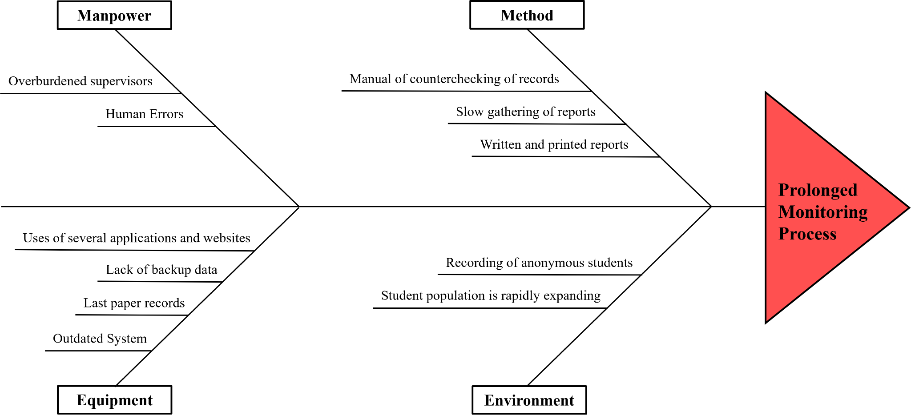

Figure 2. Fishbone Diagram

The selection of the Fishbone Diagram as a problem analysis tool stemmed from its capacity to facilitate a comprehensive understanding of the underlying causes of system issues. The systematic identification and categorization of factors within the dimensions of Manpower, Material, Environment, Method, and Prolonged Monitoring Process were effectively enabled by the diagram. This approach allowed for a holistic view of the challenges encountered by the On-the-Job Training Information System (OJTIS). By employing the Fishbone Diagram, we were able to highlight significant causes, such as an overburdened supervisor, outdated system, multiple application usage, recording of anonymous students, expanding student population, manual record counterchecking, undefined application methods, and prolonged monitoring process. The analysis of these causes to propose the development of targeted recommendations and solutions aimed at enhancing the OJTIS.

**1.3.2. Problem And Solution Statement**

The proponents have identified several issues with the project based on the past client interview and recommendations from previous researchers. One of the problems is the frequent printing of Memorandum of Agreement (MOA) due to students' poor formatting, typing, and signature mistakes. This leads to unnecessary paper consumption and delays in the process.

Another issue is the limited usage of various programs and websites by the advisers, which are meant to track the progress of the students. This limitation hampers effective monitoring and communication between the advisers and students. The OJT Coordinator also faces difficulties in manually informing the students about the completion and signing of the MOA. This manual process is time-consuming and prone to errors. The group suggests the need for permanent human monitoring to ensure accurate information and the daily effectiveness of the system.

In evaluating the system's acceptance, the group considers several factors such as functionality, performance, portability, compatibility, usability, and reliability. These factors are crucial in determining how well the system meets the expectations and requirements of its users. To improve the system, the group emphasizes the importance of enhancing the aesthetics of user interaction. The current system lacks visual appeal and fails to provide a satisfying user experience. Taking user feedback and comments from the pre-oral defense panelists into account, the system should be visually enhanced to create a more engaging and pleasant user interface.

Additionally, the system needs to improve its features for modification and modularity. This would allow the super admin to make necessary adjustments effectively without introducing errors or compromising the quality of the final result. Furthermore, the group suggests considering the addition of a feature that allows students to access their approved uploaded files and papers through the system. This feature would enhance convenience and streamline the process for both students and faculty members.

By addressing these identified issues and considering the factors of acceptance, the group aims to develop an enhanced system that not only resolves the current challenges but also provides a more efficient and user-friendly experience for all stakeholders involved.

**1.3.3. Problem-Requirements Matrix**

**Table 5.**

**Problem-Requirements Matrix**

| **Problem** | | **Requirements** | |
| --- | --- | --- | --- |
| 1. | **Manual counter checking of records** | R1 | Ability to develop a system for automatically categorizing documents based on their content, format, or metadata. |
| 2. | **Slow generating of reports** | R2    R3 | Ability to sort the data before generating a report. |
| Ability to generate a report instantly. |
| 3. | **Outdated User-Interfaces** | R4 | Ability to improve accessibility features to meet the requirements of all users, especially those with limitations. |
| 4. | **Losing track of student records** | R5    R6 | Ability to upload relevant information and documents to all users that is required by the system. |
| Ability to retrieve required information at any time and from any location. |

Table 5. The table identifies key issues within the system and outlines corresponding requirements for improvement. The matrix highlights problems such as manual record checking, slow report generation, outdated user interfaces, and losing track of student records. The associated requirements call for automated record checking, sorting of documents, accelerated report generation, enhanced user interfaces, improved accessibility features, secure storage of records, efficient document management, and separation of attendance records. Addressing these requirements is essential to optimize system performance, enhance user experience, and ensure efficient data management within the system.

**1.4. PURPOSE AND DESCRIPTION**

The development of an OJT Information System for managing apprenticeship in PUP – Taguig holds significant importance as it aims to improve the efficiency and effectiveness of OJT programs. By automating administrative tasks, providing access to training materials, enabling data-driven decision making, ensuring standardization, and promoting long-term organizational benefits, this system can enhance the OJT process, and contribute to the overall success of individuals and organizations. This holds immense usefulness for students, professors, advisers/coordinators, and future researchers.

* **Students** undergoing on-the-job training can utilize the system to efficiently record their daily attendance, deliverables, and pending tasks.
* **Professors** can monitor the performance of intern students participating in the on-the-job training program using this system.
* **Future Researchers**, the system's outcomes may prove valuable by aiding them in their studies and other academic pursuits to fulfill their course requirements.

**1.5. SPECIFIC OBJECTIVES**

The OJTIS is designed to replace the manual process of managing apprenticeship in PUP - Taguig for students, which uses paper and other time-consuming software programs. By automating outdated systems, the project intends to make things easier not only for the school but also for the students in this community. The existing system had been evaluated and several functionalities were considered to be improved. This study aims to determine and answer the following:

* Evaluate the current system implemented in the PUP - Taguig Branch and the systems from other schools or organizations in connection with OJT Information Management System and form specific, measurable, attainable, realistic and time bound solutions for existing problems.
* To make improvements to the existing system that will accelerate data processing. Maintaining an active website for sharing information.
* Enable students, adviser and OJT Coordinator to keep track of the daily attendance, deliverables, and unfinished tasks of students.
* Create summary and remarks reports for students.
* Improve the current interactive web application that users can use.
* Avoiding or reducing human error in data tracking and the amount of paperwork.
* Avoiding the creation of duplicate records, which may result in inaccurate records.
* Equip the system with the functionality of being able to view the contents of a specific file without downloading it first.
* Facilitate deadline function and other functionalities like certificate generator subject for approval of the adviser and OJT Coordinator.

**1.6. SCOPE AND LIMITATIONS**

The OJT Information System is designed to facilitate the monitoring of attendance, deliverables, and tasks assigned to student interns. The system caters to four types of users: admin (superuser and supervisors), professors, students, and super admin (responsible for approving student registration requests). The system consists of the following modules:

Security

* To log in, each user must enter the proper username and password.
* The system uses single-factor authentication.
* Passwords stored in the database will be encrypted using hash value.

Super Admin User Modules:

* Creation of professor accounts through user accounts.
* Maintenance of courses and file categories.
* Dashboard containing the number of professor, and student
* Update account information and change password under account management.
* Approval or denial of MOA (Memorandum of Agreement).
* Viewing of MOA and overall student files.
* Viewing a list of companies where students are undergoing OJT.

OJT Adviser User Modules:

* Dashboard containing the number of accounts of students pending approval, student, pending MOA and letter, approved letter and MOA and room approval.
* Update account information and change password under account management.
* Viewing of student information and approval of accounts.
* Approval or denial of Recommendation Letters.
* Approval or denial of MOA.
* Attachment of signature on the documents.
* Creating classes or rooms and assigning students based on their year and course.
* Create announcements under respective rooms.

Student User Modules:

* Joining of classes or rooms.
* Viewing of announcements based on the respective rooms,
* Updating personal information and changing passwords.
* Uploading relevant documents; specifically MOA and Recommendation Letter
* Providing information about the company that the student is undergoing OJT.

The system has limitations of the following modules:

* System Integration: The scope of the OJT Information System may not include integration with other existing systems or databases within the organization. It operates as a standalone system focused on OJT-related processes and may not interface with other university or enterprise systems.

**Chapter 2**

**REVIEW OF RELATED LITERATURE, STUDIES, SYSTEMS & SYNTHESIS**

This chapter presents various connected literary works, systems, and studies regarding OJT Information System, internet-based or any other linked services which are significant in the conduct of this research.

According to El Kadiri et al. (2016), information systems have experienced rapid growth and complexity, becoming crucial tools for storing and providing information. To enhance their efficiency, these systems need to be context-aware, adapting to the specific situations in which they are used. The challenge lies in providing users with relevant and important information amidst large volumes of data, while also ensuring their understanding of the context and its implications. The emergence of the social web and Web 2.0 has transformed information generation, interaction, and communication, requiring new intuitive interaction metaphors. Human-centric approaches are crucial, focusing on human-computer interaction, usability, and ergonomics.

According to the Indeed Editorial Team (2022), because students may lack prior experience in a particular profession or industry, their on-the-job training may be significantly more thorough. In other circumstances, students complete OJT during their academic teaching at a technical high school, college or university. For instance, some schools encourage or require students to conduct internships in which they acquire hands-on experience in their intended career path and earn school credits. Students may also take comprehensive on-the-job training in their first employment following graduation. Along with acquiring practical processes and skills for their role, students may also study general workplace norms in their first employment. This includes professional conventions including dress code, organizational hierarchy, productivity requirements, industry jargon and professional connections with coworkers.

On-the-job training, according to Garavan et al., entails assimilating and acquiring integrated clusters of values, skills, knowledge, and feelings that lead to fundamental changes in a worker's or a team's behaviors within a specific organizational context (Nakahara & Matsuo, 2013).

According to an article written by Bowers (2017) entitled "The Disadvantages of Manual Document Filing Processes", there are six disadvantages of manual document filing. The proponents discovered that this can be considered in the case of manual recording of data and file for the on-the-job training process. This is considered to make way for a possible improvement of the OJT system that is to be developed. Manual document filing takes up a lot of space and is prone to being misplaced and damaged. It could also be hard to make changes and find a specific file out of the stock pile of documents. And once it lacks security and can lead to higher cost due to it can consume a lot of paper and ink.

According to Cobb (2018), in this manner, processes involving paper documents that must be physically handed from one person to another can take too long. The workflow for a document is halted while a crucial individual is away from the office so they can approve or edit the record. Due to the possibility of loss or misplacement, manual document filing involves time and labor costs. Filing cabinets are quickly losing their usefulness in manual operations, which lack or have outmoded security measures. Additionally, paperwork cannot be easily edited and must be reproduced if a mistake is found during the document creation process. Additionally, paperwork cannot be easily edited and must be reproduced if a mistake is found during the document creation process.

According to the article entitled "Difference Between Manual And Automated System - Manual System vs Automated System" (2023), a manual system is comparable to a bookkeeping system where records are maintained by hand without the aid of a computer or any other automatic system. Transactions in this kind of system are recorded in journals, from which data is manually collected to create a set of financial statements. These systems are slower than computerized ones and have a higher rate of error. An automated system is a mix of hardware and software that is created and configured to operate automatically without requiring input from a human operator for each task.

Speed is the primary distinction between manual and electronic systems. Compared to manual procedures, accounting software processes data significantly faster and generates reports. Software programs perform calculations automatically, reducing errors and boosting productivity. Once data has been entered, a computerized system allows you to make reports by clicking a button. Using paper and a pencil for manual accounting is far less expensive than using a computerized system, which calls for hardware and software. The simplicity of backup for a computerized system is a third distinction between manual and computerized systems. For protection against a fire or other disaster, all transactions can be preserved and backed up.

According to the article entitled "7 Ways Technology Can Simplify Document Management" (2020), although the traditional filing approach has been a useful one for a very long time, the organizational landscape is now dynamic due to ongoing technology advancement. Therefore, firms must change to accommodate digital technology in order to maintain a competitive edge and meet growth-related expectations.

Especially for the construction industry, which is recognized for the large amounts of information required for functionality, using an automated document management system enables the proper processing of papers at every organizational level. As a result, businesses now have a superior method for processing papers for maximum internal and external functionality.

According to Yusuf (2020), think about turning your paper records into electronic ones by digitizing them. By simply clicking a button, you may quickly and conveniently share these, saving you time and work. You can quickly find all of your files with an electronic document management system. There are various techniques to recover deleted files, even in the worst-case scenario of someone erasing the document. Once more, this problem of information security can be quickly and simply overcome with an electronic document management system. Only those with the appropriate permissions can read or edit documents using an electronic document management system, which offers improved control over and access to documents. Anywhere in the world, you may get your documents updated or signed off electronically, making it simple to obtain and change them as needed.

The study entitled "OJT and Internship Management System" (2020) entailed that the goal of the researcher who developed the OJT and Internship Management System was to give students and employers a platform on which they could easily transact for internship opportunities. The user side and the admin side are the two sides of the system. The admin has access to all users and employers and can manage them. Users can include both employers (internship providers) and students (internship finders). The students will register or log in to their accounts so they can search for employers offering internships. Additionally, employers must log into their accounts in order to publish or edit any internship openings.

In order to increase productivity, knowledge, and workplace abilities, students who participate in an on-the-job training program are immersed in a professional environment connected to their studies. As was previously mentioned, on-the-job training programs are course requirements that give students the chance to learn on the job while applying the theories, principles, and ideas they have learned in class. They also help students develop the technical skills, abilities, and work-related attitudes necessary for successful job performance. Through programs that train students on the job, students can also make money. It is also advantageous for people to have work experience in fields linked to their academic degrees, since this opens up options for a variety of future career routes that will result in satisfying employment.

OJT programs aim to expose students to real-world work environments, a range of industries, and the management styles, industries, and methodologies of diverse vocations in terms of their various fields of study.

Establish criteria and regulations for performing OJTs, including the workload requirements in terms of hours, the hours worked, the learning objectives, the monitoring system, and consequences.

Define rules for various situations that may arise during the event OJT by defining the roles and duties of all participants involved.

Promote additional institutions to engage in the OJT program by using standardized, uniform approaches that are manageable and practical.

The government, as well as academics and commercial businesses, are focusing on defining clear targets, clear expectations, clear means of execution, verification of learning, and effective monitoring. Encourage and build strategic relationships between academia and industry.

Any company that wants to succeed now and in the future must be innovative. Keep personnel who are eager to improve themselves every day. The successful management and maintenance of a skilled workforce depend on the development and training of human capital. Training is one way to increase an organization's effectiveness. To use the right training methods, organizations need to be aware of training techniques and their effectiveness.

The training knowledge bases give the staff of the organization a new professional perspective that will help them in the future. In the long term, this results in higher production. The way a person views a situation is determined by the ring of protection they have created around it. A positive attitude affects an organization's output, whereas talents are the capacity to carry out certain duties.

Practicality with which employees can perform their duties: employees are more productive and self-assured. When employees learn what data will be needed, how the data will be collected, and how the data will be analyzed, their roles change.

There are comparable studies that were taken into consideration to compare the similarities and differences when generating the on-the-Job training information for the Polytechnic University of the Philippines, Taguig Branch, as a capstone project of the university's researchers.

Velasquez, J. E., and Vengco, J. V. (2014) of Lyceum-Batangas Campus designed a system that is intended to assist the school, specifically the practicum coordinator of on-the-Job training (OJT), with the goal of providing a quality education and fully equipped graduates. This system is a tool and a platform that assists the university in finding a solution to their OJT problem, wherein practicum coordinators struggle to keep track of trainees' performance and timely submission of requirements and reports, particularly when there are many trainees and distant locations. This mechanism was created to help students and coordinators solve the issue. Students will have their own user profiles with the opportunity to upload reports and photographs taken on-site. They can submit from anywhere because the software is web-based and accessible online. Coordinators can also create their own accounts so they can access, download, and verify the criteria that students have provided. This will make the monitoring process easier for them. In order to know and be updated on the reports and requirements supplied by the students, they can also create real-time data from the system.

Another study exists and proves that the OJT system is not impossible to do and can help a lot. The university was from the Nueva Ecija University of Science and Technology in Cabanatuan City, developed by Oliveros, A. G. G. (2022). This system aims to help both students and coordinators have a trouble-free OJT procedure. As with the first study or system mentioned above, this study also helped students save time, money, and effort they would have spent just by submitting their weekly reports face-to-face at the university, and coordinators, as this system will serve as a tool for keeping and monitoring the weekly reports submitted by the students by collecting the files online. However, this system will level up the game and integrate the system by adding SMS and online helpdesk features that will enable the system to immediately send important information and announcements to OJT students. It can also serve as a wall for the students where they can freely post their concerns and queries regarding OJT. And since it has help desk functionality, communication between the OJT students and coordinators will be easy and possible.

Pablo II and R. D. A. (2016) developed the system at Mabalacat City College. The challenge with OJT, like the other two universities, is the manual inspection, monitoring, and keeping of submitted reports and requirements by students to the university. Because everything is done manually, OJT coordinators and counselors are having difficulty balancing their roles as practicum advisers and college instructors. The researcher conducted an interview with an OJT adviser and discovered that due to the large number of students and the manual process of the internship, particularly the submission of reports and requirements, documents were sometimes submitted, but the date submitted was frequently not recorded. There were no direct notifications from industry partners to the OJT Coordinator for proper monitoring of OJT students while they were on duty, and students concerned were addressed. Late students may only be addressed. With the previous issue observed by OJT coordinators and advisers in mind, the researcher created an online system that intends to enable OJT advisers, industry partners, and OJT students with quick and dependable access to the information and files required for OJT by both students and coordinators. The system also serves as a tool for quick submission of student requirements and reports, and for the coordinators, everything from student OJT status checking, announcement postings, job postings, a basic resume profile data bank, and OJT certificate generation was designed to help them maximize their time and effort, work efficiently, and have a trouble-free OJT at the university.

Marco Jr. N. Del Rosario and Ronnel A. Dela Cruz (2022) developed the system at Mabalacat City College at Laguna State Polytechnic University. IPMIS is a web-based system that supports the internship program processes at Laguna State Polytechnic University. It includes processes from the beginning up to the end of the program. The system is divided into four modules, corresponding to the users of the system. The student's module allows the students to process pre-training requirements (Recommendation letter, waiver, and contract), manage their personal account, submit their company profile for approval, create their daily journal, and monitor their progress through the automatic computation of the total number of hours rendered in training. Moreover, the system allows the intern’s supervisor to rate their performance using the evaluation instrument available in the system. On the other hand, in the coordinator module, the system grants the coordinator the capability to approve the company where the student intends to conduct their training, monitor the number of hours rendered by the students, and view the performance rating given by the evaluator or intern’s supervisor. Lastly, the system has the administrator module, where user management, user logs, and creating database backups can be seen.

This system is a foreign-based study created by Ibri College of Technology of Oman and was developed by Evangelista and Al Wahshi (n d), as cited by Pablo II, R. D. A. (2016) in his study entitled, Organizing the Practicum Scheme of Mabalacat City College through an On-the-Job Training Monitoring and Assessment System". The system aims to check and keep track of graduates' personal and professional information. The website's services include online directories, member search, message boards, resume storage, and more. Using this system, current students at the university can have contact with their alumni to get internship opportunities and professional positions outside the university. This serves as a database and will allow the users to: receive regular updates on programs, events, and employment opportunities at the college; expand opportunities for career placement; and upload a CV or resume. Data regarding internships and job opportunities will basically all come from the alumni registered and included in the system.

Afiza Nur et al. (2022) Industrial Training is a compulsory course that must be taken by Electrical Engineering students who follow a five-semester program at Universiti Teknologi MARA (UiTM). A Web-Based System of Internship Management has been developed to computerize the whole process of practical training and make it accessible online. The portal allows internship eligibility checking, registration, visit scheduling, and monitoring of the industrial internship program at UiTM. This system gives an advantage to the students’ education process as they can check their application status online. During their spare time, they can focus more on their lesson activities instead of checking their application status at the coordinator’s office. The System Development Life Cycle (SDLC) is used in the development of this system. This system emphasizes online pre-registration by the student and online evaluation by the industrial supervisor and faculty. This online system, which is integrated with a database system, can help the coordinator manage and monitor the application process that was completed by the students. This system has special features as it introduces the pre-registration stage for the student to register information about the host organization that they would like to apply to for an internship program. The system also has an online system assessment for industrial supervisors to evaluate the trainee. The system can be easily used to aid the process of an internship program. Thus, in general, this system will benefit the students as well as every party involved in this internship program.

Agus Johana et al. (2018) of Bandung, Indonesia, developed the system entitled "E-Portfolio Web-Based for Students’ Internship Program Activities". An internship program is an important part of the vocational education process to improve the quality of competent graduates. The complete work documentation process in the electronic portfolio (e-Portfolio) platform will facilitate students in reporting the results of their work to both their university and industry supervisors. The purpose of this research is to create a more easily accessible e-Portfolio that is appropriate for students and supervisors’ needs in documenting their work and monitoring processes. The method used in this research is fundamental research. This research is focused on the implementation of internship e-Portfolio features by demonstrating them to students who have conducted internship programs. The result of this research is to create a proper web-based e-Portfolio that can be used to facilitate students in documenting the results of their work and aid supervisors in monitoring the process during internships.

Hussain et al. (2106) The use of information technology in people’s lives is rapidly becoming more important every day. The development and use of the web page or portal is also part of this information technology and is becoming more popular among people because it makes it easier for people to access information and services all over the world. Therefore, this system will discuss the details of the development of the USM Internship and Career Portal. This portal was developed in order to overcome the problems and limitations that arise when using the manual system. The current system, which is not efficient and effective in the workflow, is no longer reliable to use. The proposed system is divided into seven modules: the profile module, Internship module, Career module, Forum module, Evaluation module, Report module, and Logbook module.

**Synthesis**

The articles and studies included in this study are highly beneficial for creating the system. The old methods of handling document filing have a number of drawbacks, including the fact that they are time-consuming, take up a lot of room, are prone to damage and loss, and many more. It is claimed that this may be fixed by utilizing technology to build a suitable system. Since it strives to increase the effectiveness and efficiency of OJT programs, the OJT Information System, which is used to manage apprenticeship at PUP-Taguig, is of utmost significance. This system can improve the OJT process and contribute to the general success of people and organizations by automating administrative tasks, providing access to training materials, enabling data-driven decision making, ensuring standardization, and promoting long-term organizational benefits. The characteristics of the current OJT system allow for effective document management and allow users to receive notifications via email. The articles and studies will help the proponents understand the precise scenario and the issues encountered, and they will then work to enhance the current system.

**Chapter 3**

**METHODOLOGY**

**3.1 REQUIREMENTS ANALYSIS**

3.1.1 REQUIREMENTS – FEATURES MATRIX

|  | R1 | R2 | | R3 | R4 | R5 | R6 |
| --- | --- | --- | --- | --- | --- | --- | --- |
| **Web-Based Application** | ✔ | ✔ | | ✔ | ✔ | ✔ | ✔ |
| **Manage Users** |  |  | |  | ✔ | ✔ |  |
| **Centralized Storage** | ✔ | ✔ | | ✔ |  |  | ✔ |
| **Record Student and Information and Documents** |  | ✔ | | ✔ |  |  | ✔ |
| **Upadate / Delate** |  |  | | ✔ | ✔ |  | ✔ |
| **Provide Alerts and Nofication** |  |  | | ✔ |  |  | ✔ |
| **Generate Data into Dashboard** |  |  | | ✔ | ✔ |  | ✔ |
| **Security of Data / Information** | ✔ | ✔ | | ✔ | ✔ |  | ✔ |
| **Generate data into graphs** |  |  | | ✔ | ✔ |  | ✔ |
|  |  |  |  |  |  |  |  |

*Table 6.* Requirements – Features Matrix

3.1.2 USE CASE DIAGRAM

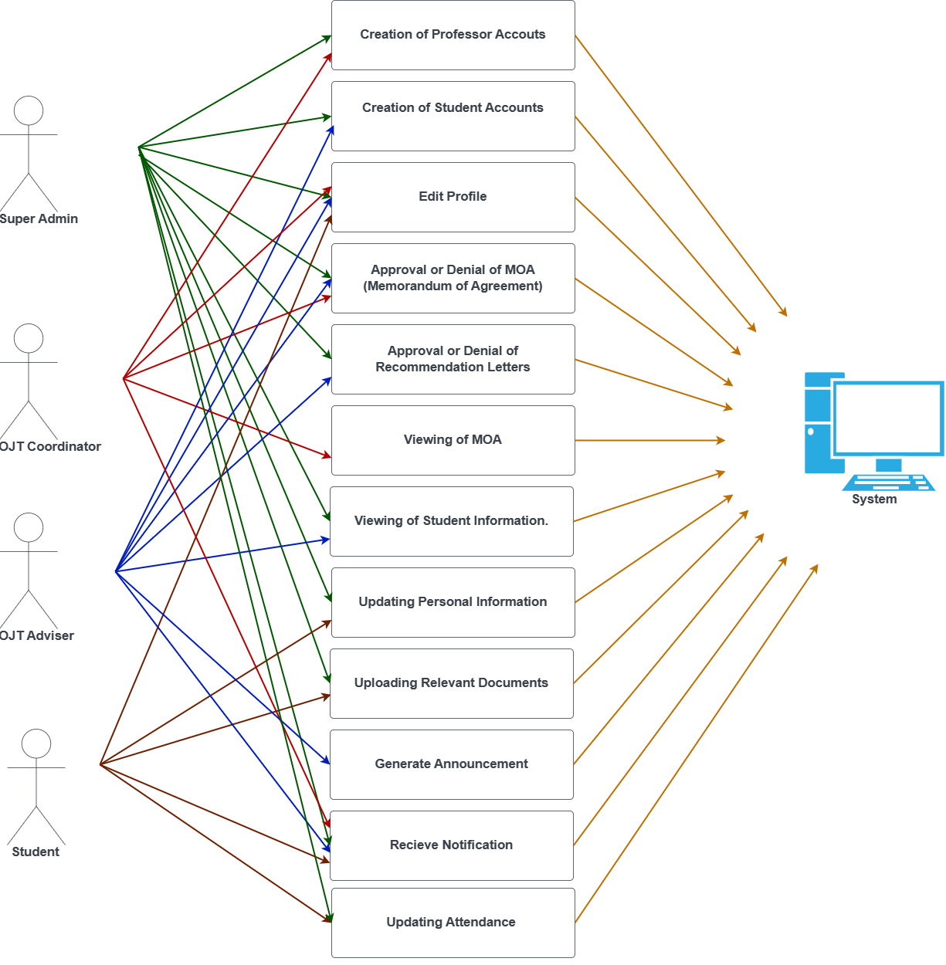

*Figure 3. System Use Case Diagram*

Detailed Use Case Diagram

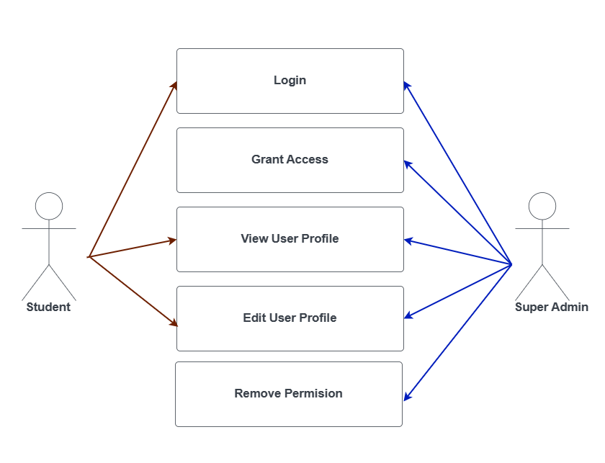

*Figure 4.1. Detailed Use Case Diagram - Account Management*

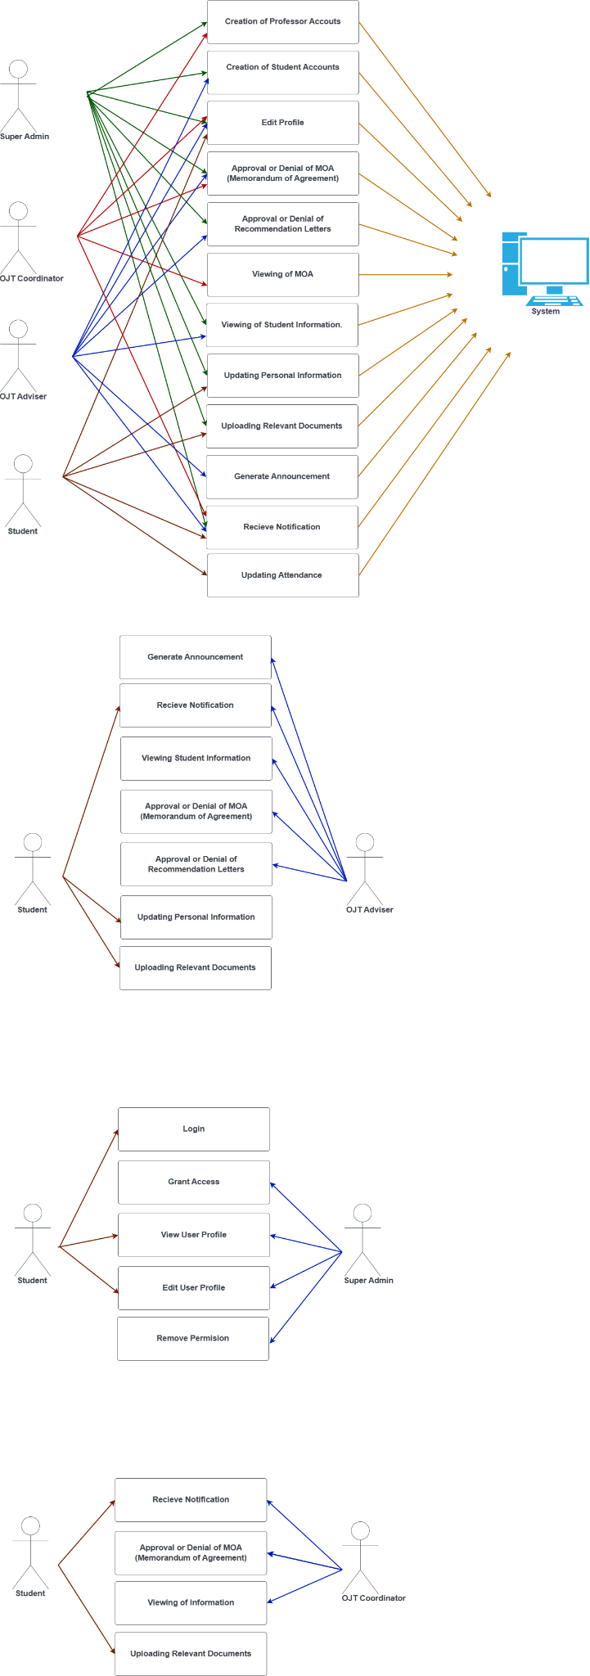

*Figure 4.2. Detailed Use Case Diagram - Document and Information Management*



*Figure 4.3. Detailed Use Case Diagram - Generate Announcement*

3.1.3 USE CASE REPORT

| **Use Case ID:** | UC-1 |
| --- | --- |
| **Use Case Name:** | User Accounts |

| **Actor/User:** | Superadmin |
| --- | --- |
| **Description:** | Provides each user their roles and the capabilities of what they can perform within the system |
| **Trigger:** | Upon entering the credentials of Superadmin account and clicking the “User Accounts” on the sidebar navigation |
| **Pre-Conditions:** | 1. A pre-existing account for the Superadmin, who has full access to the database and system.  2. The ability to grant roles to other system users belongs to the Superadmin.  3. Based on their position and what they will do for the system, roles must be assigned. |
| **Post Conditions:** | 1. Users may receive roles from the Superadmin.  2. The system's users must be able to see their roles. |
| **Normal Flow:** | 1. The Superadmin logs in and goes to the "User Accounts" portion of the system.  2. The program shows a list of current users.  3. A user is added to the list and given a role by the Superadmin.  4. The system accepts email input and displays a list of open roles.  5. Based on the user's position and duties, the Superadmin chooses the suitable role for them.  6. The system records the user's allocated role.  7. The user may now see the role that has been given to them in the system. |
| **Alternative Flow:** | None |
| **Exceptions:** | 1. The process ends and an error notice is displayed if the Superadmin encounters a problem or is unable to access the "User Accounts" section.  2. If the Superadmin enters an invalid email format during the role assignment process, an error message is given and the Superadmin is unable to select an unavailable position. |
| **Includes:** | None |
| **Priority** | High |
| **Frequency of Use:** | Every time the Superadmin will add another user to the system |
| **Assumptions:** | The user management functionality of the system is correctly integrated and implemented. |
| **Notes and Assumptions:** | The system's Superadmin has access to all of the data. |

*Table 7. UCR -User Accounts Table*

| **Use Case ID:** | UC-2 |
| --- | --- |
| **Use Case Name:** | Maintenance (Courses and File Categories) |

| **Actor/User:** | Superadmin |
| --- | --- |
| **Description:** | Manage courses and file categories |
| **Trigger:** | Upon clicking the “Maintenance”, “Courses” and “File Categories” will show on the sidebar navigation |
| **Pre-Conditions:** | 1. The Superadmin account must be logged in.  2. The ability to manage courses allowed and File Categories should be handled by the Superadmin. |
| **Post Conditions:** | 1. Users may only upload files and select courses allowed by the Superadmin.  2. The system's users must be able to view allowed courses and file categories.. |
| **Normal Flow:** | 1. The Superadmin logs in and goes to the "Maintenance" portion of the system and selects either “Courses” or “File Categories”.  2. The program shows a list of current courses and file categories allowed.  3. A course or file category is added to the list and allowed to be selected or uploaded by the Superadmin.  4. The system accepts course or category input.  5. The system records the course and file category allowed.  6. The user may now see the course and file categories that have been allowed in the system. |
| **Alternative Flow:** | None |
| **Exceptions:** | 1. Error notice is displayed if the Superadmin encounters a problem or is unable to access the "Maintenance" section. |
| **Includes:** | None |
| **Priority** | High |
| **Frequency of Use:** | Every time the Superadmin needs to add courses or file categories to the system |
| **Assumptions:** | The courses and file categories management functionality of the system is correctly processed. |
| **Notes and Assumptions:** | The system's Superadmin has access to all of the data. |

*Table 8. UCR - Maintenance Table*

| **Use Case ID:** | UC-3 |
| --- | --- |
| **Use Case Name:** | Authentication and Validation Module |

| **Actor/User:** | Every user of the system |
| --- | --- |
| **Description:** | To access the system, the user must log in. |
| **Trigger:** | By clicking the login button after entering your email and password. |
| **Pre-Conditions:** | 1. The user has to be signed up.  2. Before using the system, the user must enter the correct information. |
| **Post Conditions:** | 1. The system must be accessible to the user.  2. Depending on their function, the user must be able to use the system. |
| **Normal Flow:** | 1. The user enters their password and email.  2. The entered credentials are checked by the system.  3. The user is given access to the system if the credentials are legitimate. |
| **Alternative Flow:** | None |
| **Exceptions:** | 1. If the user enters the incorrect credentials, an error message stating that the entered credentials was incorrect must be displayed.  2. The user must be registered if they receive an error message stating that the system cannot recognize them. |
| **Includes:** | None |
| **Priority** | High |
| **Frequency of Use:** | Anytime a user needs system access. |
| **Assumptions:** | The login procedure adheres to accepted security procedures to verify the user's legitimacy. |
| **Notes and Assumptions:** | None |

*Table 9. UCR - Authentication and Validation Module*

| **Use Case ID:** | UC-4 |
| --- | --- |
| **Use Case Name:** | Account Management |

| **Actor/User:** | OJT Coordinator, Adviser and Student |
| --- | --- |
| **Description:** | The OJT coordinator, adviser and students can update personal information and change passwords. |
| **Trigger:** | When you click the “Account” on the Sidebar Navigation you can choose either “Account Information” or “Change Password”. |
| **Pre-Conditions:** | 1. The user must login to their account.  2. The user must be aware of the existing password and information on the account. |
| **Post Conditions:** | The user can either update personal information and or change the password of the account. |
| **Normal Flow:** | 1. The user will select the “Account” on the sidebar navigation and will click “Account Information” for updating personal information and “Change Password” for changing the password of the account.  2. Upon clicking “Account Information” the user can edit the first, middle and last name, address, suffix, email address, etc. And by selecting update the information will be successfully updated.  3. Upon clicking “Change Password”, the user must enter the existing password, the passcode that the operator wants to change it to and confirm it. By selecting change, the password will be updated. |
| **Alternative Flow:** | N/A |
| **Exceptions:** | 1. If the user’s existing password doesn’t match the entered passcode and if the new password doesn’t match the confirmed one, it will display an error if the current password does not match.  2. If the length of the new password is less than eight characters the changes will not occur. |
| **Includes:** | UC-4 |
| **Priority** | High |
| **Frequency of Use:** | Whenever the user wants to update information stored in the account. |
| **Assumptions:** | The system maintains a database of users’ information. |
| **Notes and Assumptions:** | N/A |

*Table 10. UCR - Account Management*

| **Use Case ID:** | UC-5 |
| --- | --- |
| **Use Case Name:** | Memorandum of Agreement and Other Files Management |

| **Actor/User:** | OJT Coordinator, Adviser and Student |
| --- | --- |
| **Description:** | This is where the Memorandum of Agreement and other files are stored, approved and denied. |
| **Trigger:** | When you click the files, overall student files and memorandum of agreement on the Sidebar Navigation. |
| **Pre-Conditions:** | 1. The OJT Coordinator and Adviser can view the files uploaded by the students.  2. The students must be able to upload files under their individual account. |
| **Post Conditions:** | 1. The Adviser will approve and provide signatures for the files or deny especially the memorandum of agreement and it will then be raised to the OJT Coordinator that will review and provide either an approval or a denial.  2. The students will be able to view if the files are approved or denied through their accounts and will be uploading revised versions of files if necessary. |
| **Normal Flow:** | 1. The student will click “Files” and upload needed documents by clicking “Choose File” and “Upload”.  2. It will be viewed by the Adviser through “Overall Students’ Files” and it will be approved by clicking the checkbox on the side of the file and clicking “Update”.  3. The OJT Coordinator can download the file by clicking “Overall Students’ Files” and clicking “Download” beside the file that needs to be downloaded.  4. The student can see if the document was approved or not through checking the “Status” part of the “Files” page. |
| **Alternative Flow:** | N/A |
| **Exceptions:** | The system generates an error notice and asks the administrator to try again later if there are technical problems or difficulties. |
| **Includes:** | UC-5 |
| **Priority** | High |
| **Frequency of Use:** | Every time a document needs approval. |
| **Assumptions:** | 1. The system maintains a database of users’ information.  2. The file being uploaded is allowed by the system and its size is allowable as well. |
| **Notes and Assumptions:** | The function that the user can perform will be based on the role in the system. |

*Table 11. UCR - Memorandum of Agreement and Other Files Management*

| **Use Case ID:** | UC-6 |
| --- | --- |
| **Use Case Name:** | Announcement Module |

| **Actor/User:** | Adviser and Student |
| --- | --- |
| **Description:** | The adviser will create an announcement that needs to be received by the students |
| **Trigger:** | Adviser will click the “Announcements” on the sidebar navigation    The student will also be able to view the announcements under “Announcements”. |
| **Pre-Conditions:** | To access the system, the adviser must log in with their credentials.  An announcement can be added and deleted by the adviser.  The student must provide their login information to access the system. |
| **Post Conditions:** | The announcement given by the administrator is viewable by the students. |
| **Normal Flow:** | 1. The adviser logs into the platform.  2. The advisor goes to the part where announcements are created.  3. The advisor inserts the announcement's pertinent information, including the announcement's title, room name, message, and any required attachments.  4. The advisor approves the announcement's settings before sending it for distribution.  5. The announcement gets distributed by the system to every student in the chosen room. |
| **Alternative Flow:** | N/A |
| **Exceptions:** | There must be a prompt informing you to try again later if there is an error. |
| **Includes:** | None |
| **Priority** | Medium |
| **Frequency of Use:** | Whenever the advisor feels it is necessary to make an announcement. |
| **Assumptions:** | The advisor has the necessary access rights and permissions to create and distribute announcements. |
| **Notes and Assumptions:** | To prevent misunderstandings, announcements should be accurate and proofread. |

*Table 12. UCR - Announcement Module*

| **Use Case ID:** | UC-7 |
| --- | --- |
| **Use Case Name:** | Dashboard |

| **Actor/User:** | Adviser and OJT Coordinator |
| --- | --- |
| **Description:** | The system generates an overview report of the tasks and number of students who have access on the system. |
| **Trigger:** | The "Dashboard" link in the sidebar menu is clicked by the administrator. |
| **Pre-Conditions:** | The person in charge has the rights necessary to access the dashboard and is logged into the system. |
| **Post Conditions:** | 1. Based on the given information a visualization is produced.  2. The dashboard displays the created data.  3. The user in charge can explore and view tasks on the dashboard. |
| **Normal Flow:** | 1. The system operator logs in.  2. The user in charge uses the sidebar menu to navigate.  3. The "Dashboard" option is chosen by the administrator.  4. The system retrieves the information needed to create the visual representation.  5. The tasks and number of students are viewed by the person in charge.  6. Based on the given parameters, the system processes the data and generates a visualization.  7. The dashboard displays the created list. |
| **Alternative Flow:** | N/A |
| **Exceptions:** | In the event of a technical issue, the system generates an error notice and requests that the administrator try again later. |
| **Includes:** | None |
| **Priority** | High |
| **Frequency of Use:** | The administrator can access the dashboard whenever they wish to see the data on a diagram. |
| **Assumptions:** | 1. The data required to create the graph can be retrieved and processed by the system.  2. The administrator is acquainted with the information and specifications needed to produce the graph.  3. The system has a dashboard feature that is usable and effectively integrated. |
| **Notes and Assumptions:** | None |

*Table 13. UCR - Dashboard*

**3.2 DESIGN SPECIFICATIONS**

3.2.1 ACTIVITY DIAGRAM

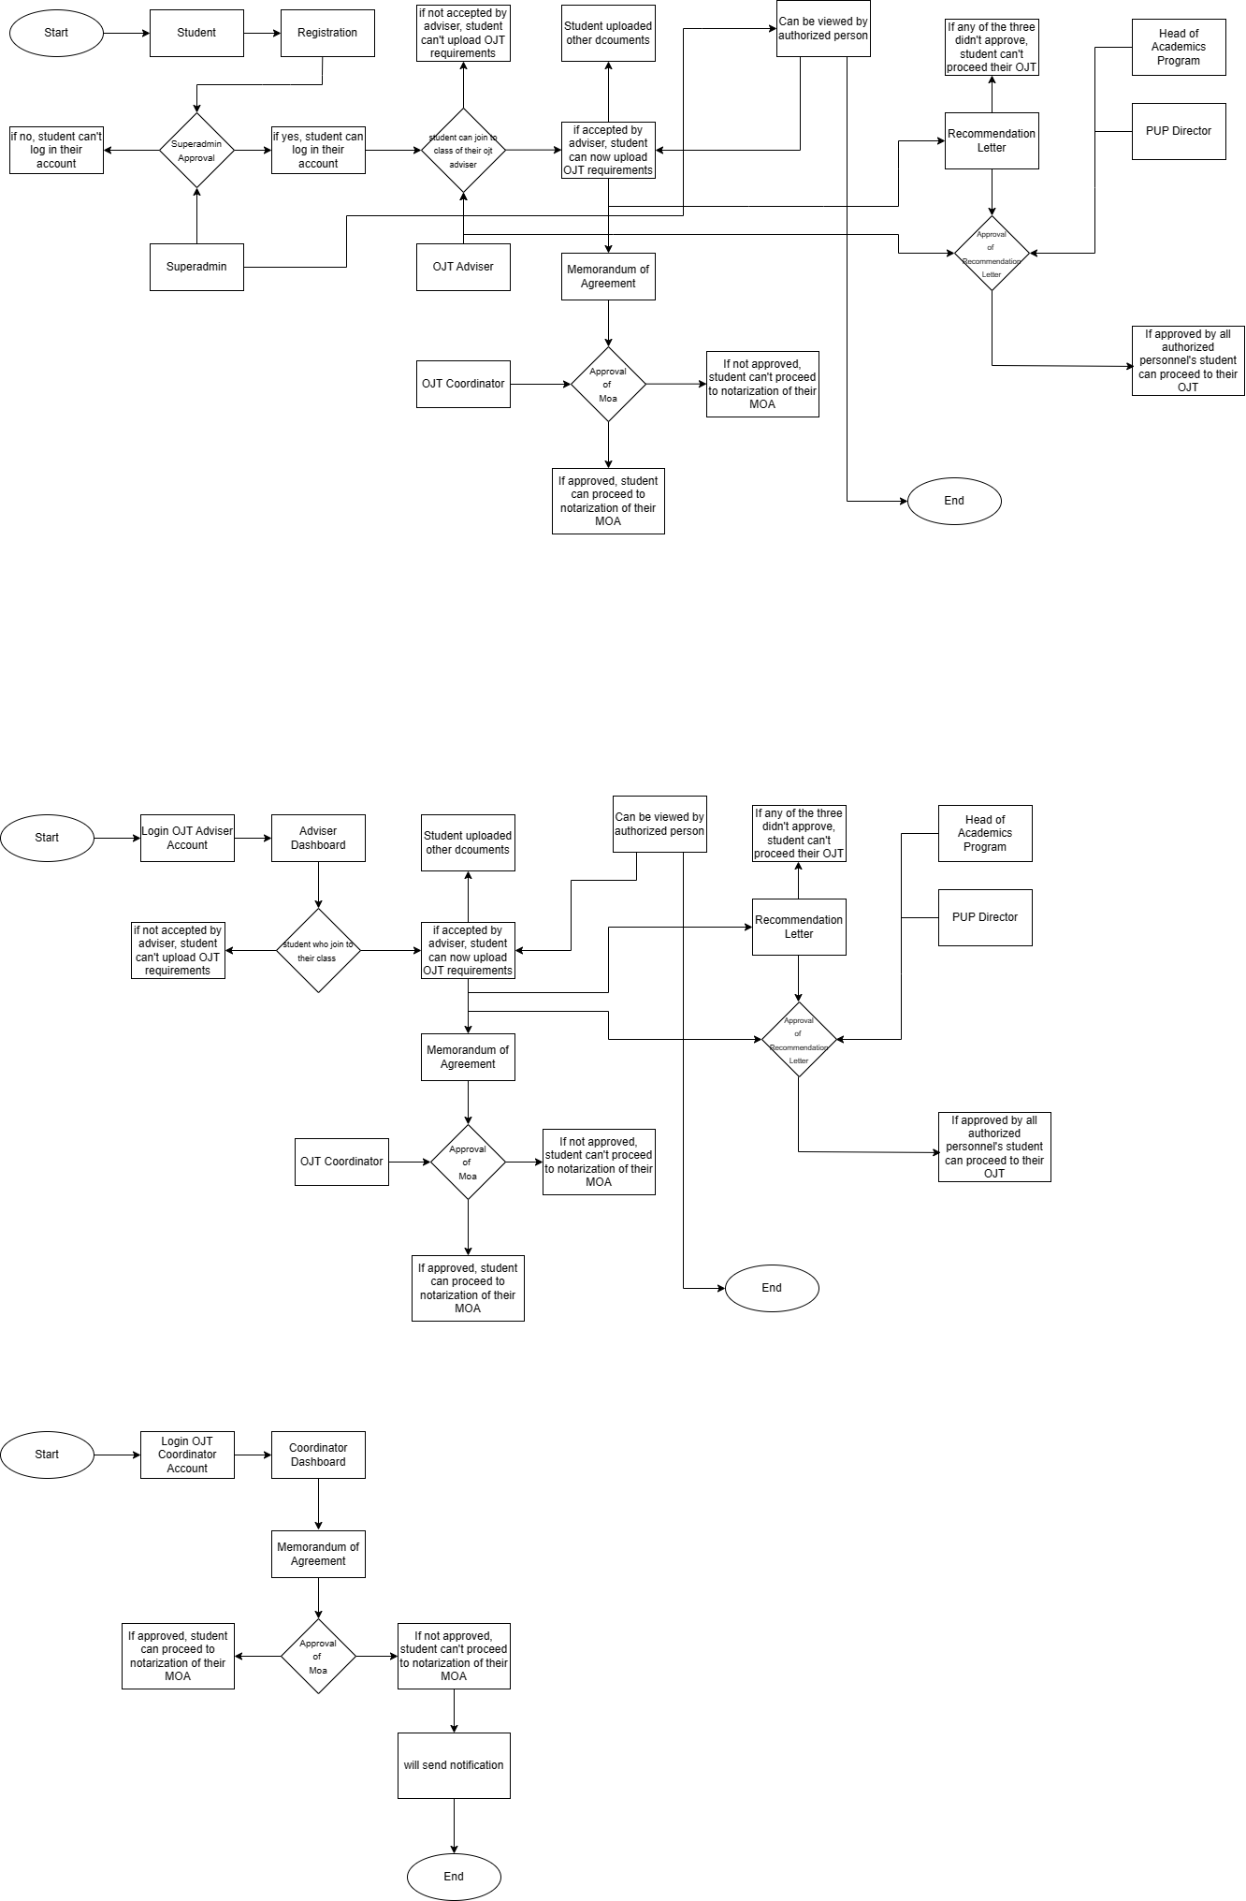

*Figure 5. Activity Student*



*Figure 6. Activity OJT Adviser*



*Figure 7. Activity OJT Coordinator*

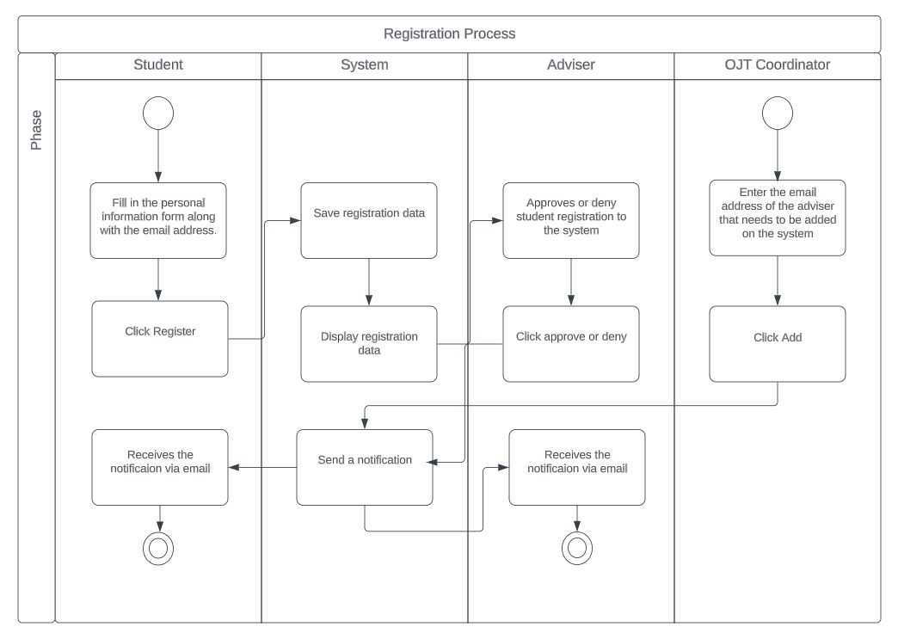

*Figure 8. Registration and Inclusion of Adviser and Students*

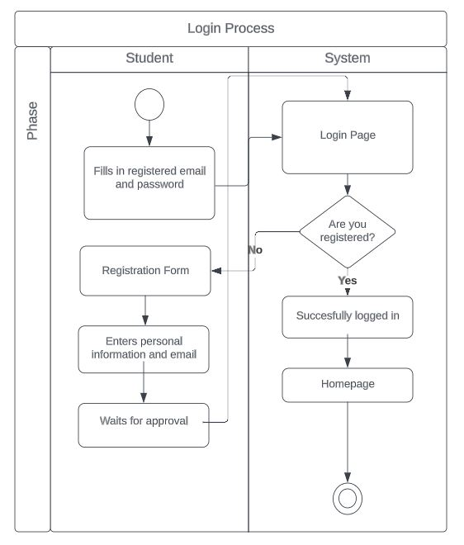

*Figure 9. Process for Identification and Verification*

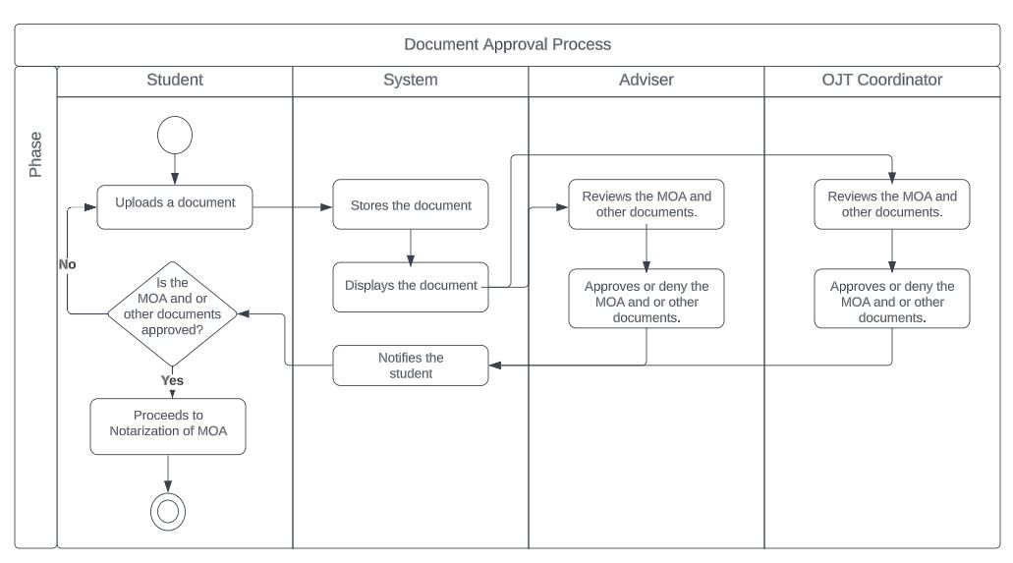

*Figure 10. Document Approval Process*

**REFERENCES**

Halili K. (n.d.). School To Work Transition In On-The Job Training Facilitated By OJT Monitoring, MFI Technological Institute Retrieved from eprints.uny.ac.id

Information System Theory (n d). Anandavala.info website. Retrieved from: https://www.anandavala.info/TASTMOTNOR/Information%20System%20Theory.html

Pablo II, R. D. A. Organizing Practicum Scheme of Mabalacat City College through On-the-Job Training Monitoring and Assessment System.

Richards, E. (2023). Advantages of On-The-Job Training for Students Retrieved from https://trainingmag.com/advantages-of-on-the-job-training-for-students/#:~:text=OJT%20gives%20students%20hands%2Don,closer%20insight%20into%20the%20industry.

Indeed Editorial Team.(2022). What Is On-the-Job Training? Retrieved from <https://www.indeed.com/career-advice/starting-new-job/what-is-on-the-job-training>

Bowers, K. (2017). The Disadvantages of Manual Document Filing Processes. MES. Retrieved from <https://blog.mesltd.ca/the-disadvantages-of-manual-document-filing-processes>

Difference Between Manual And Automated System - Manual System vs Automated System. (2023, May 6). PadaKuu. <https://padakuu.com/difference-between-manual-and-automated-system-manual-system-vs-automated-system-1-article>

El Kadiri, S., Grabot, B., Thoben, K.-D., Hribernik, K., Emmanouilidis, C., von Cieminski, G., & Kiritsis, D. (2016). Current trends on ICT technologies for enterprise information systems. Computers in Industry, 79, 14–33. doi:10.1016/j.compind.2015.06.008

10.1016/j.compind.2015.06.008. Retrieved from <https://sci-hub.se/https://doi.org/10.1016/j.compind.2015.06.008>

Bouchrika, I. (2023). On the Job Training: OJT Meaning, Advantages & Types. Research.com. Retrieved from <https://research.com/careers/on-the-job-training>

Cobb, D. (2018). 6 Problems Caused by Inefficient Document Management. Sumnerone. Retrieved from <https://www.sumnerone.com/blog/naming-the-problem-6-issues-caused-by-inefficient-document-management>

7 Ways Technology Can Simplify Document Management. (2020). Filecloud. <https://www.filecloud.com/blog/2020/06/7-ways-technology-can-simplify-document-management/>

Yusuf, L. (2022). 6 Document Management Obstacles & Their Solutions. Linkedin. Retrieved from <https://www.linkedin.com/pulse/6-document-management-obstacles-solutions-yusuf-pmp-itil-sfpc/>

OJT and Internship Management System. (2020). iNetTutor.com. Retrieved from <https://www.inettutor.com/source-code/ojt-and-internship-management-system/>