**Yoan Marvic J. Lagan BSIT 4-1**

**Screenshots of Output:**

* **Click button**

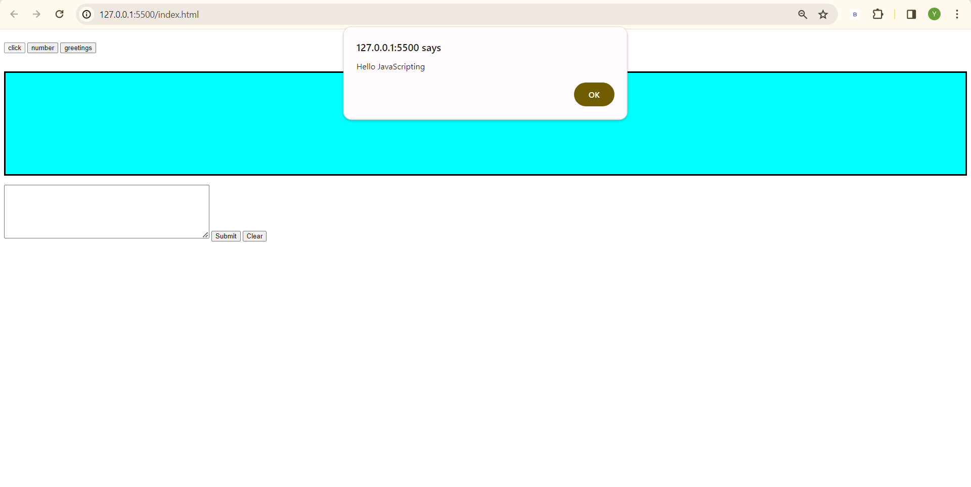

* **Number button**

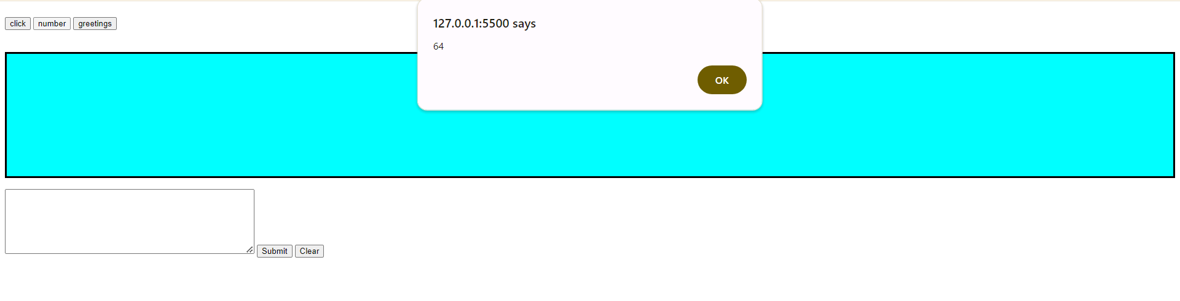

* **Greetings button**

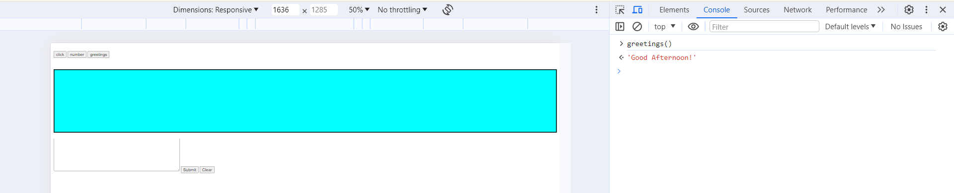

* **Submit button**

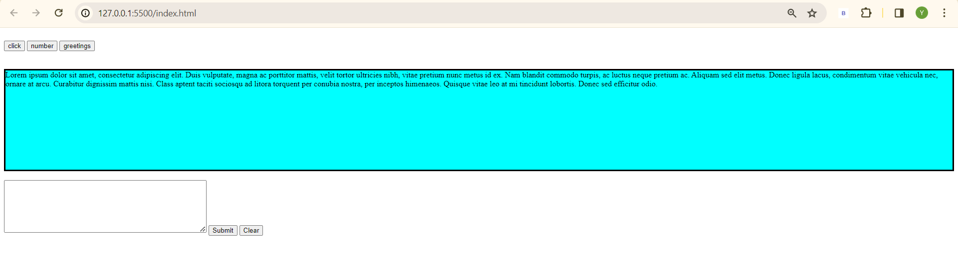

* **Clear button**

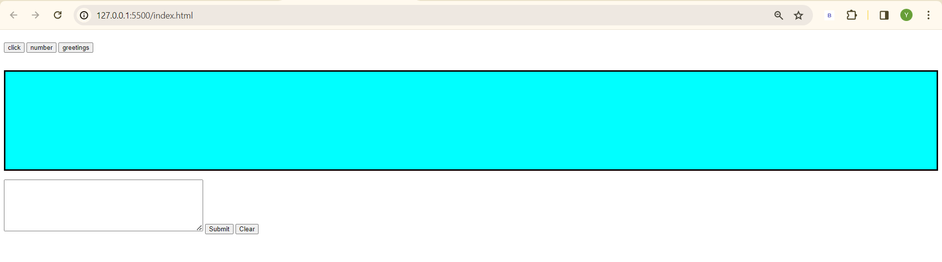

* **Count meter**

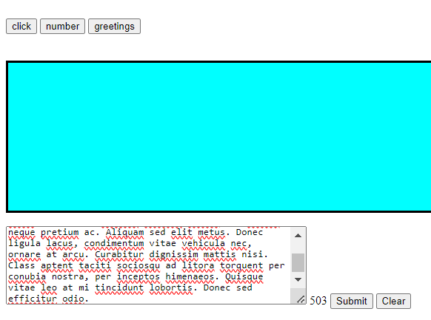

**Source code:**

* **Index.html**

<!DOCTYPE html>

<html lang="en">

<head>

    <meta charset="UTF-8">

    <meta name="viewport" content="width=device-width, initial-scale=1.0">

    <title>ITE3:02032024</title>

    <script type="text/javascript" src="js/jquery-3.6.1.min.js"></script>

    <script type="text/javascript" src="js/common.js"></script>

</head>

<body>

    <!-- <script type="text/javascript">

        // alert("Hello JavaScripting");

        // console.log("Hello JavaScripting"); inline javascript

    </script> -->

    <br>

    <form>

        <input type="button" value="click" onclick="msg()"/>

        <input type="button" value="number" onclick="getcube(4)"/>

        <input type="button" value="greetings" onclick="greetings()"/>

        <input type="button" value="query disappear" id="query" />

    </form>

    <br>

    <br>

    <div id="message" style="background-color:aqua; border: solid black; height: 200px;"></div>

    <br>

    <textarea id="comment" style="height: 100px; width: 400px;"></textarea>

    <span id="count"></span>

    <!-- var a = 1 + 1 + "string" = 2string

    var a = "string" + 1 + 1 = string11 -->

    <input type="button" value="Submit" id="submit" />

    <input type="button" value="Clear" id="clear" />

</body>

</html>

<!-- <script type="text/javascript" src="../common.js"></script> case to case baseis if the script needs to load the html/css code first-->

* **Common.js**

$(document).ready(function() {

    //jQuery methods go here...

    $("#query").hide();

    $("#submit").click(function() {

        var msg=$("#comment").val();

        var html = "<div>" + msg + "<div>"

        // console.log(msg);

        $("#message").append(html);

        $("#comment").val("");

    });

    $("#clear").click(function() {

        $("#message").text("");

    });

    // $("#count").click(function() {

        $("#comment").keyup(function() { //onchange

            var count = $(this).val().length;

            $("#count").text(count);

        });

    // });

});

function msg(){

    alert("Hello JavaScripting");

}

function getcube(number){

    alert(number*number*number);

}

function greetings(){

    return "Good Afternoon!";

    // alert("Good Afternoon!");

}

function ajax1 (){

    $.ajax({

        type: "GET",

        url: "https://dummyjson.com/users",

        success: function(result){

            console.log(result);

        }, error: function(error){

        }

    });

}