**Database Configuration**

Step 1: Go to <http://localhost/phpmyadmin> and create a database that named “questify”.

Step 2: After you create a database go to the provided folder you can see inside there is questify.sql, import that to mysql database that have name questify.

Tips: you can really change the database name, but the default name of the database in environment of the backend is named to “questify” if you wanted to change it go to .env inside of questify-backend.

**Frontend Questify (./Questify/questify-frontend)**

Make sure you know what is your IP Address, but if you don’t know your IP address just run this command to your command promt, “/ipconfig”. Since you’re Henry Ong I will assume that you know it.

**Configuration**

Step 1: Go to ./Questify/questify-frontend/vite.config.ts

Step 2: inside the vite.config.ts you can see the picture below.

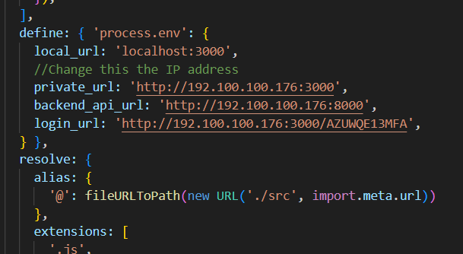

Replace the private_url, backend_api_url, and login_url of your IP Address, and don’t, and don’t forget the port.

**How to run?**

Step 1: Open your command promt

Step 2: Copy the full path of questify-frontend, and run the command “cd fullpath”

Step 3: Run the command “yarn dev --host”

Step 4: After that you will see the picture below

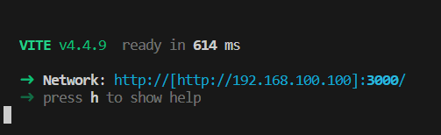

Copy the url and paste it in your browser.

Note: Make sure the unit of the students run in the same network of you. Because this kind of network is called WLAN. I’m sure you know it, because you’re Henry Ong the legend.

**Something wrong?**

* Double check your IP Address
* Make sure the backend is open, and you run the command “yarn dev --host”
* Check the **SANCTUM_STATEFUL_DOMAINS** at .env in questify backend, make sure the root of frontend questify URL is added to it.
* If you encounter 404 status make sure you added this hash “AZUWQE13MFA”

– http://192../ AZUWQE13MFA it will go to the login page.

**Backend Questify (./Questify/questify-backend)**

**Configuration**

Step 1: Go to the ./Questify/questify-backend/.env, if you don’t have it inside the backend folder go to the root of Questify folder I provide a .env file.

Step 2: Inside the .env file you will see this picture below.

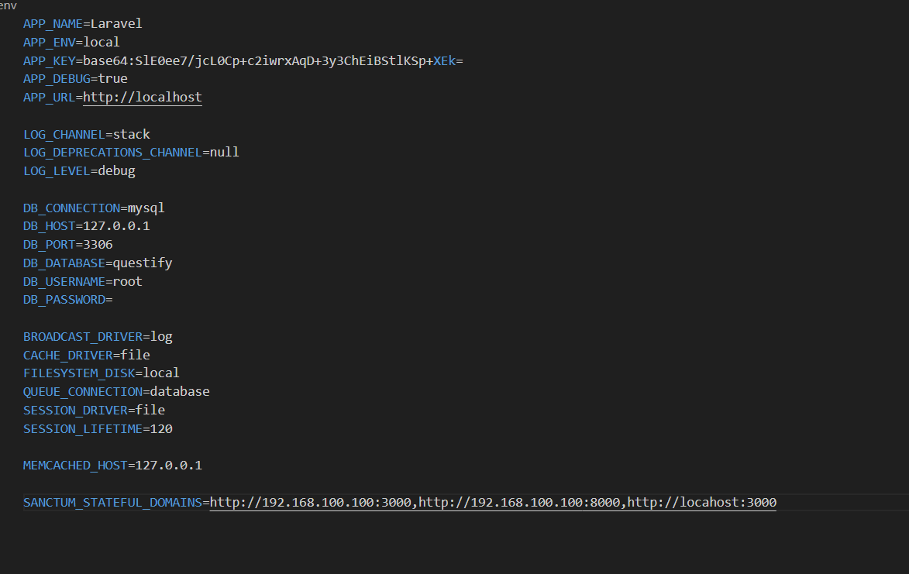

Step 3: Replace the IP address value in SANCTUM_STATEFUL_DOMAINS variable.

Step 4: Change the DB_DATABASE, DB_USERNAME, and DB_PASSWORD.

**How to run?**

Step 1: Open your command promt

Step 2: Copy the full path of questify-backend, and run the command “cd fullpath”

Step 3: Run the command “php artisan serve –host=http://*your ip address”

Step 4: Run the command “php artisan queue:work --daemon” don’t forget this command or the request will not be process it will pending only.

**Something wrong?**

* Double check your IP Address
* Double check the .env
* Make sure you run the command “php artisan serve –host=http://*your ip address” and “php artisan queue:work --daemon”