**ICE6 – TDM Simulation**

**Authors:** C3C Lauren Humpherys and C3C Christopher Katz

**Documentation:** None to report.

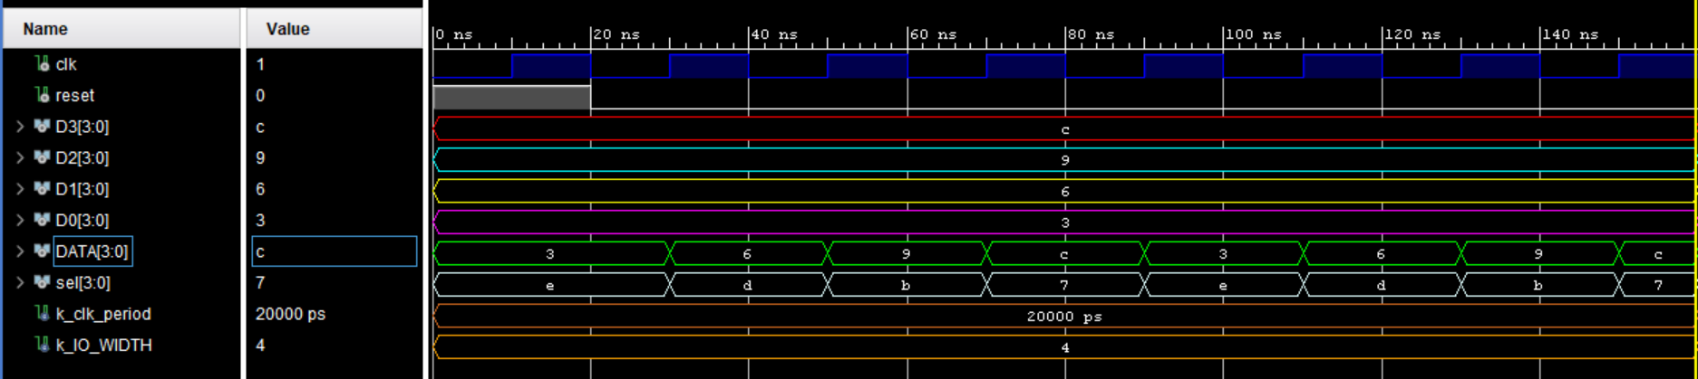

1. What does the TDM do?

*The TDM cycles between four data inputs continuously. After reset, it begins with “0011” and switches to “0110”, then “1001”, then “1100,” and then starts again with “0011” to repeat the process again. The TDM switches from one value to the next every time the clock rises.*

1. What is the importance of k_WIDTH?

*The generic constant k_WIDTH enables the TDM to take an input size of a specified number of bits. In this case, k_WIDTH is 4 for the TDM to take in a 4-bit input.*

1. What is the purpose of SEL?

*SEL is the connection where the TDM output o_SEL travels, telling the user which of the input channels have been selected.*

1. Why was your waveform different than the provided example?

*Our waveform is different from the provided example because we redefined our input vectors and assigned them values that differed than the ones that yielded the example waveform. Instead of assigning “1110” to D0, we used “0011.” We also assigned “0110” to D1 instead of “1101,” D2 was “1001,” and D3 was made “1100” instead of “0111.”*