**Lab 2 – Seven Segment Display Decoder**

By Christopher Katz

**Documentation:**

Lauren Humpherys and I worked together on this assignment.

**Purpose:**

Develop a hardware-based binary to hex converter.

**Preliminary Design:**

I would implement POS equations in my hardware because it is based off of OR terms for each input combinations which produces a LOW output (i.e. lighting the segment of the display).

A = D3

B = D2

C = D1

D = D0

**Sa** = A’B’C’D + BC’D’ +ABC’ + AB’CD

**Sb** = ABD’ + ACD + BCD’ + A’BC’D

**Sc** = ABD’ + A’B’CD’ + ABC

**Sd** = A’BC’D’ + B’C’D + BCD + AB’CD’

**Se** = A’BC’ + B’C’D + A’D

**Sf** = ABC’ + A’B’D + A’B’C + A’CD

**Sg** = A’B’C’ + A’BC’D

Using the second method, with the lookup table (LUT) is way easier than the original way with the AND, NOT, and OR gates.

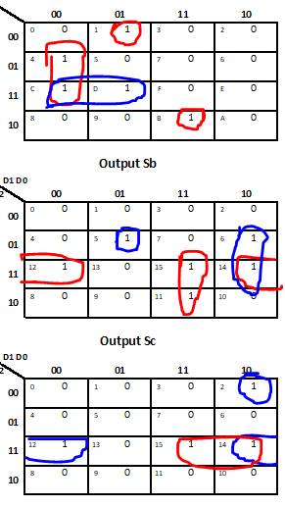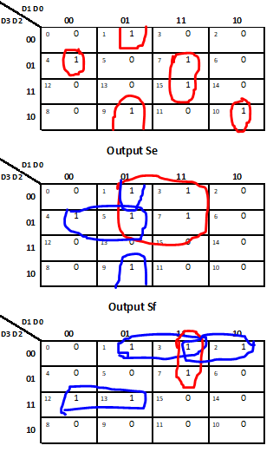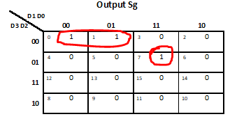

**Results:**

Design:

Debugging:

Testing:

Simulation Results:

Final Results/Demonstration

**Observations and Conclusions:**

**Reflection:**

Number of hours: 1.5

Most difficult part:

Lessons:

Suggestions: