**APPENDIX A**

**Project Team Assignment Form**

|  |  |
| --- | --- |
| Team Alias | **eGiGCafe: An Online Services Ordering and Reservation Management System for GiGCafe** |

|  |  |  |
| --- | --- | --- |
| **Name and Signature** | **Project Role** | **Email Address and Number** |
| Chynna I. Alcantara | * Researcher * System   analyst | [Alcantarachynna123@gmail.com](mailto:Alcantarachynna123@gmail.com)  09932526443 |
| Jenny Rose L. Fajilan | * Technical Writer * Researcher | [landichojennyrose@gmail.com](mailto:landichojennyrose@gmail.com)  09510068658 |
| King Jayjay A. Pacheco | * Team Manager * Programmer * Database manager * Researcher | Pachecoking38@gmail.com  09182594781 |

**APPENDIX B**

**Capstone Project Topic Proposal Form**

|  |  |
| --- | --- |
| **CAPSTONE/RESEARCH PROJECT TOPIC PROPOSAL** | |
| **Proposed Title** | eGiGCafe: An Online Services Ordering and Reservation Management System for GiGCafe |
| **Name of Student/**  **Course, Year & Section** | Chynna I. Alacantara  Jenny Rose L. Fajilan  King Jayjay A. Pacheco  BSIT 4F1 |
| **Introduction** | People’s lives revolved around technology. This way of life is sometimes referred to as the *Digital Age*. The digital age is defined as the current environment in which digital media and technologies are complexly present within all spheres of life (Ferreira et al.,2021). This period resulted in the production of various types of systems and applications which are now heavily used by people all over the world. Despite this, it’s far from perfect and some gaps are still present, especially inside the business of catering and restaurant which leaves room for improvements and possibilities. Despite major technological improvements and the incorporation of digital solutions into many parts of everyday life, the catering and restaurant sector faces problems and inefficiencies. The complicated and time-consuming nature of the reservation procedure is one of the key difficulties that restaurants like GigCafe encounter. The traditional face-to-face approach frequently causes delays, particularly during peak hours, impeding the organization's overall efficiency. Furthermore, the difficulty of managing resources in a busy environment that mixes catering, and restaurant services exacerbates the problem. These weaknesses in the present system provides a space for the development of eGigCafe which adapts to the unique needs of GigCafe. Taking care of these difficulties would not only help to simplify operations. |
| **Statement of the Problem** | The following statements of the research are the questions that will serve the purpose of the website that the researchers will focus on answering which are:   1. What are the benefits that customers will have from the website? 2. What are the benefits that employees will have from the website? 3. What are the features that enable ease of access? 4. What are the important security concerns on the website? |
| **Objectives of the Study** | This study aims to develop eGigCafe to make reservation of catering services and ordering menu items convenient for both customers and staffs. Specifically, this study has the following objectives: 1. Allow customers to browse, filter and order from the menu while also choosing the preferred method of getting the order, once successful, receive an e-receipt. 2. Enable the customers to reserve a unique date and time for the desired catering service, option, and food package all together, and get notified of its status through email, once successful, receive an e-receipt and rate the experience. 3. Incorporate an inventory management feature, allowing staffs and admins to monitor the quantity and condition of catering supplies before and after each service. 4. Create data analytics to help see patterns and trends in menu listings and catering services. |
| **Review of Related Literatures and System** | Reservation systems benefit a lot of fields. In accordance with a similar study, it stated that healthcare benefits from a time scheduler system as well (Dela Fuente et al., 2023). This means that this kind of system isn’t limited to restaurants or hotels but rather, to many fields as well such as medicine or healthcare.  Automating the reservation system not only encourages more bookings but also speeds up the process, with fewer overbookings and greater revenue, prevents issues related to language or countless hours of waiting for the traveler, and the guarantee of having everything automated and controlled via the Internet, is a must(Valdez, 2019).  Traditional systems that need face to face visits to terminals for ticket and fare transactions all pose difficulties for commuters (Cabatit et al.,2023).The same goes for physical visits to restaurants with booking services such as tables or catering services.  A computerized reservation system is a type of software that allows administrators to manage the schedule and cost of any goods or services (e.g.,additional packages) and instantly change the customer's reservation details instead of the manual system typically used (Pamanay et al., 2020).  According to Ivanov (2019), the reservation system should have characteristics such as changes in reservation status, correct website design, information accuracy, customization, simplicity of update, online payment, and an interactive idea |
| **References** | Fuente, M. A. M. D., Facunla, J. A., De Guzman, H.N.F., Jacinto, E. F., Hilario, J. B., Olipas, C. N. P., & Cunanan, A. I. (2023). Project Clinik: A Cross-Platform Scheduling and Appointment Reservation System. Formosa Journal of Computer and Information Science, 2(1), 13-24.  Pamanay, A.., Mestizo, J. E.., Temilloso, J. M.., Delos Santos, D.., & Besinal, J. C. (2020). Proposed Computerized Reservation System for Villa Prescilla Resort. Ascendens Asia Singapore–Bestlink College of the Philippines Journal Research, 2(1). Retrieved from <https://www.ojs.aaresearchindex.com/index.php/aasg> bcpjmra/article/view/2300  Cabatit Jr, J. P., Capia, M. D. L. B., Tubije, J. L. P.,Hermoso, S. K. P., & Olipas, C. N. P. (2023).Viajeros: The Assessment of an Online MinibusTicket Reservation System. International Journal of Integrative Sciences, 2(8), 1207-1222.  Valdez, E. J. (2019). Trends and Issues of Hotel Industry: Impact to the Influx of Tourists in Batangas, Philippines. Asia Pacific Journal of Multidisciplinary Research, 7(3), 110-120.  Capuno, M., Benigno, J., Reyes, R., & Tojino, K. C. M. (2021). iReserve: An Online Event Reservation for Lipa City Cultural with SMS Notification. JPAIR Multidisciplinary Research, 43(1), 146-165. |

**APPENDIX C**

**Notice of Title Acceptance**

**C E R T I F I C A T I O N**

The undersigned members comprising the panel for oral examination hereby approve the Research/Capstone Project entitled **eGiGCafe: An Online Services Ordering and Reservation Management System for GiGCafe** including its team members composed of Chynna I. Alcantara, Jenny Rose L. Fajilan, and King Jayjay A. Pacheco.

**SARAH JANE M. FWSTIJO, *MSIT***

Research Adviser

**REGINE A. PONCE-MACHETE, *MIT***

Capstone Project Course Facilitator

**DEZZA MARIE M. MAGSINO, *MSIT***

Program Research Coordinator

**EPIE F. CUSTODIO, *DIT***

Program Chairperson

**POLEMER M. CUARTO *Ph.D.***

RDE Representative

**JOHN EDGAR S. ANTHONY, *MSIT***

College Dean

**APPENDIX E**

**Grammarian’s Certificate**

Date: December 16, 2024

***GRAMMARIAN’S CERTIFICATE***

This is to certify that the undersigned has reviewed the grammatical construction and the text organization of this Research/ Capstone Project entitled **“eGiGCafe: An Online Services Ordering and Reservation Management System for GiGCafe.”**

Signed:

**ALICE R. RAMOS, *Ph.D.***

Grammarian

Conformed:

**CHYNNA I. ALCANTARA**

Project Manager

**APPENDIX F**

**Certification of Originality**

This is to certify that the research work presented inthis Research/Capstone Project, **eGiGCafe: An Online Services Ordering and Reservation Management System for GiGCafe** for the degree **Bachelor of Science in Information and Technology** at the Mindoro State University embodies the result of original and scholarly work carried out by the undersigned. This Research/Capstone Project does not contain words or ideas taken from published sources or written works that have been accepted as basis for the award of a degree from any other higher education institution, except where proper referencing and acknowledgment were made.

|  |
| --- |
| **CHYNNA I. ALCANTARA**  Researcher |
| **JENNY ROSE L. FAJILAN**  Researcher |
| **KING JAYJAY A. PACHECO**  Researcher |

**APPENDIX H**

**Data Elements / Dictionary**

|  |  |  |  |  |
| --- | --- | --- | --- | --- |
| **Field for users** | | | | |
| **Field** | **Type** | **Null** | **Default** | **Comment** |
| id | bigint UNSIGNED | NO |  | Unique user identifier |
| name | varchar(255) | NO |  | Full name of the user |
| username | varchar(255) | NO |  | Unique username |
| email | varchar(255) | NO |  | Email address |
| email_verified_at | timestamp | YES | NULL | Timestamp of email verification |
| password | varchar(255) | NO |  | Encrypted user password |
| remember_token | varchar(100) | YES | NULL | Token for "remember me" functionality |
| created_at | timestamp | YES | NULL | Record creation timestamp |
| updated_at | timestamp | YES | NULL | Record last update timestamp |
| role | varchar(255) | NO | customer | User role (e.g., customer, admin) |
| status | int | NO | 1 | User status (active/inactive) |
| active_status | tinyint(1) | NO | 0 | Indicator if the user is active |
| avatar | varchar(255) | NO | .png | User avatar image file name |
| dark_mode | tinyint(1) | NO | 0 | Dark mode preference |
| messenger_color | varchar(255) | YES | NULL | Preferred messenger color |
| mobile_number | varchar(255) | NO |  | User's mobile phone number |

|  |  |  |  |  |
| --- | --- | --- | --- | --- |
| **Field for reservations** | | | | |
| **Field** | **Type** | **Null** | **Default** | **Comment** |
| id | bigint UNSIGNED | NO |  | Primary key |
| first_name | varchar(255) | NO |  | Customer's first name |
| last_name | varchar(255) | NO |  | Customer's last name |
| email | varchar(255) | NO |  | Customer's email address |
| tel_number | varchar(255) | NO |  | Customer's phone number |
| service_id | bigint | NO | 1 | Related service ID |
| cateringoption_id | bigint UNSIGNED | NO | 1 | Catering option ID |
| package_id | bigint | YES | 1 | Package ID |
| status | varchar(255) | NO | Pending | Reservation status |
| payment_status | varchar(255) | NO | Not Paid | Payment status |
| payment_selection | varchar(255) | YES | NULL | Payment method |
| receipt_image | json | NO |  | Receipt image (JSON) |
| res_date | datetime | NO |  | Reservation date |
| guest_number | int | NO |  | Number of guests |
| venue_address | varchar(255) | NO |  | Venue address |
| created_at | timestamp | YES | NULL | Record creation timestamp |
| updated_at | timestamp | YES | NULL | Record update timestamp |
| user_id | bigint UNSIGNED | YES | NULL | Associated user ID |
| role | varchar(255) | YES | customer | User role |
| deleted_at | timestamp | YES | NULL | Deletion timestamp (soft delete) |
| supply_details | json | YES | NULL | Supply details (JSON) |
| supply_total | decimal(10,2) | YES | NULL | Total supply cost |
| theme_type | varchar(50) | YES | NULL | Type of theme |
| main_color | varchar(50) | YES | NULL | Main color theme |
| sub_color | varchar(50) | YES | NULL | Sub color theme |
| custom_main_color | varchar(50) | YES | NULL | Custom main color |
| custom_sub_color | varchar(50) | YES | NULL | Custom sub color |
| theme_comments | text | YES | NULL | Comments on the theme |

|  |  |  |  |  |
| --- | --- | --- | --- | --- |
| **Field for orders** | | | | |
| **Field** | **Type** | **Null** | **Default** | **Comment** |
| id | int | NO |  | Primary key |
| user_id | int | YES | NULL | Foreign key to user |
| created_at | timestamp | YES | CURRENT_  TIMESTAMP | Record creation time |
| updated_at | timestamp | YES | CURRENT_  TIMESTAMP | Record update time |
| dateTime | timestamp | YES | NULL | Event date and time |
| completed | tinyint(1) | YES | 0 | Completion status |
| type | varchar(255) | YES | NULL | Type or category |

|  |  |  |  |  |
| --- | --- | --- | --- | --- |
| **Field for inventories** | | | | |
| **Field** | **Type** | **Null** | **Default** | **Comment** |
| id | bigint | No |  | Primary key, auto-increment |
| name | varchar(255) | No |  | Item name |
| price | decimal(10,2) | No |  | Price of the item |
| quantity | int | No | 0 | Available stock quantity |
| initial_stock | int | Yes | NULL | Initial stock count |
| status | varchar(255) | Yes | NULL | Item status (e.g. active) |
| created_at | timestamp | Yes | NULL | Record creation timestamp |
| updated_at | timestamp | Yes | NULL | Last update timestamp |

|  |  |  |  |  |
| --- | --- | --- | --- | --- |
| **Field for notifications** | | | | |
| **Field** | **Type** | **Null** | **Default** | **Comment** |
| id | char(36) | No |  | Primary key |
| type | varchar(255) | No |  | Notification type |
| notifiable_type | varchar(255) | No |  | Type of the entity being notified |
| notifiable_id | bigint | No |  | ID of the entity being notified |
| data | text | No |  | Notification data |
| read_at | timestamp | Yes | NULL | Read timestamp (if read) |
| created_at | timestamp | Yes | NULL | Record creation timestamp |
| updated_at | timestamp | Yes | NULL | Last update timestamp |

|  |  |  |  |  |
| --- | --- | --- | --- | --- |
| **Field for reservation transactions** | | | | |
| **Field** | **Type** | **Null** | **Default** | **Comment** |
| id | bigint | No |  | Primary key, auto-increment |
| payment_id | varchar(255) | No |  | Payment ID |
| payer_id | varchar(255) | No |  | Payer ID |
| payer_email | varchar(255) | No |  | Payer email |
| amount | double(10,2) | No |  | Payment amount |
| currency | varchar(255) | No |  | Currency type |
| payment_status | varchar(255) | No |  | Payment status |
| reservation_id | bigint | No |  | Reservation ID |
| created_at | timestamp | Yes | NULL | Record creation timestamp |
| updated_at | timestamp | Yes | NULL | Last update timestamp |

|  |  |  |  |  |
| --- | --- | --- | --- | --- |
| **Field for order transactions** | | | | |
| **Field** | **Type** | **Null** | **Default** | **Comment** |
| id | int | No |  | Primary key, auto-increment |
| order_id | int | Yes | NULL | Order ID |
| user_id | bigint | Yes | NULL | User ID |
| discount_id | int | Yes | NULL | Discount ID |
| final_amount | decimal(6,2) | Yes | NULL | Final payment amount |
| created_at | timestamp | Yes | CURRENT_  TIMESTAMP | Record creation timestamp |
| updated_at | timestamp | Yes | CURRENT_  TIMESTAMP | Last update timestamp |

|  |  |  |  |  |
| --- | --- | --- | --- | --- |
| **Field for reservation ratings** | | | | |
| **Field** | **Type** | **Null** | **Default** | **Comment** |
| id | bigint | No |  | Primary key, auto-increment |
| service_rating | double | No |  | Rating for the service |
| package_rating | double | Yes | NULL | Rating for the package (if any) |
| service_id | bigint | No |  | Service ID |
| package_id | bigint | Yes | NULL | Package ID (if any) |
| user_id | bigint | No |  | User ID |
| reserv_id | int | No |  | Reservation ID |
| comment | varchar(255) | Yes | NULL | Optional comment |
| rated | int | No |  | Rating status (e.g., 1 if rated) |
| created_at | timestamp | No |  | Record creation timestamp |
| updated_at | timestamp | No |  | Last update timestamp |

|  |  |  |  |  |
| --- | --- | --- | --- | --- |
| **Field for reservation supplies** | | | | |
| **Field** | **Type** | **Null** | **Default** | **Comment** |
| id | int | No |  | Primary key, auto-increment |
| reservation_id | bigint | No |  | Reservation ID |
| supplies_name | varchar(255) | No |  | Name of the supplies |
| supplies_quantity | int | No |  | Quantity of the supplies |
| supplies_grandprice | decimal(10,2) | No |  | Grand price of the supplies |
| created_at | timestamp | Yes | CURRENT_  TIMESTAMP | Record creation timestamp |
| updated_at | timestamp | Yes | CURRENT_  TIMESTAMP | Last update timestamp |

|  |  |  |  |  |
| --- | --- | --- | --- | --- |
| **Field for reservation inventories** | | | | |
| **Field** | **Type** | **Null** | **Default** | **Comment** |
| id | bigint | No |  | Primary key, auto-increment |
| inventory_id | bigint | No |  | Inventory ID |
| reservation_id | bigint | No |  | Reservation ID |
| quantity | int | No | 1 | Quantity of the inventory |

|  |  |  |  |  |
| --- | --- | --- | --- | --- |
| **Field for reservation events** | | | | |
| **Field** | **Type** | **Null** | **Default** | **Comment** |
| id | bigint | No |  | Primary key, auto-increment |
| name | varchar(255) | No |  | Event name |
| description | text | No |  | Event description |
| image | varchar(255) | No |  | Event image |
| created_at | timestamp | Yes | NULL | Record creation timestamp |
| updated_at | timestamp | Yes | NULL | Last update timestamp |

|  |  |  |  |  |
| --- | --- | --- | --- | --- |
| **Field for reservation options** | | | | |
| **Field** | **Type** | **Null** | **Default** | **Comment** |
| id | bigint | No |  | Primary key, auto-increment |
| name | varchar(255) | No |  | Option name |
| description | text | No |  | Option description |
| image | varchar(255) | No |  | Image URL or file path |
| created_at | timestamp | Yes | NULL | Record creation timestamp |

|  |  |  |  |  |
| --- | --- | --- | --- | --- |
| **Field for reservation galleries** | | | | |
| **Field** | **Type** | **Null** | **Default** | **Comment** |
| id | bigint | No |  | Primary key, auto-increment |
| image | varchar(255) | No |  | Image URL or file path |
| category | varchar(255) | No |  | Category of the image |
| created_at | timestamp | Yes | NULL | Record creation timestamp |
| updated_at | timestamp | Yes | NULL | Last update timestamp |

|  |  |  |  |  |
| --- | --- | --- | --- | --- |
| **Field for order ratings** | | | | |
| **Field** | **Type** | **Null** | **Default** | **Comment** |
| id | bigint | No |  | Primary key, auto-increment |
| menu_id | bigint | No |  | Menu ID |
| user_id | bigint | No |  | User ID |
| order_id | int | No |  | Order ID |
| rating | tinyint | No |  | Rating value (e.g., 1-5) |
| comment | text | Yes | NULL | Optional comment |
| created_at | timestamp | Yes | NULL | Record creation timestamp |
| updated_at | timestamp | Yes | NULL | Last update timestamp |

|  |  |  |  |  |
| --- | --- | --- | --- | --- |
| **Field for order menus** | | | | |
| **Field** | **Type** | **Null** | **Default** | **Comment** |
| id | bigint | No |  | Primary key, auto-increment |
| name | varchar(255) | No |  | Menu item name |
| description | varchar(255) | No |  | Description of the menu item |
| price | decimal(6,2) | No |  | Price of the menu item |
| image | varchar(255) | No |  | Image URL of the menu item |
| size | varchar(255) | No |  | Size of the menu item |
| type | varchar(255) | Yes | undefined | Type of the menu item |
| estCost | decimal(6,2) | Yes | 0.00 | Estimated cost of the item |
| allergic | int | Yes | 0 | Allergy indicator (0 for no) |
| vegetarian | int | Yes | 0 | Vegetarian indicator (0 for no) |
| vegan | int | Yes | 0 | Vegan indicator (0 for no) |

|  |  |  |  |  |
| --- | --- | --- | --- | --- |
| **Field for order cart items** | | | | |
| **Field** | **Type** | **Null** | **Default** | **Comment** |
| id | int | No |  | Primary key, auto-increment |
| user_id | int | Yes | NULL | User ID |
| menu_id | int | Yes | NULL | Menu item ID |
| order_id | int | Yes | NULL | Order ID (if associated) |
| quantity | int | Yes | NULL | Quantity of the item |
| fulfilled | tinyint(1) | Yes | 0 | Fulfillment status (0 or 1) |

|  |  |  |  |  |
| --- | --- | --- | --- | --- |
| **Field for order discounts** | | | | |
| **Field** | **Type** | **Null** | **Default** | **Comment** |
| id | int | No |  | Primary key, auto-increment |
| created_at | timestamp | Yes | CURRENT_TIMESTAMP | Record creation timestamp |
| updated_at | timestamp | Yes | CURRENT_TIMESTAMP | Last update timestamp |
| discountCode | varchar(255) | Yes | NULL | Discount code |
| percentage | smallint | Yes | NULL | Discount percentage |
| minSpend | decimal(6,2) | Yes | NULL | Minimum spend for the discount |
| cap | decimal(5,2) | Yes | NULL | Discount cap (maximum value) |
| startDate | date | Yes | NULL | Discount start date |
| endDate | date | Yes | NULL | Discount end date |
| description | text | Yes | NULL | Discount description |

|  |  |  |  |  |
| --- | --- | --- | --- | --- |
| **Field for order packages** | | | | |
| **Field** | **Type** | **Null** | **Default** | **Comment** |
| id | bigint | No |  | Primary key, auto-increment |
| user_id | int | Yes | NULL | User ID |
| name | varchar(255) | No |  | Package name |
| description | text | No |  | Package description |
| image | varchar(255) | No |  | Image URL |
| guest_number | int | No |  | Number of guests |
| status | varchar(255) | No | Available | Package status |
| price | int | No |  | Package price |
| created_at | timestamp | Yes | NULL | Record creation timestamp |
| updated_at | timestamp | Yes | NULL | Last update timestamp |

|  |  |  |  |  |
| --- | --- | --- | --- | --- |
| **Field for ch_chatify** | | | | |
| **Field** | **Type** | **Null** | **Default** | **Comment** |
| id | bigint | No |  | Primary key, auto-increment |
| message | longtext | Yes | NULL | Message content |
| user_id | bigint | No |  | Sender user ID |
| receiver | bigint | No |  | Receiver user ID |
| is_seen | tinyint(1) | No | 0 | Message read status (0/1) |
| created_at | timestamp | Yes | NULL | Message creation timestamp |
| updated_at | timestamp | Yes | NULL | Last update timestamp |
| file | varchar(191) | Yes | NULL | File path (if any) |
| file_name | varchar(191) | Yes | NULL | File name (if any) |

|  |  |  |  |  |
| --- | --- | --- | --- | --- |
| **Field for ch_messages** | | | | |
| **Field** | **Type** | **Null** | **Default** | **Comment** |
| id | char(36) | No |  | Primary key |
| from_id | bigint | No |  | Sender's user ID |
| to_id | bigint | No |  | Recipient's user ID |
| body | varchar(5000) | Yes | NULL | Message body |
| attachment | varchar(255) | Yes | NULL | Attachment file path (if any) |
| seen | tinyint(1) | No | 0 | Message read status (0 = not seen, 1 = seen) |
| created_at | timestamp | Yes | NULL | Message creation timestamp |
| updated_at | timestamp | Yes | NULL | Last update timestamp |

|  |  |  |  |  |
| --- | --- | --- | --- | --- |
| **Field for ch_favorites** | | | | |
| **Field** | **Type** | **Null** | **Default** | **Comment** |
| id | char(36) | No |  | Primary key |
| user_id | bigint | No |  | User ID |
| favorite_id | bigint | No |  | Favorite ID |
| created_at | timestamp | Yes | NULL | Record creation timestamp |
| updated_at | timestamp | Yes | NULL | Last update timestamp |

|  |  |  |  |  |
| --- | --- | --- | --- | --- |
| **Field for event & package groups** | | | | |
| **Field** | **Type** | **Null** | **Default** | **Comment** |
| service_id | bigint | No |  | Service ID |
| package_id | bigint | No |  | Package ID |

|  |  |  |  |  |
| --- | --- | --- | --- | --- |
| **Field for password reset** | | | | |
| **Field** | **Type** | **Null** | **Default** | **Comment** |
| email | varchar(255) | No |  | User's email address |
| token | varchar(255) | No |  | Password reset token |
| created_at | timestamp | Yes | NULL | Token creation timestamp |

**APPENDIX I**

**Capstone Evaluation Form**

**“EGIGCAFE: AN ONLINE SERVICES ORDERING AND RESERVATION  
MANAGEMENT SYSTEM FOR GIGCAFE”**

**Direction** : Test the performance and acceptability of the Project based on the rating below using ISO 25010 Software Metrics Evaluation and Unified Theory of Acceptance and Use of Technology (UTAUT) Model.

Name: Date:_______ Stakeholder Type: Age:

Admin 18-25 yrs old

Employee 26-35 yrs old

Customer 36-45 yrs old

IT Expert 46-55 yrs old

Others(specify) 56 and above

Gender: Office:

Female Male

Rate the following question by checking the number that corresponds to your answer. Use the legend below.

**Rating**

**4**-Strongly Agree **2**-Disagree

**3**-Agree **1**-Strongly Disagree

1. **ISO 25010 Software Metrics**

|  |  |  |  |  |  |
| --- | --- | --- | --- | --- | --- |
| **1 Functional Sustainability** | | 4 | 3 | 2 | 1 |
| 1.1 | The functions of system covers all the specified task and user  objectives. |  |  |  |  |

|  |  |  |  |  |  |
| --- | --- | --- | --- | --- | --- |
| 1.2 | The functions of system provides the correct results with the  needed degree of precision. |  |  |  |  |
| 1.3 | The functions of system facilitate the accomplishment of  specified tasks and objectives. |  |  |  |  |

|  |  |  |  |  |  |
| --- | --- | --- | --- | --- | --- |
| **2 Performance Efficiency** | | 4 | 3 | 2 | 1 |
| 2.1 | The functions of system response and process the output on time to meet the user  requirements. |  |  |  |  |
| 2.2 | The resources used by the system, when performing its functions, meet requirements |  |  |  |  |
| 2.3 | The maximum limits of the product or system, parameter meet  requirements. |  |  |  |  |

|  |  |  |  |  |  |
| --- | --- | --- | --- | --- | --- |
| **3 Usability** | | 4 | 3 | 2 | 1 |
| 3.1 | The system is appropriate for  my needs. |  |  |  |  |
| 3.2 | The use of system is effective and efficient in emergency  situations. |  |  |  |  |
| 3.3 | The system is easy to operate,  control and appropriate to use. |  |  |  |  |
| 3.4 | The system protects users  against making errors. |  |  |  |  |
| 3.5 | The user interface of the system enables pleasing and satisfying interaction for the  user. |  |  |  |  |
| 3.6 | The system can be used by people with the widest range of characteristics and capabilities to achieve a specified goal in a specified  context of use. |  |  |  |  |

|  |  |  |  |  |  |
| --- | --- | --- | --- | --- | --- |
| **4 Reliability** | | 4 | 3 | 2 | 1 |
| 4.1 | The system meets needs for reliability under normal  operation. |  |  |  |  |
| 4.2 | The system is operational and  accessible when required for use |  |  |  |  |
| 4.3 | The system operates as intended despite the presence of hardware  or software faults |  |  |  |  |
| 4.4 | When an interruption or a failure happened, the system can recover the data on the directly affected and re-establish the  desired state of the system. |  |  |  |  |

1. **Unified Theory of Acceptance and Use of Technology (UTAUT) Model**

|  |  |  |  |  |  |  |  |  |  |  |
| --- | --- | --- | --- | --- | --- | --- | --- | --- | --- | --- |
| **1 Performance Expectancy** | | | 4 | | 3 | | 2 | | 1 | |
| 1.1 | Using the system, my job would  increase my productivity. | |  | |  | |  | |  | |
| 1.2 | Using the system would enhance my  effectiveness on the job. | |  | |  | |  | |  | |
| 1.3 | Using the system would make it  easier to do my job. | |  | |  | |  | |  | |
| 1.4 | I would find the system useful in  my job. | |  | |  | |  | |  | |
| 1.5 | Using the system enables me to  accomplish tasks more quickly. | |  | |  | |  | |  | |
| 1.6 | Using the system improves the  quality of work I do. | |  | |  | |  | |  | |
| 1.7 | Using the system makes it easier  to do my job. | |  | |  | |  | |  | |
| 1.8 | Using the system enhances my  effectiveness on the job. | |  | |  | |  | |  | |
| 1.9 | If I will use the system I will increase my effectiveness on the  job. | |  | |  | |  | |  | |
| 1.10 | If I will use the system I will spend less time on routing job  tasks. | |  | |  | |  | |  | |
| **2 Effort Expectancy** | | | | 4 | | 3 | | 2 | | 1 | |
| 2.1 | | Learning to operate the system  would be easy for me. | |  | |  | |  | |  | |
| 2.2 | | I would find it easy to get the  system to do what I want it to do. | |  | |  | |  | |  | |
| 2.3 | | My interaction with the system is  clear and understandable. | |  | |  | |  | |  | |
| 2.4 | | My interaction with the system would be clear and  understandable. | |  | |  | |  | |  | |
| 2.5 | | I would find the system to be  flexible to interact with. | |  | |  | |  | |  | |
| 2.6 | | Using the system don’t take too  much time from my normal duties. | |  | |  | |  | |  | |
| 2.7 | | Working with the system is so simple, it is not difficult to  understand what is going on | |  | |  | |  | |  | |
| 2.8 | | Using the system involves lesser time doing mechanical operations  (e.g., data input) | |  | |  | |  | |  | |
| 2.9 | | My interaction with the system is  clear and understandable. | |  | |  | |  | |  | |
| 2.10 | | I believe that it is easy to get the system to do what I want it  to do. | |  | |  | |  | |  | |

|  |  |  |  |  |  |
| --- | --- | --- | --- | --- | --- |
| **3 Facilitating Conditions** | | 4 | 3 | 2 | 1 |
| 3.1 | I have control over using the  system. |  |  |  |  |
| 3.2 | I have the resources necessary to  use the system. |  |  |  |  |
| 3.3 | I have the knowledge necessary to  use the system. |  |  |  |  |
| 3.4 | Given the resources, opportunities and knowledge it takes to use the system, it would  be easy for me to use the system. |  |  |  |  |
| 3.5 | Guidance was available to me in  the selection of the system. |  |  |  |  |
| 3.6 | Specialized instruction concerning the system was  available to me. |  |  |  |  |
| 3.7 | A specific person (or group) is available for assistance with  system difficulties. |  |  |  |  |
| 3.8 | Using the system is compatible  with all aspects of my work. |  |  |  |  |
| 3.9 | I think that using the system fits  well with the way I like to work. |  |  |  |  |
| 3.10 | Using the system fits into my work  style. |  |  |  |  |

|  |  |  |  |  |  |
| --- | --- | --- | --- | --- | --- |
| **4 Behavioral Intention** | | 4 | 3 | 2 | 1 |
| 4.1 | Using the system is a good idea. |  |  |  |  |
| 4.2 | Using the system is a wise idea. |  |  |  |  |
| 4.3 | I like the idea of using the  system. |  |  |  |  |
| 4.4 | I find using the system to be  enjoyable. |  |  |  |  |
| 4.5 | The actual process of using the  system is pleasant. |  |  |  |  |
| 4.6 | I have fun using the system. |  |  |  |  |
| 4.7 | The system makes work more  interesting. |  |  |  |  |
| 4.8 | Working with the system is fun. |  |  |  |  |
| 4.9 | I like working with the system. |  |  |  |  |
| 4.10 | I look forward to those aspects of my job that require me to use  the system. |  |  |  |  |

**Comments and Recommendations:**

Signature

**APPENDIX J**

**Pictures During Deployment**

The photos below are taken during the deployment of the eGigCafe.

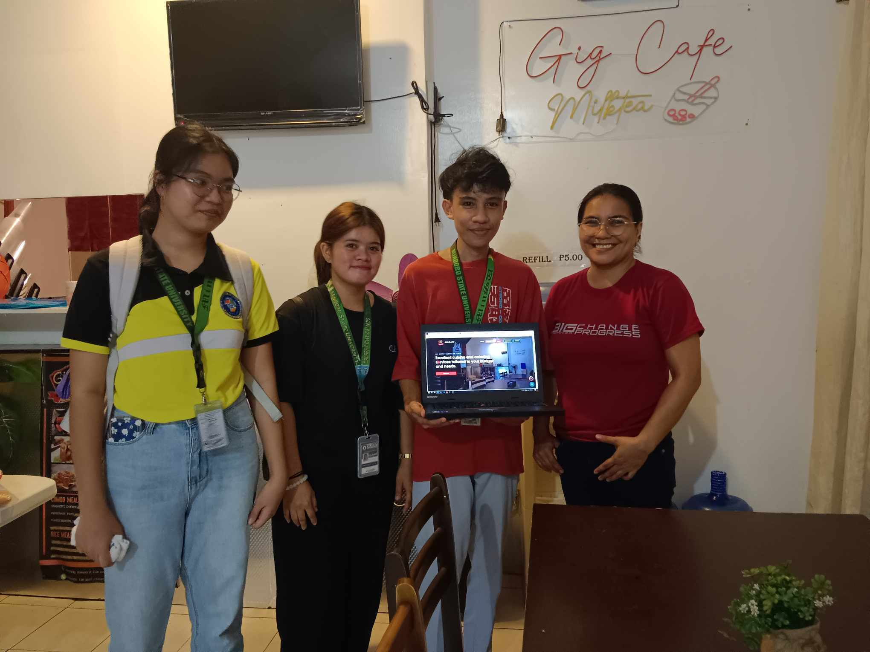

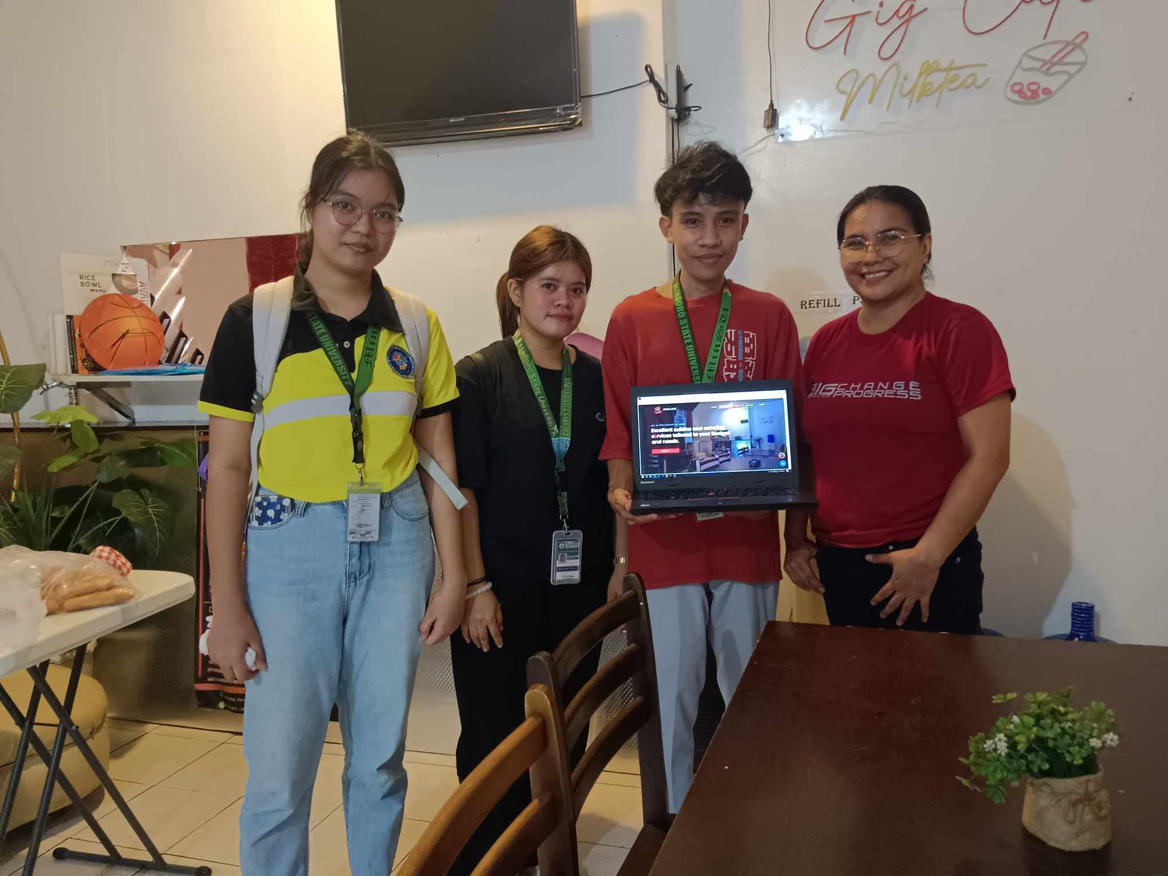

**APPENDIX K**

**Pictures During Final Defense**

The photos below are taken during the final defense of the capstone project on 28th day of November, 2024.

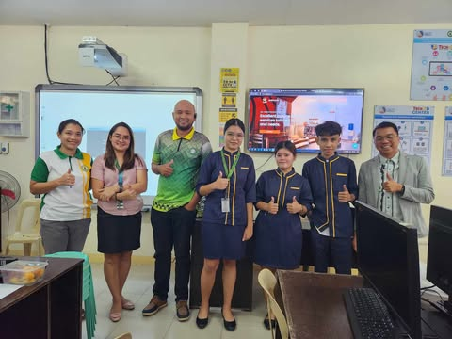

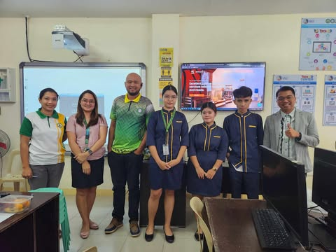

**APPENDIX L**

**Research/Capstone Project Waiver**

**RESEARCH/CAPSTONE PROJECT WAIVER**

We, **CHYNNA I. ALCANTARA, JENNY ROSE L. FAJILAN,** and **KING JAYJAY A. PACHECO** of legal ages, the sole proponent of the Research/Capstone Project entitled **“EGIGCAFE: AN ONLINE SERVICES ORDERING AND RESERVATION MANAGEMENT SYSTEM FOR GIGCAFE”** for the degree **Bachelor of Science in Information and Technology**”, hereby authorize our Adviser, Course Facilitator and the College of Computer Studies – Research Unit to submit our Research/Capstone Project for paper presentation, publication and funding.

Whereas, if the research project will be accepted in any form of publication or presentation, the proponents shall be assisted by their Adviser, Course Facilitator and/or CCS Research Unit Head. However, if the sole proponents unable to attend, the Adviser, Course Facilitator and/or CCS Research Unit Head may represent the group.

Whereas, the Adviser, Course Facilitator and/or CCS Research Unit Head may improve the content of the manuscript in accordance with the requirements set forth by the conference and forum organizers. If improvement had been made by the Adviser, Course Facilitator and/or CCS Research Unit Head, they will be a part of the research group as Co-Authors. The original proponents shall be notified and included as one of the proponents of the Research/Capstone Project.

Whereas our actions and decisions will be beneficial/advantageous for all of us, to the College of Computer Studies and its respective programs.

**CHYNNA I. ALCANTARA KING JAYJAY A. PACHECO**

Research Proponent Research Proponent

Date: Date:

**JENNY ROSE L. FAJILAN**

Research Proponent

Date: _________

**APPENDIX O**

**Curriculum Vitae**

|  |  |
| --- | --- |
| **PERSONAL INFORMATION** |  |
| **Name :** Chynna I. Alcantara  **Email address :** [alcantarachynna123@gmail.com](mailto:alcantarachynna@gmail.com) |  |

**Contact Number :** 09932526443

**Address :** Monte de Oro Homes II, Barangay Sapul

Calapan City, Oriental Mindoro

**Age :** 22

**Birthday :** November 9, 2002

**Father :** Fernando D. Alcantara

**Mother :** Cheryll Ann I. Alcantara

**EDUCATIONAL ATTAINMENT**

**Tertiary**

**Mindoro State University**

Masipit, Calapan City, Oriental Mindoro

2021-present

**Secondary**

**Oriental Mindoro National High School**

San Vicente East, Calapan City Oriental Mindoro

2019-2021

**Oriental Mindoro National High School**

San Vicente East, Calapan City oriental Mindoro

2014-2019

**Elementary**

**Adriatico Memorial Elementary School**

San Vicente East, Calapan City oriental Mindoro

2009-2015

**Curriculum Vitae**

|  |  |
| --- | --- |
| **PERSONAL INFORMATION** |  |
| **Name :** Jenny Rose L. Fajilan  **Email address :** landichojennyrose@gmail.com |  |

**Contact Number :** 09510068658

**Address :** Tarigay Piñahan, Naujan Oriental Mindoro

**Age :** 22

**Birthday :** October 28, 2002

**Father :** Ramon V. Fajilan Jr.

**Mother :** Lina L. Fajilan

**EDUCATIONAL ATTAINMENT**

**Tertiary**

**Mindoro State University**

Masipit, Calapan City, Oriental Mindoro

2021-present

**Secondary**

**St. Mark Arts And Training Institute Inc.**

San Vicente East, Calapan City Oriental Mindoro

2019-2021

**Porfirio G. Comia Memorial National High School**

Barcenaga, Naujan Oriental Mindoro

2015-2019

**Elementary**

**Porfirio G. Comia Elementary School**

Barcenaga, Naujan Oriental Mindoro

2009-2015

**Curriculum Vitae**

|  |  |
| --- | --- |
| **PERSONAL INFORMATION** |  |
| **Name :** King Jayjay A. Pacheco  **Email address :** pachecoking38@gmail.com |  |

**Contact Number :** 0 9948862312

**Address :** St. Cadre, Brgy. Lazareto,  
Calapan City, Oriental Mindoro

**Age :** 21

**Birthday :** July 04, 2003

**Father :** Judith L. Pacheco

**Mother :** Jannete A. Pacheco

**EDUCATIONAL ATTAINMENT**

**Tertiary**

**Mindoro State University**

Masipit, Calapan City, Oriental Mindoro

2021-present

**Secondary**

**Oriental Mindoro National High School**

San Vicente East, Calapan City Oriental Mindoro

2019-2021

**Oriental Mindoro National High School**

San Vicente East, Calapan City oriental Mindoro

2014-2019

**Elementary**

**Lazareto Elementary School**

2009-2015