CPRO306 — Capstone Project | Skillup Labs WIL Program

Nepal News Australia
UI/UX Design Document
Week 6 — User Interface & Experience Design

Team 9 — Shushil Shah Teli (K231666) • Subash Khatri (K250035) • Sujan Shrestha (K250040)
Kent Institute Australia | May 2026

1. Introduction
This document presents the complete UI/UX design for Nepal News Australia. The design follows Apple's Human Interface Guidelines with a glassmorphism aesthetic, combining cultural relevance with modern web design principles.

Project | Nepal News Australia
Document | UI/UX Design Document — Week 6
Design Style | Apple-Inspired Glassmorphism
Framework | Laravel Blade Templates + Custom CSS
Responsive | Desktop, Tablet, Mobile (375px to 1440px+)
Languages | English and Nepali (Devanagari script)

2. Design Principles
- Apple-Inspired Glassmorphism — frosted glass cards with backdrop-filter blur, layered shadows, and rounded corners following Apple HIG
- Mobile First Responsive — fluid grid collapses at 960px breakpoint, hamburger menu activates at 900px
- Cultural Relevance — Nepal red (#C0392B) and Australia navy (#1A3A5C) as primary brand colors
- Accessibility — WCAG AA contrast ratios, semantic HTML5, alt text on all images, keyboard navigation
- Performance — CSS-only animations, minimal JavaScript, lazy loading for images

3. Color Palette
The color palette combines Nepal's national crimson red with Australia's traditional navy blue.

Color Name | Hex Code | Usage | Description
Primary Red | #C0392B | CTAs, Nav, Badges | Nepal-inspired crimson for calls-to-action and navigation
Navy Blue | #1A3A5C | Headers, Titles | Australia-inspired navy for headers and primary text
Gold | #D4AC0D | Accents, Stars | Accent for breaking news, star ratings, date highlights
Success Green | #27AE60 | Published status | For published badges and success confirmations
Light Gray | #F5F5F7 | Page background | Same as apple.com background for consistency
Dark Gray | #6E6E73 | Body text | Secondary text for descriptions and metadata
Near Black | #1D1D1F | Primary text | Primary content text for articles
White | #FFFFFF | Cards, Modals | Card and modal backgrounds

4. Typography
4.1 Font Families
Font | Type | Usage | CSS
Georgia | Serif | Article titles, Section headers, Logo | font-family: Georgia, serif
Inter | Sans-serif | Navigation, Body text, UI elements | font-family: 'Inter', -apple-system, sans-serif
Noto Sans Devanagari | Devanagari | Nepali language, BS dates | font-family: 'Noto Sans Devanagari'

4.2 Type Scale
Element | Size | Weight | Usage
H1 Page Title | 48pt | Bold 900 | Homepage hero headlines
H2 Section Title | 36pt | Bold 700 | Article titles, Section headers
H3 Card Title | 22pt | SemiBold 600 | News card headings
Body Text | 16pt | Regular 400 | Article content, descriptions
Caption / Meta | 13pt | Regular 400 | Author, date, views, tags
Label / Badge | 11pt | Bold 700 | Category badges, nav items

5. User Flow Diagrams
The following diagrams show how each user role (Reader, Contributor, Editor, Admin) navigates through Nepal News Australia.

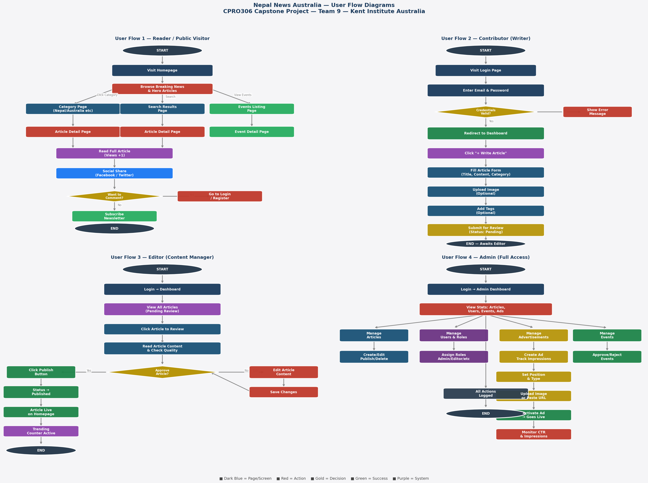

5.1 Flow Summary
User Role | Entry Point | Key Actions | Exit Point
Reader/Public | Homepage | Browse, Search, Share, Subscribe | Newsletter or Login
Contributor | Login to Dashboard | Write Article, Submit for Review | Pending editor approval
Editor | Login to Dashboard | Review, Edit, Publish or Reject | Article published
Admin | Login to Dashboard | Manage content, users, ads, events | Management complete

6. Screen Wireframes
Six key screens define the layout, information hierarchy, and interaction patterns for Nepal News Australia.

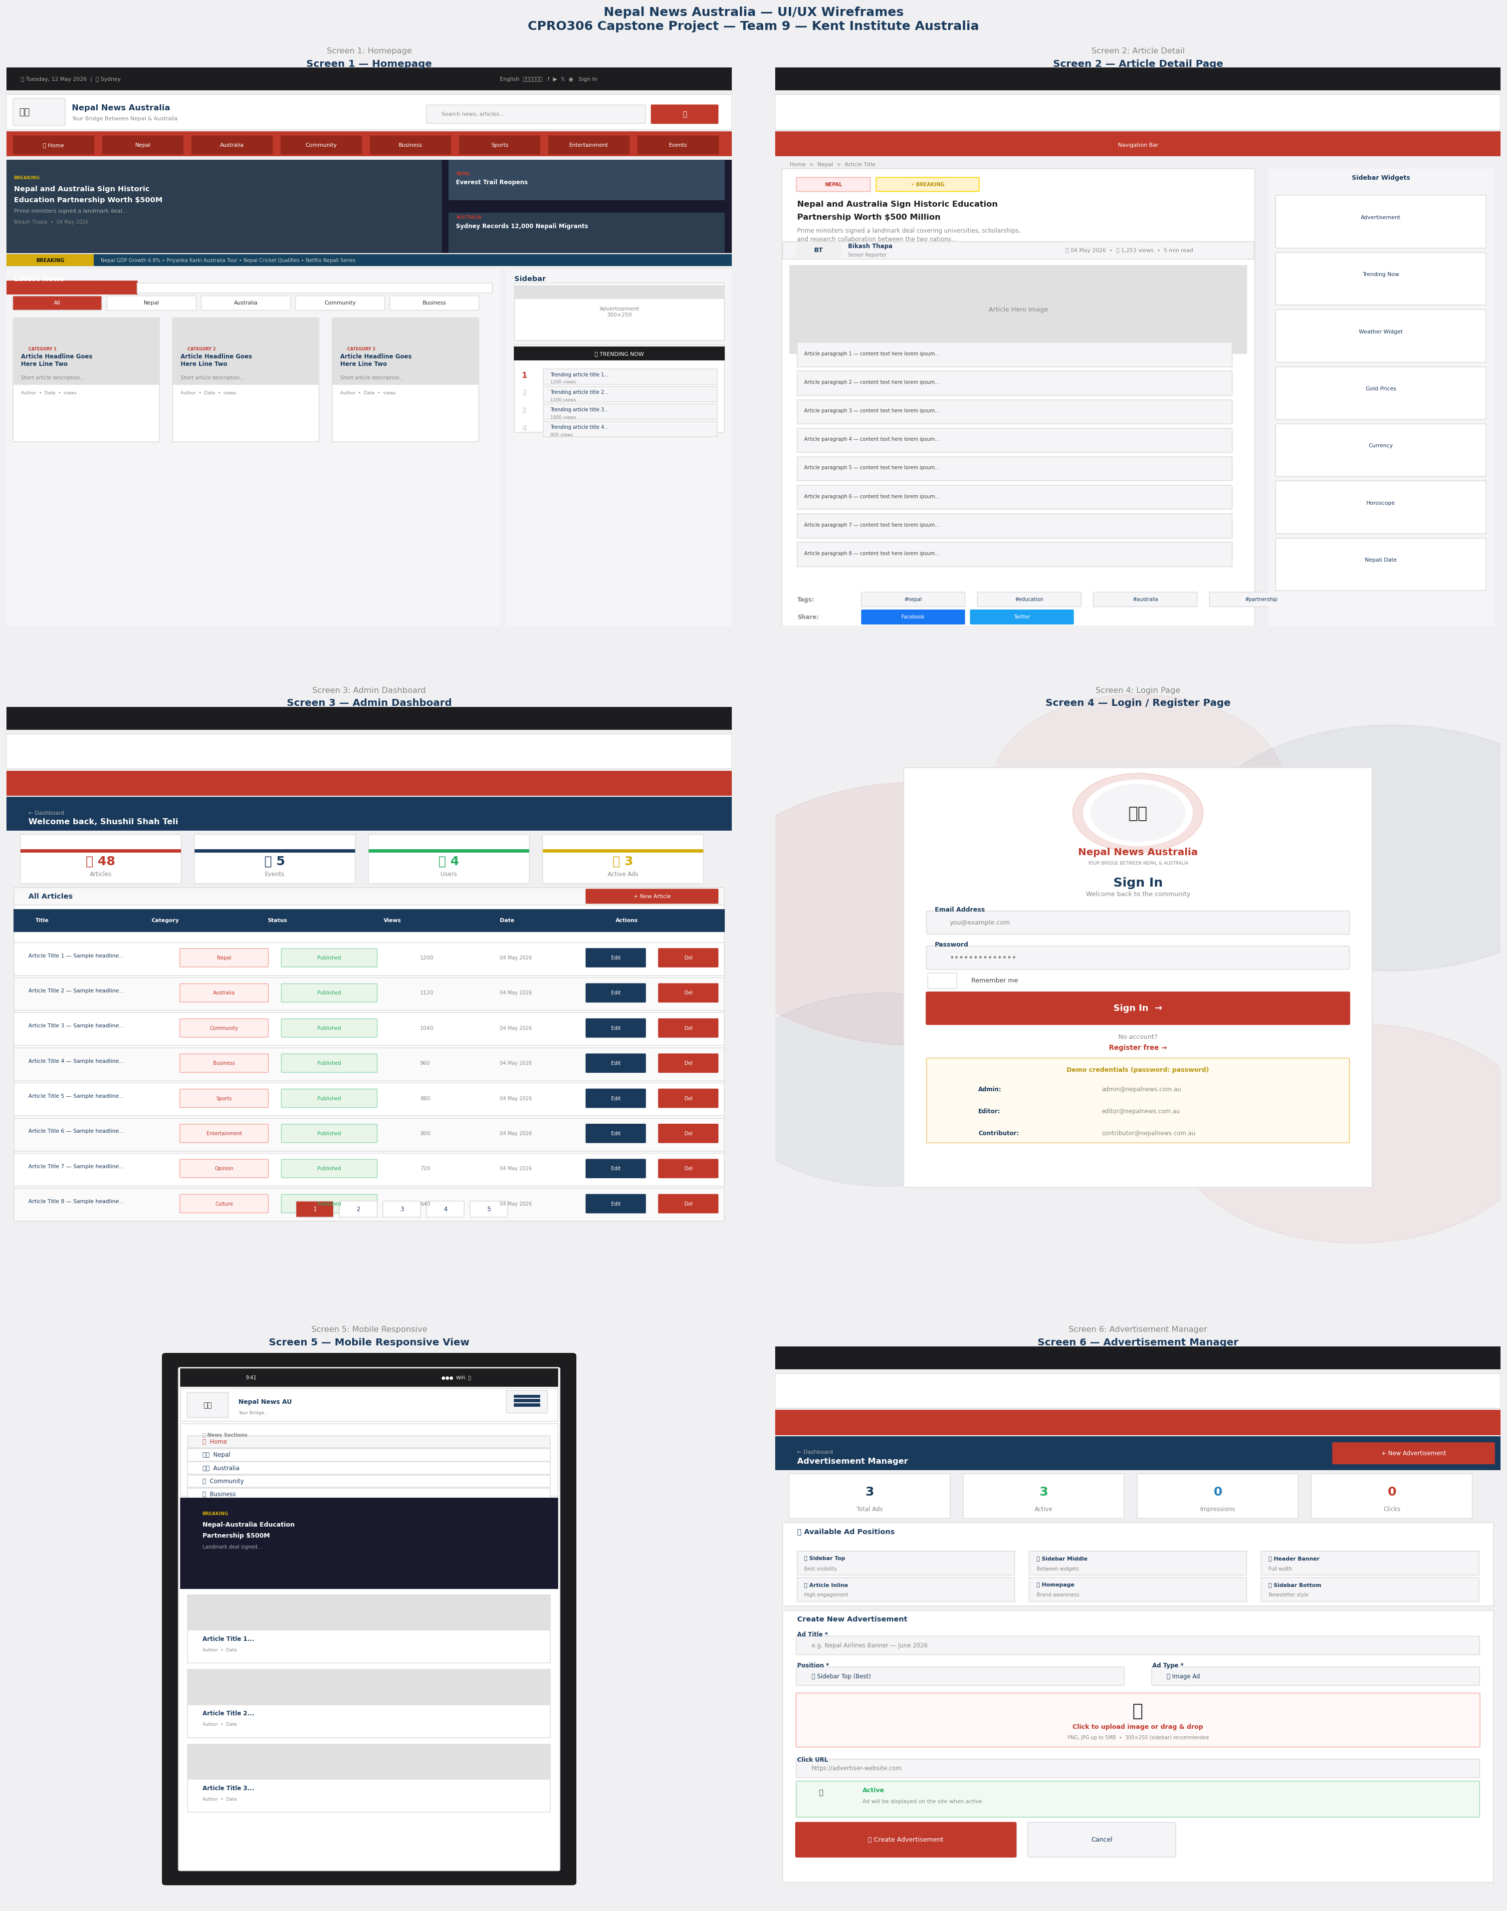

6.1 Screen Inventory
# | Screen | Key Elements | User Goal
1 | Homepage | Hero, Breaking ticker, News grid, Sidebar widgets | Discover latest news
2 | Article Detail | Full content, Author, Tags, Share buttons | Read full article
3 | Admin Dashboard | Stats cards, Articles table, Action buttons | Manage site content
4 | Login / Register | Animated logo, Form fields, Demo credentials | Authenticate
5 | Mobile Responsive | Hamburger menu, Stacked layout, Touch targets | Browse on mobile
6 | Advertisement Manager | Positions guide, Create form, Image upload | Manage ads

7. UI Style Guide
Complete design tokens, components, and patterns used throughout the interface.

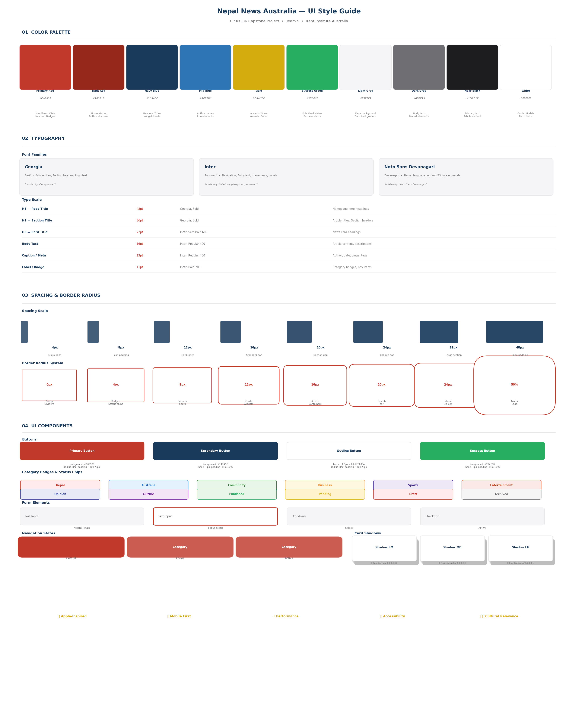

8. Component Library
8.1 Navigation Components
- Top Bar — Dark background, date, language switcher, social icons, auth links
- Site Header — Glassmorphism with logo, tagline, search bar. Sticky on scroll.
- Navigation Bar — Red gradient with pill-shaped links, animated hover states
- Mobile Menu — Slide-in drawer with categorized sections and emoji icons

8.2 Content Components
- News Card — Rounded 16px corners, glassmorphism, hover lift animation
- Hero Section — Full-width image with gradient overlay and article metadata
- Breaking Ticker — Dark blue scrolling marquee with gold breaking badge
- Article Page — Reading-optimized typography at 17px with 1.85 line height

8.3 Sidebar Widgets
- Weather Widget — 4 cities live temperatures (Sydney, Melbourne, Kathmandu, Brisbane)
- Gold/Silver Widget — Metal prices in AUD per oz, gram, and tola
- Currency Converter — NPR to AUD with live rates and direction toggle
- Rashifal Widget — Purple zodiac grid with 12 signs and daily readings
- Nepali Date Widget — AD and BS dates side by side with Hamro Patro link

9. Responsive Breakpoints
1200px+ | Full layout — 2 column content and sidebar, full navigation
960-1199px | Content expands, sidebar stacks below, nav remains
960px and below | Single column, sidebar moves below, hamburger appears
600px and below | Mobile — search hidden, touch targets 44px minimum
375px | iPhone SE — minimum supported width

10. Accessibility Standards
- WCAG AA compliance — minimum 4.5:1 contrast ratio for body text
- Semantic HTML5 — proper use of header, nav, main, article, footer elements
- Alt text — all images include descriptive alt attributes
- Keyboard navigation — all interactive elements accessible via Tab key
- Focus indicators — visible focus rings on all interactive elements
- ARIA labels — form inputs, buttons, and navigation include ARIA attributes

