***OBJECTIVE 1: TASK 1:-***

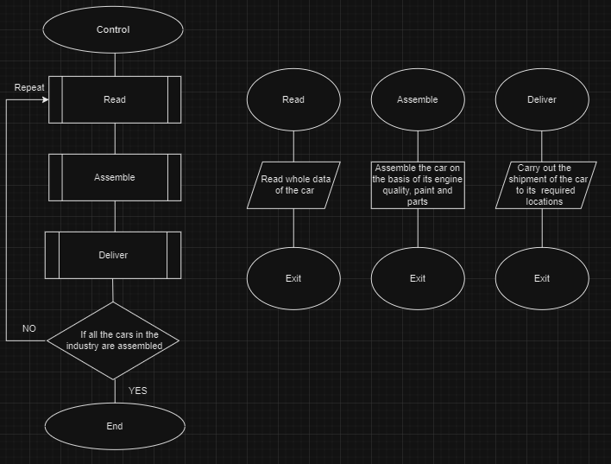***You are working at Toyota Indus Motors and want to assemble a car. Design a flowchart with proper process modules and decision structures to replicate a pipeline production.***

***OBJECTIVE 2: TASK 2:-***

***Take three variables as input and add them without using the + operator.***

START

INPUT Variable 1

INPUT Variable 2

INPUT Variable 3

SET sum to 0

ADD the three Variable

IF sum >0 THEN

PRINT “sum as positive”

ELSE

PRINT “sum as negative”

ENDIF

***OBJECTIVE 2: TASK 3:-***

***Create a small calculator which only does ‘+’ or ‘ –‘Operations. (Hint: Take three variable inputs with one being used for the operator)***

START

INPUT Variable 1

INPUT Variable 2

INPUT Variable 3

ASSUME that the third Variable is used for operator

IF the Variable 3==”+” THEN

ADD the other Variables

ELSE

IF the Variable 3==”-“ THEN

Take DIFFERENCE of the other Variables

ENDIF

ENDIF

***OBJECTIVE 3: TASK 1:-***

***Implement an algorithm for determining if an Nth is a divisor of an n Number (i.e. 2 is a divisor of 6). If so, determine if it’s an even number or odd number as well.***

1. Ask the user to input any number.
2. Ask the user to divide that the by 2.
3. If Number MOD 2= 0, then the number is “even”.
4. Else the input is an “odd” number.

***OBJECTIVE 3: TASK 3:-***

***Implement an algorithm for making a simple calculator with all the operators (+,-,*,/,%)***

1. Ask the user to input any 2 numbers.
2. Ask the user to use arithmetic operators ***(+,-,*,/,%)*** to formulate an arithmetic calculator.
3. To take the sum between the two Numbers add the operator “+”.
4. To take the difference between the two Numbers add the operator “-”.
5. To take the product between the two Numbers add the operator “*”.
6. To take the ratio between the two Numbers add the operator “/”.
7. To calculate the percentage of the given number, multiply it by “%”.
8. Display the result of the specific operation.
9. End.