Lab 04 and 05
Name: Syed Muhammad Wajeeh Hasan
Roll Number: 25K-0030
Section: BAI-1A
Repository Link:

Output of all Programs.

Question 1 Output:
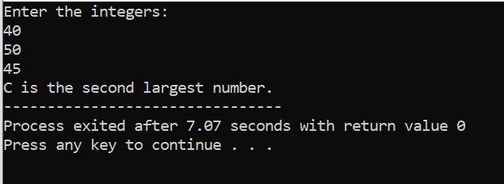
Question 2 Output:
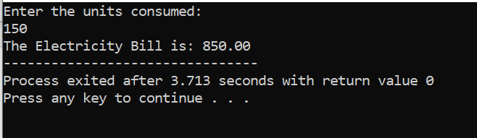

Question 3 Output:
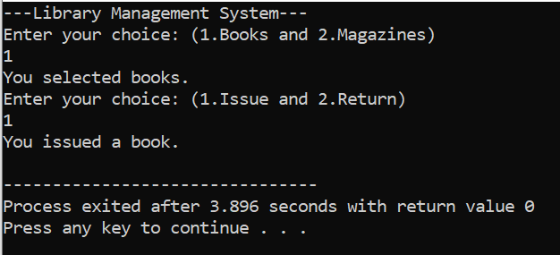
Question 4 Output:
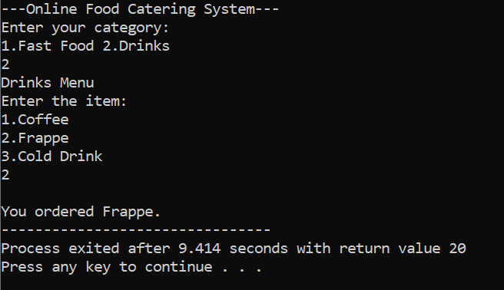

Question 5 Output:
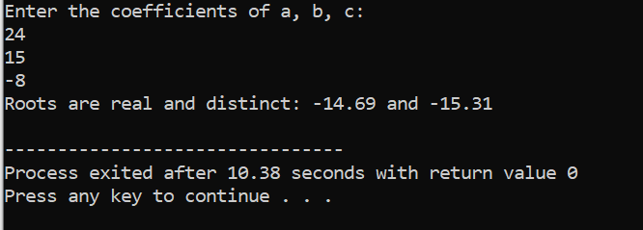
Question 6 Output:
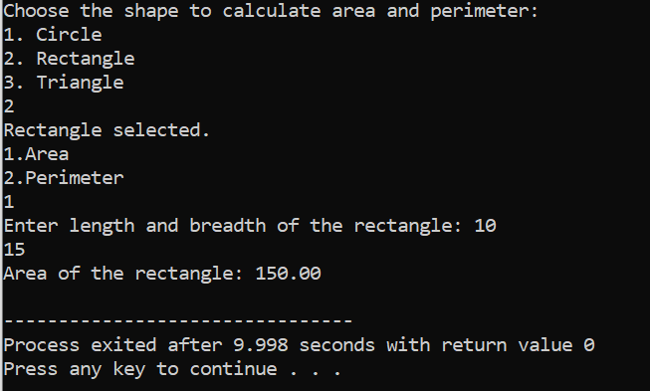

Question 7 Output:
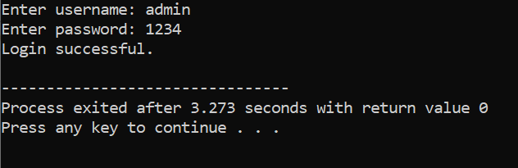
Question 8 Output:
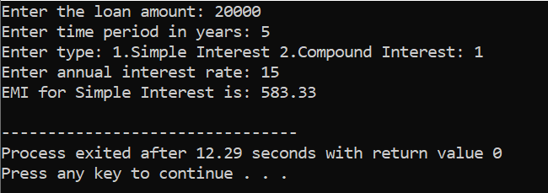

Question 9 Output:
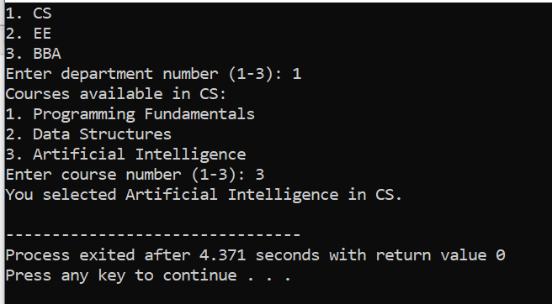
Question 10 Output:
