**Lab03 Homework**

**Name:** Syed Muhammad Wajeeh Hasan

**Roll Number:** 25k-0030

**Section:** BAI-1A

**Repository Link:** [**https://github.com/K250030-WajeehHasan/PFLab03HW.git**](https://github.com/K250030-WajeehHasan/PFLab03HW.git)

**Problem 1:**

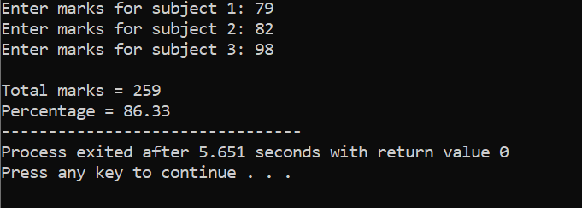

**Problem 2:**

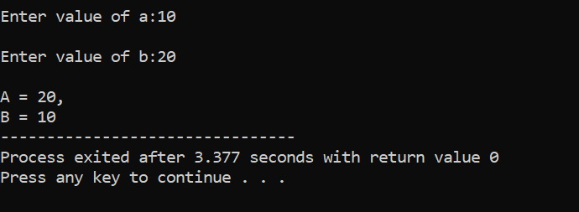

**Problem 3:**

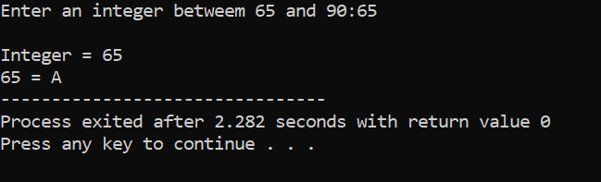

**Problem 4:**

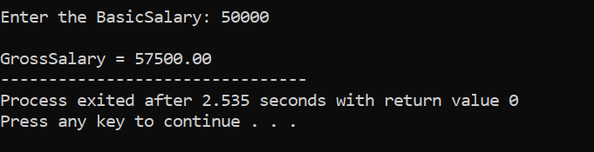

**Problem 5:**

