Final Project Report — Programming Fundamentals
University Name: KHI-FAST
Department: Department of Artificial Intelligence
Course: Programming Fundamentals
Project Title: Budget Tracker
Submitted By: Abdur Rafay Ahmed 25K-0048
Nehal Ali Khan 25K-0133
Submitted To: Ms. Ramsha Jat
Semester: Fall 2025
Date: 23/Nov/2025

Abstract
The Budget Tracking App is a GUI-based program developed in C language to keep record of expenses made by user so they can manage it more efficiently by keeping a track of it. It allows users to input their salary and savings along with the amount spent and their purpose. The system stores users expenses and show them a record of all previous expenses made, at users will. This project applies fundamental programming concepts such as decision structures, functions and file handling along with working with external libraries. It demonstrates how simple data handling and storage can replace manual calculations, excess usage of materials and reduce errors in managing user expenses.

1. Introduction
Managing personal finance is quite challenging when tracking them manually as most records are scattered or maybe lost. With this system user doesn’t have to worry about these things as data is stored and processed for them. All data is stored in a file and can generate a report showing expenses made, remaining budget and helpful suggestions when expenses go beyond limit. It’s an easy digital solution for managing everyday expenses.

2. Objectives
- To store and manage multiple user expenses efficiently.
- To calculate if expenses are exceeding remaining budget automatically.
- To display all expenses and total in a structured format.
- To reinforce programming concepts like arrays, functions and file handling.

3. System Design

System Overview
Flow of the program:
Start → Window Opens → Input Salary/ Savings → Store Expenses → Compute Bugdet and total expenses → Display Expenses and total → Provide suggestion → Exit at will

Algorithm
- Start the program
- User enters Salary along with monthly savings to be made.
- Input expenses and its reason and store it in a file.
- Report of previous expenses made is shown when user wants.
- User can clear previous records too.
- Program gives suggestions to control expneses when limit is exceeded.
- Program will end at users will.

Input & Output
Input: Salary, Savings to be made, Expenses made
Output: expenses made, Total of expenses, suggestions if needed

4. Implementation
Language: C
Compiler/IDE: MinGW / VsCode

Key Features
- Input multiple expenses and salary
- Calculate total expenses
- Report of expenses made
- Suggestions
- GUI based

Code Snippet
char* generate_line(char line[], char return_line[], int *cost){
char expense[15] = "\0";
int found = 0;
char reason[64] = "\0";

for (int i = 0; i < strlen(line); i++)
{
char temp[2];
temp[0] = line[i];
temp[1] = '\0';

if (line[i] == '_')
{
found = 1;
}
else if (found)
{
strcat(reason, temp);
}
else{
strcat(expense, temp);
}
}

(*cost) = atoi(expense);
strcat(return_line, expense);
strcat(return_line, " ---------- ");
strcat(return_line, reason);
return return_line;
}

Sample Output
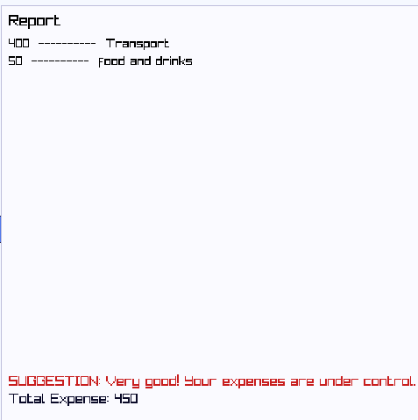

5. Testing & Results
The program performed successfully for every case. It stored expenses in a file efficiently displayed the report, and gave suggestions based on expenses made. Execution speed was near-instant, and the program required minimal system resources. 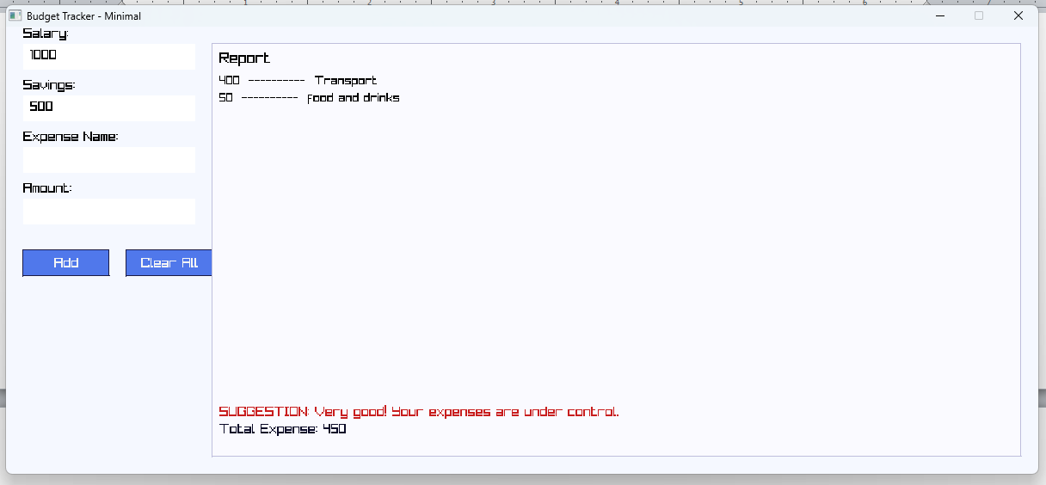

6. Conclusion, Limitations & References

Conclusion
The App is a simple and practical way to manage daily spending. Allows user to record expenses, view reports and to not exceed their budget with helpful suggestions. The project helped polish the skills required for file handling, working with functions and helping us understand how front end and backend work together.

Limitations
- Data cant be deleted or edited once stored
- Very general suggestions.

Future Enhancements
- Add data deletion and editing between records.
- Give suggestions to specific expenses which are high compared to others.

References
- Youtube Video : Get Started in raylib by Programming with Nick
- Chat GPT

