**LAB#03 TASK 01 TO 05 (OUTPUTS)**

**SUBMITTED BY: 25K-0095 MOHSINA ZEESHAN**

**TASK#01**

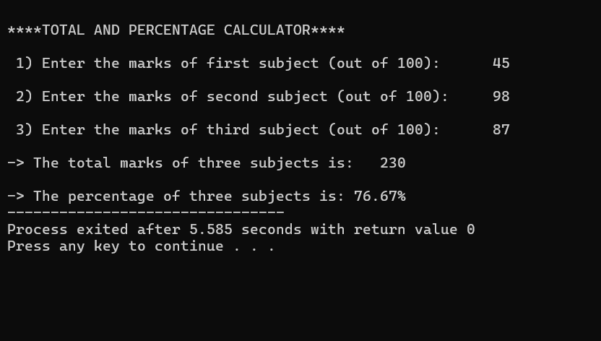

**TASK#02**

**TASK#03**

**TASK#04**

**TASK#05**

