ARDHI UNIVERSITY

DEPARTMENT OF COMPUTER SYSTEMS AND MATHEMATICS (CSM)
BACHELORS IN DATA SCIENCE AND ARTIFICIAL
INTELLIGENCE (Bsc. DSAi)
DA 181: PROBLEM SOLVING USING FUNDAMENTAL CONCEPTS OF DATA SCIENCE AND ARTIFICIAL INTELLIGENCE.

PROJECT TITLE: EF-02 FINANCIAL SENTIMENT ANALYSER FOR ECONOMIC FORECASTING

GROUP (5) MEMBERS :
S/N | FULL NAMES | REG.NO. | SIGNATURE
 | KITULA, KITULA-MASAGANYA ABDUL | 35552/T.2025
 | ILEKA, REVOCATUS OREST | 37058/T.2025
 | LYELLU, SABRINA RASHID | 37463/T.2025
 | IBRAHIM, GHADHAL NKRUMAH | 37254/T.2025

DECLARATION
We, the members of Group 5 , hereby declare that this report is our own work and effort. The work in this report was carried out in accordance with the Regulations of Ardhi University. We have faithfully acknowledged, given credit to, and referred to the research workers wherever their work has been cited in the text and the body of this project. We further certify that we have not willfully lifted another person's paragraph, text, data, or results reported in journals, books, magazines, reports, dissertations, theses, or available at websites and included them in this project and cited them as our own work.

S/no | Student’s Name | Signature | Date
1 | KITULA, Kitula-Masaganya Abdul | …………….……… | ………………..
2 | ILEKA, Revocatus Orest | …………………… | ………………..
3 | LYELLU, Sabrina Rashid | …………………… | ………………..
4 | IBRAHIM, Ghadhal Nkurumah | …………………… | ………………..

CERTIFICATION
The undersigned certify that they have read and hereby recommend for acceptance by Ardhi University a project titled: EF-02: Financial News Sentiment Analyser for Economic Forecasting, in fulfillment of the requirements for the accomplishment of first year studies at Ardhi University.

`

………………………………
Dr. Winfrida
(Supervisor)

Date: ……………….

……………………………….
Mr. Benitho
(Supervisor)

Date: ……………….

ACKNOWLEDGMENT

First and foremost, we thank Almighty God for giving us the strength and guidance to complete this project. We express our sincere gratitude to our supervisors, Mr. Benitho and Dr. Winfrida, for their advice, feedback, and support throughout the development of EF-02. Their guidance helped us structure our pipeline and present our findings in a clear academic manner.
We also thank Ardhi University and the Department of Computer Systems and Mathematics for providing the learning environment and resources that made this work possible. We acknowledge Daily News Tanzania and The Citizen for publishing the financial news used in this study, the National Bureau of Statistics (NBS) for CPI data, and Investing.com for historical USD/TZS exchange rate data. Finally, we thank Groq for providing API access to large language models used in headline classification.

LIST OF ABBREVIATIONS AND ACRONYMS

ARU : | Ardhi University
BOT : | Bank of Tanzania
CPI : | Consumer Price Index
CRISP-DM : | Cross Industry Standard Process for Data Mining
DSE : | Dar es Salaam Stock Exchange
FX : | Foreign Exchange
LLM : | Large Language Model
NBS : | National Bureau of Statistics
NLP : | Natural Language Processing
TZS : | Tanzanian Shilling
USD : | United States Dollar
VPC :  SDK : | Value Proposition Canvas  Software Development Kit

ABSTRACT
This project investigates whether sentiment in Tanzanian financial news headlines is related to macroeconomic movement, specifically the USD/TZS exchange rate and headline inflation, across 2022 to 2024.
A six-stage data science pipeline was implemented: web scraping from Daily News and The Citizen, data cleaning, model benchmarking, Groq-based LLM classification, monthly consolidation with CPI and USD/TZS series, and visualisation with Pearson correlation testing. The final production run classified 6,235 headlines, of which 5,163 (82.8%) were relevant, using an 11-category v5 prompt schema.
Monthly aggregates were produced for the full 36-month window (January 2022 to December 2024) after data completeness corrections. Benchmarking retained strong LLM performance (~93% sentiment accuracy on the benchmark set), but full-period macro correlation results were statistically weak.
No sentiment pair met the conventional 5% significance threshold in the final 36-month dataset. The largest observed association was Negative % vs USD/TZS Rate (r = -0.293, p = 0.083), followed by Net Sentiment vs USD/TZS Rate (r = 0.254, p = 0.135). Inflation relationships remained weak and non-significant.
The project provides a reproducible workflow for Tanzanian financial sentiment analytics, while highlighting that monthly-level sentiment signals should be interpreted cautiously due to modest sample size and limited statistical power.

TABLE OF CONTENTS
DECLARATION i
CERTIFICATION ii
ACKNOWLEDGMENT iii
LIST OF ABBREVIATIONS AND ACRONYMS iv
ABSTRACT v
TABLE OF CONTENTS vi
LIST OF TABLES ix
LIST OF FIGURES x
CHAPTER ONE: INTRODUCTION 1
1.1 General Introduction 1
1.2 Statement of the Problem 1
1.3 Objectives 2
1.3.1 General Objective 2
1.3.2 Specific Objectives 2
1.3.3 Value Proposition Canvas 3
1.4 Research Questions 4
1.5 Significance of the Study 5
1.6 Structure of the Report 5
CHAPTER TWO: LITERATURE REVIEW 6
2.1 Introduction 6
2.2 Related Studies 6
2.3 Research Gap 9
CHAPTER THREE: METHODOLOGY 10
3.1 Introduction 10
3.2.1 General Methodology 10
3.2.2 Methodology for Gathering User Requirements 10
3.2.3 Methodology for System Design 10
3.2.4 Methodology for System Implementation. 11
3.2.5 Methodology for System Testing and Validation 11
3.3 Methodology Table 12
CHAPTER FOUR: SYSTEM ANALYSIS AND DESIGN 13
4.1 Introduction 13
4.2 Requirement Analysis 13
4.2.1 System Requirements 13
4.2.1.1 Data Requirements 14
4.2.1.2 Software Requirements 15
4.2.1.3 Hardware Requirements 16
4.2.2.1 Functional Requirements 17
4.2.2.2 Non Functional Requirements 17
4.3 System Design 18
4.3.1 System Architecture 18
CHAPTER FIVE: IMPLEMENTATION AND TESTING 19
5.1 Introduction 19
5.2 Implementation 19
5.2.1 Web Scraper 19
5.2.2 Data Cleaning 20
5.2.3 Model Benchmarking 20
5.2.4 Production Classifier 21
5.2.5 Data Consolidation 22
5.2.6 Visualisation and Analysis 22
5.3 Testing 24
5.3 Testing 24
5.3.1 Functional Testing 24
5.3.2 Benchmark Testing 25
5.3.3 Statistical Validation 25
CHAPTER SIX: CONCLUSION AND RECOMMENDATION 27
6.1 Introduction 27
6.2 Conclusion 27
6.2.1 Classification Objective 27
6.2.2 Monthly Aggregation Objective 27
6.2.3 Correlation Objective 27
6.2.4 Visualisation Objective 27
6.2.5 Model Evaluation Objective 28
6.3 Challenges and Limitations 28
6.4 Recommendations 28
REFERENCES 29
APPENDIX 31

LIST OF TABLES
Table 1.1: Value Proposition Canvas for EF-02
Table 3.1: Methodology Table
Table 5.1: Model Benchmarking Results
Table 5.2: Functional Testing Results
Table 5.3: Pearson Correlation Results

LIST OF FIGURES
Figure 1.1: Value Proposition Canvas
Figure 5.1: Headline relevance split
Figure 5.2: Monthly sentiment distribution
Figure 5.3: Positive and Negative sentiment versus USD/TZS exchange rate
Figure 5.4: Pearson correlation matrix

CHAPTER ONE: INTRODUCTION

1.1 General Introduction
Sentiment analysis, also called opinion mining, is a branch of Natural Language Processing (NLP) that identifies subjective information in text. In finance, researchers study whether the tone of news, reports, and social media can help explain or predict economic behaviour. Loughran and McDonald (2011) showed that general purpose sentiment dictionaries perform poorly on financial text because many words carry special meanings in economics. Baker, Bloom, and Davis (2016) built an Economic Policy Uncertainty index partly from newspaper tone, which is now used in many countries.
In Tanzania, English language outlets such as Daily News and The Citizen publish regular business and financial news covering monetary policy, banking, trade, agriculture, energy, and foreign exchange. Despite this rich media output, computational analysis of Tanzanian financial news remains limited. Adelani et al. (2021) noted that African language and domain NLP resources are underdeveloped. This project applies data science methods to Tanzanian financial headlines from 2022 to 2024 and tests whether monthly sentiment patterns relate to official macroeconomic indicators published by the Bank of Tanzania and the National Bureau of Statistics.

1.2 Statement of the Problem
Financial news shapes how the public, investors, and policymakers understand the economy. Headlines about currency weakness, inflation, or banking performance can influence expectations even before official statistics are released. In Tanzania, this information exists in large volumes online, but it is mostly unstructured text.
Existing sentiment research focuses on Western markets and tools trained on Western financial language. Rule based models and even FinBERT struggle with Tanzanian economic phrasing. There is also no published study that correlates Tanzanian financial media sentiment with BOT reported inflation and the USD/TZS exchange rate over a multi year period.
This project addresses the gap by building a reproducible pipeline that scrapes local news, classifies headlines using a large language model, merges results with official economic data, and tests statistical relationships through correlation analysis and visualisation.

1.3 Objectives

1.3.1 General Objective
The general objective of this project is to investigate whether sentiment expressed in Tanzanian financial news media is meaningfully correlated with movements in the USD/TZS exchange rate and CPI inflation over the period 2022 to 2024.

1.3.2 Specific Objectives
- To apply a pre-trianed NLP model to financial news headlines by topic category and economic sentiment label.
- To compute monthly average sentiment scores aggregated from the labelled headline dataset across the study period.
- To correlate monthly sentiment scores with NBS published CPI inflation and USD/TZS exchange rate data using Pearson correlation.
- To visualise the relationship between media sentiment trends and macroeconomic movements through time series plots and correlation charts.
- To evaluate the performance and suitability of NLP approaches, including rule based tools, FinBERT, and LLMs, for Tanzanian financial text.

1.3.3 Value Proposition Canvas
A Value Proposition Canvas (VPC) is a tool that links what users need with what a product offers. It helps clarify who benefits from a system and why it matters. For EF-02, the canvas below maps stakeholders, their problems, desired outcomes, and the project deliverables.

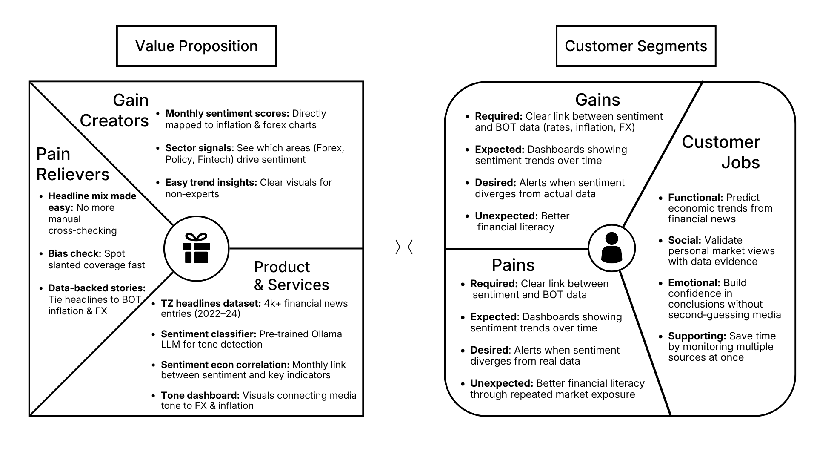
Figure 1.1: Value proposition canvas FOR EF-02

The value proposition: addresses these needs through a six-notebook pipeline powered by a pre-trained Ollama LLM classifier and a dataset of over 4,000 Tanzanian financial news entries (2022–24) as detailed in Figure 1.1. This system acts as a pain reliever by utilizing local news sources tuned for economic outcomes, which eliminates manual cross-checking and filters out slanted media bias. Additionally, it serves as a gain creator by delivering interactive charts, tone dashboards, and correlation tables that map monthly sentiment scores directly to inflation and forex charts, providing a highly replicable framework for East African financial NLP.
The customer segment: comprises policymakers, economists, investors, researchers, and data science students who need to track currency pressure and inflation trends ahead of official data releases. These users seek to predict economic trends, validate market views, and save time by monitoring multiple media sources simultaneously. Currently, they are hindered by delayed official statistics, unstructured news data, and Western-biased NLP tools. To overcome these pains, they require clear links between media sentiment and macro indicators, expecting comprehensive dashboards that track sentiment trends over time to improve financial literacy

1.4 Research Questions
RQ1: Can a large language model accurately classify Tanzanian financial headlines by topic and economic sentiment?
RQ2: Do monthly sentiment scores show a statistical relationship with the USD/TZS exchange rate?
RQ3: Do monthly sentiment scores show a statistical relationship with CPI inflation?
RQ4: Which NLP approach performs best on Tanzanian financial text compared to rule based and transformer models?
RQ5: What limitations affect the reliability of the sentiment signal in this study?

1.5 Significance of the Study
Upon completing this study, the following benefits are expected:
- It contributes local evidence on whether financial media sentiment relates to Tanzanian macro indicators.
- It demonstrates a practical data science pipeline that students and researchers can extend to other sectors.
- It highlights the need for African context NLP tools rather than relying only on Western trained models.
- It supports early awareness of currency and inflation trends for academic and policy discussion.
- It builds skills in scraping, prompt engineering, time series analysis, and visualisation.

1.6 Structure of the Report
- Chapter One introduces the problem, objectives, research questions, and significance.
- Chapter Two reviews related literature and identifies the research gap.
- Chapter Three explains the methodology and tools used.
- Chapter Four presents system requirements and architecture.
- Chapter Five describes implementation, results, and testing.
- Chapter Six provides conclusions, limitations, and recommendations.

CHAPTER TWO: LITERATURE REVIEW

2.1 Introduction
A literature review surveys existing research to show what is already known about a topic and where gaps remain. It helps justify the methods chosen and positions this project within academic discourse. This chapter reviews studies on financial sentiment analysis, NLP methods, links between media tone and macroeconomic indicators, and research in the African context.

2.2 Related Studies
2.2.1 Finance-Specific Sentiment Lexicon (Loughran and McDonald, 2011)
Loughran and McDonald (2011) argued that using general-purpose dictionaries to analyse financial text produces unreliable results. Words like "liability" or "risk" carry negative connotations in everyday language but are routine and neutral in financial reporting. To address this, they built a sentiment lexicon designed specifically for financial documents. Their work showed that domain-specific vocabulary matters a great deal when classifying tone in financial text, and it remains one of the most widely referenced resources in financial NLP. For EF-02, this study reinforces the importance of being careful about how sentiment labels are assigned to Tanzanian financial headlines, where general tools may similarly misread local financial language.

2.2.2 Media Tone and Stock Market Returns (Tetlock, 2007)
Tetlock (2007) took a column from the Wall Street Journal and measured the tone of its language over time. He found that when the column was more pessimistic than usual, stock prices tended to fall the following day. This was an early and influential demonstration that media sentiment is not just background noise it carries real information that markets respond to. The study helped establish media tone as a legitimate variable in financial analysis, which is a core assumption that EF-02 builds on when treating Tanzanian news headlines as signals worth measuring.

2.2.3 Public Mood and Market Movement (Bollen, Mao and Zeng, 2011)
Bollen, Mao, and Zeng (2011) moved the conversation from traditional media to social media. They collected Twitter data and used a psychological mood measurement tool called POMS to track the emotional state of the public over time. Their finding was that a specific mood dimension calmness preceded movements in the Dow Jones Industrial Average by two to six days. This study broadened the idea that sentiment does not have to come from formal financial reporting to be useful, and it showed that collective public mood can be a leading indicator of market behaviour.

2.2.4 BERT and Contextual Language Understanding (Devlin et al. 2018)
Devlin et al. (2018) introduced BERT, a transformer-based language model that reads text in both directions simultaneously, giving it a much stronger understanding of context than earlier tools. Before BERT, most NLP models read text left to right and struggled with sentences where meaning depended on words that came later. BERT changed this and became the foundation for nearly all modern NLP work that followed. It is directly relevant to EF-02 because the models used in this project, including FinBERT and Llama 3, are built on the same transformer architecture that BERT established.

2.2.5 FinBERT and Domain-Specific Fine-Tuning (Araci, 2019)
Araci (2019) took BERT and fine-tuned it on financial text to create FinBERT. The motivation was straightforward: a general language model trained on broad internet data may not perform well on the specific vocabulary and structure of financial reporting. By training on financial corpora, FinBERT outperformed general sentiment tools on financial benchmarks by a meaningful margin. This study makes a clear case that domain-specific training improves classification quality, which is a principle EF-02 applies when using an instruction-tuned LLM with a finance-focused prompt rather than a generic sentiment classifier.

2.2.6 News tone as a Macroeconomic Indicator (Shapiro, Sudhof, and Wilson, 2022)
Shapiro, Sudhof, and Wilson (2022) built a monthly sentiment index by processing thousands of newspaper articles and tracking how the tone of coverage changed over time. They found that this index had predictive power for macroeconomic outcomes including GDP growth and unemployment in the United States. This is the study that sits closest to what EF-02 is attempting. Where Shapiro et al. worked at scale with US data, EF-02 applies a similar logic to a much smaller and less studied context tracking whether the tone of Tanzanian financial news aligns with movements in local indicators like CPI and the TZS/USD exchange rate.

2.2.7 Financial News Sentiment in Kenya (Muriungi and Kimani, 2020)
Muriungi and Kimani (2020) conducted a sentiment analysis of Kenyan financial news and found a moderate correlation between media tone and the KES/USD exchange rate. This is the most geographically relevant study in this review, as Kenya shares many economic and media characteristics with Tanzania. Their findings suggest that the relationship between news sentiment and currency movement is detectable even in East African markets with limited data availability. EF-02 is partly motivated by the absence of an equivalent study for Tanzania, and Muriungi and Kimani's work provides a useful regional benchmark against which EF-02's findings can eventually be compared.

2.2.8 NLP Resource Gaps in African Languages (Adelani et al. 2021)
Adelani et al. (2021) documented how severely underrepresented African languages and contexts are in NLP research. Datasets, benchmarks, and pre-trained models are overwhelmingly built around English and a small number of high-resource languages, leaving African researchers with tools that were not designed for their data. While EF-02 operates primarily in English, it works with Tanzanian sources, local institutions, and economic indicators that mainstream NLP tools were not built with in mind. Adelani et al.'s work frames exactly the kind of gap that projects like EF-02 begin to address, even in a small way.

2.3 Research Gap
The literature review reveals four main gaps that EF-02 addresses:
- Most sentiment analysis research in finance has been conducted using data from developed markets, particularly the United States and Western Europe. There is very little equivalent work done using African financial news as the primary data source.
- The only East African study in this review is Muriungi and Kimani (2020), and that focuses on Kenya. Tanzania has not been the subject of a comparable study despite having its own distinct financial media landscape and macroeconomic environment.
- No fine-tuned language model exists for Tanzanian or East African financial text. Projects like EF-02 must rely on general instruction-tuned LLMs with carefully constructed prompts as a substitute for true domain adaptation.
- Lexicons such as the one developed by Loughran and McDonald (2011) were built using American financial documents. Their applicability to Tanzanian financial reporting, which reflects different institutions and terminology, has not been tested.
- There are no publicly available labelled datasets of Tanzanian financial headlines that could be used to train or evaluate a classifier, which Adelani et al. (2021) would recognise as consistent with the broader African NLP resource gap.
- The TZS/USD pair has not been analysed through a media sentiment lens despite Tanzania's dependence on imports and foreign currency flows, leaving a clear gap in the local economic literature. .

CHAPTER THREE: METHODOLOGY

3.1 Introduction
This chapter outlines the methodology used to design, implement, and validate the project's financial NLP pipeline. It explains the process of gathering requirements, preparing the headline dataset, and developing the system architecture. The following sections detail the technical deployment of the sentiment classifier and its correlation with macroeconomic indicators.

3.2.1 General Methodology
The project followed CRISP-DM (Cross Industry Standard Process for Data Mining), adapted with an iterative rebuild approach. CRISP-DM covers business understanding, data understanding, data preparation, modelling, evaluation, and deployment. This life cycle fits a pipeline that moves from raw news text to labelled data, merged monthly series, and visual insights. The team first benchmarked models on sample data, then scraped full headlines, then ran production classification, as recorded in the project decision log.

3.2.2 Methodology for Gathering User Requirements
Requirements were gathered through literature review, inspection of Tanzanian news websites, and comparison of data availability. Daily News and The Citizen were selected because they cover 2022 to 2024 and allow requests based scraping. IPP Media was excluded because its archive lacked full range coverage. Other local news outlets lacked publicly available archives for news headlines in that period.

3.2.3 Methodology for System Design
The system was developed as a modular notebook-based pipeline with clear inputs and outputs at each stage. Each notebook performs a specific task, including scraping, cleaning, benchmarking, classification, consolidation, and visualization. This modular structure improves maintainability and preserves data integrity. The final notebook acts as the complete project output, combining results from all previous stages into a single summary and presenting the overall findings of the workflow.

3.2.4 Methodology for System Implementation.
The system was implemented using Python and Jupyter Notebook due to their suitability for data science workflows and ease of experimentation. Python was selected because of its extensive ecosystem of libraries for our workflow. Libraries such as requests and BeautifulSoup were used for web scraping, pandas for data cleaning and consolidation, openai and groq SDKs for sentiment classification, and matplotlib for visual analysis. Jupyter Notebook was chosen to structure the project into sequential modules and provide a proper virtual environment for testing, allowing each phase benchmarking, scraping, cleaning, classification, consolidation, and visualization to be developed, tested, and executed independently while maintaining a clear and reproducible workflow.

3.2.5 Methodology for System Testing and Validation
The system was tested and validated using benchmark testing and output validation methodologies. Benchmark testing was used to evaluate the performance of different sentiment classification models by comparing their predictions against labelled sample data to determine the most accurate approach. Output validation was applied throughout the pipeline to verify that generated outputs matched expected formats and conditions, such as correct label values, batch completeness, and successful data merging. These methodologies were selected to ensure the system produced reliable results, maintained data quality across all processing stages, and selected the most suitable model before deployment on the full dataset.

3.3 Methodology Table
Table 3.1: Methodology Table
Specific Objective | Methodology | Tools | Deliverable
Gather financial news headlines | Web scraping | requests, BeautifulSoup | dailynews_raw.csv, citizen_raw.csv,
Clean and unify headline data | Merging and cleaning scrapped data | pandas | tz_headlines_clean.csv
Comparing available NLP Models | Multi model accuracy comparison on labeled data | TextBlob, VADER, FinBERT, GPT-mini 4.0, Llama-3.1B & 3.3B | benchmarking_results.csv
Classify headlines by category and sentiment | LLM processing and api retrieval | Groq API,  Llama -3.1B | tz_headlines_labelled.csv
Consolidating news and aggregating data | Monthly aggregation and dataset merging | pandas | Visualization_Data.csv
Analyse sentiment vs economy | Time series plots and Pearson correlation | matplotlib, seaborn, scipy | Visualisation notebook, Project analysis and conclusion

Table 1.1: Methodology Tables For EF-02

CHAPTER FOUR: SYSTEM ANALYSIS AND DESIGN

4.1 Introduction
This chapter presents the analysis and implementation requirements of the proposed system for Tanzanian financial news sentiment analysis. It describes the requirements identified before development and explains the resources needed for successful system operation. The chapter also outlines the system and data requirements used to support data collection, processing, sentiment classification, and visualisation of findings. These requirements formed the foundation for a complete project workflow.

4.2 Requirement Analysis
Requirement analysis is the process of identifying, evaluating, documenting, and managing the needs and constraints of a system to ensure that it fulfills its intended objectives (Sommerville, 2016). It helps ensure that the developed system satisfies both operational and technical expectations before implementation begins. For this project, requirement analysis focused on two major categories:
- User requirements: defines what end users expect from the system
- System requirements: define the technical capabilities and resources necessary to support system functionality.

4.2.1 System Requirements
System requirements refer to the technical specifications and resources needed for a system to operate effectively and achieve its intended functions (Pressman & Maxim, 2020). They define the environment and conditions required to develop, execute, and maintain the system successfully. For this project, system requirements were analysed under three categories:
- Hardware Requirements: The physical computing infrastructure needed to execute system workloads and data computations.
- Software Requirements: The platforms, tools, and libraries required to provide development and analytical capabilities.
- Data Requirements: The raw inputs and datasets necessary to perform sentiment classification and economic analysis.

4.2.1.1 Data Requirements
The system used multiple datasets collected from publicly available sources to support financial sentiment analysis and economic correlation assessment for the period 2022–2024. The data was collected, processed, and consolidated into a final dataset used for analysis and visualisation.
The following data types were collected and used:
- News Headlines: Collected through web scraping from the business sections of Daily News Tanzania and The Citizen. The dataset included publication date, headline text, article URL, and source. It was used for sentiment classification, category assignment, and monthly sentiment analysis.

- USD/TZS Exchange Rate Data: Daily exchange rate data was collected from Investing.com and converted into monthly averages with month-on-month percentage changes. This data was used to analyse currency movement against news sentiment trends.

- Consumer Price Index (CPI) Data: Monthly inflation data was collected from NBS Tanzania CPI reports (2022–2024). This dataset was used to compare inflation behaviour with aggregated sentiment results.

- Labelled Sample Dataset: Synthetic and test headlines were prepared and used during benchmarking to evaluate sentiment classification models before full dataset processing.

- Processed Sentiment Dataset: Generated after classification and consolidation, containing sentiment labels, categories, and monthly aggregates used for final visualisation and correlation analysis.

4.2.1.2 Software Requirements
Software requirements refer to the applications and development tools required for implementing, executing, and maintaining a system successfully (Pressman & Maxim, 2020). These tools provide the environment necessary for data collection, processing, classification, analysis, and visualisation.
The following software was used in this project:
- Python 3: Used as the primary programming language for implementing all stages of the project pipeline due to its flexibility and strong support for data science applications.

- Jupyter Notebook: Used as the development environment to build and execute the project in modular stages while supporting reproducibility and easier testing.

- Python Libraries: Several libraries were used to support implementation:
  - pandas: data cleaning, merging, and monthly aggregation.
  - requests and BeautifulSoup: web scraping and HTML parsing.
  - Openai and Groq SDK : API pipelines for accessing LLMs.
  - matplotlib and seaborn: charts and visual analysis.
  - Scipy: Pearson correlation and p-value calculations.
  - Python-dotenv: secure loading of API keys from environment files.

4.2.1.3 Hardware Requirements
Hardware requirements refer to the physical computing resources required to develop, execute, and maintain a system effectively (Pressman & Maxim, 2020). For this project, no specialised hardware was required since model inference was performed through Groq cloud servers.
The following hardware resources were sufficient:
- Laptop/Desktop Computer: A standard personal computer was used to develop and run all project notebooks, perform web scraping, process datasets, and generate visualisations.

- Memory (RAM): At least 8 GB RAM was sufficient to support data cleaning, aggregation, classification workflows, and notebook execution.

- Storage: Local storage was required to store notebooks, CSV datasets, and generated outputs. Storage requirements remained low since processed datasets were below approximately 50 MB.

- Internet Connection: Required for web scraping, accessing external datasets, and communicating with Groq APIs for sentiment classification.
No dedicated GPU was required because large language model inference was executed on Groq cloud infrastructure rather than locally.

4.2.2.1 Functional Requirements
The system shall scrape and store financial news headlines together with publication date, source, and article URL.
- Headline Classification: The system shall filter irrelevant headlines and assign both economic categories and sentiment labels (Positive, Negative, Neutral).
- Sentiment Aggregation: The system shall aggregate relevant headlines into monthly sentiment indicators and distributions.
- Data Consolidation: The system shall merge sentiment outputs with CPI inflation and USD/TZS exchange rate datasets.
- Visualisation and Analysis: The system shall generate charts and correlation statistics to support interpretation of relationships between financial news sentiment and economic indicators.
- Scraping Recovery Support: The system shall support checkpointing and resume capability during long scraping sessions to minimise data loss from interruptions.

4.2.2.2 Non Functional Requirements
Non-functional requirements describe the quality attributes and operating conditions that determine how effectively a system performs its functions (Sommerville, 2016). Unlike functional requirements, they focus on characteristics such as reliability, usability, maintainability, and security rather than specific system operations.
- Reproducibility: The system shall support repeatable execution through a numbered notebook pipeline with documented inputs and outputs at each stage.
- Security: The system shall protect sensitive credentials by storing API keys in environment files (.env) and excluding them from version control.
- Reliability: The system shall maintain stable execution through batch retries, validation checks, and checkpoint saving to handle network and API interruptions.
- Usability: The system shall present outputs through clear notebook sections, structured summaries, and readable visualisations without code.
- Maintainability: The system shall use a modular notebook structure so that individual stages can be modified without affecting the entire workflow.
- Transparency: The system shall document known limitations and data quality considerations within the final analysis stage to support interpretation of results.

4.3 System Design

4.3.1 System Architecture
System architecture refers to the high-level structure of a system that defines its components, their relationships, and the flow of data and processes between them (Sommerville, 2016). It provides a blueprint for how system components interact to achieve the intended objectives and supports understanding, implementation, maintenance, and future improvements. For this project, the system architecture was included to illustrate the complete workflow of the financial news sentiment analysis pipeline and show how data moves from collection through processing, classification, consolidation, and final analysis.
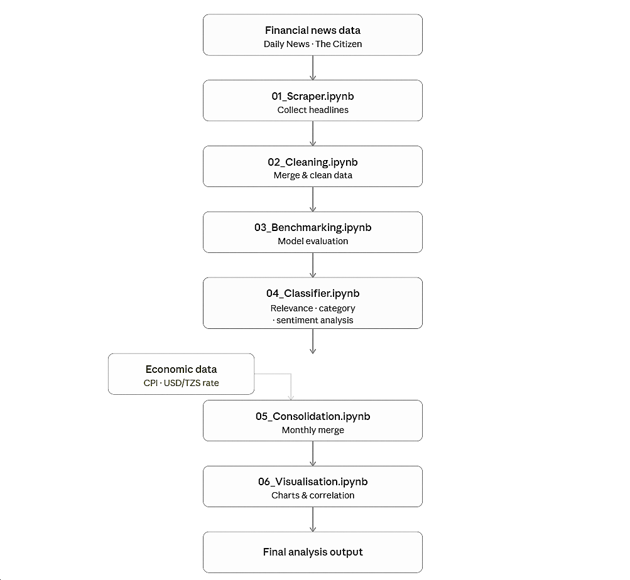
Figure 4.1: System Architecture for EF-02.

CHAPTER FIVE: IMPLEMENTATION AND TESTING

5.1 Introduction
This chapter presents the implementation of the proposed financial news sentiment analysis system. It describes the major system components, their functions, and how they operate within the complete workflow. The chapter also demonstrates how data moves through the system from collection to final analysis and presents screenshots to illustrate implementation outcomes.

5.2 Implementation

5.2.1 Web Scraper
This module was implemented using Python with requests and BeautifulSoup to collect financial news headlines from Daily News Tanzania and The Citizen. The scraper automatically extracted publication date, headline text, article URL, and source information from business category pages covering 2022–2024. The module supports checkpoint saving and resume functionality to reduce data loss during long scraping sessions.
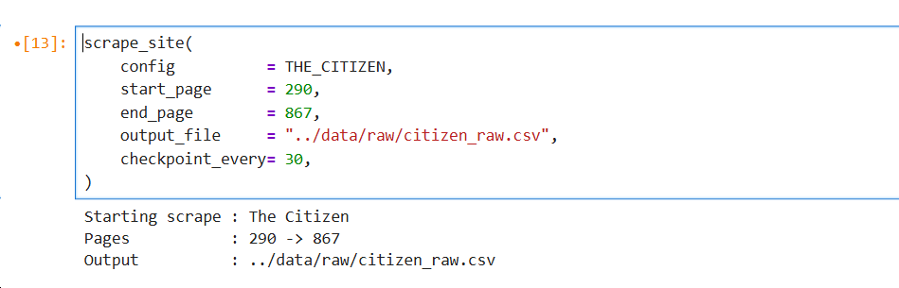
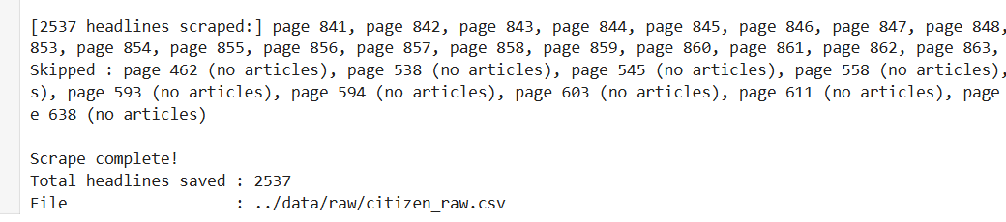
Figure 5.1: Screenshots showing the initiation and termination of headline scrapping function for EF-02.

5.2.2 Data Cleaning
This module merged headline datasets collected from different sources into a unified dataset. It performed date standardisation, duplicate removal, and filtering of malformed records to improve data quality before classification of the news headlines.
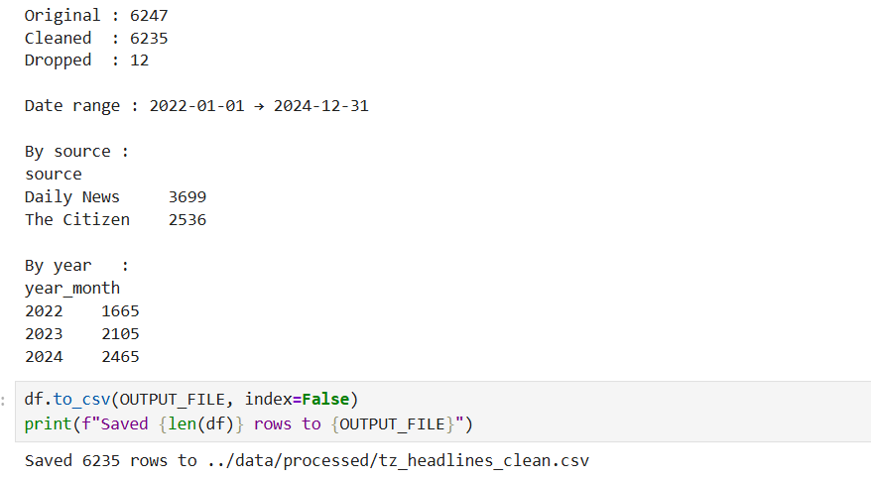
Figure 5.2: Screenshots showing succesful data cleaning for EF-02.

5.2.3 Model Benchmarking
This module evaluated multiple sentiment classification approaches using a labelled sample dataset. Models including TextBlob, VADER, FinBERT, and LLM-based approaches were compared to identify the most suitable model for production use based on classification performance.
Model | Accuracy (%)
TextBlob | 28.2 %
VADER | 50.0 %
FinBERT | 66.7 %
GPT-4o-mini | 92.9 %
Llama 3.1 8B (Groq) | 92.7 %
Llama 3.3 70B (Groq) | 93.5 %
Table 5.1: Model Benchmarking Results

5.2.4 Production Classifier
The production classifier (04_classifier.ipynb) uses the Groq API with Llama models. Each API call processes 25 headlines and returns a JSON array with relevance, category (one of nine: Forex, Policy, Banking, Trade, Agriculture, Energy, Transport, Investment, General), and sentiment (Positive, Negative, Neutral) based on implied economic outcome. Batch size is 25 with up to 3 retries. Temperature is set to 0 for consistent output. Of 5,310 headlines, 72.2% were marked relevant (3,836). Among relevant headlines, Neutral was most common (2,398), followed by Positive (1,114) and Negative (323). Top categories included Banking (785), Agriculture (593), Trade (580), General (551), and Policy (508).
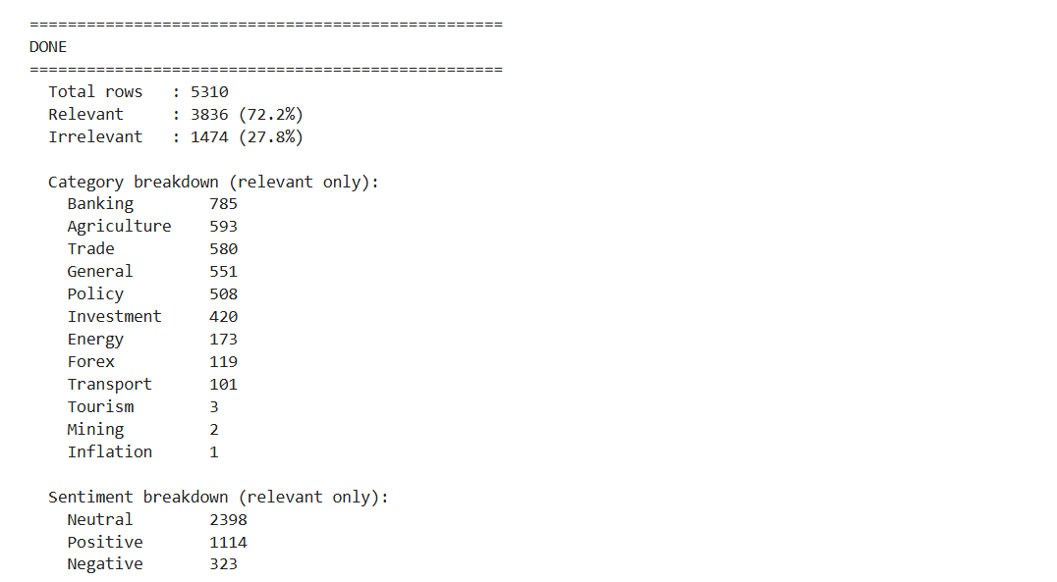
Figure 5.2: Screenshots showing Results after classification for EF-02.

5.2.5 Data Consolidation
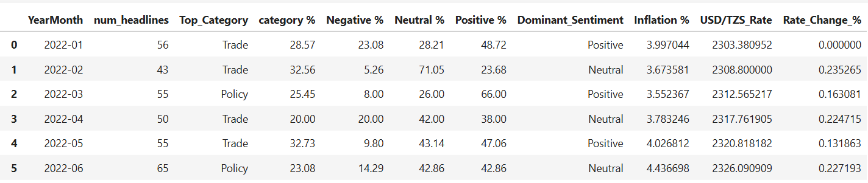
The consolidation notebook (05_consolidation.ipynb) drops irrelevant headlines, groups by YearMonth, and computes num_headlines, category shares, sentiment percentages, and dominant sentiment per month. It merges with monthly CPI inflation and average USD/TZS rate. The final dataset has 3 monthly rows from March 2022 to December 2024.
Figure 5.2: Screenshots showing fully consolidated dataset for EF-02.

5.2.6 Visualisation and Analysis
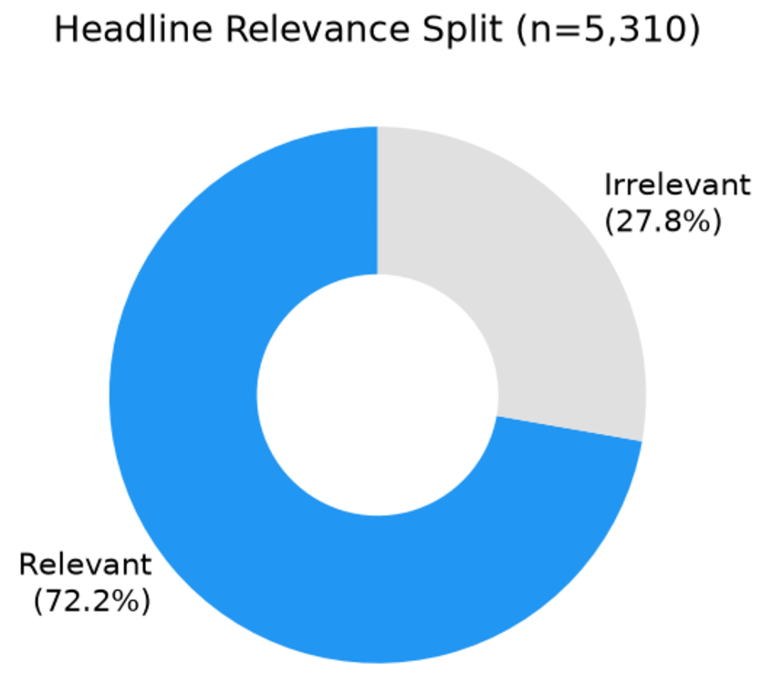
The visualisation notebook (06_visualisation.ipynb) presents eight sections: raw data summary, monthly overview, sentiment distribution, economic indicators, dual axis sentiment versus economy charts, Pearson correlation heatmap, a ranked correlation table with p values, and a limitations section. Inflation ranged from 2.96% to 4.94%. USD/TZS ranged from about 2,313 to 2,720 TZS per dollar.
Figure 5.1: Headline relevance split (Relevant 72.2%, Irrelevant 27.8%)
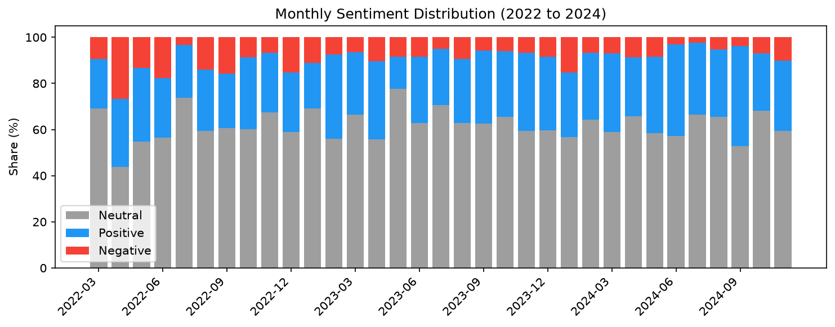
Figure 5.2: Monthly sentiment distribution (Neutral, Positive, Negative shares)

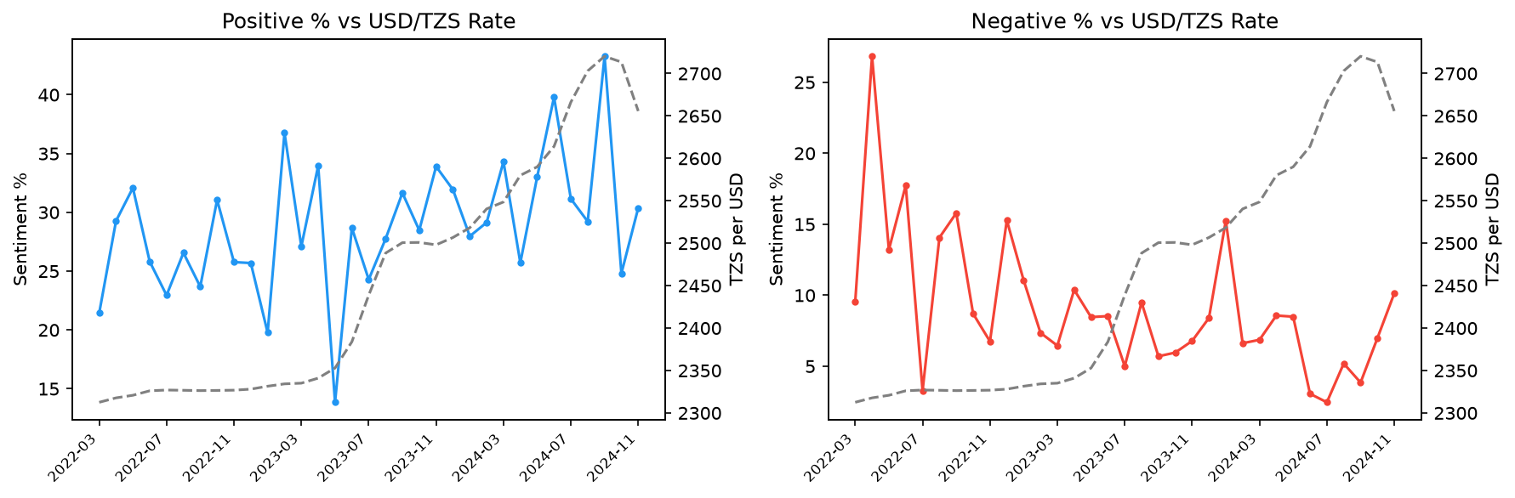
Figure 5.3: Positive and Negative sentiment versus USD/TZS exchange rate
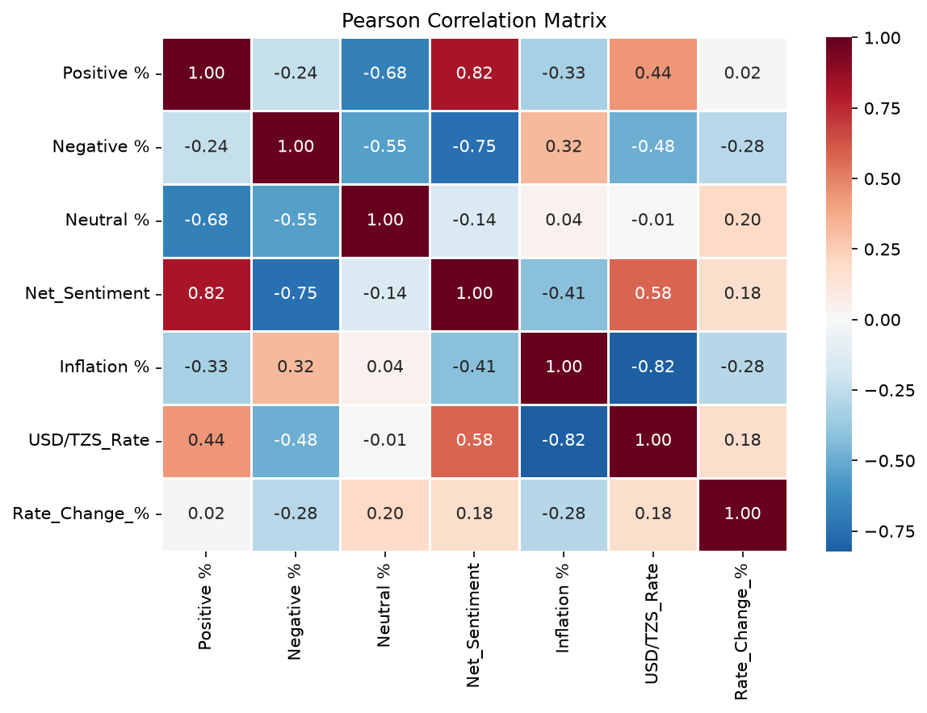
Figure 5.4: Pearson correlation matrix for sentiment and economic variables

5.3 Testing

5.3 Testing
System testing was conducted to verify that the implemented pipeline executed correctly and produced reliable outputs on the final Groq run (6,235 headlines, 5,163 relevant headlines, and 36 monthly aggregates). Testing methods included functional testing, benchmark testing, and statistical validation.

5.3.1 Functional Testing
Functional testing verified that each major system function produced the expected output on the final end-to-end run. The results are summarised in Table 5.2.
S/N | Functional Requirement | Expected Outcome | Test Results
1. | News Collection | System collects and stores headlines with date, source, and URL | Passed
2. | Headline Classification | System assigns relevance, category, and sentiment labels | Passed
3. | Sentiment Aggregation | System produces monthly sentiment distributions | Passed
4. | Data Consolidation | System merges sentiment, CPI, and USD/TZS datasets correctly | Passed
5. | Visualisation and Analysis | System generates charts and correlation outputs | Passed

Result: All functional requirements passed and produced outputs consistent with the intended system behaviour.

5.3.2 Benchmark Testing
Benchmark testing was used during model selection to compare sentiment classification performance before production deployment. The tested models included TextBlob, VADER, FinBERT, and LLM-based approaches.

Model | Approximate Accuracy
TextBlob | ~28%
VADER | ~50%
FinBERT | ~67%
LLM-based Classification | ~92%

Result: The benchmark confirmed that the selected LLM-based approach was the most reliable for Tanzanian financial headlines. Production deployment used a prompt with an 11-category schema and post-classification retry checks to ensure complete relevance/category/sentiment labels.

5.3.2 Statistical Validation
Pearson correlation measured linear association between monthly sentiment variables and economic indicators using the full 36-month dataset (January 2022 to December 2024). Results are summarised in Table 5.3.

Table 5.3: Pearson Correlation Results (Sentiment vs Economic Indicators)
Rank | Pair | Pearson r | p value | Significance
1 | Negative % vs USD/TZS Rate | -0.293 | 0.0831 | Not significant
2 | Net Sentiment vs USD/TZS Rate | 0.254 | 0.1348 | Not significant
3 | Positive % vs USD/TZS Rate | 0.139 | 0.4185 | Not significant
4 | Negative % vs Inflation % | 0.139 | 0.4202 | Not significant
5 | Net Sentiment vs Inflation % | -0.083 | 0.6304 | Not significant
6 | Positive % vs Inflation % | -0.023 | 0.8943 | Not significant

All tested sentiment-economy pairs were not statistically significant at the 5% level. The largest magnitude was Negative % vs USD/TZS Rate (r = -0.293, p = 0.083), while inflation pairs remained weak. Month-on-month Rate_Change_% pairs also remained non-significant. Visual co-movement appears in parts of 2023-2024, but the full-sample statistics do not support a robust monthly coupling.
All month-on-month Rate_Change_% pairs were also non-significant, indicating no robust short-term FX-volatility linkage with monthly sentiment.

CHAPTER SIX: CONCLUSION AND RECOMMENDATION

6.1 Introduction
This chapter summarises project outcomes against each objective using the final Groq production run, then discusses limitations and practical recommendations.

6.2 Conclusion

6.2.1 Classification Objective
The project successfully classified 6,235 Tanzanian financial headlines using a Groq-hosted large language model. Benchmarking showed LLM sentiment accuracy near 93%, and the final production output retained 5,163 relevant headlines (82.8%). The deployed v5 prompt used an 11-category schema with explicit retry checks to avoid incomplete labels.

6.2.2 Monthly Aggregation Objective
Monthly sentiment indicators were computed for the full 36 months from January 2022 to December 2024. The merged dataset combines headline counts, category dominance, sentiment shares, inflation, and exchange rate in one table suitable for time-series analysis.

6.2.3 Correlation Objective
Statistical testing did not find significant monthly correlation between sentiment and macroeconomic indicators at the 5% level. The strongest observed pair was Negative % vs USD/TZS Rate (r = -0.293, p = 0.083), followed by Net Sentiment vs USD/TZS Rate (r = 0.254, p = 0.135). Inflation relationships remained weak and non-significant.

6.2.4 Visualisation Objective
Visualisations showed neutral and positive sentiment alternating as dominant across the 36-month period, with net sentiment remaining positive but variable. USD/TZS rose through much of 2023-2024, and some concurrent movement with sentiment was visible; however, this was not statistically robust in full-sample testing.

6.2.5 Model Evaluation Objective
LLMs remained the most suitable approach for Tanzanian financial sentiment classification compared with rule-based methods and FinBERT. The production workflow used the updated v5 schema (11 categories), and evaluation on the labelled gold sample showed strict 3-in-1 performance around 69% for the Groq production model, with stronger sentiment-only benchmark accuracy.

6.3 Challenges and Limitations
Key limitations include modest monthly sample size (n = 36), which reduces statistical power; sentiment distribution compression where neutral and positive shares are often close; and operational API constraints (rate limits and retries) during long classification runs. Domain-specific wording in Tanzanian business reporting also remains challenging for non-LLM tools.

6.4 Recommendations
Future work should expand temporal granularity (e.g., weekly aggregation) to increase statistical power, broaden source coverage beyond the two newspapers, and include periodic human validation samples for label quality assurance. Extending the study window beyond 2024 may also improve robustness of sentiment-macro inference.

REFERENCES
Adelani, D. I., Abbott, J., Neubig, G., Dossou, B. F. P., Alabi, J. O., Masinde, W., ... & Buzaaba, H. (2021). MasakhaNER: Named entity recognition for African languages. Transactions of the Association for Computational Linguistics, 9, 1116–1131.
Araci, D. (2019). FinBERT: Financial sentiment analysis with pre-trained language models. arXiv preprint arXiv:1908.10063.
Baker, S. R., Bloom, N., & Davis, S. J. (2016). Measuring economic policy uncertainty. The Quarterly Journal of Economics, 131(4), 1593–1636.
Bollen, J., Mao, H., & Zeng, X. (2011). Twitter mood predicts the stock market. Journal of Computational Science, 2(1), 1–8.
Devlin, J., Chang, M. W., Lee, K., & Toutanova, K. (2018). BERT: Pre-training of deep bidirectional transformers for language understanding. arXiv preprint arXiv:1810.04805.
Hutto, C. J., & Gilbert, E. (2014). VADER: A parsimonious rule-based model for sentiment analysis of social media text. Proceedings of the International AAAI Conference on Web and Social Media, 8(1), 216–225.
Loughran, T., & McDonald, B. (2011). When is a liability not a liability? Textual analysis, dictionaries, and 10-Ks. The Journal of Finance, 66(1), 35–65.
Muriungi, P., & Kimani, D. (2020). Media sentiment and exchange rate volatility: Evidence from Kenyan financial news. African Journal of Economics and Finance, 8(2), 45–61.
National Bureau of Statistics Tanzania. (2024). Consumer Price Index (CPI) summary data [Data set].
Pressman, R. S., & Maxim, B. R. (2020). Software Engineering: A Practitioner’s Approach (9th ed.). McGraw-Hill.
Shapiro, A. H., Sudhof, M., & Wilson, D. J. (2022). Measuring news sentiment. Journal of Econometrics, 228(2), 221–243.
Sommerville, I. (2016). Software Engineering (10th ed.). Pearson Education.
Tetlock, P. C. (2007). Giving content to investor sentiment: The role of media in the stock market. The Journal of Finance, 62(3), 1139–1168.

APPENDIX
No questionnaire was used in this project. Data collection relied on publicly available news archives and official economic statistics. Sample headline records are available in EF-02/data/processed/tz_headlines_labelled.csv.

