ARDHI UNIVERSITY

DEPARTMENT OF COMPUTER SYSTEMS AND MATHEMATICS (CSM)
BACHELORS IN DATA SCIENCE AND ARTIFICIAL
INTELLIGENCE (Bsc. DSAi)
DA 181: PROBLEM SOLVING USING FUNDAMENTAL CONCEPTS OF DATA SCIENCE AND ARTIFICIAL INTELLIGENCE.

PROJECT TITLE: EF-02 FINANCIAL SENTIMENT ANALYSER FOR ECONOMIC FORECASTING

GROUP (5) MEMBERS :
S/N | FULL NAMES | REG.NO. | SIGNATURE
 | KITULA, KITULA-MASAGANYA ABDUL | 35552/T.2025
 | ILEKA, REVOCATUS OREST | 37058/T.2025
 | LYELLU, SABRINA RASHID | 37463/T.2025
 | IBRAHIM, GHADHAL NKRUMAH | 37254/T.2025

DECLARATION
We, the members of Group 5, hereby declare that this report is our own work and effort. The work in this report was carried out in accordance with the Regulations of Ardhi University. We have faithfully acknowledged all sources of information, and the tool described herein was designed and implemented by the group.

S/no | Student's Name | Signature | Date
1 | KITULA, KITULA-MASAGANYA ABDUL | ……………… | …………..
2 | ILEKA, REVOCATUS OREST | ……………… | …………..
3 | LYELLU, SABRINA RASHID | ……………… | …………..
4 | IBRAHIM, GHADHAL NKRUMAH | ……………… | …………..

CERTIFICATION
The undersigned certify that they have read and hereby recommend for acceptance by Ardhi University a project titled: EF-02: Financial Sentiment Analyser Dashboard, in fulfillment of the requirements for the Bachelor of Science in Data Science and Artificial Intelligence.

……………………
Dr. Winfrida Senga
(Supervisor)
Date: ………….

……………………
Mr. Benitho Chengula
(Supervisor)
Date: ………….

ACKNOWLEDGMENT
First and foremost, we thank Almighty God for giving us the strength and guidance to complete this project. We express our sincere gratitude to our supervisors, Mr. Benitho and Dr. Winfrida, for their guidance, constructive feedback, and encouragement throughout the development of the EF-02 dashboard.
We also thank Ardhi University and the Department of Computer Systems and Mathematics for providing the learning environment and resources that made this work possible. We acknowledge publicly available economic statistics from the National Bureau of Statistics Tanzania and exchange-rate series used as example macro inputs in the tool demonstrations.

LIST OF ABBREVIATIONS AND ACRONYMS
Abbreviation | Meaning
API | Application Programming Interface
ARU | Ardhi University
BOT | Bank of Tanzania
CPI | Consumer Price Index
CSV | Comma-Separated Values
FX | Foreign Exchange (USD/TZS)
JSON | JavaScript Object Notation
LLM | Large Language Model
NBS | National Bureau of Statistics
NLP | Natural Language Processing
UI | User Interface
USD/TZS | United States Dollar to Tanzanian Shilling

ABSTRACT
This project delivers EF-02, a web-based Financial Sentiment Analyser dashboard for Tanzanian financial headlines. The tool lets users upload headline and macroeconomic CSV files, classify headlines with a large language model for relevance, topic category, and economic-outcome sentiment, then consolidate monthly aggregates and review interactive analysis views in a saved session.
The implemented workflow follows a clear product schema: Data Import → Classify → Consolidate / Analyse. Classification uses OpenAI gpt-4o-mini through a FastAPI-backed dashboard with progress tracking, downloadable labelled outputs, and session history. Macro inputs (CPI inflation and USD/TZS rates) are provided by the user as separate uploads rather than being collected by the system.
An example end-to-end GPT run on the dashboard demonstrates the tool in use: uploaded headline and macro CSVs covering an overlapping window from 2022 through 2024, batch classification with gpt-4o-mini, monthly consolidation, and analysis pages that show sentiment balances, net sentiment, inflation and exchange-rate series, and comparative charts. Model selection was guided by an earlier benchmark which showed that LLM labelling substantially outperformed TextBlob, VADER, and FinBERT on Tanzanian financial phrasing.
The contribution of this project is a practical, reusable analyser: students and analysts can load their own headline files, obtain structured labels, merge them with macro series, and inspect results in a single session-based interface.

TABLE OF CONTENTS
DECLARATION 2
CERTIFICATION 3
ACKNOWLEDGMENT 4
LIST OF ABBREVIATIONS AND ACRONYMS 5
ABSTRACT 6
TABLE OF CONTENTS 7
LIST OF TABLES 9
LIST OF FIGURES 10
CHAPTER ONE: INTRODUCTION 11
1.1 General Introduction 11
1.2 Statement of the Problem 11
1.3 Objectives 12
1.4 System Capability Questions 15
1.5 Significance of the Study 15
1.6 Structure of the Report 16
CHAPTER TWO: LITERATURE REVIEW 17
2.1 Introduction 17
2.2 Related Studies 17
2.3 Product Gap 20
CHAPTER THREE: METHODOLOGY 21
3.1 Introduction 21
3.2 Methodological Steps 21
3.3 Methodology Table 22
CHAPTER FOUR: SYSTEM ANALYSIS AND DESIGN 23
4.1 Introduction 23
4.2 Requirement Analysis 23
4.3 System Design 28
CHAPTER FIVE: IMPLEMENTATION AND TESTING 29
5.1 Introduction 29
5.2 Implementation 29
5.3 Testing 33
CHAPTER SIX: CONCLUSION AND RECOMMENDATION 34
6.1 Introduction 34
6.2 Conclusion 34
6.3 Challenges and Limitations 35
6.4 Recommendations 35
REFERENCES 36
APPENDIX 37

LIST OF TABLES
Table 1.1: Value Proposition Canvas for EF-02
Table 3.1: Methodology Table
Table 4.1: Headline and Macro CSV Schemas
Table 5.1: Model Benchmarking Results (classifier selection)
Table 5.2: Functional Testing Results

LIST OF FIGURES
Figure 1.1: Value Proposition Canvas for EF-02
Figure 4.1: EF-02 dashboard system architecture
Figure 5.1: Dashboard home and saved sessions
Figure 5.2: Data Import — uploading headlines, CPI, and USD/TZS
Figure 5.3: Classify headlines with gpt-4o-mini
Figure 5.4: Analysis summary panel after consolidation
Figure 5.5: Monthly sentiment and macro time-series charts
Figure 5.6: Sentiment versus inflation and USD/TZS comparative charts

CHAPTER ONE: INTRODUCTION

1.1 General Introduction
Sentiment analysis is a Natural Language Processing (NLP) technique that assigns directional labels to text. In finance, sentiment tools help users summarise how coverage describes growth, risk, currency movement, or policy change. For Tanzania, English-language financial headlines discuss banking, trade, monetary policy, agriculture, energy, and investment topics that matter to students, analysts, and decision makers who want a fast overview of media tone alongside official indicators.
EF-02 is built as a software tool: a web dashboard that accepts CSV uploads, runs an LLM classifier, consolidates labelled headlines with CPI and USD/TZS series, and presents results in interactive charts. The product goal is repeatable analysis in a browser session, not a one-off research experiment.

1.2 Statement of the Problem
Financial headlines are plentiful, but turning them into structured labels and linking them to macroeconomic series still usually requires scripting, scattered files, and manual charting. General-purpose lexicons and Western-trained finance models often misread East African economic phrasing, while calling APIs from disconnected scripts is hard to hand to a non-technical user.
What is missing is a coherent local tool: upload headline and macro files, classify with an LLM tuned for economic-outcome sentiment, consolidate by month, and inspect outputs in one dashboard with downloadable artefacts and saved sessions.

1.3 Objectives

1.3.1 General Objective
To design and implement a Financial Sentiment Analyser dashboard that classifies Tanzanian financial headlines and presents monthly sentiment views together with user-supplied CPI and USD/TZS data.

1.3.2 Specific Objectives
- To provide Data Import for headline CSVs (and CPI / USD/TZS series) with schema validation and session storage.
- To classify uploaded headlines for relevance, topic category, and economic-outcome sentiment using an LLM (gpt-4o-mini in the demonstrated build).
- To consolidate relevant labels into monthly aggregates and merge them with inflation and exchange-rate series.
- To present analysis outputs (summary panels and charts) in a browser UI with downloadable labelled and visualisation CSVs.
- To evaluate classifier approach suitability (rule-based, FinBERT, LLM) as an engineering choice for the labelling component.

1.3.3 Value Proposition Canvas

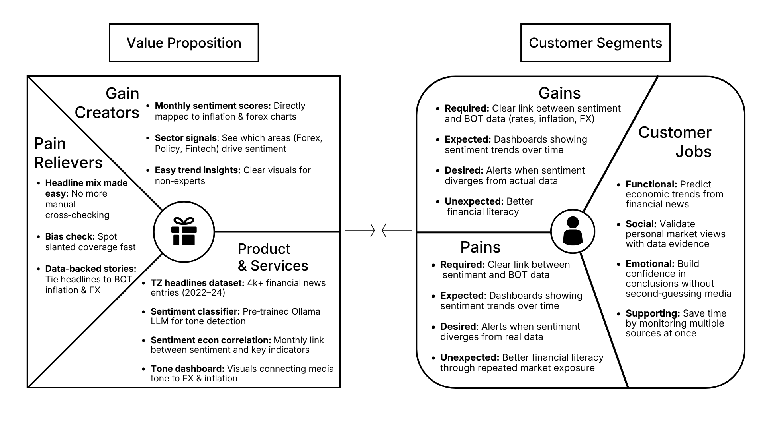
A Value Proposition Canvas links user needs to what the product offers. For EF-02, users need a fast way to label financial headlines and view them beside macroeconomic context without building a pipeline from scratch. The dashboard answers that need with upload, classification, consolidation, and analysis in one session-based tool.
Figure 1.1: Value proposition canvas for EF-02

The value proposition: addresses these needs through the EF-02 Sentiment Dashboard a session-based web tool powered by an LLM classifier (gpt-4o-mini) that labels uploaded Tanzanian financial headlines for relevance, topic category, and economic-outcome sentiment, then consolidates them with user-supplied CPI and USD/TZS data, as outlined in Figure 1.1. The system acts as a pain reliever by turning unstructured headline CSVs into structured labels tuned for economic meaning, reducing manual labelling and cross-checking. It acts as a gain creator by delivering interactive charts, monthly tone views, and analysis panels that place sentiment beside inflation and forex series in one interface a reusable East African financial-NLP workflow students and analysts can re-run on their own data.
The customer segment: comprises policymakers, economists, investors, researchers, and data science students who need a practical way to summarise financial media tone alongside inflation and exchange-rate context. These users want to explore sentiment trends, support market or policy discussion, and save time by processing many headlines in batch instead of reading them one by one. They are currently hindered by delayed or sparse official releases, unstructured news text, and Western-tuned NLP defaults that miss local phrasing. To overcome these pains, they need a clear Import then Classify then finaly Analyse tool with validated uploads, downloadable labelled outputs, and dashboards that track sentiment over time to improve financial interpretation and literacy.

Table 1.1: Value Proposition Canvas for EF-02
Canvas side | Items
Customer jobs | Label financial headlines; track monthly tone; overlay inflation/FX; reuse past runs
Pains | Manual labelling; fragile scripts; Western lexicons; no single UI for Tanzanian text + macros
Gains | Batch LLM labels; 11-category schema; cached sessions; downloads; charts in one place
Products & services | EF-02 Sentiment Dashboard (Import → Classify → Analyse)
Pain relievers | CSV upload workflow, progress UI, settings for model/API, optional pre-labelled skip path
Gain creators | Structured JSON labels, monthly consolidation, interactive analysis screens

1.4 System Capability Questions
- Can the dashboard accept validated headline and macro CSV uploads and store them in a named session?
- Can an LLM classifier assign relevance, category, and economic sentiment to Tanzanian financial headlines in batch with progress and downloadable labels?
- Can the system consolidate monthly sentiment shares and merge them with CPI and USD/TZS series?
- Does the Analysis page present usable summary metrics and charts for an end-to-end GPT run?
- Is an LLM-based classifier a stronger engineering choice than rule-based or FinBERT baselines for this labelling task?

1.5 Significance of the Study
Upon completing this project, the following benefits are expected:
It delivers a reusable software tool for Tanzanian financial headline sentiment analysis.
It demonstrates an end-user workflow (upload → classify → analyse) suitable for students and analysts.
It shows how prompt-configured LLMs can handle local economic phrasing better than lexicon or Western FinBERT defaults.
It packages labelling, consolidation, and visualisation so results are inspectable without writing custom scripts for each run.
It builds practical skills in API integration, web application design, data validation, and interactive visualisation.

1.6 Structure of the Report
- Chapter One: introduces the problem, tool objectives, capability questions, and significance.
- Chapter Two reviews related literature and the product gap that motivates a dashboard tool.
- Chapter Three explains the methodology used to build and validate the system.
- Chapter Four presents requirements and system design for the dashboard.
- Chapter Five describes implementation, the example GPT run, and testing.
- Chapter Six provides conclusions, limitations, and product recommendations.

CHAPTER TWO: LITERATURE REVIEW

2.1 Introduction
This chapter reviews selected work on financial text sentiment and language models. The goal is not to reproduce prior correlation studies, but to justify why EF-02 uses an LLM-based classifier inside a practical upload-and-analyse tool for Tanzanian financial headlines.

2.2 Related Studies

2.2.1 Finance-Specific Sentiment Lexicon (Loughran and McDonald, 2011)

General-purpose dictionaries often fail when they are applied to financial writing. Loughran and McDonald (2011) argued that everyday polarity lists produce unreliable results because words like “liability” or “risk” sound negative in ordinary English yet are routine and largely neutral in financial reporting. They responded by building a sentiment lexicon designed specifically for financial documents, and that resource remains one of the most widely cited references in financial NLP. The study shows that domain-specific vocabulary matters when classifying tone. For EF-02, it supports a careful labelling design for Tanzanian financial headlines inside the dashboard, where generic polarity tools may similarly misread local financial language, which is why the tool relies on an LLM with finance-oriented prompting rather than off-the-shelf word lists.

2.2.2 Media Tone and Stock Market Returns (Tetlock, 2007)
Media language can carry information that markets notice. In an influential early study, Tetlock (2007) measured the tone of a Wall Street Journal column over time and found that unusually pessimistic language tended to be followed by weaker stock returns the next day. That result helped establish media tone as a legitimate analytical input rather than background noise. EF-02 builds on the same premise when it treats Tanzanian financial headlines as text worth structuring. Inside the tool, those headlines are uploaded, labelled for economic-outcome sentiment, and placed beside user-supplied macro series so analysts can inspect media tone in a practical dashboard workflow.

2.2.3 Public Mood and Market Movement (Bollen, Mao and Zeng, 2011)

Sentiment signals do not have to come only from formal newspapers. Bollen, Mao, and Zeng (2011) shifted attention to social media by collecting Twitter data and tracking public mood with a psychological measurement framework known as POMS. They reported that a calmness dimension preceded movements in the Dow Jones Industrial Average by two to six days. The work broadened computational sentiment into a product class of its own and showed that collective mood features can be operationally useful. EF-02 keeps that computational outlook but applies it to financial news headlines through an upload, classify, and analyse dashboard rather than a social-media pipeline.

2.2.4 BERT and Contextual Language Understanding (Devlin et al., 2018)
Modern NLP quality depends heavily on context. Devlin et al. (2018) introduced BERT, a transformer model that reads text in both directions and captures meaning more effectively than earlier left-to-right systems. Before BERT, many models struggled when the sense of a sentence depended on words appearing later. BERT became the foundation for much of the work that followed. It is relevant to EF-02 because later finance-oriented and generative models used in model selection for the labelling stage sit on the same transformer lineage that BERT established.

2.2.5 FinBERT and Domain-Specific Fine-Tuning (Araci, 2019)
Domain adaptation can raise classification quality beyond generic NLP. Araci (2019) fine-tuned BERT on financial corpora to create FinBERT, motivated by the fact that models trained on broad internet text often miss the vocabulary and structure of financial reporting. On financial benchmarks, FinBERT outperformed general sentiment tools by a clear margin. That principle still guides EF-02, but the dashboard’s production labelling path uses an instruction-tuned LLM with a finance-focused prompt because that approach fitted Tanzanian headline phrasing better in project benchmarking than frozen FinBERT defaults alone.

2.2.6 News Tone as a Macroeconomic Indicator (Shapiro and Wilson, 2022)

Tone can also be summarised as a time series. Shapiro, Sudhof, and Wilson (2022) built a monthly sentiment index from large volumes of newspaper text and studied how that index related to macroeconomic outcomes such as GDP growth and unemployment in the United States. Their aggregation logic is close to what EF-02 implements as a product feature. Where they worked at national research scale, EF-02 rolls labelled Tanzanian headlines into monthly shares inside the dashboard and lets users overlay those series with uploaded CPI and USD/TZS files for inspection, exploration, and reporting.

2.2.7 Financial News Sentiment in Kenya (Muriungi and Kimani, 2020)

Regional evidence matters because East African markets and media environments are not identical to Western datasets. Muriungi and Kimani (2020) analysed Kenyan financial news sentiment and reported a moderate link between media tone and the KES/USD exchange rate. Kenya shares several economic and media traits with Tanzania, so their study is the closest geographic reference in this review. EF-02 is motivated by the need for a usable Tanzanian-facing workflow and tool, and the Kenyan work provides a regional benchmark for why local financial headlines and currency context belong in one analyser.2.2.7 East African Financial News (Muriungi and Kimani, 2020)

2.2.8 NLP Resource Gaps in African Languages (Adelani et al., 2021)

Many NLP assets were never built with African settings in mind. Adelani et al. (2021) documented how strongly African languages and contexts are underrepresented in datasets, benchmarks, and pre-trained models, which remain concentrated on English and a small set of high-resource settings. Even though EF-02 mainly processes English headlines, it works with Tanzanian sources, local institutions, and local macro indicators that mainstream tools rarely target. Adelani et al.’s framing helps explain why a regional dashboard for upload-based classification and analysis is a useful contribution, even at course-project scale.

2.3 Product Gap
Prior work establishes that financial sentiment is useful and that domain or LLM methods beat naive lexicons. The remaining gap for this course project is productisation: an end-user dashboard where Tanzanian headline CSVs can be uploaded, classified, consolidated with CPI and FX files, and reviewed visually in one place. EF-02 addresses that gap.

CHAPTER THREE: METHODOLOGY

3.1 Introduction
This chapter describes how EF-02 was planned, designed, implemented, and tested as a software tool. Methods follow a practical systems approach suitable for a dashboard product with an NLP labelling core.

3.2 Methodological Steps

3.2.1 General Methodology
Development followed an iterative build-and-test cycle: define the upload, classify and analyse workflow, implement each stage behind a FastAPI service with a browser UI, validate CSV schemas, run classification against the LLM API, consolidate monthly outputs, and verify functional behaviour on an end-to-end GPT demonstration run.

3.2.2 Gathering User Requirements
Requirements were elicited by reviewing how analysts would use the tool: provide headline files, attach official CPI and FX CSVs, obtain labelled downloads, and view charts. Supervisory feedback emphasised a clear product schema and a dashboard presentation suited to end users.

3.2.3 System Design Methodology
Design used modular separation: presentation (HTML/CSS/JS dashboard), application services (job/session orchestration), and core processing (validation, classification, consolidation, analysis helpers). Sessions persist artefacts under a runs directory so users can reopen work.

3.2.4 Implementation Methodology
Implementation used Python (FastAPI, pandas, OpenAI SDK) for the backend and a static SPA-style frontend for Import, Classify, and Analysis pages. Classification prompts request structured JSON with relevance, one of eleven topic categories, and Positive/Negative/Neutral economic sentiment.

3.2.5 Testing and Validation
Validation combined functional tests of each dashboard stage, schema checks on uploads, and a classifier benchmark comparing lexicon, FinBERT, and LLM accuracy on a labelled sample to justify the production labelling choice.

3.3 Methodology Table
Table 3.1: Methodology Table
Specific Objective | Methodology | Tools | Deliverable
Import headline and macro data | CSV upload with column validation and session storage | FastAPI, pandas | Session files: headlines, cpi.csv, fx.csv
Classify headlines | Batch LLM classification with structured JSON schema | OpenAI gpt-4o-mini, dashboard progress UI | tz_headlines_labelled.csv
Consolidate monthly views | Aggregate relevant labels by YearMonth; merge CPI and FX | pandas consolidation module | Visualization_Data.csv
Present analysis | Summary panels and interactive charts in Analysis page | Chart.js, dashboard UI | Analysis screens / downloads
Select labelling approach | Benchmark lexicon, FinBERT, and LLM accuracy | Labelled sample set, sklearn metrics | Benchmark table; LLM adopted for tool
Verify system behaviour | Functional testing of Import / Classify / Analyse | Manual UI tests on GPT demo session | Table 5.2 test results

CHAPTER FOUR: SYSTEM ANALYSIS AND DESIGN

4.1 Introduction
This chapter presents the analysis and implementation requirements of the proposed system for Tanzanian financial news sentiment analysis. It describes the requirements identified before development and explains the resources needed for successful system operation. The chapter also outlines the system and data requirements used to support data collection, processing, sentiment classification, and visualisation of findings. These requirements formed the foundation for a complete project workflow.

4.2 Requirement Analysis
Requirement analysis is the process of identifying, evaluating, documenting, and managing the needs and constraints of a system to ensure that it fulfills its intended objectives (Sommerville, 2016). It helps ensure that the developed system satisfies both operational and technical expectations before implementation begins. For this project, requirement analysis focused on two major categories:
- User requirements: defines what end users expect from the system
- System requirements: define the technical capabilities and resources necessary to support system functionality.

4.2.1 System Requirements
System requirements refer to the technical specifications and resources needed for a system to operate effectively and achieve its intended functions (Pressman & Maxim, 2020). They define the environment and conditions required to develop, execute, and maintain the system successfully. For this project, system requirements were analysed under three categories:
- Hardware Requirements: The physical computing infrastructure needed to execute system workloads and data computations.
- Software Requirements: The platforms, tools, and libraries required to provide development and analytical capabilities.
- Data Requirements: The raw inputs and datasets necessary to perform sentiment classification and economic analysis.

4.2.1.1 Data Requirements
The system uses multiple datasets drawn from publicly available sources to support financial sentiment labelling and dashboard analysis for the period 2022–2024. Data are uploaded by the user, processed inside the EF-02 tool, and consolidated into session outputs used for analysis and visualisation.
The following data types are used:
- News Headlines: Provided as CSV uploads containing at least publication date and headline text (optional fields such as article URL and source may also be included). Headlines are used for relevance filtering, category assignment, economic-outcome sentiment classification, and monthly sentiment summaries in the dashboard.
- USD/TZS Exchange Rate Data: Daily exchange rate files (for example, series obtained from Investing.com) are uploaded and converted into monthly averages with month-on-month percentage changes. This data is used in Analysis views to place currency movement beside monthly sentiment trends.
- Consumer Price Index (CPI) Data: Monthly inflation figures from NBS Tanzania CPI reports (2022–2024) are uploaded as a separate CSV. This dataset is used to display inflation behaviour alongside aggregated sentiment results.
- Labelled Sample Dataset: Synthetic and test headlines were prepared and used during benchmarking to evaluate sentiment classification approaches before selecting the LLM labelling path for the tool.
- Processed Sentiment Dataset: Generated after classification and consolidation within a dashboard session, containing sentiment labels, categories, and monthly aggregates used for visualisation, downloads, and comparative analysis panels.

4.2.1.2 Software Requirements
Software requirements refer to the applications and development tools required for implementing, executing, and maintaining a system successfully (Pressman & Maxim, 2020). These tools provide the environment necessary for data upload, processing, classification, consolidation, analysis, and visualisation in the EF-02 dashboard.
The following software was used in this project:
- Python 3: Used as the primary programming language for the dashboard backend and core processing modules due to its flexibility and strong support for data science and web service applications.
- FastAPI and Uvicorn: Used to serve the EF-02 web application, manage analysis sessions, handle CSV uploads, and expose classification, consolidation, and analysis endpoints.
- Web Dashboard Frontend: HTML, CSS, and JavaScript (including Chart.js) were used to build the Import, Classify, and Analysis interfaces shown to the user.
- Python Libraries: Several libraries were used to support implementation:
  - Pandas: data cleaning, merging, and monthly aggregation.
  - Openai: API access to the LLM classifier (gpt-4o-mini in the demonstrated build).
  - Mmatplotlib and Seaborn (where used in supporting analysis or testing): charts and visual checks.
  - Scipy: Pearson correlation and p-value calculations used in Analysis panels.
  - Python-dotenv: secure loading of API keys from environment files.
.

4.2.1.3 Hardware Requirements
Hardware requirements refer to the physical computing resources required to develop, execute, and maintain a system effectively (Pressman & Maxim, 2020). For this project, no specialised hardware was required since model inference was performed through OpenAI cloud servers.
The following hardware resources were sufficient:
- Laptop/Desktop Computer: A standard personal computer was used to develop and run the EF-02 dashboard server, upload and validate CSV datasets, process labelled outputs, and view analysis visualisations in a browser.
- Memory (RAM): At least 8 GB RAM was sufficient to support data cleaning, aggregation, dashboard operation, and classification workflows.
- Storage: Local storage was required to store application code, uploaded CSV datasets, and session outputs under the dashboard runs folder. Storage requirements remained low since processed datasets were below approximately 50 MB.
- Internet Connection: Required for accessing external macro datasets for upload and communicating with the OpenAI API for sentiment classification.

No dedicated GPU was required because large language model inference was executed on OpenAI cloud infrastructure rather than locally.

4.2.2.1 Functional Requirements
The system shall accept and store uploaded financial news headline CSVs together with publication date and optional source or article URL fields.
- Headline Classification: The system shall filter irrelevant headlines and assign both economic categories and sentiment labels (Positive, Negative, Neutral).
- Sentiment Aggregation: The system shall aggregate relevant headlines into monthly sentiment indicators and distributions.
- Data Consolidation: The system shall merge sentiment outputs with uploaded CPI inflation and USD/TZS exchange rate datasets.
- Visualisation and Analysis: The system shall generate charts and analysis panels to support interpretation of financial news sentiment alongside economic indicators.
- Classification Progress Support: The system shall support progress tracking, checkpointing, and resume capability during long classification runs to minimise loss of work from interruptions.

4.2.2.2 Non Functional Requirements
Non-functional requirements describe the quality attributes and operating conditions that determine how effectively a system performs its functions (Sommerville, 2016). Unlike functional requirements, they focus on characteristics such as reliability, usability, maintainability, and security rather than specific system operations.
i. Reproducibility: The system shall support repeatable execution through a clear Import to Classify to Analyse schema with documented inputs and outputs at each stage, stored in named dashboard sessions.
ii. Security: The system shall protect sensitive credentials by storing API keys in environment files (.env) or secure session settings and excluding them from version control.
iii. Reliability: The system shall maintain stable execution through batch retries, validation checks, and checkpoint saving to handle network and API interruptions.
iv. Usability: The system shall present outputs through a browser dashboard with locked navigation, structured summaries, and readable visualisations without requiring users to write code.
v. Maintainability: The system shall use a modular architecture (frontend, API services, and core processing modules) so that individual stages can be modified without affecting the entire workflow.
vi. Transparency: The system shall surface analysis outputs and session artefacts clearly in the final Analysis stage so users can inspect labelled data, consolidated tables, and charts when interpreting results.

4.3 System Design

4.3.1 System Architecture
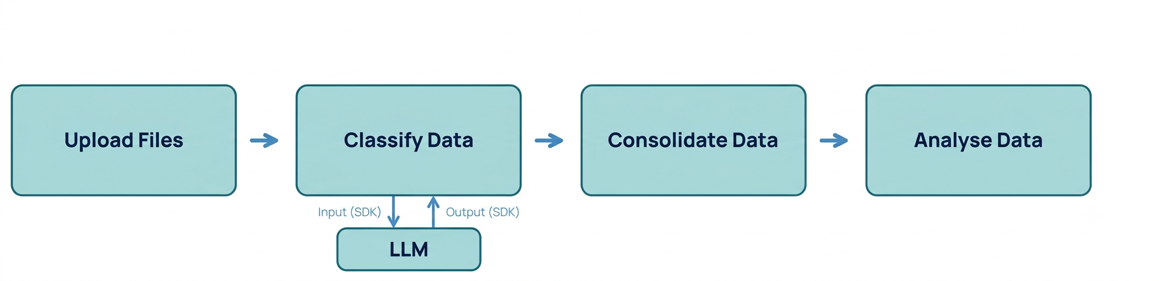
System architecture refers to the high-level structure of a system that defines its components, their relationships, and the flow of data and processes between them (Sommerville, 2016). It provides a blueprint for how system components interact to achieve the intended objectives and supports understanding, implementation, maintenance, and future improvements. For this project, the system architecture was included to illustrate the complete workflow of the financial news sentiment analysis pipeline and show how data moves from collection through processing, classification, consolidation, and final analysis.

Figure 4.1: System Architecture for EF-02.

CHAPTER FIVE: IMPLEMENTATION AND TESTING

5.1 Introduction
This chapter presents the implemented EF-02 Sentiment Dashboard and demonstrates an example gpt-4o-mini run using the screenshots in the accompanying images folder. Testing confirms that each stage of the upload → classify → analyse schema behaves as designed.

5.2 Implementation

5.2.1 Home and Session Management
The home page introduces the three-step workflow and lists saved sessions with status, headline counts, and open/rename/delete actions. Users start a named analysis or resume a previous session.
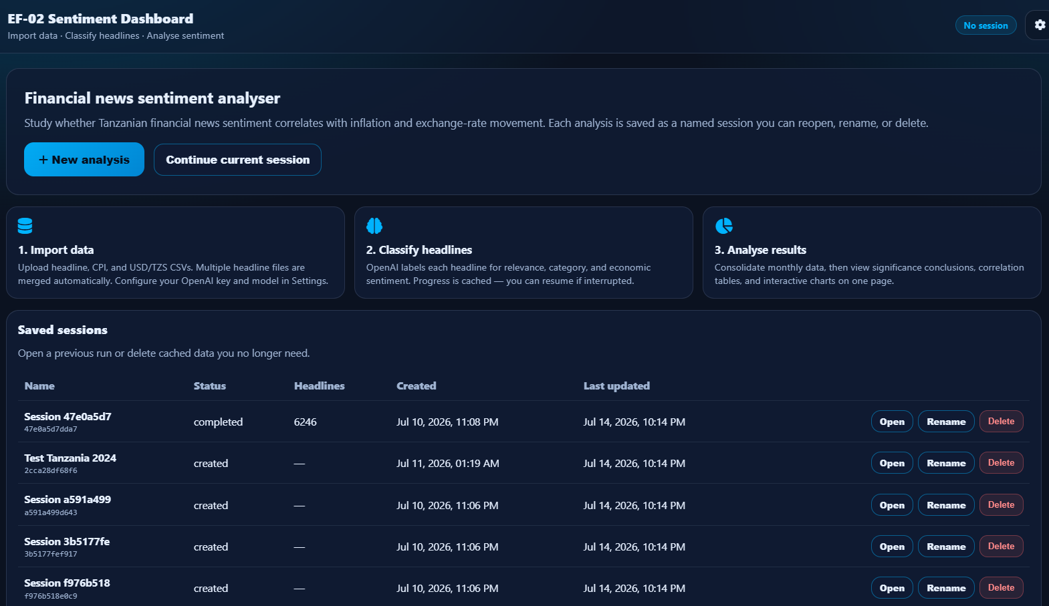
Figure 5.1: Dashboard home and saved sessions

5.2.2 Data Import
Data Import accepts headline CSVs (date, headline), CPI (date, inflation_rate_pct), and USD/TZS (Date, Price). Multiple headline files can be merged. After successful uploads, the UI shows the overlap window and headline count, then unlocks Classify. Users with a pre-labelled CSV can also skip classification and proceed to Analysis once macro files are present.
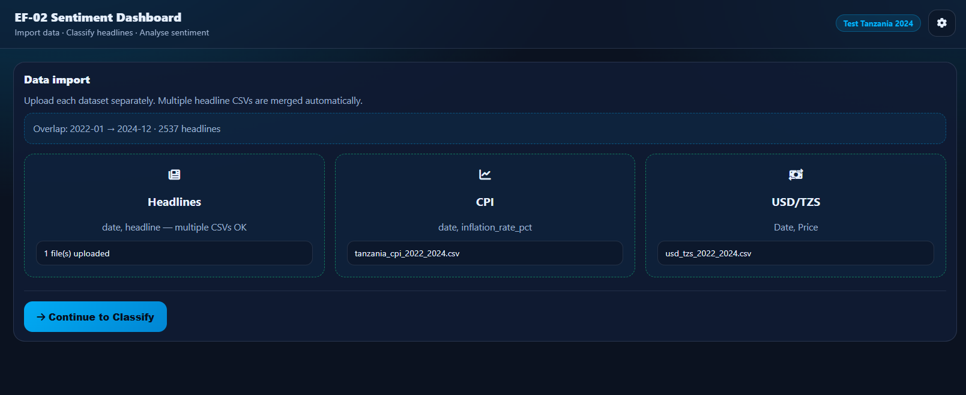
Figure 5.2: Data Import — uploading headlines, CPI, and USD/TZS

5.2.3 Classification
The Classify page runs OpenAI gpt-4o-mini with model and API key configured under Settings. Headlines are processed in batches with an elapsed timer, progress bar, and activity log. Each successful run yields a labelled CSV with relevance, category, and sentiment fields that can be downloaded from the same screen.
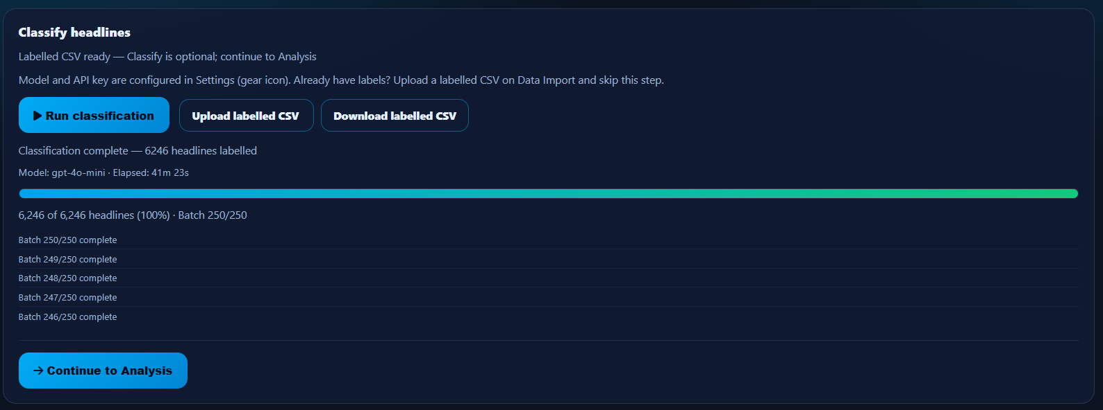
Figure 5.3: Classify headlines with gpt-4o-mini

5.2.4 Consolidation and Analysis Views
After labels exist, Analysis consolidates relevant headlines by month, merges CPI and FX series, and renders a summary panel plus interactive charts. The example GPT run shows a 36-month window with Neutral and Positive months alternating as dominant, comparatively low average negative share, and visual overlays of inflation and USD/TZS movement. Correlation outcome rows appear as part of the Analysis UI for user inspection; they are a feature of the tool’s display, not a research verdict claimed by this report.
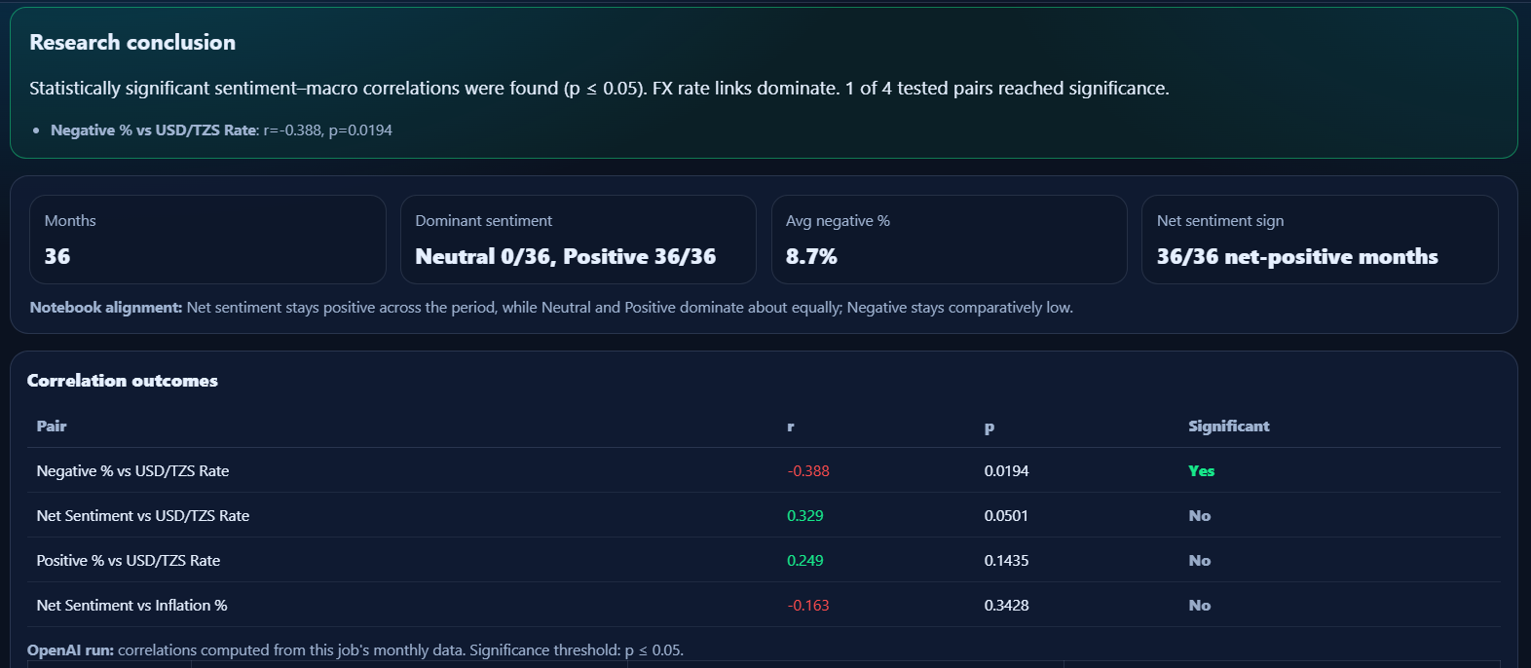
Figure 5.4: Analysis summary panel after consolidation (example GPT run)

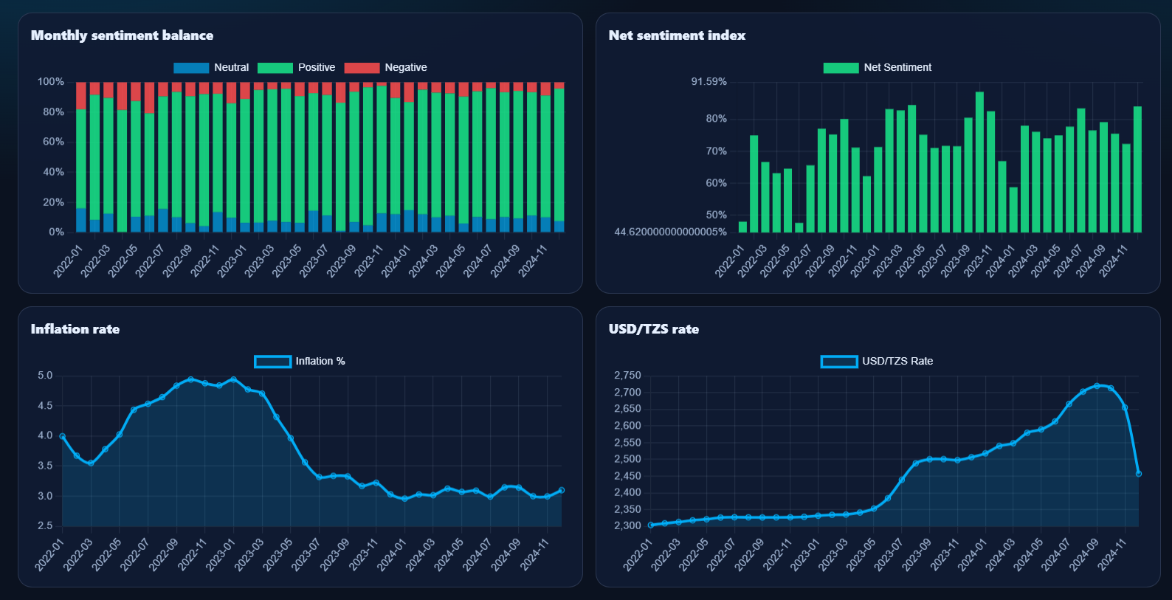
Figure 5.5: Monthly sentiment and macro time-series charts (example GPT run)

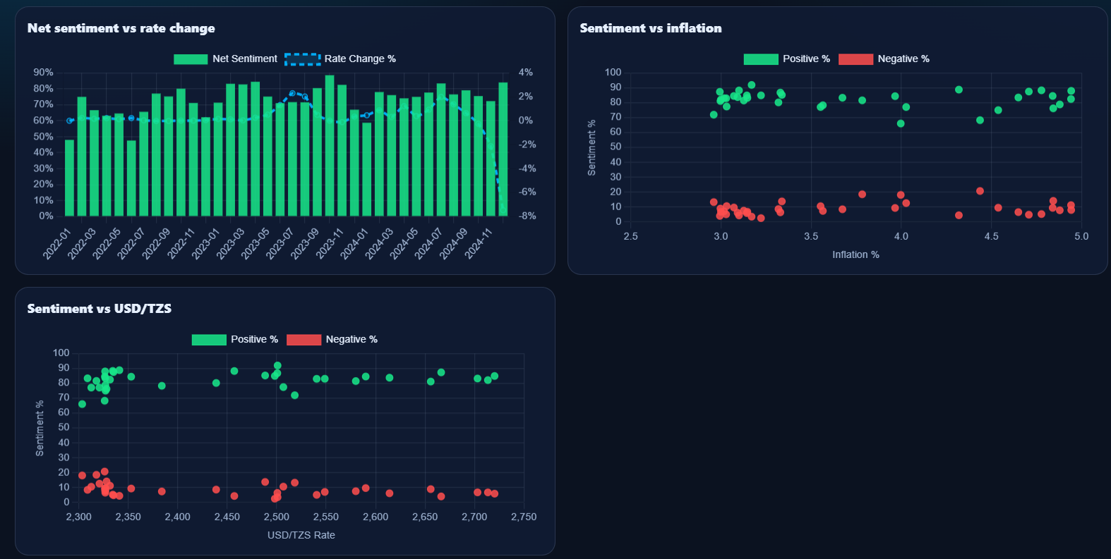
Figure 5.6: Sentiment versus inflation and USD/TZS comparative charts (example GPT run)

5.2.5 Classifier Selection Note
Before locking the labelling component, candidate approaches were scored on a labelled sample. Rule-based tools and FinBERT underperformed relative to LLM prompting on Tanzanian financial phrasing. The dashboard therefore uses an LLM classifier (gpt-4o-mini in the demonstrated build).

Table 5.1: Model Benchmarking Results (classifier selection)
Model | Approximate accuracy
TextBlob | ~28%
VADER | ~50%
FinBERT | ~67%
LLM (prompted) | ~92–93%

5.3 Testing

5.3.1 Functional Testing
Functional testing verified each major dashboard capability on the example GPT session. Results are summarised in Table 5.2.
Table 5.2: Functional Testing Results
S/N | Functional requirement | Expected outcome | Test result
1 | Session management | Create/open/rename/delete sessions | Passed
2 | Data import | Validate and store headline, CPI, FX CSVs | Passed
3 | Classification | Produce labelled CSV via gpt-4o-mini batches | Passed
4 | Consolidation | Build monthly merged visualisation dataset | Passed
5 | Analysis UI | Show summary metrics and charts | Passed
6 | Downloads | Export labelled and visualisation CSVs | Passed

Result: All functional requirements exercised in the demonstration run produced outputs consistent with the intended tool behaviour.

5.3.2 Usability Observation
The locked navigation pattern (Import before Classify, labels and macros before Analysis) kept the schema clear during the demo. Progress feedback during classification made long batch runs observable without leaving the page.

CHAPTER SIX: CONCLUSION AND RECOMMENDATION

6.1 Introduction
This chapter evaluates EF-02 against its tool objectives, notes practical limitations of the dashboard build, and recommends product next steps.

6.2 Conclusion

6.2.1 Data Import Objective
The dashboard accepts validated headline, CPI, and USD/TZS CSV uploads into named sessions. The example GPT run successfully loaded overlapping 2022–2024 inputs and proceeded through the schema.

6.2.2 Classification Objective
Batch classification with gpt-4o-mini produces structured relevance, category, and economic-outcome sentiment labels, with progress UI and downloadable labelled CSV. Benchmark evidence supported choosing an LLM over lexicon and FinBERT baselines for this labelling component.

6.2.3 Consolidation Objective
Relevant labels are aggregated by month and merged with inflation and exchange-rate series into a visualisation dataset ready for the Analysis page.

6.2.4 Analysis and Visualisation Objective
The Analysis page delivers summary metrics and interactive charts (sentiment balances, net sentiment, inflation, USD/TZS, and comparative views) for the example GPT run, confirming that the tool presents consolidated outputs in a usable interface.

6.2.5 Overall Tool Delivery
EF-02 meets its primary goal as a Financial Sentiment Analyser dashboard: upload → classify → consolidate / analyse, with session history and downloads. The project’s conclusion is that the tool works end-to-end for Tanzanian financial headline workflows — not that a particular sentiment–macro statistical relationship has been proven or rejected.

6.3 Challenges and Limitations
Key limitations include dependence on an external LLM API (cost, rate limits, and connectivity); sensitivity of labels to prompt wording; need for clean CSV schemas from users; and the fact that dashboard charts reflect the quality of uploaded data and labels. The tool also requires a local server process and an API key for classification runs.

6.4 Recommendations
Future product work should consider a distilled local classifier for deterministic offline labelling, stronger upload templates and validation messages, broader prompt presets for different sectors, and UI polish around long-running jobs. Supporting more flexible date formats and richer export packs (charts + CSV + summary) would further improve the analyser as a day-to-day tool.

REFERENCES
Araci, D. (2019). FinBERT: Financial sentiment analysis with pre-trained language models. arXiv preprint arXiv:1908.10063.
Bollen, J., Mao, H., & Zeng, X. (2011). Twitter mood predicts the stock market. Journal of Computational Science, 2(1), 1–8.
Devlin, J., Chang, M. W., Lee, K., & Toutanova, K. (2018). BERT: Pre-training of deep bidirectional transformers for language understanding. arXiv preprint arXiv:1810.04805.
Hutto, C. J., & Gilbert, E. (2014). VADER: A parsimonious rule-based model for sentiment analysis of social media text. Proceedings of the International AAAI Conference on Web and Social Media.
Loughran, T., & McDonald, B. (2011). When is a liability not a liability? Textual analysis, dictionaries, and 10-Ks. The Journal of Finance, 66(1), 35–65.
Muriungi, P., & Kimani, D. (2020). Media sentiment and exchange rate volatility: Evidence from Kenyan financial news. African Journal of Economics and Finance, 8(2), 45–61.
National Bureau of Statistics Tanzania. (2024). Consumer Price Index (CPI) summary data [Data set].
Pressman, R. S., & Maxim, B. R. (2020). Software Engineering: A Practitioner’s Approach (9th ed.). McGraw-Hill.
Shapiro, A. H., Sudhof, M., & Wilson, D. J. (2022). Measuring news sentiment. Journal of Econometrics, 228(2), 221–243.
Sommerville, I. (2016). Software Engineering (10th ed.). Pearson Education.
Tetlock, P. C. (2007). Giving content to investor sentiment: The role of media in the stock market. The Journal of Finance, 62(3), 1139–1168.

APPENDIX
No questionnaire was used in this project. Demonstration data consisted of user-uploaded headline and macroeconomic CSV files processed through the EF-02 Sentiment Dashboard. Sample column schemas are listed in Table 4.1. Screenshots of the example gpt-4o-mini run are included in Chapter Five.

