GREENPULSE / SYSTEM DESIGN

GreenPulse System Design
  - Environmental reporting and response coordination for District 5, Quezon City
This document describes how people report environmental issues, how city staff process and resolve them, and how information moves through the GreenPulse client, backend, data stores, and external providers.
Design area | Current implementation
Access | Responsive React web application, installable PWA, and repository packaging for mobile and desktop.
Core services | Vercel server-side API routes and Supabase Auth, PostgreSQL, private Storage, and Realtime.
Roles | Guest reporter, resident, responder, and administrator.
Primary workflow | Submit → verify → assign → respond → review → resolve or return for further action.

Prepared 11 November 2026. The diagrams and descriptions reflect the current project source and Supabase migrations.

Users and Permissions
GreenPulse supports public reporting and community visibility while restricting private report details and staff actions by role. Supabase row-level security and database workflow triggers enforce these boundaries.
Actor | Responsibilities
Guest reporter | Browse public reports and discussions; submit a report with an email or phone; track it with a private code; confirm an open issue; and give resolution feedback.
Resident | Create an account; submit and track own reports; follow or confirm open reports; post public comments; use private report communication; and give resolution feedback.
Responder | Review the staff queue and report details; update only work assigned directly or through a team; submit response notes and after-photos; and complete assigned inspection tasks.
Administrator | Verify, reject, mark duplicate, or request information; correct category and urgency; assign responders and teams; review resolutions; close or reopen work; manage staff and teams; set thresholds; schedule inspections; and view or export analytics.

External Providers
Photon supports place search, and OpenStreetMap supplies map tiles. Google Gemini can suggest a report category from an image when a signed-in user requests analysis. Resend can deliver tracking codes and report notifications by email. Authentication, database records, private files, and realtime updates run through Supabase; Vercel hosts the web application and API routes.

Authorization Rules
- Only administrators verify reports, assign work, and review resolutions.
- Responders can update only reports assigned to them or a team they belong to.
- The public map uses a reduced report projection. Private contact details and photo paths remain outside that view.
- Guest tracking codes are returned to the reporter, while the database stores a hash for access checks.

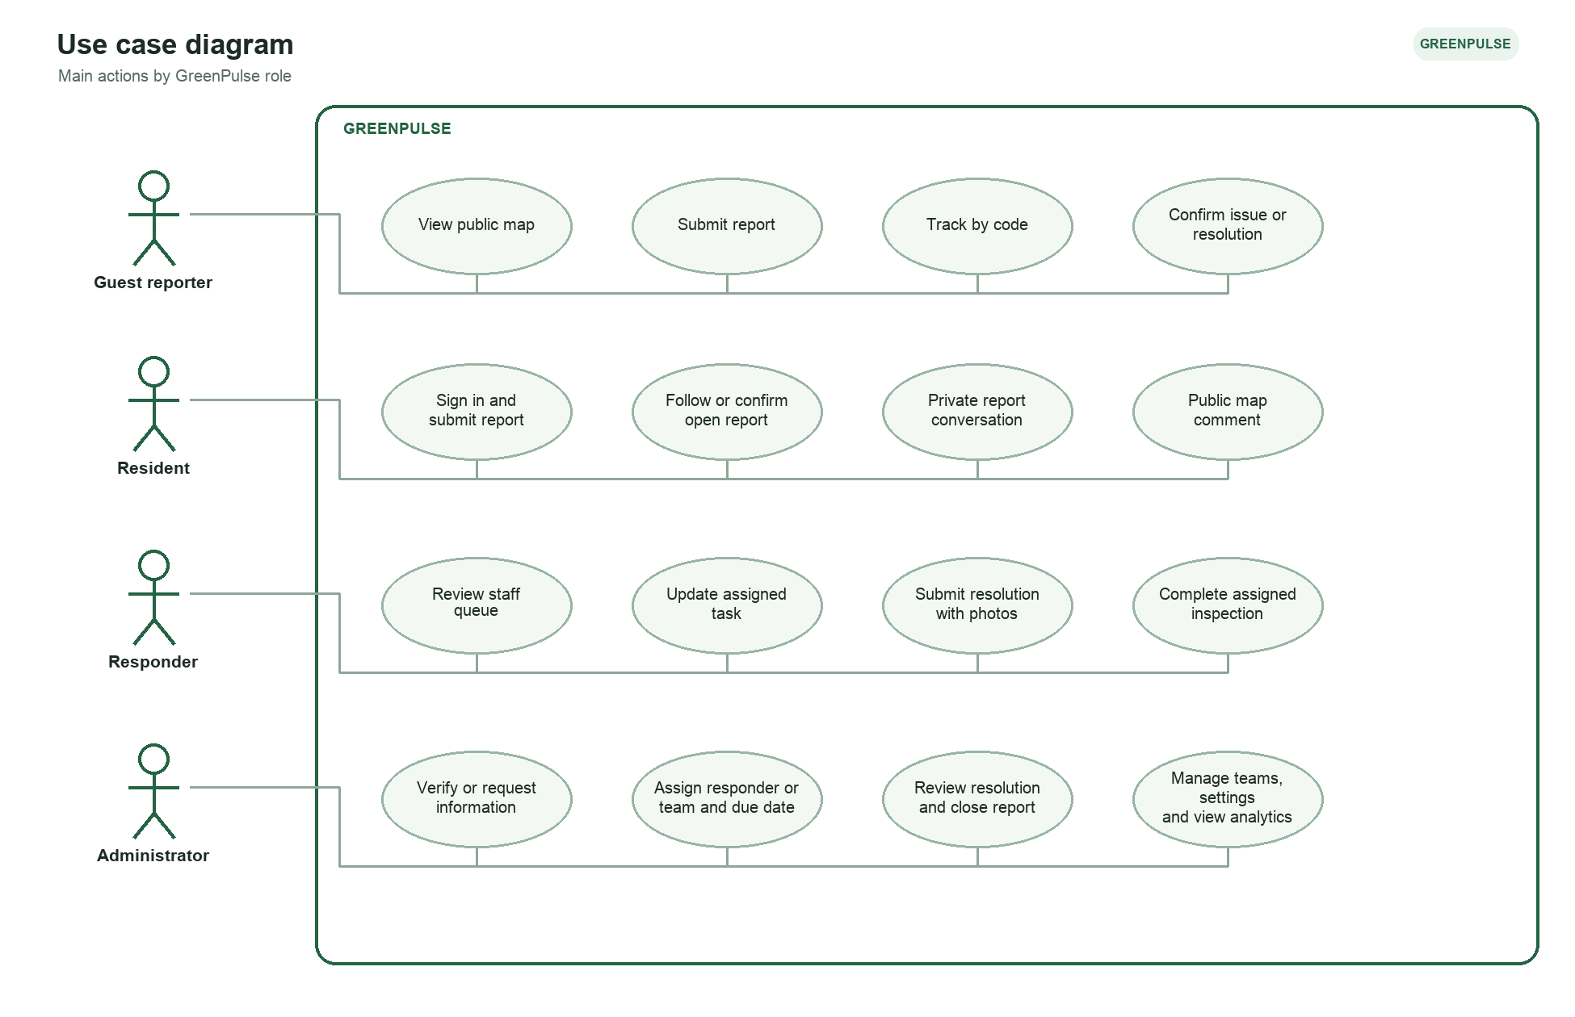
Figure 1. Use cases by GreenPulse role.

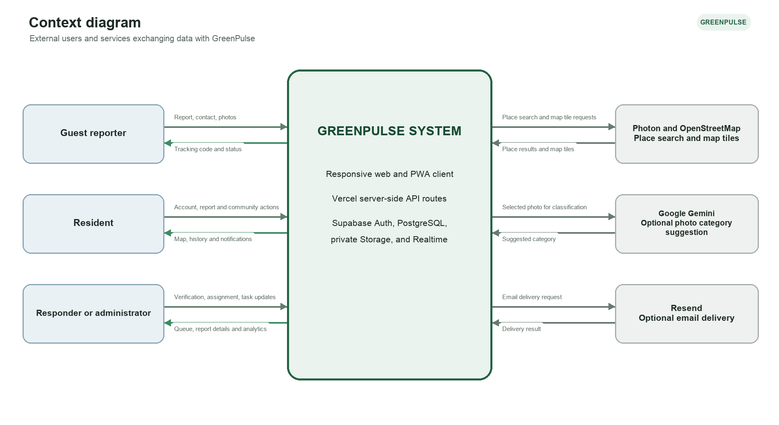
Figure 2. GreenPulse system boundary and external interactions.

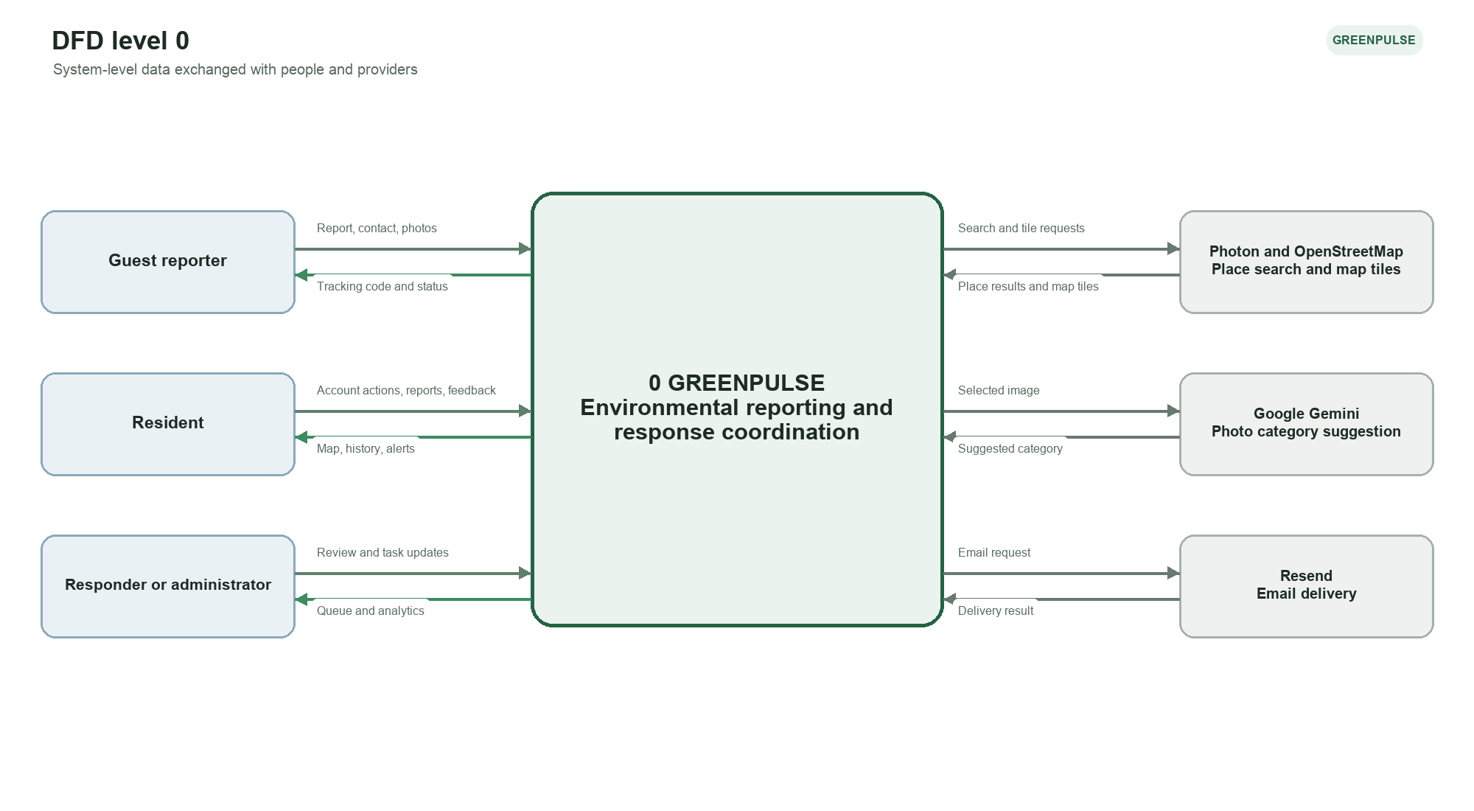
Figure 3. System-level data flows.

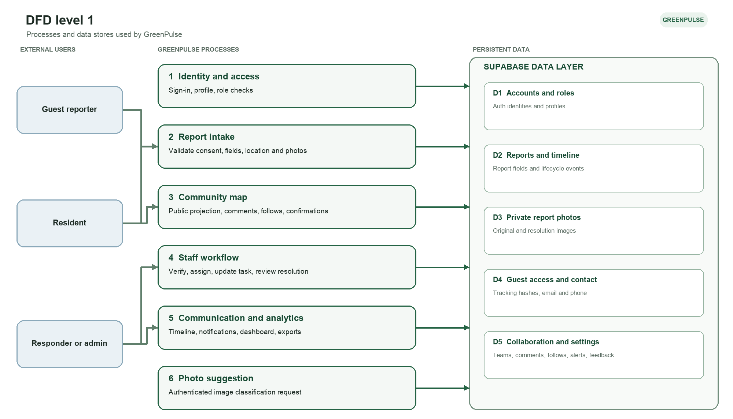
Figure 4. Major processes and persistent data.

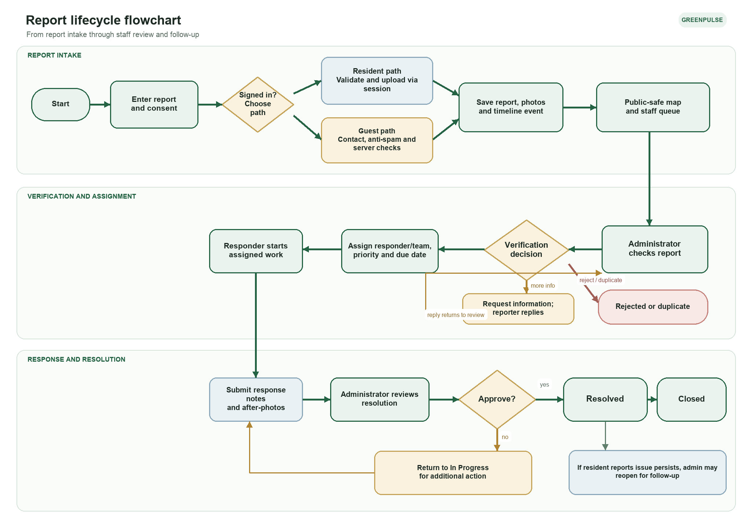
Figure 5. Report intake, staff response, and resolution review.

Core Data Model
The report record is the central object. It links to the reporter when the reporter has an account, staff assignments, photos, and an event history. Additional tables support private communication, public discussion, guest tracking, notifications, and recurring inspections.
Data object | Purpose
Accounts and roles | Supabase Auth identity plus a profile role: resident, responder, or admin.
Reports | Description, category and issue type, urgency, observation time, location/barangay, consent version, status, assignment, verification, and resolution fields.
Timeline events | Submission, status changes, verification notes, assignment changes, and resolution updates.
Private photos | Original and resolution images in the private report-photos storage bucket; report records retain paths.
Guest access | Tracking token hash, private email/phone, and submission metadata. Guest reports have no authenticated reporter ID.
Teams and memberships | Staff groups used for assignment and authorization.
Communication | Private report comments are separate from public community-map comments.
Community actions | Notifications, followers, issue confirmations, and resolution feedback.
Inspections and settings | Environmental follow-up tasks, response thresholds, escalation records, and email-delivery history.

Report Status Flow
Stage | Statuses | Rule
Intake | Submitted or Under review | Administrator triage begins.
Verification | Verified, Additional information requested, Rejected, or Duplicate | Only administrators choose a verification outcome.
Response | Verified → In progress → Awaiting verification | Assigned responders record work and submit response notes and after-photos.
Resolution review | Resolved or In progress | Administrator approves the resolution or returns the task with a review note.
Closure and follow-up | Closed, or reopened to In progress | A resident can report that the issue persists; an administrator can reopen work.

Data Protection and Operational Constraints
- Reporters accept a visibility notice before submission. Public coordinates are rounded to three decimal places and public place labels are generalized to a barangay or District 5. Reporter names may appear only after verification, as disclosed in the notice.
- The public map omits private guest contacts, additional private information, and photo paths. Staff and authorized uploaders can access private report photos.
- Guests must provide an email or phone and pass server-side field validation, anti-spam checks, and rate limits. Guest photos are limited to 2.5 MB each; signed-in photos are limited to 5 MB each.
- Residents can save a draft or queue an upload in IndexedDB. The browser resumes queued submissions when connectivity returns; local storage is a resilience aid and does not guarantee delivery.
- Photon place search and map tiles require network access. The PWA caches its app shell and same-origin static assets for offline viewing.
- Photo classification is optional, requires a signed-in session, and sends the selected image to Google Gemini through a server endpoint. Users can select a category manually.
- District geofencing becomes authoritative only after validated barangay boundary data is loaded. Until then, the application uses broad coordinate bounds and a barangay list.

