****

DAVAO VISION COLLEGE, INC

Stone Rock Village, Catalunan Grande, Davao City

In Partial Fulfillment of the Subject Soc-Sci 4

Submitted by: Romel John Capadosa BSIT-|||

Submitted to: Prof. Julius Getigan

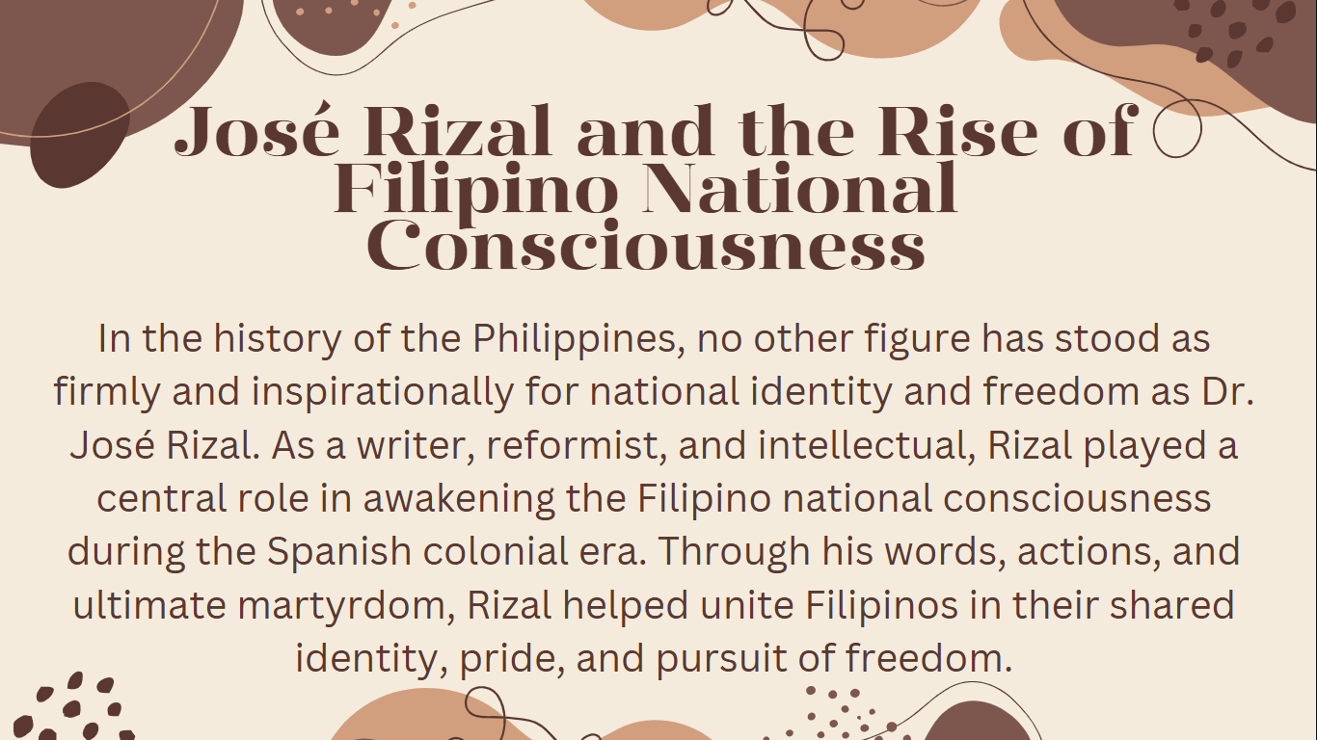

Dr. José Rizal was a key figure in Philippine history who inspired national identity and freedom. As a writer and reformer, he helped Filipinos become aware of their shared identity and fight for justice during Spanish rule. His words, actions, and sacrifice united the people in their desire for freedom.

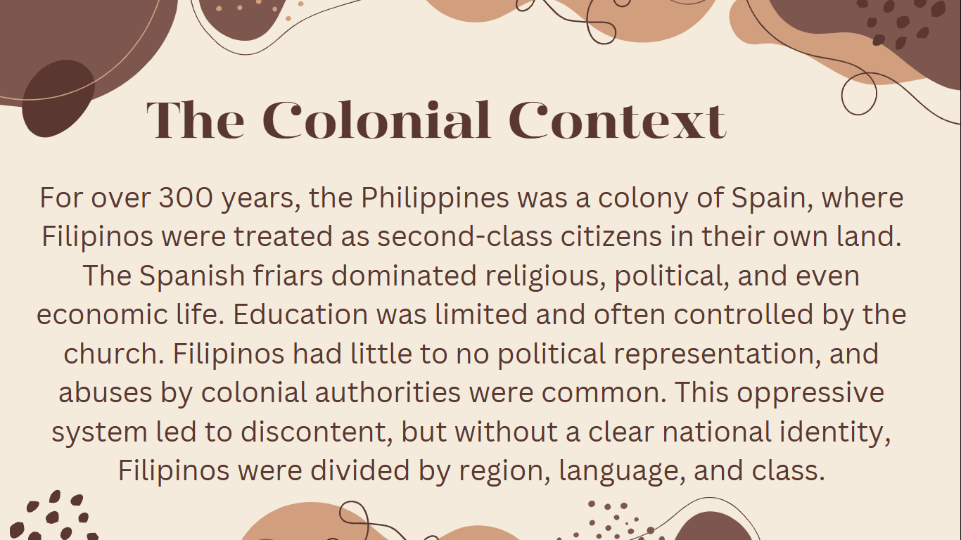

For over 300 years, Spain ruled the Philippines and treated Filipinos unfairly. Spanish friars controlled many parts of life, including religion, politics, and education. Filipinos had few rights and were often abused. Because they lacked a strong national identity, they were divided and unable to unite against this oppression.

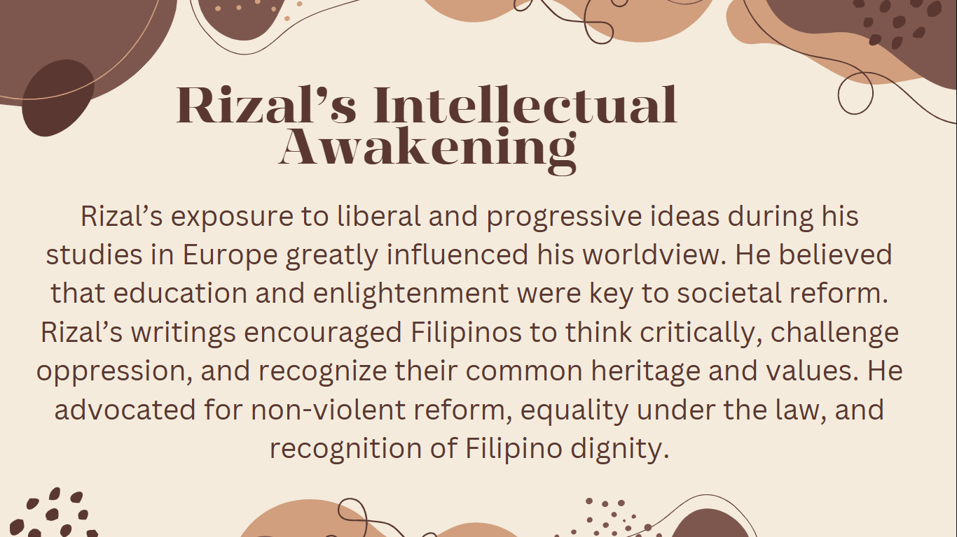

While studying in Europe, Rizal learned new ideas about freedom and progress. He believed that education could help improve society. His writings inspired Filipinos to think for themselves, stand up to injustice, and be proud of their identity. He supported peaceful change and equal rights for all.

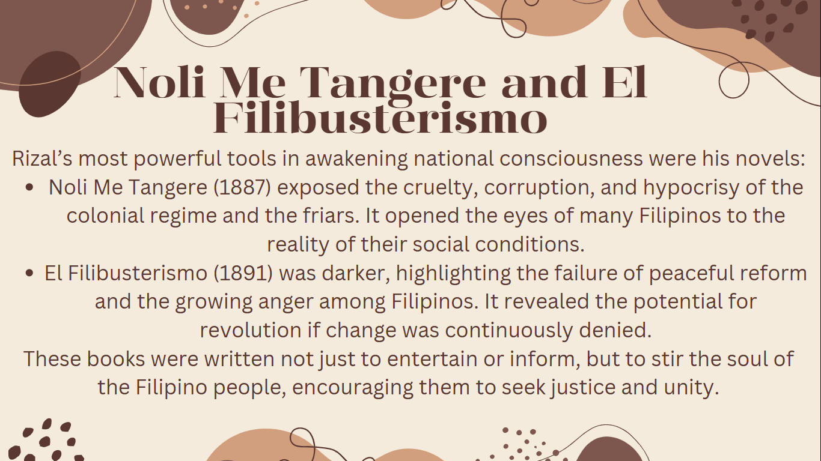

Rizal’s novels *Noli Me Tangere* and *El Filibusterismo* played a major role in awakening Filipino national consciousness. *Noli Me Tangere* exposed the cruelty of the Spanish regime, while *El Filibusterismo* showed the frustration of Filipinos with failed reforms. Both novels encouraged Filipinos to seek justice and unity, pushing them toward action.

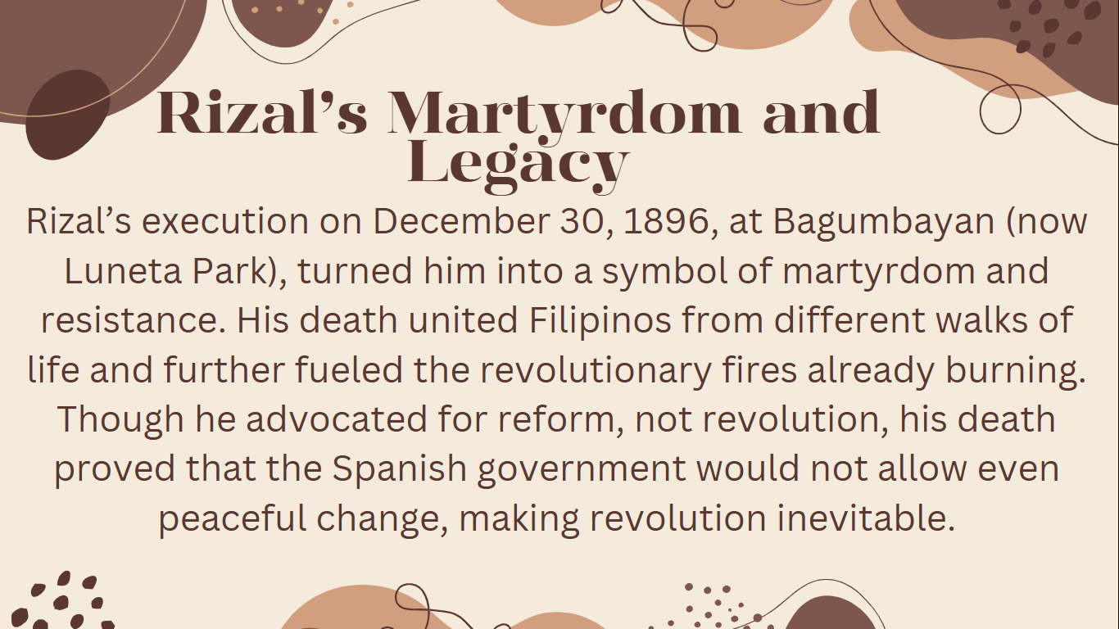

Rizal’s execution on December 30, 1896, turned him into a martyr and symbol of resistance. His death united Filipinos and strengthened their desire for revolution. Although Rizal wanted peaceful reform, his execution showed that the Spanish government would not allow change, making revolution unavoidable.

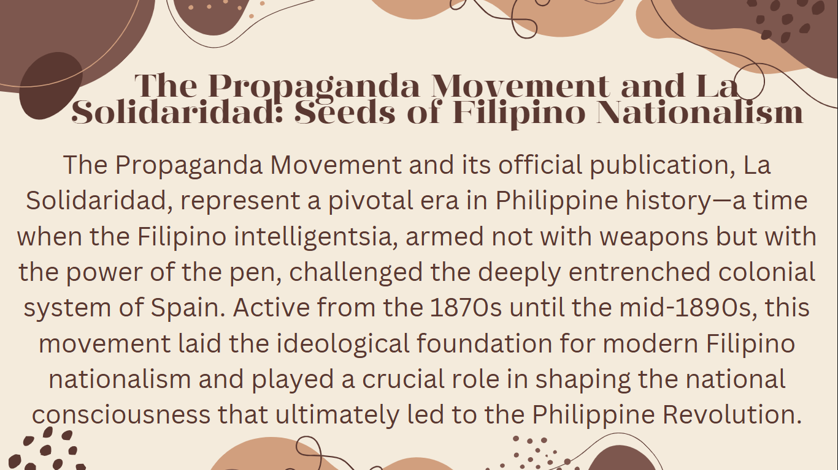

The Propaganda Movement and its newspaper, La Solidaridad, were key in Philippine history. From the 1870s to the 1890s, Filipino intellectuals used their writings to challenge Spanish colonial rule. This movement helped shape Filipino nationalism and played an important role in the Philippine Revolution.

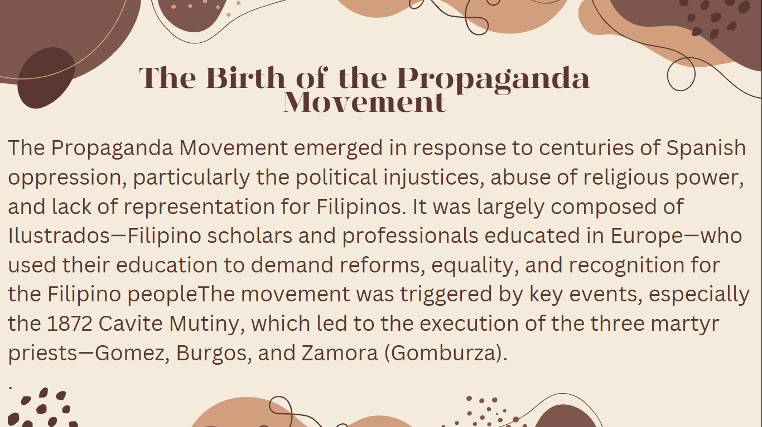

The Propaganda Movement started as a response to the long history of Spanish oppression, including political injustice and abuse of religious power. Led by Ilustrados (educated Filipinos), the movement called for reforms and equality. It was sparked by events like the 1872 Cavite Mutiny, which led to the execution of the three martyr priests, Gomez, Burgos, and Zamora (Gomburza).

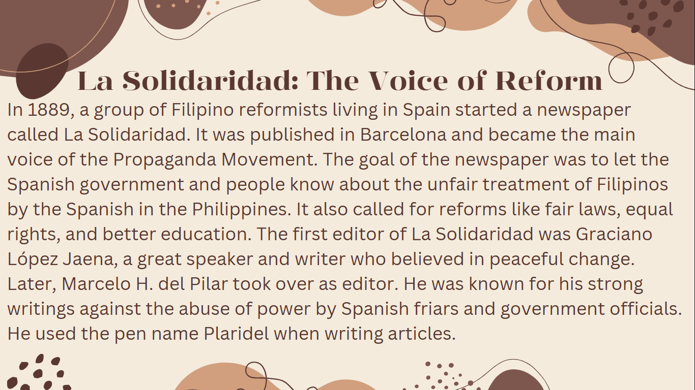

In 1889, a group of Filipino reformists in Spain started the newspaper La Solidaridad in Barcelona. It became the main voice of the Propaganda Movement, aiming to expose the unfair treatment of Filipinos by the Spanish. The newspaper called for reforms like fair laws and better education. Graciano López Jaena was the first editor, followed by Marcelo H. del Pilar, who used the pen name Plaridel and wrote strongly against the abuse of Spanish authorities.