Facet Ledger Website Flow Demonstration
  - Mock walkthrough for first time blockchain users
This guide demonstrates how the implemented website supports public verification, laboratory registration, signed attestations, relayer submission, custody transfer, and registry administration. The screenshots use sample data and represent expected interface states. They do not show a live Sepolia transaction.
The central idea is simple: reading the registry is free, signing an attestation does not spend gas, and only a submitted blockchain transaction changes registry state.

Demonstration scope
- Public visitor verifies a diamond without connecting a wallet.
- Laboratory registers directly or signs an attestation for later submission.
- Relayer submits a laboratory signature and pays the transaction gas.
- Custodian proposes or accepts a custody transfer.
- Administrator manages roles and disputed records.
Prepared from the current local application state | 16 October 2026

How the complete flow fits together
A diamond begins with a laboratory claim. The claim becomes an on-chain record either through direct registration or through a signed attestation submitted by a relayer. Later custody changes require consent from the receiving wallet. Public visitors can inspect the resulting history at any time.
Role | What the user does | Pays gas | On chain result
Visitor | Searches by laboratory and inscription | No | Reads the current record and history
Laboratory | Registers directly | Yes | Creates the record immediately
Laboratory | Signs an attestation | No | Creates a portable approval only
Relayer | Submits the attestation | Yes | Creates the lab approved record
Custodians | Propose and accept transfer | Both | Changes custody after consent
Administrator | Manages roles and status | Yes | Updates permissions or record state

Terms used in the screenshots
- Wallet an account that signs messages and transactions.
- Gas the network fee paid when a transaction changes blockchain state.
- Transaction a signed request that the blockchain executes and records.
- Attestation a signed laboratory approval that another wallet can submit.

Step 1 Verify a diamond
A visitor enters the issuing laboratory address and the laser inscription. No wallet is requested because the page only reads public blockchain data.
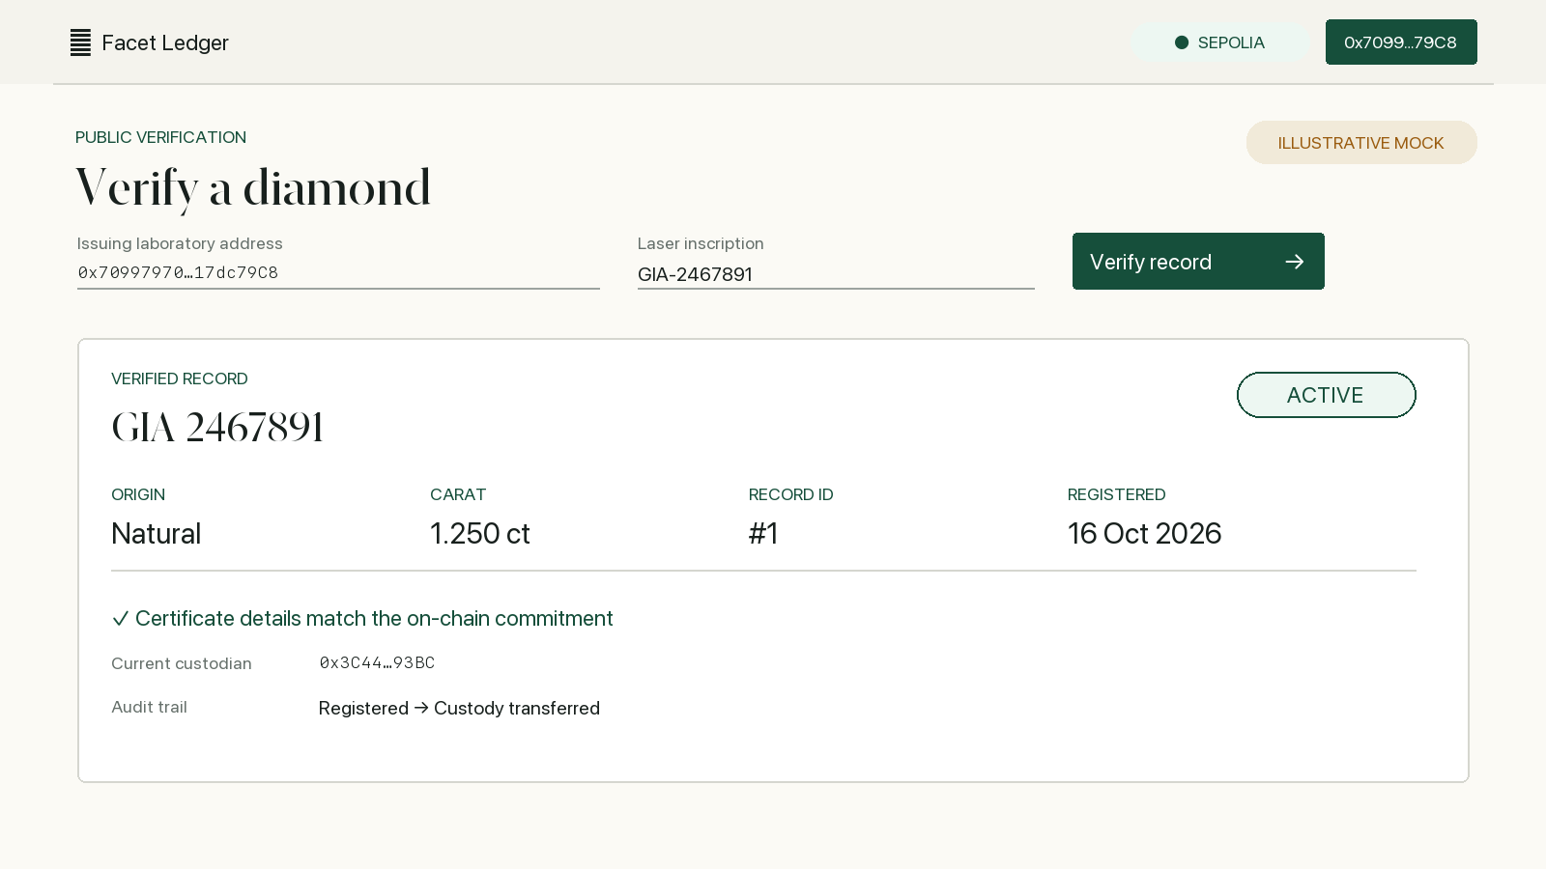
Illustrative mock screenshot

What to notice
- Current status shows whether the record is active, quarantined, or revoked.
- Certificate commitment confirms that displayed details match the stored metadata hash.
- Audit trail reconstructs registration, relaying, transfers, and status changes from events.

Step 2 Create the laboratory claim
An authorized laboratory connects MetaMask and enters the grading details. The browser hashes the report file locally. The file itself is not uploaded or stored on-chain.
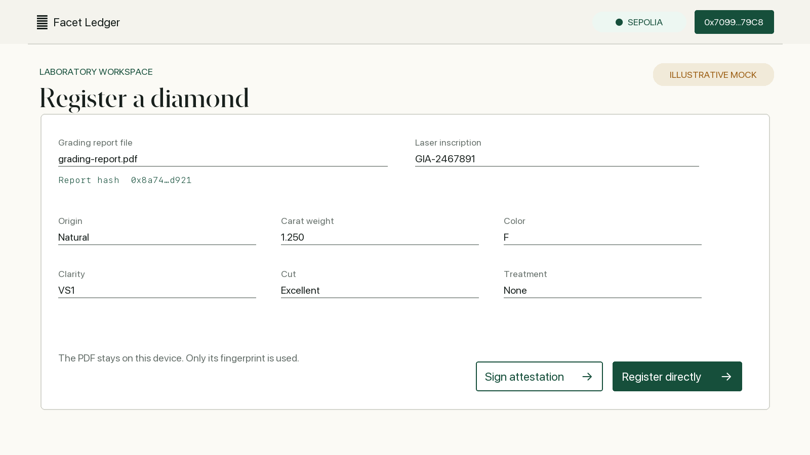
Illustrative mock screenshot

Two choices
- Register directly the laboratory sends the transaction and pays gas immediately.
- Sign attestation MetaMask signs structured data without a transaction or gas payment. The browser downloads a JSON file valid for seven days.

Step 3 Submit the signed attestation
A relayer connects any wallet and loads the JSON file. Before enabling submission, the browser verifies the signature, target chain, registry address, deadline, nonce, and current laboratory roles.
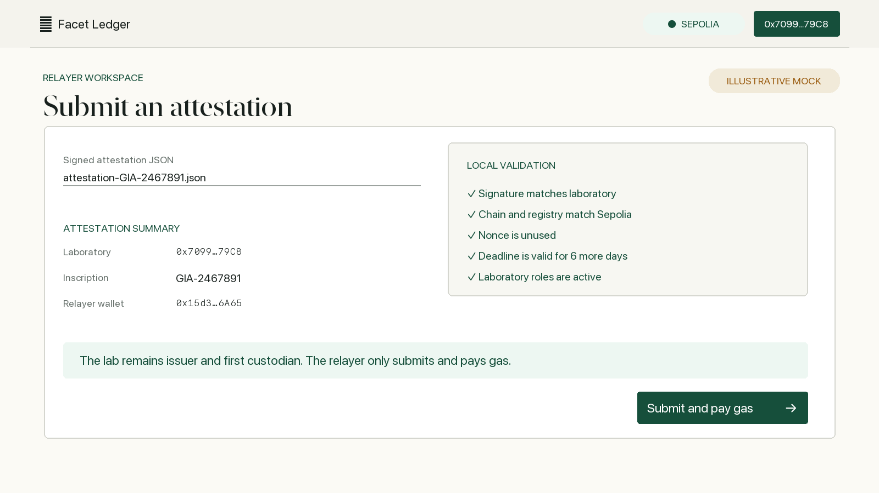
Illustrative mock screenshot

What the relayer does and does not receive
- Pays gas the relayer submits the blockchain transaction.
- Does not become owner the signing laboratory remains the issuer and first custodian.
- Cannot edit the claim changing any signed field makes signature recovery fail.

Step 4 Transfer custody with consent
The current custodian proposes a recipient. This first transaction does not move custody. The receiving wallet must load the same record and accept before the registry changes the custodian.
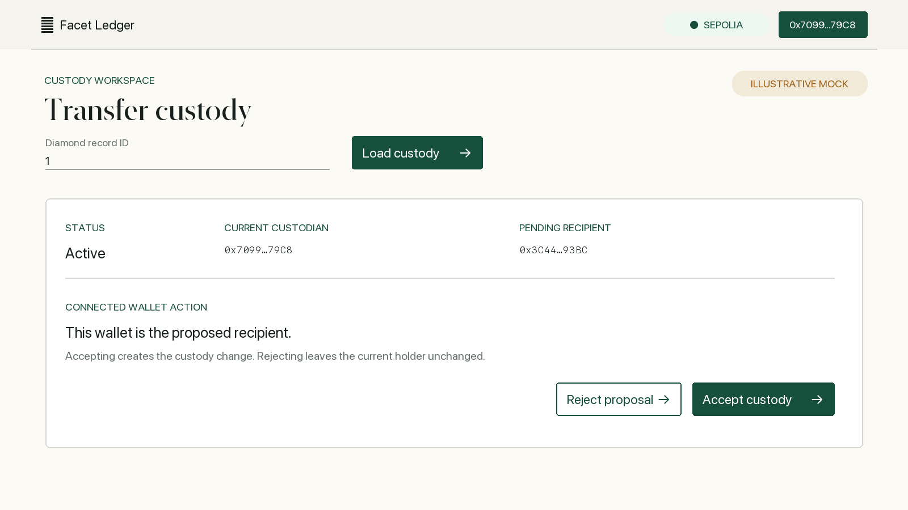
Illustrative mock screenshot

Possible outcomes
- Accept custody changes to the proposed recipient and the event appears in the audit trail.
- Reject the proposal disappears and custody remains unchanged.
- Cancel the current custodian withdraws the proposal before acceptance.
- Frozen record quarantined and revoked diamonds cannot be transferred.

Step 5 Administer roles and disputed records
Only a wallet with the administrator role can enable this workspace. It controls operational permissions and the lifecycle of disputed records, but it cannot rewrite the diamond details or force a custody transfer.
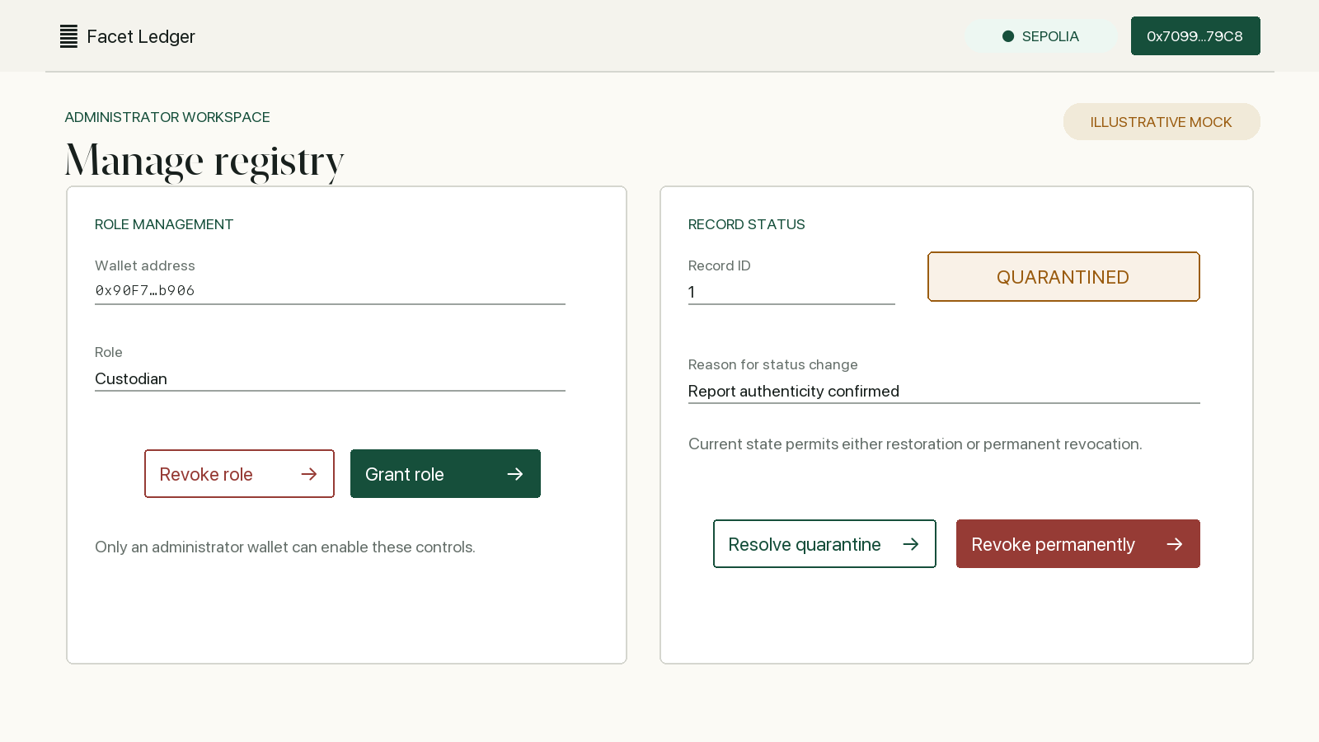
Illustrative mock screenshot

Record lifecycle
- Active to quarantined freezes transfers while a concern is investigated.
- Quarantined to active restores the record after resolution.
- Quarantined to revoked permanently marks the record invalid. Revocation is terminal.
Every status change requires a reason. That reason is stored in the event history for public review.

Suggested live demonstration script
Use these steps when presenting the application locally or on Sepolia.
Step | Presenter action | Point to explain
1 | Open public verification | Show that lookup works before connecting MetaMask.
2 | Connect the laboratory | Point out the detected network and laboratory permissions.
3 | Hash a sample report | Explain that only the file fingerprint enters the claim.
4 | Sign an attestation | Show the readable MetaMask prompt and downloaded JSON file.
5 | Switch to a relayer wallet | Load the JSON, review local validation, and submit.
6 | Verify the new record | Show the registration and relayer entries in the audit trail.
7 | Propose and accept custody | Use two custodian wallets to demonstrate consent.
8 | Quarantine and resolve | Use the admin wallet and show the public status update.

Expected final state
The audience should understand that the laboratory controls the claim, a relayer can pay gas without gaining custody, transfers require recipient consent, and the public audit trail preserves every accepted change.

