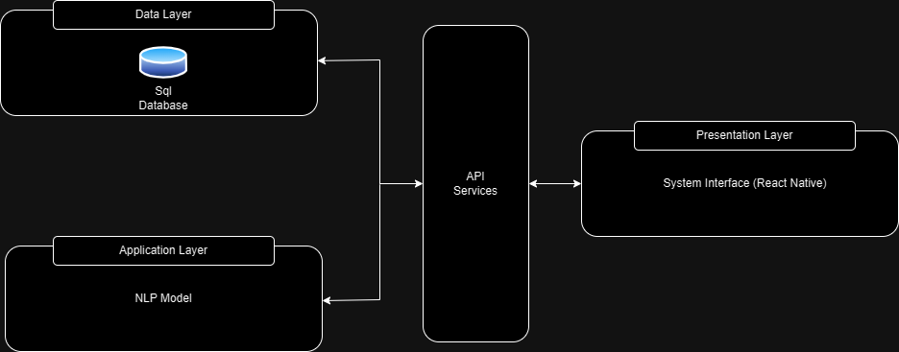  
  
  
Presentation Layer:

Presenting the user interface of “Saturday”, which includes the main aspects of “Saturday’s” functionalities. Some of the components represented would be the calendar; populated with the users prescheduled events though out the time frame presented. The Inbox displaying unopened un-opened email holding a value of high urgency according to the content. The To-Do list displaying the list of actions to be done which would ensure the completion of the user’s overall task. The actionable email lists displaying the emails according to user settings which content indicate tasks delegated to the user from the sender of urgency or importance.

Application Layer:

This is the layer which contains the logical part of Saturday which can be broken down to simple steps:

The implementation of the “Saturday” applications functionality which takes multiple forms such as:

Email processing: The function responsible for the AI processing and analysis of incoming emails. This functionality is one of the driving forces of “Saturday” as it helps the user with automatic task generation and time allocation for said tasks which ensures the completion of the tasks.

Generation of events: Post Email processing the AI module will be responsible to allocate the time of the user to tasks yet uncompleted. With the understanding of the user, the user’s self-assessment of time consumption per task and access to the user’s calendar finding optimal working hours to allocate for said task would be done automatically with the possibility of the user’s intervention.

To-Do list Generation: “Saturday’s” functionality to generate a list of actions that help the user complete tasks by breaking them down into actions.

Data Layer: which is also known as database layer where the application data is stored and maintained. The data mentioned consists of User Id, VarChar() which holds the messages, and a Boolean which helps Identifying who sent the message whether it’s Saturday or the user, createdAt time and updatedAt time.

(this done don’t change anything)