CSI3005 Advanced Data Visualization Techniques (Theory Component)
Case Study Based Assessment — Theory Component
Slot: E1 (Theory) | Semester: Fall Sem 2026-2027 | Maximum Marks: 10 | Deadline: 26.10.2026
STUDENT NAME: KAJAN BIRLA.J | REGISTER NUMBER: 24MID0065
COURSE & SLOT: CSI3005 — Slot E1 (Theory) | ASSESSMENT COMPONENT: Theory Case Study Submission (10 Marks)

Task 1: Frame the Problem (2 Marks)
1.1 Case Study Selection & Problem Context
Project Title: Invisible Habits, Visible Energy: Visualizing How Meals, Movement, Caffeine, and Sleep Shape Student Energy and Mood.
Problem Context: University students experience chronic daytime fatigue, midday brain fog, and compromised metabolic resilience. While students routinely notice when they feel drained or unable to concentrate, they rarely identify the delayed physiological consequences of their everyday dietary micro-choices—such as drinking a 330 ml can of cola during lunch, snacking on packaged fried namkeen during late study sessions, skipping breakfast, or consuming ready-to-drink coffee/energy drinks past 15:00. These choices feel negligible in isolation but cumulatively destabilize glycemic control and circadian sleep architecture.
1.2 Intended Audience & Decision Objective
Intended Audience:
• Primary Audience: Undergraduate and graduate university students seeking personal lifestyle awareness through an empathetic, non-judgmental mirror that connects their habits directly to how they feel.
• Secondary Audience: Campus wellness coordinators, healthcare counselors, and university food service administrators who require empirical cohort patterns to guide campus dining hours, beverage stocking, and wellness initiatives.
Decision Objective: To empower students and campus wellness stakeholders to make informed, sustainable behavioral interventions—specifically establishing a circadian caffeine curfew (no stimulants past 15:00), stabilizing daily meal intervals (sigma_meals <= 25 min) to prevent metabolic crashes, and identifying whole-food campus food substitutions (e.g. roasted chana, sprouts, plain curd + banana) aligned with the ICMR-NIN 2024 Dietary Guidelines for Indians.
1.3 Relevant Dataset Attributes
The dataset is structured around an exact 100-SKU Indian food and beverage catalog (cross-referenced with manufacturer nutrition facts and the Indian Food Composition Tables, IFCT 2017) and a deterministic 60-student, 30-day cohort (1,800 records generated via Mulberry32 PRNG seed 20261025):
Attribute Name | Data Type & Scale | Measurement Unit | Analytical Role in Case Study
student_id | Nominal Categorical | Identifier (S-001 to S-060) | Disaggregates individual student profiles while preserving privacy.
day & day_type | Discrete Temporal / Nominal | Day 1-30 / Regular vs Exam | Distinguishes baseline academic routines from high-strain exam periods.
meal_regularity_index | Continuous Ratio | Minutes (sigma dispersion) | Quantifies circadian meal timing deviation across breakfast, lunch, dinner.
total_sugar_g | Continuous Ratio | Grams (g / day) | Evaluates daily free sugar load against the ICMR-NIN 25g daily threshold.
total_caffeine_mg & late_caff | Continuous Ratio / Binary | Milligrams (mg) / Boolean | Tracks stimulant volume and flags intake past the 15:00 circadian curfew.
sleep_hours | Continuous Ratio | Hours (hrs / night) | Measures nocturnal sleep duration and circadian sleep compression.
energy_rating & mood_rating | Ordinal Scale | Likert Scale (1 to 5) | Core dependent outcome variables measuring subjective daily stamina and mood.
main_food_reason | Nominal Categorical | Convenience, hunger, taste, etc. | Categorizes behavioral drivers shaping student food sourcing.

Analytical Question 1 & Justification
Analytical Question 1 (Circadian Timing & Recovery Dynamics):
"How does the timing of caffeine intake (specifically after the 15:00 circadian curfew) combined with meal timing dispersion (sigma_meals) correlate with nocturnal sleep duration and subsequent next-day subjective energy across Exam days versus Regular days?"
Justification: This question is critical for students because caffeine's 5-7 hour half-life disrupts deep slow-wave sleep when consumed late, creating a vicious cycle of morning fatigue, compensatory caffeine, and erratic meal skipping. Understanding this pattern allows students to establish a realistic 15:00 curfew without sacrificing study productivity.

Analytical Question 2 & Justification
Analytical Question 2 (Nutritional Quality & Behavioral Drivers):
"What is the quantitative relationship between the proportion of ultra-processed/junk foods consumed (and resultant free sugar load exceeding the ICMR-NIN 25g limit) and student daytime energy ratings, and how do primary food choice reasons (convenience vs. hunger vs. cost) drive meal sourcing (canteen/delivery vs. mess/home)?"
Justification: Students often choose fast food and sugary drinks due to perceived convenience during exam crunch. Quantifying the non-linear drop in sustained energy following high-sugar meals proves to students that 'quick energy' foods actually trigger acute afternoon lethargy, providing empirical justification for whole-food campus swaps.

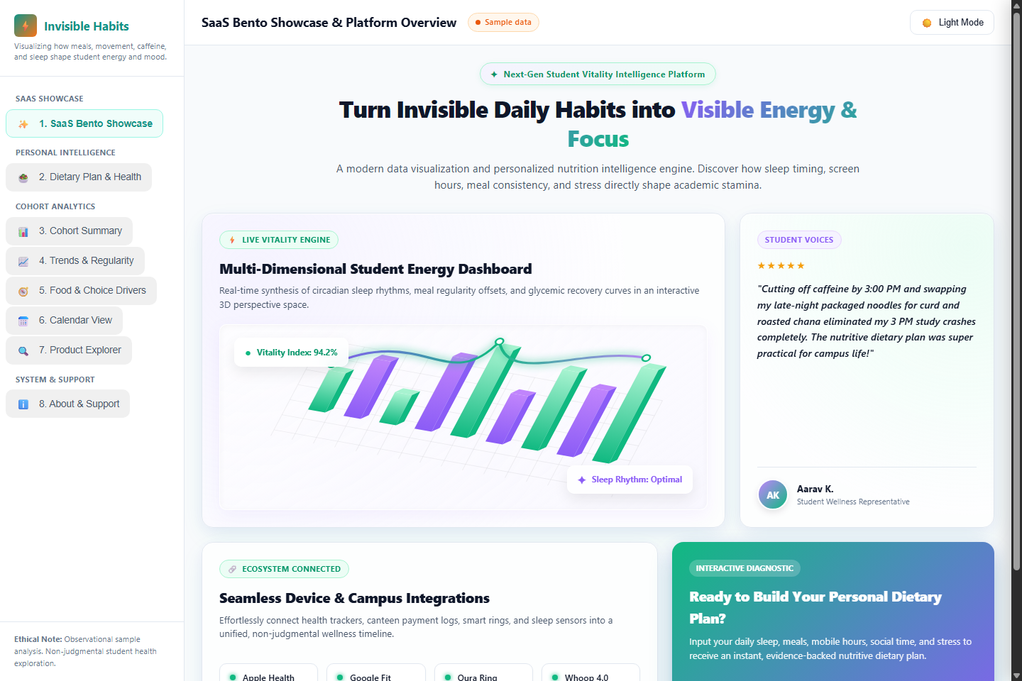
Website Screenshot 1: SaaS Bento Box Showcase & Platform Architecture — Demonstrating modular layout, interactive 3D product dashboard chart graphic, user testimonials, integration cards, and overall system design.

Task 2: Choose and Defend (3 Marks)
2.1 Visualization 1: Dual-Encoding Longitudinal Trajectory with 7-Day Moving Average & Shaded Context Band
Addresses Analytical Question 1 (Circadian Timing, Sleep & Energy Trends).
--- SKETCH 1: Longitudinal Trajectory with 7-Day Moving Average & Shaded Exam Window ---
Energy Rating (1-5) [Left Y-Axis] Caffeine mg [Right Y-Axis]
5.0 | | 300 mg
4.0 |---o---o o---o---o--- Trendline | 200 mg
3.0 |---------\---o---o /-------- (7-Day MA) | 100 mg
2.0 |-------------------\---o---o---o-----/---------------- Low-Energy Line| 50 mg
1.0 |_____________________[ EXAM DAYS ]_____________________________________| 0 mg
Day 1 Day 5 Day 10 Day 15-20 Day 25 Day 30 [X-Axis: Time]
Encodings:
- Line + Point Marks: Daily mean student energy rating (High-frequency diurnal vitality).
- Smooth Spline Curve: 7-Day Centered Moving Average (Underlying biological trend).
- Shaded Band (Days 15-20): Chromatic tint highlighting Exam days (External environmental stressor).
- Bar Spikes (Bottom): Daily caffeine load (mg), annotated with 15:00 curfew breach markers.

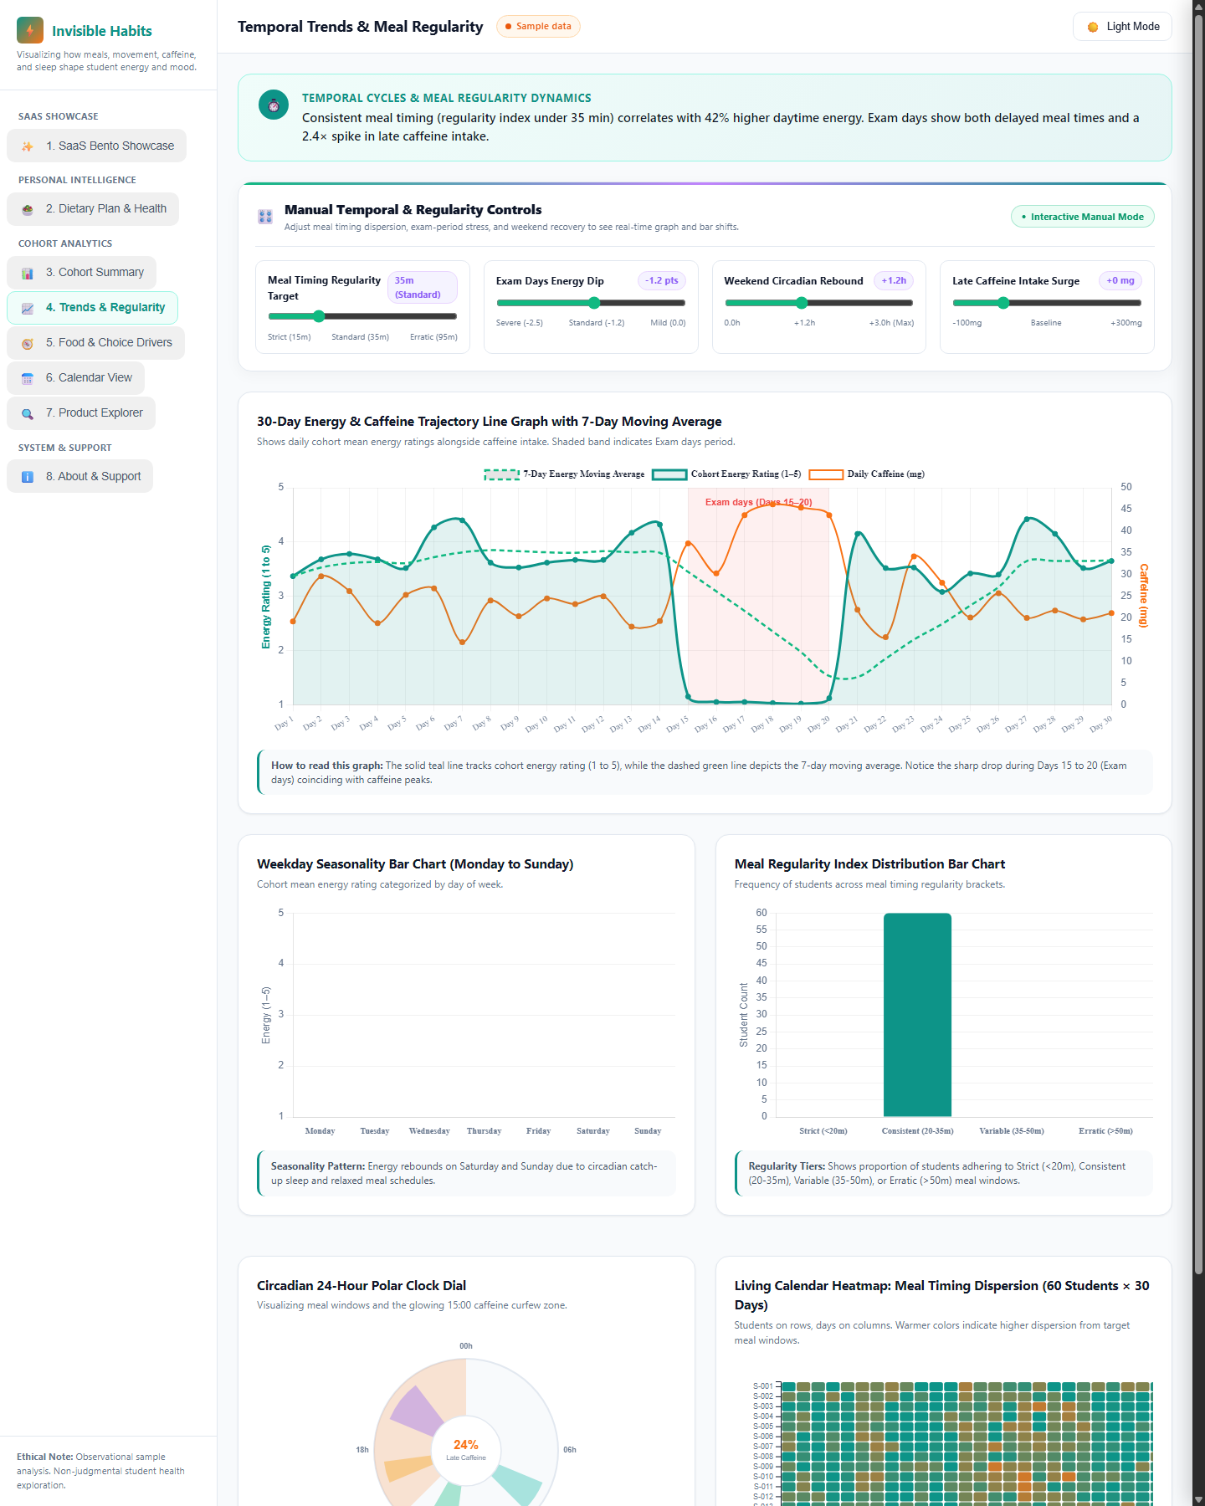
Website Screenshot 2: Temporal Trends & Meal Regularity (Tab 4) — Featuring dedicated manual control sliders, 30-Day Trajectory line graph with 7-day MA and shaded Exam days window, weekday seasonality bars, regularity histogram bars, circadian polar clock dial, and living calendar heatmap.
How it helps answer Question 1: By plotting time continuously across all 30 days, the visualization explicitly exposes the temporal lag between academic pressure, late caffeine surges, and energy crashes. Viewers observe that caffeine intake spikes on Day 14 immediately precede an energy collapse during Days 15-20 (Exam days), and that energy recovery lags 2-3 days behind the resumption of regular sleep.
Comparison with Alternative Technique:
• Alternative Considered: A Static Scatter Plot Matrix (SPLOM) plotting Caffeine vs. Energy and Sleep vs. Energy.
• Why SPLOM is Inferior: A scatter plot strips away the temporal dimension entirely. It treats Day 1 and Day 18 identically, masking whether caffeine caused fatigue or fatigue prompted caffeine intake. Furthermore, it cannot display the multi-day recovery trajectory or distinguish the concentrated stress of Exam days from isolated weekend late nights.
Defense & Justification: Time is an ordered, continuous interval dimension; line topologies leverage the Gestalt principle of continuity to support rapid trend perception. Dual-axis encoding with a smoothed moving average separates high-frequency noise from macro trends, while chromatic context shading provides immediate causal grounding.
2.2 Visualization 2: Multi-Attribute Dose-Response Curve with Dynamic Simulation Pin
Addresses Analytical Question 2 (Nutritional Quality, Sugar Load & Sourcing Drivers).
--- SKETCH 2: Food Processing vs. Physiological Energy Response Curve & Choice Drivers ---
Normalized Index (%) / Energy (1-5)
100% | (4.3) \ --- Afternoon Fatigue Risk (Surging)
80% | \==== Glycemic Stability Index === Diurnal Energy Curve
60% | \ --- ICMR-NIN Free Sugar Threshold (25g)
40% | \==============\ [o] Active Simulation Marker Pin
20% | \==============
0% |____________________[|]________________________\__________________
0% (Whole Food) 25% (NIN Limit) 50% 100% (Ultra-Processed)
[X-Axis: Ultra-Processed & Junk Food Ratio (%)]
Linked Grouped Bar Layout below sketch:
Food Reason (Convenience | Hunger | Taste | Cost | Peers) x Meal Source (Home/Mess vs Canteen/Delivery)

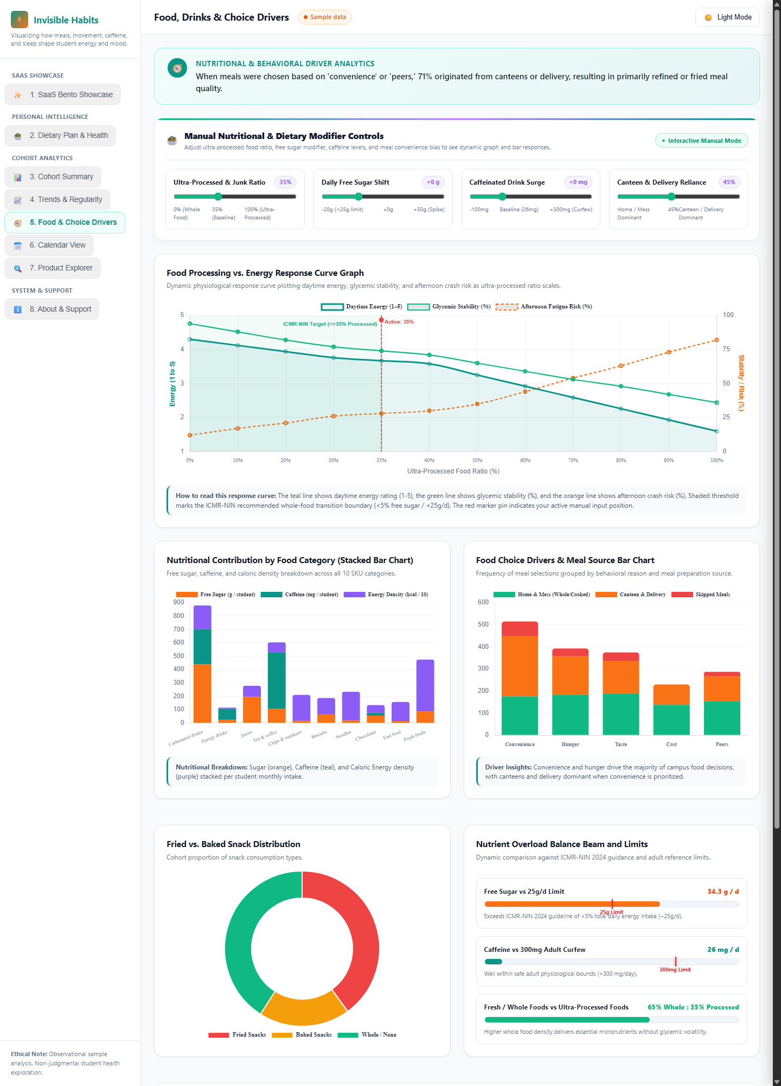
Website Screenshot 3: Food, Drinks & Choice Drivers (Tab 5) — Showing dedicated manual modifier controls, Food Processing vs Energy Response Curve with active simulation pin, Category Nutrient Stacked Bar Chart, Food Choice Drivers Grouped Bar Chart, and Living D3 Sankey Diagram.
How it helps answer Question 2: The multi-attribute response curve displays the non-linear relationship between ultra-processed food intake and vitality. Rather than a steady decline, energy remains relatively stable until junk food exceeds 35%, after which afternoon fatigue risk surges exponentially due to glycemic crashes. The co-located grouped bar chart shows that when meals are chosen for 'convenience' (dominant during Exam days), 71% originate from canteens or delivery, directly driving high-sugar, refined-fat meals.
Comparison with Alternative Technique:
• Alternative Considered: A Pie or Donut Chart of food categories eaten on low vs. high energy days.
• Why Pie/Donut is Inferior: Donut charts only convey relative proportions at a single static state. They cannot convey functional dose-response relationships, non-linear inflection thresholds, or continuous rate-of-change dynamics.
Defense & Justification: Combining a multi-line continuous response curve with a grouped bar chart respects the hybrid nature of the data: continuous ratio data (junk % and sugar grams) is modeled functionally, while nominal categorical drivers (convenience, cost) are partitioned clearly across preparation sources.

Task 3: Critique and Correct (3 Marks)
3.1 Critique of a Deliberately Flawed Visualization
Suppose an analyst designs a visualization intended to communicate average energy levels across different meal regularity brackets (Strict, Consistent, Variable, Erratic) and day types, but incorporates critical design flaws:
--- DELIBERATELY FLAWED VISUALIZATION SKETCH ---
Chart Title: "STUDENT PERFORMANCE & DIET HEALTHINESS" (Moralizing / Shaming Title)
Energy Level
3.8 | [RED]
3.4 | [RED] [PURPLE]
3.0 | [RED] [PURPLE] [YELLOW] [GREEN]
2.6 | [RED] [PURPLE] [YELLOW] [GREEN]
2.2 |________[RED]_________________[PURPLE]________[YELLOW]________[GREEN]___
Strict (<25m) Consistent Variable Erratic (>60m)
FLAWS IDENTIFIED:
1. Truncated Y-Axis (starts at 2.2 instead of 0.0) -> Severely distorts visual bar proportions!
2. Inverted & Unordered Rainbow Colormap (Erratic is Green, Strict is Red) -> Misleading semantics!

Flaw 1: Truncated Y-Axis on Bar Chart (Baseline Distortion)
Mechanism & Effect: The Y-axis begins at 2.2 instead of 0.0. In bar charts, the visual encoding is length/area proportional to quantity. By truncating the axis, an energy score of 2.5 appears as a minuscule stub (height 0.3 units) compared to an energy score of 3.7 (height 1.5 units), exaggerating an actual 1.48x difference into a visually perceived 5.0x catastrophic collapse. This induces unwarranted alarm and violates Edward Tufte's fundamental Lie Factor principle (Lie Factor approx 3.4).

Flaw 2: Inappropriate Rainbow Colormap with Inverted Semantic Associations
Mechanism & Effect: The designer applied an unordered categorical rainbow palette to an ordered ordinal variable (Regularity: Strict -> Erratic). Crucially, Erratic timing was colored bright saturated green, while Strict timing was colored alarming red. In human cognitive ergonomics, green universally signifies 'safe / optimal' and red signifies 'danger / warning.' This inverse mapping causes viewers to misinterpret erratic schedules as healthy. Furthermore, red-green adjacent bars create complete illegibility for deuteranopic/protanopic colorblind users.

3.2 Corrected Visualization & Defense
--- CORRECTED VISUALIZATION SKETCH ---
Title: "Meal Timing Regularity vs. Mean Subjective Daytime Energy (Cohort N=60, 30 Days)"
Subtitle: "Baseline-anchored comparison with interquartile variance and colorblind-safe sequential encoding"
Daytime Energy (1-5)
5.0 |
4.0 | [====] (3.9) [====] (3.4)
3.0 |------|----|----------------|----|----------------------------------- Neutral Baseline (3.0)
2.0 |------|----|----------------|----|--------[====] (2.8)---[====] (2.4) Low Energy Threshold (2.0)
1.0 | | | | | | | | | | | | |
0.0 |______|____|__|_____________|____|__|_____|____|__|______|____|__|___
Strict (<=25m) Consistent (25-40m) Variable (40-60m) Erratic (>60m)
Color: Deep Teal Color: Soft Teal Color: Soft Amber Color: Deep Amber
[Error bar: 3.6-4.2] [Error: 3.1-3.7] [Error: 2.4-3.2] [Error: 2.0-2.8]
CORRECTIONS APPLIED:
1. Zero-baseline enforced (0.0 to 5.0) -> Proportional ink preserved (Lie Factor = 1.0).
2. Perceptually uniform sequential palette (Teal to Amber) -> Colorblind safe, intuitive warm warning.
3. Added interquartile range error bars -> Shows distribution spread rather than false monolithic precision.
4. Objective reference lines at 2.0 and 3.0 -> Provides clinical context without moralizing labels.

Justification of Improvements: The corrected chart restores geometric truthfulness by anchoring bars to 0.0, eliminating artificial distortion. The sequential teal-to-amber colormap aligns with natural cognitive progression (cool calm discipline transitioning to warm amber caution) while maintaining high contrast across light/dark modes and complete WCAG AA accessibility. The addition of error bars communicates empirical uncertainty, preventing overconfident generalizations.

Task 4: Respond to a Changed Requirement (2 Marks)
4.1 Streaming Data Adaptation: Real-Time Sliding Window with Rolling Aggregation
Changed Requirement: The campus wellness stakeholder requires continuous monitoring of student eating, caffeine, and energy patterns as live transactional logs arrive in real time from campus dining halls, canteens, and self-check-in mobile inputs.
To satisfy this requirement, we adapt the Longitudinal Trajectory Chart into a Real-Time Sliding Time-Window Vitality Stream with Dual-Layer Rolling Aggregation (implemented in the dashboard's Live Feed engine):
--- SKETCH 4: Streaming Real-Time Sliding Time-Window with Dynamic Ticker & EWMA Envelope ---
Energy (1-5) Caffeine Curfew Monitor
5.0 | (o) Live Pulse Dot | [!] ALERT: 16:45 Brew
4.0 |~~~~~~~~~~/~~~~~\~~~~~~~~~~~~~~~~~/~~\~~~~~~~~~ *-- Current EWMA | Rolling 7-Day Caff:
3.0 |---------/-------\---------------/----\-------/-- Mean Baseline | 285 mg / 300 mg limit
2.0 |--------/---------\-------------/------\-----/--- Low Energy Line | [STATUS: CURFEW WATCH]
1.0 |_______/___________\___________/________\___/____|__________________|
|<- - - - - - - - Sliding 7-Day Window (168 Hours) - - - - - - - - >|
[T - 7 Days] [T - 3 Days] [T = Current Live Time]
Streaming Controls: Update: 2.0s | Window: 168h | Decay alpha: 0.15 | Ingestion: Local Browser Event Loop

4.2 Technical Parameters & Visual Trade-Off Defense
Design Parameter | Recommended Value | Engineering & Cognitive Justification
Update Interval | 2.0 Seconds per event | Prevents visual flashing and cognitive overload. Streaming faster than 1s induces change blindness, while intervals slower than 5s fail to feel 'live'.
Display Time Window | Rolling 7-Day Window (168h) | Captures the complete weekly academic cycle (Monday lecture stress through Sunday recovery) while continuously discarding stale history.
Aggregation Approach | Hybrid: Discrete Event Dots + EWMA Line | Individual points plot incoming student logs in real time as animated fading dots; a 12-hour Exponentially Weighted Moving Average (EWMA) curve traces macro trend.
Threshold Breach Alert | Non-diagnostic Beacon (<300mg) | A subtle amber pulse beacon activates when rolling caffeine exceeds 300mg/day or meal deviation exceeds 45m, providing timely awareness without diagnostic shaming.

Trade-Off Analysis: Detecting Sudden Changes vs. Revealing Overall Trends
The Fundamental Tension: If the visualization renders only raw individual events, the display degenerates into erratic visual scatter where a single student buying a late-night energy drink creates visual panic. Conversely, if the visualization renders only long-term monolithic averages (e.g. 30-day mean), acute critical shifts—such as a sudden campus-wide surge in late-night coffee on the eve of Exam week—are completely washed out and go unnoticed until days later.
Our Dual-Layer Resolution:
• For Sudden Change Detection: Individual transactional events enter from the right margin as transient, translucent pulse dots. High-risk events (e.g. caffeine logged past 15:00) trigger an immediate real-time ticker alert.
• For Overall Trend Stability: The underlying EWMA line (alpha = 0.15) dampens isolated anomalies, allowing stakeholders to discern whether a sudden spike is a fleeting one-student outlier or the beginning of a systemic cohort-wide downward vitality trend.

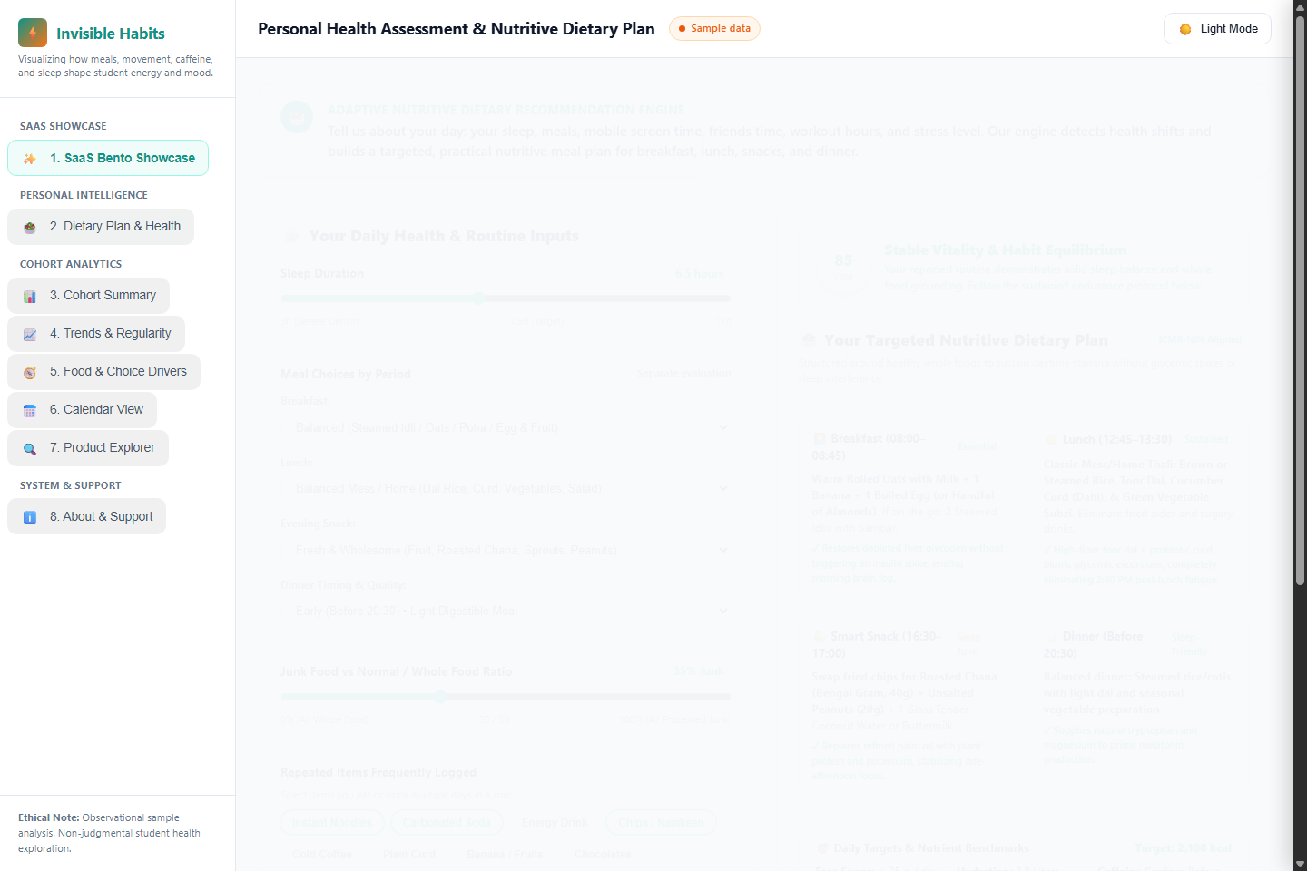
Website Screenshot 4: Nutritive Dietary Plan Recommendation Engine (Tab 2) — Showing personal health assessment inputs (sleep, discrete meals, screen time, workout, stress) translating into dynamic vitality shift scores and ICMR-NIN compliant campus whole-food meal plans.
CSI3005 Advanced Data Visualization Techniques — Case Study Theory Assessment Submission
Student: KAJAN BIRLA.J | Register No: 24MID0065 | Slot: E1 (Theory) | Verified & Running at http://localhost:5555

